ARTIFICIAL INTELLIGENCE AND MACHINE LEARNING

SMART LENDER
A Machine Learning-Based Loan Approval Prediction System

BACHELOR OF TECHNOLOGY
In
ELECTRONICS AND COMMUNICATION ENGINEERING

Submitted by
SWARNA RAJU GOVINDALAPUDI (MEMBER)

RAJIV GANDHI UNIVERSITY OF KNOWLEDGE TECHNOLOGIES
(RGUKT) – SRIKAKULAM
Semester: 4-1

ACKNOWLEDGEMENT
We express our sincere gratitude to APSCHE-SMARTBRIDGE for providing us with the opportunity to undertake this Machine Learning project titled SMART LENDER.
This project enabled us to gain practical experience in designing, developing, and deploying a complete machine learning-powered web application. Throughout the project, we enhanced our understanding of data preprocessing, exploratory data analysis, classification algorithms, model evaluation, and the integration of a trained model into a Flask-based web application.
We are also thankful to our faculty members at RGUKT Srikakulam and everyone who directly or indirectly contributed by offering suggestions, encouragement, and constructive feedback during the development process.
Finally, we thank our team for the dedication, cooperation, and commitment that made the successful completion of this project possible.

ABSTRACT
SMART LENDER is a machine learning-based web application designed to predict the eligibility of loan applicants. By leveraging historical financial data, the system provides automated, fair, and transparent recommendations on whether a loan should be approved or rejected. The project demonstrates the end-to-end integration of a trained machine learning model with a web-based user interface.
The application processes structured applicant inputs such as gender, marital status, education, employment status, income, co-applicant income, loan amount, loan term, credit history, and property area. Multiple classification algorithms — Decision Tree, Random Forest, K-Nearest Neighbors (KNN), and XGBoost — were trained and evaluated using a Classification Report and Confusion Matrix for each model. The Random Forest Classifier, trained on data balanced using SMOTE (Synthetic Minority Over-sampling Technique), emerged as the best-performing model and was serialized using Pickle for deployment.
The frontend is built using HTML5, CSS3, and vanilla JavaScript to provide a clean, banking-inspired, responsive interface, while the backend is powered by Python and Flask, which loads the trained model and serves real-time predictions. The application enforces strict preprocessing parity, ensuring that the same scaling, encoding, and feature ordering used during training is applied at inference time.
SMART LENDER is deployed on Render using Gunicorn as the production WSGI server. The project demonstrates practical machine learning engineering skills, including data cleaning, exploratory data analysis, class balancing, model selection, and deployment of an ML-powered web application.

1. Introduction
Loan approval is a critical process for banks and financial institutions, traditionally relying on manual evaluation of applicant profiles, which can be time-consuming, inconsistent, and prone to human bias. SMART LENDER addresses this challenge by using a trained machine learning model to instantly assess an applicant's eligibility based on their financial and demographic details.
The application allows a user to fill out a simple loan application form with details such as income, loan amount, credit history, and employment status, and receive an immediate, automated prediction of whether their loan is likely to be approved or rejected. By combining a rigorously trained classification model with a lightweight, easy-to-use web interface, SMART LENDER aims to make the loan eligibility assessment process faster, fairer, and more transparent.

2. Project Overview

Purpose
SMART LENDER is developed to provide a machine learning-powered platform for predicting loan eligibility based on historical financial data. The project aims to demonstrate how a trained classification model can be integrated into a real-world, web-based decision-support tool for banks and financial institutions, enabling faster and more consistent loan approval recommendations.

Key Features
- Instant Eligibility Prediction: Get immediate feedback on loan approval status based on the applicant's input parameters, without manual review.
- Robust Machine Learning Backend: Utilizes a Random Forest Classifier trained on balanced data (via SMOTE) for accurate, consistent predictions.
- Strict Preprocessing Parity: The backend strictly enforces exactly the same feature scaling, encoding, and ordering used during model training to eliminate inference bugs.
- Client-Side Validation: Ensures that all numerical inputs (e.g., Income, Loan Amount) and dropdown selections are correctly filled before submission.
- Responsive Web Interface: A clean, banking-inspired layout built entirely from scratch using HTML5, CSS3, and vanilla JavaScript — no external UI framework.

Future Enhancements
- Transition the frontend to a modern component-based framework such as React if the application scales further.
- Integrate a cloud database (e.g., PostgreSQL or MongoDB) to store applicant histories and feedback loops.
- Deploy the application across additional cloud hosting providers (AWS, Render, or Heroku) for wider availability.
- Introduce Explainable AI (XAI) features, such as SHAP values, to explain why a particular applicant was approved or rejected.

3. Architecture
- Frontend: Built using HTML5, CSS3, and vanilla JavaScript, providing a responsive, banking-inspired user interface. The frontend consists of Home, Loan Application Form, and Result pages, with client-side JavaScript performing input validation before submission.
- Backend: Developed using Python and Flask. app.py handles the main routing logic, receiving form submissions and returning prediction results. A dedicated helper module (model_helper.py) encapsulates the machine learning inference logic, ensuring that preprocessing steps exactly mirror those used during training.
- Machine Learning Layer: The trained Random Forest model, along with its supporting artifacts (label encoders, feature column order, and the StandardScaler), are serialized using Pickle and loaded by the Flask application at runtime. The project does not use a live database — it is trained on a static dataset (the SkillWallet Loan Prediction Dataset) and performs stateless, real-time predictions.

4. Setup Instructions

Prerequisites
- Python 3.8 or above
- pip (Python package manager)
- Git
- A code editor such as VS Code or PyCharm

Core Dependencies
- Flask — backend web framework
- Scikit-learn — model training and inference
- Pandas — data handling
- Imbalanced-learn (SMOTE) — class balancing during training
- Gunicorn — production WSGI server (for deployment)

Installation Steps
1. Clone the repository:
git clone https://github.com/swarnarajugovindalapudi/Smart-Lender-Loan-Approval-Prediction.git
2. Navigate into the project directory:
cd SmartLender
3. Create a virtual environment (optional but recommended):
python -m venv venv
source venv/bin/activate # On Windows: venv\Scripts\activate
4. Install the required dependencies:
pip install -r requirements.txt

5. Folder Structure
SmartLender/
├── app/
│ ├── app.py # Main Flask routing logic
│ ├── static/
│ │ ├── css/style.css # Frontend assets
│ │ └── js/validation.js
│ ├── templates/ # HTML UI layouts
│ │ ├── base.html
│ │ ├── index.html
│ │ ├── predict.html
│ │ └── result.html
│ └── utils/
│ └── model_helper.py # ML inference business logic
│
├── dataset/
│ └── loan_prediction.csv # SkillWallet Loan Prediction Dataset
│
├── models/ # Serialized artifacts
│ ├── best_model.pkl # Trained Random Forest
│ ├── encoders.pkl # Dictionary of LabelEncoders
│ ├── feature_columns.pkl # List of feature names
│ └── scaler.pkl # StandardScaler
│
├── notebooks/
│ └── 01_EDA_and_Modeling.ipynb # Data exploration and model training
│
├── tests/
│ └── test_backend.py # Local inference test script
│
├── requirements.txt # Required Python packages
└── README.md

Description
- app/: app.py — Main Flask routing logic; receives applicant data and returns predictions.
- utils/: Contains model_helper.py, which handles feature scaling, encoding, and prediction logic.
- templates/: HTML pages for the Home, Loan Application Form, and Result screens.
- dataset/: Contains the SkillWallet Loan Prediction Dataset used to train the model.
- models/: Stores the serialized Random Forest model and its associated encoders/scaler for inference.
- notebooks/: Contains the Jupyter notebook used for data exploration, preprocessing, and model training.
- tests/: Contains a local script to test backend inference outside the web interface.

6. Running the Application

Run Locally
Step 1: Navigate to the project root directory.
Step 2: Start the Flask application as a module:
python -m app.app
Step 3: Open your browser and go to:
http://127.0.0.1:5000/

Deployment (Render)
The application is deployed and configured to run on Render, using Gunicorn as a production-ready WSGI HTTP server.
- Requirements: The requirements.txt file includes gunicorn.
- Start Command: When deploying to Render, the start command is:
gunicorn app.app:app
Live Application:
https://smart-lender-loan-approval-prediction-pfqs.onrender.com

7. Application Modules
SMART LENDER does not expose a separate public REST API; instead, the Flask application directly renders HTML pages and processes form submissions server-side through the following modules:
- app.py: Serves the Home page, the Loan Application Form, and handles the POST submission from the form, passing the applicant's data to the inference logic and rendering the Result page with the outcome.
- utils/model_helper.py: Contains the core inference logic — loading the serialized Random Forest model, encoders, scaler, and feature column order (from the models/ directory), applying the same preprocessing steps used during training, and returning a prediction (Approved / Not Approved).
- static/js/validation.js: Performs client-side validation (e.g., ensuring numerical fields like Income and Loan Amount, and all dropdown selections, are correctly filled) before the form is submitted to the backend.

8. Testing
Testing was carried out to verify that SMART LENDER's machine learning pipeline and web application function correctly. During model development, each of the four candidate algorithms — Decision Tree, Random Forest, KNN, and XGBoost — was evaluated using a Classification Report and Confusion Matrix, and the best-performing model (Random Forest) was selected based on these metrics.
A local inference test script (tests/test_backend.py) was used to validate that the saved model, encoders, and scaler produce correct predictions outside of the web interface, ensuring preprocessing parity between training and inference.
On the frontend, client-side validation (static/js/validation.js) was tested to confirm that numerical fields and dropdown selections are correctly enforced before a loan application can be submitted. End-to-end testing was also performed on the deployed Render application to confirm that both the Approved and Not Approved result pages render correctly based on the model's prediction.

9. Project Flow
GitHub Repository:
https://github.com/swarnarajugovindalapudi/Smart-Lender-Loan-Approval-Prediction
Live Demo:
https://smart-lender-loan-approval-prediction-pfqs.onrender.com

Epic 1: Data Collection and Architecture Design (Duration: 2h 0m)
This phase focused on collecting and understanding the required dataset for model training. The dataset served as the foundation for data analysis, preprocessing, and machine learning model development.
- Download the Dataset
- Defining the Application Architecture
Epic 2: Visualizing and Analysing the Data (Duration: 4h 0m)
This phase focused on exploring and understanding the dataset using visualization and analysis techniques. Various charts, graphs, and statistical methods were used to identify patterns, trends, and insights from the data.
- Import and Read Dataset
- Univariate Analysis
- Bivariate Analysis
- Multivariate Analysis
Epic 3: Data Pre-processing (Duration: 3h 0m)
This phase focused on preprocessing the dataset by handling missing values, reducing noise, balancing classes, and preparing the data for effective machine learning model training.
- Checking and Handling Missing Values
- Balancing the Dataset (SMOTE)
- Scaling the Data
- Splitting Data into Training and Test Sets
Epic 4: Model Building (Duration: 3h 0m)
This phase focused on training and evaluating multiple machine learning models. The best-performing model was selected based on performance metrics and saved for deployment.
- Decision Tree Model
- Random Forest Model
- KNN Model
- XGBoost Model
- Evaluating Performance and Saving the Model
Epic 5: Application Building (Duration: 3h 0m)
This phase focused on developing the web application and integrating it with the trained model. The system accepts user inputs and provides instant predictions through a user-friendly interface.
- Building HTML Pages
- Building the Python Script
- Run the Application

10. Implementation Screenshots

10.1 Home Page
Corresponds to the Responsive Web Interface feature — a clean, banking-inspired landing page introducing Smart Lender's value proposition (Quick Processing, Fair Assessment, Transparent Criteria) with a call-to-action to check loan eligibility.
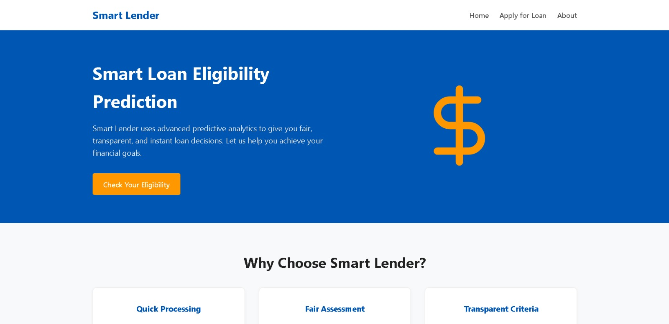
Fig 10.1: Smart Lender – Home Page

10.2 Loan Application Form
Corresponds to the Client-Side Validation feature — the applicant enters demographic and financial details (Gender, Marital Status, Dependents, Education, Employment, Income, Loan Amount, Loan Term, Credit History, Property Area), which are validated before submission.
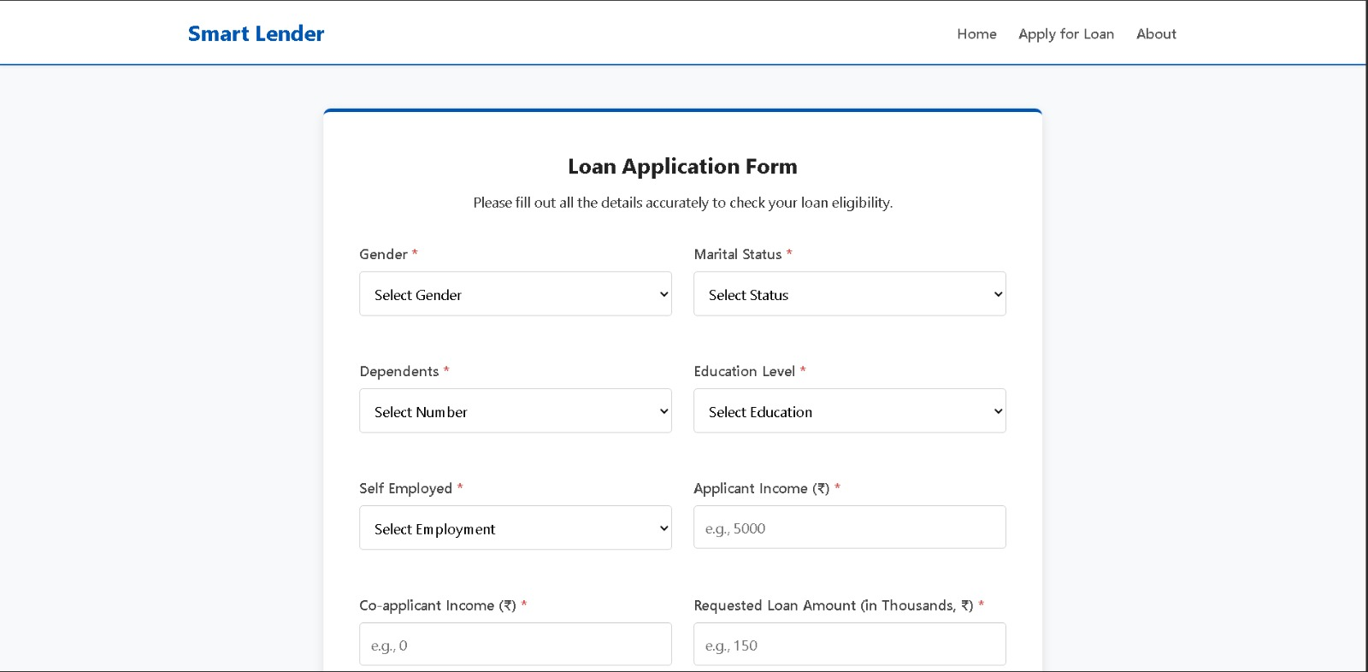
Fig 10.2: Smart Lender – Loan Application Form

10.3 Prediction Result – Approved
Corresponds to the Instant Eligibility Prediction feature — the Random Forest model returns an Approved outcome, along with a disclaimer that the prediction is an assisting recommendation rather than a final lending decision.
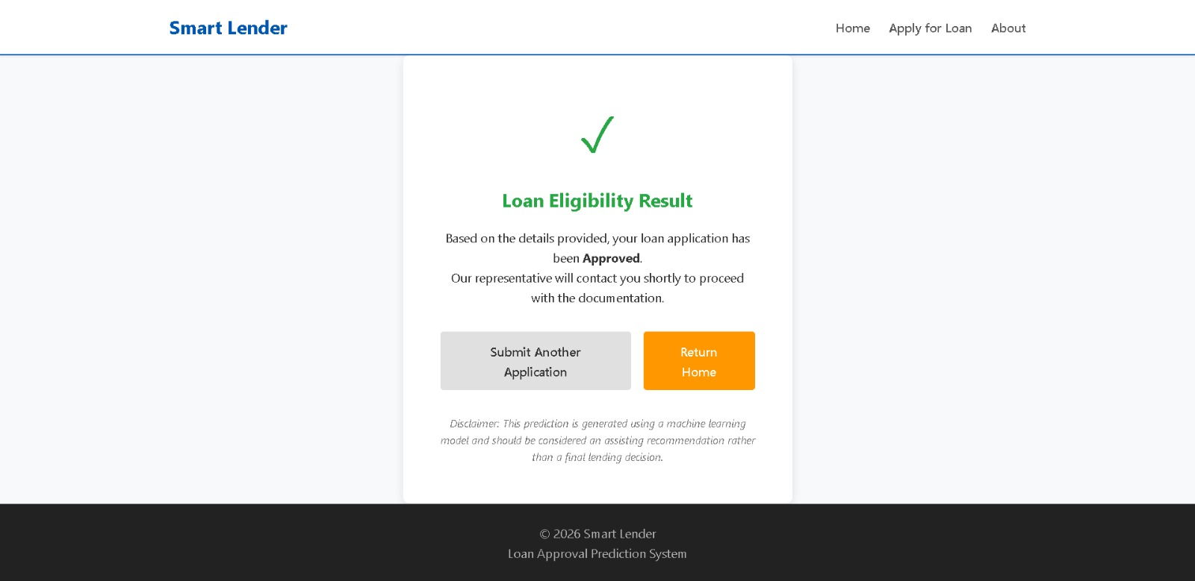
Fig 10.3: Smart Lender – Loan Approved Result

10.4 Prediction Result – Not Approved
Corresponds to the Instant Eligibility Prediction feature — the Not Approved outcome, with guidance suggesting the applicant improve their credit history or adjust the requested loan amount before reapplying.
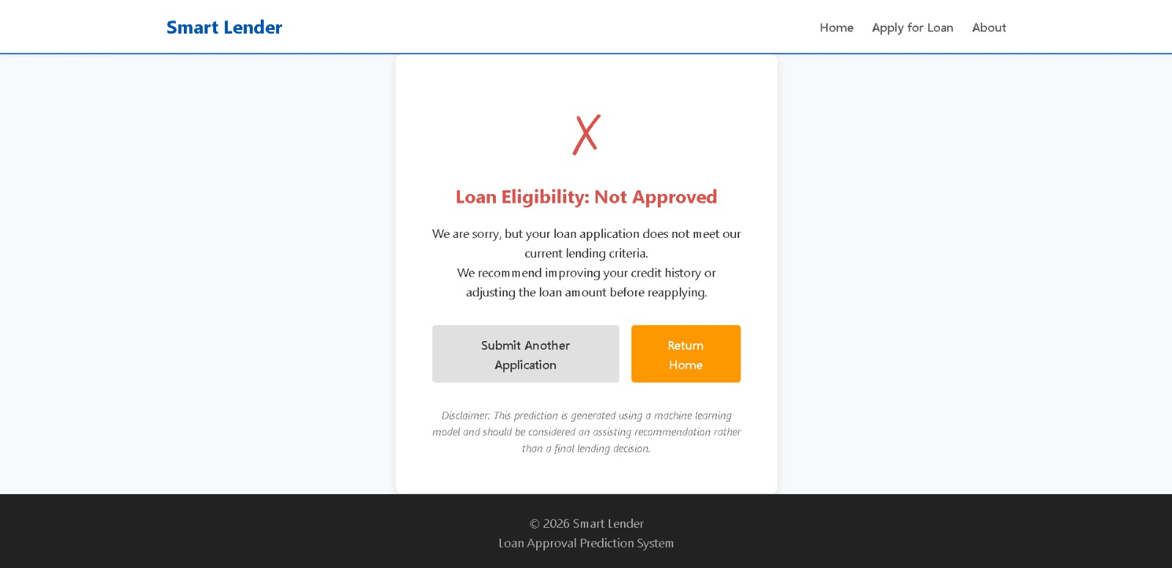
Fig 10.4: Smart Lender – Loan Not Approved Result

