**NAME : Swarnika Singh CLASS: D15B**

**ROLL NO : 63**

# Experiment No. 7

**Aim:**- To write meta data of your Ecommerce PWA in a Web app manifest file to enable “add to homescreen feature”.

**Theory**:-

## Regular Web App

A regular web app is a website that is designed to be accessible on all mobile devices such that the content gets fit as per the device screen. It is designed using a web technology stack (HTML, CSS, JavaScript, Ruby, etc.) and operates via a browser. They offer various native-device features and functionalities. However, it entirely depends on the browser the user is using. In other words, it might be possible that you can access a native-device feature on Chrome but not on Safari or Mozilla Firefox because the browsers are incompatible with that feature.

## Progressive Web App

Progressive Web App (PWA) is a regular web app, but some extras enable it to deliver an excellent user experience. It is a perfect blend of desktop and mobile application experience to give both platforms to the end-users.

## Difference between PWAs vs. Regular Web Apps:

A Progressive Web is different and better than a Regular Web app with features like:

## Native Experience

Though a PWA runs on web technologies (HTML, CSS, JavaScript) like a Regular web app, it gives user experience like a native mobile application. It can use most native device features, including push notifications, without relying on the browser or any other entity. It offers a seamless and integrated user experience that it is quite tough for one to differentiate between a PWA and a Native application by considering its look and feel.

## Ease of Access

Unlike other mobile apps, PWAs do not demand longer download time and make memory space available for installing the applications. The PWAs can be shared and installed by a link, which cuts down the number of steps to install and use. These

applications can easily keep an app icon on the user's home screen, making the app easily accessible to the users and helps the brands remain in the users' minds, and improving the chances of interaction.

## Faster Services

PWAs can cache the data and serve the user with text stylesheets, images, and other web content even before the page loads completely. This lowers the waiting time for the end-users and helps the brands improve the user engagement and retention rate, which eventually adds value to their business.

## Engaging Approach

As already shared, the PWAs can employ push notifications and other native device features more efficiently. Their interaction does not depend on the browser user uses. This eventually improves the chances of notifying the user regarding your services, offers, and other options related to your brand and keeping them hooked to your brand. In simpler words, PWAs let you maintain the user engagement and retention rate.

## Updated Real-Time Data Access

Another plus point of PWAs is that these apps get updated on their own. They do not demand the end-users to go to the App Store or other such platforms to download the update and wait until installed.

In this app type, the web app developers can push the live update from the server, which reaches the apps residing on the user's devices automatically. Therefore, it is easier for the mobile app developer to provide the best of the updated functionalities and services to the end-users without forcing them to update their app.

## Discoverable

PWAs reside in web browsers. This implies higher chances of optimizing them as per the Search Engine Optimization (SEO) criteria and improving the Google rankings like that in websites and other web apps.

## Lower Development Cost

Progressive web apps can be installed on the user device like a native device, but it does not demand submission on an App Store. This makes it far more cost-effective than native mobile applications while offering the same set of functionalities.

# CODE:

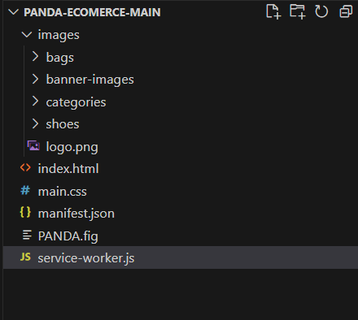

## //Manifest.json:

{

"name": "Panda Ecommerce", "short_name": "Panda", "start_url": "/index.html", "display": "standalone", "background_color": "#FEEAE9", "theme_color": "#5900b3",

"description": "Your description here.", "icons": [

{

"src": "images/logo.png", "sizes": "192x192", "type": "image/png"

},

{

"src": "images/logo.png ", "sizes": "512x512", "type": "image/png"

}

]

}

## //Index.html

<!DOCTYPE html>

<html lang="en">

<head>

<meta charset="UTF-8">

<meta http-equiv="X-UA-Compatible" content="IE=edge">

<meta name="viewport" content="width=device-width, initial-scale=1.0">

<title>Panda Ecommerce</title>

<link rel="stylesheet" href="main.css">

<!-- Reference to the manifest file -->

<link rel="manifest" href="manifest.json">

<!-- bootstrap stylesheet -->

<link [href="https://cdn.jsdelivr.net/npm/bootstrap@5.0.2/dist/css/bootstrap.min.css"](https://cdn.jsdelivr.net/npm/bootstrap%405.0.2/dist/css/bootstrap.min.css) rel="stylesheet"

integrity="sha384-EVSTQN3/azprG1Anm3QDgpJLIm9Nao0Yz1ztcQTwFspd3yD65Voh hpuuCOmLASjC" crossorigin="anonymous">

<script>

if ('serviceWorker' in navigator) { window.addEventListener('load', function() {

navigator.serviceWorker.register('/service-worker.js')

.then(function(registration) {

console.log('ServiceWorker registration successful with scope: ', registration.scope);

}, function(err) {

console.log('ServiceWorker registration failed: ', err);

});

});

}

</script>

</head>

<body>

<!-- header start -->

<header>

<!-- navigation -->

<nav class="navbar fixed-top navbar-expand-lg navbar-light bg-light">

<div class="container">

<a class="navbar-brand" href="#"><img src="images/logo.png" alt=""></a>

<button class="navbar-toggler" type="button" data-bs-toggle="collapse" data-bs-target="#navbarScroll"

aria-controls="navbarScroll" aria-expanded="false" aria-label="Toggle

navigation">

<span class="navbar-toggler-icon"></span>

</button>

<div class="collapse navbar-collapse" id="navbarScroll">

<ul class="navbar-nav me-auto my-2 my-lg-0 navbar-nav-scroll" style="--bs-scroll-height: 100px;">

<li class="nav-item">

<a class="nav-link active" aria-current="page" href="#">Home</a>

</li>

<li class="nav-item dropdown">

<a class="nav-link dropdown-toggle" href="#" id="navbarDropdown"

role="button"

data-bs-toggle="dropdown" aria-expanded="false"> Product

</a>

<ul class="dropdown-menu" aria-labelledby="navbarDropdown">

<li><a class="dropdown-item" href="#">Tv</a></li>

<li><a class="dropdown-item" href="#">Watch</a></li>

<li><a class="dropdown-item" href="#shoes">Shoes</a></li>

<li><a class="dropdown-item" href="#backpack">Backpack</a></li>

</ul>

</li>

<li class="nav-item">

<a class="nav-link" href="#">About Us</a>

</li>

<li class="nav-item">

<a class="nav-link" href="#subscribe">Subscribe Us</a>

</li>

</ul>

<form class="d-flex">

<input class="form-control me-2" type="search" placeholder="Search" aria-label="Search">

<button class="btn btn-outline-success" type="submit">Search</button>

</form>

</div>

</div>

</nav>

<!-- image slider -->

<section class="container ">

<div id="carouselExampleControls" class="carousel slide" data-bs-ride="carousel">

<div class="carousel-inner">

<div class="carousel-item active">

<div class="row mt-5 sliding-image p-5 d-flex align-items-center">

<div class="col-lg-7">

<h1>Cool Dude Headphone</h1>

<p>This is the best headphone in the world for people who just want to waste time in

front

of funky world.</p>

<h1>$420</h1>

<button class="panda-btn-buy-now">Buy Now</button>

</div>

<div class="col-lg-5">

<img src="images/banner-images/headphone.png " class="d-block w-100" alt="headphone">

</div>

</div>

</div>

<div class="carousel-item ">

<div class="row mt-5 sliding-image p-5 d-flex align-items-center">

<div class="col-lg-7">

<h1>Mega LCD TV For Sports</h1>

<p>This is the best headphone in the world for people who just want to waste time in

alt="Tv">

front

of TV.</p>

<h1>$1200</h1>

<button class="panda-btn-buy-now">Buy Now</button>

</div>

<div class="col-lg-5">

<img src="images/banner-images/tv.png" class="d-block w-100"

</div>

</div>

</div>

<div class="carousel-item ">

<div class="row mt-5 sliding-image p-5 d-flex align-items-center">

<div class="col-lg-7">

<h1>X-Box for your living room</h1>

<p>This is the best X-Box in the world for people who just want to

waste time in

alt="xbox">

front

of fake sports.</p>

<h1>$600</h1>

<button class="panda-btn-buy-now">Buy Now</button>

</div>

<div class="col-lg-5">

<img src="images/banner-images/xbox.png" class="d-block w-100"

</div>

</div>

</div>

</div>

</div>

<button class="carousel-control-prev" type="button" data-bs-target="#carouselExampleControls"

data-bs-slide="prev">

<span class="carousel-control-prev-icon" aria-hidden="true"></span>

<span class="visually-hidden">Previous</span>

</button>

<button class="carousel-control-next" type="button" data-bs-target="#carouselExampleControls"

data-bs-slide="next">

<span class="carousel-control-next-icon" aria-hidden="true"></span>

<span class="visually-hidden">Next</span>

</button>

</div>

</section>

</header>

<!-- main start -->

<main>

<!-- catagories -->

<section class="container">

<div class="overflow-hidden my-5 categories">

<div class="row gx-5">

<h1>Categories</h1>

<div class="col-lg-4 col-md-6">

<div class="p-3 bg-warning d-flex align-items-center justify-content-around rounded-3">

<h1>Watch</h1>

<img src="images/categories/watch.png" alt="">

</div>

</div>

<div class="col-lg-4 col-md-6">

<div class="p-3 bg-danger d-flex align-items-center justify-content-around rounded-3">

<h1>Bag</h1>

<img src="images/categories/bag.png" alt="">

</div>

</div>

<div class="col-lg-4 col-md-6">

<div class="p-3 bg-primary d-flex align-items-center justify-content-around rounded-3">

<h1>Shoes</h1>

<img src="images/categories/shoes.png" alt="">

</div>

</div>

</div>

</div>

</section>

<section class="container" id="shoes">

<h2>Shoes</h2>

<div class="row row-cols-1 row-cols-md-2 row-cols-lg-3 g-4">

<div class="col">

<div class="card border-0 shadow-lg h-100">

<img src="images/shoes/shoe-1.png" class="card-img-top" alt="...">

<div class="card-body">

<h5 class="card-title">Reebok Dart Men’s Shoes</h5>

<p class="card-text">Amet minim mollit non deserunt ullamco est sit aliqua dolor do amet

sint. </p>

<h2>$1289</h2>

</div>

<div>

<button class="panda-btn-buy-now">Buy Now</button>

</div>

</div>

</div>

<div class="col">

<div class="card border-0 shadow-lg h-100">

<img src="images/shoes/shoe-2.png" class="card-img-top" alt="...">

<div class="card-body">

<h5 class="card-title">Reebok Pump</h5>

<p class="card-text">Amet minim mollit non deserunt ullamco est sit aliqua dolor do amet

sint. </p>

<h2>$799</h2>

</div>

<div>

<button class="panda-btn-buy-now">Buy Now</button>

</div>

</div>

</div>

<div class="col">

<div class="card border-0 shadow-lg h-100">

<img src="images/shoes/shoe-3.png" class="card-img-top" alt="...">

<div class="card-body">

<h5 class="card-title">Reebok All Terrain</h5>

<p class="card-text">Amet minim mollit non deserunt ullamco est sit aliqua dolor do amet

sint. </p>

<h2>$699</h2>

</div>

<div>

<button class="panda-btn-buy-now">Buy Now</button>

</div>

</div>

</div>

</div>

</section>

<section class="container my-5" id="backpack">

<h2>Backpack</h2>

<div class="row row-cols-1 row-cols-md-2 row-cols-lg-3 g-4">

<div class="col">

<div class="card border-0 shadow-lg h-100">

<img src="images/bags/bag-1.png" class="card-img-top" alt="...">

<div class="card-body">

<h5 class="card-title">Ison Backpack</h5>

<p class="card-text">Amet minim mollit non deserunt ullamco est sit aliqua dolor do amet

sint.</p>

<h2>$1289</h2>

</div>

<div>

<button class="panda-btn-buy-now">Buy Now</button>

</div>

</div>

</div>

<div class="col">

<div class="card border-0 shadow-lg h-100">

<img src="images/bags/bag-2.png" class="card-img-top" alt="...">

<div class="card-body">

<h5 class="card-title">Biaowang Backpack</h5>

<p class="card-text">Amet minim mollit non deserunt ullamco est sit aliqua dolor do amet

sint. </p>

<h2>$799</h2>

</div>

<div>

<button class="panda-btn-buy-now">Buy Now</button>

</div>

</div>

</div>

<div class="col">

<div class="card border-0 shadow-lg h-100">

<img src="images/bags/bag-3.png" class="card-img-top" alt="...">

<div class="card-body">

<h5 class="card-title">Dxyizu WS54 Smart</h5>

<p class="card-text">Amet minim mollit non deserunt ullamco est sit aliqua dolor do amet

sint. </p>

<h2>$699</h2>

</div>

<div>

<button class="panda-btn-buy-now">Buy Now</button>

</div>

</div>

</div>

</div>

</section>

<!-- subscribe -->

<section style="background-color: #FEEAE9; border-radius: 10px; height: 300px;" class="container d-flex justify-content-center my-5 align-items-center"

id="subscribe">

<div>

<h1>LET'S STAY IN TOUCH</h1>

<p>Get updates on sales specials and more</p>

<input class="form-control" type="email" name="" id="" placeholder="Your

Email">

<br>

<button class="panda-btn-buy-now">SUBMIT</button>

</div>

</section>

</main>

<footer class="container footer text-center">

<p><small>Panda Ecomerce. All rights reserved. Dhaka Bangladesh</small></p>

</footer>

<!-- bootstrap script -->

<script [src="https://cdn.jsdelivr.net/npm/bootstrap@5.0.2/dist/js/bootstrap.bundle.min.js"](https://cdn.jsdelivr.net/npm/bootstrap%405.0.2/dist/js/bootstrap.bundle.min.js)

integrity="sha384-MrcW6ZMFYlzcLA8Nl+NtUVF0sA7MsXsP1UyJoMp4YLEuNSfAP+Jc Xn/tWtIaxVXM"

crossorigin="anonymous"></script>

</body>

</html>

## //service-worker.js Register worker

<script>

if ('serviceWorker' in navigator) { window.addEventListener('load', function() {

navigator.serviceWorker.register('/service-worker.js')

.then(function(registration) {

console.log('ServiceWorker registration successful with scope: ', registration.scope);

}, function(err) {

console.log('ServiceWorker registration failed: ', err);

});

});

}

</script>

# OUTPUT:

**//open developers tools options**

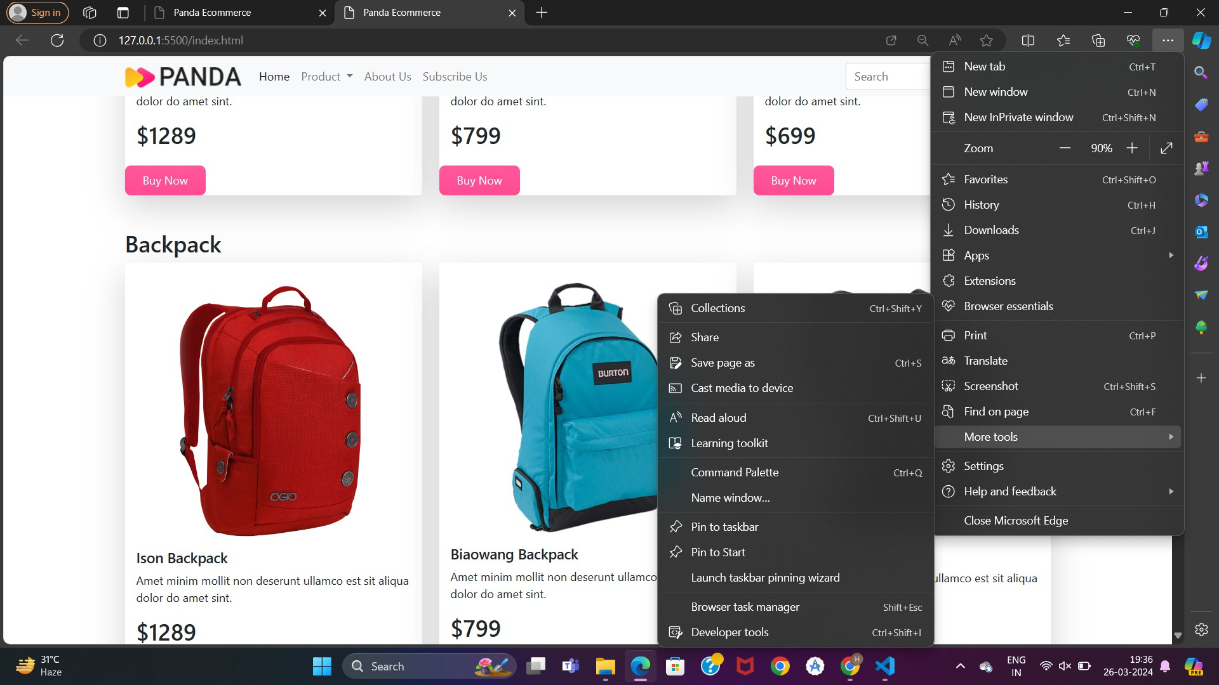

**//Developer tools → Application**

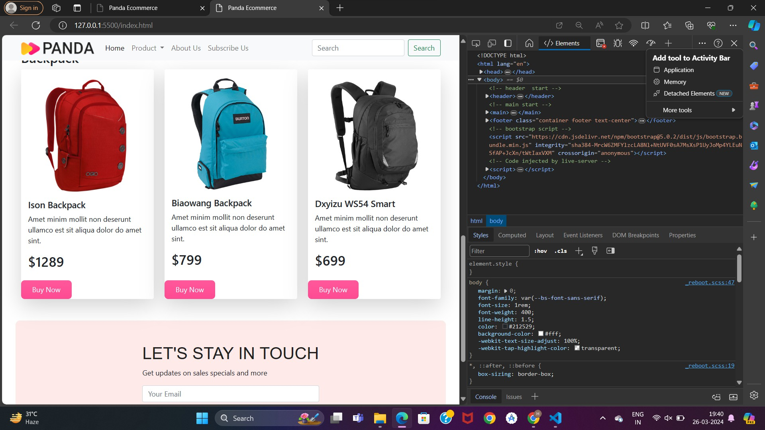

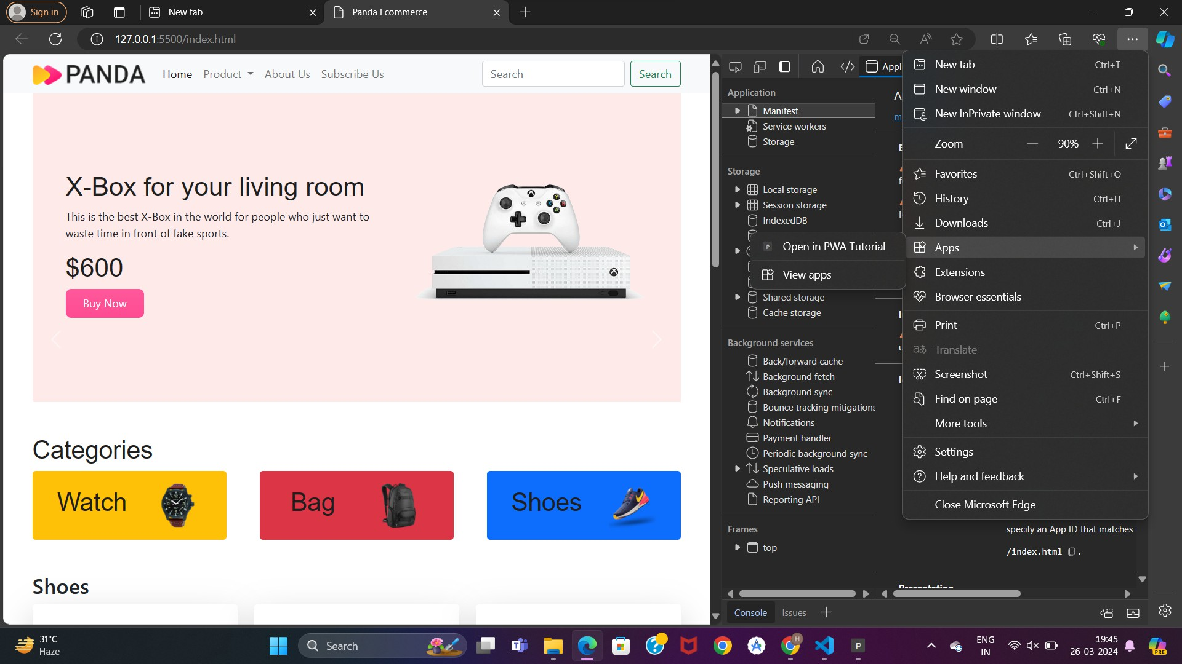**//click on 3 dots on top right corner of browser from app option install this site as an app**

**App icon will appear at the bottom**

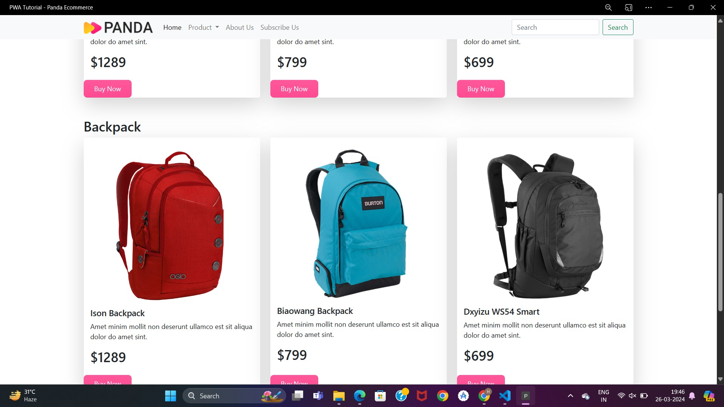

**CONCLUSION:**

Hence we learnt how to write the metadata of our E- commerce website PWA in a Web App Manifest file to enable adding to home screen feature.