SkillUp Project Abstract & System Architecture
This document provides a detailed abstract and a comprehensive system architecture overview for SkillUp, an AI-powered career growth and learning platform.

1. Project Abstract
SkillUp (also referred to under its API namespace as SkillSphere) is an end-to-end, AI-orchestrated educational and career accelerator platform. It addresses the critical gaps between academic learning, skill acquisition, and job market entry by integrating three core user groups into a single unified ecosystem:
- Candidates (Learners): Who receive hyper-personalized career roadmaps, real-time interactive voice tutoring, adaptive AI mock interviews, and automated job recommendation tracking.
- Creators (Educators): Who upload and structure courses with dynamic learning materials that feed into the AI system.
- Companies (Recruiters): Who post jobs, manage applicants, and inspect candidates’ gamified performance profiles, course history, and career-readiness scores.

Key Innovation Features
- AI Learning Roadmaps: Using candidate goals or uploaded resumes, the system extracts skill gaps and compiles a custom sequential curriculum, matching modules with curated external materials and localized database courses.
- MURPH Voice Tutor: A voice-first learning helper that allows hands-free audio interaction while watching course videos. Using natural language processing, it can pause video playback, answer context-specific questions about the lecture, fetch transcript segments, and quiz the user on the fly.
- AI Mock Interviews: A simulation environment where users practice mock interviews. The AI dynamically speaks role-specific questions, records user responses, and analyzes performance across criteria like confidence, delivery speed, clarity, and keyword optimization.
- AI Resume Analyzer & Builder: An ATS-scoring engine providing specific recommendations, template updates, and keyword optimization tips using large language models.
- Smart Job Matching & Scraper: An automated background service that scrapes real-world job roles matching candidate profiles, allowing seamless application tracking.
- Gamification Engine: Encourages user retention through leaderboards, xp points, achievements, and course completion badges.

2. System Architecture
The platform operates on a robust, multi-tier decoupled architecture designed for high throughput, AI orchestration, and separation of concerns.

Tier 1: Next.js Frontend
- Technologies: Next.js (App Router), TypeScript, TailwindCSS, GSAP, Framer Motion, MagicUI.
- Role: Serve candidate, creator, and company dashboards. Renders complex video players, records microphone audio streams for interviews and tutoring sessions, and controls animation/theme states.
- Authentication: Managed via Clerk Auth, ensuring secure, metadata-driven role assignment during user onboarding.

Tier 2: Express.js Core Backend (backend/)
- Technologies: Node.js, Express, MongoDB (Mongoose), JWT.
- Role: Acts as the primary database coordinator. It manages users, courses, job postings, applications, reviews, gamification profiles, and static file uploads.
- Database & Storage: Connects to MongoDB Atlas for structured data and Cloudinary for rich media storage (images, resumes, course videos).

Tier 3: FastAPI AI Engine (backend2/)
- Technologies: Python, FastAPI, Uvicorn, LangChain / Google GenAI SDK.
- Role: Serves as the AI & automation coordinator. Offloads heavy machine learning workloads, background scraping processes, and external NLP API coordination from the Node.js API.
- Integrations:
  - Google Gemini & Groq APIs: Used for structured resume analysis, interview evaluation, explainer systems, and curriculum roadmap generation.
  - AssemblyAI: Powers the video tutor speech-to-text transcription engine.
  - Tavily API & JobSpy: Performs automated background web scraping to keep the jobs database updated.

3. System Architecture Diagram

System Design Architecture (Light Theme)
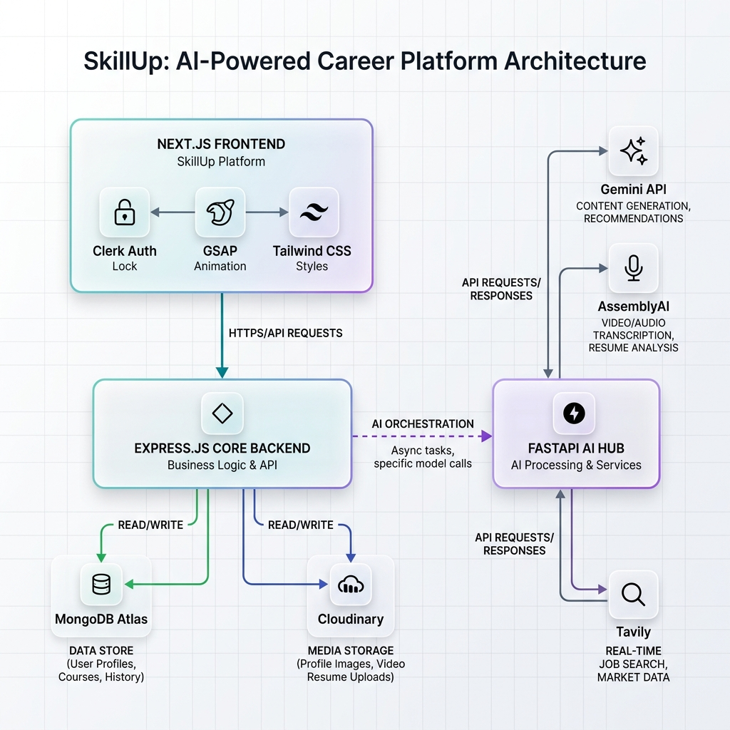
SkillUp Light Mode System Architecture

System Design Architecture (Dark Theme)
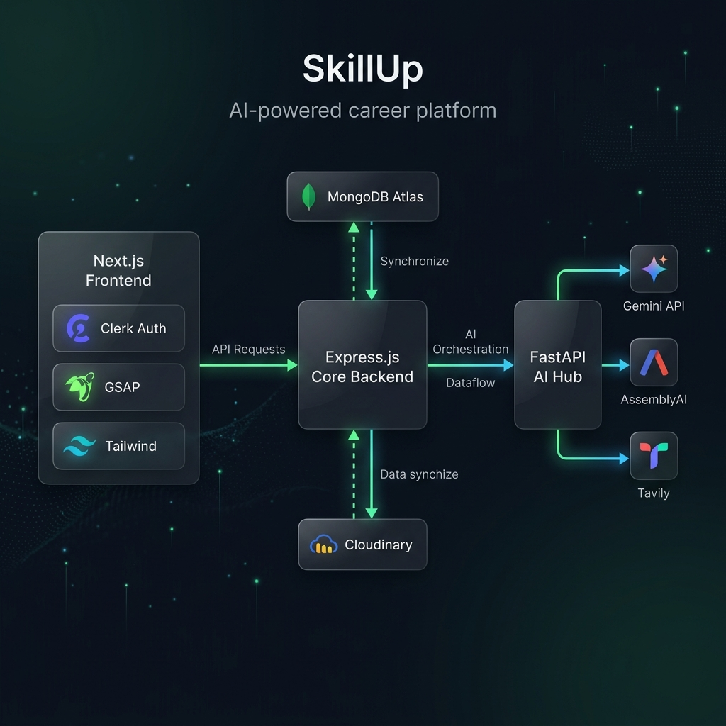
SkillUp Dark Mode System Architecture

