**Chapter 3: BACKGROUND**

**3.1 Type-1 Fuzzy Systems**

Before starting to work with fuzzy systems, it is important for us to understand the reason behind it. Fuzzy systems, enables us to work with uncertain and ambiguous situations and solve ill-posed problems or problems with incomplete information.

In fuzzy sets [24], each of the element is mapped to [0, 1] by a membership function, that denotes how much that particular element belongs to a particular class. A value close to 0 means that the element has very low degree of membership or belongingness to that class, and on the other hand, a value close to 1 means that the element has higher degree of membership or belongingness to that class.

Mathematically, a Type-1 Fuzzy set is represented as $μ_{A}: X → [0, 1]$ where [0, 1] means real numbers between 0 and 1 (including the values of 0 and 1). Unlike in a crisp set, the values can only be 0 or 1 and nothing in between.

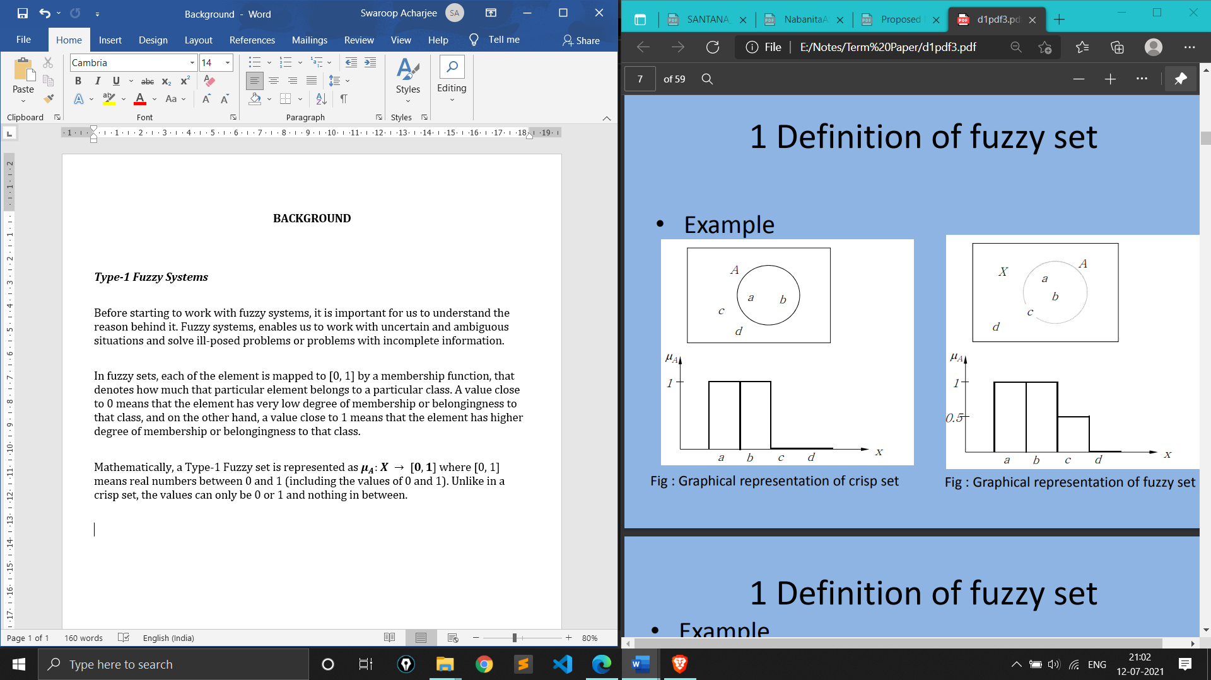

Figure 3.1 **Pictorial representation of a Crisp set**

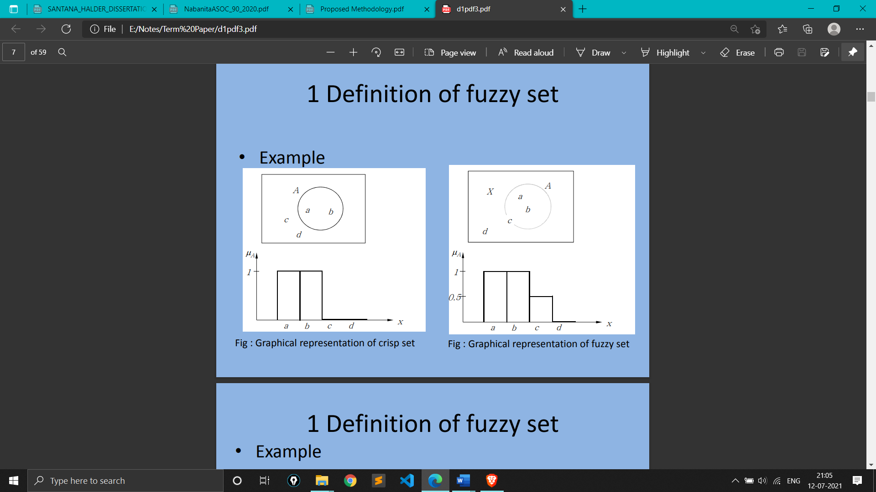

Figure 3.2 **Pictorial representation of a Type-1 Fuzzy set**

**3.2 Type-2 Fuzzy System**

The value of the membership degree might include uncertainty. If the value of the membership function is given by a fuzzy set, it is a type-2 fuzzy set. This concept can be extended up to Type-n fuzzy set.

Mathematically, Type-2 fuzzy sets can be represented as **.**

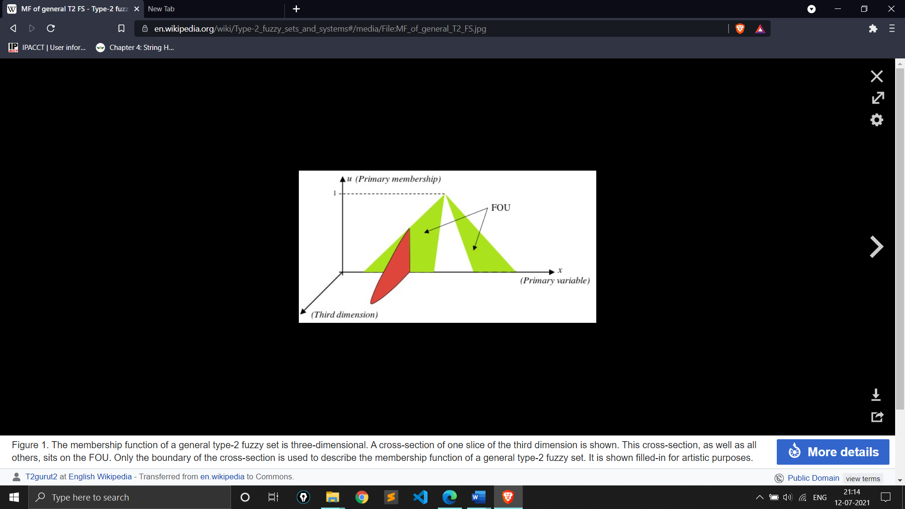

Figure 3.3 **Graphical Representation of a Type-2 Fuzzy Set**

$μ([0, 1])$ is the set of all ordinary fuzzy sets that can be defined with the universal set [0, 1]. $μ([0, 1])$ is also called a fuzzy power set of [0, 1].

FOU represents the Foot Print of Uncertainty.

**3.3 Science behind the MR Imaging of Brain**

Magnetic resonance imaging (MRI) of the brain is a safe and painless test that uses a magnetic field and radio waves to produce detailed images of the brain and the brain stem. An MRI differs from a CAT scan (also called a CT scan or a computed axial tomography scan) because it does not use radiation [26].

An MRI scanner consists of a large doughnut-shaped magnet that often has a tunnel in the centre. Patients are placed on a table that slides into the tunnel. Some centres have open MRI machines that have larger openings and are helpful for patients with claustrophobia. MRI machines are located in hospitals and radiology centres.

During the exam, radio waves manipulate the magnetic position of the atoms of the body, which are picked up by a powerful antenna and sent to a computer. The computer performs millions of calculations, resulting in clear, cross-sectional black and white images of the body. These images can be converted into three-dimensional (3-D) pictures of the scanned area. This helps to pinpoint problems in the brain and the brain stem when the scan focuses on those areas.

**3.4 Representation of Brain MR images**

The Brain MR images are represented using PGM file formats.

The full form of PGM [27] is Portable Grayscale Image Format. It is a lowest common denominator grayscale file format. It is designed to be extremely easy to learn and write programs for.

A PGM image represents a grayscale graphic image. When stack one upon another, they are capable to represent a 3D image volume. This when converted to a 3D matrix, makes the calculation and manipulation of these images easier and intuitive in nature.

There is exactly one image in a file. Each pixel in the raster is represented as an ASCII decimal number in the range of (0-255). Each pixel in the raster has a white space before and after it. There must be at least one character of white space between any two pixels, but there is no maximum.

**3.5 Information on the Brain Web Database**

There is no ***ground Truth*** or gold Standard for the analysis of the acquired 3D Brain MR images. BrainWeb Simuated Brain Database [28] provides a solution to the validation problem, in the form a Simulated Brain Database (SBD). The SBD contains a set of realistic MRI data volumes produced by an MRI simulator. For this thesis and investigatory work, we have used the images present in this database for the analysis and experimentation.

The parameter settings are fixed to 3 modalities, 5 slice thicknesses, 6 levels of noise, and 3 levels of intensity non-uniformity. We have used the Brain MR images having T1 Modality, slice thickness of 1mm. We have varied the noise by 0%, 1%, 3%, 5%, 7% and 9% and Intensity non-uniformity by 0%, 20% and 40%. This gave us a set of 6 × 3 Brain MR 3D volumes.

Apart from the noisy variations, a discrete anatomical model is provided which consists of a class label (integer) at each voxel, representing the tissue which contributes the most to that voxel (0=Background, 1=CSF, 2=Grey Matter, 3=White Matter, 4=Fat, 5=Muscle/Skin, 6=Skin, 7=Skull, 8=Glial Matter, 9=Connective). This discrete anatomical model serves as a ground truth for our investigation.