Architecture Diagram
Community Lost & Found Matching Network — Problem Statement #59 | Swaroop Venkateshwar, PES1UG24CS923
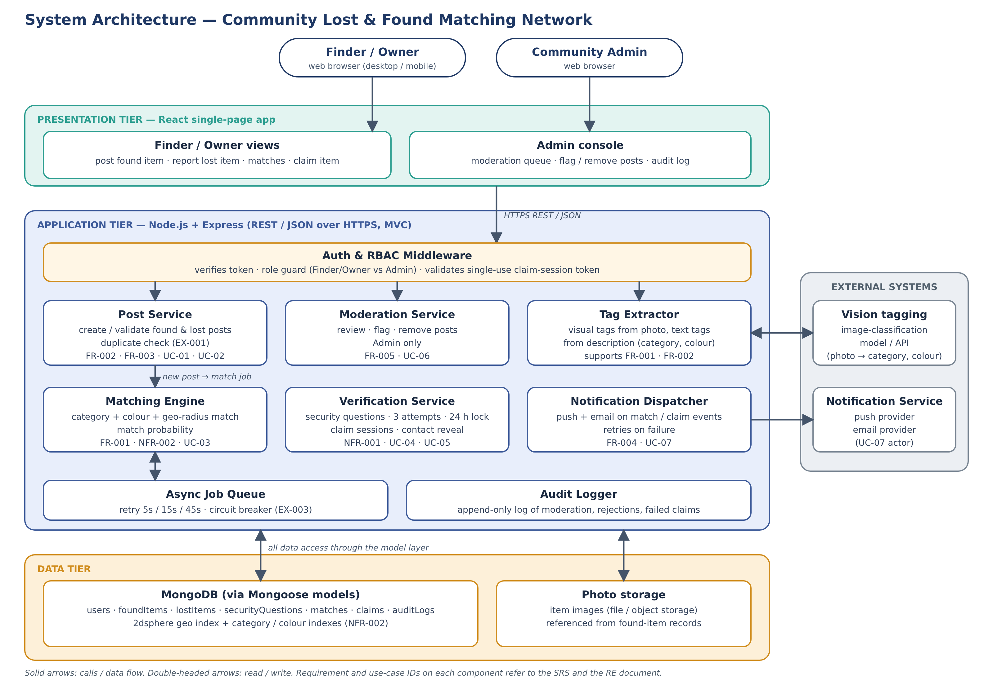

1. Overview
The system is a three-tier web application. A React single-page app is the presentation tier. A Node.js and Express API, organised in an MVC style, is the application tier. MongoDB and a photo store are the data tier. Two external systems are used: a notification provider for push and email, and an image-classification model or API that turns photos into tags.
Every request first passes the Auth & RBAC middleware. The services behind it each own one part of the Lab 1 use cases, and every component in the diagram carries the requirement and use-case IDs it satisfies, so the design traces back to the SRS and the RE document.

2. Components
Component | Responsibility | Requirements | Use cases
React single-page app | Finder / Owner views (post found item, report lost item, matches, claim) and the Admin console (moderation queue, audit log). Talks to the API over HTTPS using REST / JSON. | — | All (user interface)
Auth & RBAC middleware | Verifies the user’s token, applies the role guard (Finder / Owner versus Admin), and validates the single-use claim-session token before any security answer is compared. | NFR-001, FR-005 | UC-04, UC-06
Post Service | Creates and validates found-item posts and lost-item reports, and rejects near-duplicate posts from the same account within 24 hours. | FR-002, FR-003 | UC-01, UC-02 (EX-001)
Tag Extractor | Derives visual tags (category, colour) from the photo and text tags from the description, so posts are structured before matching. | FR-001, FR-002 | UC-02, UC-03
Matching Engine | Matches new posts with active reports on category, colour tags and location radius, and calculates a match probability. | FR-001, NFR-002 | UC-03
Async Job Queue | Runs matching as background jobs so a post is never blocked by the matching engine. Retries a failed job 3 times (5s, 15s, 45s) and has a circuit breaker. | NFR-002 | UC-03 (EX-003)
Verification Service | Stores the Finder’s security questions and hashed answers, issues single-use claim sessions, counts attempts, locks a claim for 24 hours after 3 failures, and releases contact details only after a correct answer. | NFR-001 | UC-04, UC-05 (EX-002, EX-004)
Notification Dispatcher | Sends push and email to the Finder and the Owner when a match is found and when a claim starts, fails or succeeds. Retries if the provider is unavailable. | FR-004 | UC-07
Moderation Service | Lets the Community Admin review, flag and remove suspicious, fraudulent or duplicate posts; flagged posts disappear from public search. | FR-005 | UC-06
Audit Logger | Append-only record of moderation actions, rejected duplicate posts, and failed or suspicious claims. | FR-005 | UC-06 (EX-001 to EX-004)
MongoDB | Persistent store for users, found items, lost items, security questions, matches, claims and audit logs. A 2dsphere geo index and indexes on category and colour support fast matching. | NFR-002 | All
Photo storage | Stores item photos; found-item records keep a reference to each image. | FR-002 | UC-02
Notification Service (external) | Delivers push notifications and email on request from the platform. | FR-004 | UC-07
Vision tagging (external) | Image-classification model or API used by the Tag Extractor. | FR-001 | UC-02

3. Key Flows

3.1 Posting an item and getting a match (UC-02, UC-03, UC-07)
- The Finder submits a found item in the React app. The request passes through the Auth & RBAC middleware.
- The Post Service validates the fields and rejects a near-duplicate (EX-001). The record is saved in MongoDB and the photo in photo storage.
- The Tag Extractor derives visual and text tags from the photo and description.
- The post is saved and a match job is put on the Async Job Queue. The Finder gets a response straight away and does not wait for matching.
- The Matching Engine compares the post with active lost reports on category, colour tags and location radius, using the geo index, and calculates a match probability.
- The Notification Dispatcher sends a push notification and an email to both the Finder and the Owner through the external Notification Service.
A lost-item report (UC-01) follows the same path, so a new report is matched against existing found posts.

3.2 Claiming an item (UC-04, UC-05)
- The Owner opens a match and chooses "Claim this item". The Verification Service checks that the found post is still available (EX-004) and creates a single-use claim session.
- The Owner is shown the Finder’s security questions and submits answers. The middleware validates the session token first (EX-002); a replayed or expired token is denied before any answer is compared.
- The Verification Service compares the answers with the stored hashed answers. A wrong answer shows the attempts left; after 3 failures the claim is locked for 24 hours, flagged to the Admin and written to the audit log.
- On a correct answer the match becomes "Claimed", the Finder’s contact details are returned to the Owner (UC-05), and the Dispatcher notifies the Finder.

3.3 When the matching engine is down (EX-003)
- The Matching Engine does not respond within 5 seconds. The post is still saved and marked "Match Pending – Retry Queued".
- The Async Job Queue retries the job 3 times at 5, 15 and 45 seconds. If all retries fail, an incident alert appears on the Admin console.
- When the engine is restored, queued jobs run in the order they were submitted, so no post is lost.

4. How the Non-Functional Requirements Are Met
Requirement | Design decision
NFR-001 Verify ownership (security) | Contact details are returned only by the Verification Service after a correct answer, never by the Post Service or the client. Answers are stored as hashes, each claim runs in a single-use session with a short expiry, attempts are capped at 3, and the role guard sits in front of every service.
NFR-002 Match response time (performance) | A 2dsphere geo index plus indexes on category and colour narrow the candidate set before any scoring, and matching runs as a background job. The target is a 95th-percentile response under 3 seconds at 100,000 listings, checked by TC-017 (Jira sub-task SBPS59-22).

5. Proposed Technology Stack
These are design choices for the implementation and can change without altering the architecture.
Layer | Technology
Frontend | React, React Router, Axios; map component for picking a location
Backend | Node.js and Express, organised as routes, controllers and models (MVC)
Database | MongoDB with Mongoose; 2dsphere geo index
Authentication | JWT for sessions, bcrypt for hashing passwords and security answers
Background jobs | A Node job-queue library with retry and backoff (for example BullMQ)
Tagging | A pre-trained image-classification model or API for photos; keyword extraction for descriptions
Notifications | Email through an SMTP provider and browser push notifications
Hosting | Free-tier cloud hosting for the client and server, and a free-tier MongoDB cluster
Testing | Jest and Supertest for unit and API tests; a load-test tool such as k6 or Artillery for NFR-002

