Kanban.pdf

Swaroop_PES1UG24CS923-BPS#59

Name-Swaroop V

SRN:PES1UG24CS923

1)Board with 7 FR/NFR tasks in To Do
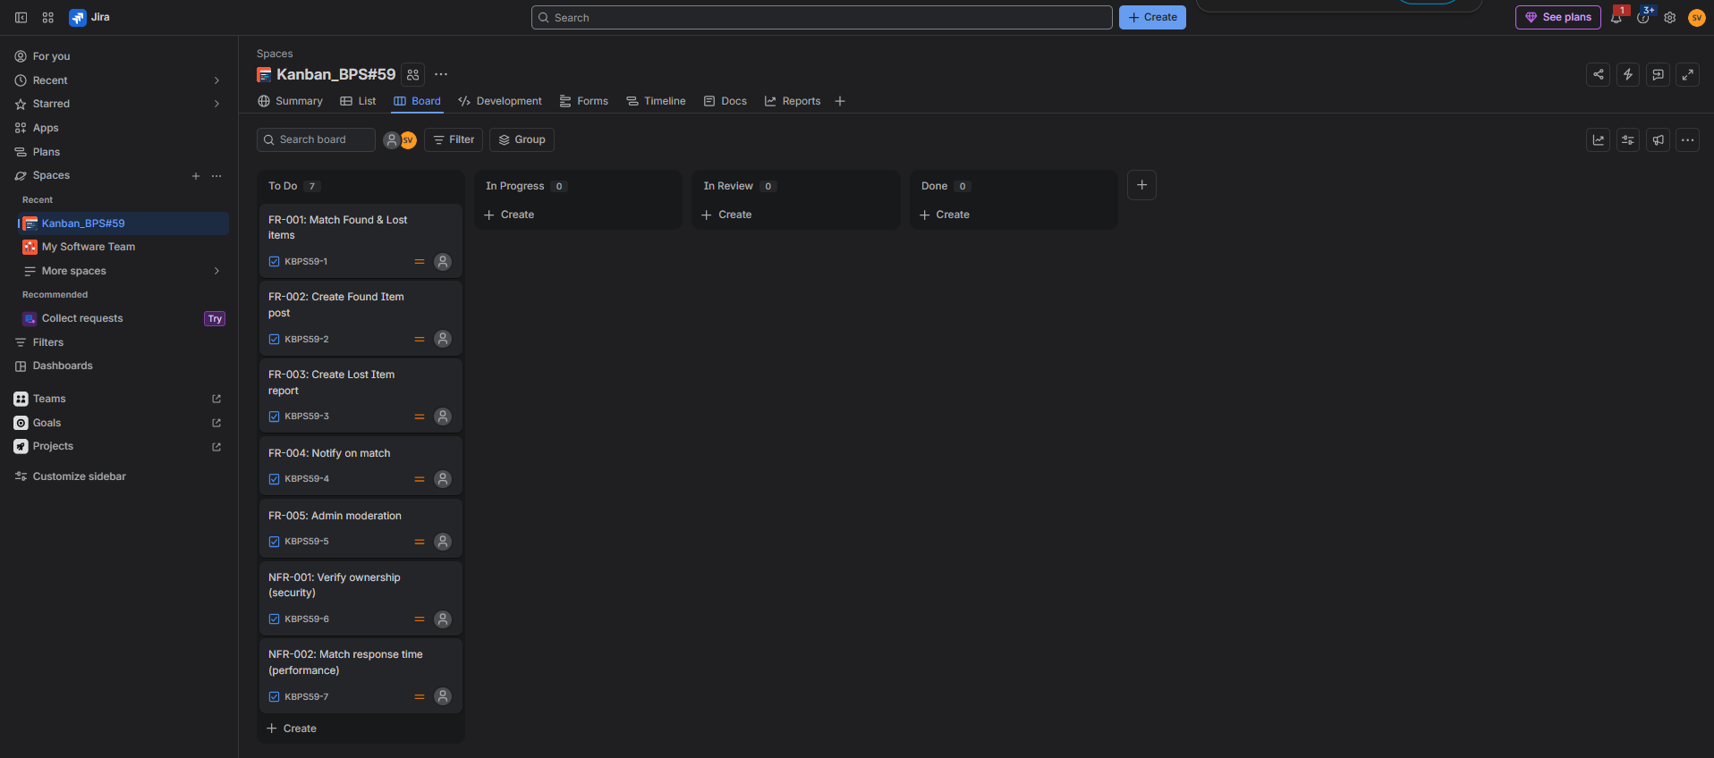

2)Epic child items (7 tasks)

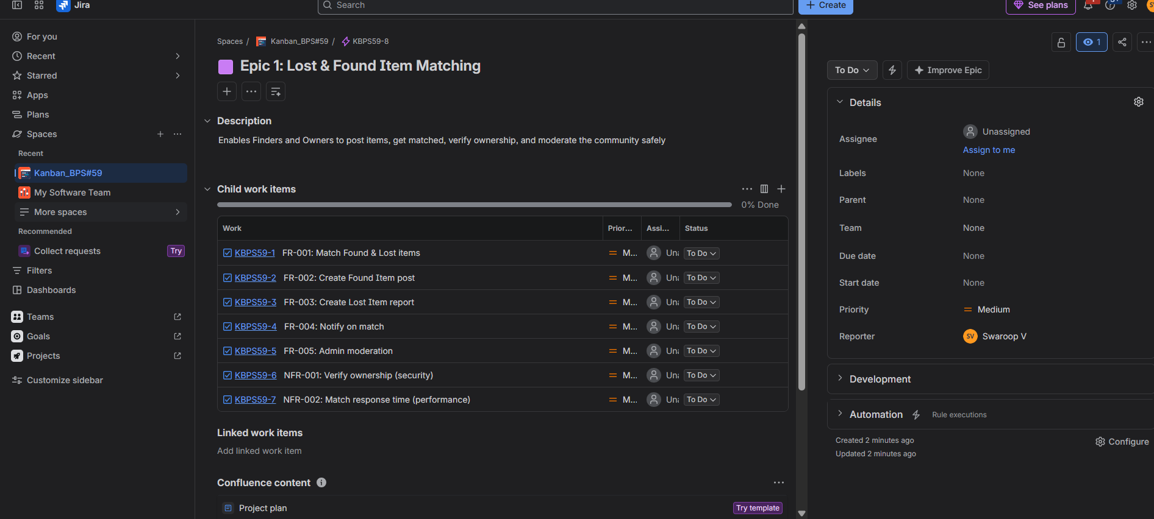

3) Epic child items (14 tasks + stories)

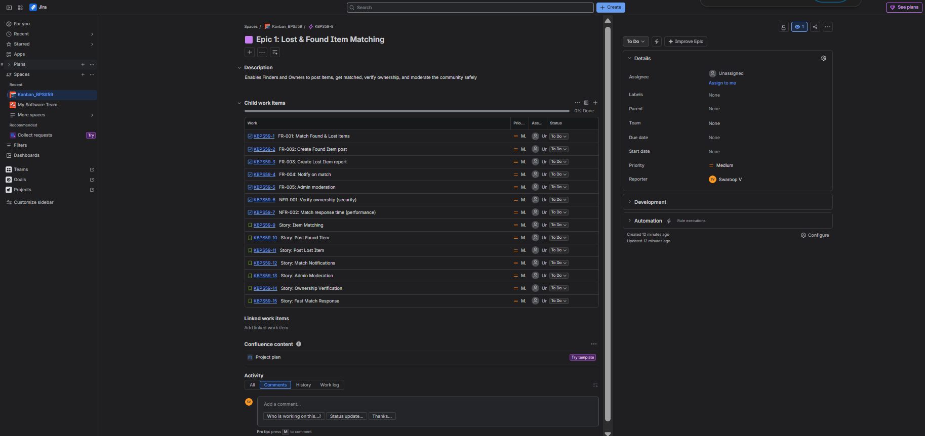

4) Task with nested subtask

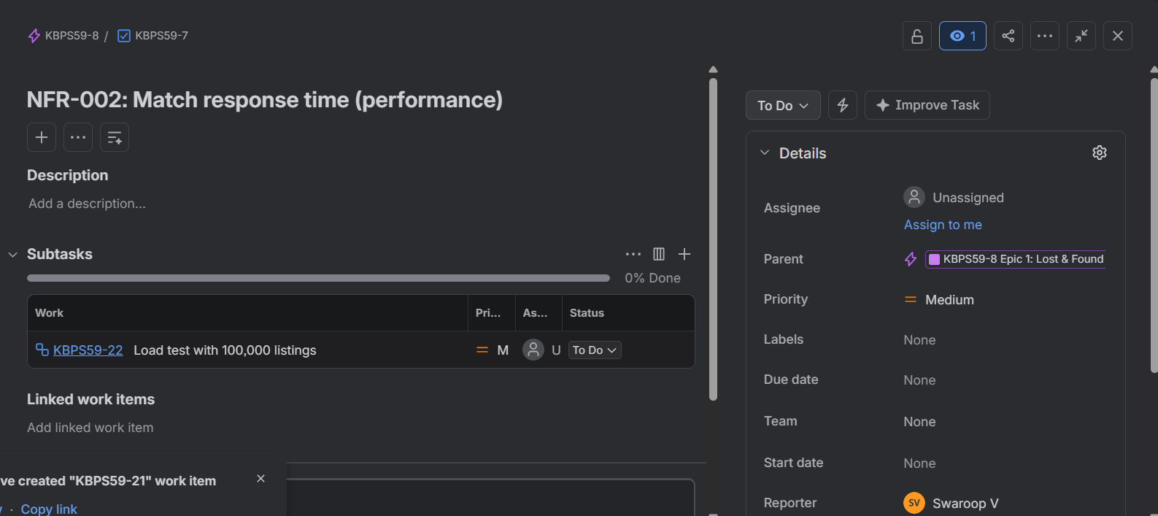

5) This full backlog list
