Swaroop_PES1UG24CS923-BPS#59
Name: Swaroop V
SRN: PES1UG24CS923
Problem Statement #59 — Community Lost & Found Matching Network
Lab 2 — Scrum Project (Jira)
1) Backlog with 7 FR/NFR tasks (SBPS59-1 to SBPS59-7)
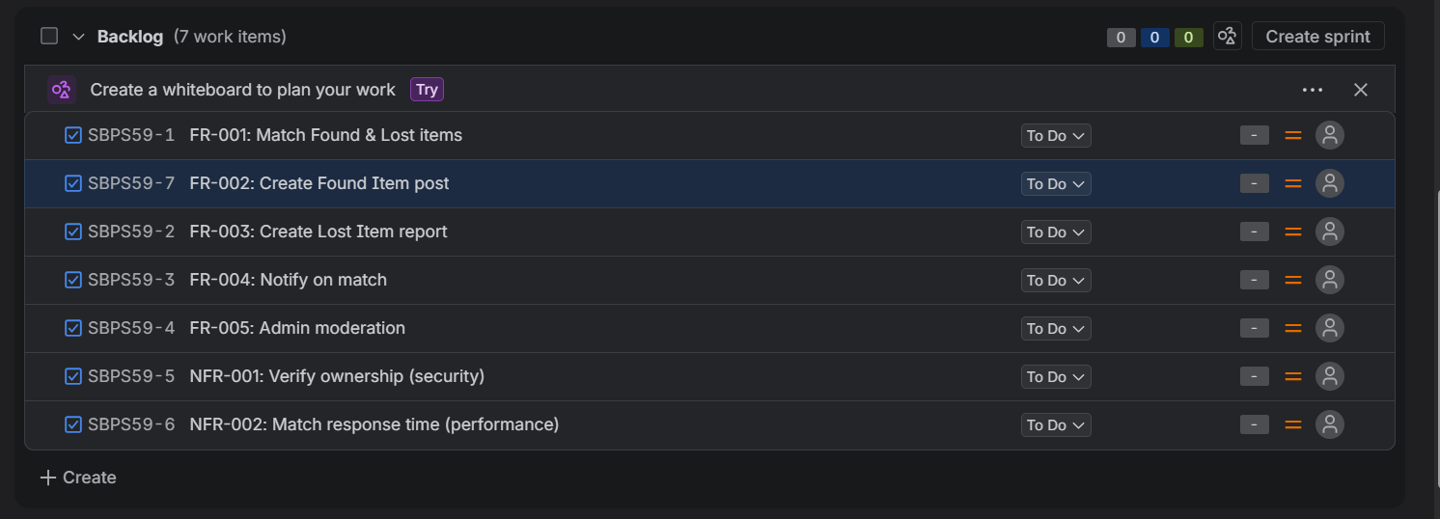
2) All 7 FR/NFR tasks tagged under Epic 1: Lost & Found Item Matching
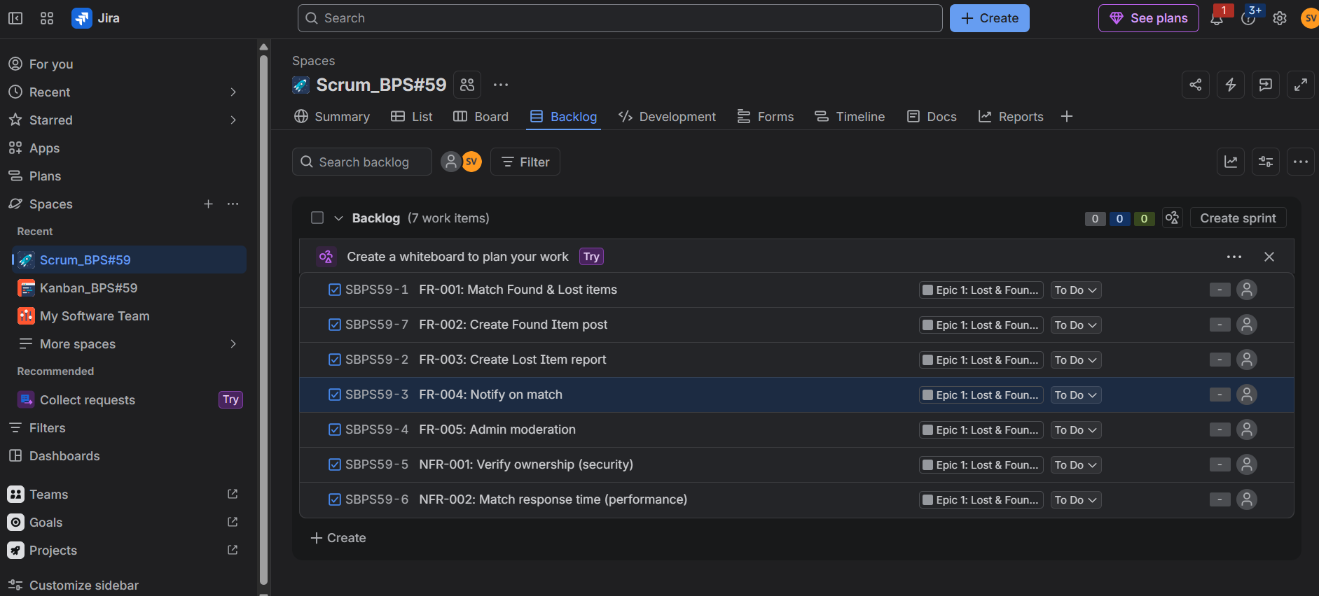
3) Backlog showing all 14 items (7 tasks + 7 user stories) under Epic 1
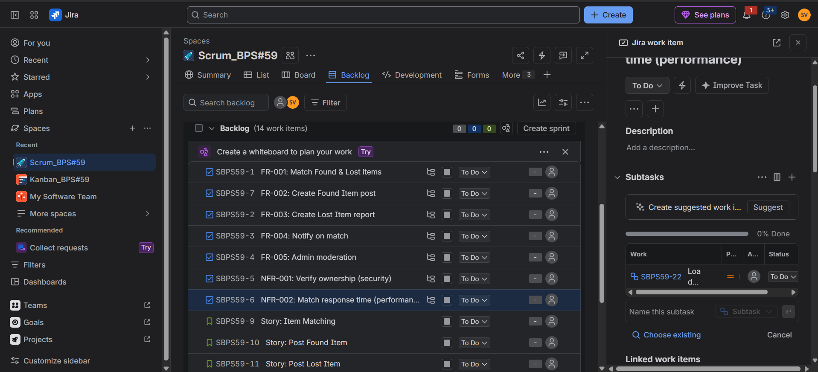
4) Task (NFR-002) with a nested Subtask (Load test with 100,000 listings)
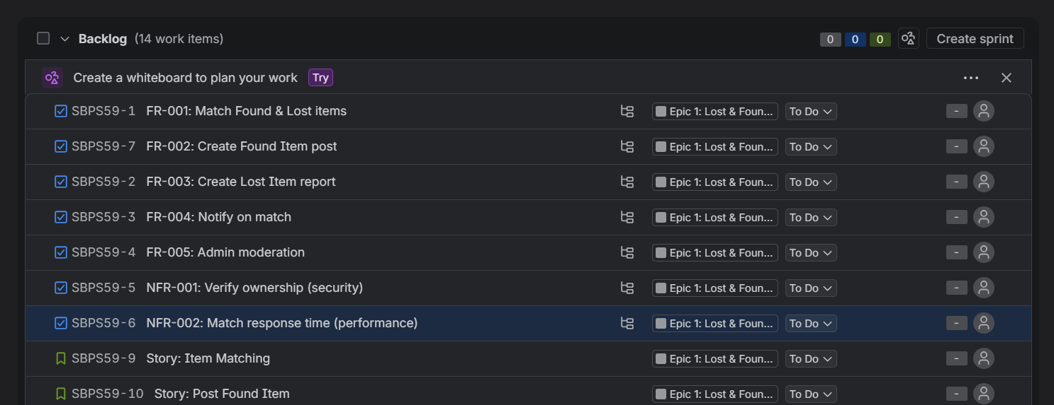
5) Story Points assigned to all 7 user stories (Fibonacci scale)
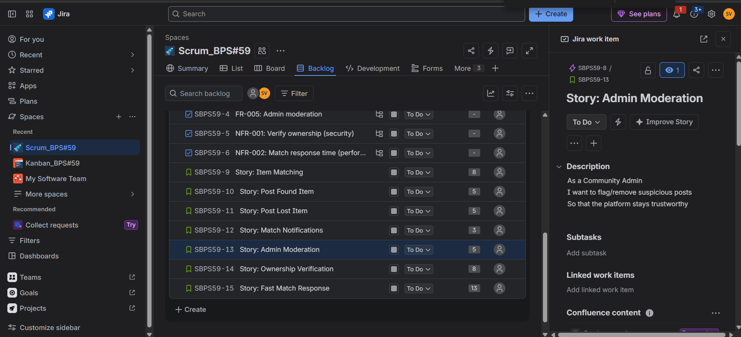
6) Sprint 1 started with 4 stories in To Do
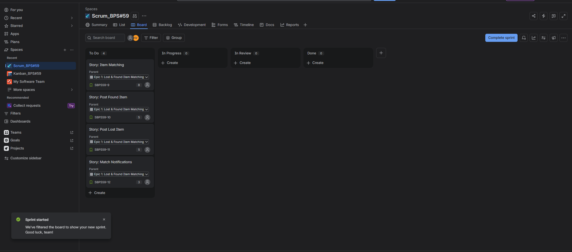
7) Sprint 1 mid-progress — items spread across To Do, In Progress, In Review, and Done
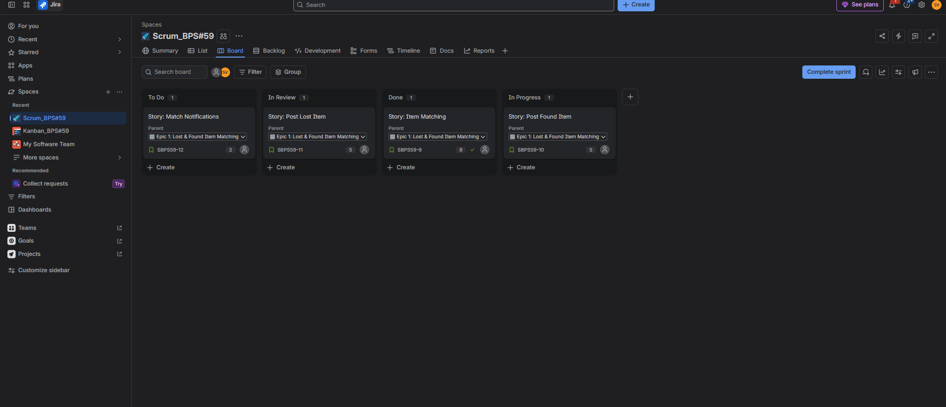
8) Sprint 2 in progress — items across In Review, Done, and In Progress
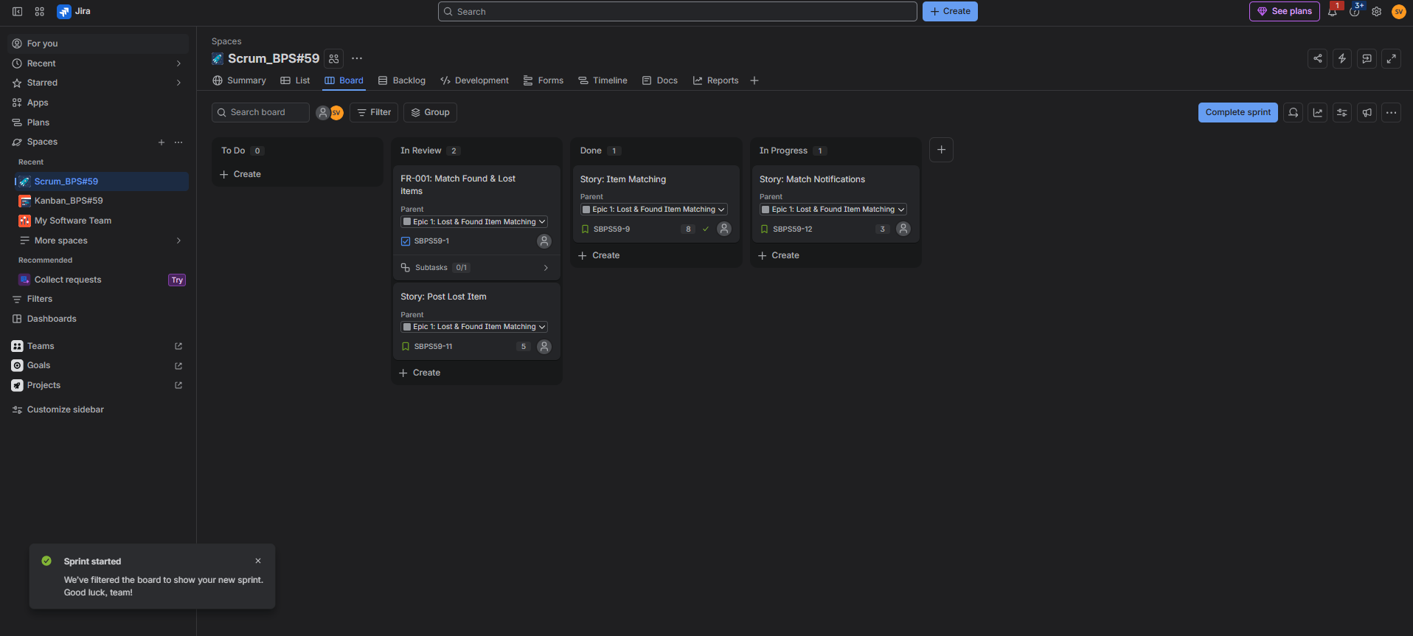
9) Sprint Burndown Chart for Sprint 2
