Project Design Phase-II
Data Flow Diagram & User Stories
Date | 06 July 2026
Team members | Jyothi swaroop,bhu Mahesh,mohith
Project Name | MERN Stack Customer Management Application
Maximum Marks | 4 Marks

Data Flow Diagram
Level-0 Flow:
Customer/Admin → React Frontend → Express.js API → MongoDB Database
Admin manages products, orders and users. Customers register/login, browse products, add to cart, place orders and track orders.
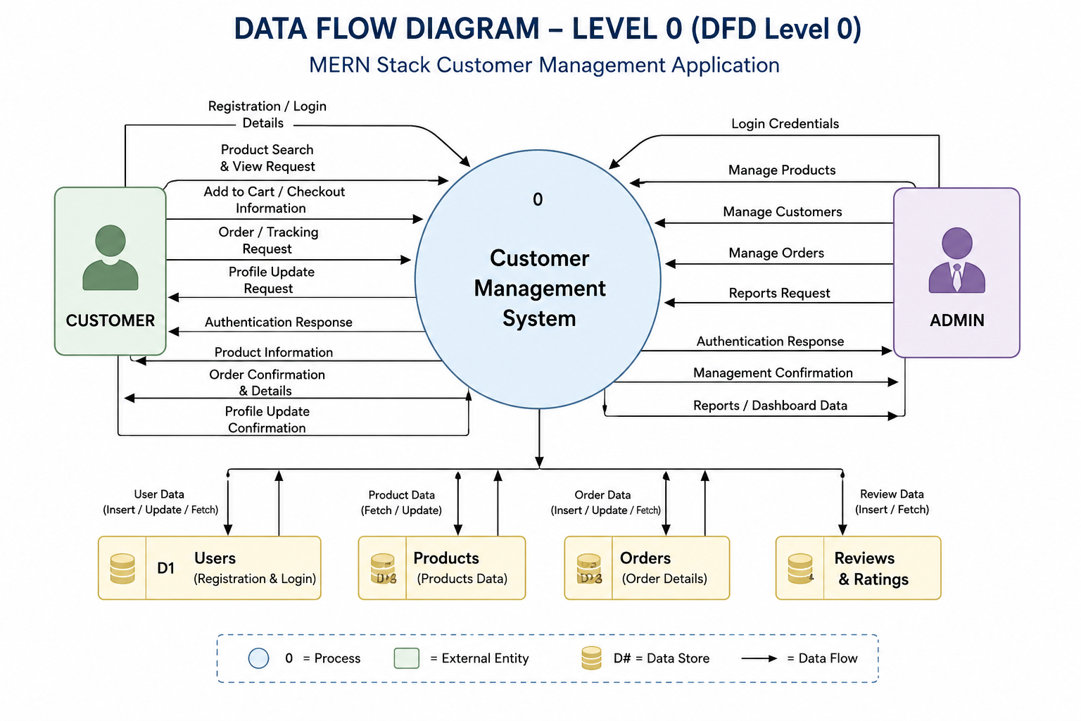
User Stories
The following table lists the user stories for the MERN Stack Customer Management Application.

User Type | Epic | Story ID | User Story | Acceptance Criteria | Priority | Release
Customer | Authentication | US-01 | As a customer, I want to register an account so that I can access the application. | Registration is successful and user can log in. | High | Sprint 1
Customer | Authentication | US-02 | As a customer, I want to log in securely so that I can access my account. | Valid credentials allow login. | High | Sprint 1
Customer | Products | US-03 | As a customer, I want to browse products so that I can choose items to purchase. | Products are displayed correctly. | High | Sprint 1
Customer | Cart | US-04 | As a customer, I want to add products to my cart so that I can purchase them later. | Cart updates successfully. | High | Sprint 2
Customer | Orders | US-05 | As a customer, I want to place an order so that I can buy products online. | Order is created successfully. | High | Sprint 2
Admin | Product Management | US-06 | As an administrator, I want to add, edit, and delete products so that the catalog remains up to date. | CRUD operations work correctly. | High | Sprint 2
Admin | User Management | US-07 | As an administrator, I want to manage customer accounts so that I can maintain the system. | User records can be viewed and updated. | Medium | Sprint 3
Admin | Reports | US-08 | As an administrator, I want to view sales reports so that I can monitor business performance. | Reports are generated correctly. | Medium | Sprint 3

Project Flow Diagram (Text)
[Customer/Admin]
|
React Frontend
|
Express.js API
/ | \
Auth Products Orders
\ | /
MongoDB
|
Responses to UI

