**Entity Relationship Diagram (ERD):**

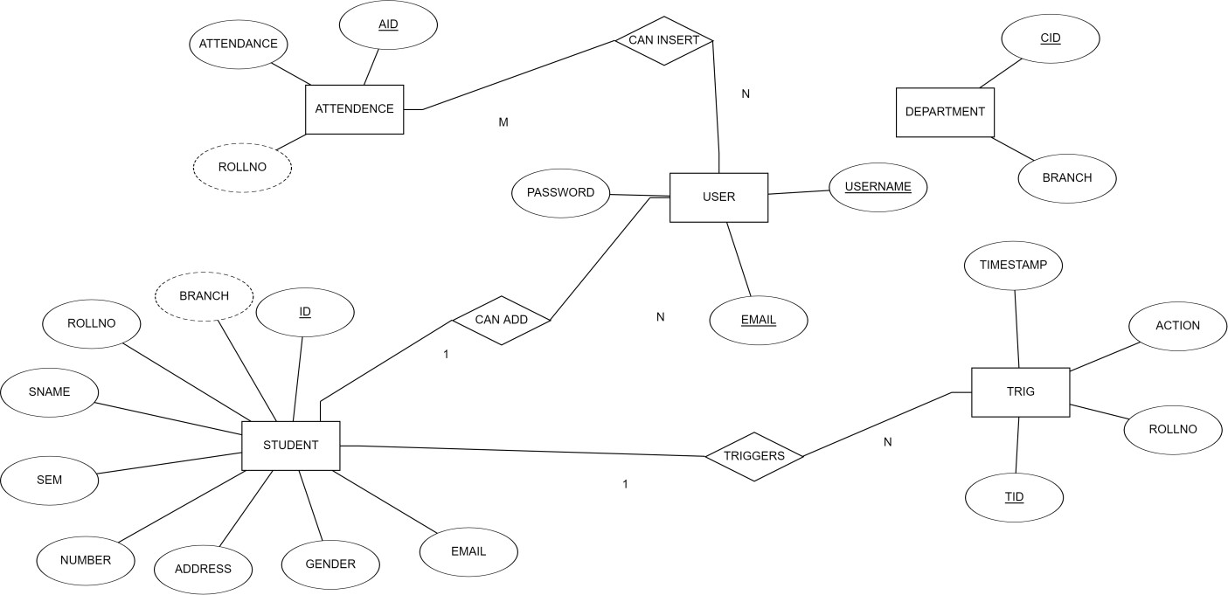**Schema Diagram:**

