MySQL - Mini-Project - Data Analysis on a database

1. Which products generate the highest and lowest revenue?
Query:
(SELECT p.productName, SUM(od.quantityOrdered * od.priceEach) AS highest_and_lowest_revenue
FROM products p
JOIN orderdetails od ON p.productCode = od.productCode
GROUP BY p.productName
ORDER BY highest_and_lowest_revenue DESC LIMIT 1)
UNION
(SELECT p.productName, SUM(od.quantityOrdered * od.priceEach) AS highest_and_lowest_revenue
FROM products p
JOIN orderdetails od ON p.productCode = od.productCode
GROUP BY p.productName
ORDER BY highest_and_lowest_revenue ASC LIMIT 1);
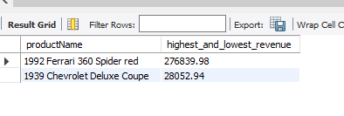
Insights:
Market Preference: High-performance, modern classic sports cars (like Ferrari) have significantly higher market demand and price points than older, standard coupes.
Revenue Concentration: A small number of "superstar" products are likely carrying the company's financial health, creating a risk if interest in those specific models declines.
Strategy:
Priority Fulfilment: Ensure the Ferrari is never "Out of Stock." Since it is the primary revenue driver, any delay in availability results in the largest possible financial loss.
Upselling: Target customers who bought the Ferrari with "related" lower-performing models via personalized email marketing to increase the sales volume of niche items.

2. Which product lines result in highest revenue?
Query:
SELECT p.productLine,
SUM(od.quantityOrdered * od.priceEach) AS total_revenue
FROM products p
JOIN orderdetails od ON p.productCode = od.productCode
GROUP BY p.productLine
ORDER BY total_revenue DESC LIMIT 3;
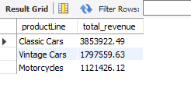
Analysis:
Revenue Leader: Classic Cars is the dominant category, generating significantly more revenue than any other line.
Revenue Laggard: Trains represents the smallest portion of the business, contributing the least to the total sales.
Insights:
Market Core: The business's primary strength is in the automotive sector, specifically high-end collectible cars.
Low Diversification: A huge portion of income relies on one category, creating a risk if interest in classic cars declines.
Strategy:
Capital Allocation: Reinvest profits into the Classic Cars line to acquire exclusive models and maintain market leadership.
Efficiency Move: Reduce inventory variety in the Trains line to minimize storage costs while keeping only the top-selling items.

3. Who are the top customers, and what are their purchasing behaviours?
Query:
SELECT c.customerName,
COUNT(DISTINCT o.orderNumber) AS total_orders,
SUM(od.quantityOrdered * od.priceEach) AS total_spent,
ROUND(SUM(od.quantityOrdered * od.priceEach) / COUNT(DISTINCT o.orderNumber), 2) AS avg_order_value
FROM customers c
JOIN orders o ON c.customerNumber = o.customerNumber
JOIN orderdetails od ON o.orderNumber = od.orderNumber
GROUP BY c.customerName
ORDER BY total_spent DESC
LIMIT 5;

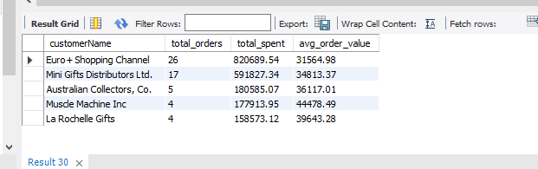

Analysis:
High-Value Accounts: Identify the customer with the highest total_spent to see who dominates your revenue stream.
Order Frequency: Compare total_orders among the top 5 to see if they buy in bulk occasionally or place many small orders frequently.
Insights:
Pareto Principle: A small group of "Power Buyers" generates a massive percentage of total revenue, making the business highly dependent on these specific relationships.
Behavioral Split: Customers with high avg_order_value are likely wholesalers, while those with high total_orders but lower averages are frequent restockers.
Strategy:
Dedicated Support: Assign "Key Account Managers" to the top 5 customers to provide personalized service and prevent them from moving to competitors.
Tiered Incentives: Offer volume-based discounts or "Loyalty Rebates" to encourage these top customers to increase their order frequency even further.

4. How do seasonal trends and order volumes vary over time?
Query:
SELECT YEAR(o.orderDate) AS Year,
MONTH(o.orderDate) AS Month,
COUNT(o.orderNumber) AS Order_Volume,
SUM(od.quantityOrdered * priceEach) AS Monthly_Revenue
FROM orders o
JOIN orderdetails od ON o.orderNumber = od.orderNumber
GROUP BY Year, Month
ORDER BY Year, Month;
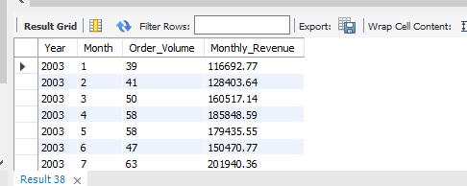
Analysis:
Peak Period: Identification of the specific month (typically November) where Order_Volume and Monthly_Revenue reach their highest points.
Low Season: Identification of "troughs" or slow months (often early in the year) where customer activity drops significantly.
Insights:
Holiday Seasonality: The massive spike in Q4 (Quarter 4) suggests that the business is heavily driven by end-of-year holiday shopping or annual clearance events.
Growth Consistency: Comparing the same month across different years (e.g., Nov 2003 vs Nov 2004) reveals whether the company is growing year-over-year or stagnating.
Strategy:
Inventory Pre-loading: Increase stock levels and warehouse staffing 60 days prior to the identified "Peak Month" to prevent shipping delays and stockouts.
Off-Peak Promotions: Launch "Flash Sales" or loyalty discounts during the identified "Slow Months" to stabilize cash flow and keep the warehouse active during quiet periods.

5. How does the status of orders affect purchases?
Query:
SELECT o.status,
COUNT(o.orderNumber) AS order_count,
SUM(od.quantityOrdered * od.priceEach) AS total_value
FROM orders o
JOIN orderdetails od ON o.orderNumber = od.orderNumber
GROUP BY o.status
ORDER BY total_value DESC;

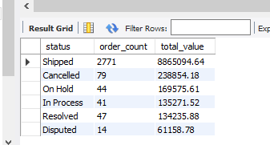
Analysis:
Operational Success: The majority of revenue is successfully captured in the 'Shipped' status, showing a functional delivery pipeline.
Revenue at Risk: A significant amount of value is held in 'In Process' or 'On Hold', representing money that has not yet been finalized.
Insights:
Efficiency Bottlenecks: If 'Disputed' or 'On Hold' values are high, it indicates issues with product quality or payment verification processes.
Cancellation Impact: 'Cancelled' orders represent a direct loss of marketing and operational effort, reflecting missed opportunities.
Strategy:
Process Speed: Streamline the transition from 'In Process' to 'Shipped' to reduce the time it takes to realize actual cash flow.
Feedback Loop: Analyse the reasons behind 'Disputed' orders to improve warehouse accuracy and reduce the costs of returns or refunds.

6. Understanding employee contribution in processing orders?
Query:
SELECT e.employeeNumber,
CONCAT(e.firstName, ' ', e.lastName) AS sales_rep_name,
COUNT(DISTINCT o.orderNumber) AS total_orders_handled,
SUM(od.quantityOrdered * od.priceEach) AS total_revenue_generated
FROM employees e
JOIN customers c ON e.employeeNumber = c.salesRepEmployeeNumber
JOIN orders o ON c.customerNumber = o.customerNumber
JOIN orderdetails od ON o.orderNumber = od.orderNumber
GROUP BY e.employeeNumber, sales_rep_name
ORDER BY total_revenue_generated DESC;

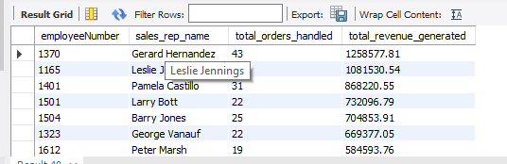
Analysis:
Top Performer: Identify the specific sales representative who has brought in the highest total revenue for the company.
Workload Distribution: Compare the number of orders handled vs. the revenue generated to see who is managing "big ticket" clients.
Insights:
Efficiency vs. Volume: Some employees might handle fewer orders but higher value, indicating they are skilled at managing premium accounts.
Training Needs: A large gap between the top and bottom performers suggests that lower-performing staff may need better sales scripts or territory assignments.
Strategy:
Incentive Program: Use these results to create a commission or bonus structure that rewards high-value revenue generation.
Knowledge Sharing: Pair the top-performing sales rep with lower-performing ones for a "Mentorship Program" to standardize sales techniques across the team.

7. Whether credit limit of customers affects purchase?
Query:
SELECT c.customerName,
c.creditLimit,
SUM(od.quantityOrdered * od.priceEach) AS total_order_value,
(SUM(od.quantityOrdered * od.priceEach) / c.creditLimit) * 100 AS credit_utilization_pct
FROM customers c
JOIN orders o ON c.customerNumber = o.customerNumber
JOIN orderdetails od ON o.orderNumber = od.orderNumber
GROUP BY c.customerName, c.creditLimit
ORDER BY total_order_value DESC;

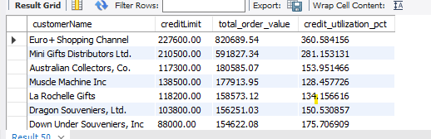

Analysis:
Credit Saturation: Identifies high-value customers whose total orders have reached or exceeded their assigned credit limits.
Under-utilization: Highlights customers with high credit limits who are making very few purchases, indicating untapped sales potential.
Insights:
Growth Bottleneck: Customers with high "Credit Utilization" may want to buy more but are restricted by their financial caps, leading to stagnant sales.
Risk Exposure: Customers with significantly higher spending than their credit limit (if payments are slow) represent a high financial risk to the company's cash flow.
Strategy:
Strategic Increases: Offer a Credit Limit Extension (e.g., 20% increase) to loyal, top-tier customers who are near their limit to encourage larger future orders.
Risk Re-assessment: For customers with high credit limits but low spending, investigate if their limit can be lowered to reduce the company's "potential" risk exposure.

8. Which countries are driving the most revenue?
Query:
SELECT c.country,
COUNT(DISTINCT c.customerNumber) AS customer_count,
SUM(od.quantityOrdered * od.priceEach) AS total_revenue
FROM customers c
JOIN orders o ON c.customerNumber = o.customerNumber
JOIN orderdetails od ON o.orderNumber = od.orderNumber
GROUP BY c.country
ORDER BY total_revenue DESC;

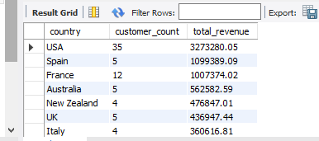
Analysis:
Market Concentration: Identifies which country (typically the USA or France) is the primary revenue source for the company.
Customer Density: Compares how many customers it takes to reach that revenue (e.g., many small customers vs. a few giant ones).
Insights:
Regional Strength: High revenue in specific regions suggests strong brand awareness and a successful localized supply chain in those countries.
Untapped Markets: Countries with many customers but low total revenue indicate a market that is wide but shallow, perhaps needing higher-priced offerings.
Strategy:
Localized Marketing: Increase advertising spend in the top 3 countries to capitalize on existing brand momentum.
Expansion Planning: Investigate the 4th and 5th ranked countries to see if opening a local warehouse could reduce shipping costs and boost sales further.

9. What is the average "Time to Ship" across different product lines?
Query:
SELECT p.productLine,
ROUND(AVG(DATEDIFF(o.shippedDate, o.orderDate)), 2) AS avg_days_to_ship
FROM orders o
JOIN orderdetails od ON o.orderNumber = od.orderNumber
JOIN products p ON od.productCode = p.productCode
WHERE o.shippedDate IS NOT NULL
GROUP BY p.productLine
ORDER BY avg_days_to_ship DESC;

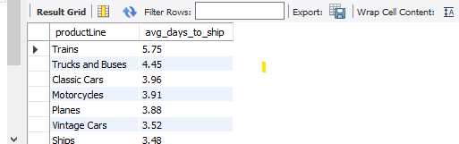
Analysis:
Fulfilment Speed: Measures the efficiency of the warehouse in moving a product from "Ordered" to "Shipped."
Category Lag: Identifies if certain categories (like "Ships" or "Planes") take significantly longer to process than others.
Insights:
Process Bottlenecks: A high average for specific lines suggests that those items might be harder to pack, require more documentation, or are located in a less accessible part of the warehouse.
Customer Satisfaction Risk: Long shipping times are a primary cause of customer complaints and order cancellations.
Strategy:
Warehouse Re-organization: Move product lines with high "Days to Ship" but high demand closer to the shipping docks (Fast-Picking zones).
Process Standardization: Investigate the "fastest" product line and apply its picking/packing workflow to the slower categories to improve overall efficiency.

10. Which products have zero sales?
Query:
SELECT p.productCode,
p.productName,
p.productLine,
p.quantityInStock
FROM products p
LEFT JOIN orderdetails od ON p.productCode = od.productCode
WHERE od.productCode IS NULL;

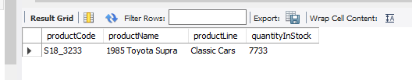
Analysis:
Non-Performing Assets: Lists products that are taking up warehouse space but have never been purchased.
Capital Lockdown: Quantifies how much inventory (quantityInStock) is sitting idle without generating cash.
Insights:
Inventory Obsolescence: These products are "Dead Stock" — they represent money that is frozen and potentially losing value over time.
Assortment Error: Having these items in the catalog suggests a mismatch between procurement choices and actual customer demand.
Strategy:
Liquidation Sale: Launch a "Clearance Event" specifically for these items to recover whatever capital is possible.
Catalog Pruning: Remove these items from future procurement cycles to ensure the company stops wasting money on unpopular stock.

Project Executive Summary

Strategic Data Analysis

1. Sales Performance (The Revenue Engine)
Analysis:
Revenue is heavily concentrated in the Classic Cars product line, with a massive performance gap between "star" products like the 1992 Ferrari and niche models.
Insight:
The business has a strong brand identity in high-end automotive collectibles, but the high reliance on a few top-sellers creates a "concentration risk."
Strategy:
Reinvest profits into the top 20% of high-performing SKUs to protect market share while "pruning" the bottom 10% (Dead Stock) to free up warehouse capital.

2. Customer Purchases (The Relationship Value)
Analysis:
A small group of "Power Buyers" (e.g., Euro+ Shopping) contributes a disproportionate amount of total revenue, often pushing their Credit Limits to the edge.
Insight:
Purchasing behaviour is split between high-frequency restockers and high-value bulk wholesalers; credit limits currently act as a ceiling for our most loyal partners.
Strategy:
Implement a Tiered Loyalty Program and strategically increase credit limits for verified top-tier customers to remove bottlenecks and encourage larger order volumes.

3. Supply Chain Reliability (The Operational Pulse)
Analysis:
While the majority of orders are "Shipped," there is measurable "Revenue Leakage" from Cancelled and Disputed orders, alongside varying shipping speeds across product lines.
Insight:
Inconsistencies in shipping times for complex models (like Ships/Planes) and order disputes indicate a need for better quality control and warehouse "picking" efficiency.
Strategy:
Optimize warehouse layout by moving high-demand items to "Fast-Pick" zones and automate status alerts for orders "On Hold" to decrease lead times and improve cash flow.
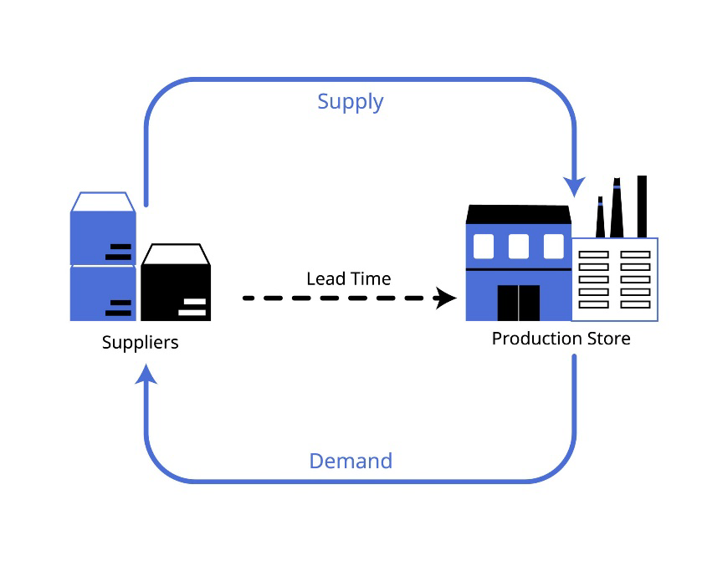
Final Project Conclusion:
"By moving from raw data to actionable insights, this project demonstrates that the path to growth lies in protecting high-revenue assets, empowering high-value customers, and eliminating operational friction. This data-driven approach transforms the database from a storage tool into a strategic roadmap for business optimization."

