Cafeteria Sales Data Analysis Report

Analysis 1: Impact of Purchase Quantity on Total Revenue
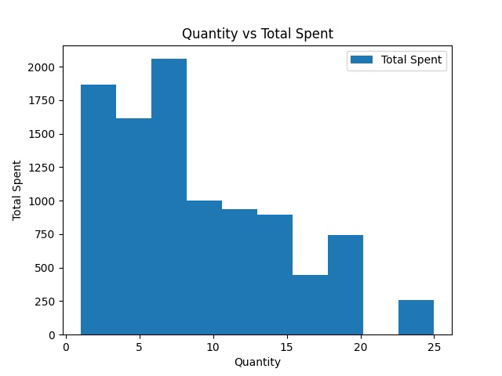
Figure 1: Scatter Plot – Quantity Purchased vs Total Amount Spent

Distribution Analysis
The distribution is right-skewed, with revenue concentrated in low to medium quantity ranges. As quantity increases, total spending decreases, indicating reduced revenue efficiency at higher quantities.

Key Contributors
Purchases between 2 and 7 units are the major contributors to revenue, while high quantity purchases contribute significantly less.

Profit & Loss Zones
Low to medium quantities represent profit zones with stable margins. High quantity purchases indicate potential loss zones due to discounting.

Insights
Higher quantity does not guarantee higher revenue. Optimized pricing and purchasing behavior drive total sales performance.

Strategies
Adopt tiered pricing, limit bulk discounts, and introduce combo offers to improve revenue while protecting margins.

Analysis 2: Effect of Unit Price on Total Revenue
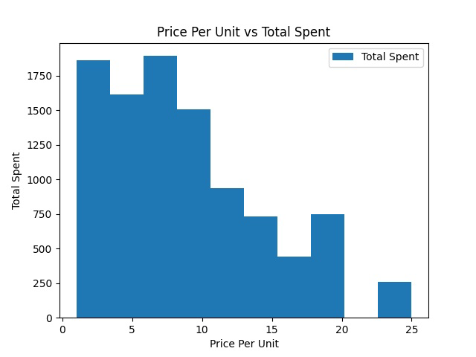
Figure 2: Scatter Plot – Price Per Unit vs Total Amount Spent

Distribution Analysis
Revenue is concentrated in lower to mid price ranges. Higher prices result in lower total spending, indicating strong customer price sensitivity.

Key Contributors
Low to mid-priced products contribute most to revenue due to higher demand, while high-priced products contribute less.

Profit & Loss Zones
Mid-priced products form strong profit zones, while high-priced products risk low turnover and inventory stagnation.

Insights
Customers prefer affordable pricing. Premium pricing reduces purchase frequency and overall revenue contribution.

Strategies
Optimize pricing bands, bundle premium products, and apply value-based pricing strategies to improve total revenue.

Overall Conclusion & Business Implications
The combined analysis of quantity-based and price-based patterns enables better decision-making. By focusing on high-performing segments and optimizing pricing strategies, businesses can achieve sustainable sales and revenue growth.

Correlation Analysis of Cafeteria Sales Variables

Correlation analysis helps in understanding the relationship between numerical variables in the dataset. It indicates how strongly variables move together and in which direction.

Correlation Interpretation
• Positive Correlation: Both variables increase or decrease together.
• Negative Correlation: One variable increases while the other decreases.
• No Correlation: Variables show little to no linear relationship.

Key Correlation Observations
• Quantity vs Total Spent: Shows a positive correlation, meaning higher quantities generally lead to higher total spending.
• Price Per Unit vs Total Spent: Displays a weak or slightly negative correlation, suggesting that higher prices may reduce overall spending.
• Quantity vs Price Per Unit: Shows minimal correlation, indicating independent behavior.

Key Insights from Correlation Analysis
The correlation findings validate the distribution plots. Total spending is driven more by balanced pricing and purchase volume rather than extreme values of a single variable.

Strategic Recommendations
• Focus on optimal pricing rather than maximum pricing.
• Encourage bulk purchases through offers and discounts.
• Maintain mid-range pricing to maximize both quantity sold and revenue.

