**Error due to Bias**

Error due to bias is the amount by which the expected model prediction differs from the true value of the training data. It is introduced by approximating the complicated model by much simpler model. High bias algorithms are easier to learn but less flexible, due to this they have lower predictive performance on complex problems. Linear algorithms and oversimplified model lead to high bias in the model.

**Error due to variance**

Error due to variance is the amount by which the prediction, over one training set, differs from the expected value over all the training sets. In machine learning, diﬀerent training data sets will result in a diﬀerent estimation. But ideally it should not vary too much between training sets. However, if a method has high variance then small changes in the training data can result in large changes in results.

**Bias and Variance Trade-off**

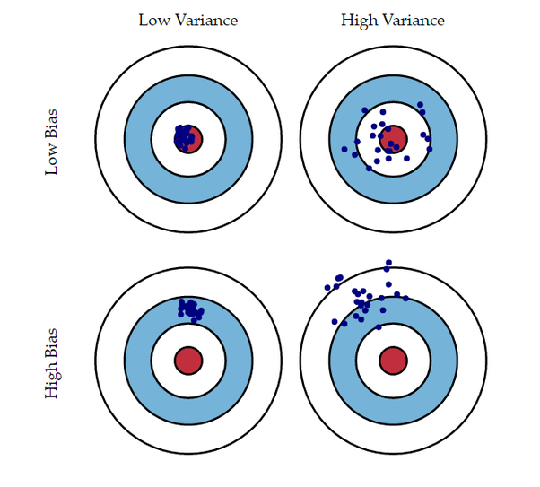

Suppose the red circle is the target which perfectly predicts the correct values. If we move away from that, our prediction gets worse. The above figure displays four different cases representing combinations of both high and low bias and variance. High bias is when all dots are far from bulls eye and high variance is when all dots are scattered.

There is always a trade-off between bias and variance because it is easy to achieve low bias but high variance (complex model)

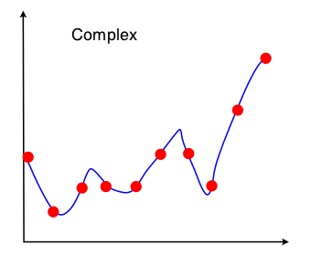

and low variance and high bias (simple model)

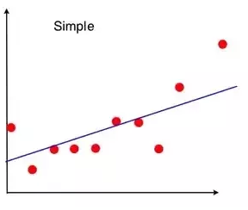

The challenge lies in ﬁnding a method/model which exhibits both low bias and variance.