Steps to execute the project:
- Set the OPENAI_API_KEY in .env file
- cd translator/
- pip install -r requirement.txt
- streamlit run main.py

Project contains 5 python files
- AudioConvertor: it convert from text to speech
- LLMExecuter: it request the openai and get response
- TextExtractor: it is extract the text from different format file(pdf,docx,txt,csv,xlsx)
- CustomError: it is custom exception class inherited from base exception
- Main: it contains all UI related code
- All Audio file save in media folder

Below are screens

- Type the text
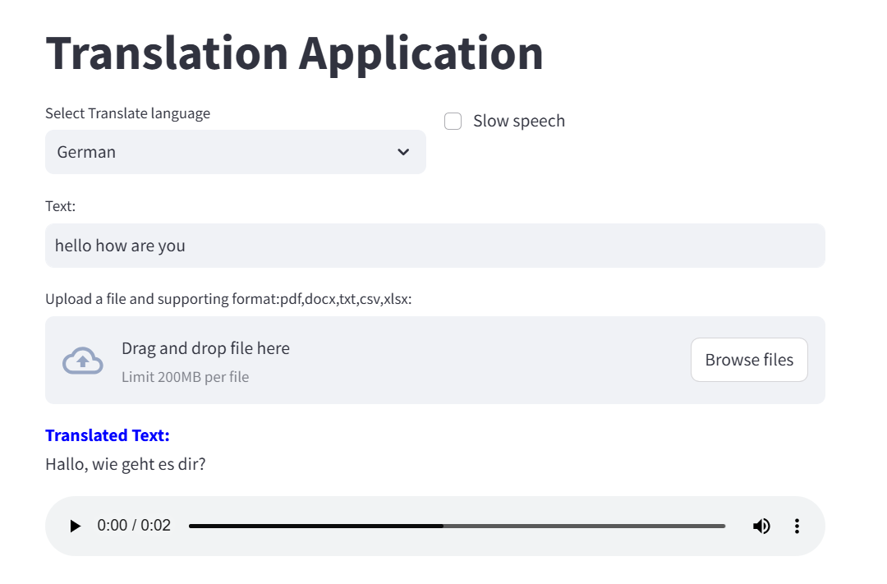

2. Upload the pdf file
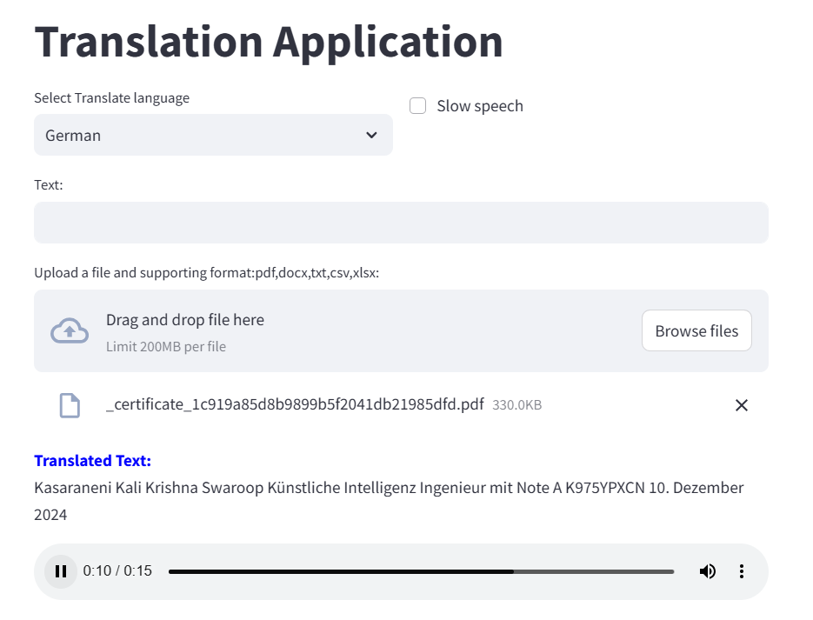
- Without providing the data
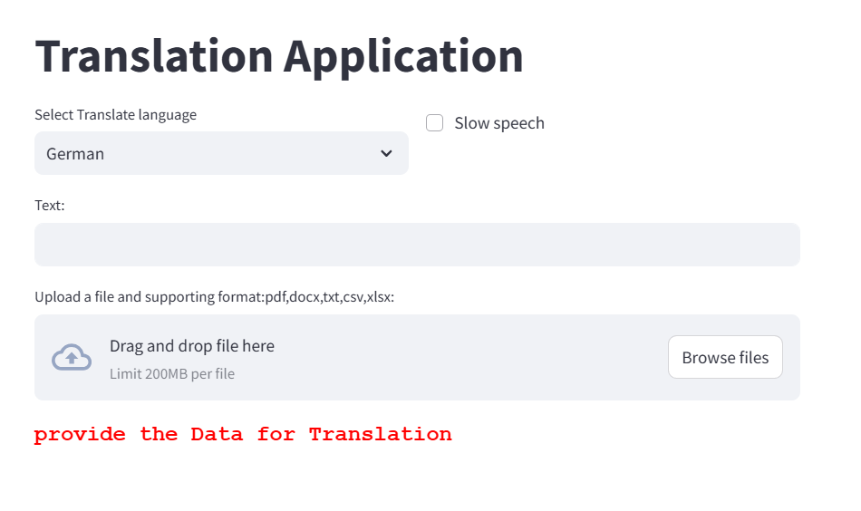
4. Unsupported file format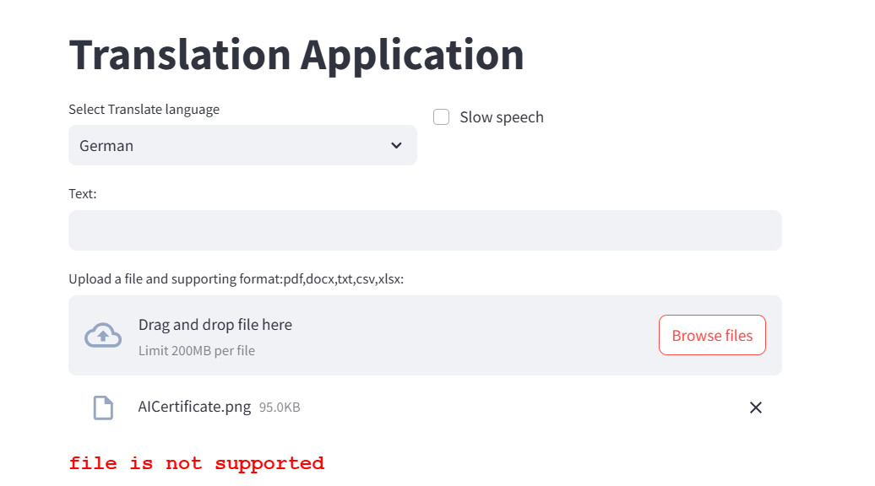

- OpenAi api_key expired
