DOCKER-2
- Create a tomcat container on 8080 and deploy sample application in tomcat.

Objective
To create an Apache Tomcat Docker container, expose Tomcat on port 8080, and deploy a sample Java web application (.war) inside the Tomcat container.

Expected architecture
Developer / Browser
|
| http://<EC2-IP>:8080
↓
Docker Host
|
| Port Mapping
| 8080:8080
↓
┌─────────────────────────┐
│ Tomcat Container │
│ │
│ Tomcat :8080 │
│ ↓ │
│ sample-app.war │
│ ↓ │
│ Web Application │
└─────────────────────────┘

Prerequisites

Infrastructure
You need:
- Linux server / EC2 instance
- Docker installed
- Internet connectivity
- Port 8080 allowed in the EC2 Security Group/firewall
- Sample .war application

Verify Docker
docker --version

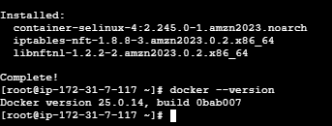
Check Docker service:
sudo systemctl status docker
If it isn't running:
sudo systemctl start docker
Enable at boot:
sudo systemctl enable docker

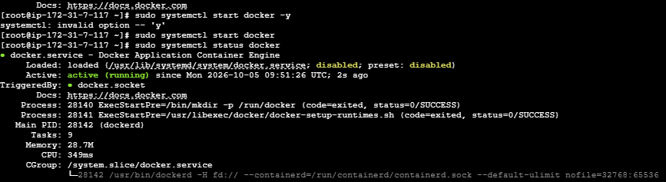

3. Open Port 8080
If you're using an AWS EC2 instance, go to:
EC2
↓
Security Groups
↓
Inbound Rules
↓
Add Rule
Add:
Type: Custom TCP
Port: 8080
Source: Your IP
For a temporary lab, you can use:
0.0.0.0/0
but restricting access to your IP is safer.

4. Pull Tomcat Image
First search/pull the Tomcat image:
docker pull tomcat
Verify:
docker images
You should see:
REPOSITORY TAG IMAGE ID
tomcat latest xxxxxxxxx

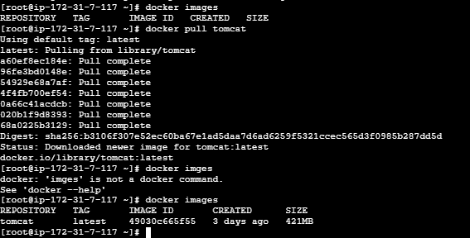

5. Create Tomcat Container
Run:
Ex : docker run -d \ --name tomcat-server \ -p 8080:8080 \
Tomcat

docker run -itd --name cont1 -p 8080:8080 tomcat

Explanation
docker run
Creates and starts a container.
-d
Runs the container in detached/background mode.
--name tomcat-server
Gives the container a name.
-p 8080:8080
Maps:
Host port 8080 → Container port 8080
tomcat
is the Docker image.

6. Verify Container
Run:
docker ps
Expected:
CONTAINER ID IMAGE PORTS
xxxxxxxx tomcat 0.0.0.0:8080->8080/tcp
You can also check:
docker ps -a

7. Check Tomcat Logs
Run:
docker logs tomcat-server
You should see Tomcat startup messages.
For continuous logs:
docker logs -f tomcat-server
Press:
Ctrl + C
to exit the log view.

8. Test Tomcat
From the Docker host:
curl http://localhost:8080
Or from your browser:
http://<EC2-PUBLIC-IP>:8080

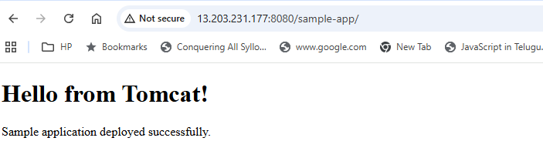

Important
If you're using a newer official Tomcat image, the default root/web management content may differ from older Tomcat images. A successful HTTP response still confirms that Tomcat is listening.

9. Prepare a Sample Application
For this lab, create a simple HTML page and package it as a WAR.
Create a directory:
mkdir sample-app
cd sample-app
Create:
mkdir -p ROOT
Create the HTML file:
vi ROOT/index.html
Add:
<!DOCTYPE html>
<html>
<head>
<title>Docker Tomcat Application</title>
</head>
<body>
<h1>Hello from Docker Tomcat!</h1>
<p>Sample application deployed successfully.</p>
</body>
</html>
Save the file.

10. Create WAR File
From the directory containing ROOT:
jar -cvf sample-app.war -C ROOT .
Verify:
ls -lh sample-app.war
You should get:
sample-app.war

WAR structure
Conceptually:
sample-app.war
│
├── index.html
└── ...
For a real Java web application, the WAR would normally contain:
WEB-INF/
META-INF/
JSP/HTML
Java classes
Libraries

11. Copy WAR into Tomcat Container
Now copy the application into Tomcat's webapps directory:
docker cp sample-app.war tomcat-server:/usr/local/tomcat/webapps/

What does this mean?
Docker Host
|
| sample-app.war
↓
Tomcat Container
|
↓
/usr/local/tomcat/webapps/
Tomcat automatically detects the WAR and deploys it.

12. Verify WAR Deployment
Check inside the container:
docker exec -it tomcat-server ls -lh /usr/local/tomcat/webapps/
You should see:
ROOT
docs
examples
host-manager
manager
sample-app.war
Tomcat should also create:
sample-app/
Check:
docker exec -it tomcat-server ls -lh /usr/local/tomcat/webapps/
Expected:
sample-app.war
sample-app/

13. Check Tomcat Logs
Run:
docker logs tomcat-server
Look for deployment messages.
You can also check:
docker exec -it tomcat-server \
ls -lh /usr/local/tomcat/webapps/sample-app/

14. Access the Application
Because the WAR file is:
sample-app.war
Tomcat normally uses:
sample-app
as the context path.
Therefore open:
http://<EC2-PUBLIC-IP>:8080/sample-app/
Expected:
Hello from Docker Tomcat!

Sample application deployed successfully.

15. Complete Flow
AWS EC2
┌─────────────────────────┐
│ │
│ Docker Engine │
│ │ │
│ ↓ │
│ ┌───────────────┐ │
│ │ Tomcat │ │
│ │ Container │ │
│ │ │ │
8080 ───┼───►│ Tomcat :8080 │ │
│ │ │ │ │
│ │ ↓ │ │
│ │ sample-app.war│ │
│ │ ↓ │ │
│ │ Application │ │
│ └───────────────┘ │
│ │
└─────────────────────────┘
▲
|
Browser

16. Useful Docker Commands

Check running containers
docker ps

Check all containers
docker ps -a

View logs
docker logs tomcat-server

Enter container
docker exec -it tomcat-server /bin/bash

Check Tomcat webapps
docker exec -it tomcat-server \
ls -lh /usr/local/tomcat/webapps/

Stop container
docker stop tomcat-server

Start container
docker start tomcat-server

Restart container
docker restart tomcat-server

Remove container
docker rm -f tomcat-server

17. Alternative: Deploy WAR During Container Creation
You can also create a Dockerfile.
Create:
Dockerfile
FROM tomcat:latest

COPY sample-app.war /usr/local/tomcat/webapps/

EXPOSE 8080
Build:
docker build -t my-tomcat-app:1.0 .
Run:
docker run -d \
--name tomcat-app \
-p 8080:8080 \
my-tomcat-app:1.0
Now the application is already included in the image.
Flow:
sample-app.war
|
↓
Dockerfile
|
| docker build
↓
my-tomcat-app:1.0
|
| docker run
↓
Tomcat Container
|
↓
sample-app

Which approach is better?
For a basic Docker lab, docker cp is easy to understand.
For CI/CD, the Dockerfile approach is generally more repeatable:
GitHub
↓
Jenkins
↓
Maven Build
↓
WAR
↓
Docker Image
↓
Docker Registry
↓
Tomcat Container

- Create volume and deploy tomcat container on port 8081.

Objective
The objective is to:
- Create a Docker named volume.
- Deploy a Tomcat container using that volume.
- Expose Tomcat on port 8081 of the EC2 host.
- Store Tomcat application data in the Docker volume.
- Deploy a sample application and verify it.
- Understand how volumes provide persistent storage independent of the container lifecycle.

2. Prerequisites
Before starting, make sure:
- Linux EC2 instance is available.
- Docker is installed and running.
- Port 8081 is allowed in the EC2 Security Group.
- Internet access is available to pull the Tomcat image.
Check Docker:
docker --version
Check Docker service:
systemctl status docker
Check Docker:
docker ps

3. Step-by-Step Implementation

Step 1: Pull the Tomcat image
docker pull tomcat
Verify:
docker images
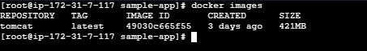

Step 2: Create a Docker volume
Create a volume called tomcat-data:
docker volume create tomcat-data
Verify:
docker volume ls
Expected:
DRIVER VOLUME NAME
local tomcat-data

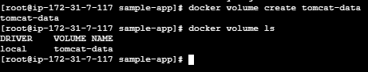

Why are we creating a volume?
Normally, data inside a container belongs to that container. If the container is deleted, that data can be lost.
A Docker volume allows us to keep important data outside the container's writable layer.
Container
|
| mounted volume
↓
tomcat-data

Step 3: Inspect the volume
docker volume inspect tomcat-data
You will see information similar to:
[
{
"CreatedAt": "2026-10-05T10:22:28Z",
"Driver": "local",
"Labels": null,
"Mountpoint": "/var/lib/docker/volumes/tomcat-data/_data",
"Name": "tomcat-data",
"Options": null,
"Scope": "local"
}
]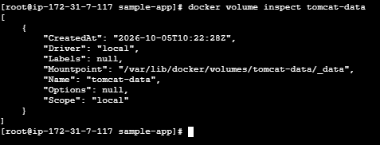
The important field is:
Mountpoint
This is where Docker stores the volume data on the host.

4. Create the Tomcat container on port 8081
Run:
docker run -d \
--name tomcat-volume \
-p 8081:8080 \
-v tomcat-data:/usr/local/tomcat/webapps \
tomcat

Understand the command
docker run -d
Runs the container in detached/background mode.
--name tomcat-volume
Container name:
tomcat-volume
-p 8081:8080
Port mapping:
EC2 Host Container
8081 → 8080
Tomcat listens on 8080 inside the container, but users access it through 8081 on the EC2 host.
-v tomcat-data:/usr/local/tomcat/webapps
Mounts the Docker volume:
tomcat-data
↓
/usr/local/tomcat/webapps

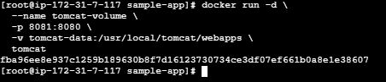

5. Verify the container
docker ps
You should see something similar to:
CONTAINER ID IMAGE STATUS PORTS
xxxxxx tomcat Up ... 0.0.0.0:8081->8080/tcp
This confirms:
Host Port 8081 → Container Port 8080

6. Check the mounted volume
Run:
docker exec -it tomcat-volume ls -lh /usr/local/tomcat/webapps/
Because we mounted a new empty volume, the directory may initially be empty.
This is important:
When you mount a volume over /usr/local/tomcat/webapps, the volume becomes the directory that Tomcat sees at that location.

7. Create a sample application
On the EC2 host:
mkdir -p ~/sample-app
cd ~/sample-app
Create an HTML file:
cat > index.html <<'EOF'
<!DOCTYPE html>
<html>
<head>
<title>Tomcat Docker Volume</title>
</head>
<body>
<h1>Hello from Tomcat with Docker Volume!</h1>
<p>Application deployed successfully on port 8081.</p>
</body>
</html>
EOF

8. Create the WAR file
Since Java isn't installed on your EC2 host, you can use zip.
Install it if necessary:
dnf install zip -y
Create the WAR:
zip -r sample-app.war index.html
Verify:
ls -lh sample-app.war

9. Deploy the WAR into the container
Copy it to the Tomcat webapps directory:
docker cp sample-app.war tomcat-volume:/usr/local/tomcat/webapps/
Verify:
docker exec -it tomcat-volume ls -lh /usr/local/tomcat/webapps/
You should see:
sample-app.war
sample-app/
Tomcat automatically extracts the WAR.

10. Test Tomcat locally
Run:
curl http://localhost:8081/sample-app/
You should get:
<h1>Hello from Tomcat with Docker Volume!</h1>
You can also test using the EC2 public IP:
curl http://13.203.231.177:8081/sample-app/
Or open in your browser:
http://<EC2-PUBLIC-IP>:8081/sample-app/

11. Configure AWS Security Group
If the browser cannot access port 8081, add an inbound rule to the EC2 Security Group:
Type | Protocol | Port | Source
Custom TCP | TCP | 8081 | My IP
For a temporary lab you could use:
0.0.0.0/0
but My IP is safer.
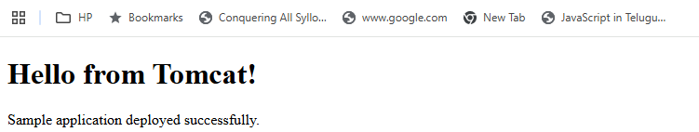

12. Verify the Volume
Check the volume:
docker volume inspect tomcat-data
Check its contents through the container:
docker exec -it tomcat-volume ls -lh /usr/local/tomcat/webapps/
You should see:
sample-app/
sample-app.war

13. Most Important Test — Delete the Container
This demonstrates why we created the volume.
First stop the container:
docker stop tomcat-volume
Remove it:
docker rm tomcat-volume
Verify:
docker ps -a
The container is gone.
But check the volume:
docker volume ls
You should still see:
tomcat-data
The application data is still stored in the volume.

14. Create a New Tomcat Container Using the Same Volume
Now create another container:
docker run -d \
--name tomcat-volume-new \
-p 8081:8080 \
-v tomcat-data:/usr/local/tomcat/webapps \
tomcat
Verify:
docker ps
Then:
docker exec -it tomcat-volume-new ls -lh /usr/local/tomcat/webapps/
You should still find:
sample-app/
sample-app.war
Test again:
curl http://localhost:8081/sample-app/
The application should still work.

This proves:
Container 1
|
↓
tomcat-data
|
↓
Container 2
The container was deleted, but the volume remained.

15. Final Architecture
EC2 Instance
Public IP: x.x.x.x
|
|
Port 8081
|
↓
Docker Host / Engine
|
↓
┌──────────────────┐
│ tomcat-volume │
│ Container │
│ │
│ Tomcat :8080 │
└────────┬─────────┘
|
| Mount
↓
┌──────────────────┐
│ tomcat-data │
│ Docker Volume │
└──────────────────┘
|
↓
sample-app.war

Key interview points
Why use a volume?
Docker volumes provide persistent storage that exists independently of the container lifecycle.
What does -p 8081:8080 mean?
Port 8081 on the Docker host is mapped to port 8080 inside the Tomcat container.
What does -v tomcat-data:/usr/local/tomcat/webapps mean?
It mounts the Docker volume tomcat-data to Tomcat's webapps directory inside the container.
What happens if the container is deleted?
The container is deleted, but the named Docker volume remains, so the application data can be reused by another container.
One important difference from your previous lab: previously you used docker cp into the container's filesystem. Here, the webapps directory is backed by tomcat-data, so the deployed application is stored in the persistent volume.

- Limit the nginx container to 500 MB.

Objective
The objective is to run an Nginx Docker container with a maximum memory limit of 500 MB.
We will:
- Pull the Nginx image.
- Run an Nginx container.
- Set the memory limit to 500 MB.
- Verify the configured memory limit.
- Monitor the container's memory usage.
- Understand what happens when the container reaches its memory limit.
Important: In Docker, --memory 500m limits the container's RAM usage, not the Docker image size or disk/storage usage.

2. Prerequisites
You need:
- Linux EC2 instance
- Docker installed
- Docker service running
- Internet connectivity
- Nginx image
Check Docker:
docker --version
Check Docker service:
systemctl status docker
Check available memory:
free -h

3. Pull Nginx Image
docker pull nginx
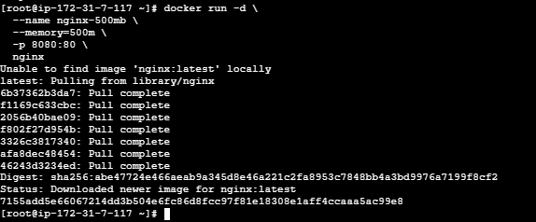
Verify:
docker images
You should see:
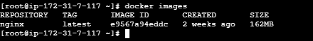

4. Run Nginx with 500 MB Memory Limit
Run:
docker run -d \
--name nginx-500mb \
--memory=500m \
-p 8080:80 \
nginx

Explanation
--name nginx-500mb
Creates the container with the name:
nginx-500mb
--memory=500m
Sets the maximum memory limit to approximately 500 MB.
-p 8080:80
Maps:
EC2 host port 8080
↓
Container port 80
↓
Nginx

5. Verify Container
Run:
docker ps
You should see:
CONTAINER ID IMAGE STATUS PORTS
xxxxxx nginx Up ... 0.0.0.0:8080->80/tcp

6. Verify the 500 MB Memory Limit
Run:
docker inspect nginx-500mb --format='{{.HostConfig.Memory}}'
You may see:
524288000
Why?
500 MB × 1024 × 1024
= 524,288,000 bytes
So:
524288000 bytes ≈ 500 MB

7. Check Container Memory Usage
Run:
docker stats nginx-500mb
You will see something similar to:
CONTAINER ID NAME CPU % MEM USAGE / LIMIT
xxxxxx nginx-500mb 0.00% 2.5MiB / 500MiB
The important column is:
MEM USAGE / LIMIT
For example:
2.5MiB / 500MiB
means:
- Current usage = approximately 2.5 MB
- Maximum allowed = 500 MB
Press:
Ctrl + C
to exit docker stats.

8. Test Nginx
From the EC2 server:
curl http://localhost:8080
You should receive the Nginx welcome page HTML.
You can also access it from your browser:
http://<EC2-PUBLIC-IP>:8080
Make sure your EC2 Security Group allows TCP 8080.
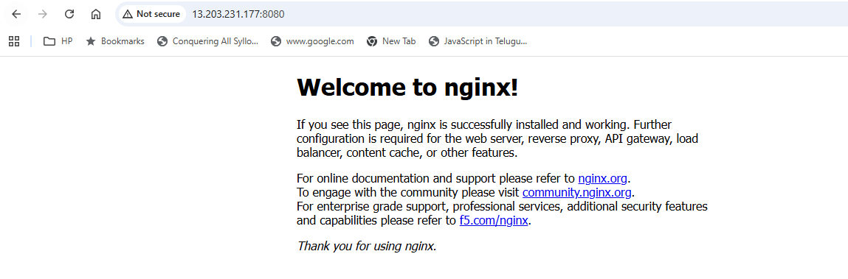

9. Check the Memory Limit Using docker inspect
You can also run:
docker inspect nginx-500mb | grep -i -A 5 '"Memory"'
You should find:
"Memory": 524288000
This confirms that the container has a memory limit configured.
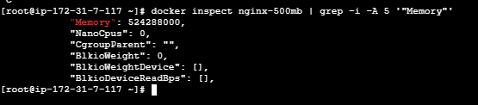

10. Test Container Configuration
You can use:
docker inspect nginx-500mb --format='Memory Limit: {{.HostConfig.Memory}} bytes'
Expected:
Memory Limit: 524288000 bytes

11. What Happens If Nginx Uses More Than 500 MB?
Docker enforces the memory limit through the Linux kernel's control groups (cgroups).
Your configuration is:
Docker Host
|
↓
┌───────────────────┐
│ nginx-500mb │
│ │
│ Memory limit │
│ 500 MB │
└───────────────────┘
If the container attempts to use more memory than its configured limit, the kernel can invoke the OOM (Out Of Memory) killer, potentially terminating processes in the container.
You can check whether a container was OOM-killed with:
docker inspect nginx-500mb --format='OOMKilled={{.State.OOMKilled}}'
For a normally running container:
OOMKilled=false

12. Stop and Remove the Container
When the lab is complete:
docker stop nginx-500mb
Remove it:
docker rm nginx-500mb
Verify:
docker ps -a

13. One-Line Production-Style Command
The essential command for this task is:
docker run -d --name nginx-500mb --memory=500m -p 8080:80 nginx

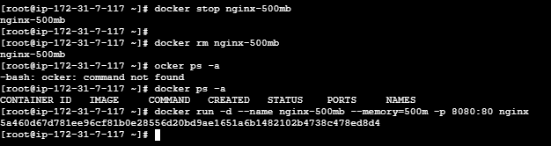

Interview Answer
Question: How do you limit a Docker container to 500 MB memory?
Answer:
"I use Docker's memory resource constraint. For example, I can run Nginx using docker run -d --name nginx-500mb --memory=500m -p 8080:80 nginx. The --memory=500m option limits the container's memory to approximately 500 MB. I can verify the limit using docker inspect and monitor actual consumption using docker stats."

Important distinction
Requirement | Docker option
Limit RAM | --memory=500m
Limit CPU | --cpus
Limit CPU shares | --cpu-shares
Limit block I/O | --device-read-bps, --device-write-bps
Limit number of processes | --pids-limit
For your lab, the key option is:
--memory=500m

- Create a sample docker file using below instructions.
  - Base module as amazonlinux:latest
  - Maintainer you name
  - Install nginx
  - COPY one index.html file to image
  - Expose on port 80
  - Command to start the nginx container

Objective
The objective is to create a custom Docker image using amazonlinux:latest as the base image and configure it to:
- Use Amazon Linux as the base image.
- Define the maintainer/author.
- Install Nginx.
- Copy a custom index.html into the image.
- Expose port 80.
- Start Nginx automatically when the container starts.
- Build and run the image and verify the application.

Final architecture
Dockerfile
|
| docker build
↓
Custom Nginx Image
|
| docker run
↓
Nginx Container
|
| Port 80
↓
Custom index.html

Prerequisites
You need:
- Linux EC2 instance
- Docker installed
- Docker service running
- Internet connectivity
- Port 80 allowed in the EC2 Security Group
- Basic Linux commands
Check Docker:
docker --version
Check Docker service:
systemctl status docker
Check available disk space:
df -h

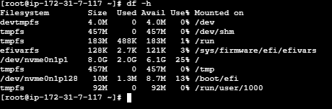

3. Create a Working Directory
Create a directory for the Docker project:
mkdir -p ~/nginx-docker
cd ~/nginx-docker
Verify:
pwd
You should be inside:
/root/nginx-docker

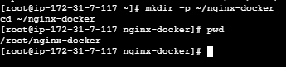

4. Create index.html
Create the HTML file:
vi index.html
Add:
<!DOCTYPE html>
<html>
<head>
<title>My Custom Nginx</title>
</head>
<body>
<h1>Hello from Custom Nginx Docker Image!</h1>
<p>Application deployed successfully.</p>
</body>
</html>
Save and exit.
Verify:
cat index.html

5. Create the Dockerfile
Create a file named exactly:
vi Dockerfile
Add the following:
FROM amazonlinux:latest

LABEL maintainer="Swaroop Kumar"

RUN dnf install -y nginx && \
dnf clean all

COPY index.html /usr/share/nginx/html/index.html

EXPOSE 80

CMD ["nginx", "-g", "daemon off;"]

6. Understand Each Dockerfile Instruction

FROM
FROM amazonlinux:latest
This uses the latest Amazon Linux image as the base image.
Amazon Linux
↓
Nginx
↓
Custom application

LABEL
LABEL maintainer="Swaroop Kumar"
This adds metadata to the image identifying the image maintainer/author.
MAINTAINER is an older Dockerfile instruction and is deprecated. LABEL maintainer=... is the recommended approach.

RUN
RUN dnf install -y nginx && \
dnf clean all
This installs Nginx during image build time.
The command:
dnf install -y nginx
installs Nginx.
The:
dnf clean all
removes cached package metadata and helps reduce unnecessary image size.

COPY
COPY index.html /usr/share/nginx/html/index.html
Copies the local:
index.html
into the Nginx default web root:
/usr/share/nginx/html/index.html
Therefore, when Nginx starts, it serves your custom page.

EXPOSE
EXPOSE 80
Documents that the application inside the container listens on port 80.
Important: EXPOSE does not actually publish the port to the EC2 host.
Port publishing is done with docker run -p.

CMD
CMD ["nginx", "-g", "daemon off;"]
Starts Nginx when the container starts.
The important part is:
daemon off;
Docker containers need their main process to remain in the foreground. If Nginx runs as a background daemon, the container can exit.

7. Check the Project Files
Run:
ls -lh
You should have:
Dockerfile
index.html
For example:
-rw-r--r-- Dockerfile
-rw-r--r-- index.html

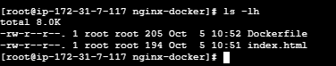

8. Build the Docker Image
Run:
docker build -t custom-nginx:1.0 .

Explanation
docker build
Builds an image.
-t custom-nginx:1.0
Names the image:
custom-nginx
with tag:
1.0
.
means use the current directory as the Docker build context.

9. Verify the Image
Run:
docker images
You should see:
REPOSITORY TAG IMAGE ID SIZE
custom-nginx 1.0 xxxxxxxx ...

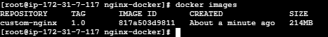

10. Run the Container
Run:
docker run -d \
--name custom-nginx \
-p 80:80 \
custom-nginx:1.0

Port mapping
EC2 Host Container
80 ─────────→ 80
Nginx
So when a user accesses:
http://<EC2-PUBLIC-IP>
the request reaches:
EC2 port 80
↓
Docker container port 80
↓
Nginx
↓
index.html

11. Verify the Container
docker ps
You should see something similar to:
CONTAINER ID IMAGE STATUS PORTS
xxxxxx custom-nginx:1.0 Up ... 0.0.0.0:80->80/tcp

12. Test Nginx Locally
Run:
curl http://localhost
You should get:
<!DOCTYPE html>
<html>
<head>
<title>My Custom Nginx</title>
</head>
<body>
<h1>Hello from Custom Nginx Docker Image!</h1>
<p>Application deployed successfully.</p>
</body>
</html>
You can also use:
curl http://localhost:80

13. Test From Your Browser
First make sure the EC2 Security Group allows:
Type: HTTP
Protocol: TCP
Port: 80
Source: My IP
Then open:
http://<EC2-PUBLIC-IP>
You should see:
Hello from Custom Nginx Docker Image!

14. Verify the HTML Inside the Container
Run:
docker exec -it custom-nginx cat /usr/share/nginx/html/index.html
You should see your custom HTML.
You can also verify Nginx:
docker exec -it custom-nginx nginx -t
Expected:
syntax is ok
test is successful
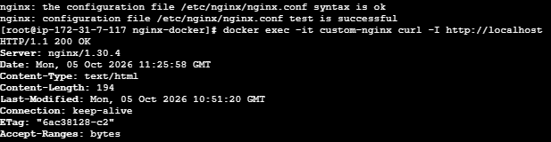

15. Check Container Logs
docker logs custom-nginx
You can also check the running processes:
docker top custom-nginx

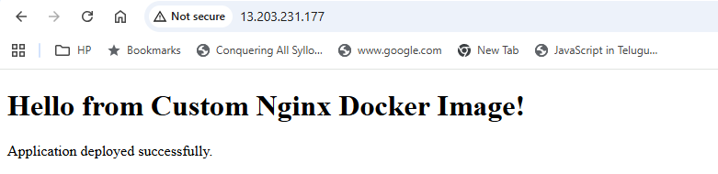

16. Complete Dockerfile
Your final Dockerfile is:
FROM amazonlinux:latest

LABEL maintainer="Swaroop Kumar"

RUN dnf install -y nginx && \
dnf clean all

COPY index.html /usr/share/nginx/html/index.html

EXPOSE 80

CMD ["nginx", "-g", "daemon off;"]

Complete implementation
Dockerfile
|
↓
docker build -t
custom-nginx:1.0
|
↓
┌─────────────────┐
│ Custom Image │
│ │
│ Amazon Linux │
│ Nginx │
│ index.html │
└────────┬────────┘
|
docker run
|
↓
┌─────────────────┐
│ Nginx Container │
│ │
│ Port 80 │
└────────┬────────┘
|
↓
Custom Web Page

Interview points
Q: Why do we use FROM?
FROM specifies the base image from which the Docker image is built.
Q: What is the difference between COPY and RUN?
RUN executes a command during image build, while COPY copies files from the build context into the image.
Q: Does EXPOSE 80 publish port 80?
No. EXPOSE documents the container port. We publish it to the host using docker run -p 80:80.
Q: Why use daemon off with Nginx?
Docker needs a foreground process to keep the container running. daemon off prevents Nginx from moving into the background.
Q: What happens when we run docker build?
Docker reads the Dockerfile instruction by instruction, creates image layers, installs Nginx, copies index.html, and produces the final custom-nginx:1.0 image.

- Push image to Docker hub

Objective
To tag a locally built Docker image and push it to Docker Hub, so the image can be stored in a remote registry and pulled from any server.
For your current lab, we can use the image you already created:
custom-nginx:1.0

Prerequisites
- Docker must be installed and running.
- You need a Docker Hub account.
- You need to know your Docker Hub username.
- Your local image must exist.
Check your image:
docker images

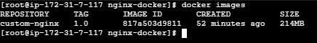

Step-by-step implementation

Step 1: Create Docker Hub repository
Log in to Docker Hub and create a repository.
For example:
Repository name: custom-nginx
Visibility: Public
Your final image name will look like:
YOUR_DOCKERHUB_USERNAME/custom-nginx:1.0

Step 2: Login to Docker Hub
On your EC2 server:
docker login
Docker will ask for:
Username:
Password:
Enter your Docker Hub credentials.
For better security, Docker Hub supports a Personal Access Token (PAT) instead of your account password.
Successful login should show:
Login Succeeded
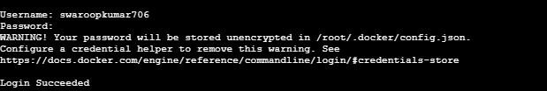

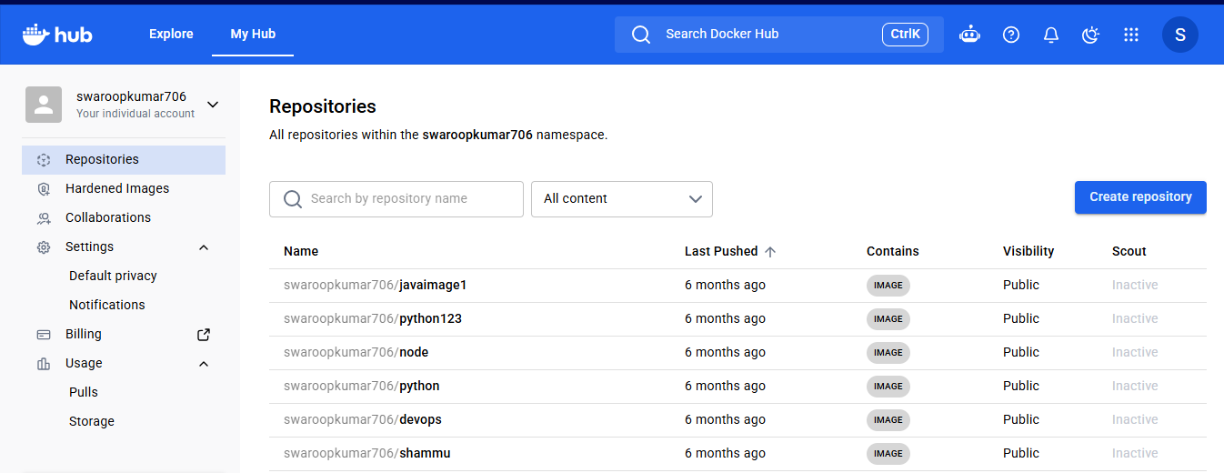

Step 3: Check your local image
docker images
Suppose you have:
custom-nginx 1.0
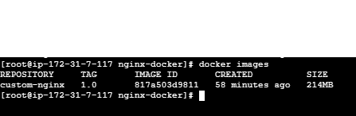

Step 4: Tag the image
Docker Hub expects the image to be tagged with your Docker Hub username.
Syntax:
docker tag SOURCE_IMAGE:TAG DOCKERHUB_USERNAME/REPOSITORY:TAG
Example:
docker tag custom-nginx:1.0 swaroopkumar/custom-nginx:1.0
Replace swaroopkumar with your actual Docker Hub username.
Check:
docker images
You should now see:
REPOSITORY TAG
custom-nginx 1.0
YOUR_USERNAME/custom-nginx 1.0
Both tags point to the same image.

Step 5: Push the image
Run:
docker push YOUR_USERNAME/custom-nginx:1.0
Example:
docker push swaroopkumar/custom-nginx:1.0
You should see layers being uploaded:
The push refers to repository [...]
Preparing
Waiting
Layer already exists
Pushed
...
1.0: digest: sha256:xxxxxxxx...
That means the image has been successfully pushed. ✅
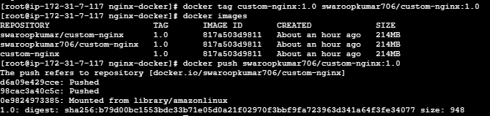

Step 6: Verify in Docker Hub
Open your Docker Hub account and go to:
Repositories → custom-nginx
You should see the tag:
1.0
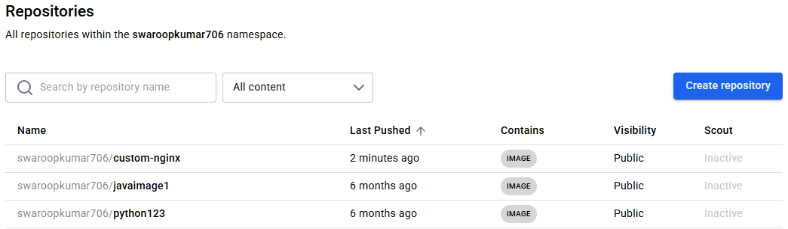

Complete command sequence
For your current custom-nginx:1.0 image:
docker images
docker login
docker tag custom-nginx:1.0 YOUR_USERNAME/custom-nginx:1.0
docker images
docker push YOUR_USERNAME/custom-nginx:1.0
Then on another server:
docker pull YOUR_USERNAME/custom-nginx:1.0
docker run -d \
--name nginx-from-hub \
-p 8082:80 \
YOUR_USERNAME/custom-nginx:1.0

Important concept for interviews
The flow is:
Dockerfile
↓
docker build
↓
Local Docker Image
↓
docker tag
↓
Docker Hub Image Name
↓
docker push
↓
Docker Hub
↓
docker pull
↓
Another Server
↓
docker run
↓
Container

Difference between docker tag and docker push
docker tag → gives your local image a Docker Hub repository name.
docker push → uploads that tagged image to Docker Hub.
For example:
docker tag custom-nginx:1.0 swaroopkumar/custom-nginx:1.0
does not upload anything.
docker push swaroopkumar/custom-nginx:1.0
actually uploads the image.
Interview answer:
“First I build the Docker image locally, then I authenticate to Docker Hub, tag the image with my Docker Hub username and repository name, and finally use docker push to upload it. On another server, I can use docker pull to download the image and run a container from it.”

- push image to AWS ECR

Objective
To push a Docker image from an EC2 server to Amazon Elastic Container Registry (ECR).
In this lab, we'll take your existing image:
custom-nginx:1.0
and push it to an Amazon ECR private repository.
The overall flow is:
Dockerfile
↓
docker build
↓
custom-nginx:1.0
↓
AWS ECR Login
↓
docker tag
↓
docker push
↓
Amazon ECR Repository

Prerequisites

1. Docker installed
Verify:
docker --version
Example:
Docker version 29.x

2. AWS CLI installed
aws --version

3. AWS credentials configured
Verify:
aws sts get-caller-identity
You should get your AWS account information.

4. AWS region
Your previous AWS lab uses ap-south-1 (Mumbai), so we'll use:
ap-south-1

5. Existing Docker image
You already have:
custom-nginx:1.0
Verify:
docker images

Step 1: Set AWS Region
You can configure the region:
aws configure
Or specify it directly in commands.
For this lab:
REGION=ap-south-1
You can verify:
echo $REGION
Expected:
ap-south-1

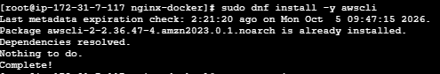

Step 2: Create an ECR Repository
Create a private ECR repository:
aws ecr create-repository \
--repository-name custom-nginx \
--region ap-south-1
You should receive output containing something similar to:
"repositoryUri": "107489387187.dkr.ecr.ap-south-
1.amazonaws.com/custom-nginx"

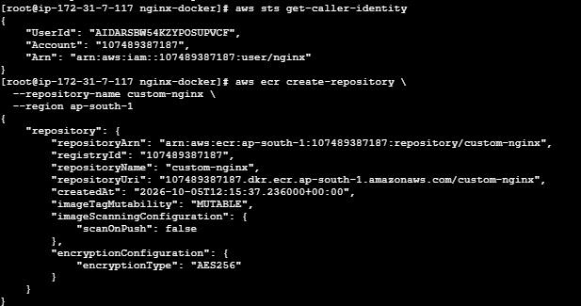
The important part is the repository URI.
It follows this format:
AWS_ACCOUNT_ID.dkr.ecr.REGION.amazonaws.com/REPOSITORY_NAME
For example:
123456789012.dkr.ecr.ap-south-1.amazonaws.com/custom-nginx

Step 3: Verify the ECR Repository
Run:
aws ecr describe-repositories \
--repository-names custom-nginx \
--region ap-south-1
You should see your repository details.
You can also list repositories:
aws ecr describe-repositories \
--region ap-south-1 \
--query 'repositories[*].repositoryName'
Expected:
[
"custom-nginx"
]

Step 4: Authenticate Docker with ECR
This is an important step.
Run:
aws ecr get-login-password --region ap-south-1 | \
docker login --username AWS --password-stdin \
$(aws sts get-caller-identity --query Account --output text).dkr.ecr.ap-south-1.amazonaws.com
Successful output:
Login Succeeded

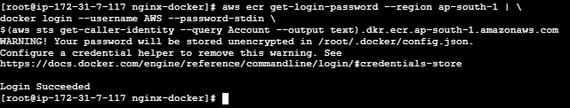

Why do we do this?
Docker needs permission to push images into your private ECR repository.
The AWS CLI obtains a temporary ECR authentication token and passes it to Docker.

Step 5: Get Your AWS Account ID
Run:
aws sts get-caller-identity \
--query Account \
--output text
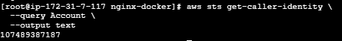
Store it in a variable:
ACCOUNT_ID=$(aws sts get-caller-identity --query Account --output text)
Check:
echo $ACCOUNT_ID

Step 6: Create the ECR Image URI
Set:
ECR_URI=$ACCOUNT_ID.dkr.ecr.ap-south-1.amazonaws.com/custom-nginx
Check:
echo $ECR_URI

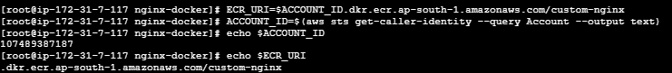
Example:
123456789012.dkr.ecr.ap-south-1.amazonaws.com/custom-nginx

Step 7: Check Your Existing Image
You already built:
docker images

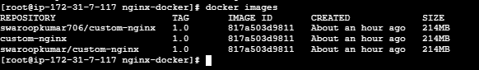

Step 8: Tag the Image for ECR
Now tag your local image with the ECR repository URI:
docker tag custom-nginx:1.0 $ECR_URI:1.0
Verify:
docker images
You should see something like:
REPOSITORY TAG
custom-nginx 1.0
123456789012.dkr.ecr.ap-south-1.amazonaws.com/custom-nginx 1.0
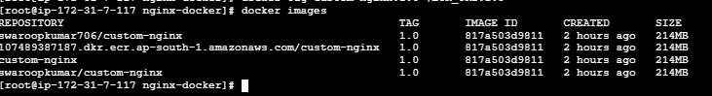
Both tags point to the same image ID.

Step 9: Push the Image to ECR
Now push:
docker push $ECR_URI:1.0
You will see layers being uploaded:
The push refers to repository [...]
Preparing
Waiting
Pushed
Pushed
Pushed
1.0: digest: sha256:xxxxxxxx...
That means the image has successfully been uploaded to ECR. ✅
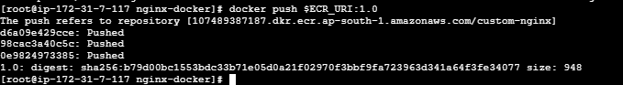

Step 10: Verify the Image in ECR
Run:
aws ecr describe-images \
--repository-name custom-nginx \
--region ap-south-1
You should see:
imageTags
---------
1.0
You can also use:
aws ecr list-images \
--repository-name custom-nginx \
--region ap-south-1
Expected:
custom-nginx:1.0
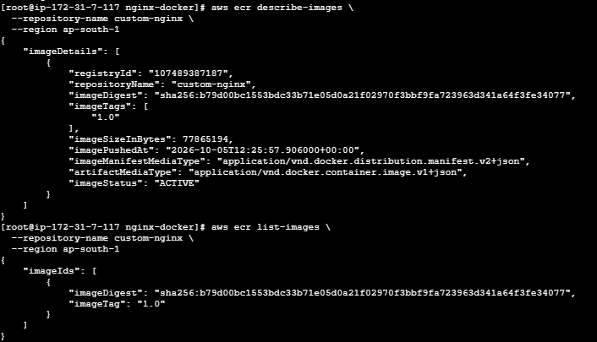

Step 11: Verify from AWS Console
Go to:
AWS Console → ECR → Private registry → Repositories
Select:
custom-nginx
You should see:
Image tag: 1.0
Your Docker image is now stored in Amazon ECR.
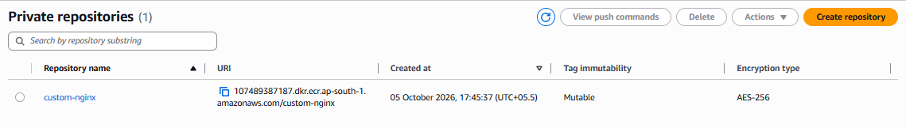
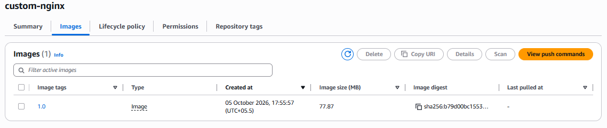
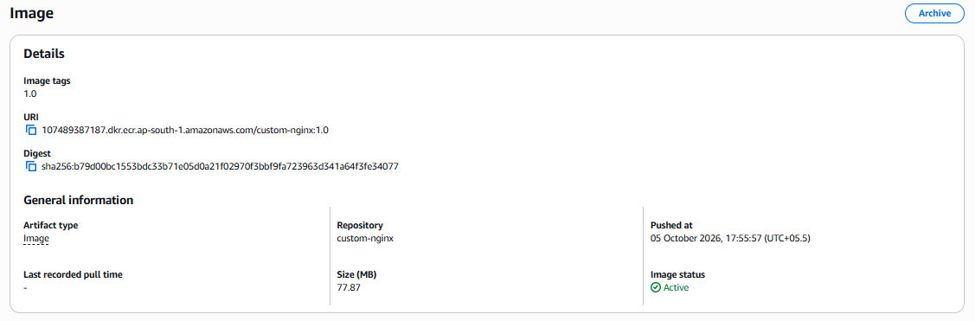

Complete Command Sequence
For your lab, you can execute these commands in order:
aws sts get-caller-identity
aws ecr create-repository \
--repository-name custom-nginx \
--region ap-south-1
ACCOUNT_ID=$(aws sts get-caller-identity --query Account --output text)
echo $ACCOUNT_ID
aws ecr get-login-password --region ap-south-1 | \
docker login --username AWS --password-stdin \
$ACCOUNT_ID.dkr.ecr.ap-south-1.amazonaws.com
ECR_URI=$ACCOUNT_ID.dkr.ecr.ap-south-1.amazonaws.com/custom-nginx
docker images
docker tag custom-nginx:1.0 $ECR_URI:1.0
docker images
docker push $ECR_URI:1.0
Finally:
aws ecr list-images \
--repository-name custom-nginx \
--region ap-south-1

Important: ECR vs Docker Hub
Docker Hub | AWS ECR
Public/private registry | AWS-managed registry
docker login | AWS CLI + ECR authentication
docker push username/image | docker push account-id.dkr.ecr.region.amazonaws.com/image
Username-based repository | AWS account-based repository
Common for public images | Common for AWS workloads

Interview answer
“First I create an ECR repository, authenticate Docker using the AWS ECR login command, tag my local Docker image with the ECR repository URI, and then execute docker push to upload the image. After that I verify the image using the AWS Console or aws ecr list-images.”

One important AWS point
For a real EC2 environment, it's better to give the EC2 instance an IAM role with appropriate ECR permissions rather than storing long-lived AWS access keys on the server.
For your current lab, start with:
aws sts get-caller-identity
If that works, proceed with Step 2.

