JENKINS-4
TASK -01 Setup Jenkins CICD pipeline using freestyle job using Docker containers using below code.
Source Code: https://github.com/betawins/hiring-app.git
Stages:
- Git Clone
- SonarQube Integration
- Maven Compilation
- Nexus Artifactory
- Slack Notification
- Deploy On tomcat

Pipeline Flow
Developer
|
v
GitHub
|
v
Jenkins Freestyle Job
|
+----> 1. Git Clone
|
+----> 2. SonarQube Analysis
|
+----> 3. Maven Compilation
| |
| v
| Docker Maven Container
|
+----> 4. Nexus Repository
|
+----> 5. Slack Notification
|
+----> 6. Deploy to Tomcat
|
v
Application Running

Objective:
To implement a complete CI/CD pipeline using a Jenkins Freestyle project for the hiring-app Java application.
The pipeline will automate:
- Clone source code from GitHub.
- Perform static code analysis using SonarQube.
- Compile/package the application using Maven inside a Docker container.
- Upload the generated artifact to Nexus Repository.
- Send build/deployment notifications to Slack.
- Deploy the application to an Apache Tomcat server.
This provides an automated flow from source-code commit → build → quality analysis → artifact repository → deployment.

Prerequisites

A. Jenkins Server
Jenkins should be installed and running.
Verify:
systemctl status jenkins
Check Jenkins:
http://<JENKINS-IP>:8081
Since your Jenkins setup is using port 8081, make sure that port is accessible.

3. Required Jenkins Plugins
Go to:
Manage Jenkins
↓
Plugins
↓
Available plugins
Install the following.

Git
Git
Required for cloning the GitHub repository.

SonarQube Scanner
SonarQube Scanner
The SonarQube Scanner plugin provides Jenkins integration with SonarQube.

Maven Integration
Maven Integration
Useful if you want Jenkins to manage Maven installations.

Docker
For Freestyle Docker build steps, install the Docker Build Step plugin. It provides Docker operations that can be added to Freestyle jobs.

Slack Notification
Slack Notification
Used to send build results to Slack.

Credentials Binding
Credentials Binding
Useful for securely passing credentials to build steps.

STEP 1 — Verify Jenkins
On your Jenkins server:
java -version
Expected:
openjdk version "21..."
Check Jenkins:
sudo systemctl status jenkins
Open: http://<JENKINS-IP>:8080
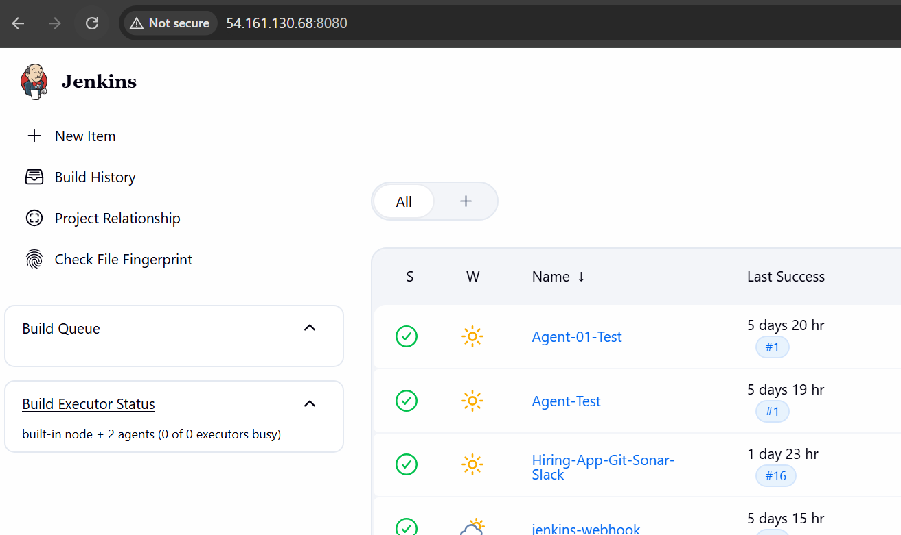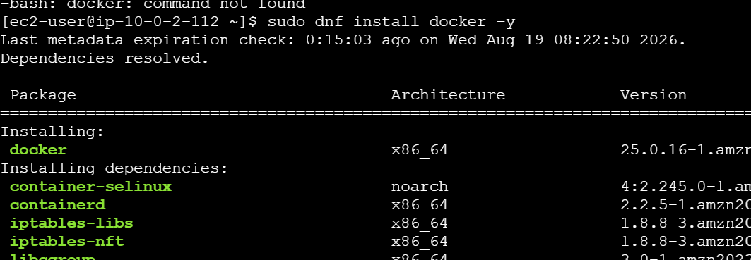

STEP 2 — Install Docker
2.1 Check Docker
docker --version
If Docker is already installed, continue.
If not: sudo dnf install docker -y
Start Docker: sudo systemctl start docker
Enable Docker: sudo systemctl enable docker
Check: sudo systemctl status docker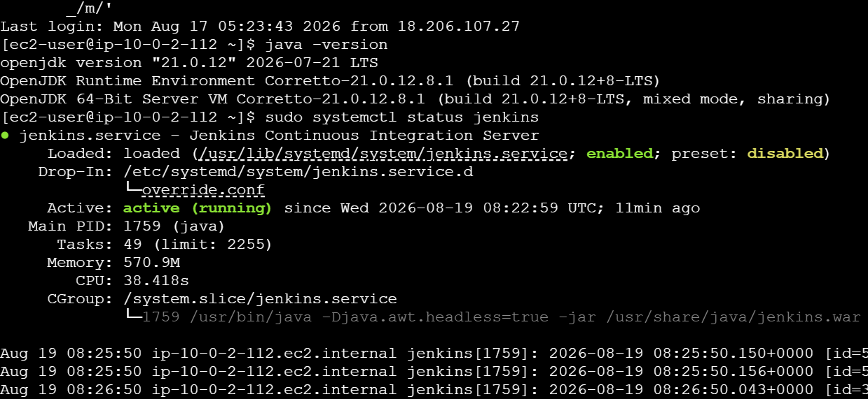
2.2 Give Jenkins permission to use Docker
Run: sudo usermod -aG docker jenkins
Restart Jenkins:sudo systemctl restart jenkins
Test: sudo -u jenkins docker ps
If you don't get a permission error, Docker is ready.
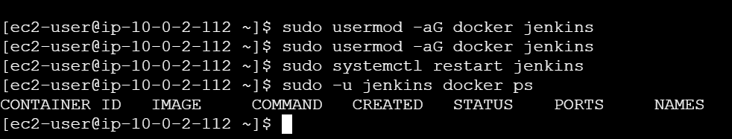
STEP 3 — Configure Maven
Check:
mvn -version
If not installed: sudo dnf install maven -y
Check again: mvn -version
You should see: Apache Maven
Java version: 21
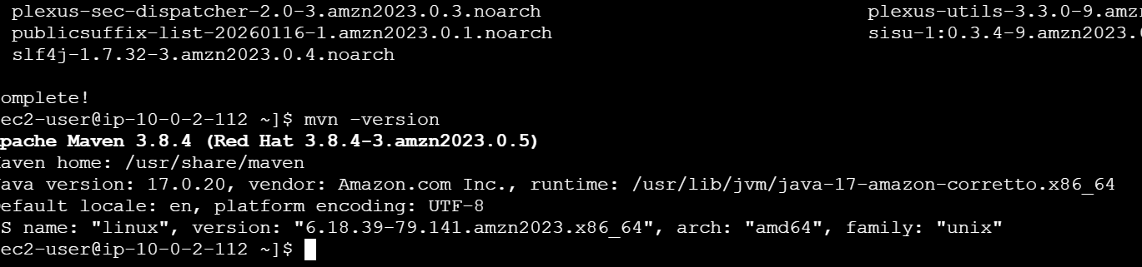

STEP 4 — Configure SonarQube
You already have SonarQube running on: http://<SONARQUBE-IP>:9000
Open it in the browser.
Go to:
Administration
↓
Security
↓
Users
Select your user.
Click: Tokens
Create: Name: jenkins-token
Click: Generate
Copy the token immediately.
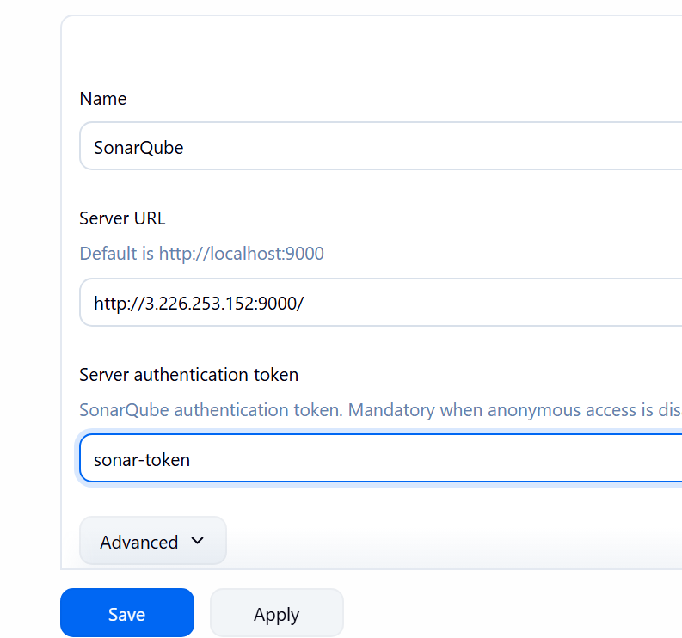

4.1 Add SonarQube Credential to Jenkins
Go to: Jenkins
→ Manage Jenkins
→ Credentials
→ System
→ Global credentials
→ Add Credentials
Select: Kind: Secret text
Enter: Secret: <SONAR-TOKEN>
ID: sonar-token
Click: Create
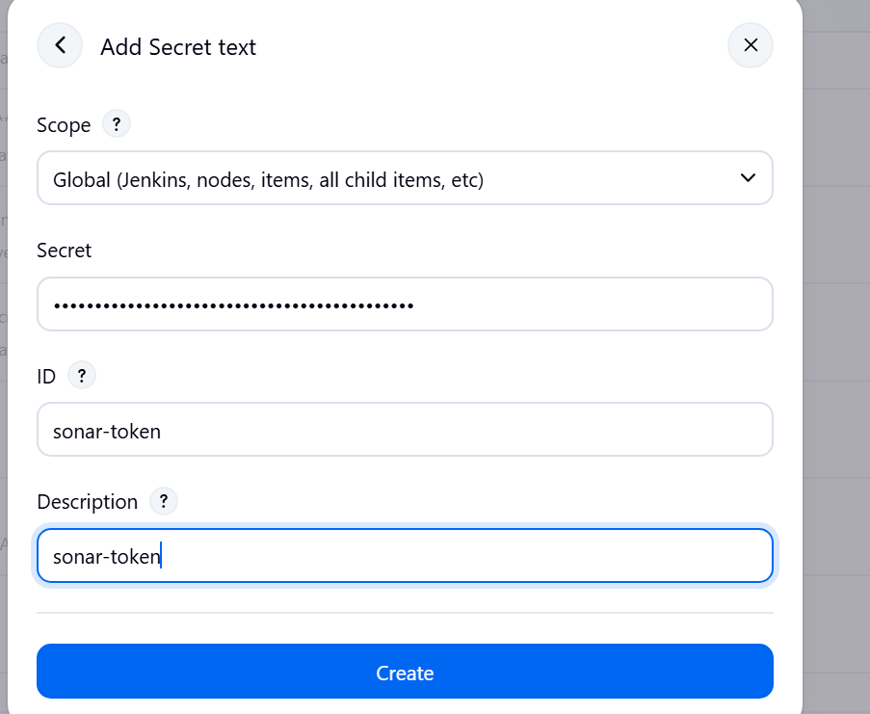

4.2 Configure SonarQube Server
Go to: Manage Jenkins
→ System
Find: SonarQube servers
Click: Add SonarQube
Enter: Name: SonarQube
Server URL: http://<SONARQUBE-IP>:9000
Select: sonar-token
Save.
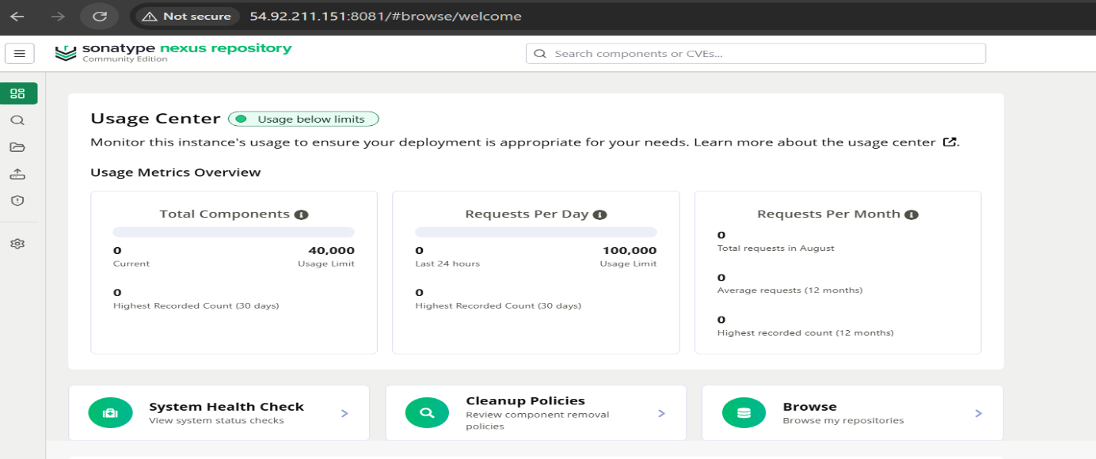
STEP 5 — Configure Nexus
Open Nexus: http://<NEXUS-IP>:8081
Login. Go to: Settings
→ Repositories
→ Create repository
Select: maven2 (hosted)
Enter: Name: maven-releases
Version policy: Release
Layout policy: Strict
Deployment policy: Allow redeploy
Click: Create repository
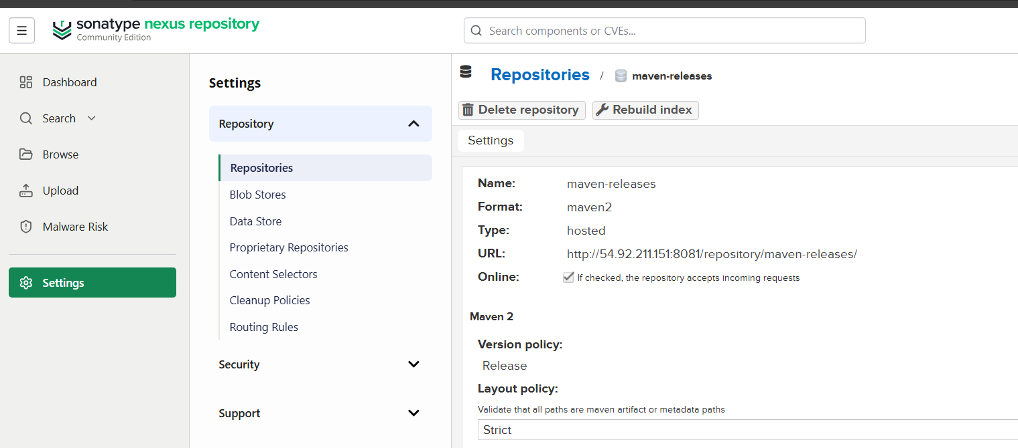

5.1 Create Nexus credentials in Jenkins
Go to: Manage Jenkins
→ Credentials
→ System
→ Global credentials
→ Add Credentials
Select: Kind: Username with password
Enter: Username: admin
Password: <NEXUS-PASSWORD>
ID: nexus-credentials
Click: Create
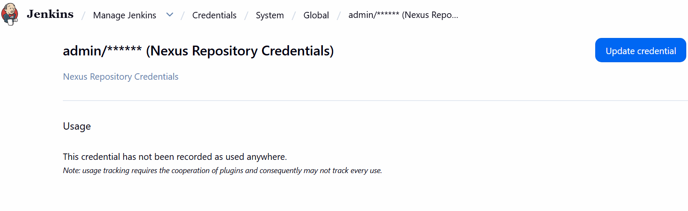

STEP 6 — Configure Slack
First install the plugin.
Go to: Manage Jenkins
→ Plugins
→ Available plugins
Search: Slack Notification
Install it.
Restart Jenkins if requested.

6.1 Configure Slack
Go to: Manage Jenkins
→ System
Find: Slack
Configure your Slack workspace/channel according to the Slack app/webhook credentials you have.
For example: Workspace: your-workspace
Channel: #jenkins
Click:Test Connection

STEP 7 — Verify Tomcat
Your Tomcat is using: 8082
Check: sudo systemctl status tomcat
If running: active (running) 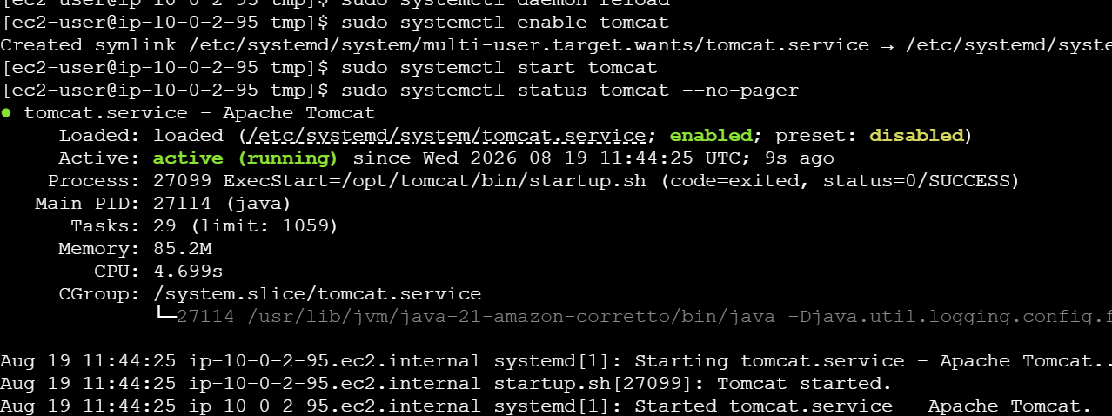
Test: curl http://localhost:8082
Open: http://<TOMCAT-IP>:8082
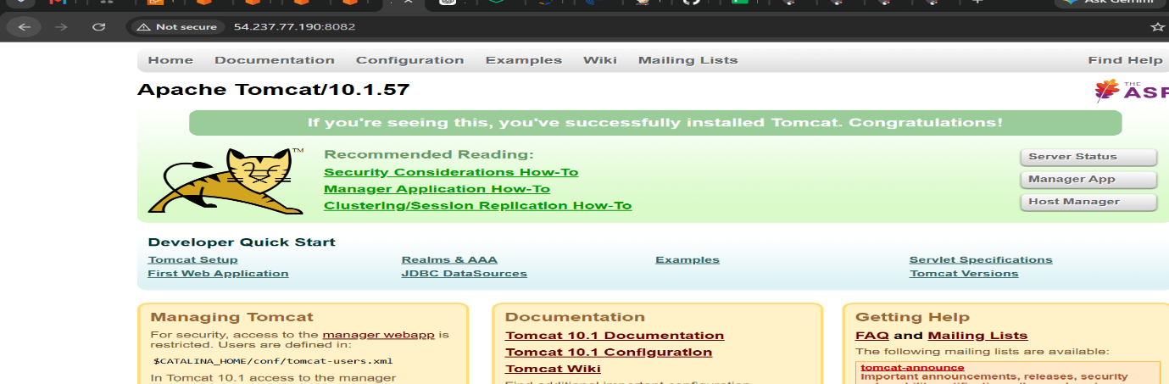

1) Setup Jenkins CICD pipeline using freestyle job using Docker containers using below code.
Repository: hiring-app

STEP 8 — Create Freestyle Job
Go to: Jenkins Dashboard
→ New Item
Enter: Hiring-App-Freestyle-Docker
Select: Freestyle project
Click: OK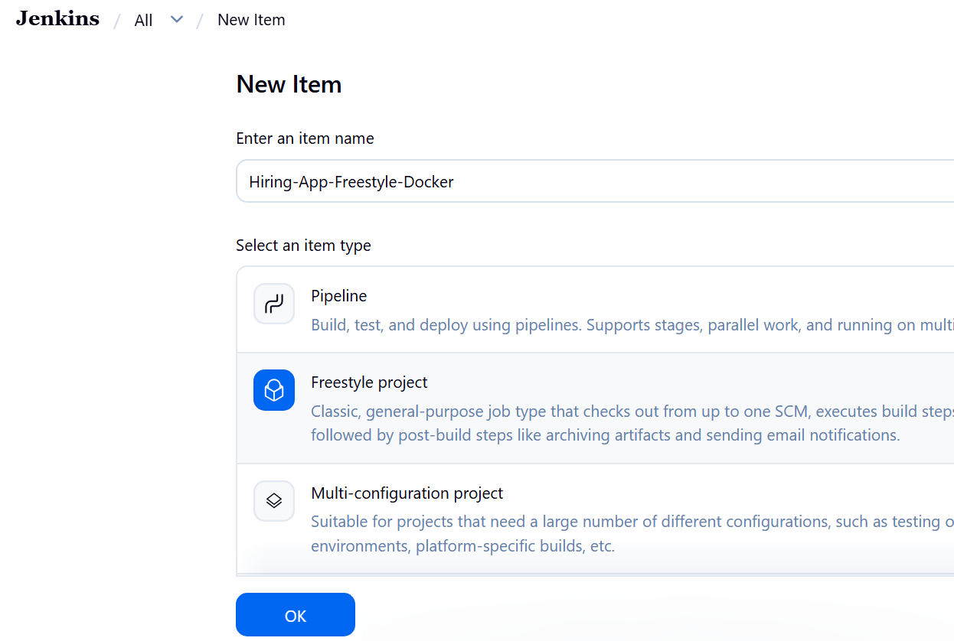

STEP 9 — Configure Git
Go to: Source Code Management
Select: Git
Repository: https://github.com/swaroopkumar706-design/hiring-app
Branch: */main
Save.

STEP 10 — Git Clone
Jenkins automatically clones the repository during the build because you configured Git under:
Source Code Management → Git
So you don't need a separate git clone command. 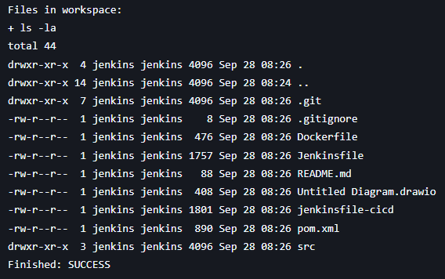
STEP 11 — Maven Build Using Docker
Go to: Build
→ Add build step
→ Execute shell
Use: docker run --rm \
-v "$WORKSPACE:/workspace" \
-w /workspace \
maven:3.9-eclipse-temurin-21 \
mvn clean package
This means:
Jenkins
↓
Docker
↓
Maven container
↓
mvn clean package
Click: Save
Click: Build Now
Check: Console Output
You should see: BUILD SUCCESS
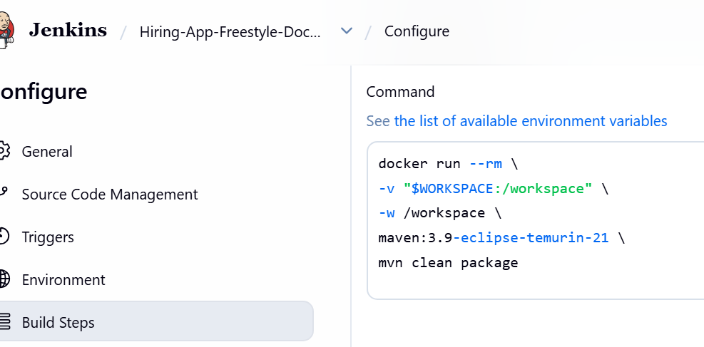

STEP 12 — SonarQube
After confirming Maven works, add another build step:
Build
→ Execute shell
For the initial test:
mvn sonar:sonar \
-Dsonar.host.url=http://<SONARQUBE-IP>:9000 \
-Dsonar.token=$SONAR_TOKEN
Make sure SONAR_TOKEN is injected from Jenkins credentials.
The important sequence is:
Git
↓
Maven
↓
SonarQube
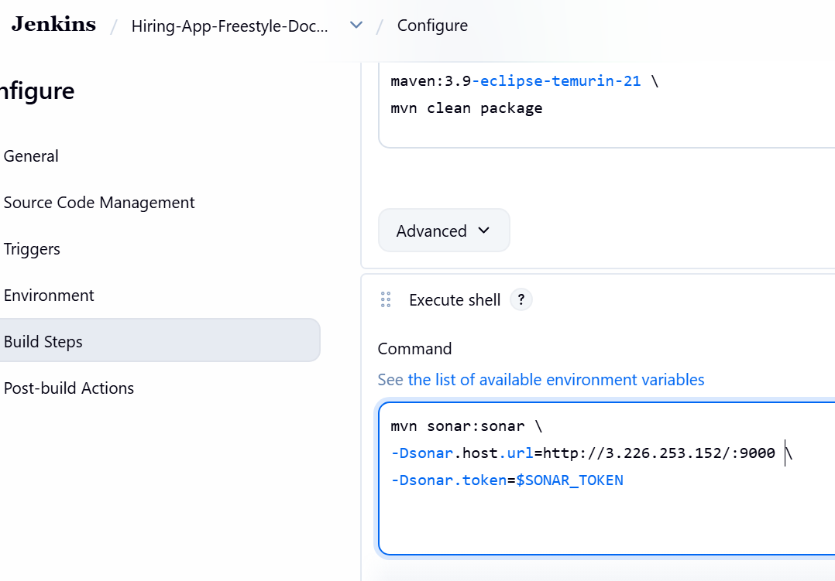

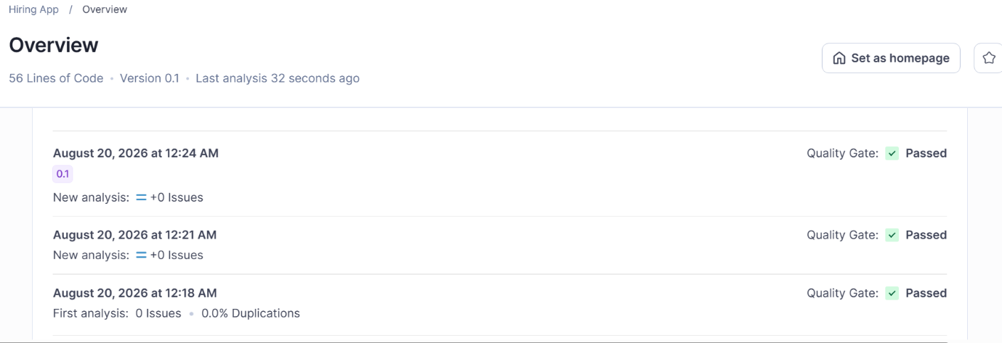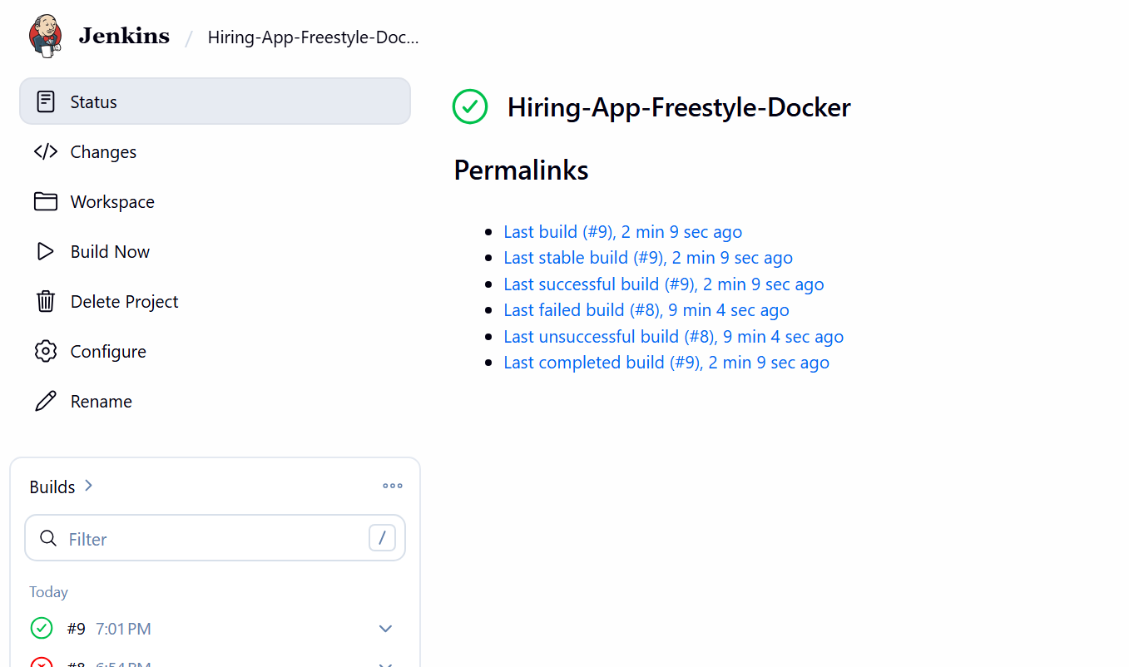
STEP 13 — Nexus
First make sure the project's pom.xml contains the Nexus repository configuration.
Then use: mvn deploy
Expected: Uploading to Nexus
Then check Nexus: Nexus
→ Browse
→ maven-releases
You should see your artifact.
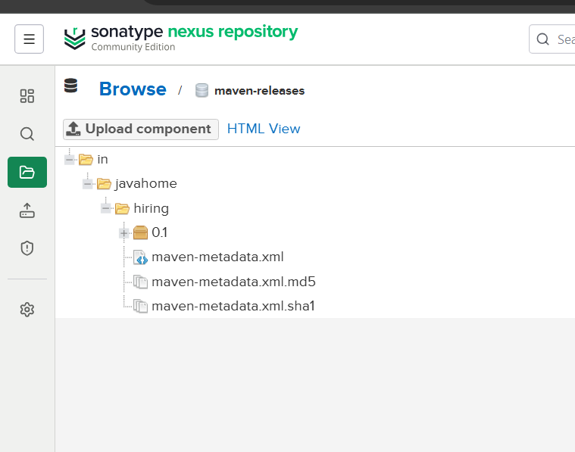
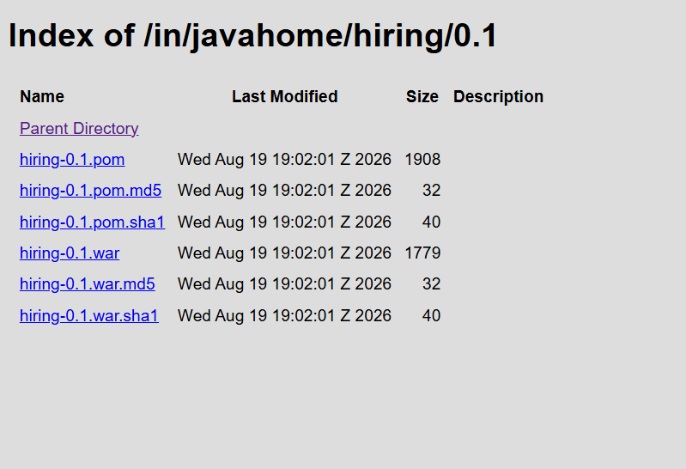

STEP 14 — Slack
In the Freestyle job: Post-build Actions
Select: Slack Notifications
Enable: Notify Success
Notify Failure
Save.
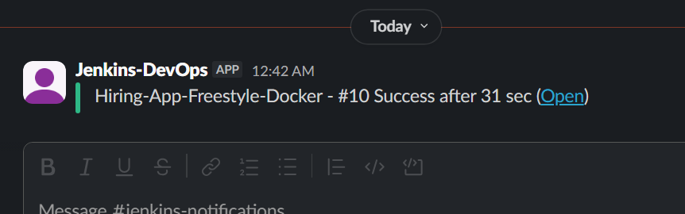

STEP 15 — Deploy to Tomcat
After Maven creates the WAR:
ls -lh target/
You should see something similar to:
application.war
Add another: Build
→ Execute shell
Use: cp target/*.war /opt/tomcat/webapps/
Restart Tomcat: sudo systemctl restart tomcat
Then open: http://<TOMCAT-IP>:8082
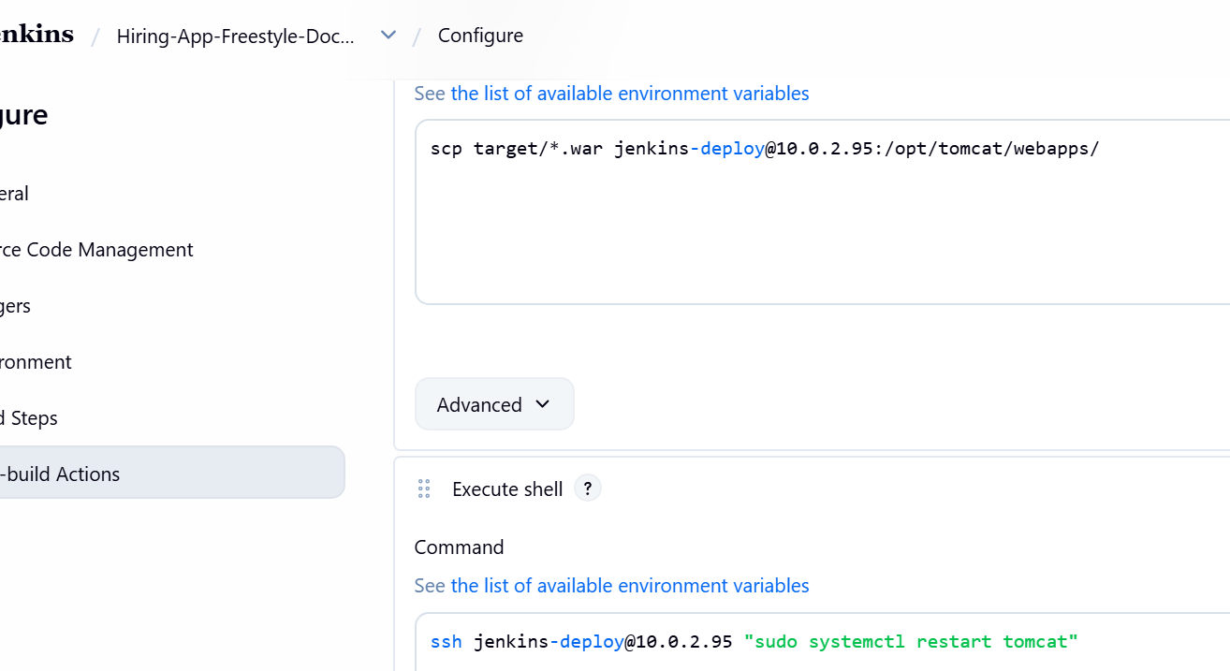

TASK 1 Final Flow
GitHub
↓
Git Clone
↓
Docker
↓
Maven
↓
SonarQube
↓
Nexus
↓
Slack
↓
Tomcat

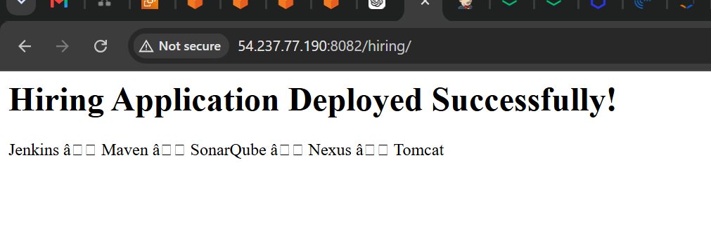
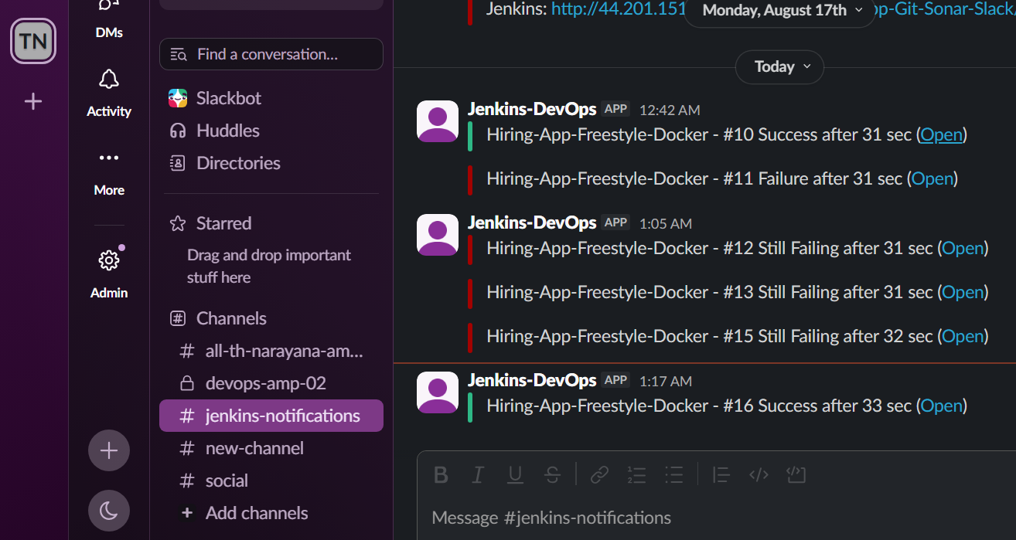

TASK 2 — Declarative Pipeline
Repository: sabear_simplecutomerapp feature-1.1

STEP 16 — Create Pipeline Job
Go to: New Item
Enter: SimpleCustomer-Declarative
Select: Pipeline
Click: OK
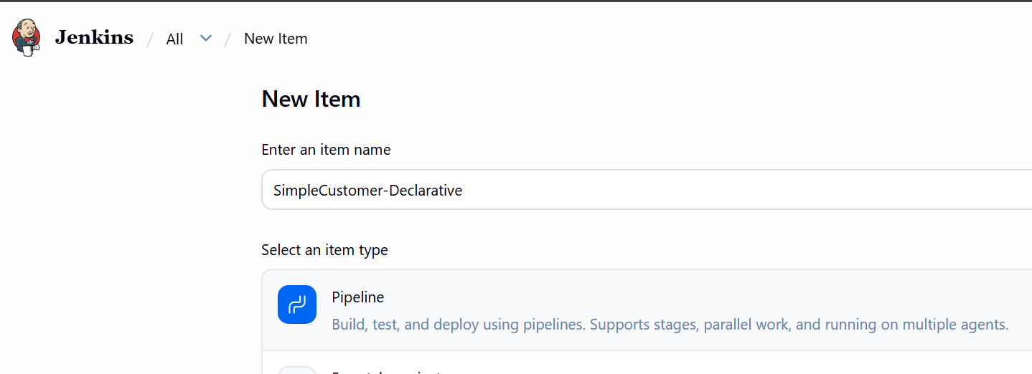
step 16.1— Create the project
From the SonarQube dashboard:
Projects → Create Project
Choose: Create a local project Enter:
Field | Value
Project display name | SimpleCustomerApp
Project key | com.javatpoint:SimpleCustomerApp
Go to: Pipeline
→ Definition
→ Pipeline script
Paste: pipeline {

agent any

stages {

stage('Git Clone') {
steps {
git branch: 'feature-1.1',
url: 'https://github.com/swaroopkumar706-design/sabear_simplecutomerapp.git'
}
}

stage('SonarQube Integration') {
steps {
withCredentials([
string(
credentialsId: 'sonar-token',
variable: 'SONAR_TOKEN'
)
]) {
sh '''
mvn org.sonarsource.scanner.maven:sonar-maven-plugin:5.7.0.6970:sonar \
-Dsonar.host.url=http://34.234.170.203:9000 \
-Dsonar.token=$SONAR_TOKEN
'''
}
}
}

stage('Maven Compilation') {
steps {
sh 'mvn clean package'
}
}

stage('Nexus Artifactory') {
steps {
sh 'mvn deploy'
}
}

stage('Slack Notification') {
steps {
echo 'Sending Slack notification...'

slackSend(
channel: '#jenkins',
message: "SUCCESS: SimpleCustomerApp Build ${BUILD_NUMBER} completed Maven, SonarQube and Nexus stages."
)
}
}

stage('Deploy On Tomcat') {
steps {
sh '''
scp -i /var/lib/jenkins/.ssh/tomcat_deploy \
target/*.war \
jenkins-deploy@10.0.2.95:/opt/tomcat/webapps/
'''
}
}

stage('Restart Tomcat') {
steps {
sh '''
ssh -i /var/lib/jenkins/.ssh/tomcat_deploy \
jenkins-deploy@10.0.2.95 \
"sudo systemctl restart tomcat"
'''
}
}
}

post {

success {
slackSend(
channel: '#jenkins-notifications',
message: "SUCCESS: SimpleCustomerApp Build ${BUILD_NUMBER} deployed successfully to Tomcat."
)
}

failure {
slackSend(
channel: '#jenkins-notifications',
message: "FAILURE: SimpleCustomerApp Build ${BUILD_NUMBER} failed. Check Jenkins console output."
)
}
}
}
Important: Paste only the Groovy code into Jenkins. Don't paste the Markdown ``` markers.
Click: Save
→ Build Now
You should see:Git Clone
SonarQube Integration
Maven Compilation
Nexus Artifactory
Slack Notification
Deploy On Tomcat
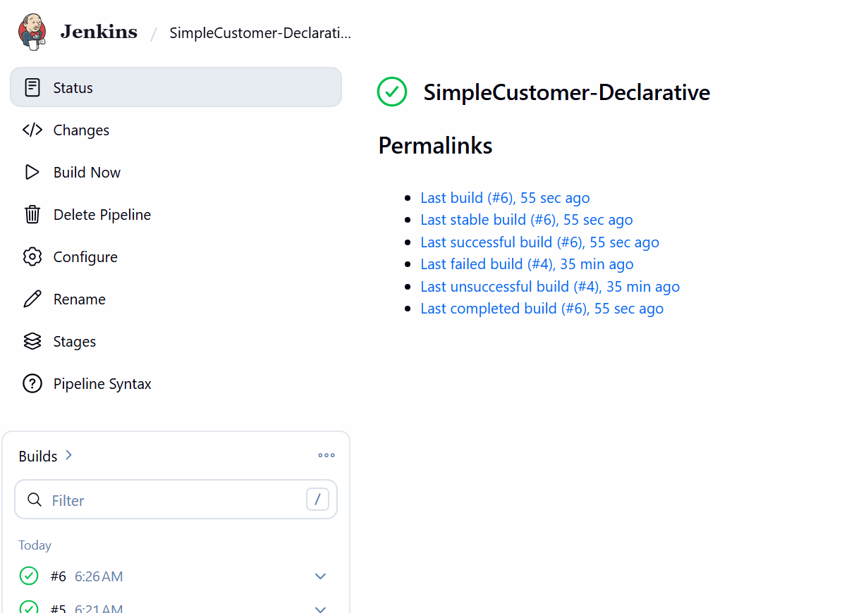
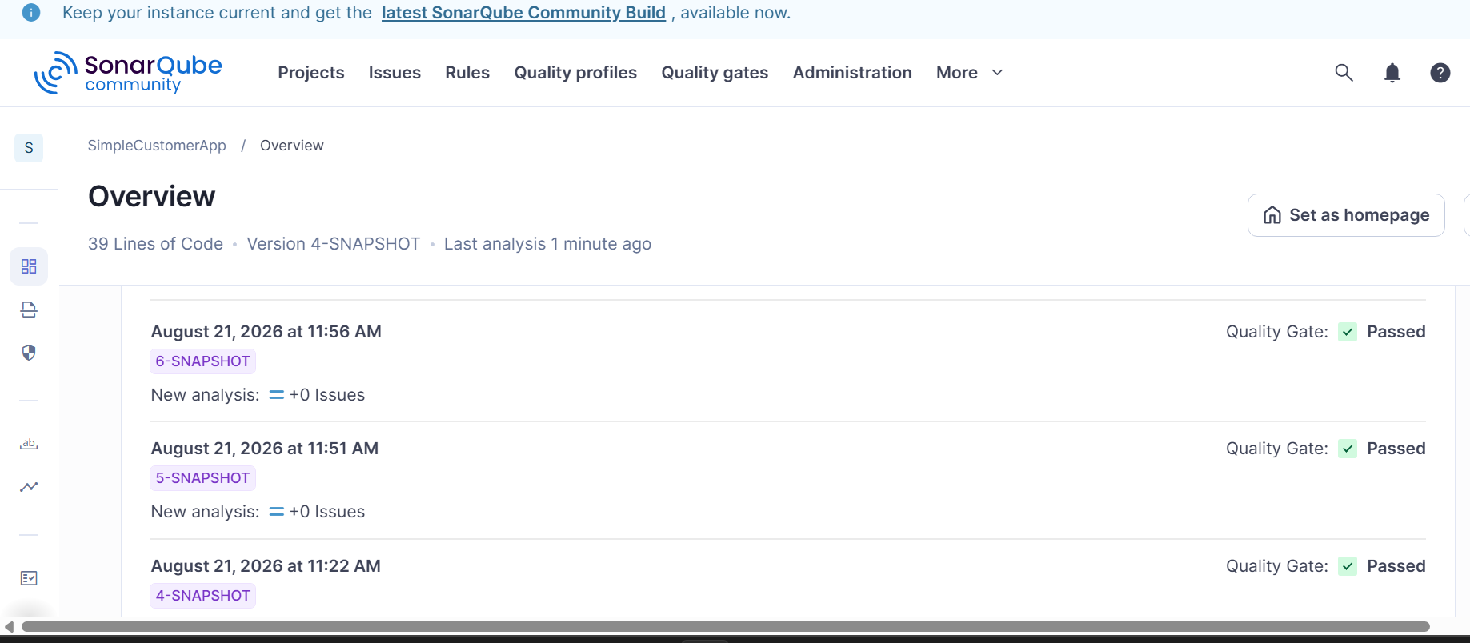
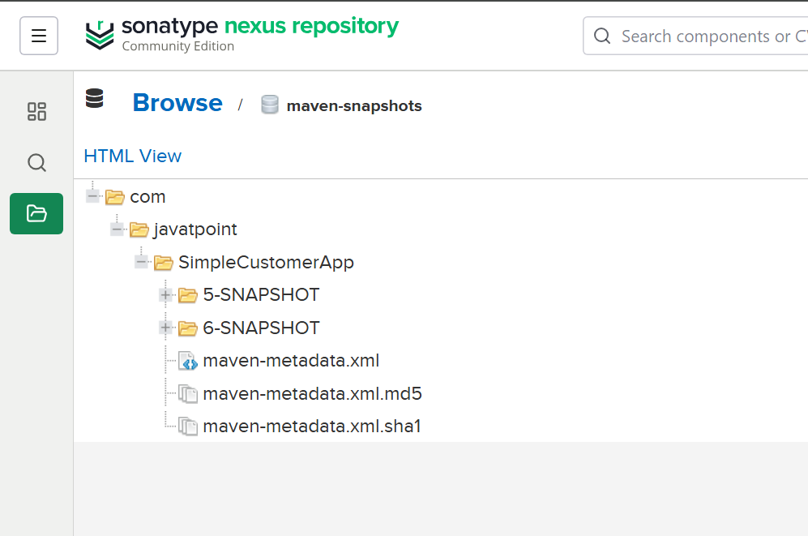
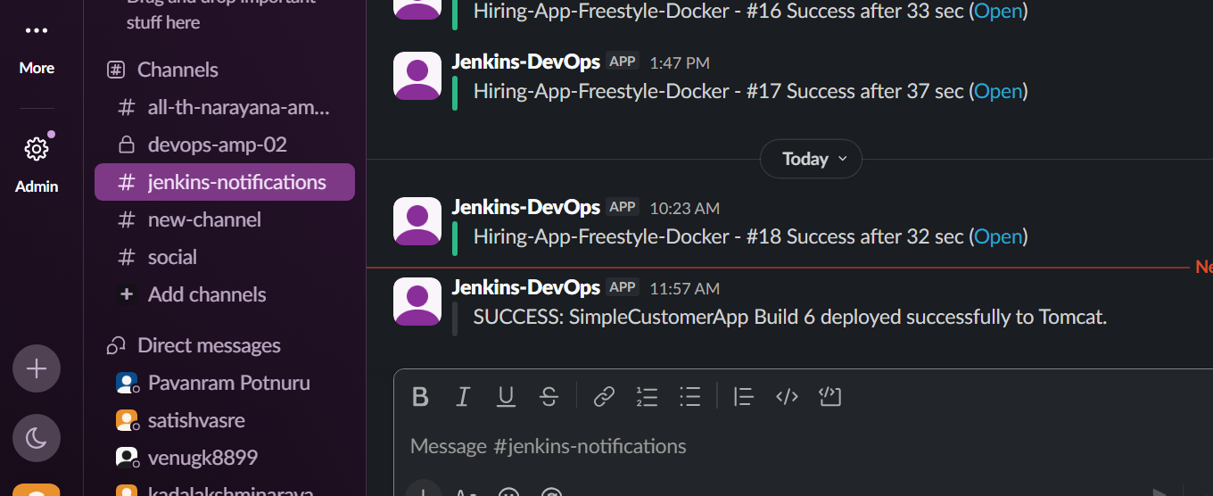
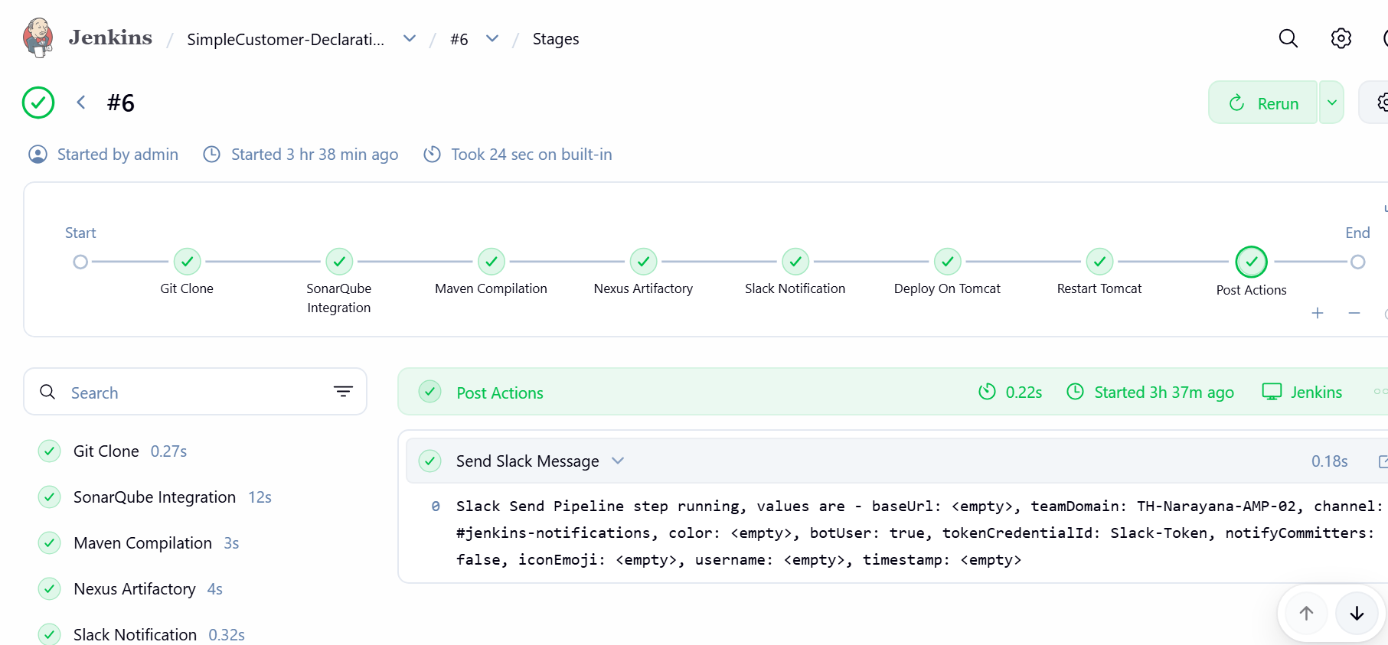

TASK 3 Setup a Jenkins CICD pipeline using Scripted pipeline using feature-1.1 branch.
Source Code: https://github.com/betawins/sabear_simplecutomerapp/tree/feature-1.1
stages:
- Git Clone
- SonarQube Integration
- Maven Compilation
- Nexus Artifactory
- Slack Notification
- Deploy On tomcat

STEP 1 — Create the Jenkins job
From Jenkins dashboard:
New Item
Enter: SimpleCustomer-Scripted
Select: Pipeline
Click: OK
STEP 2 — Configure Pipeline
Scroll down to: Pipeline
Set: Definition: Pipeline script
Paste the following exactly.
Do not paste the ```groovy markers.
node {
try {
stage('Git Clone') {
git branch: 'feature-1.1',
url: 'https://github.com/swaroop706-design /sabear_simplecutomerapp.git'
}
stage('SonarQube Integration') {
withCredentials([string(credentialsId: 'sonar-token', variable: 'SONAR_TOKEN')]) {
sh '''
mvn org.sonarsource.scanner.maven:sonar-maven-plugin:5.7.0.6970:sonar \
-Dsonar.host.url=http://34.234.170.203:9000 \
-Dsonar.token=$SONAR_TOKEN '''
}
}
stage('Maven Compilation') {
sh 'mvn clean package'
}

stage('Nexus Artifactory') {
sh 'mvn deploy'
}
stage('Deploy On Tomcat') {
sh '''
scp \
-i /var/lib/jenkins/.ssh/tomcat_deploy \
target/*.war \
jenkins-deploy@10.0.2.95:/opt/tomcat/webapps/
'''
}
stage('Restart Tomcat') {
sh '''
ssh \
-i /var/lib/jenkins/.ssh/tomcat_deploy \
jenkins-deploy@10.0.2.95 \
"sudo systemctl restart tomcat"
'''
}
stage('Slack Notification - Success') {
slackSend(
channel: 'jenkins-notifications',
color: 'good',
message: "SUCCESS: ${JOB_NAME} #${BUILD_NUMBER} completed successfully. Application deployed to Tomcat."
)
}

} catch (Exception e) {

stage('Slack Notification - Failure') {
slackSend(
channel: 'jenkins-notifications',
color: 'danger',
message: "FAILURE: ${JOB_NAME} #${BUILD_NUMBER} failed. Please check Jenkins Console Output."
)
}

throw e
}
}
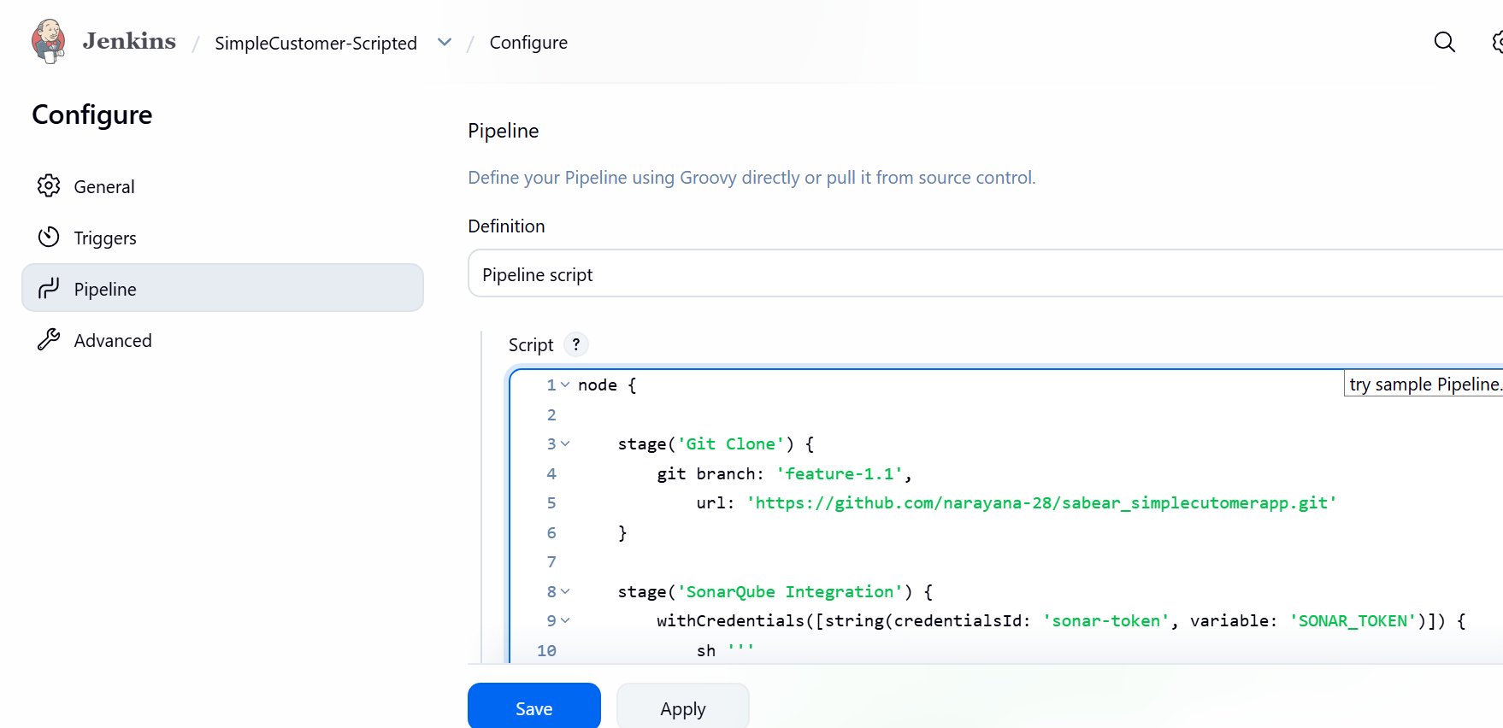
Why I'm using this version
Your previous Declarative Pipeline already proved that these pieces work:
- sonar-token credential
- SonarQube server 34.234.170.203:9000
- Nexus configuration in your GitHub POM
- /var/lib/jenkins/.ssh/tomcat_deploy
- jenkins-deploy@10.0.2.95
- passwordless sudo systemctl restart tomcat
So we're reusing the same working configuration.

STEP 3 — Save
Click: Save
You should now see the job:
SimpleCustomer-Scripted

STEP 4 — Build Now
Click: Build Now
Then click the build number, for example:
#1
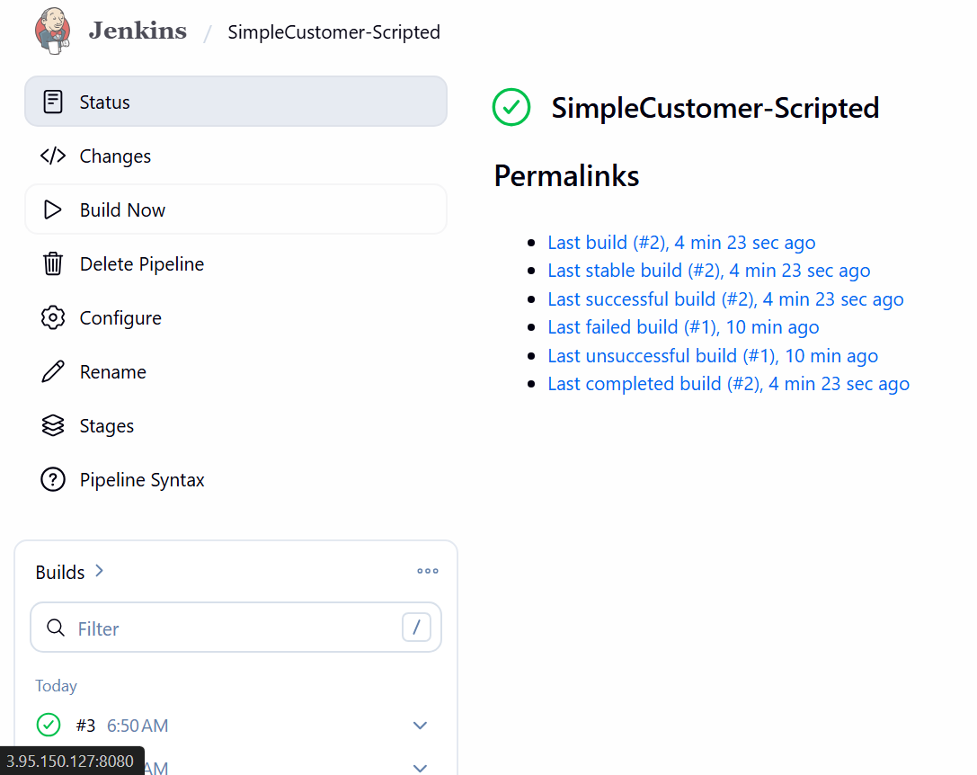
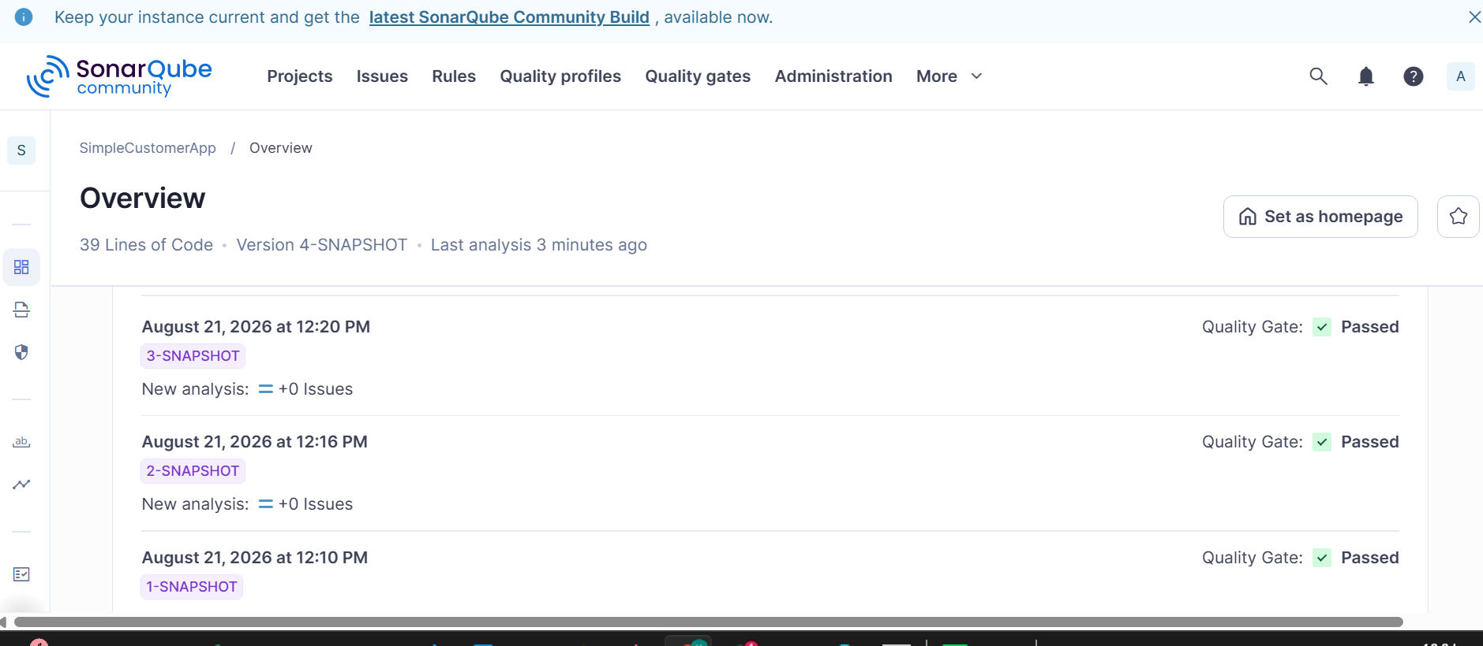
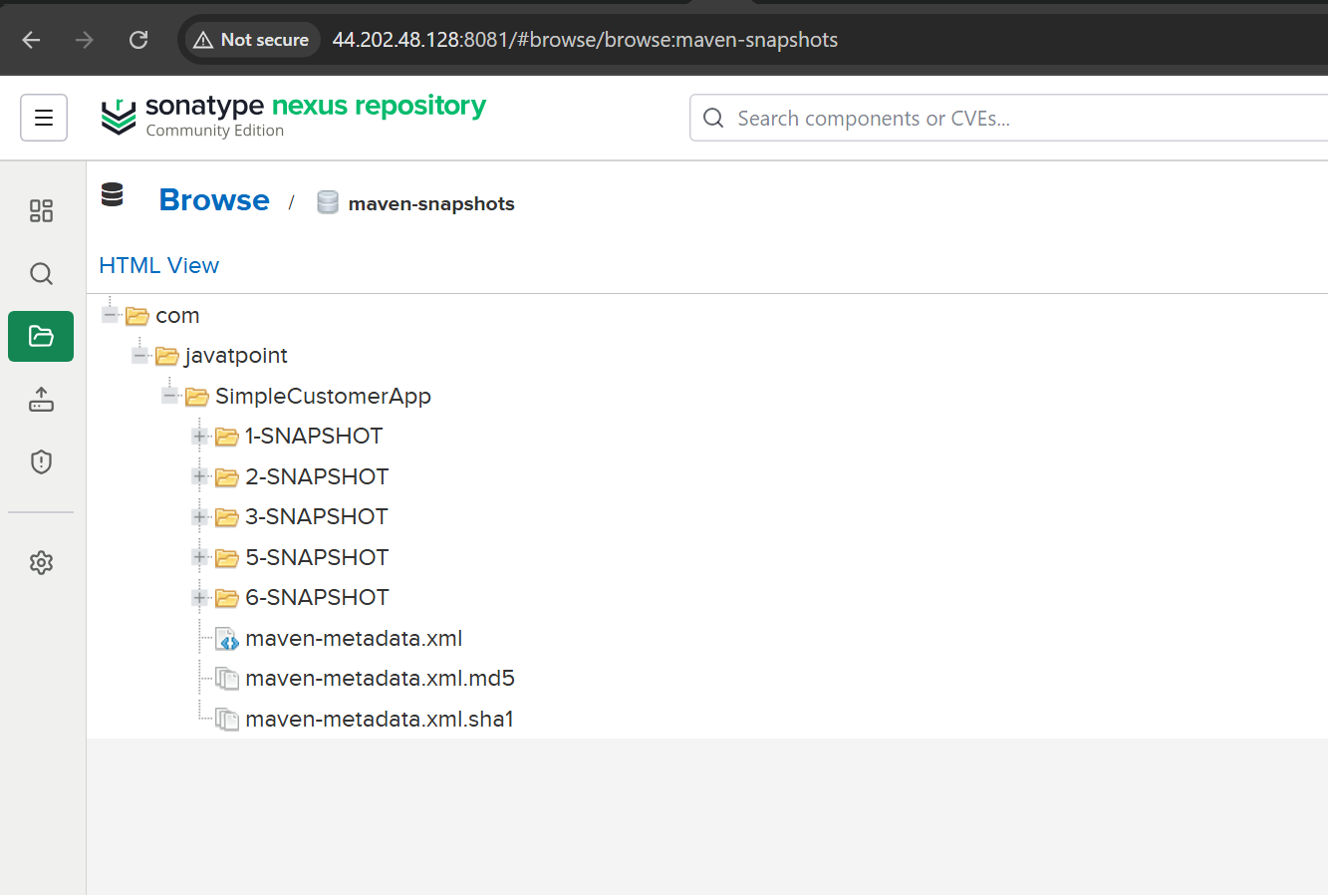
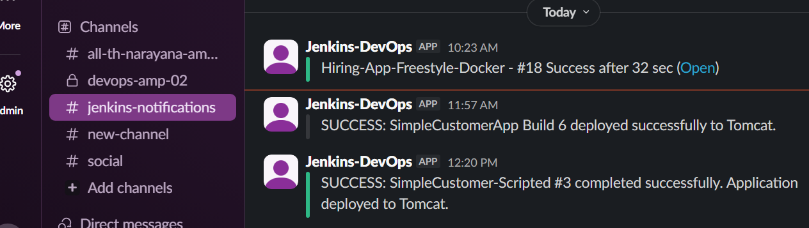
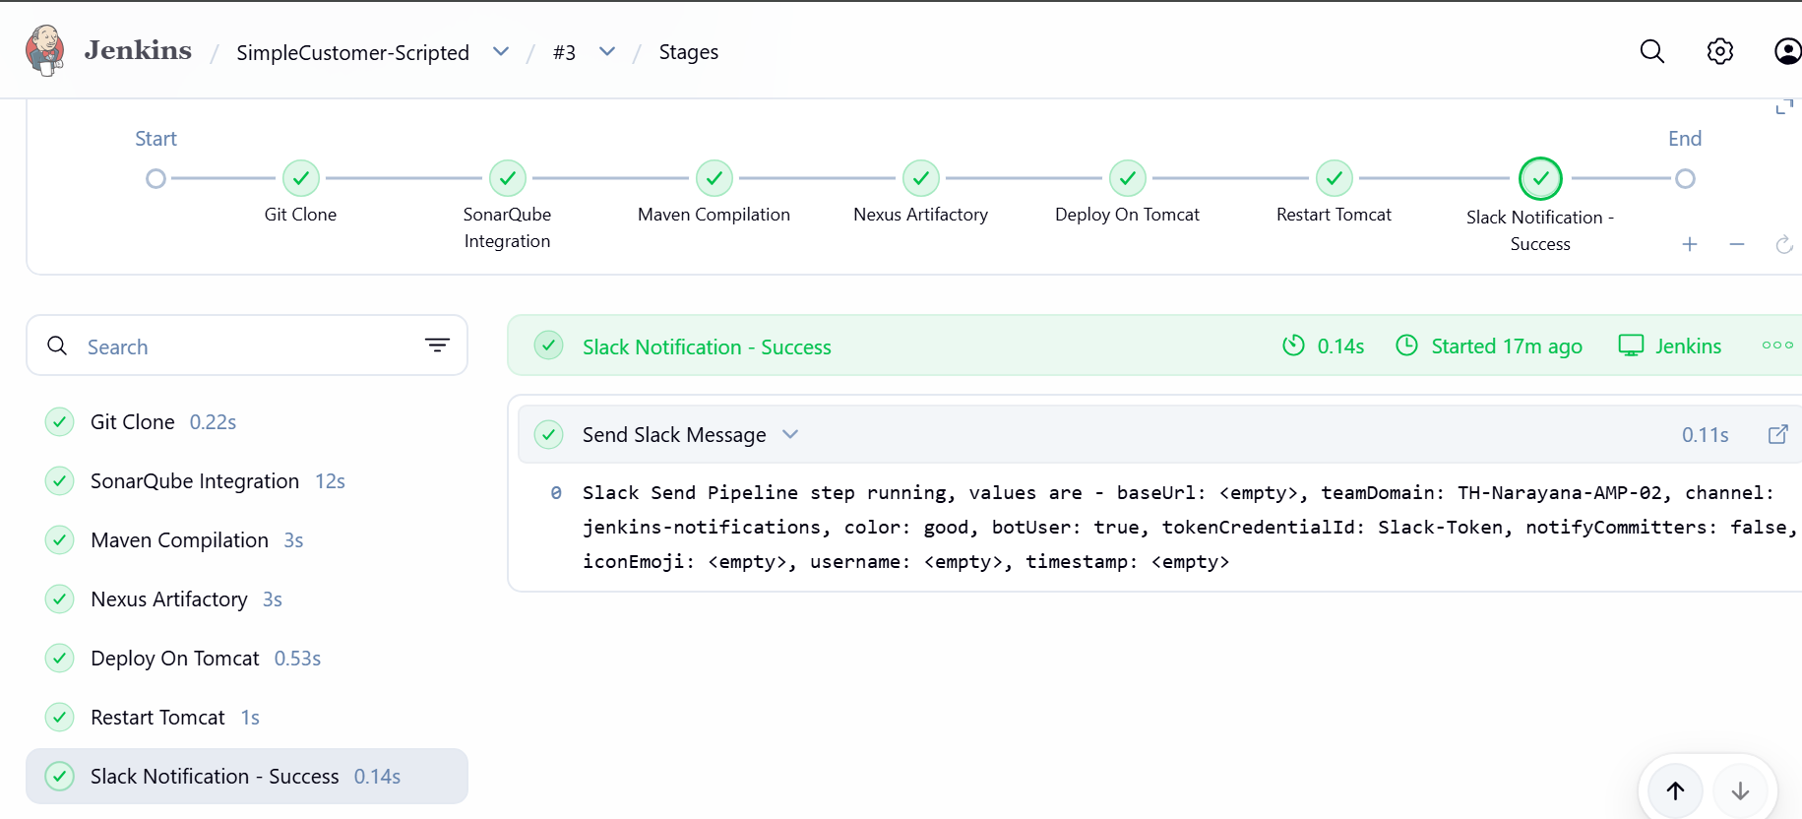

TASK 4 — Sample Skeleton of Pipelines
We will create 3 sample skeletons:
- Declarative Pipeline skeleton
- Scripted Pipeline skeleton
- Complete CI/CD Pipeline skeleton
The purpose is to understand the pipeline structure, stages, steps, and post actions.

STEP 1 — Create a new Jenkins Pipeline job
Go to: Jenkins Dashboard → New Item
Enter: Pipeline-Skeleton
Select: Pipeline
Click OK.
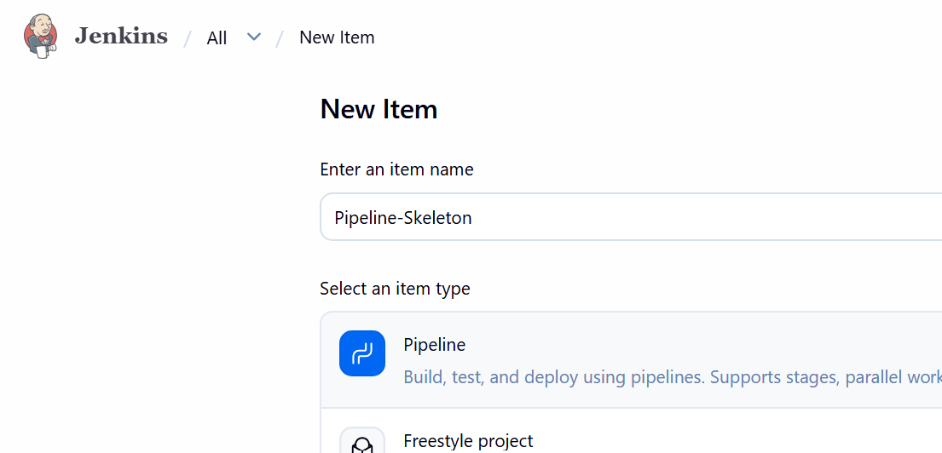

STEP 2 — Create Declarative Pipeline Skeleton
Go to: Pipeline → Definition → Pipeline script
Paste this:
pipeline {

agent any

stages {

stage('Build') {
steps {
echo 'Building application...'
}
}

stage('Test') {
steps {
echo 'Running tests...'
}
}

stage('Deploy') {
steps {
echo 'Deploying application...'
}
}
}

post {

success {
echo 'Pipeline completed successfully!'
}

failure {
echo 'Pipeline failed!'
}

always {
echo 'Pipeline execution completed.'
}
}
}
Click: Save → Build Now
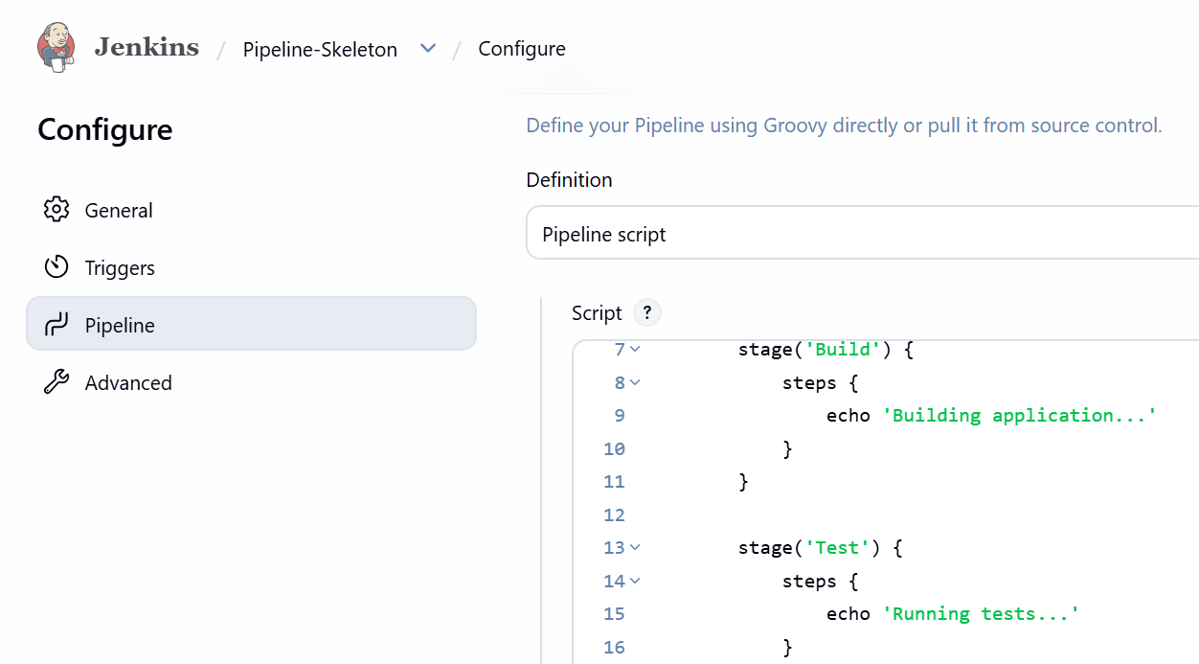

STEP 3 — Check the build
Click the build number, for example:
#1 ✅ Declarative skeleton completed.
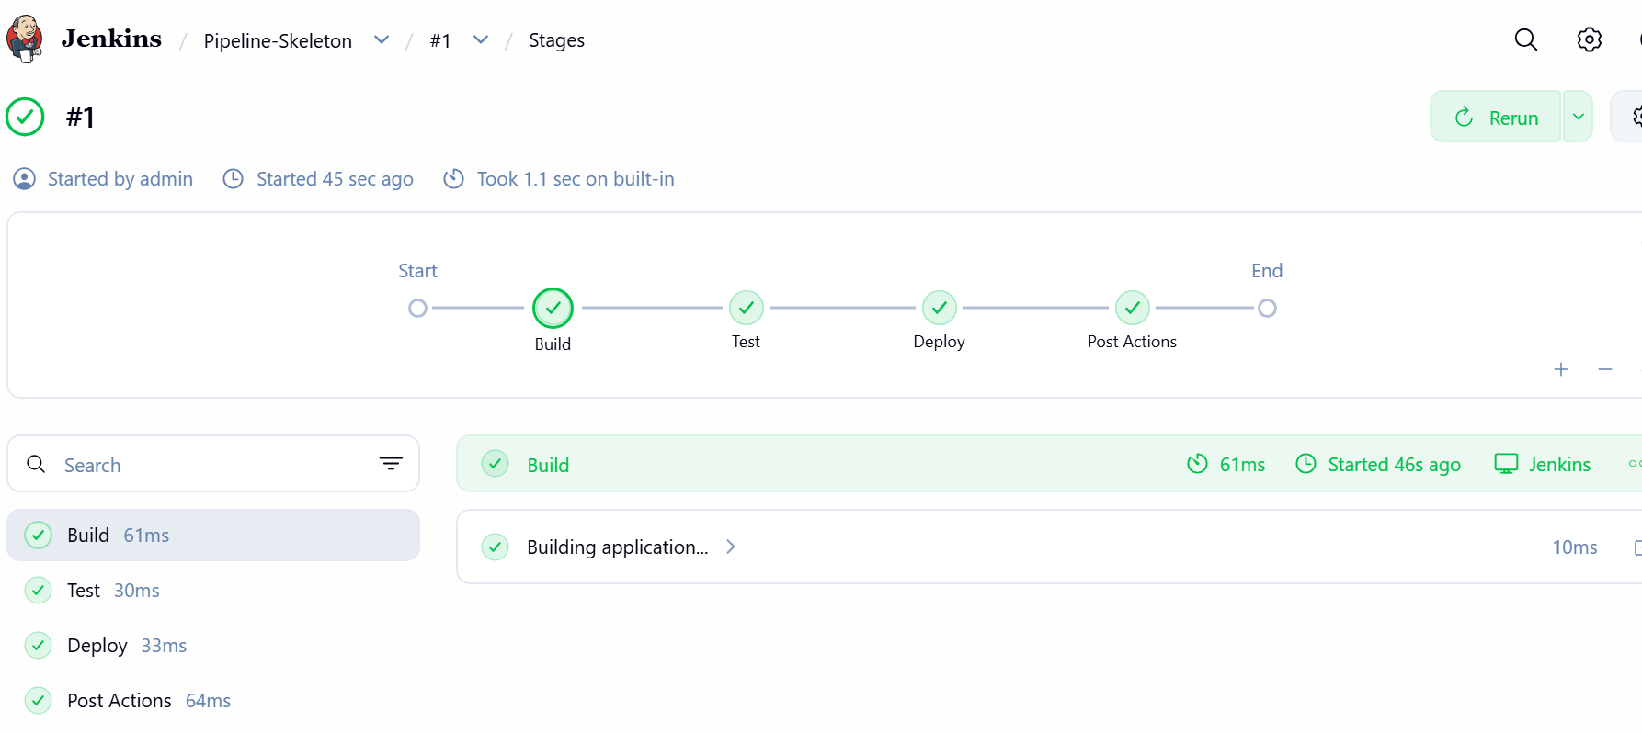

STEP 4 — Create Scripted Pipeline Skeleton
Go back to: Jenkins Dashboard → New Item
Enter: Pipeline-Skeleton-Scripted
Select: Pipeline
Click OK.
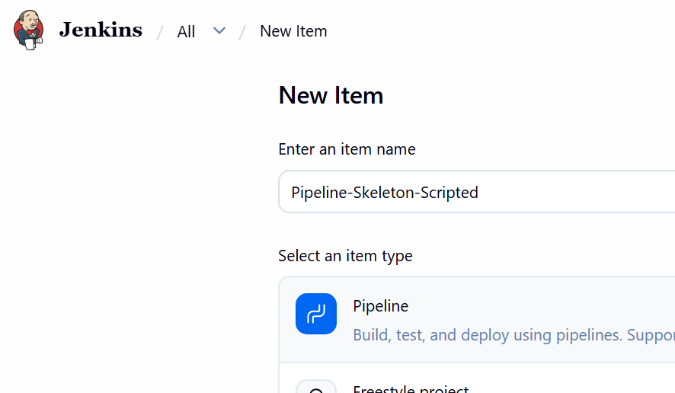
Go to:Pipeline → Pipeline script
Paste:
node {

stage('Build') {
echo 'Building application...'
}

stage('Test') {
echo 'Running tests...'
}

stage('Deploy') {
echo 'Deploying application...'
}

echo 'Pipeline completed.'
}
Click: Save → Build Now
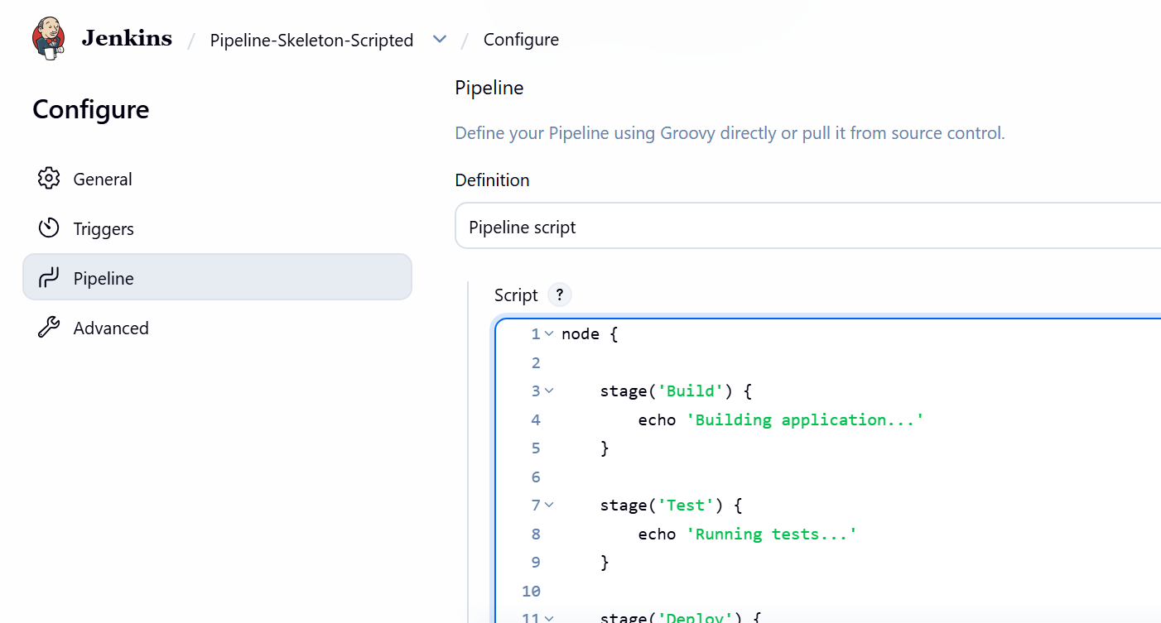

STEP 5 — Verify Scripted Pipeline
Open: ✅ Scripted skeleton completed.
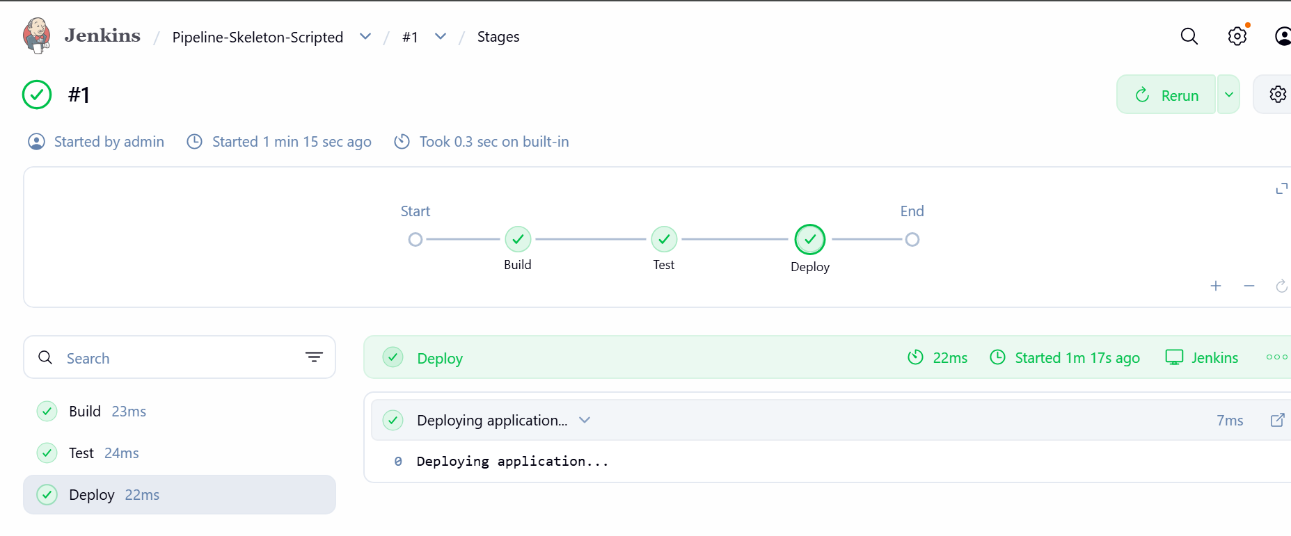

STEP 6 — Create CI/CD Skeleton
Now create one more job: Jenkins Dashboard → New Item
Name: CI-CD-Skeleton
Select: Pipeline
Click OK.
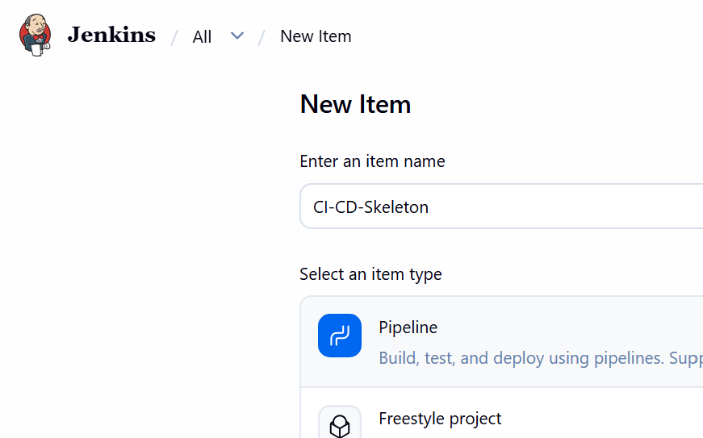
Use this pipeline:
pipeline {

agent any

stages {

stage('Checkout') {
steps {
echo 'Checking out source code...'
}
}

stage('Build') {
steps {
echo 'Building application...'
}
}

stage('SonarQube') {
steps {
echo 'Running SonarQube analysis...'
}
}

stage('Test') {
steps {
echo 'Running application tests...'
}
}

stage('Nexus') {
steps {
echo 'Uploading artifact to Nexus...'
}
}

stage('Deploy') {
steps {
echo 'Deploying application to Tomcat...'
}
}

stage('Notification') {
steps {
echo 'Sending Slack notification...'
}
}
}

post {

success {
echo 'CI/CD Pipeline SUCCESS'
}

failure {
echo 'CI/CD Pipeline FAILURE'
}

always {
echo 'Pipeline execution finished'
}
}
}
Click: Save → Build Now
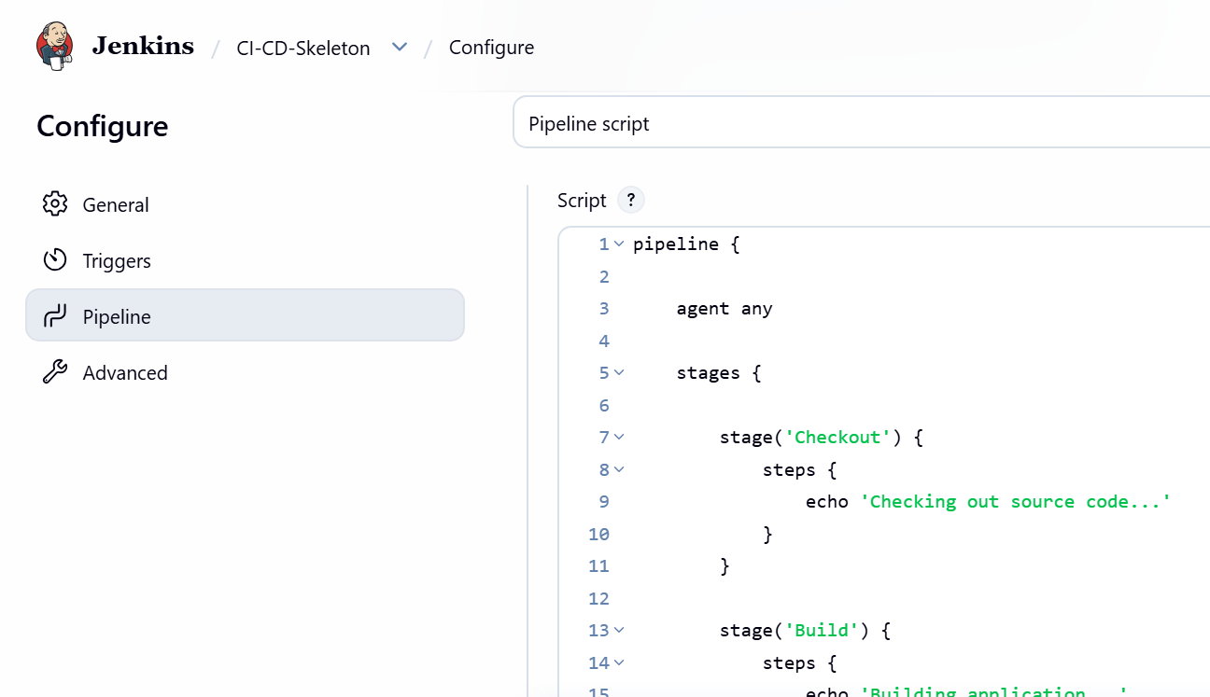

STEP 7 — Verify the CI/CD skeleton
You should see these stages:
Checkout
↓
Build
↓
SonarQube
↓
Test
↓
Nexus
↓
Deploy
↓
Notification
The pipeline will not actually perform Git checkout, Maven build, SonarQube analysis, Nexus upload, or Tomcat deployment.
It only demonstrates the pipeline structure using echo.
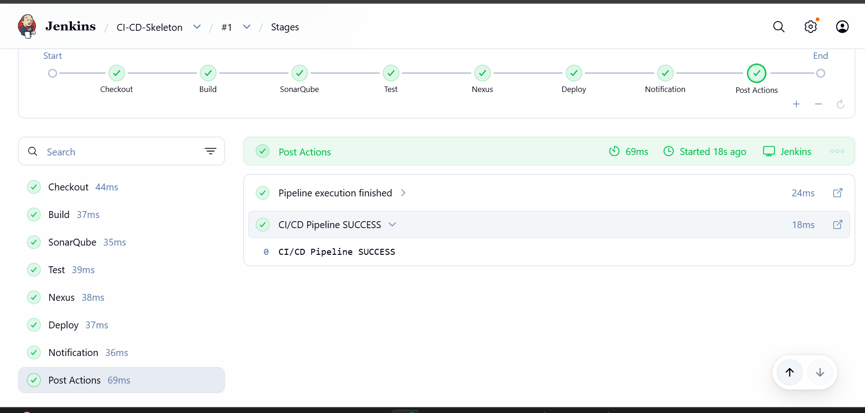

STEP 8 — Understand the Skeleton
Remember this structure for your interview:
pipeline
│
├── agent
│
├── stages
│ │
│ ├── Checkout
│ ├── Build
│ ├── Test
│ └── Deploy
│
└── post
│
├── success
├── failure
└── always
Important keywords
Keyword | Meaning
pipeline | Defines a Declarative Pipeline
agent | Specifies where pipeline runs
stages | Container for pipeline stages
stage | Individual phase of pipeline
steps | Commands executed inside a stage
node | Used in Scripted Pipeline
post | Actions after pipeline execution
success | Runs when pipeline succeeds
failure | Runs when pipeline fails
always | Runs regardless of result
echo | Prints a message in console

Task 4 Final Deliverables
You should now have 3 Jenkins jobs:
1. Pipeline-Skeleton → Declarative Pipeline
2. Pipeline-Skeleton-Scripted → Scripted Pipeline
3. CI-CD-Skeleton → Complete CI/CD structure
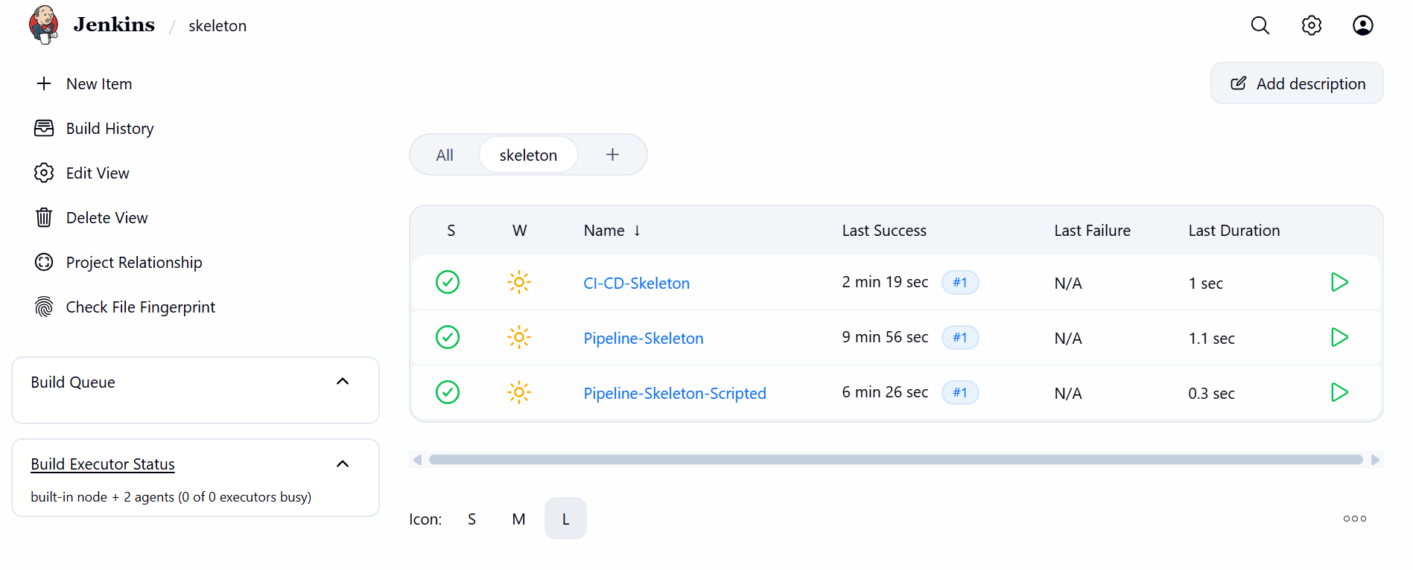

TASK 5 — Parameterized Job
Repository:
spring3-mvc-maven-xml-hello-world-1

STEP 17 — Create Job
Go to: New Item
Enter: HelloWorld-Parameterized
Select: Freestyle project
Click: OK
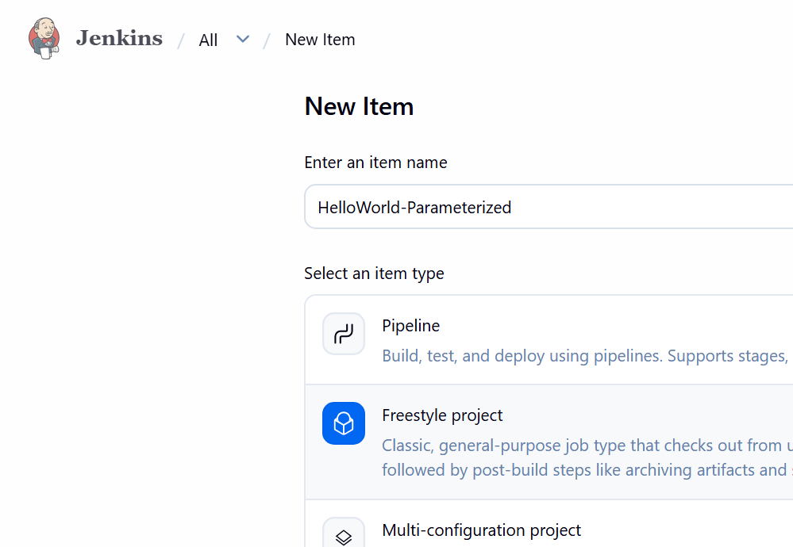

STEP 18 — Enable Parameter
Select: This project is parameterized
Click: Add Parameter
→ Choice Parameter
Enter: Name: ENVIRONMENT
Choices:DEV
UAT
PROD
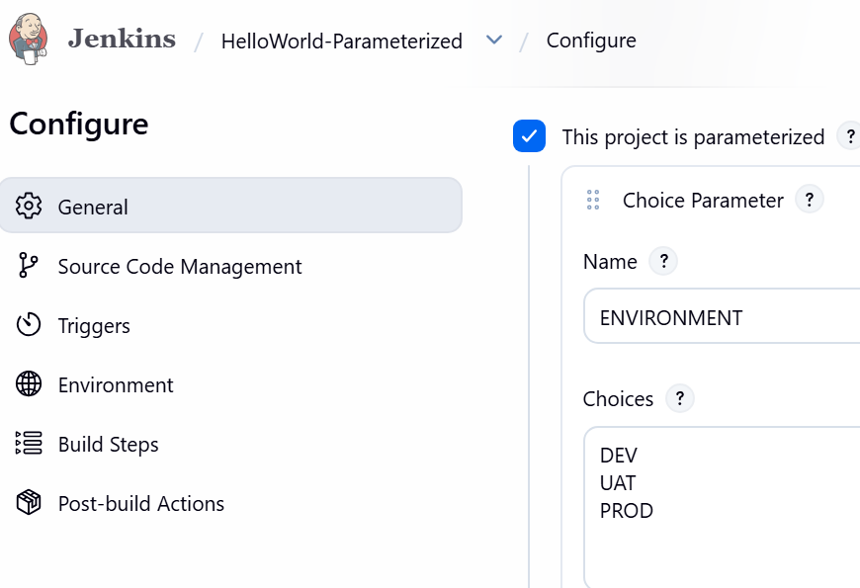
Add another: String Parameter
Name: VERSION
Default: 1.0.0
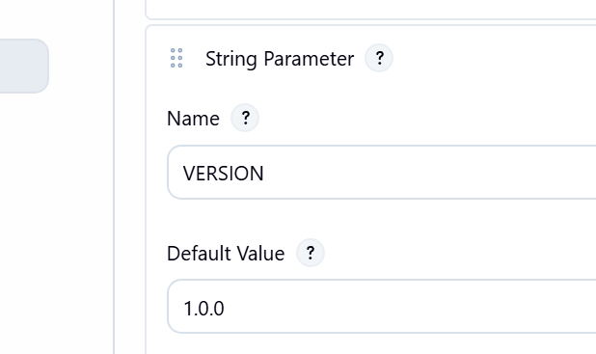

STEP 19 — Configure Git
Go to:Source Code Management
→ Git
Repository: https://github.com/betawins/spring3-mvc-maven-xml-hello-world-1.git
Use the repository's actual default branch, for example:
*/master
or:
*/main

STEP 20 — Use Parameters
Go to:
Build
→ Execute shell
Use:
echo "Environment = $ENVIRONMENT"
echo "Version = $VERSION"

mvn clean package
Save.
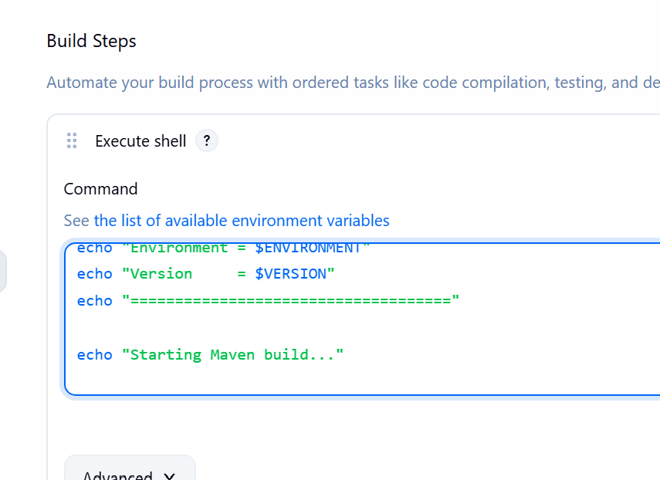
Now instead of: Build Now
you'll get: Build with Parameters
Select:ENVIRONMENT = UAT
VERSION = 1.0.5
Click:Build
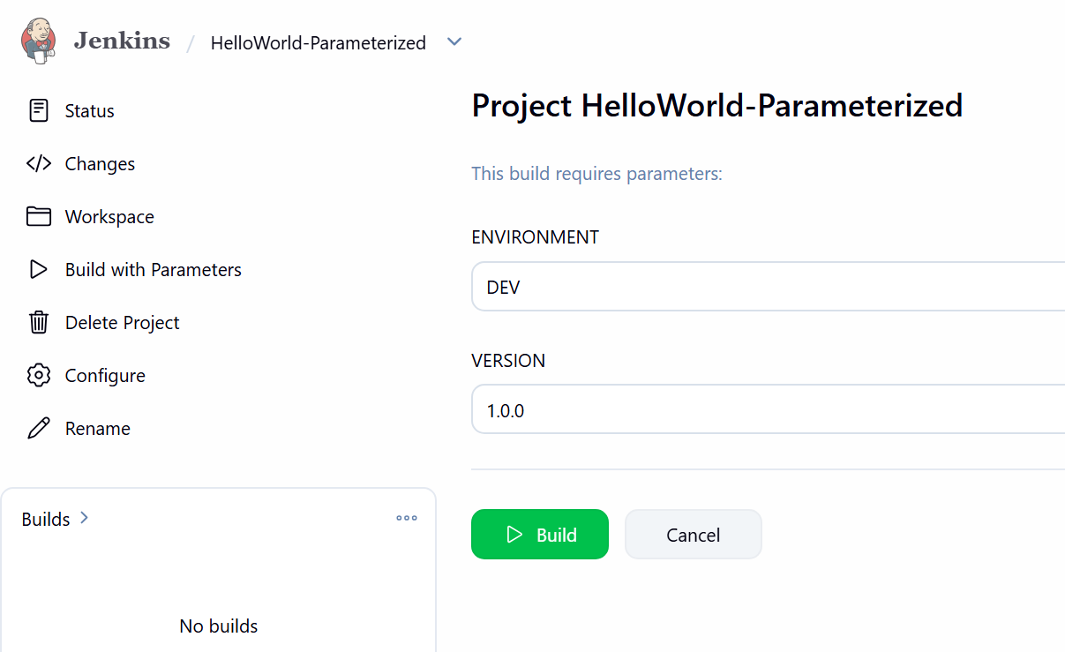
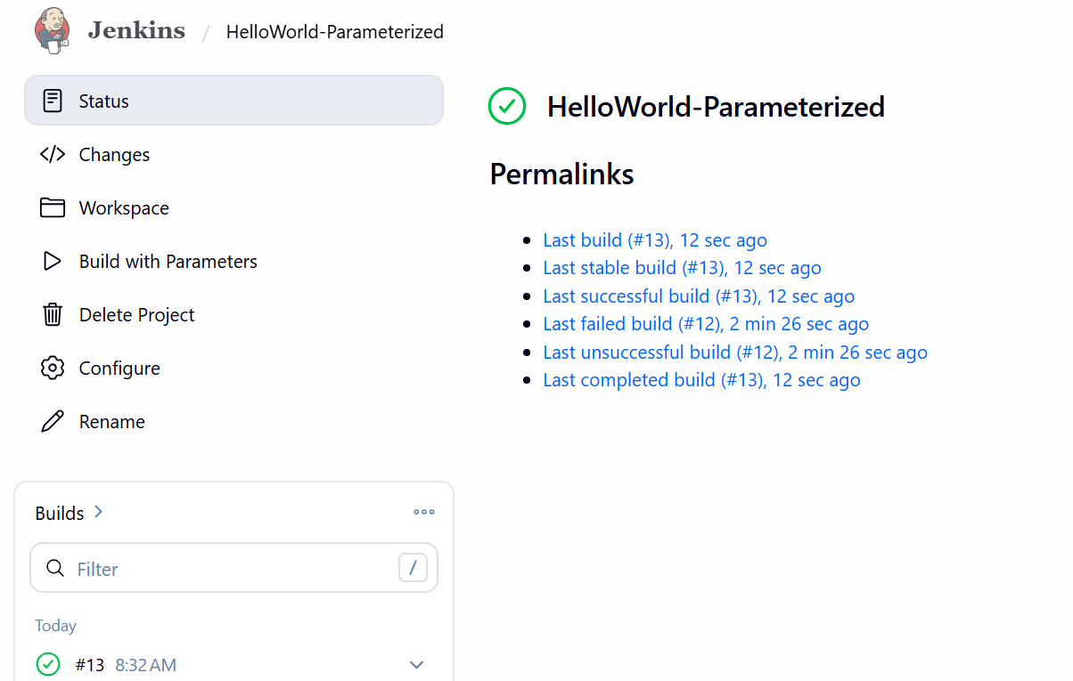
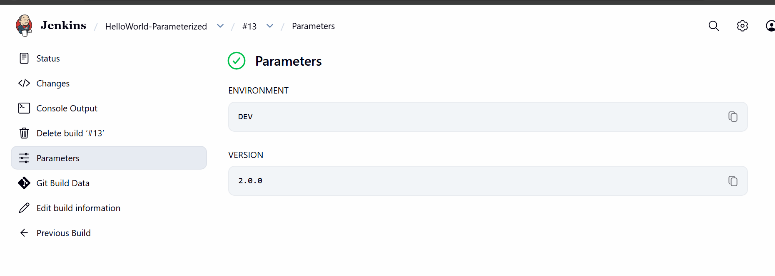
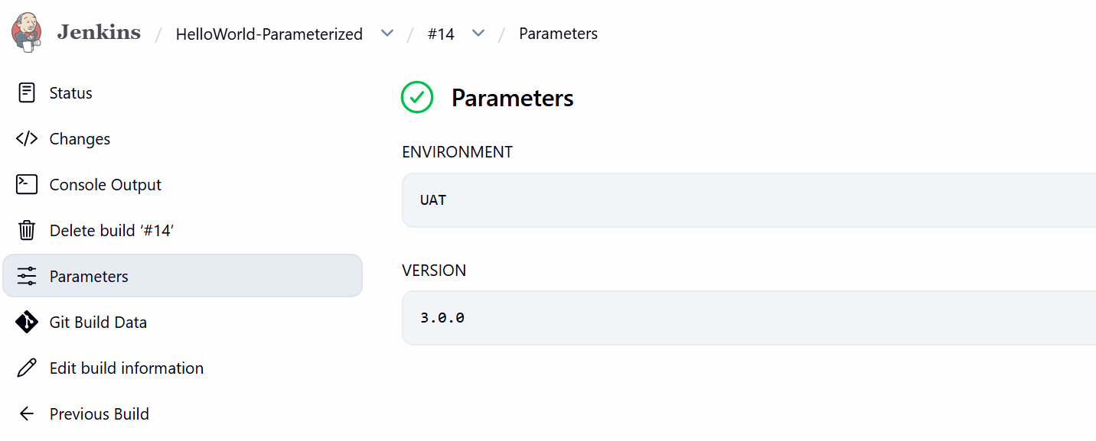

TASK 6 — Jenkins Slave/Agent
This is best done after the pipelines work.

STEP 21 — Create EC2 Agent
Launch another Amazon Linux 2023 EC2.
Call it: Jenkins-Agent-01(slave-01)
Connect: ssh -i key.pem ec2-user@<AGENT-IP>
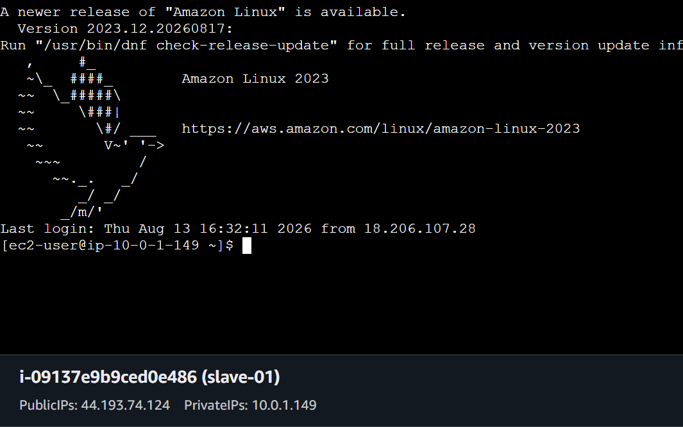

STEP 22 — Install Java
On the agent: sudo dnf install java-21-amazon-corretto -y
Check: java -version
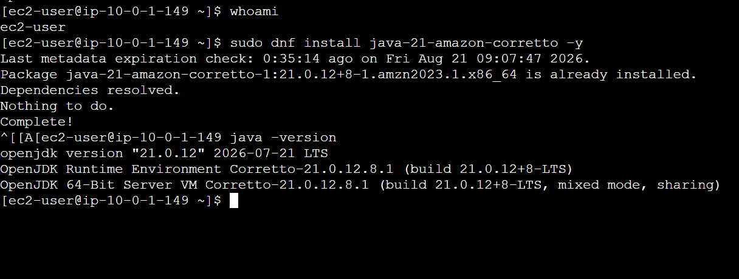

STEP 23 — Create Agent Directory
mkdir -p ~/jenkins

STEP 24 — Create Node in Jenkins
Go to:
Manage Jenkins → Nodes
→ New Node
Enter:Name: slave-01
Select: Permanent Agent
Click: Create
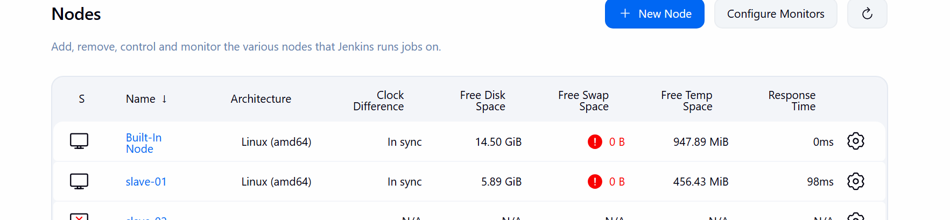

STEP 25 — Agent Configuration
Enter:Description:
Linux Jenkins Agent
Executors:
2
Remote root directory:
/home/ec2-user/jenkins
Labels: linux
Launch method: Launch agents via SSH
Host: <AGENT-IP>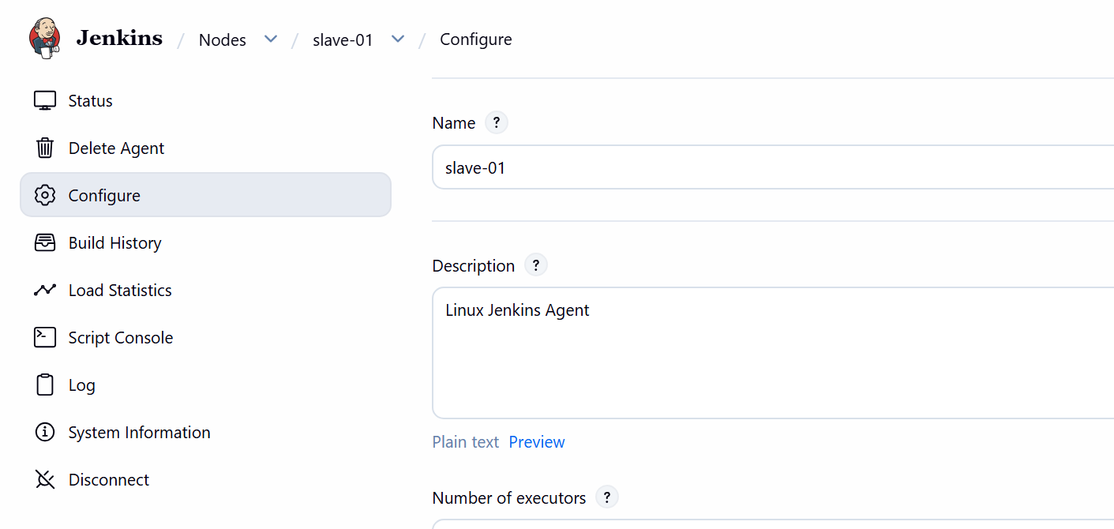

STEP 26 — SSH Credential
On Jenkins controller: sudo -u jenkins ssh-keygen -t ed25519
Display public key: sudo cat /var/lib/jenkins/.ssh/id_ed25519.pub
Copy it.
On the agent: mkdir -p ~/.ssh
chmod 700 ~/.ssh
vi ~/.ssh/authorized_keys
Paste the Jenkins public key.
Then: chmod 600 ~/.ssh/authorized_keys

STEP 27 — Test SSH
From Jenkins server: sudo -u jenkins ssh ec2-user@<AGENT-IP>
It should connect.
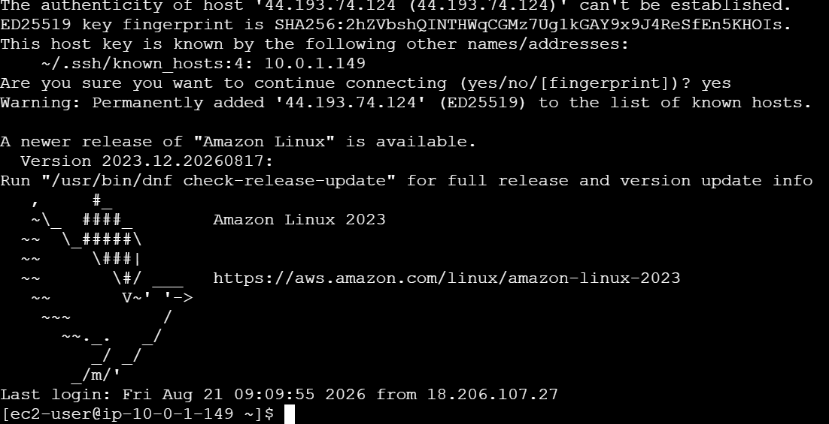

STEP 28 — Add SSH Credential
Jenkins:Manage Jenkins
→ Credentials
→ System
→ Global credentials
→ Add Credentials
Select: SSH Username with private key
Username:ec2-user
Private key: Jenkins private key
ID:slave-01-key
Save.
Go back to: Nodes
→ slave-01
→ Configure
Select:slave-01-key
Save.
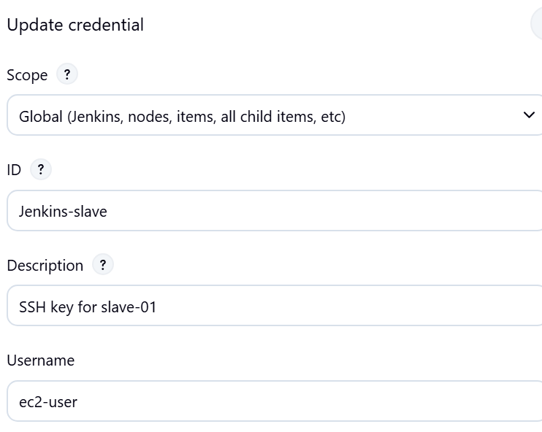
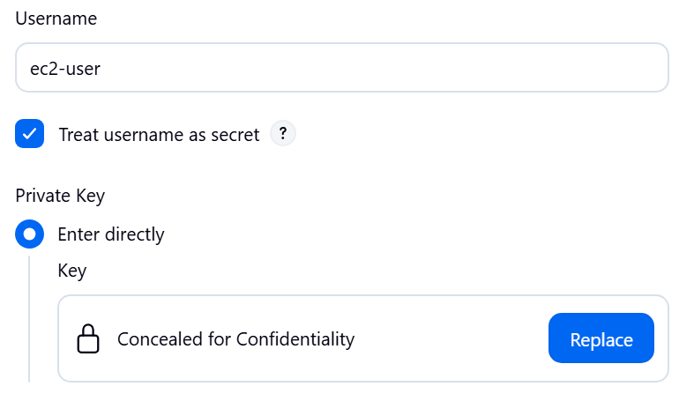

STEP 29 — Verify Agent
Go to: Manage Jenkins
→ Nodes
You should see: Built-In Node
slave-01
And: slave-01 → Connected

STEP 30
Test the Agent
Now let's prove that Jenkins actually executes a job on slave-01.
Go to: Jenkins Dashboard → New Item
Enter:Agent-Test4
Select: Pipeline
Click OK.
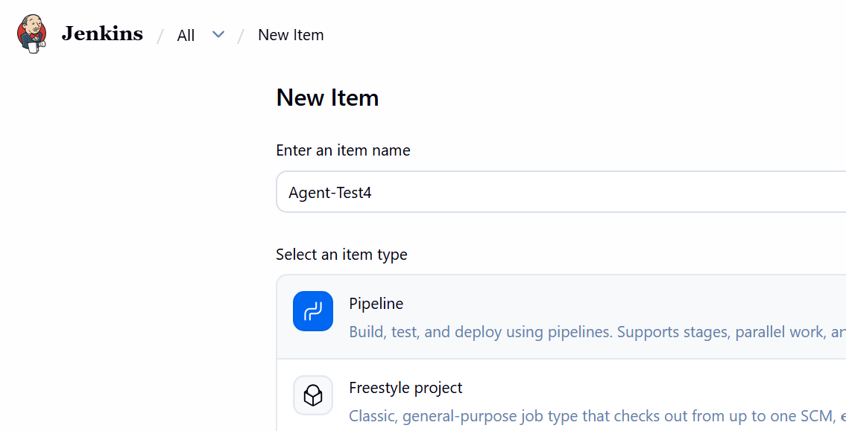
Under Pipeline, select:
Definition → Pipeline script
Paste this:
pipeline {
agent {
label 'linux'
}

stages {
stage('Agent Test') {
steps {
sh 'echo "=== Agent Information ==="'
sh 'hostname'
sh 'echo "=== Java Version ==="'
sh 'java -version'
sh 'echo "=== Current User ==="'
sh 'whoami'
sh 'echo "=== Working Directory ==="'
sh 'pwd'
}
}
}
}
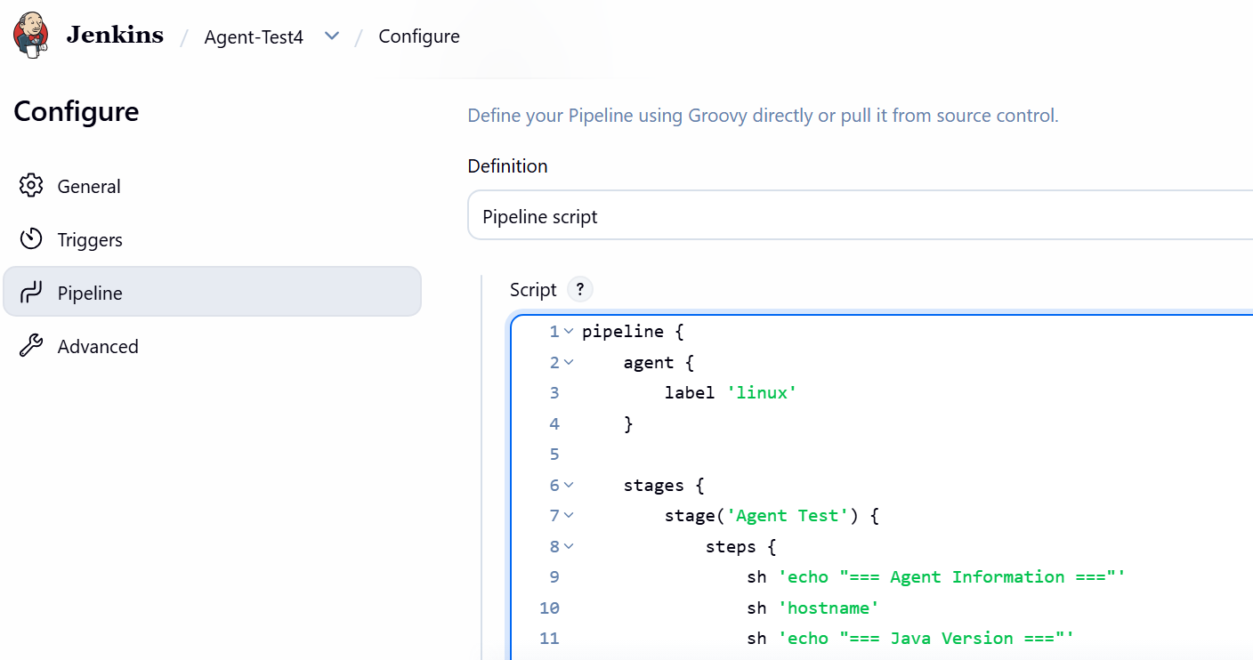
Click Save → Build Now.
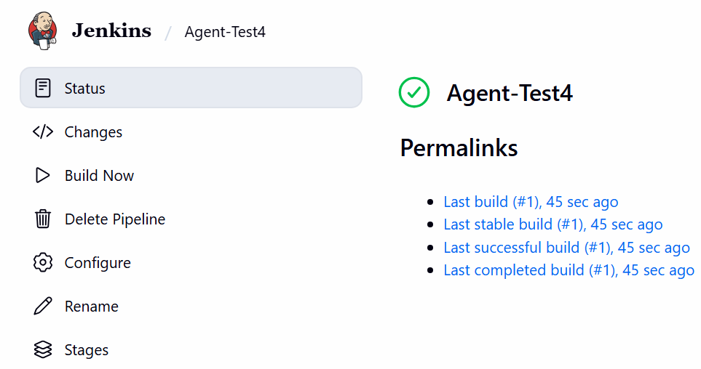
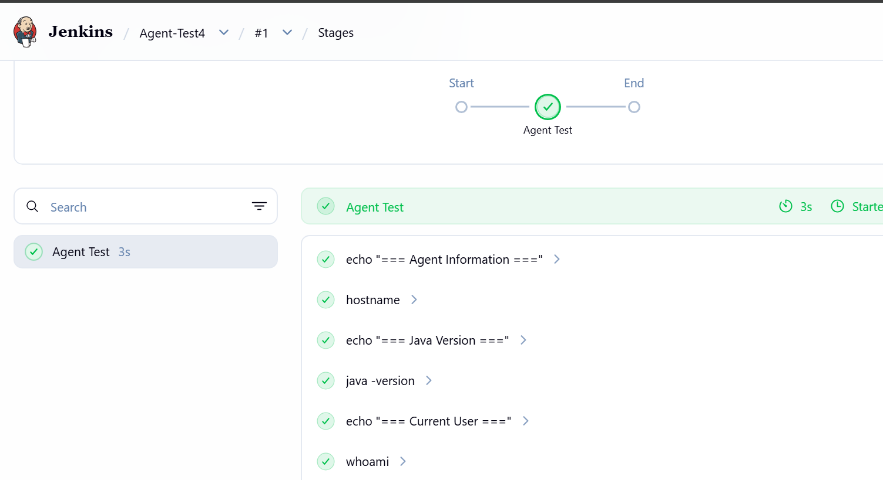
Architecture now
Jenkins Controller
3.95.150.127
|
| SSH
↓
┌───────────────┐
│ slave-01 │
│ Linux │
│ Java 21 │
│ 2 Executors │
│ label=linux │
└───────────────┘
|
↓
/home/ec2-user/jenkins
So you now have a working Jenkins Controller → Agent architecture. 🎯

