DOCKER CHALLENGE

Task 1: Create a Custom Python Docker Image and Push to Docker Hub

Objective
Package the application and dependencies into a portable Docker image.

Prerequisites
- Docker installed and running
- Git installed
- Docker Hub account with a Read & Write token

Step-by-Step Implementation

Step 1: Clone Source Code
Run in a terminal:
git clone https://github.com/betawins/Python-app.git
cd Python-app
ls -la

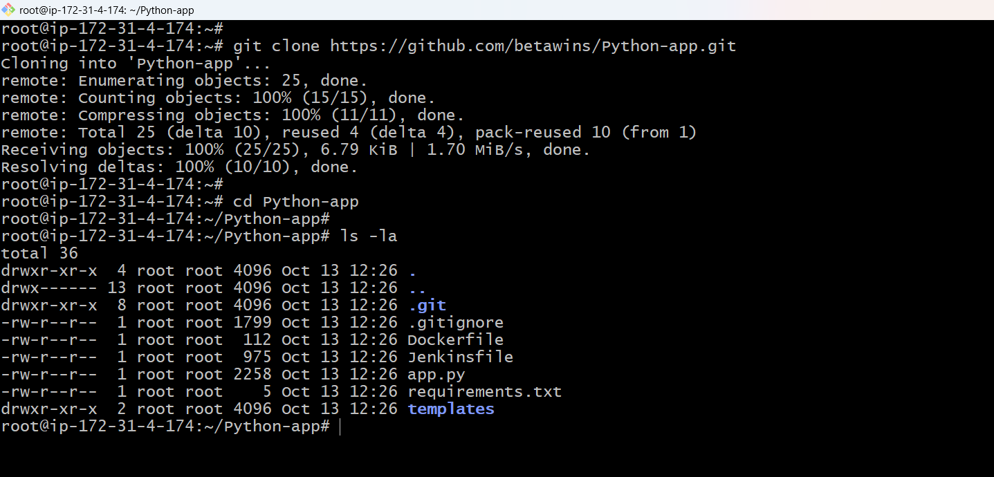

Step 2: Create Dockerfile
Create this file in the repository root. Check that requirements.txt supports Python 3.12 and the app listens on port 8080:
FROM python:3.12-slim
ENV PYTHONDONTWRITEBYTECODE=1 PYTHONUNBUFFERED=1
WORKDIR /app
COPY requirements.txt .
RUN pip install --no-cache-dir -r requirements.txt
COPY app.py .
COPY templates ./templates
EXPOSE 8080
CMD ["python", "app.py"]

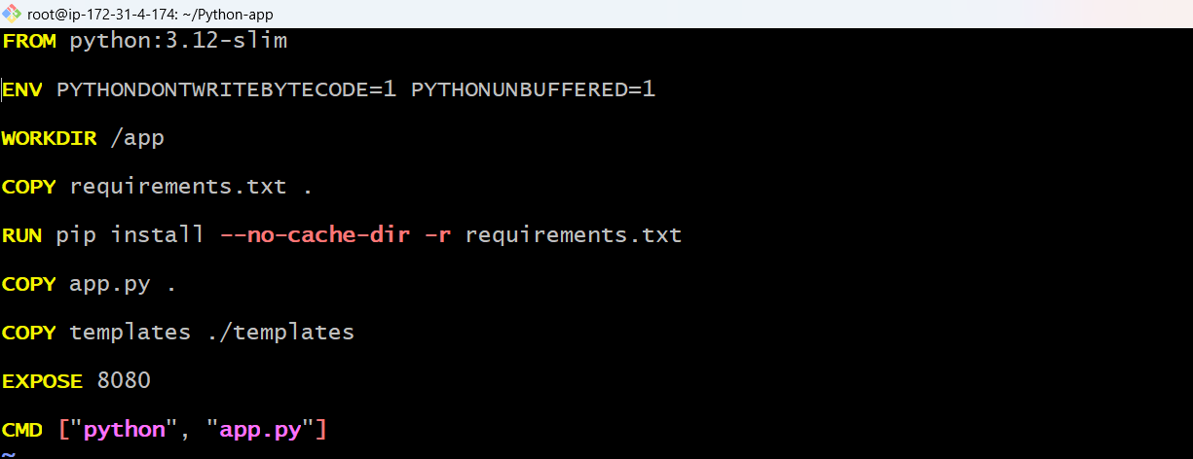

Step 3: Build and Run
Replace YOUR_DOCKERHUB_USERNAME with your username:
docker build -t swaroopkumar706/python-app:v1 .
docker run -d --name python-app -p 8080:8080 swaroopkumar706/python-app:v1
curl http://localhost:8080

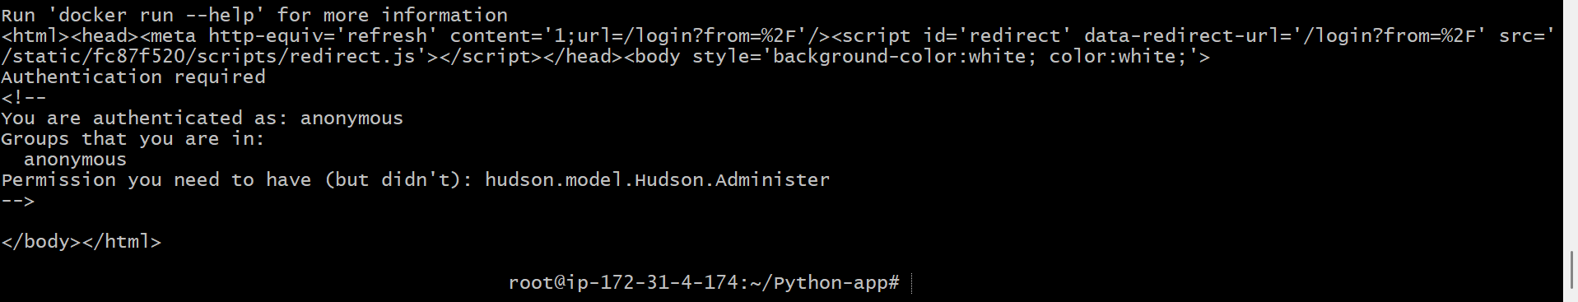

Step 4: Push Image
Create a python-app repository on Docker Hub, then run:
docker login --username swaroopkumar706
docker push swaroopkumar706/python-app:v1

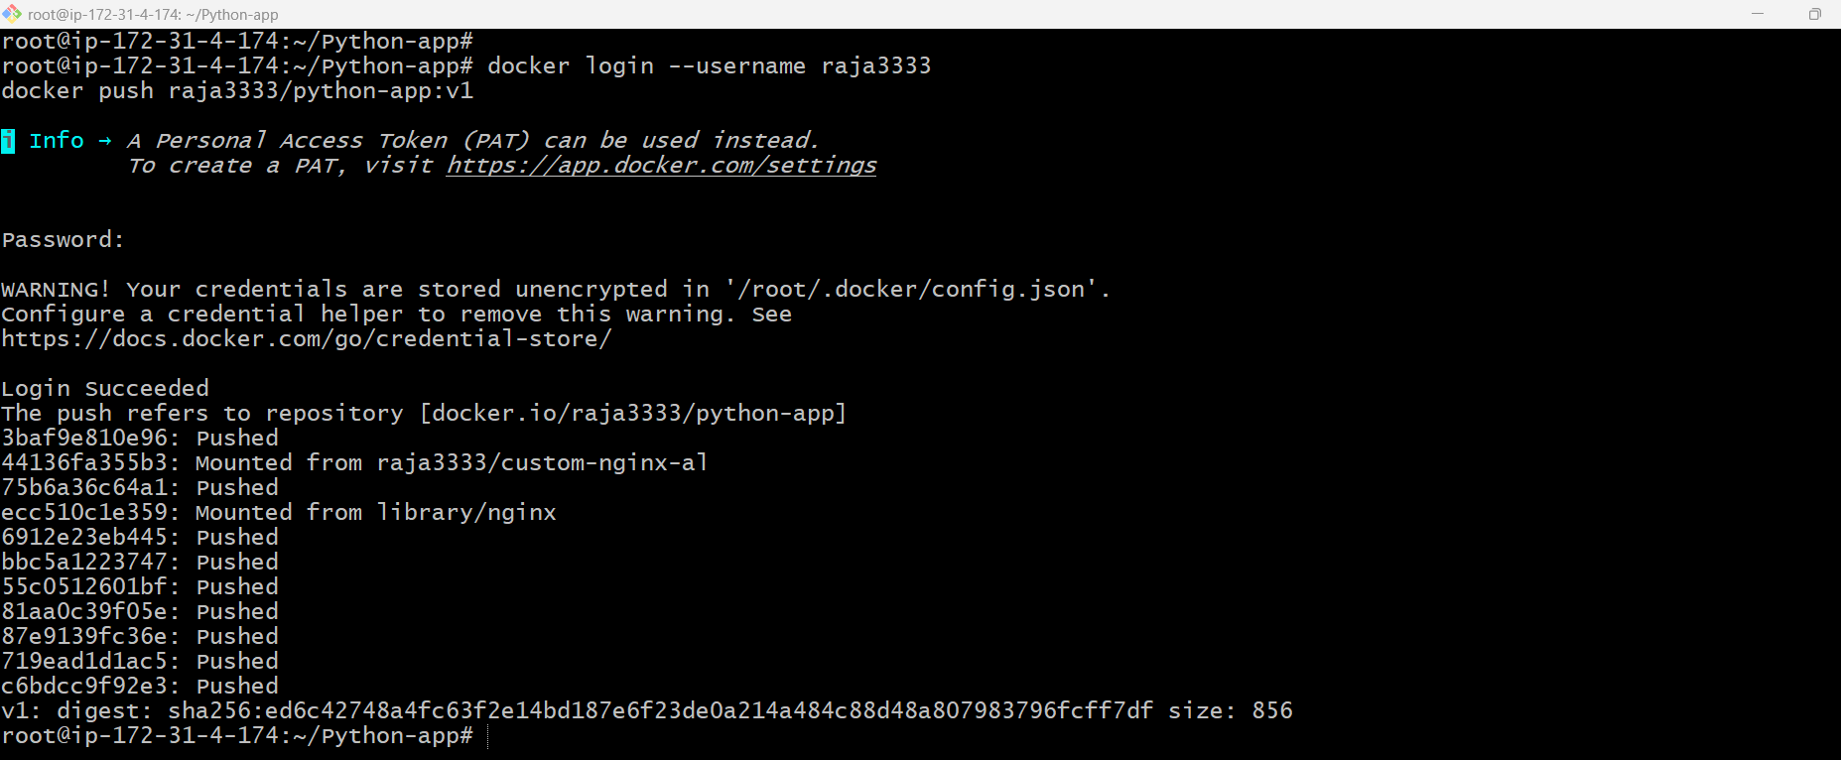

Validation Steps
- docker ps shows the container running.
- http://localhost:8080 responds.
- Docker Hub shows the v1 tag.

Validation Screenshot

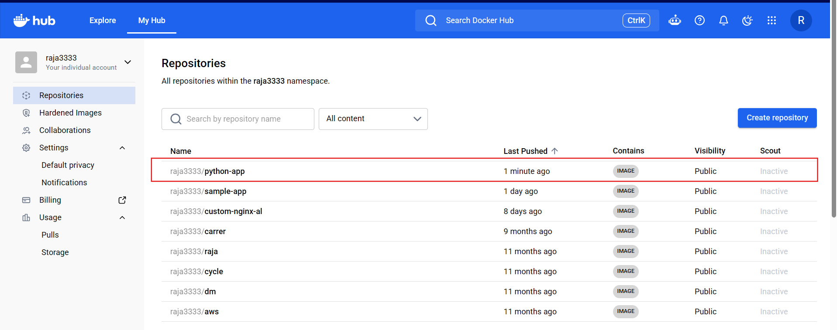

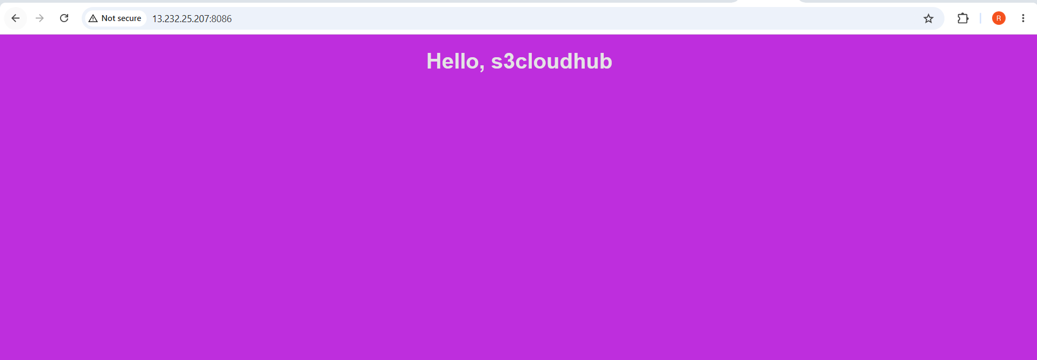

Explanation
The Dockerfile defines the runtime, dependency installation, app files, port, and start command. It helps run the app consistently across environments.

Real-Time Use Case
Teams use container images to deploy the same tested application across development, testing, and production.

Common Errors and Troubleshooting
Error | Cause | Resolution
Container exits | Dependency or start-command problem | Run docker logs python-app and check requirements.txt and app.py.
Push denied | Wrong username or token scope | Use a token with Read & Write access and verify repository ownership.

Task 2: Push the Same Image to Amazon ECR

Objective
Publish the already-built image to AWS's managed container registry without rebuilding it.

Prerequisites
- AWS CLI configured
- IAM permissions for ECR login and upload
- Task 1 image exists
- AWS region selected

Step-by-Step Implementation

Step 1: Set AWS Variables
Run in the terminal where the image exists:
export AWS_REGION=ap-south-1
export AWS_ACCOUNT_ID="$(aws sts get-caller-identity --query Account --output text)"

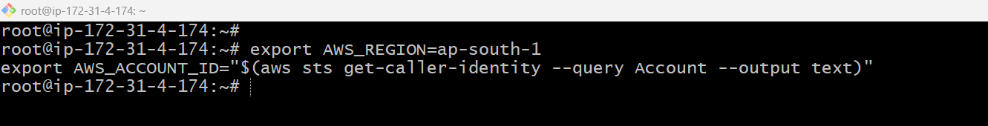

Step 2: Create ECR Repository
Create the repository (if it already exists, continue):
aws ecr create-repository --repository-name python-app --region "$AWS_REGION"
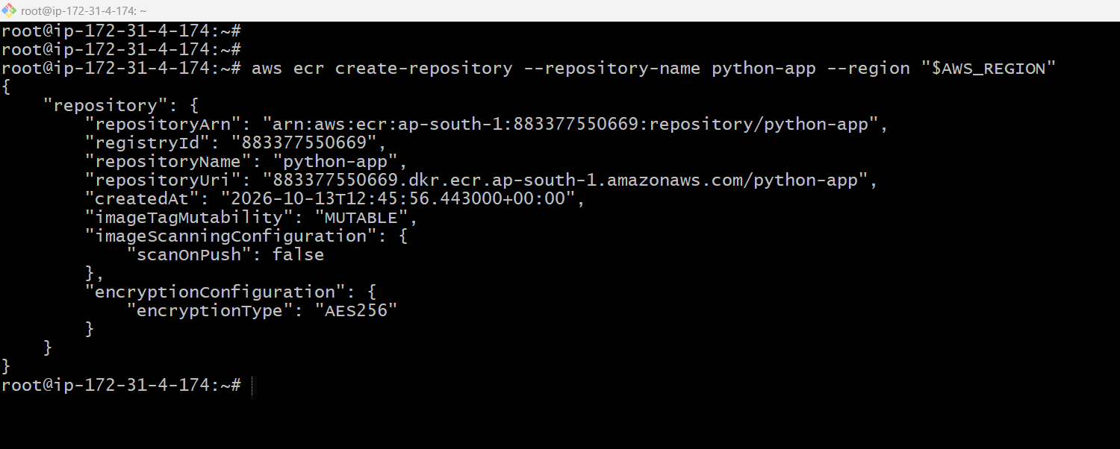

Step 3: Login, Tag, and Push
Authenticate and push the same image:
export ECR_URI="$AWS_ACCOUNT_ID.dkr.ecr.$AWS_REGION.amazonaws.com/python-app"
aws ecr get-login-password --region "$AWS_REGION" | docker login --username AWS --password-stdin "$AWS_ACCOUNT_ID.dkr.ecr.$AWS_REGION.amazonaws.com"
docker tag swaroopkumar706/python-app:v1 "$ECR_URI:v1"
docker push "$ECR_URI:v1"
aws ecr describe-images --repository-name python-app --region "$AWS_REGION"

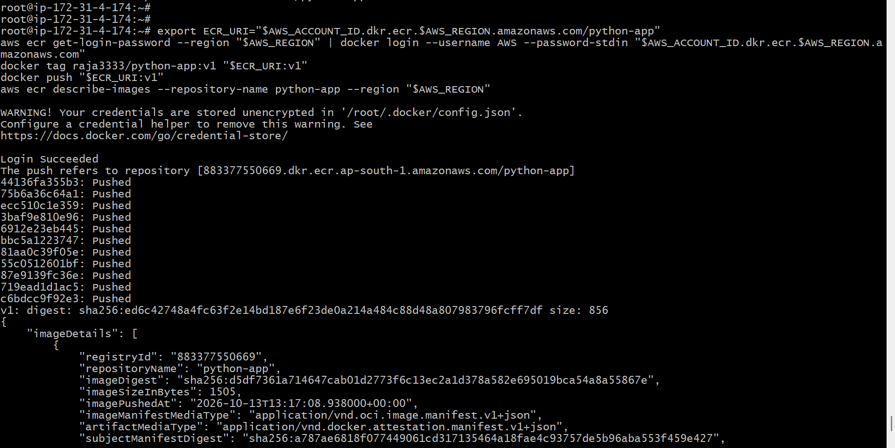
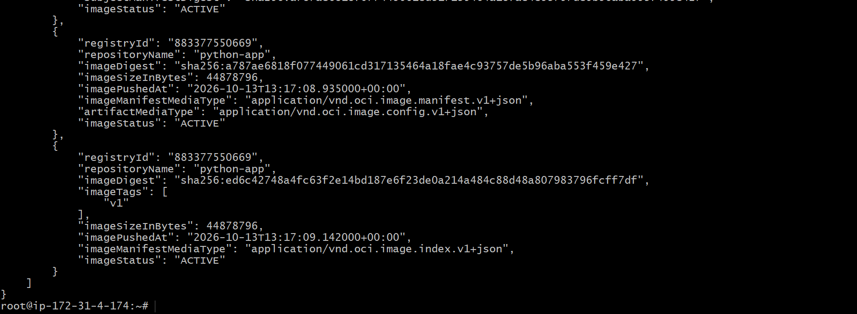

Validation Steps
- ECR lists image tag v1.
- Repository is visible in the AWS console.

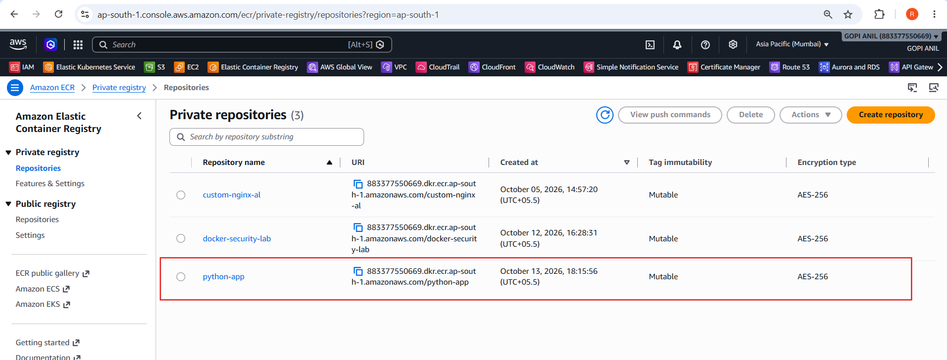
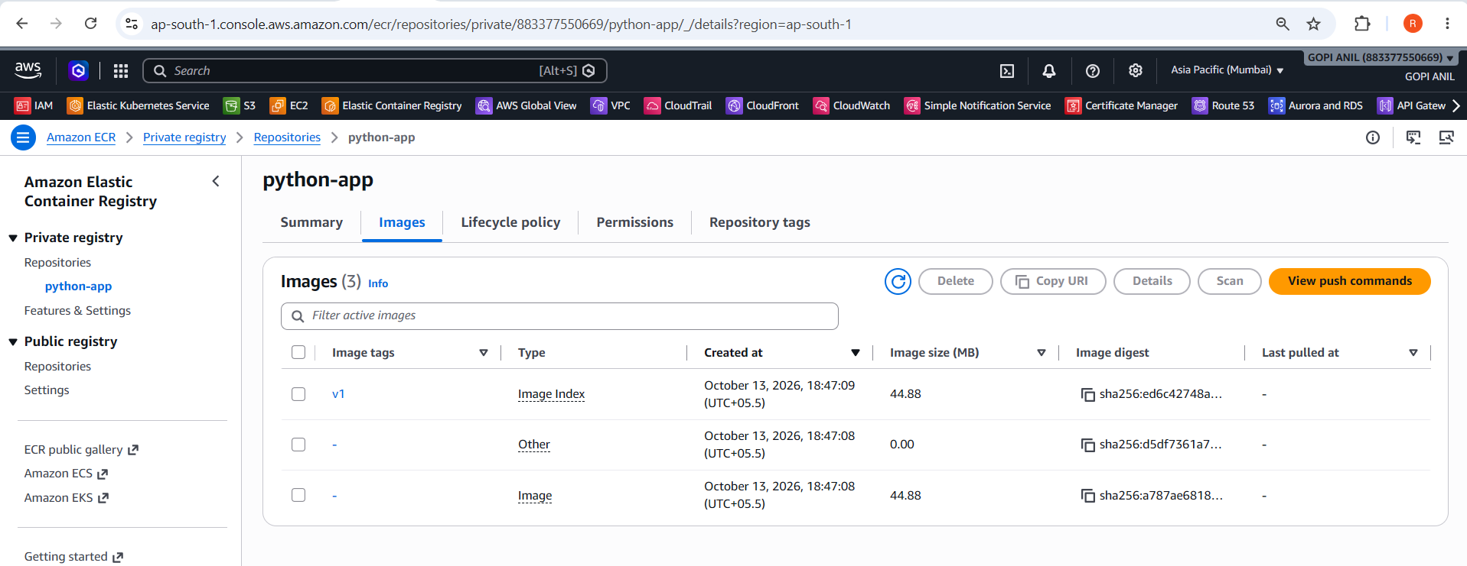

Explanation
The image is retagged with the ECR registry address and uploaded. Its contents do not need to be rebuilt.

Real-Time Use Case
AWS services such as ECS, EKS, and EC2 workloads can pull application images from ECR.

Common Errors and Troubleshooting
Error | Cause | Resolution
AccessDeniedException | IAM permissions missing | Grant the required ECR authentication and upload permissions.
Login failure | Wrong region/account | Check AWS identity and use the same region for login and repository.

Task 3: Provision EC2 and Install Jenkins Using Terraform

Objective
Automate infrastructure creation and Jenkins installation using repeatable code.

Prerequisites
- AWS account and credentials
- Terraform installed
- Existing EC2 key pair in ap-south-1
- Your public IP in CIDR form
- Default VPC/subnet

Step-by-Step Implementation

Step 1: Create Terraform Files
Create jenkins-terraform with main.tf, variables.tf, terraform.tfvars, and user_data.sh. Use the Terraform and user-data examples in the implementation guide.

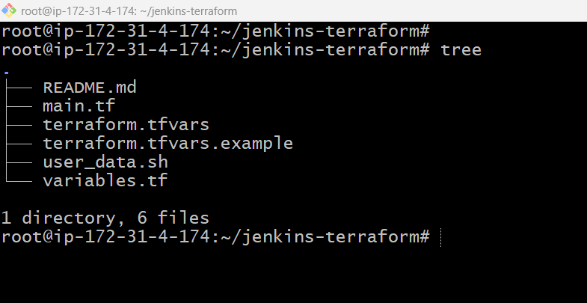

Step 2: Set Variables
Configure region, existing key-pair name, instance type, and your IP/32. Do not expose SSH to 0.0.0.0/0.
aws_region = "ap-south-1"
key_name = " jenkins-key.pem"
instance_type = "t3.medium"
my_ip_cidr = "13.232.25.207/32"

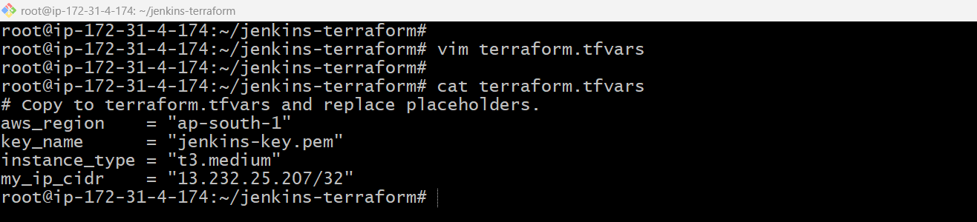

Step 3: Deploy Infrastructure
Run from the Terraform directory and review the plan before confirming:
terraform init
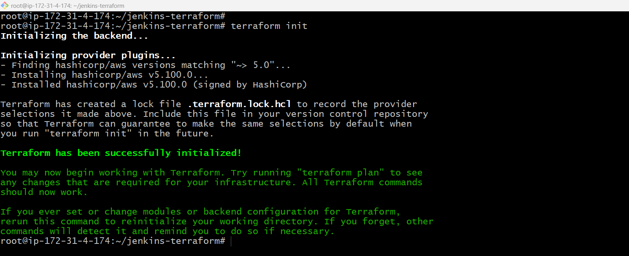
terraform fmt
terraform validate
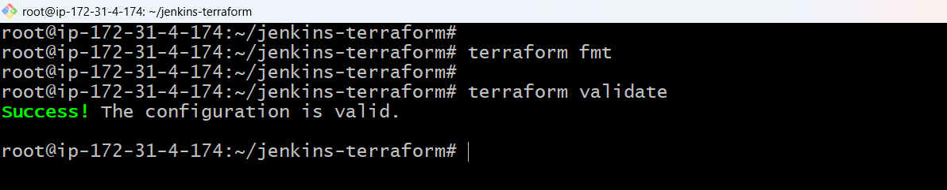
terraform plan
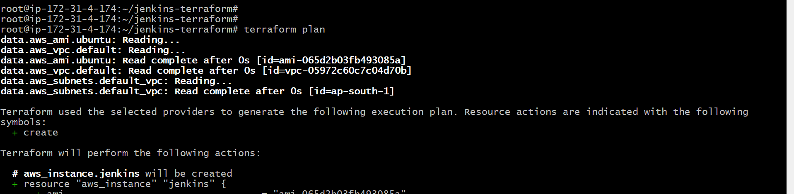
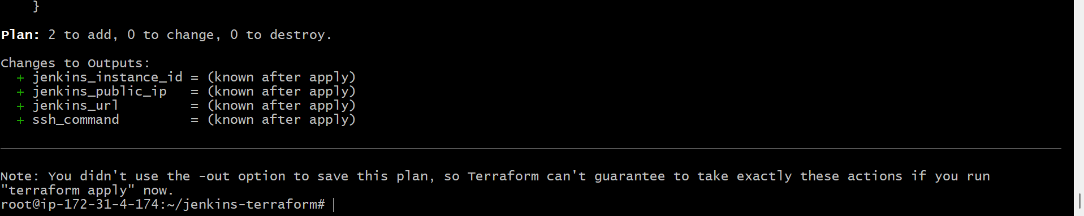
terraform apply

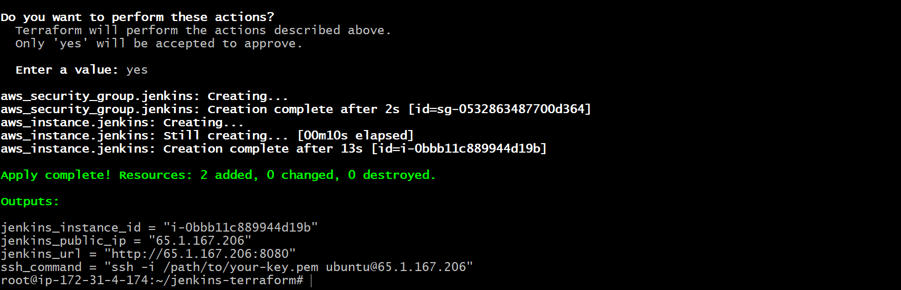

Step 4: Finish Jenkins Setup
SSH to the output IP and retrieve the initial admin password:
ssh -i /path/to/key.pem ubuntu@EC2_PUBLIC_IP
sudo cat /var/lib/jenkins/secrets/initialAdminPassword

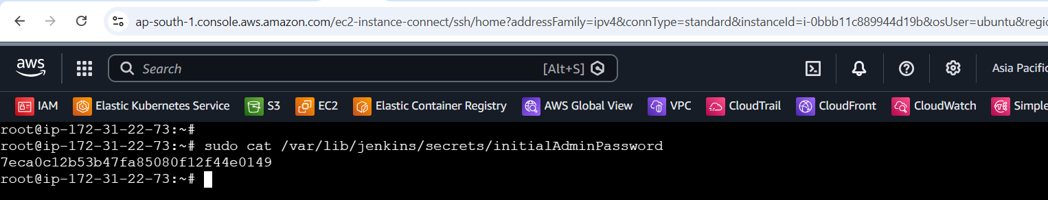

Validation Steps
- Terraform outputs Jenkins public IP and URL.
- Jenkins UI opens from the allowed IP.
- Jenkins service is active.
- sudo -u jenkins -H docker version succeeds.

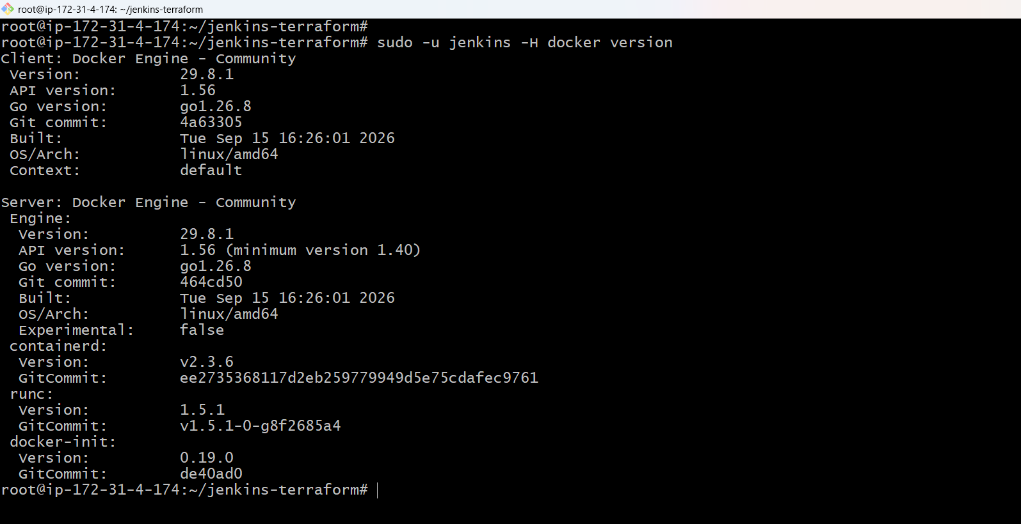

Explanation
Terraform defines EC2 and security group resources. User data installs Docker and Jenkins during first boot. Docker group access is powerful, so restrict this lab and its access.

Real-Time Use Case
Teams use infrastructure-as-code to provision repeatable CI servers and cloud environments.

Common Errors and Troubleshooting
Error | Cause | Resolution
Jenkins unavailable | Bootstrap failed or port blocked | Check /var/log/jenkins-bootstrap.log, service status, and security group.
Key pair not found | Wrong key name or region | Use an existing key pair in the selected region.
Docker permission denied | Jenkins lacks Docker group access | Add Jenkins to the docker group and restart the service.

Task 4: Jenkins Job to Build and Push the Python Image

Objective
Automate image delivery while storing credentials securely in Jenkins.

Prerequisites
- Jenkins running
- Docker and curl on the Jenkins agent
- Jenkinsfile committed to the repository
- Docker Hub token with Read & Write permissions

Step-by-Step Implementation

Step 1: Add Jenkins Credential
Jenkins → Manage Jenkins → Credentials → Add Credentials. Use Username with password; ID must be dockerhub-creds.
Username: YOUR_DOCKERHUB_USERNAME
Password: Docker Hub Personal Access Token with Read & Write
ID: dockerhub-creds

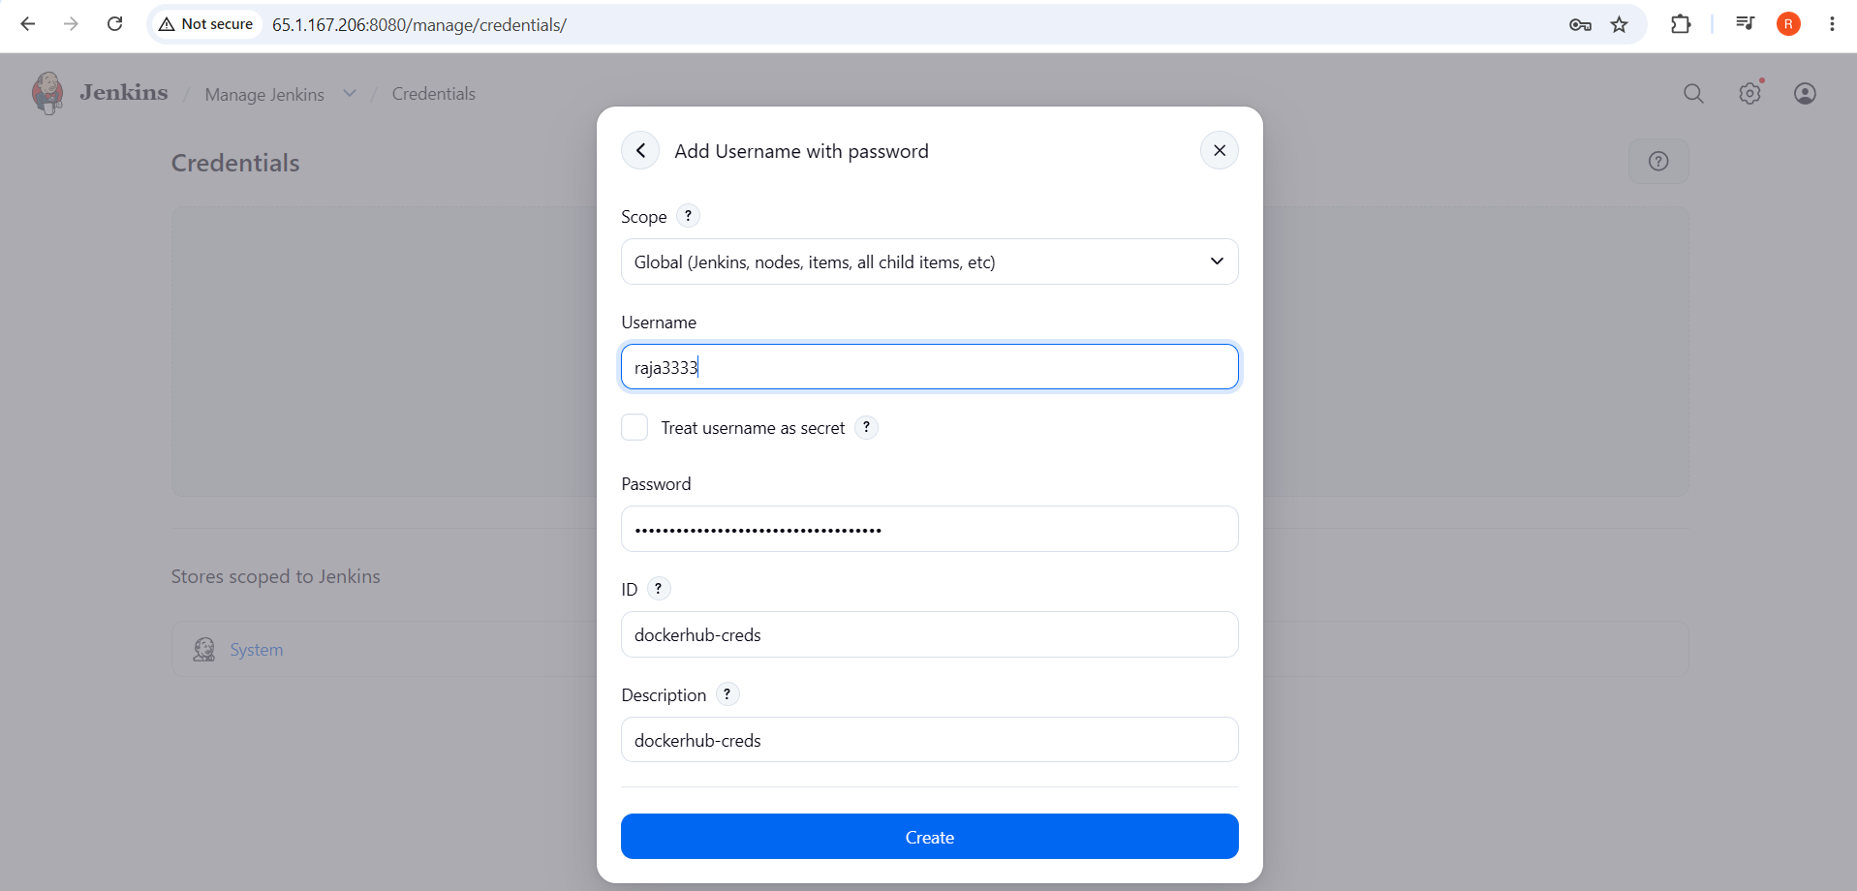 Step 2: Add Jenkinsfile
Commit a Jenkinsfile to Python-app. Use the pipeline from the implementation guide and replace YOUR_DOCKERHUB_USERNAME. Do not hardcode the token.

Step 3: Create Pipeline Job
Jenkins Dashboard → New Item → python-app-docker-pipeline → Pipeline. Select Pipeline script from SCM → Git.
Repository: https://github.com/swaroopkumar706/Python-app.git
Branch: */main
Script Path: Jenkinsfile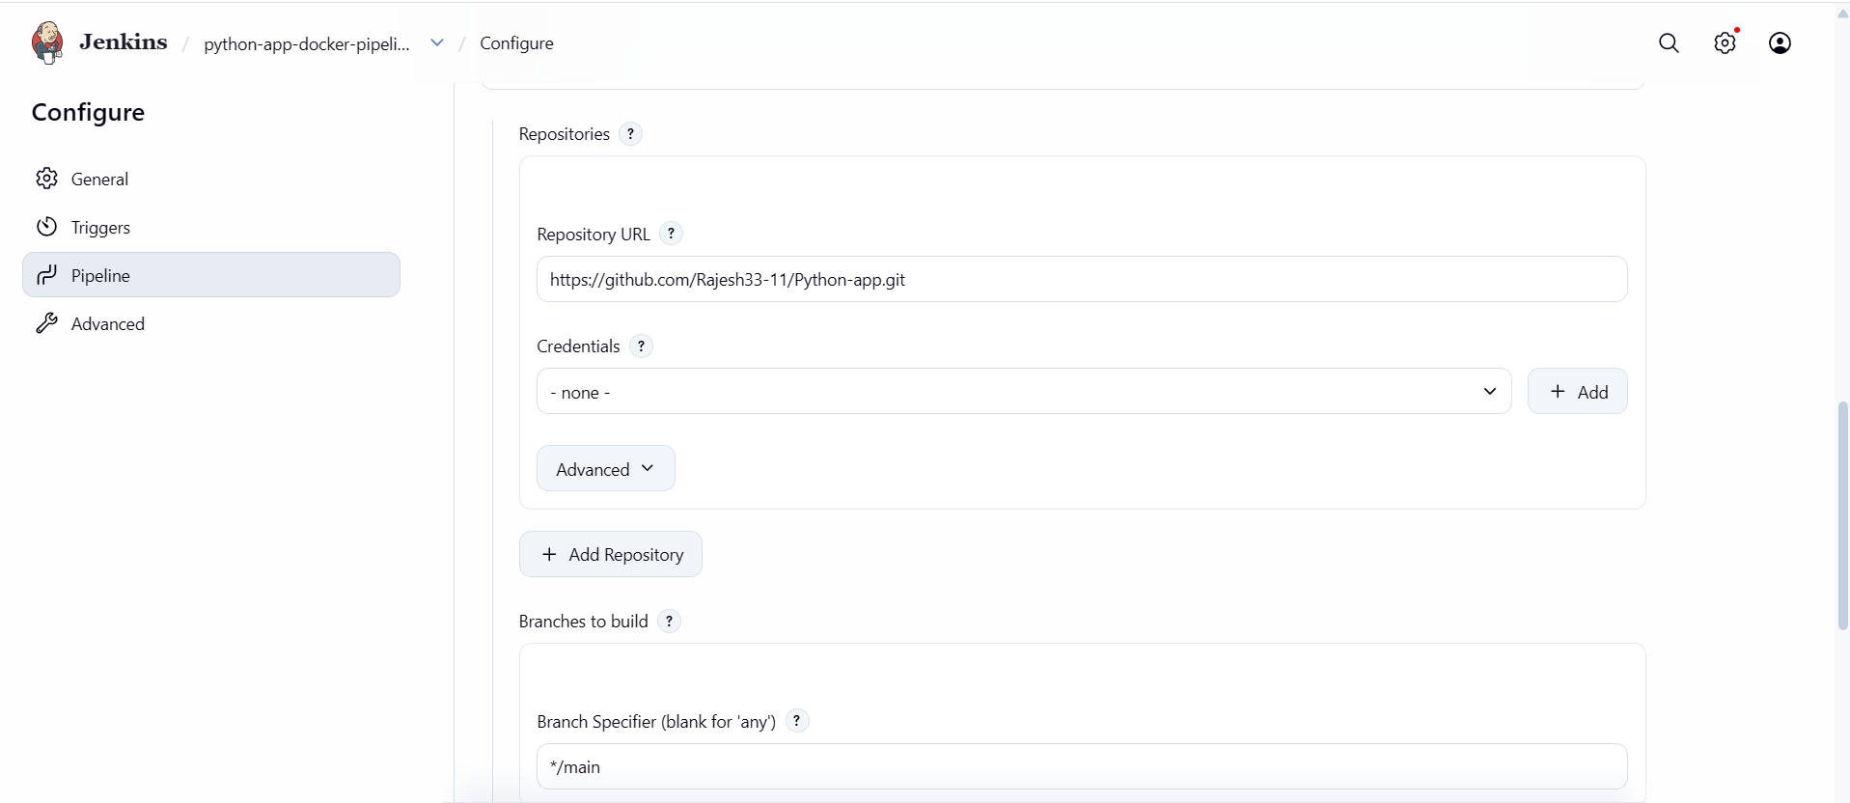

Step 4: Run Job
Click Save → Build Now → Console Output. Check each stage.

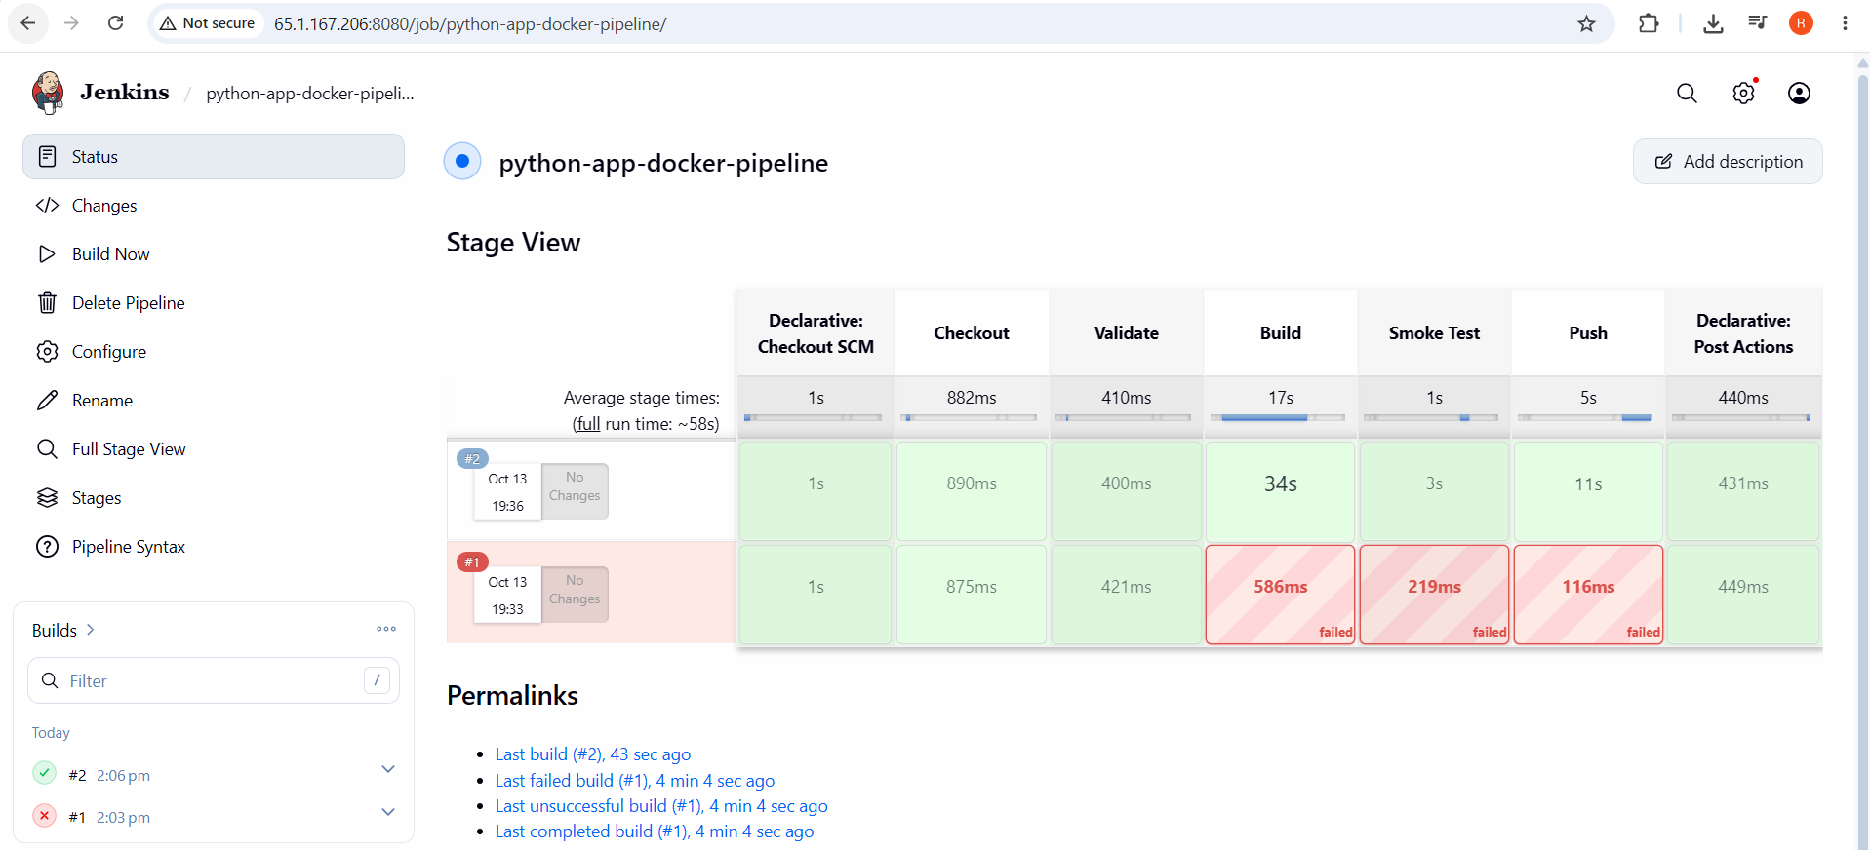

Validation Steps
- Checkout, Validate, Build, Smoke Test, and Push stages pass.
- Docker Hub contains build-number and latest tags.
- Console ends with Finished: SUCCESS.

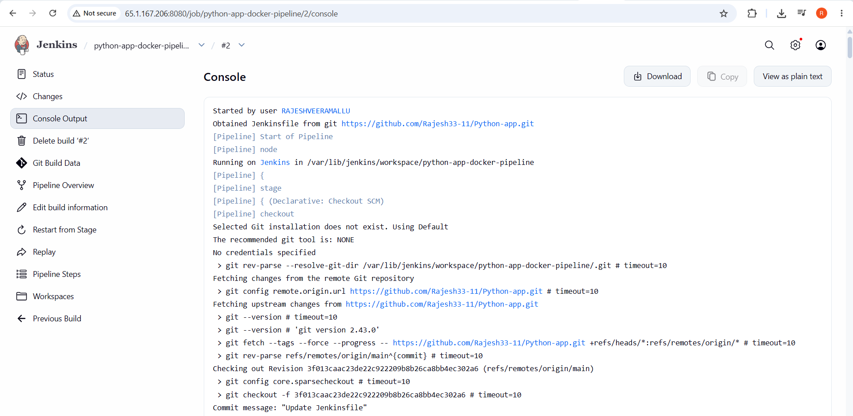


Explanation
The pipeline automates checkout, validation, build, smoke test, and registry push. Credentials are injected only when needed.

Real-Time Use Case
CI/CD pipelines make container builds repeatable after source changes.

Common Errors and Troubleshooting

Error | Cause | Resolution
Token has insufficient scopes | Docker Hub token lacks write permission | Create a Read & Write token and update dockerhub-creds.
Docker permission denied | Agent cannot access Docker | Configure agent access and restart Jenkins after group changes.
Smoke test fails | App startup or port issue | Review container logs and confirm the app listens on port 8080.

Task 5: Build, Run, and Push the Frontend Image

Objective
Package frontend build output into a deployable image.

Prerequisites
- docker-tasks repository
- Docker running
- Docker Hub write access
- Frontend framework and output folder identified

Step-by-Step Implementation

Step 1: Inspect Source
Clone and inspect the frontend folder:
git clone https://github.com/swaroopkumar706/docker-tasks.git
cd docker-tasks
find Frontend_based_source -maxdepth 3 -type f

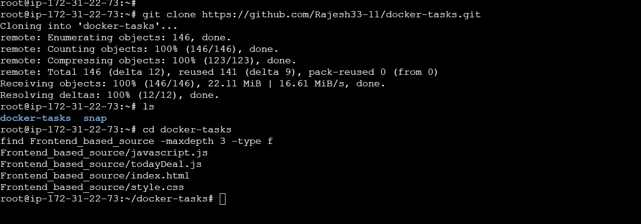

Step 2: Create Dockerfile
For React outputting build/, use a Node build stage and Nginx runtime. For Vite, copy dist/ instead. Adapt based on package.json.
FROM node:22-alpine AS build
WORKDIR /app
COPY package*.json ./
RUN npm ci
COPY . .
RUN npm run build
FROM nginx:alpine
COPY --from=build /app/build /usr/share/nginx/html
EXPOSE 80

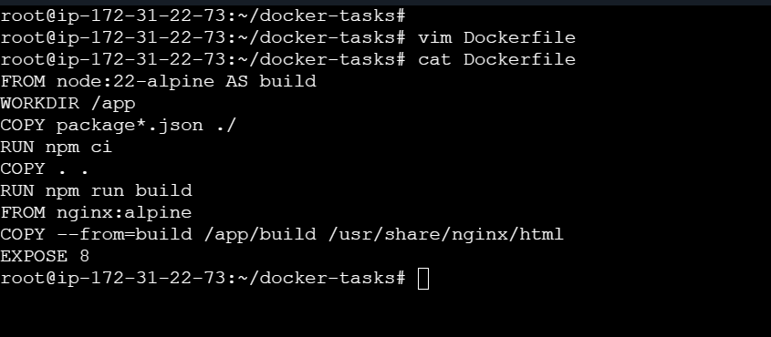Step 3: Build, Run, Push
Run from the frontend project root:
docker build -t swaroopkumar706/frontend-app:v1 .
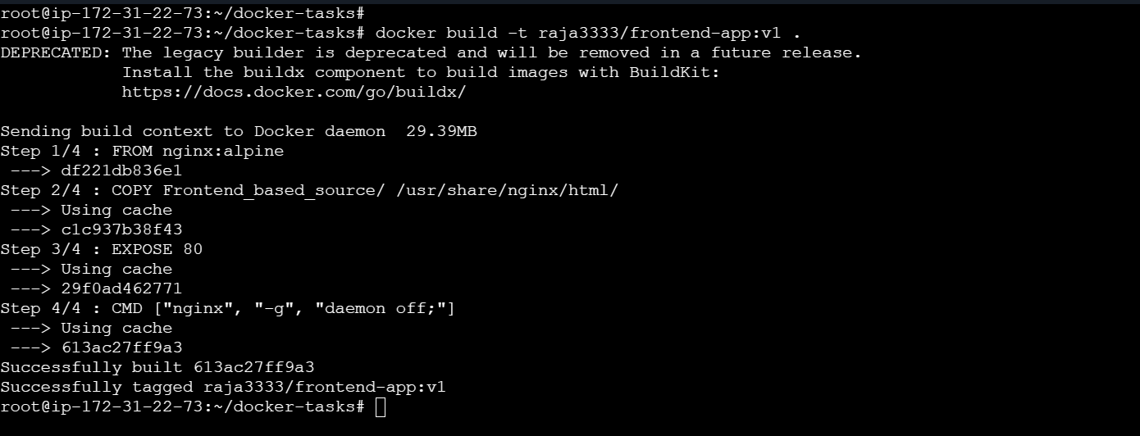
docker run -d --name frontend-app -p 8081:80 swaroopkumar706/frontend-app:v1
docker push swaroopkumar706/frontend-app:v1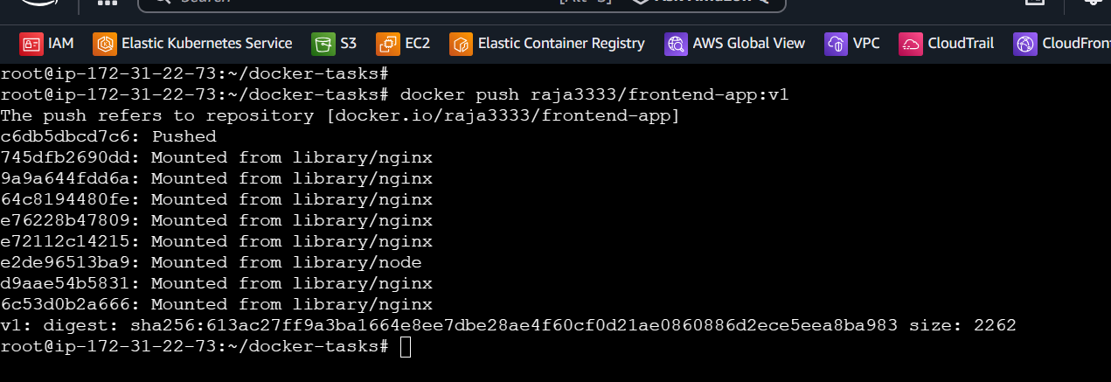

Validation Steps
- Container runs.
- http://localhost:8081 shows the frontend.
- Docker Hub contains frontend-app:v1.

Validation Screenshot



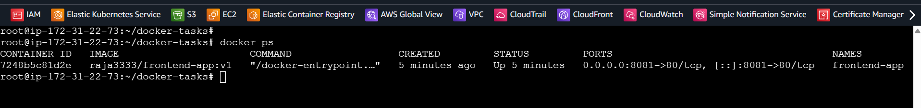

Explanation
A multi-stage build keeps build tools out of the final Nginx image and serves the static frontend.

Real-Time Use Case
Frontend teams commonly serve production assets from Nginx containers.

Common Errors and Troubleshooting
Error | Cause | Resolution
Build output missing | Framework uses a different output folder | Inspect package.json and use the correct build output, such as dist/.
npm ci fails | Lock file missing or inconsistent | Commit a matching package-lock.json and use the correct package manager.

Task 6: Build, Run, and Push the Java Image

Objective
Package Java application code and runtime dependencies into a portable container.

Prerequisites
- Java project inspected
- Docker running
- Docker Hub write access
- Java version and artifact type identified

Step-by-Step Implementation

Step 1: Inspect Java Project
Find Maven or Gradle files and confirm whether output is executable JAR or WAR:
find Java_based_source -maxdepth 4 -type f
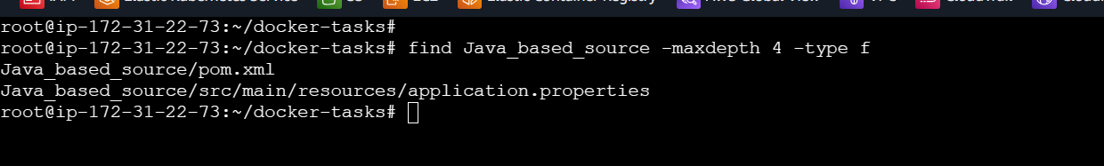

Step 2: Create Dockerfile
Example only for Maven, Java 17, and executable JAR output. Adapt to actual project:
FROM maven:3.9-eclipse-temurin-17 AS build
WORKDIR /src
COPY pom.xml .
COPY src ./src
RUN mvn -B clean package -DskipTests
FROM eclipse-temurin:17-jre
WORKDIR /app
COPY --from=build /src/target/*.jar app.jar
EXPOSE 8080
ENTRYPOINT ["java", "-jar", "app.jar"]

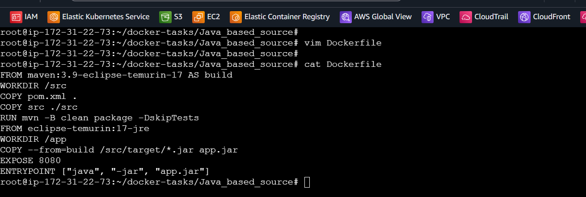

Step 3: Build, Run, Push
Run from the Java project root:
docker build -t swaroopkumar706/java-app:v1 .
docker run -d --name java-app -p 8082:8080 swaroopkumar706/java-app:v1
docker push swaroopkumar706

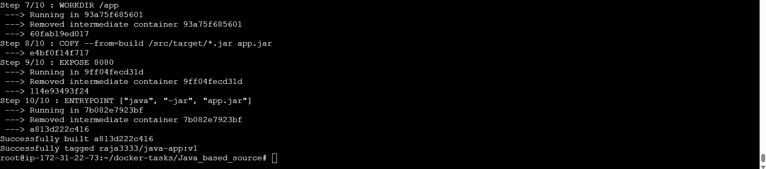
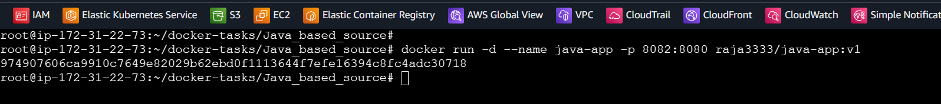

Validation Steps
- Container stays running.
- App responds at the actual route on localhost:8082.
- Docker Hub contains java-app:v1.

Validation Screenshot

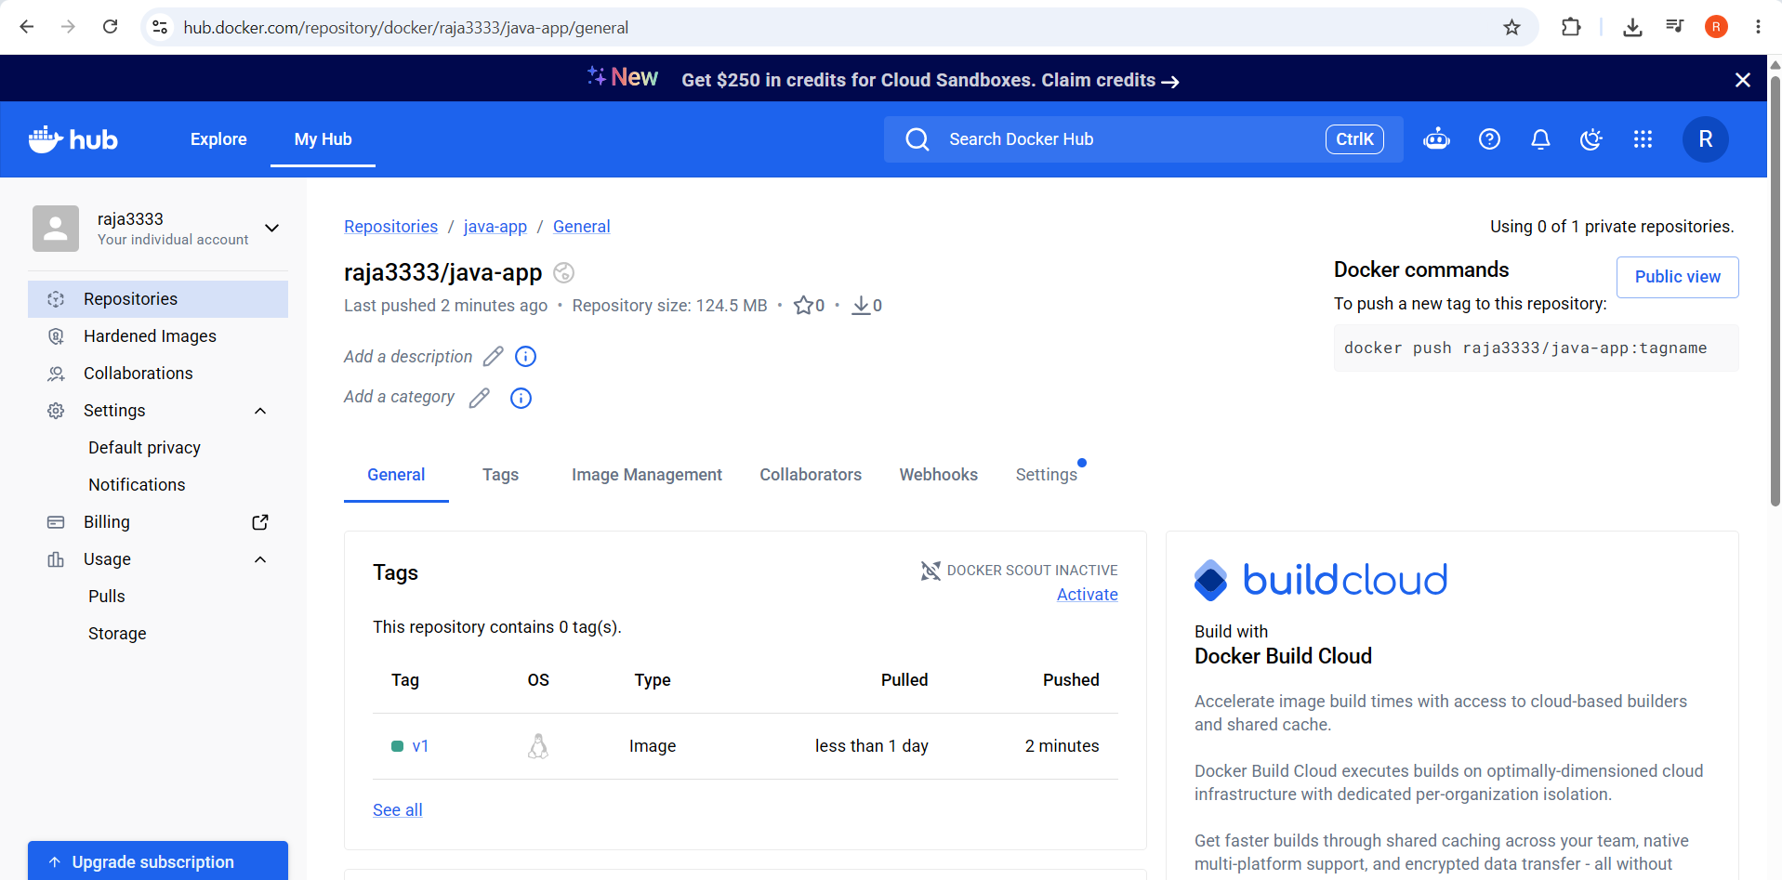

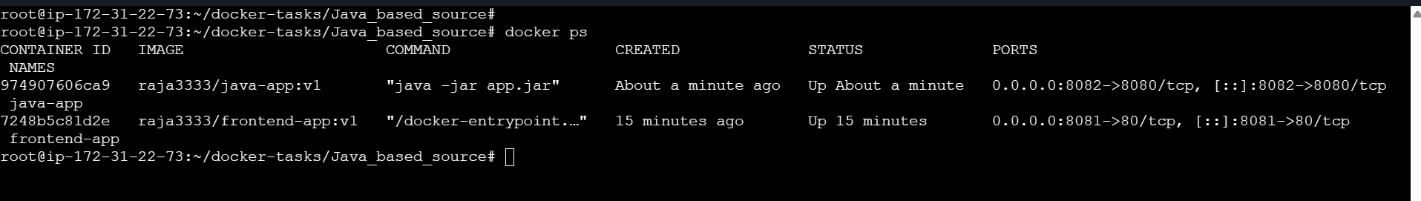
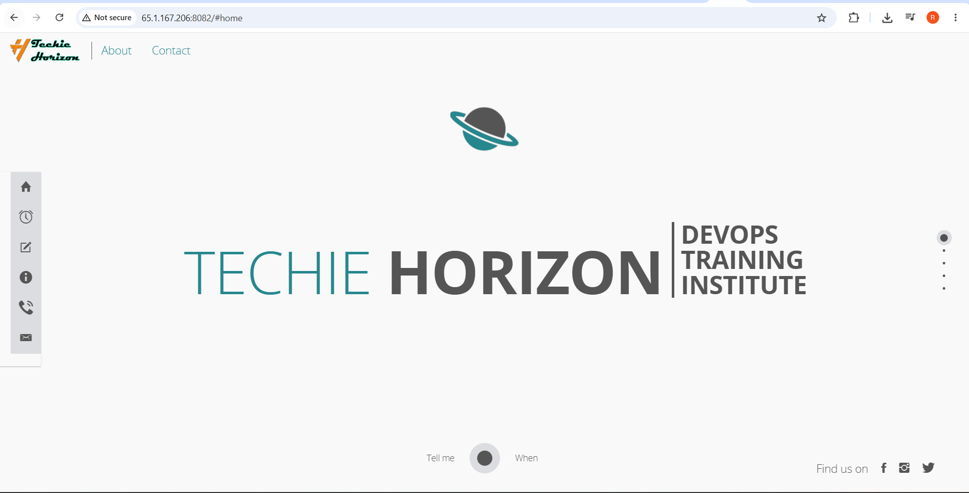

Explanation
A multi-stage build compiles with Maven and copies the artifact into a smaller JRE runtime image.

Real-Time Use Case
Java services are frequently shipped as container images for orchestration platforms.

Common Errors and Troubleshooting
Error | Cause | Resolution
No JAR found | Project creates WAR or other output | Inspect build configuration and adapt the runtime.
Container exits | Wrong Java version or artifact | Check docker logs and match runtime to the built artifact.

Task 7: Run, and Push Node.js Image with Tag v1

Objective
Package a Node.js application and production dependencies into a versioned image.

Prerequisites
- Node.js source inspected
- Docker running
- Docker Hub write access
- Start script and port identified

Step-by-Step Implementation

Step 1: Inspect Node.js Project
Inspect package.json and lock files:
find NodeJs_based_source -maxdepth 3 -type f

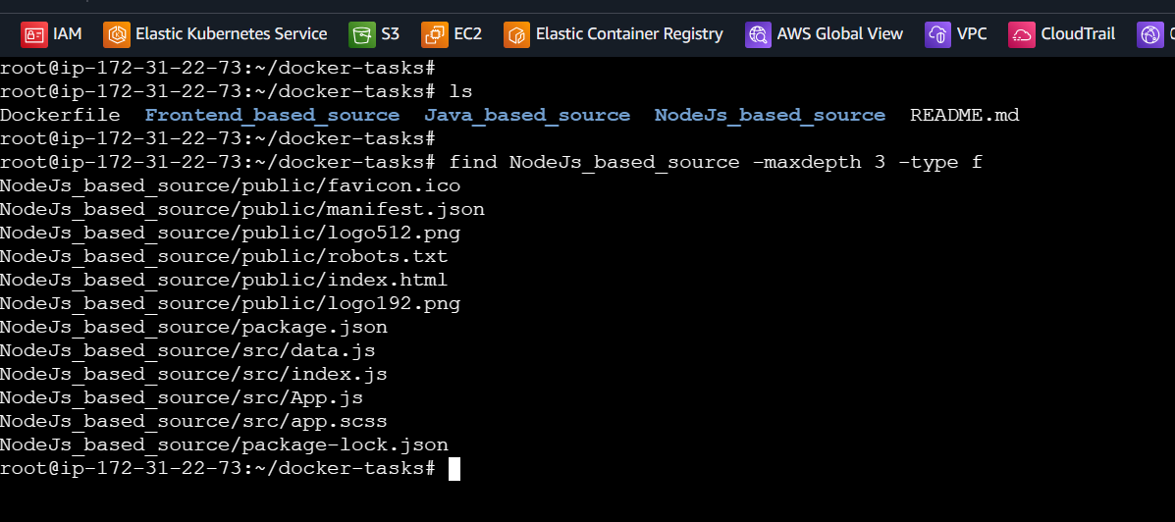

Step 2: Create Dockerfile
Example assumes npm start and port 3000. Adapt for TypeScript or other build output:
FROM node:22-alpine
WORKDIR /app
COPY package*.json ./
RUN npm ci --omit=dev
COPY . .
ENV NODE_ENV=production
EXPOSE 3000
CMD ["npm", "start"]

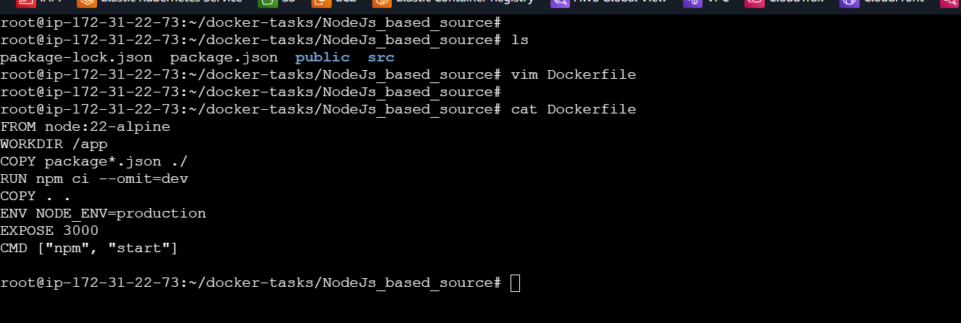

Step 3: Build with v1, Run, Push
Run from the Node.js project root:
docker build -t raja3333/node-app:v1 .
docker run -d --name node-app -p 8083:3000 raja3333/node-app:v1
docker push raja3333/node-app:v1

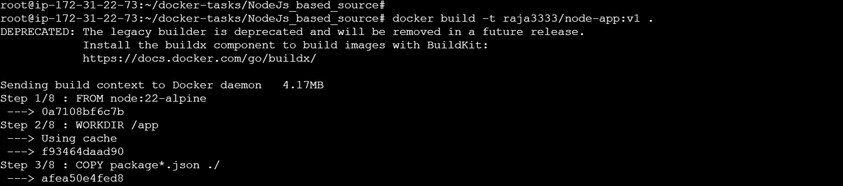
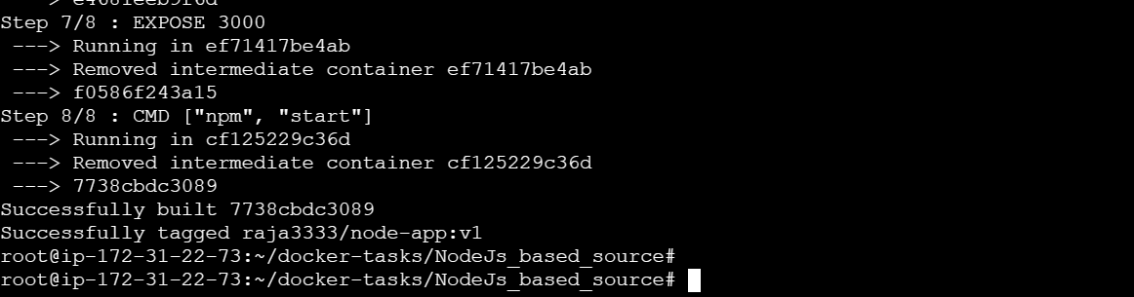
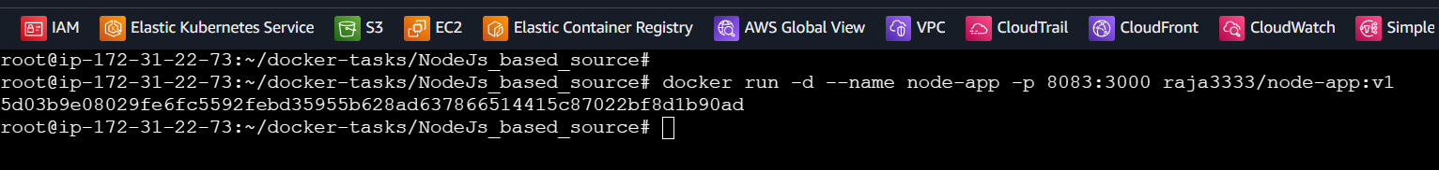

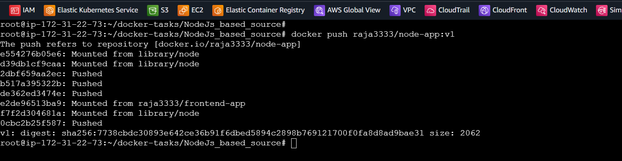

Validation Steps
- Container is running.
- Application responds at localhost:8083.
- Docker Hub contains node-app:v1.

Validation Screenshot



Explanation
The image contains Node.js and application files. The v1 tag identifies the required image version.

Real-Time Use Case
Node.js web apps and APIs are commonly deployed as versioned container images.

Common Errors and Troubleshooting
Error | Cause | Resolution
npm ci fails | package-lock.json absent | Generate and commit a lock file or use the package manager in the project.
Wrong port | App listens on another port | Update EXPOSE and port mapping to match the app.

Task 8: WordPress and MySQL with Docker Compose

Objective
Define a multi-container application, service network, startup dependency, and persistent volumes declaratively.

Prerequisites
- Docker Engine
- Docker Compose v2
- Host port 8084 available

Step-by-Step Implementation

Step 1: Create Lab Directory
Create and enter the folder:
mkdir wordpress-lab
cd wordpress-lab

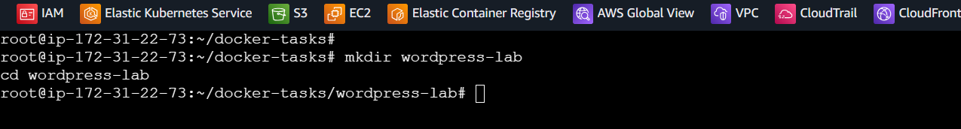

Step 2: Create compose.yaml
Create a db service using mysql:8.0 and a wordpress service using wordpress:latest. Use a private network, db_data and wordpress_data named volumes, database healthcheck, and WORDPRESS_DB_HOST=db:3306. Put separate strong passwords in a local .env file and never commit it.
nano compose.yaml

services:
db:
image: mysql:8.0
restart: unless-stopped
environment:
MYSQL_DATABASE: ${MYSQL_DATABASE}
MYSQL_USER: ${MYSQL_USER}
MYSQL_PASSWORD: ${MYSQL_PASSWORD}
MYSQL_ROOT_PASSWORD: ${MYSQL_ROOT_PASSWORD}
volumes:
- db_data:/var/lib/mysql
networks:
- wordpress_network
healthcheck:
test:
- CMD
- mysqladmin
- ping
- -h
- 127.0.0.1
- -u
- root
- --password=${MYSQL_ROOT_PASSWORD}
interval: 10s
timeout: 5s
retries: 12
start_period: 30s

wordpress:
image: wordpress:latest
restart: unless-stopped
depends_on:
db:
condition: service_healthy
ports:
- "8084:80"
environment:
WORDPRESS_DB_HOST: db:3306
WORDPRESS_DB_NAME: ${MYSQL_DATABASE}
WORDPRESS_DB_USER: ${MYSQL_USER}
WORDPRESS_DB_PASSWORD: ${MYSQL_PASSWORD}
volumes:
- wordpress_data:/var/www/html
networks:
- wordpress_network

volumes:
db_data:
wordpress_data:

networks:
wordpress_network:
driver: bridge

Screenshot Evidence

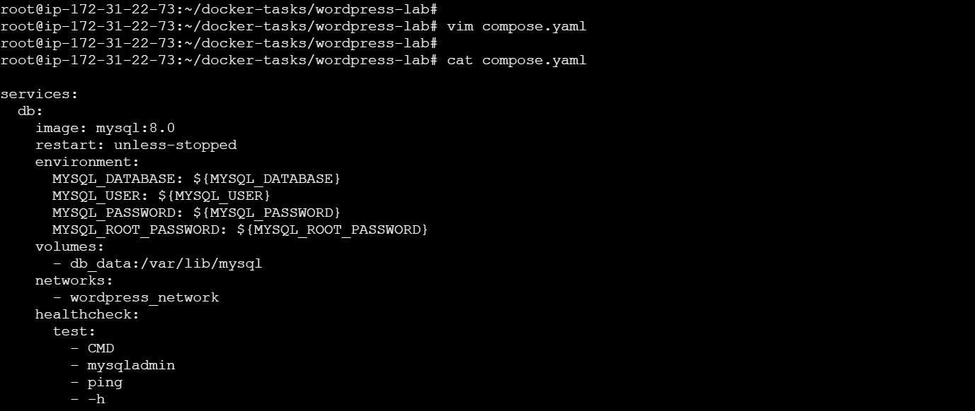

Step 3: Start Services
Run and inspect the services:
docker compose up -d
docker compose ps
docker compose logs -f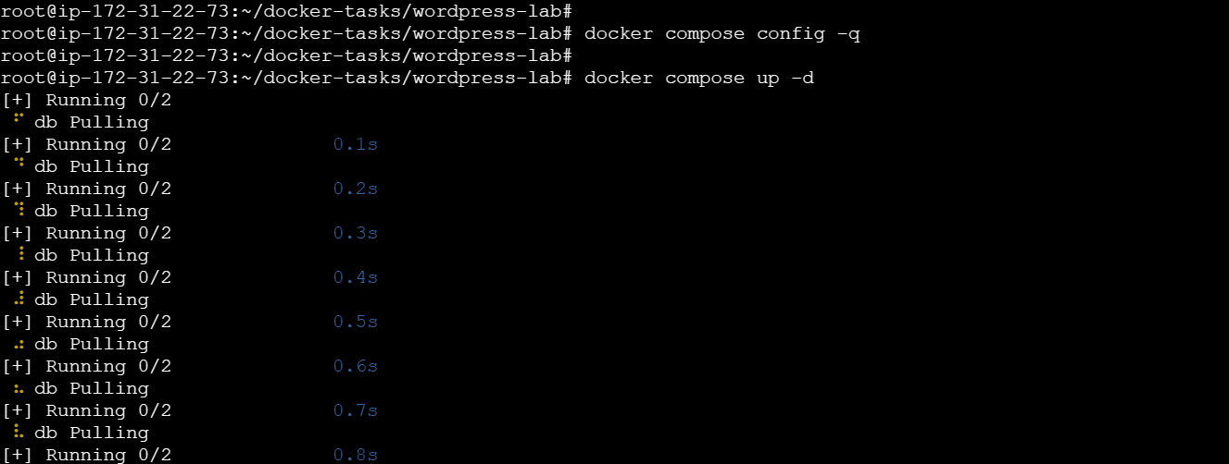
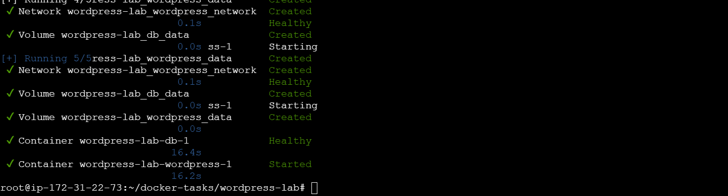
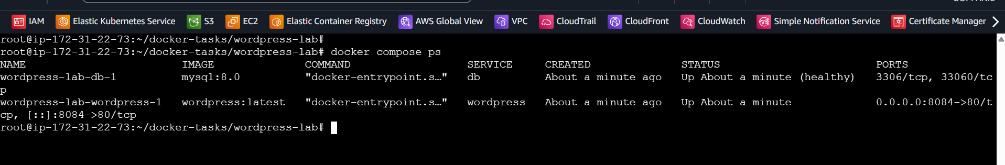
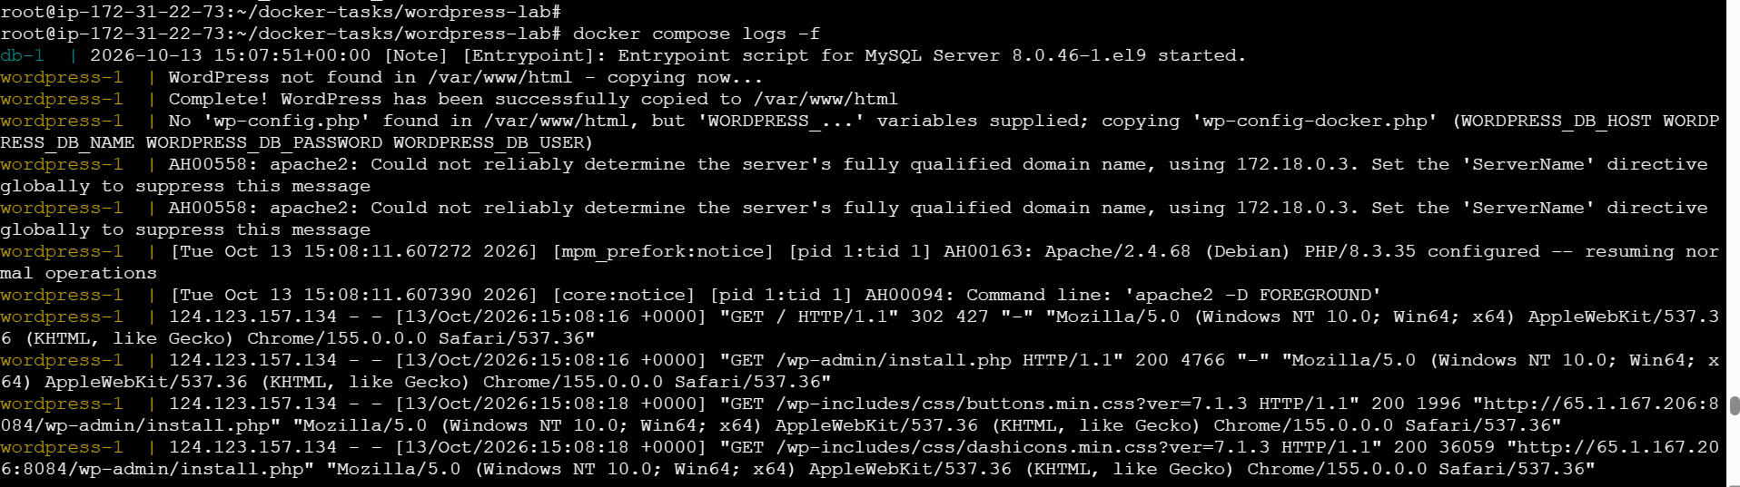

Step 4: Open WordPress
Open the setup page in a browser:
http://localhost:8084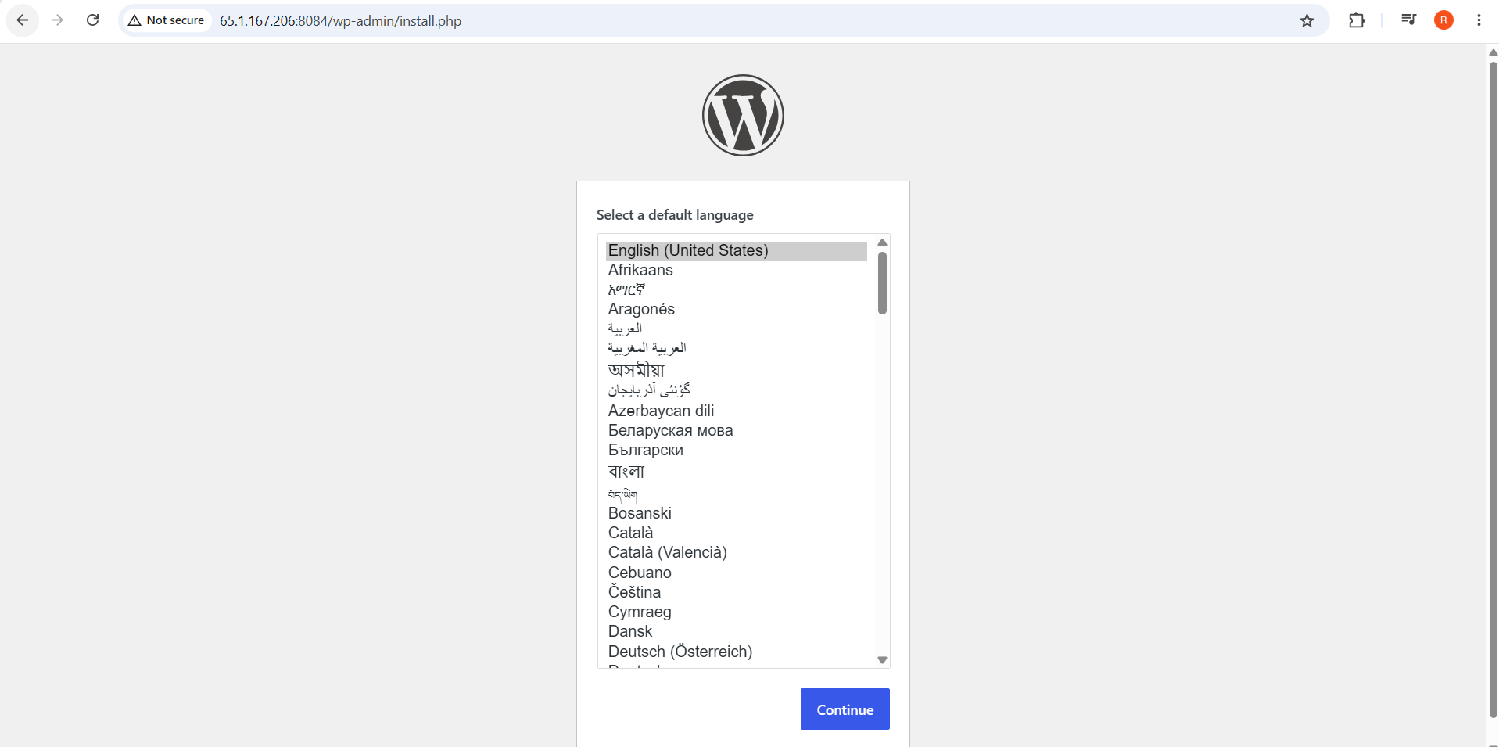

Validation Steps
- WordPress and MySQL show running/healthy.
- WordPress setup opens at localhost:8084.
- Named volumes preserve data after docker compose down.

Validation Screenshot

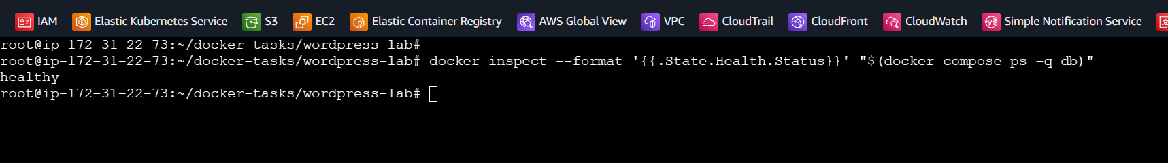

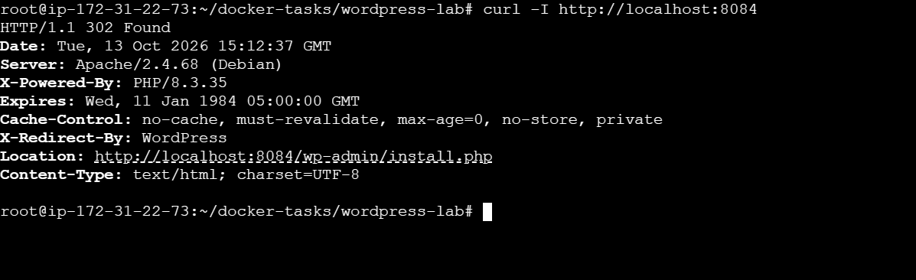

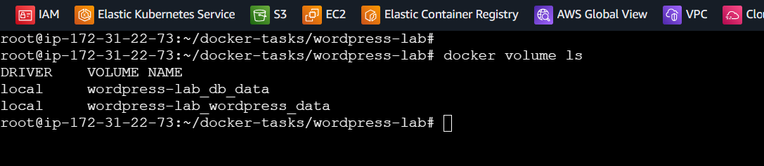

Explanation
Compose configures services, their network, database readiness, and named volumes. WordPress connects to MySQL using the service name db.

Real-Time Use Case
Compose is useful for local development and testing multi-container applications.

Common Errors and Troubleshooting
Error | Cause | Resolution
Database connection error | Wrong password or DB not ready | Check .env and docker compose logs db wordpress.
Port in use | Another process uses 8084 | Change the host port in compose.yaml.
Data removed | docker compose down -v used | Avoid -v unless intentionally deleting volumes.

