DOCKER-3
- Create a image from running container.

Task 1: Create an Image from a Running Container in Linux AMI

1. Objective
To create a new Docker image from an already running container in a Linux environment (Amazon Linux 2 / Amazon Linux 2023 EC2 instance).
Purpose: If we make manual changes inside a running container, we can save those changes into a new Docker image and reuse that image to launch new containers.
Example: Run an Nginx container, add a custom webpage, and create a new image containing that webpage.

2. Prerequisites
- An AWS EC2 instance running Amazon Linux 2 or Amazon Linux 2023.
- Docker installed and running.
- SSH access to the EC2 instance.
- Required security group rules for SSH (TCP 22).
- Internet access to download the Docker image, if needed.

3. Step-by-step implementation

Step 1: Connect to the Linux EC2 instance
From your local terminal, connect using SSH:
ssh -i your-key.pem ec2-user@<EC2-PUBLIC-IP>

Step 2: Install Docker
For Amazon Linux 2023:
sudo dnf update -y
sudo dnf install docker -y

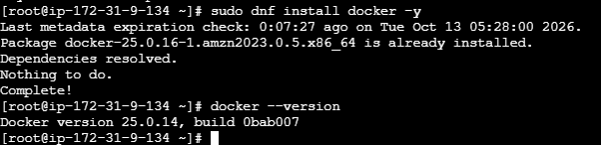
Start Docker and enable it at boot:
sudo systemctl enable --now docker
Verify Docker:
sudo docker --version
sudo docker info

Step 3: Download the Nginx image
sudo docker pull nginx:latest
Verify the image:
sudo docker images

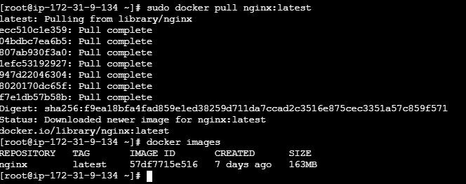

Step 4: Create a container
sudo docker run -d --name my-nginx nginx:latest
Check whether the container is running:
sudo docker ps

Expected output:
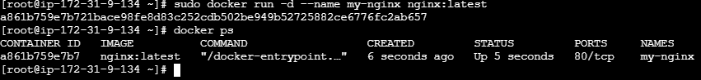

Step 5: Make a change inside the running container
Replace the default Nginx webpage with a custom webpage:
sudo docker exec my-nginx sh -c \
'echo "<h1>Hello from my custom Docker image</h1>" > /usr/share/nginx/html/index.html'
Verify the webpage:
sudo docker exec my-nginx cat /usr/share/nginx/html/index.html

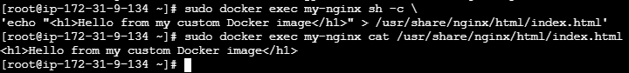

Step 6: Create an image from the running container
This is the main command for the task:
sudo docker commit my-nginx my-custom-nginx:v1
Explanation:
- docker commit — creates a new image from a container's current filesystem changes.
- my-nginx — name of the existing container.
- my-custom-nginx — name of the new image.
- v1 — image tag or version.

Step 7: Verify the new image
sudo docker images
Expected output:
REPOSITORY TAG IMAGE ID
my-custom-nginx v1 <image-id>
nginx latest <image-id>
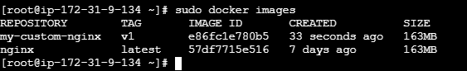
Step 8: Run a new container using the custom image
sudo docker run -d \
--name my-nginx-test \
-p 8080:80 \
my-custom-nginx:v1
Verify that it is running:
sudo docker ps

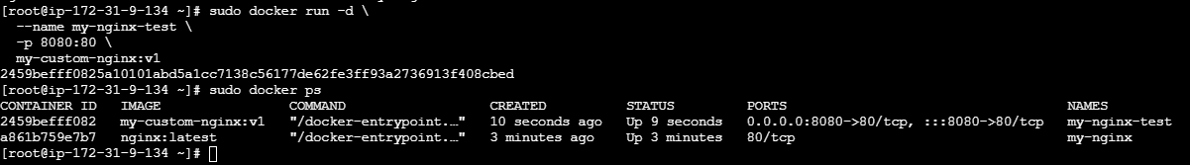

Step 9: Test the custom webpage
Run this command on the EC2 instance:
curl http://localhost:8080
Expected output:
<h1>Hello from my custom Docker image</h1>

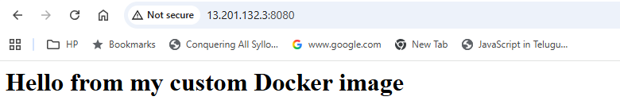
- Copy image from local machine to docker server and load the image.

Objective
To save a Docker image as a .tar archive on a local machine, transfer that archive to a remote Linux Docker server, and load the image into the Docker server without pulling it from Docker Hub.
Real-time scenario: You have created a custom Docker image on your laptop and need to deploy it on an AWS EC2 instance running Amazon Linux 2023. The server has no access to Docker Hub, so you transfer the image manually.

Prerequisites :
- Local machine with Docker installed.
- Remote Docker server running Amazon Linux 2 or Amazon Linux 2023.
- SSH access to the remote server.
- Private key file (.pem) for connecting to the EC2 instance.
- Docker installed and running on the remote server.
- Network connectivity between your local machine and the server, with SSH port 22 allowed.
- Sufficient disk space on both machines.

Step-by-step implementation
Local machine
Docker image → save as .tar file
Transfer image archive using SCP
myapp.tar
Remote Linux Docker server
Docker load → image becomes available locally

Step 1: Check the Docker image on your local machine
Open a terminal on your local machine and run:
docker images
Example output:
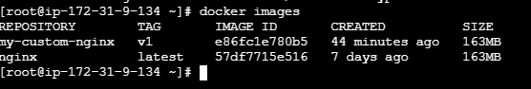
For this lab, we will transfer my-custom-nginx:v1.

Step 2: Save the Docker image as a TAR file
Run this command on your local machine:
docker save -o myapp.tar my-custom-nginx:v1
Explanation:
- docker save — exports an image and its layers.
- -o myapp.tar — specifies the output archive filename.
- my-custom-nginx:v1 — the image and tag to export.
Verify the file:
ls -lh myapp.tar
On Windows PowerShell, use:
Get-Item .\myapp.tar

Step 3: Connect to the remote Linux server
From your local machine, connect to the AWS EC2 instance:
ssh -i your-key.pem ec2-user@<EC2-PUBLIC-IP>
Replace the key filename and public IP with your actual values.
On the remote server, check Docker:
sudo docker --version
sudo systemctl status docker
If Docker is not installed on Amazon Linux 2023, install and start it:
sudo dnf install docker -y
sudo systemctl enable --now docker
Exit the remote SSH session before proceeding:
exit

Step 4: Copy the image archive to the Docker server
Run the following command on your local machine:
scp -i your-key.pem myapp.tar \
ec2-user@<EC2-PUBLIC-IP>:/home/ec2-user/
This copies myapp.tar into the remote user's home directory.
For Windows PowerShell, if OpenSSH is installed, the same scp syntax works.
Verify the transfer by connecting to the server:
ssh -i your-key.pem ec2-user@<EC2-PUBLIC-IP>
Then run:
ls -lh /home/ec2-user/myapp.tar

Step 5: Load the image into Docker on the remote server
This is the main command for the task. Run it on the remote Linux Docker server:
sudo docker load -i /home/ec2-user/myapp.tar
Expected output:
Loaded image: my-custom-nginx:v1

Docker now has the image available locally. It does not need to pull it from Docker Hub.

Step 6: Verify the loaded image
sudo docker images
Expected output:
REPOSITORY TAG IMAGE ID
my-custom-nginx v1 abc123456789

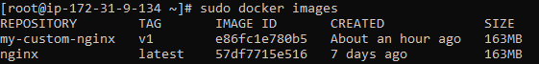
The image ID should match the image you exported, although the output format may vary.

Step 7: Run a container from the loaded image
sudo docker run -d \
--name myapp-container \
-p 8080:80 \
my-custom-nginx:v1
Verify the container:
sudo docker ps

Test Nginx locally on the remote server:
curl http://13.201.132.3:8080/

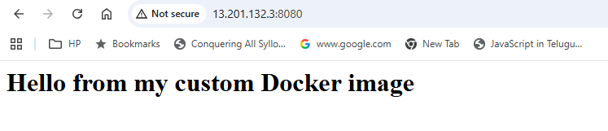
If the image contains the custom webpage from the previous lab, the response should show that webpage.
If you want to access the application through a browser, allow inbound TCP port 8080 in the EC2 security group, preferably restricted to your IP address.

4. Important commands to remember
Command | Purpose | Where to run
docker images | List images | Local or remote
docker save -o myapp.tar IMAGE:TAG | Export an image to a TAR archive | Local
scp ... | Transfer the archive over SSH | Local
docker load -i myapp.tar | Import the image into Docker | Remote
docker run IMAGE:TAG | Create and start a container | Remote
Important difference:
- docker save and docker load are used to transfer and restore Docker images.
- docker export and docker import are used to export and import container filesystems, and do not preserve the complete image history and metadata in the same way.

- Create Docker image using alpine and customize with tomcat.

Objective :
Create a custom Docker image based on Alpine Linux, install Java and Apache Tomcat inside it, and run a Tomcat container to deploy and access a sample web application.
By the end of this lab, you will understand how to:
- Use Alpine Linux as a lightweight base image.
- Install Java and Tomcat inside a Docker image.
- Create a custom image using a Dockerfile.
- Build and run a Docker container.
- Access the Tomcat application from a browser.

Prerequisites :
Requirement | Purpose
Linux EC2 instance or Linux machine | Docker host
Docker installed and running | Build and run images
SSH access | Connect to the EC2 instance
Security group inbound rule | Allow access to Tomcat on port 8080
Internet access | Download Alpine, Java, and Tomcat
Architecture
Dockerfile
Alpine Linux + Java + Tomcat
Custom Docker Image
alpine-tomcat:v1
Running Container
Host port 8080 → Container port 8080
Browser
http://13.201.132.3:8080/
Step-by-step implementation :

Step 1: Connect to your Docker server
Connect to your EC2 instance using SSH, then check Docker:
docker --version
sudo systemctl status docker
If Docker is not installed on Amazon Linux 2023:
sudo dnf install docker -y
sudo systemctl enable --now docker

Step 2: Create a project directory
mkdir -p ~/alpine-tomcat
cd ~/alpine-tomcat
Check your location:
pwd
Expected output will resemble:
/home/ec2-user/alpine-tomcat

Step 3: Create the Dockerfile
Create a file named Dockerfile:
vi Dockerfile
Add this content:

FROM alpine:3.22

RUN apk add --no-cache openjdk17-jre curl tar

RUN mkdir -p /opt/tomcat \
&& curl -fSL https://archive.apache.org/dist/tomcat/tomcat-10/v10.1.42/bin/apache-tomcat-10.1.42.tar.gz \
| tar -xz --strip-components=1 -C /opt/tomcat

RUN echo '<html><body><h1>Welcome to Alpine Tomcat Docker Lab!</h1></body></html>' \
> /opt/tomcat/webapps/ROOT/index.html

ENV JAVA_HOME=/usr/lib/jvm/java-17-openjdk
ENV CATALINA_HOME=/opt/tomcat
ENV PATH="${CATALINA_HOME}/bin:${PATH}"

EXPOSE 8080

CMD ["catalina.sh", "run"]
Save and exit Vim by pressing Esc, typing :wq, and pressing Enter.
Explanation of the Dockerfile
Instruction | Purpose
FROM alpine:3.22 | Uses lightweight Alpine Linux as the base image
RUN apk add | Installs Java 17, curl and tar
RUN curl ... | Downloads and extracts Tomcat
ENV | Configures Java and Tomcat environment variables
EXPOSE 8080 | Documents the port Tomcat uses
CMD | Starts Tomcat when the container runs
Tomcat runs in the foreground with catalina.sh run, allowing Docker to track the process.

Step 4: Build the custom Docker image
Run this command from the directory containing your Dockerfile:
sudo docker build -t alpine-tomcat:v1 .
Here:
- docker build builds an image.
- -t alpine-tomcat:v1 assigns the image name and tag.
- . tells Docker to use the current directory as the build context.
The first build downloads Alpine, Java dependencies and Tomcat, so it may take a few minutes.
Verify the image:
sudo docker images
Expected output will include a row similar to:
REPOSITORY TAG IMAGE ID SIZE
alpine-tomcat v1 <image-id> <size>

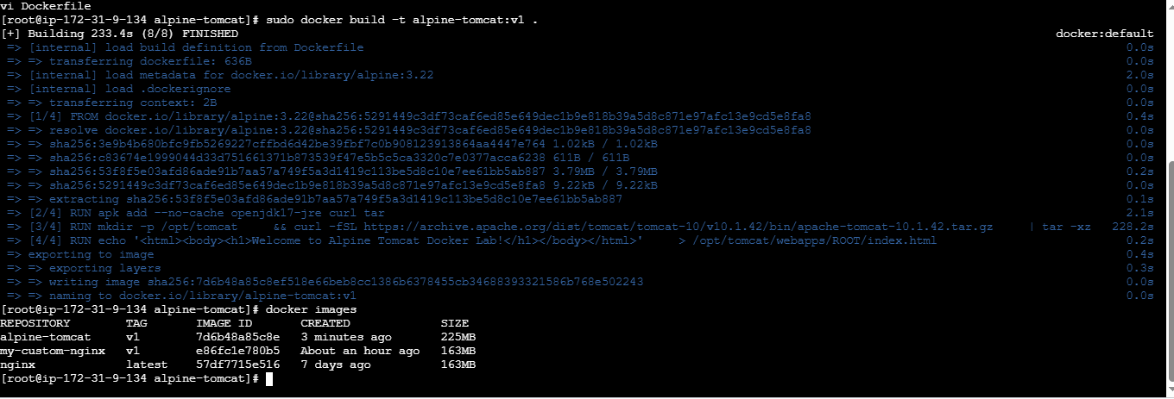

Step 5: Run a container
sudo docker run -d \
--name alpine-tomcat-container \
-p 8080:8080 \
alpine-tomcat:v1
Port mapping means:
- First 8080: port on the EC2 host.
- Second 8080: port inside the container.
Check whether the container is running:
sudo docker ps
Check its logs:
sudo docker logs alpine-tomcat-container
Look for Tomcat startup messages and a message indicating that the server started.

Step 6: Test Tomcat locally
On the EC2 instance, run:
curl -I http://localhost:8081/
Then check the custom page:
curl http://localhost:8081/
Expected response will contain:
<h1>Welcome to Alpine Tomcat Docker Lab!</h1>

Step 7: Access Tomcat from your browser
In the AWS EC2 console, open the instance's Security Group and add this inbound rule:
Setting | Value
Type | Custom TCP
Port | 8080
Source | My IP
Then open the following URL, replacing the placeholder with your EC2 public IP:
http://EC2-PUBLIC-IP:8080/
You should see the message:

Welcome to Alpine Tomcat Docker Lab!
Your custom application is running inside Tomcat in a Docker container.
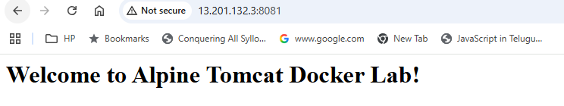

4. Troubleshooting
Problem | What to check
Image build fails | Check internet access and the Tomcat download URL
Container exits | Run sudo docker logs alpine-tomcat-container
Port 8080 already in use | Map a different host port, e.g. -p 8081:8080
Browser times out | Verify the Security Group inbound rule and public IP
docker permission denied | Run commands with sudo

5. Useful Docker commands
# List images
sudo docker images

# List running containers
sudo docker ps

# List all containers
sudo docker ps -a

# Stop the container
sudo docker stop alpine-tomcat-container

# Start the container again
sudo docker start alpine-tomcat-container

# Remove the container (must be stopped)
sudo docker rm alpine-tomcat-container

# Remove the custom image (after removing its container)
sudo docker rmi alpine-tomcat:v1

6. Interview questions
- What is Alpine Linux, and why is it used as a Docker base image?
- What is the difference between a Docker image and a container?
- What is the purpose of a Dockerfile?
- What is the difference between RUN and CMD?
- What is the difference between EXPOSE 8080 and -p 8080:8080?
- How do you check why a Docker container exited?
- How would you deploy a WAR file into Tomcat in this image?
Important: This is a learning lab. For production, use a maintained Tomcat version and a trusted, preferably digest-pinned base image. Also consider running Tomcat as a non-root user and using a multi-stage or otherwise minimized build.

- Create single stage and multi stage docker file using this source code:https://github.com/betawins/multi-stage-example.git
Source code: betawins/multi-stage-example on GitHub

Objective :
Build and compare two Docker images for the same Java application:
- Single-stage build: Uses one image environment to build and run the application.
- Multi-stage build: Uses a builder stage to compile the application and a separate runtime stage to run the packaged JAR.
The goal is to understand how multi-stage builds can reduce the final image size by excluding development tools such as the JDK and Maven from the runtime image. This is a standard Docker optimization technique.

GitHub
+1

Prerequisites :
Requirement | Purpose
Linux EC2 instance | Docker host
Docker installed and running | Build and run images
Git | Clone the source repository
Internet access | Download source code and dependencies
EC2 security group | Allow the application's port, if accessing it remotely
Check the tools:
docker --version
git --version
sudo systemctl status docker
If Git is missing on Amazon Linux 2023:
sudo dnf install git -y
For Docker commands, use sudo if your current user does not have Docker permissions.
The repository contains a Maven-based Spring Boot application, targets Java 8, and includes a Maven wrapper (mvnw). Its existing Dockerfile already uses named build stages, but both stages use the same builder image, so it doesn't achieve the full runtime-image separation we're going to demonstrate.
GitHub
+2

Step 1 — Clone the source code
Run on your EC2 instance:
mkdir -p ~/docker-lab
cd ~/docker-lab

git clone https://github.com/betawins/multi-stage-example.git
cd multi-stage-example
Verify the files:
ls -la
You should see files and directories similar to:
.mvn/
src/
mvnw
mvnw.cmd
pom.xml
Dockerfile
README.md
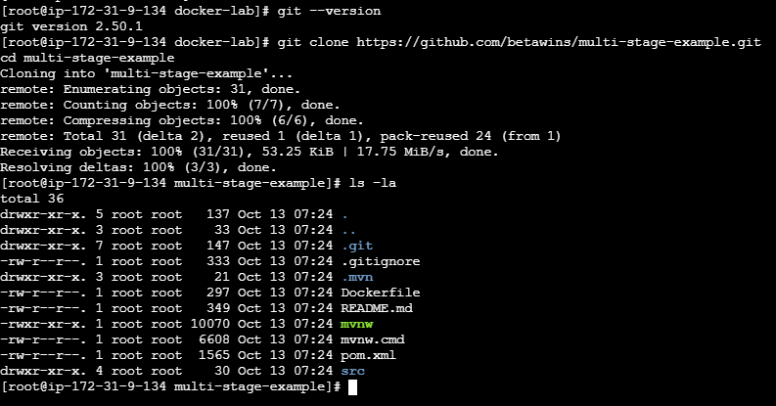
Check the Java version configured in Maven:
grep -n '<java.version>' pom.xml
Expected:
<java.version>1.8</java.version>

4. Step 2 — Create a single-stage Dockerfile
We'll keep the repository's original Dockerfile untouched and create a separate file named Dockerfile.single.
cat > Dockerfile.single <<'EOF'
FROM openjdk:8-jdk-alpine

WORKDIR /app

COPY . .

RUN chmod +x mvnw && ./mvnw clean package -DskipTests

EXPOSE 8080

ENTRYPOINT ["java", "-Djava.security.egd=file:/dev/./urandom", "-jar", "/app/target/multi-stage-example-0.0.1-SNAPSHOT.jar"]
EOF

Explanation
- FROM openjdk:8-jdk-alpine: Uses Java 8 JDK and Alpine Linux.
- WORKDIR /app: Sets the working directory.
- COPY . .: Copies the source code and Maven files into the image.
- RUN ...: Builds the application and creates the executable JAR.
- EXPOSE 8080: Documents the application's port.
- ENTRYPOINT: Starts the packaged Spring Boot application.
This image includes the JDK and build-time files alongside the application.

Build the single-stage image
sudo docker build -f Dockerfile.single -t multi-stage-single:v1 .
Check the result:
sudo docker images multi-stage-single

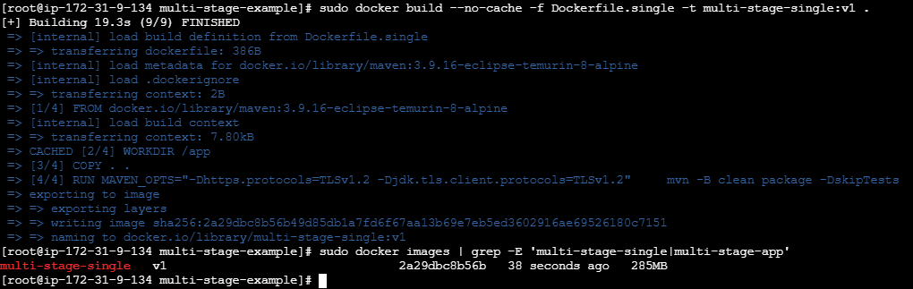

5. Step 3 — Create a multi-stage Dockerfile
Create a separate file named Dockerfile.multi:
cat > Dockerfile.multi <<'EOF'
FROM openjdk:8-jdk-alpine AS builder

WORKDIR /app

COPY . .

RUN chmod +x mvnw && ./mvnw clean package -DskipTests

FROM eclipse-temurin:8-jre-alpine AS runtime

WORKDIR /app

COPY --from=builder /app/target/multi-stage-example-0.0.1-SNAPSHOT.jar /app/app.jar

EXPOSE 8080

ENTRYPOINT ["java", "-Djava.security.egd=file:/dev/./urandom", "-jar", "/app/app.jar"]
EOF

Explanation

Stage 1: Builder
Uses a Java 8 JDK image, copies source code, runs Maven, and produces the executable JAR.
COPY --from=builder

Stage 2: Runtime
Uses a Java 8 JRE image and copies only the packaged JAR from the builder stage.
The key instruction is:
COPY --from=builder /app/target/multi-stage-example-0.0.1-SNAPSHOT.jar /app/app.jar
It copies the compiled JAR from the builder stage. The final image does not include the source tree, Maven wrapper, or JDK.

Build the multi-stage image
sudo docker build -f Dockerfile.multi -t multi-stage-app:v1 .
If the eclipse-temurin:8-jre-alpine image tag is unavailable, check the build error and choose a compatible Java 8 JRE image. Do not change the application's Java target without checking compatibility.

6. Step 4 — Compare image sizes
Run:
sudo docker images

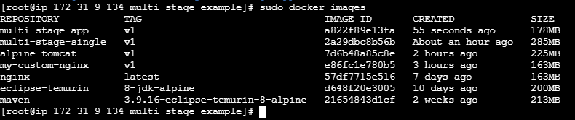
Or compare only the two images:
sudo docker image inspect multi-stage-single:v1 \
--format='Single-stage size: {{.Size}} bytes'

sudo docker image inspect multi-stage-app:v1 \
--format='Multi-stage size: {{.Size}} bytes'
The exact sizes depend on the base images and dependencies downloaded. The multi-stage image is expected to be smaller because it excludes the JDK and build environment.

7. Step 5 — Run both containers
Your earlier Docker lab already uses ports 8080 and 8081, so use 8082 and 8083 for this comparison.
Run the single-stage application:
sudo docker run -d \
--name spring-single \
-p 8082:8080 \
multi-stage-single:v1
Run the multi-stage application:
sudo docker run -d \
--name spring-multi \
-p 8083:8080 \
multi-stage-app:v1
Verify both:
sudo docker ps

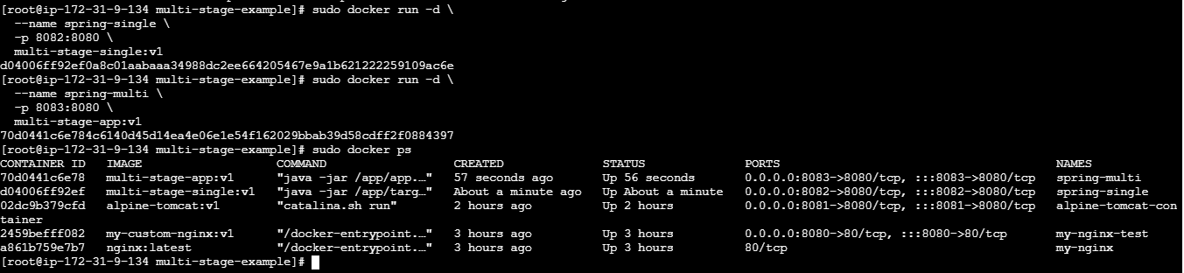
Check their logs:
sudo docker logs --tail 50 spring-single
sudo docker logs --tail 50 spring-multi

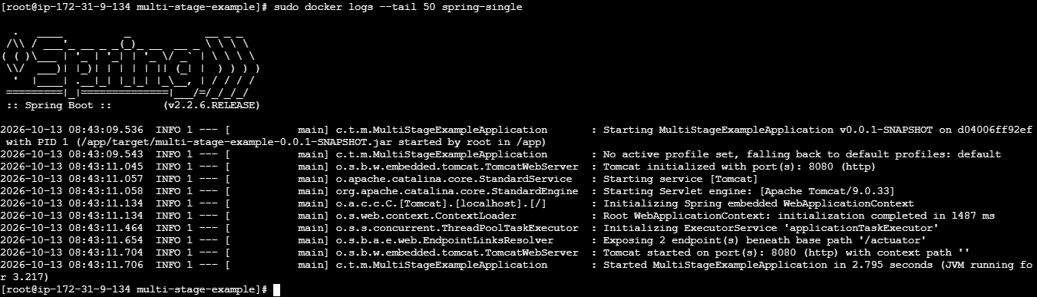

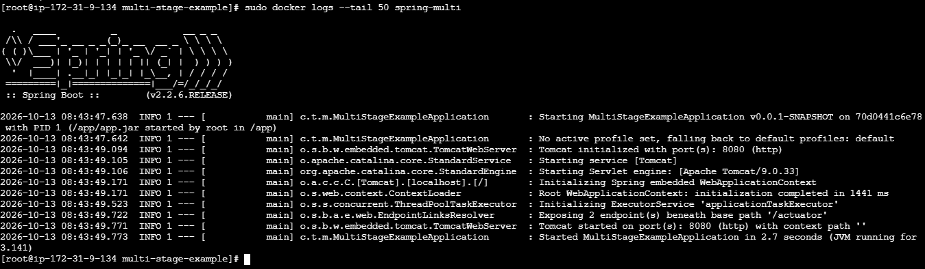

8. Step 6 — Test the applications
From the EC2 server:

curl -i --max-time 10 http://13.201.132.3:8082/
curl -i --max-time 10 http://13.201.132.3:8083/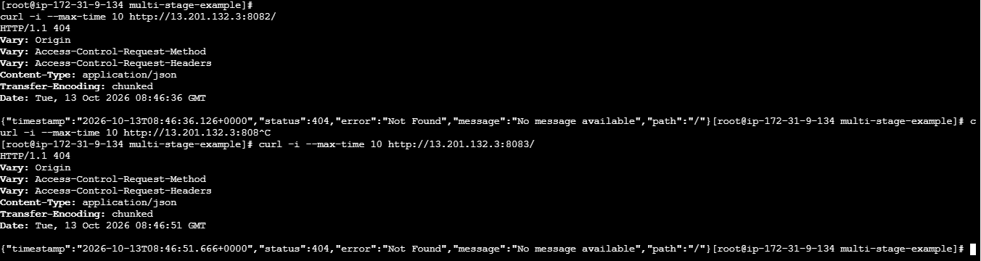
The response depends on the Spring Boot application's configured endpoints. If / returns 404, that does not necessarily mean the application failed to start; check the logs and available endpoints.

9. Step 7 — Cleanup
When the lab is complete:
sudo docker rm -f spring-single spring-multi
Remove the images if you no longer need them:
sudo docker rmi multi-stage-single:v1 multi-stage-app:v1

10. Single-stage vs. multi-stage — interview summary
Feature | Single-stage | Multi-stage
Build environments | One | Separate build and runtime
JDK in final image | Yes | No, if runtime uses JRE
Source and build files | Usually retained | Can be excluded
Final image size | Often larger | Often smaller
Security attack surface | Potentially larger | Can be reduced
Production suitability | Depends on needs | Generally preferred
Interview answer: “In a single-stage Docker build, we compile and package the application in the same image that runs it. In a multi-stage build, we compile using a builder image containing the JDK and Maven, then copy only the executable JAR into a smaller runtime image containing the JRE. This reduces the final image size and removes unnecessary build tools.”
For the general Docker multi-stage build pattern, see the official Docker documentation.

- Install docker compose and execute sample application.

Objective :
Install Docker Compose on your Amazon Linux EC2 instance and use it to deploy a sample application with multiple containers.
By completing this lab, you will learn how to:
- Install and verify Docker Compose.
- Create a compose.yaml file.
- Define application services, images, ports, and networking.
- Start, stop, and troubleshoot containers using Docker Compose.
- Access a sample web application from your browser.

Prerequisites :
Requirement | Details
EC2 instance | Amazon Linux 2023
Access | SSH with a working key pair
Docker | Installed and running
Permissions | Root or a user with Docker access
Security group | Allow inbound TCP port 8085 from your IP
Application | Nginx web server
Your existing Docker version is 25.0.14, so we'll use the Docker Compose plugin, which integrates with the Docker CLI.

Step-by-step implementation :

Step 1: Verify Docker is running
Execute on your EC2 instance:
docker --version
sudo systemctl status docker --no-pager
If Docker is stopped:
sudo systemctl enable --now docker

Step 2: Check whether Docker Compose is installed
docker compose version
If you see a version such as Docker Compose version v2.x.x, skip to Step 4.
If the command is unavailable, install the Compose plugin.

Step 3: Install Docker Compose
First, identify your EC2 architecture:
uname -m
Run the following installation commands for the common Amazon Linux 2023 x86-64 instance:
sudo mkdir -p /usr/local/lib/docker/cli-plugins

sudo curl -SL \
https://github.com/docker/compose/releases/latest/download/docker-compose-linux-x86_64 \
-o /usr/local/lib/docker/cli-plugins/docker-compose

sudo chmod +x /usr/local/lib/docker/cli-plugins/docker-compose
Verify the installation:
docker compose version

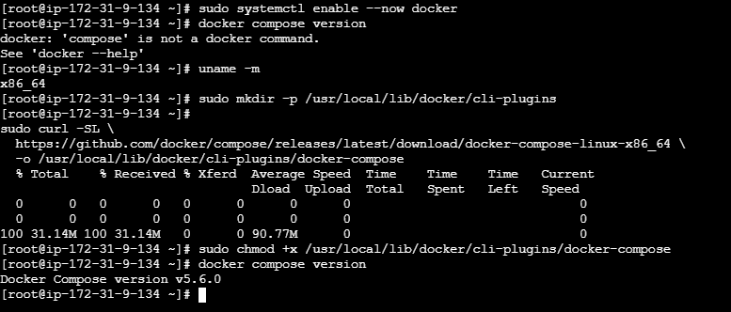
If your instance reports aarch64 rather than x86_64, use docker-compose-linux-aarch64 in the download URL.
Note: This installs the Compose CLI plugin system-wide. The modern command is docker compose with a space, rather than the legacy docker-compose command.

Step 4: Create a project directory
mkdir -p ~/compose-lab/html
cd ~/compose-lab
Create a sample HTML page:
cat > html/index.html <<'EOF'
<!DOCTYPE html>
<html>
<head>
<title>Docker Compose Lab</title>
</head>
<body>
<h1>Hello from Docker Compose!</h1>
<p>My sample application is running on Amazon Linux EC2.</p>
</body>
</html>
EOF

Step 5: Create the Compose file
Create compose.yaml:
cat > compose.yaml <<'EOF'
services:
web:
image: nginx:alpine
container_name: compose-web
ports:
- "8085:80"
volumes:
- ./html:/usr/share/nginx/html:ro
restart: unless-stopped
EOF
Understand the configuration:
Configuration | Purpose
services | Defines the application services
web | Name of the service
image | Uses the lightweight Nginx image
container_name | Assigns a container name
ports | Maps EC2 port 8085 to container port 80
volumes | Mounts the HTML directory into Nginx
:ro | Makes the mounted directory read-only
restart | Restarts the container unless explicitly stopped

Step 6: Validate the Compose file
sudo docker compose config
If the YAML configuration is valid, Compose prints the resolved configuration.

Step 7: Start the application
sudo docker compose up -d
The -d option runs the application in the background.
Expected behavior:
- Docker downloads the Nginx image if it is not already present.
- Compose creates the container.
- Port 8085 is mapped to Nginx port 80.
Check the running container:
sudo docker compose ps

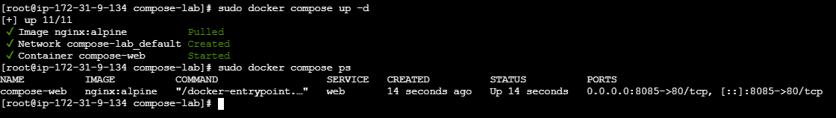
Check the logs:
sudo docker compose logs

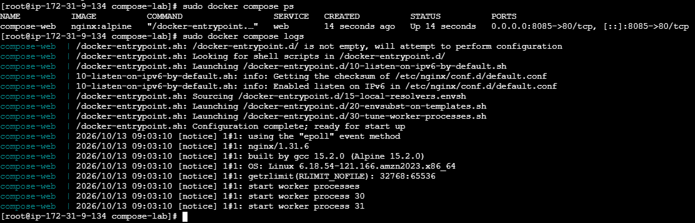

Step 8: Test the application
From your EC2 terminal:
curl -i http://localhost:8085/
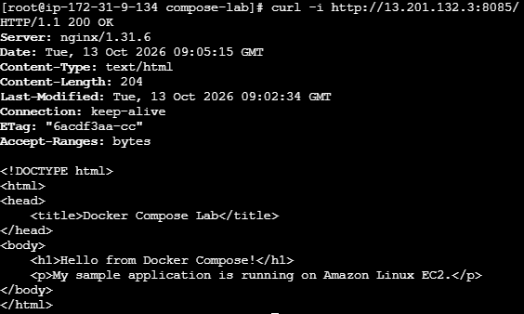
You should receive HTTP/1.1 200 OK and the HTML page containing:
Hello from Docker Compose!
You can also open the following URL in your browser:
http://YOUR_EC2_PUBLIC_IP:8085/
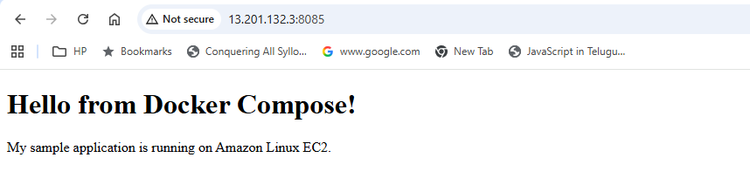
Replace YOUR_EC2_PUBLIC_IP with your instance's public IPv4 address. In the EC2 security group, allow inbound TCP port 8085 from your own public IP address.

Step 9: Update the application
Change the HTML page:
echo '<h1>Application updated using Docker Compose!</h1>' \
> html/index.html
Refresh the browser. The updated content should appear without rebuilding the image or recreating the container because the directory is bind-mounted.

Step 10: Stop and remove the application
Stop the service while retaining the container:
sudo docker compose stop
Start it again:
sudo docker compose start
Stop and remove the Compose-managed container and network:
sudo docker compose down
The Nginx image and your project files remain on the EC2 instance.

4. Docker Compose command reference
Command | Purpose
docker compose up -d | Create and start services
docker compose ps | Show Compose-managed containers
docker compose logs -f | Follow application logs
docker compose restart | Restart services
docker compose stop | Stop services
docker compose start | Start stopped services
docker compose down | Stop and remove containers and Compose network
docker compose pull | Download newer versions of configured images
docker compose config | Validate and display resolved configuration

5. Real-time DevOps example
Suppose a project has a frontend, backend API, and Redis cache. Instead of starting each container manually with separate docker run commands, you define the services in a single Compose file.
Compose can create the containers, configure their networking, apply environment variables, and start the application together. For production environments, teams may use Kubernetes or other orchestration platforms depending on their scale and requirements.
Lab completion checklist
Your progress
0 of 6
Docker service is running
Docker Compose version is verified
compose.yaml is created
Application starts successfully
Browser or curl returns HTTP 200
Application stops successfully using docker compose down

- Implement solution to scan images when pushed to docker registry.

Objective :
Implement automatic security scanning of Docker images whenever an image is pushed to a Docker registry. The scan identifies vulnerabilities in operating-system packages, application dependencies, and known CVEs (Common Vulnerabilities and Exposures).
Real-time DevOps example: A developer pushes application code to GitHub. Jenkins builds a Docker image, scans it for vulnerabilities, and pushes it to Docker Hub only if the scan passes the security policy.
For this lab, we'll use Docker Hub + Trivy. Trivy is an image vulnerability scanner, and Docker Hub is the registry. This is a practical way to learn the workflow without needing a paid registry feature.
1. Build Docker image
2. Scan image using Trivy
3. Apply security policy
Pass
Push image to registry
Fail
Stop the pipeline

Prerequisites :
- An Amazon Linux 2023 EC2 instance or another Linux server.
- Docker installed and running.
- A Docker Hub account and repository.
- Internet access to download the scanner and container images.
- An EC2 security group allowing SSH (port 22) for administration. No inbound application port is required for this scanning lab.
- Basic knowledge of Docker images, tags, and registries.
Check Docker:
docker --version
docker info
If Docker is not running:
sudo systemctl enable --now docker

Step-by-step implementation :

Step 1: Install Trivy
On Amazon Linux 2023, run:
sudo dnf install -y curl tar gzip
curl -sfL https://raw.githubusercontent.com/aquasecurity/trivy/main/contrib/install.sh \
| sudo sh -s -- -b /usr/local/bin
Verify the installation:
trivy –version

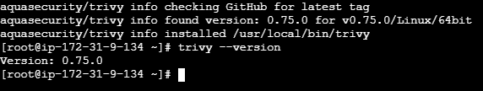
If the installation script fails, check internet access and the command output before continuing.

Step 2: Create a sample application
mkdir -p ~/image-scan-lab
cd ~/image-scan-lab
Create a Dockerfile:
cat > Dockerfile <<'EOF'
FROM nginx:alpine
COPY index.html /usr/share/nginx/html/index.html
EOF
Create a sample web page:
cat > index.html <<'EOF'
<html>
<body>
<h1>Docker Image Security Scan Lab</h1>
<p>Image scanned with Trivy.</p>
</body>
</html>
EOF

Step 3: Build the Docker image
docker build -t swaroopkumar706/image-scan-lab:v1 .
Verify:
docker images
Expected: an image named image-scan-lab with tag v1.
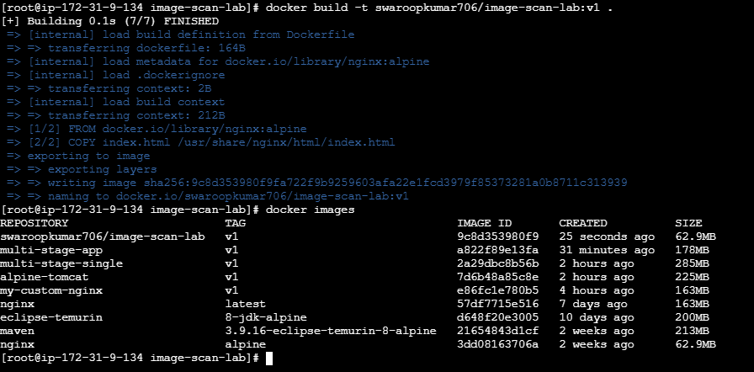

Step 4: Scan the image for vulnerabilities
First, run a full scan:
trivy image YOUR_DOCKERHUB_USERNAME/image-scan-lab:v1

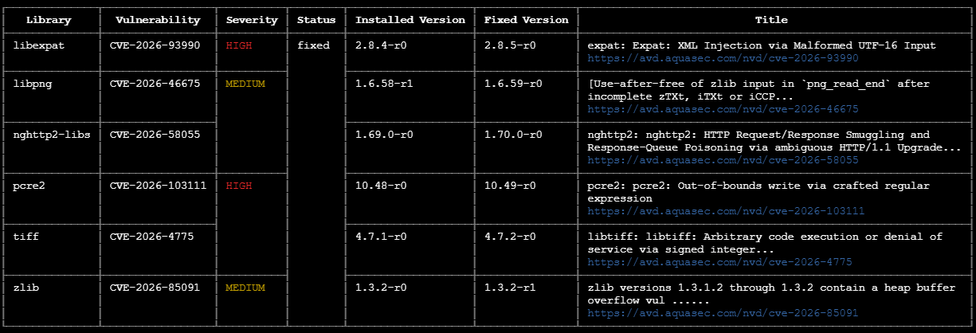
Trivy downloads its vulnerability database and checks the image's operating-system packages and supported application dependencies.
To focus on high and critical vulnerabilities:
trivy image \
--severity HIGH,CRITICAL \
YOUR_DOCKERHUB_USERNAME/image-scan-lab:v1
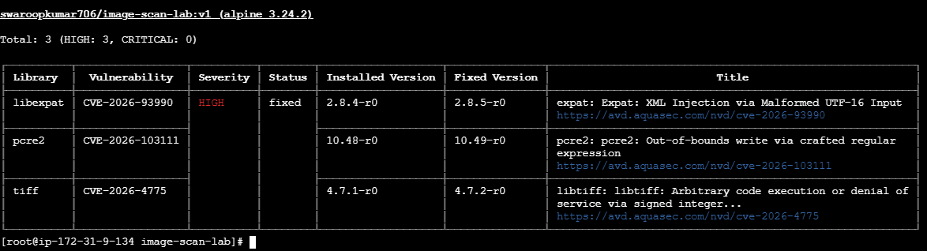
Example of the type of information you may see:
Package | Vulnerability | Severity
Example package | CVE-XXXX-XXXX | HIGH
Example library | CVE-XXXX-YYYY | CRITICAL
These are illustrative examples, not actual findings from your image.

Step 5: Fail the scan if high or critical vulnerabilities exist
In a real CI/CD pipeline, we normally block the image from being published if the scan finds vulnerabilities above our accepted threshold.
Run:
trivy image \
--severity HIGH,CRITICAL \
--exit-code 1 \
YOUR_DOCKERHUB_USERNAME/image-scan-lab:v1

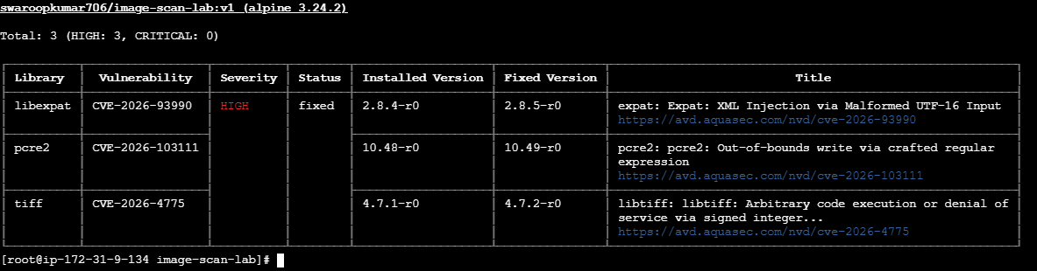
How --exit-code 1 works:
- If no HIGH or CRITICAL findings are detected, Trivy exits successfully with code 0.
- If HIGH or CRITICAL findings are detected, Trivy exits with code 1.
The scan command may return a failure even though the image was built successfully. This is intentional: it acts as a security gate.

Step 6: Log in to Docker Hub
Create a Docker Hub access token in your account settings. Use the token instead of your account password.
docker login --username swaroopkumar706
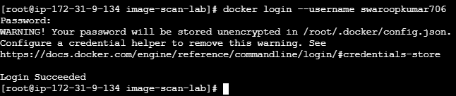
Enter the access token when prompted for a password. Avoid placing tokens directly in shell commands, scripts, or source control.

Step 7: Push the image only if the scan passes
Run the following commands in the same terminal session:
IMAGE="YOUR_DOCKERHUB_USERNAME/image-scan-lab:v1"

if trivy image --severity HIGH,CRITICAL --exit-code 1 "$IMAGE"; then
echo "Security scan passed. Pushing image..."
docker push "$IMAGE"
else
echo "Security scan failed. Image will NOT be pushed."
exit 1
fi
This implements the key security rule: the image is pushed only if the configured vulnerability scan passes.

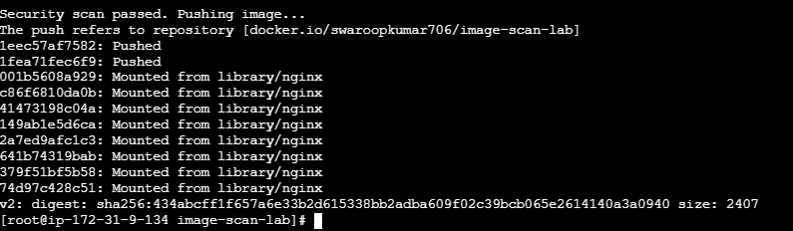

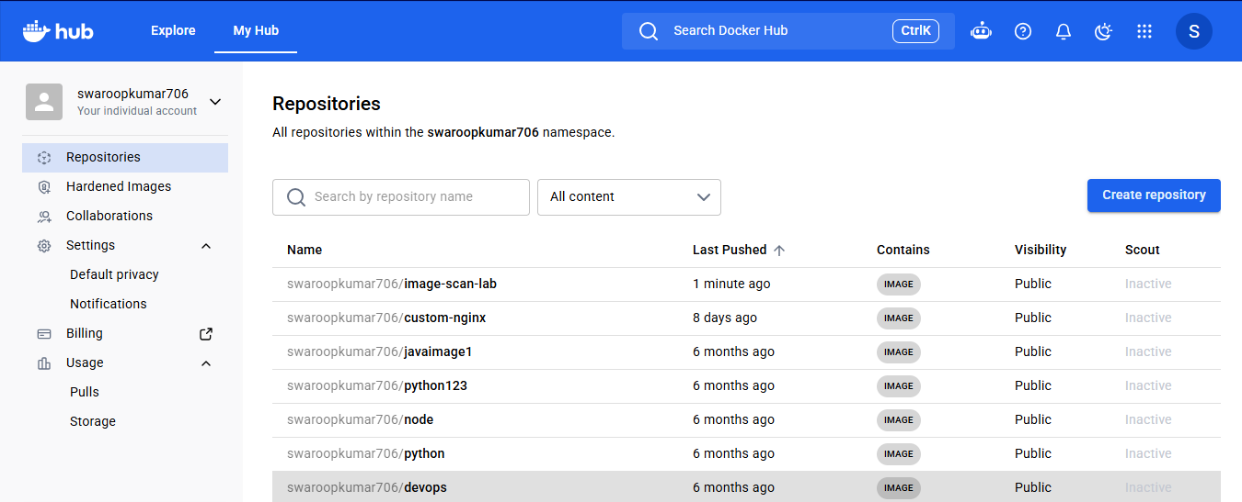

Step 8: Verify the image in Docker Hub
Open Docker Hub, sign in, and open your repository. Verify that the v1 tag is present after a successful push.
You can also check locally:
docker image inspect YOUR_DOCKERHUB_USERNAME/image-scan-lab:v1

4. How does scanning happen automatically?
The commands above implement a scan-before-push security gate. They do not, by themselves, detect an arbitrary image pushed by another person or process.
For automatic handling of registry pushes, you need a trigger and a scanner workflow. A common DevOps implementation is:
1. Developer pushes code
GitHub repository receives a commit.
2. Jenkins pipeline starts
Triggered by a GitHub webhook or another configured build trigger.
3. Build the Docker image
Assign a version tag to the image.
4. Trivy scans the image
The security gate checks the configured severity threshold.
5. Push or reject
Push to Docker Hub if the scan passes; fail the pipeline otherwise.
If your requirement is specifically “scan after an image is already pushed to Docker Hub,” configure a Docker Hub registry webhook to notify a webhook receiver or Jenkins job. That workflow should identify the pushed image tag, pull the image, run Trivy, and report or enforce the result. A registry webhook alone only sends a notification; it does not run Trivy automatically.

5. Interview explanation
Question: How do you scan Docker images for vulnerabilities in a real-time DevOps project?
Answer: “We integrate Trivy into our Jenkins CI/CD pipeline. After building the Docker image, Jenkins scans it for known vulnerabilities. We configure the pipeline to fail if HIGH or CRITICAL vulnerabilities are found. Only images that pass the security gate are pushed to the Docker registry. This helps prevent vulnerable images from being released. We can also use registry webhooks to trigger scanning of images that have already been pushed.”
Important: Trivy detects known vulnerabilities, but it cannot guarantee that an image is completely secure. Keep the scanner database updated, patch vulnerable dependencies, and apply an agreed security policy.

- Implement solution to scan images when pushed to AWS ECR.

Objective :
Configure Amazon Elastic Container Registry (Amazon ECR) to scan Docker images for known vulnerabilities whenever an image is pushed to a repository.
We will use Amazon ECR enhanced scanning with Amazon Inspector where available, or ECR basic scanning as an alternative. We'll also configure an EventBridge event to react to image-push scan results, so the workflow can notify your team or trigger further actions.
The key difference from your previous Trivy lab is that AWS can scan images inside ECR without requiring you to run a separate Trivy command on your EC2 instance.
1. Build Docker image
2. Push image to Amazon ECR
3. ECR / Amazon Inspector scans
4. EventBridge receives scan findings
Important: ECR scanning after a push detects and reports vulnerabilities; it does not automatically reject the push. To block vulnerable images before deployment, add a policy check in Jenkins or your deployment pipeline.

Prerequisites :
Requirement | Purpose
AWS account | Create and manage ECR
AWS CLI v2 | Configure ECR from the terminal
Docker | Build, tag, and push the image
IAM permissions | Create repositories, authenticate, push images, and view scan findings
AWS Region | Use the same region for ECR commands and the repository
We'll use ap-south-1 (Mumbai) and your sample image name image-scan-lab.
For this first lab, we'll configure ECR basic scanning on push. Basic scanning is suitable for learning how to automatically scan supported operating-system package vulnerabilities. Enhanced scanning through Amazon Inspector can additionally cover supported programming-language dependencies and continuous rescanning.

Amazon Inspector

Step-by-step implementation :

Step 1: Verify AWS CLI and permissions
Run these commands on your EC2 instance:
aws --version
docker --version
aws sts get-caller-identity
The last command should return your AWS account ID and the identity associated with your credentials.
Set the region and retrieve the account ID:
export AWS_REGION=ap-south-1

export AWS_ACCOUNT_ID=$(aws sts get-caller-identity \
--query Account --output text)

echo "$AWS_ACCOUNT_ID"
echo "$AWS_REGION"

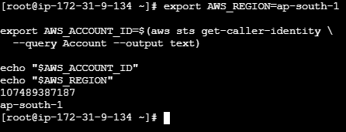
If aws sts get-caller-identity fails, fix your AWS CLI credentials or EC2 instance role before continuing. For an EC2-hosted lab, an attached IAM role is preferable to storing long-lived access keys.
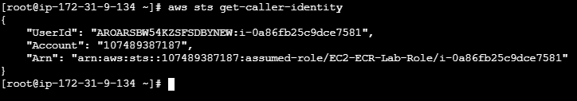

Step 2: Create an ECR repository with scan-on-push enabled
Run:
aws ecr create-repository \
--repository-name image-scan-lab \
--image-scanning-configuration scanOnPush=true \
--region "$AWS_REGION"
This creates a private repository and enables image scanning when images are pushed.
If the repository already exists, configure scanning on the existing repository instead:
aws ecr put-image-scanning-configuration \
--repository-name image-scan-lab \
--image-scanning-configuration scanOnPush=true \
--region "$AWS_REGION"
Verify the configuration:
aws ecr describe-repositories \
--repository-names image-scan-lab \
--region "$AWS_REGION" \
--query 'repositories[0].{Name:repositoryName,URI:repositoryUri,ScanOnPush:imageScanningConfiguration.scanOnPush}'
Expected: ScanOnPush should be true.
Amazon ECR supports creating repositories and configuring image scanning through the AWS CLI.
Amazon ECR
+1

Step 3: Authenticate Docker to ECR
aws ecr get-login-password --region "$AWS_REGION" |
docker login \
--username AWS \
--password-stdin \
"$AWS_ACCOUNT_ID.dkr.ecr.$AWS_REGION.amazonaws.com"
Expected:
Login Succeeded

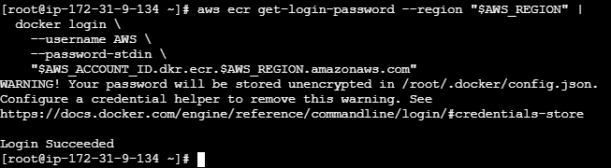
The ECR login token is provided by AWS CLI and passed to Docker through standard input.
Amazon ECR

Step 4: Tag your existing Docker image
Check whether your previous image exists locally:
docker images
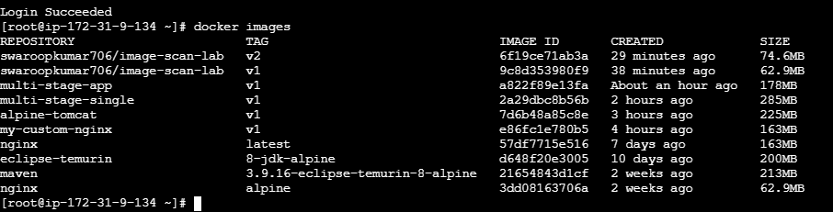
If you have swaroopkumar706/image-scan-lab:v1, tag it for ECR:
export ECR_URI="$AWS_ACCOUNT_ID.dkr.ecr.$AWS_REGION.amazonaws.com/image-scan-lab"

docker tag \
swaroopkumar706/image-scan-lab:v1 \
"$ECR_URI:v1"
If you have built a newer image such as v2, use that local tag instead.

Step 5: Push the image to ECR
docker push "$ECR_URI:v1"

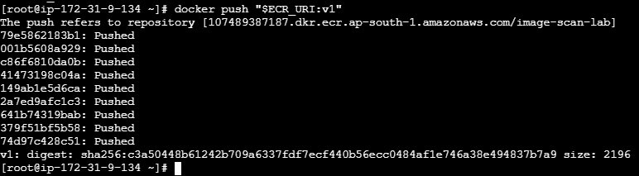
Once the image is pushed, ECR automatically initiates the configured scan. You do not need to run Trivy separately to trigger this ECR scan.

Step 6: Check the image scan status and findings
First, retrieve the image digest:
aws ecr describe-images \
--repository-name image-scan-lab \
--image-ids imageTag=v1 \
--region "$AWS_REGION"
Then retrieve the scan results:
aws ecr describe-image-scan-findings \
--repository-name image-scan-lab \
--image-id imageTag=v1 \
--region "$AWS_REGION"
The scan may take some time to complete. If the results are not ready yet, retry the findings command after a short wait.
To display only the scan status and vulnerability counts:
aws ecr describe-image-scan-findings \
--repository-name image-scan-lab \
--image-id imageTag=v1 \
--region "$AWS_REGION" \
--query 'imageScanStatus.status'
For the vulnerability counts:
aws ecr describe-image-scan-findings \
--repository-name image-scan-lab \
--image-id imageTag=v1 \
--region "$AWS_REGION" \
--query 'imageScanFindings.findingSeverityCounts'
If your repository is configured for enhanced scanning instead, use Amazon Inspector's findings and coverage views; the basic-scanning findings command is not the general interface for enhanced scanning.

4. Verify from the AWS Console
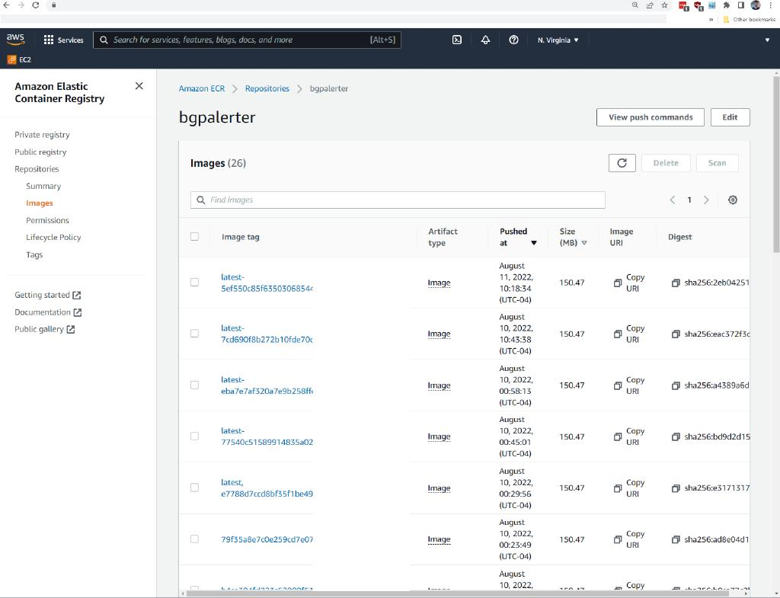
1. Open Amazon ECR
Go to the Amazon ECR console and select the Mumbai region.
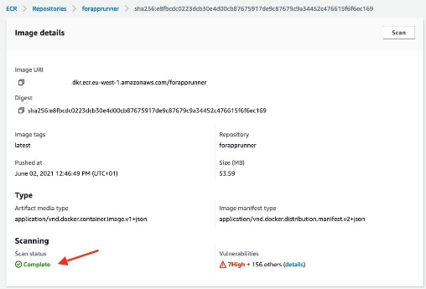
2. Open your repository
Select image-scan-lab, then open the image tagged v1 and view its scan findings.

5. Optional: Send scan-result events to EventBridge
If you want an automated notification or a follow-up action after scanning, configure an Amazon EventBridge rule for completed basic scans.
Example event pattern:
{
"source": ["aws.ecr"],
"detail-type": ["ECR Image Scan"],
"detail": {
"scan-status": ["COMPLETE"]
}
}
You can configure the rule's target to be an SNS topic for email notifications or a Lambda function for custom processing. For enhanced scanning, Amazon Inspector emits scan-completion and finding events to EventBridge.
Amazon ECR
+1

6. Expected result
- Image is pushed successfully to ECR.
- ECR automatically starts the configured scan.
- Vulnerability counts and findings become available after scanning completes.
- EventBridge can notify another service about scan results.
Production best practice: Automatic scanning is not the same as blocking vulnerable images. For a secure deployment pipeline, configure Jenkins to check the findings and fail the release when your agreed severity threshold is exceeded.
Cost note: ECR basic scanning and enhanced scanning have different pricing models. Check the Amazon ECR pricing and Amazon Inspector pricing pages before enabling enhanced scanning for production workloads.

- Create a Jenkins pipeline to create a docker image and push the image to Docker hub.

Objective :
Create a Jenkins Declarative Pipeline that automatically:
- Downloads application source code from GitHub.
- Builds a Docker image using a Dockerfile.
- Logs in securely to Docker Hub using Jenkins credentials.
- Tags the image with a version.
- Pushes the image to Docker Hub.
- Displays the build result in Jenkins.
Real-time DevOps workflow:
GitHub Repository
Application code and Dockerfile
Jenkins Pipeline
Clone → Build → Tag → Push
Docker Hub
Versioned Docker image available for deployment

Prerequisites :
- A running Jenkins controller.
- A Jenkins agent with Docker CLI installed and permission to access the Docker daemon.
- Git installed on the agent.
- A GitHub repository containing application files and a Dockerfile.
- A Docker Hub account and repository.
- A Docker Hub access token saved in Jenkins Credentials.
- Network connectivity from the Jenkins agent to GitHub and Docker Hub.
Important: Since your Jenkins setup uses controller and agent nodes, run the pipeline on the node that has Docker installed and working. The example below uses agent any; change this to your Docker-enabled agent label if necessary.

3. Prepare a sample application
For this lab, create a GitHub repository named jenkins-docker-lab containing two files.
File 1: index.html
<!DOCTYPE html>
<html>
<head>
<title>Jenkins Docker Lab</title>
</head>
<body>
<h1>Hello from Jenkins CI/CD!</h1>
<p>Docker image built and pushed automatically.</p>
</body>
</html>
File 2: Dockerfile
FROM nginx:alpine

COPY index.html /usr/share/nginx/html/index.html

EXPOSE 80
Commit and push both files to GitHub. Your repository should look like this:
jenkins-docker-lab/
├── Dockerfile
└── index.html

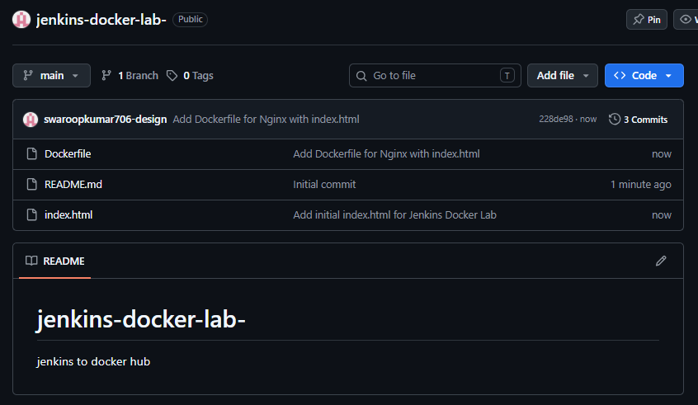

4. Create a Docker Hub repository
- Open Docker Hub.
- Sign in to your account.
- Create a repository named jenkins-docker-lab.
- Note your Docker Hub username and repository name.
For example, the image name will be:
Swaroopkumar706/jenkins-docker-lab

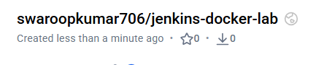

5. Create Docker Hub credentials in Jenkins
Never hardcode your Docker Hub password or access token in a Jenkinsfile.
- Open Jenkins.
- Go to Manage Jenkins → Credentials.
- Select the appropriate credentials store and domain, usually Global credentials (unrestricted).
- Click Add Credentials.
- Enter the following details:

. Run
docker login -u swaroopkumar706
2. At the password prompt, enter the personal access token.
dckr_pat_WVQaUDtHM59xf8Mos87WrAW1qGA

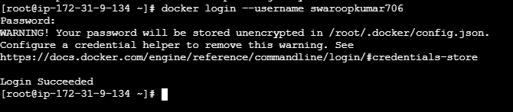

Field | Value
Kind | Username with password
Username | Your Docker Hub username
Password | Docker Hub access token
ID | dockerhub-creds
Description | Docker Hub credentials for image publishing
6. Click Create.
The pipeline will refer to this credential using the ID dockerhub-creds.

6. Create the Jenkins pipeline
- From the Jenkins dashboard, select New Item.
- Enter DockerHub-Push-Pipeline.
- Select Pipeline and click OK.
- Scroll to the Pipeline section.
- Select Pipeline script.
- Paste the following Jenkinsfile.

7. Jenkins Declarative Pipeline
Replace YOUR_GITHUB_USERNAME and YOUR_DOCKERHUB_USERNAME with your actual account names.

pipeline {
agent any

environment {
DOCKERHUB_REPO = 'YOUR_DOCKERHUB_USERNAME/jenkins-docker-lab'
IMAGE_TAG = "${BUILD_NUMBER}"
}

stages {
stage('Checkout') {
steps {
git branch: 'main',
url: 'https://github.com/YOUR_GITHUB_USERNAME/jenkins-docker-lab.git'
}
}

stage('Validate Files') {
steps {
sh '''
test -f Dockerfile
test -f index.html
echo "Required files are available."
'''
}
}

stage('Build Docker Image') {
steps {
sh '''
docker build \
-t "$DOCKERHUB_REPO:$IMAGE_TAG" \
-t "$DOCKERHUB_REPO:latest" .
'''
}
}

stage('Push to Docker Hub') {
steps {
withCredentials([
usernamePassword(
credentialsId: 'dockerhub-creds',
usernameVariable: 'DOCKERHUB_USER',
passwordVariable: 'DOCKERHUB_TOKEN'
)
]) {
sh '''
set -eu

echo "$DOCKERHUB_TOKEN" |
docker login \
--username "$DOCKERHUB_USER" \
--password-stdin

docker push "$DOCKERHUB_REPO:$IMAGE_TAG"
docker push "$DOCKERHUB_REPO:latest"

docker logout
'''
}
}
}
}

post {
success {
echo "Docker image pushed successfully: ${DOCKERHUB_REPO}:${IMAGE_TAG}"
}

failure {
echo 'Pipeline failed. Check the Jenkins console output.'
}

always {
echo 'Docker image pipeline execution completed.'
}
}
}
Click Save, then select Build Now.

How this pipeline works
Stage | What happens
Checkout | Clones the GitHub repository
Validate Files | Confirms the Dockerfile and HTML file exist
Build Docker Image | Builds the image and creates versioned and latest tags
Push to Docker Hub | Authenticates securely and uploads both tags
Post | Reports whether the pipeline succeeded or failed
BUILD_NUMBER is a Jenkins environment variable. For example, build number 1 creates:
YOUR_DOCKERHUB_USERNAME/jenkins-docker-lab:1
YOUR_DOCKERHUB_USERNAME/jenkins-docker-lab:latest
The next successful build uses tag 2, and so on.

8. Verify the result
After the Jenkins build succeeds, open your Docker Hub repository and verify that the tags are present.
You can also verify from a machine with Docker installed:
docker pull YOUR_DOCKERHUB_USERNAME/jenkins-docker-lab:1
docker image ls
To run the sample application locally:
docker run -d \
--name jenkins-docker-test \
-p 8085:80 \
YOUR_DOCKERHUB_USERNAME/jenkins-docker-lab:1
Test it:
curl http://localhost:8085/
You should see the HTML containing Hello from Jenkins CI/CD!.
Clean up afterward:
docker rm -f jenkins-docker-test

9. Common errors and fixes
Error | Fix
docker: command not found | Install Docker CLI on the Jenkins agent running the pipeline.
permission denied ... docker.sock | Grant the Jenkins agent service account appropriate Docker access, then restart or reconnect the agent. Docker-group access effectively grants root-level privileges.
unauthorized: authentication required | Check the dockerhub-creds ID, username, token, and Docker Hub repository permissions.
Dockerfile not found | Verify the repository URL and branch, and ensure the Dockerfile is in the repository root.
repository does not exist | Create the Docker Hub repository or correct the image name.
Important for your setup: If Jenkins is running on a controller and separate agents, agent any can select a node that does not have Docker installed. If your Docker-enabled agent has a label such as linux, replace agent any with agent { label 'linux' }.

10. Real-time interview answer
Question: How do you build and push Docker images using Jenkins?
“I create a Jenkins Declarative Pipeline that checks out source code from GitHub, validates the Dockerfile, builds and tags the Docker image, and authenticates to Docker Hub using credentials stored in Jenkins. The pipeline pushes versioned and latest tags to the registry. I also configure post-build notifications and troubleshoot agent permissions, Docker build errors, and registry authentication failures.”
Next improvement: In a production pipeline, add a Trivy image scan between the build and push stages, so vulnerable images are rejected before they reach Docker Hub.

