ECS - TASK
Task related to ECS.
1. Setup a highly available ecs cluster with load balancer and dynamic port mapping.
Your cluster should maintain atleast 6 tasks at any point of time and should be highly availble across multiple AZ's.
Use the below image from deployment:
sabair0509/hiring-app:works

AWS ECS High Availability Cluster with ALB and Dynamic Port Mapping
We’ll deploy your Docker image sabair0509/hiring-app:works on Amazon ECS using the EC2 launch type, an Application Load Balancer (ALB), and dynamic port mapping.
The target is to maintain at least 6 running tasks, distributed across multiple Availability Zones (AZs), with automatic recovery if a task or EC2 instance fails.

1. Objective
To design and deploy a highly available Amazon ECS cluster using the Docker image sabair0509/hiring-app:works, integrated with an Application Load Balancer (ALB) and dynamic port mapping.
The ECS service should maintain a minimum desired count of 6 tasks distributed across multiple Availability Zones (AZs) to improve application availability, scalability, and fault tolerance.

Key objectives
- High availability: Distribute ECS tasks across at least two Availability Zones to reduce the impact of an AZ failure.
- Minimum task count: Configure the ECS service with a desired count of 6 tasks and enable automatic replacement of failed tasks.
- Load balancing: Use an Application Load Balancer to distribute incoming HTTP traffic across healthy application tasks.
- Dynamic port mapping: Configure container port mapping with host port 0 in bridge network mode so ECS can assign available host ports dynamically.
- Fault tolerance: Configure ECS health checks and task replacement, along with sufficient EC2 capacity to recover from failures.
- Scalability: Use an EC2 Auto Scaling group or ECS capacity provider to add container instances when additional capacity is required.
- Secure communication: Configure security groups so public traffic reaches the ALB and application traffic reaches ECS instances through the ALB.
- Validation: Verify task health, target registration, multi-AZ distribution, and application accessibility through the ALB DNS name.
Expected outcome: A working ECS deployment in which the ALB routes traffic to healthy application tasks, ECS replaces failed tasks, and the service is designed to maintain six healthy tasks during normal operation. Maintaining six healthy tasks during sudden failures additionally requires sufficient spare capacity and recovery time.

2. Prerequisites

A. AWS account and permissions
- An active AWS account with access to the AWS Management Console.
- Appropriate IAM permissions to create and manage:
  - Amazon ECS clusters, services, and task definitions.
  - Amazon EC2 instances and Auto Scaling groups.
  - Application Load Balancers and target groups.
  - VPCs, subnets, route tables, and security groups.
  - IAM roles and instance profiles.
  - CloudWatch logs and metrics.

B. Docker image
- Docker image available at Docker Hub:
sabair0509/hiring-app:works
- Verify that the image is accessible and can be pulled by the ECS container instances.
- Identify the actual application listening port inside the container, such as 8080 or 80.
- Ensure the application starts correctly and has a suitable health-check endpoint.

C. Networking requirements
- A VPC in the selected AWS region, for example ap-south-1 (Mumbai).
- At least two Availability Zones.
- At least two public subnets for the ALB.
- At least two private subnets for ECS container instances, recommended for production-style deployment.
- An Internet Gateway for public ALB access.
- NAT Gateway access or suitable VPC endpoints and network configuration for private instances to retrieve images and access required AWS services.
- Proper route tables and security groups.

D. ECS cluster and compute capacity
- An ECS cluster named hiring-app-cluster.
- ECS-optimized Amazon Linux EC2 instances.
- At least two ECS container instances across multiple AZs; additional instances or spare capacity are recommended for resilience.
- An EC2 Auto Scaling group or ECS capacity provider for instance recovery and scaling.
- Sufficient CPU, memory, and network resources to run six tasks simultaneously and recover from failures.

E. Load balancer requirements
- An Application Load Balancer named hiring-app-alb.
- A target group named hiring-app-tg.
- An HTTP listener on port 80 (or HTTPS on port 443 with a valid TLS certificate).
- Health checks configured to match the application's actual endpoint.
- Security groups allowing public traffic to the ALB and ALB-originated traffic to the ECS dynamic host port range.

F. ECS task and service configuration
- Task definition named hiring-app-task.
- EC2 launch type or a compatible EC2 capacity provider.
- bridge network mode.
- Container port set to the actual application port.
- Host port set to 0 for dynamic port mapping.
- ECS service named hiring-app-service.
- Desired task count set to 6.
- Multi-AZ placement strategy and automatic task replacement enabled.

G. Monitoring and validation
- CloudWatch logs configured for the application containers.
- ECS service events and task health available for troubleshooting.
- ALB target health monitoring enabled.
- Access to the ALB DNS name for browser or command-line testing.

3. Resources summary
Resource | Example name / configuration
AWS Region | ap-south-1
ECS Cluster | hiring-app-cluster
ECS Service | hiring-app-service
Task Definition | hiring-app-task
Docker Image | sabair0509/hiring-app:works
Desired Tasks | 6
Load Balancer | hiring-app-alb
Target Group | hiring-app-tg
Network Mode | bridge
Host Port | 0 (dynamic)
Availability Zones | Minimum 2
Success criteria: All six desired tasks reach RUNNING, register as healthy targets, receive traffic through the ALB, and are replaced automatically if a task fails. The infrastructure should have enough spare capacity to recover from an instance or AZ failure.

1. Target architecture
Users / Internet
Application Load Balancer
Public subnets • AZ-A and AZ-B • HTTP :80
Listener → target group → dynamic host ports
AZ-A
Private subnet A
ECS EC2 instance A
Tasks 1, 2, 3
Example ports: 32768, 32769, 32770
AZ-B
Private subnet B
ECS EC2 instance B
Tasks 4, 5, 6
Example ports: 32771, 32772, 32773
ECS Service: desired count = 6 • multi-AZ placement • health checks • automatic task replacement
Important: The six tasks and port numbers above illustrate the intended design; the actual ports are assigned by ECS at deployment. For stronger availability, use at least two ECS container instances across two AZs, and preferably three or more instances across three AZs if your selected AWS region and budget allow it.

2. Resources to create
We’ll use the AWS region ap-south-1 (Mumbai) for this lab.
Resource | Configuration
ECS cluster | hiring-app-cluster
ECS service | hiring-app-service
Task definition | hiring-app-task
Docker image | sabair0509/hiring-app:works
Launch type | EC2
Desired task count | 6
Load balancer | Application Load Balancer
Target group | hiring-app-tg
Availability Zones | At least 2
Container network mode | Bridge
Port mapping | Container port fixed; host port 0 for dynamic assignment
For EC2 tasks using bridge networking, setting the host port to 0 enables dynamic port mapping. The ALB registers each task using the EC2 instance ID and the assigned host port.

Amazon Elastic Container Service
+1

3. Step 1 — Prepare your VPC and subnets
Open the AWS Console and select ap-south-1.
- Navigate to VPC → Your VPCs.
- Use an existing VPC or create a dedicated VPC.
- Ensure it has subnets in at least two different AZs, such as ap-south-1a and ap-south-1b (the actual AZ names available to your account may vary).
- Create or identify:
  - Two public subnets for the ALB.
  - Two private subnets for ECS EC2 instances, recommended for production-style deployment.
- Configure internet access for the ALB through an Internet Gateway.
- Provide outbound internet access for private ECS instances through a NAT Gateway, or configure the required VPC endpoints and image/logging connectivity.
For a budget-conscious lab, you can use public subnets for ECS instances while keeping their inbound access restricted to the ALB. Remember that NAT Gateways and load balancers incur charges.
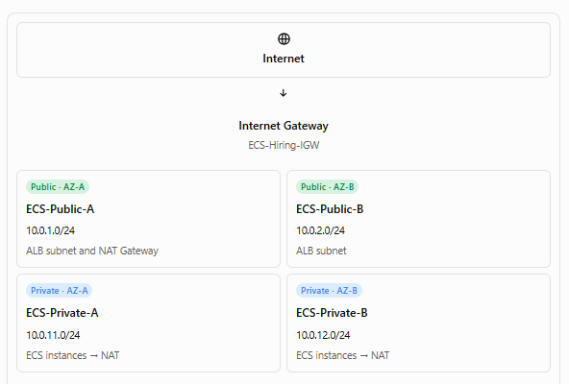
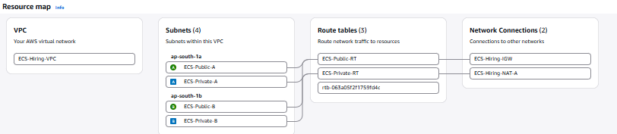

4. Step 2 — Create security groups
Create two security groups under EC2 → Security Groups.

Security group 1: hiring-alb-sg
Attach this to the Application Load Balancer.
Type | Port | Source
HTTP | 80 | 0.0.0.0/0
HTTPS | 443 | 0.0.0.0/0 (optional, with TLS configured)

Security group 2: hiring-ecs-sg
Attach this to the ECS EC2 instances.
Type | Port | Source
Custom TCP | 32768–61000 | hiring-alb-sg
SSH | 22 | Your trusted IP only, if needed
The dynamic port range shown is typical for the ECS-optimized Linux AMI. Verify the ephemeral port range used by your instances and configure the rule accordingly.
Why this configuration? The ALB receives public traffic and forwards requests to the dynamically assigned task ports. ECS instances should accept those requests only from the ALB security group, not from the entire internet.
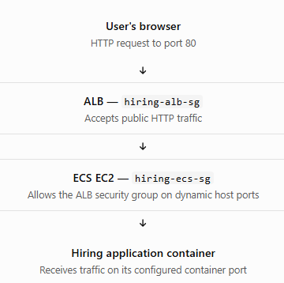

5. Step 3 — Create the ECS cluster
- Open Amazon ECS → Clusters → Create cluster.
- Enter the cluster name hiring-app-cluster.
- Choose the EC2-backed infrastructure option, if presented.
- Configure the EC2 capacity using an ECS-optimized Amazon Linux AMI and an Auto Scaling group or ECS capacity provider.
- Select the VPC and subnets you prepared.
- Configure the instance IAM role with the required ECS permissions.
- Launch at least two container instances, distributed across two AZs. For better resilience, use an Auto Scaling group with a minimum capacity that can support six tasks even after one instance fails.
- Create the cluster.
Make sure the EC2 instances register with hiring-app-cluster. You can verify this under ECS → Clusters → hiring-app-cluster → Infrastructure.
Capacity planning: Two instances may be enough for six small tasks, but do not assume that without checking the application's CPU and memory requirements. To continue serving six tasks after an instance or AZ failure, the surviving capacity must have room for those tasks, or the Auto Scaling group must add replacement capacity promptly.
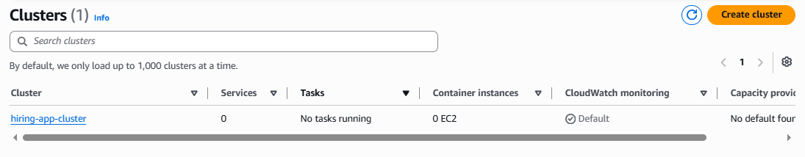

6. Step 4 — Create the task definition
Navigate to Amazon ECS → Task definitions → Create new task definition.
Use these settings:
- Family: hiring-app-task
- Launch compatibility: EC2
- Network mode: bridge
- Task CPU and memory: choose values appropriate for your image and instance size.
- Container name: hiring-app
- Image URI: sabair0509/hiring-app:works
- Essential container: enabled
For this example, I’ll use container port 8080. Confirm the actual listening port of your image before proceeding. If the application listens on port 80, 3000, or another port, replace 8080 throughout the configuration.

Port mapping
Container port | 8080
Host port | 0
Protocol | TCP
Network mode | bridge
Host port 0 tells ECS to assign an available host port dynamically. Do not enter 8080 as the host port if you want this dynamic mapping.
You can use this container definition JSON as a reference for the container settings:
{
"name": "hiring-app",
"image": "sabair0509/hiring-app:works",
"essential": true,
"portMappings": [
{
"containerPort": 8080,
"hostPort": 0,
"protocol": "tcp"
}
]
}
Save the task definition.
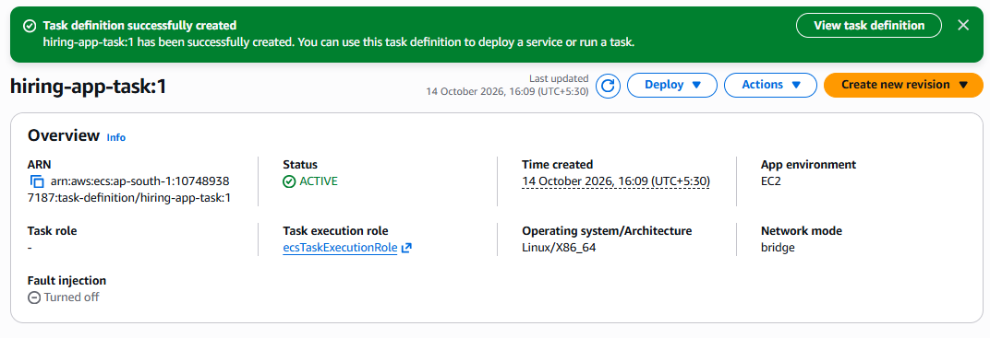

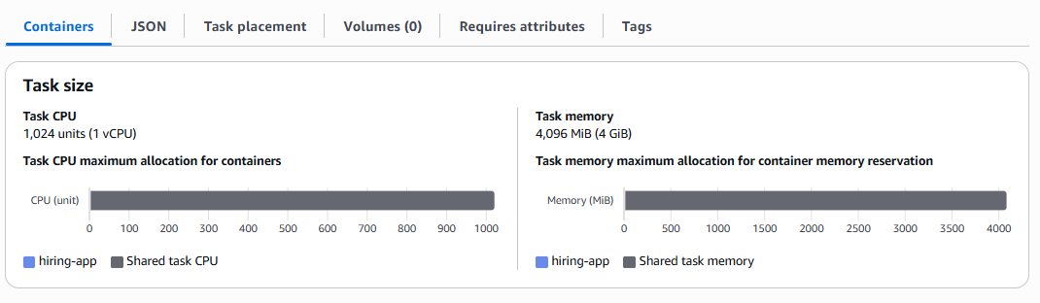

7. Step 5 — Create the Application Load Balancer
Open EC2 → Load Balancing → Load Balancers → Create load balancer.
- Select Application Load Balancer.
- Name it hiring-app-alb.
- Set the scheme to Internet-facing.
- Select the VPC.
- Choose public subnets in at least two AZs.
- Attach hiring-alb-sg.
- Create a target group named hiring-app-tg.
Configure the target group as follows:
Setting | Value
Target type | Instances
Protocol | HTTP
Port | 8080 (initial/default target group port)
Health check protocol | HTTP
Health check path | /
Success codes | 200 (adjust if your app uses another valid response)
For this EC2 bridge-networking setup, the ECS service registers the actual dynamic host port for each task, so the target group's default port is not the port that every task must use. If your application has a health endpoint such as /health, use that instead of /.
Add an HTTP listener on port 80 and set its default action to forward traffic to hiring-app-tg.
Do not manually register individual EC2 instances as targets for the ECS tasks; the ECS service will manage task registration and deregistration.
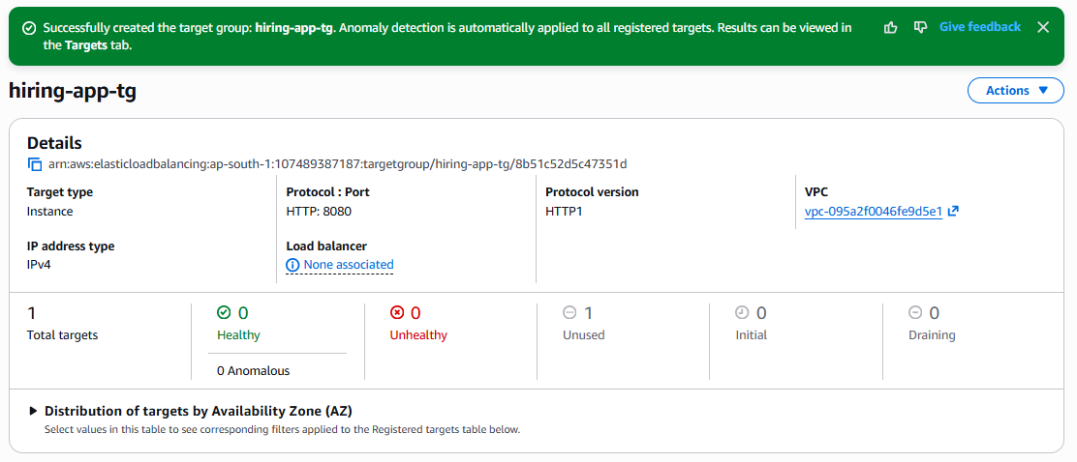

8. Step 6 — Create the ECS service with six tasks
Return to Amazon ECS → Clusters → hiring-app-cluster → Services → Create.
Configure the service:

Service configuration
Service name
hiring-app-service
Task definition
hiring-app-task
Scheduling strategy
Replica
Desired tasks

6
Load balancer
Application Load Balancer
Target group
hiring-app-tg
During service creation:
- Select hiring-app-task and its latest revision.
- Set the desired task count to 6.
- Select the EC2 capacity provider or launch configuration connected to your cluster.
- Select hiring-app as the load-balanced container and port 8080.
- Attach hiring-app-alb and hiring-app-tg.
- Configure deployment health checks and allow the service scheduler to replace failed tasks.
- Use Availability Zone spread as the first placement strategy. If the console exposes AZ rebalancing, enable it.
- Create the service.
The ECS replica scheduler maintains the desired task count, and ECS supports spreading tasks across AZs and rebalancing them as needed. However, placement is best-effort and depends on available capacity.
Amazon Elastic Container Servie

9. Step 7 — Verify the deployment
After the service is created, open:
ECS → Clusters → hiring-app-cluster → Services → hiring-app-service → Tasks
Confirm that all six tasks have status RUNNING.
Next, open EC2 → Target Groups → hiring-app-tg → Targets and verify that the targets are healthy.
You should see entries similar to these examples:
Target | Port | Health
EC2 instance A | 32768 | Healthy
EC2 instance A | 32769 | Healthy
EC2 instance A | 32770 | Healthy
EC2 instance B | 32768 | Healthy
EC2 instance B | 32769 | Healthy
EC2 instance B | 32770 | Healthy
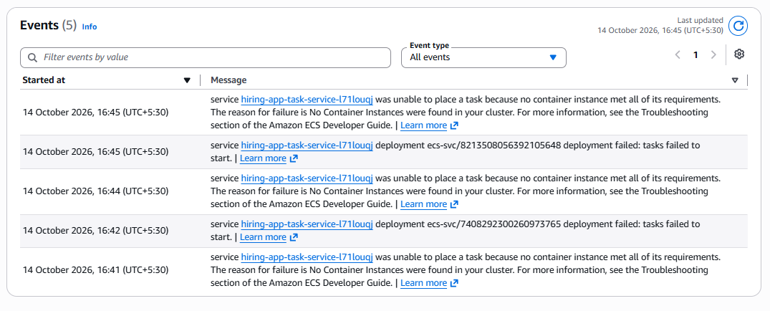
These are illustrative ports; ECS assigns the actual ports, and ports can overlap across different EC2 instances.
Now open the ALB details, copy its DNS name, and test it in your browser:
http://YOUR-ALB-DNS-NAME
The application should respond through the ALB without exposing the individual task ports publicly.

10. Step 8 — Test high availability
Perform these tests only after the service is healthy.
Test A — Stop one task
Stop one ECS task manually. ECS should launch a replacement to return the service to its desired count of six.
Test B — Check AZ distribution
Inspect the Availability Zone of each running task. Verify that tasks are distributed across both AZs.
Test C — Verify dynamic mapping
Open a task's details and inspect its container instance and network bindings. Confirm that the host port differs from the container port.
Test D — Test load balancing
Send repeated HTTP requests to the ALB DNS name. Confirm that healthy tasks receive traffic and the application remains accessible when an individual task is replaced.

Important: guaranteeing at least six healthy tasks
A desired count of six means ECS aims to maintain six running tasks. It does not guarantee that six remain healthy during a sudden instance failure or task replacement.
For a stronger availability requirement:
- Run more than six tasks, such as a desired count of 8, if your budget and capacity allow it.
- Maintain spare EC2 capacity across AZs.
- Configure the service's deployment minimum healthy percentage to 100% and maximum percentage to 200%, where supported.
- Use an EC2 Auto Scaling group or capacity provider to replenish failed instances.
- Configure ALB health checks and monitor ECS service events.
Even with these settings, a strict guarantee of six healthy tasks at every instant cannot be made during abrupt failures. ECS recovery and new instance provisioning take time.

11. Troubleshooting checklist
Problem | What to check
Tasks remain PENDING | EC2 capacity, CPU/memory, AZ placement and available host ports
Tasks stop immediately | Container logs, image pull permissions, application startup
Targets are unhealthy | Actual application port, health-check path and ECS security group
ALB returns 503 | Healthy target count, listener rule and target-group registration
Tasks cannot pull the image | Outbound connectivity and Docker Hub image access
Only one AZ has tasks | ECS instance distribution, subnet configuration and placement events

One detail to confirm before you start
Do you know which port the image sabair0509/hiring-app:works listens on inside the container — 8080, 80, or another port? If you're unsure, tell me, and I'll guide you through checking the image and identifying the correct port before you create the task definition.

