BASH SCRIPTING
- Create a bash script tocheck if a directory is available or not.
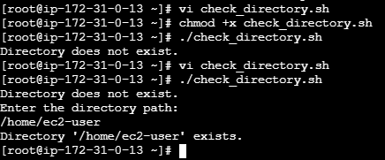
Bash scripting
#!/bin/bash

DIR="/home/ec2-user/mydirectory"

if [ -d "$DIR" ]; then
echo "Directory exists."
else
echo "Directory does not exist."
Fi

