RDS TASK
AMAZON RELATIONAL DATABASE SERVICE

1.Create MariaDB DB on EC2.

Objective :
To install and configure MariaDB Server on an AWS EC2 instance, create a database and database user, and verify that the MariaDB database is working correctly.
Architecture:
Your Computer
|
| SSH
↓
+----------------------+
| EC2 Instance |
| Amazon Linux 2023 |
| |
| MariaDB Server |
| :3306 |
+----------------------+

Prerequisites
Before starting, you need:
- AWS account
- IAM permissions to launch EC2
- EC2 instance
- Amazon Linux 2023 / Amazon Linux 2
- Key pair (.pem)
- Security Group
- SSH access to the EC2 instance
- Basic Linux commands knowledge

Security Group
For initial setup, allow:
Type | Port | Source
SSH | 22 | Your IP
MySQL/Aurora | 3306 | Only your application server/private IP
Important: Do not expose port 3306 to 0.0.0.0/0 in a production environment.

Step-by-Step Implementation

Step 1: Launch EC2
Go to:
AWS Console → EC2 → Instances → Launch Instance
Choose:
Name: MariaDB-Server
AMI: Amazon Linux 2023
Instance type: t2.micro / t3.micro
Select or create a key pair.
For the Security Group, allow:
SSH
Port: 22
Source: My IP
Launch the instance.

Step 2 Update the Server
Run:
sudo dnf update -y
This updates the installed packages.

Step 3 Install MariaDB
First check which MariaDB packages are available:
sudo dnf list available | grep mariadb
On Amazon Linux 2023, install the available MariaDB server package, for example:
sudo dnf install mariadb105-server -y
If that exact package is unavailable, use the MariaDB server package shown by the previous command.
Verify installation:
mariadb –version

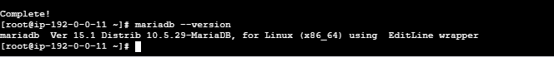

Step 4 Start MariaDB
Start the service:
sudo systemctl start mariadb
Check status:
sudo systemctl status mariadb
You should see:
Active: active (running)

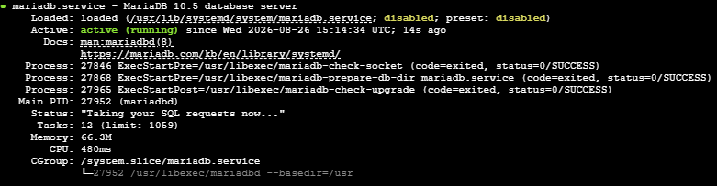

Step 5 Enable MariaDB at Boot
Run:
sudo systemctl enable mariadb
This means MariaDB will automatically start whenever the EC2 instance reboots.
Verify:
sudo systemctl is-enabled mariadb
Expected:
enabled

Step 6 Secure MariaDB
Run:
sudo mariadb-secure-installation
Depending on the MariaDB version, you may be asked several questions.
Typical options include:
Enter current password for root:
Then:
Switch to unix_socket authentication? [Y/n]
Remove anonymous users? [Y/n]
Disallow root login remotely? [Y/n]
Remove test database and access to it? [Y/n]
Reload privilege tables now? [Y/n]
For a normal production-style setup, answer Y to removing anonymous users, disabling remote root login, removing the test database, and reloading privileges.

Step 7 Login to MariaDB
Run:
sudo mariadb
You should see:
MariaDB [(none)]>

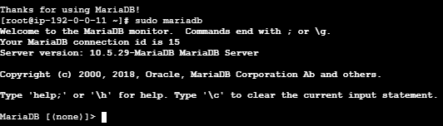

Step 8 Create a Database
Let's create a database called:
companydb
Run:
CREATE DATABASE companydb;
Check databases:
SHOW DATABASES;
You should see:
information_schema
companydb
mysql
performance_schema
sys

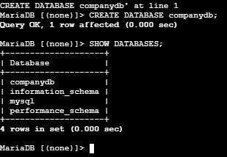

Step 9 Create a Database User
Create a user:
CREATE USER 'appuser'@'localhost' IDENTIFIED BY 'StrongPassword@123';
Here:
appuser
↓
Database username

localhost
↓
User can connect from the EC2 server itself

Step 10 Give Permissions
Give the user permissions on companydb:
GRANT ALL PRIVILEGES ON companydb.* TO 'appuser'@'localhost';
Apply privileges:
FLUSH PRIVILEGES;
Check:
SHOW GRANTS FOR 'appuser'@'localhost';
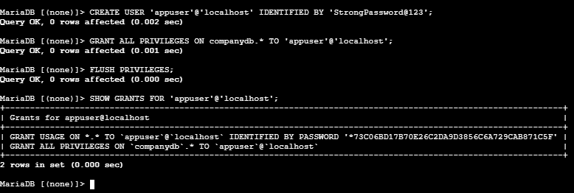

Step 11 Use the Database
Select the database:
USE companydb;
Create a table:
CREATE TABLE employees (
id INT AUTO_INCREMENT PRIMARY KEY,
name VARCHAR(100),
department VARCHAR(100),
salary INT
);
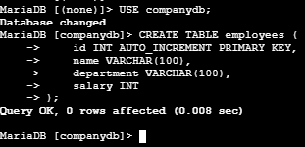
Check the table:
SHOW TABLES;
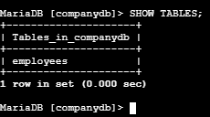
Expected:
employees

Step 12 Insert Data
Run:
INSERT INTO employees (name, department, salary)
VALUES
('Ravi', 'DevOps', 50000),
('Kumar', 'AWS', 60000),
('John', 'Linux', 45000);

Step 13 Retrieve Data
Run:
SELECT * FROM employees;
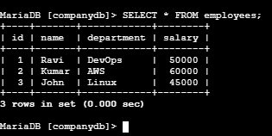

Step 14 Test the Database User
Exit MariaDB:
EXIT;
Now login using the newly created user:
mariadb -u appuser -p
Enter:
StrongPassword@123
Then:
SHOW DATABASES;
You should be able to access companydb.

Step 15 Verify MariaDB Port
MariaDB normally listens on:
3306
Check:
sudo ss -lntp | grep 3306
Example:
LISTEN 0 80 0.0.0.0:3306
or:
LISTEN 0 80 127.0.0.1:3306
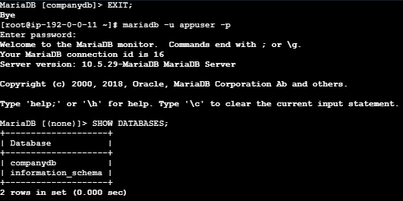

20. Final Architecture
Internet
|
|
+-----------+
| ALB |
+-----------+
|
↓
+---------------+
| Application |
| EC2 |
+---------------+
|
| TCP 3306
↓
+---------------+
| MariaDB EC2 |
| |
| MariaDB |
| companydb |
+---------------+
|
EBS Volume

Important points
EC2
↓
Operating System
↓
MariaDB Server
↓
Database
↓
Tables
↓
Data
For a production AWS architecture, you would generally prefer Amazon RDS for MariaDB instead of manually managing MariaDB on EC2, because RDS handles many database-management tasks such as automated backups, patching, monitoring, and Multi-AZ options.

2. Insert some dummy data

Objective :
To insert sample/dummy records into the companydb database, verify that the data is stored correctly, and retrieve the records using SQL queries.
We will create an employees table and insert sample employee information.

Prerequisites :
Before starting, make sure:
- MariaDB is installed and running.
- companydb database exists.
- appuser exists.
- appuser has permission to access companydb.
- You can log in to MariaDB.

Step-by-Step Implementation

Step 1: Check the databases
At the MariaDB prompt:
SHOW DATABASES;
You should see:
companydb
information_schema

Step 2: Select

companydb
Run:
USE companydb;
Expected:
Database changed
You are now working inside companydb.

Step 3: Create an employees table
Run:
CREATE TABLE employees (
id INT AUTO_INCREMENT PRIMARY KEY,
name VARCHAR(100),
department VARCHAR(100),
salary INT
);

Step 4: Verify the table
Run:
SHOW TABLES;
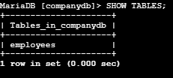

Step 5: Check table structure
Run:
DESCRIBE employees;
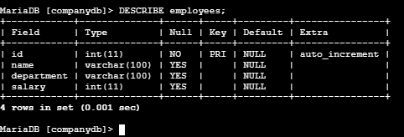

Step 6 Insert Dummy Data
Now insert some sample employees:
INSERT INTO employees (name, department, salary)
VALUES
('Ravi', 'DevOps', 50000),
('Kumar', 'AWS', 60000),
('Suresh', 'Linux', 45000),
('Priya', 'Database', 55000),
('Anil', 'Networking', 48000);
Expected:
Query OK, 5 rows affected

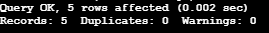

Step 7 Verify the Inserted Data
Run:
SELECT * FROM employees;
You should get something similar to:
+----+--------+------------+--------+
| id | name | department | salary |
+----+--------+------------+--------+
| 1 | Ravi | DevOps | 50000 |
| 2 | Kumar | AWS | 60000 |
| 3 | Suresh | Linux | 45000 |
| 4 | Priya | Database | 55000 |
| 5 | Anil | Networking | 48000 |
+----+--------+------------+--------+

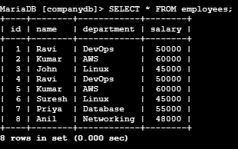

Step 8 Retrieve Specific Data

Display only employee names
SELECT name FROM employees;
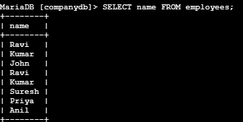

Display name and department
SELECT name, department FROM employees;
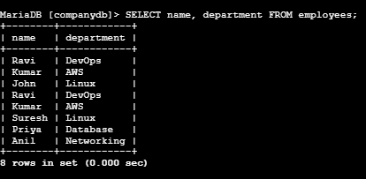

Find employees with salary greater than 50,000
SELECT * FROM employees
WHERE salary > 50000;
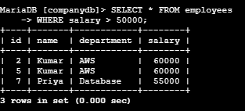

Step 9 Update Dummy Data
Suppose Ravi's salary increases from 50000 to 55000.
Run:
UPDATE employees
SET salary = 55000
WHERE name = 'Ravi';
Verify:
SELECT * FROM employees
WHERE name = 'Ravi';
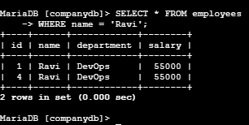

Step 10 Delete Dummy Data
If you want to delete one employee:
DELETE FROM employees
WHERE name = 'Anil';
Verify:
SELECT * FROM employees;
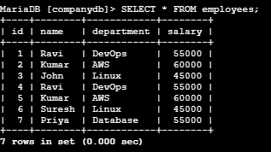

Useful Verification Commands

Show databases
SHOW DATABASES;

Select database
USE companydb;

Show tables
SHOW TABLES;

Show table structure
DESCRIBE employees;

Display all records
SELECT * FROM employees;

Count records
SELECT COUNT(*) FROM employees;
Expected after inserting five records:
5

Final Flow
MariaDB
↓
USE companydb
↓
CREATE TABLE employees
↓
INSERT dummy data
↓
SELECT * FROM employees
↓
Verify data

Important distinction
CREATE TABLE creates the structure:
employees
├── id
├── name
├── department
└── salary
INSERT puts actual records/data into that structure:
1 | Ravi | DevOps | 50000
2 | Kumar | AWS | 60000
3 | Suresh | Linux | 45000

3. Take the backup of dummy data on EC2.

Objective :
To take a backup of the MariaDB companydb database containing the dummy employee data and store the backup file on the EC2 instance.
We will use the mysqldump utility.
Architecture:
MariaDB
|
| mysqldump
↓
companydb_backup.sql
|
↓
EC2 Local Storage

Prerequisites :
Before starting, make sure:
- EC2 instance is running.
- MariaDB is installed and running.
- companydb database exists.
- Dummy data has been inserted.
- You have a MariaDB user with permission to read the database.
- You have SSH access to the EC2 instance.
- Sufficient disk space is available.
Check MariaDB:
sudo systemctl status mariadb
Check available disk space:
df -h

Step-by-Step Implementation

Step 1: Verify the Dummy Data
Login to MariaDB:
mariadb -u appuser -p
Select the database:
USE companydb;
Check the data:
SELECT * FROM employees;
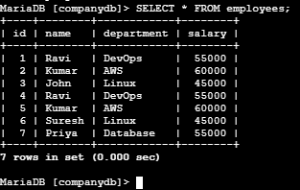
Exit MariaDB:
EXIT;
You should now be back at:
[root@ip-192-0-0-11 ~]#
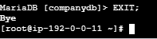

Step 2: Check mysqldump
Run:
mysqldump –version
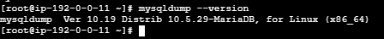

Step 3: Create a Backup Directory
Create a directory for database backups:
sudo mkdir -p /backup/mariadb
Check it:
ls -ld /backup/mariadb
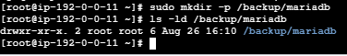

Step 4: Take the Database Backup
Run:
sudo mysqldump -u appuser -p companydb > /backup/mariadb/companydb_backup.sql
It will ask:
Enter password:
Enter the password of appuser.
If successful, there may be no output. That is normal.

Step 5: Verify the Backup File
Run:
ls -lh /backup/mariadb/
You should see:
-rw-r--r-- 1 root root ... companydb_backup.sql
You can also check the file size:
du -h /backup/mariadb/companydb_backup.sql

Step 6: Check the Backup Contents
You can inspect the beginning of the backup:
sudo head -30 /backup/mariadb/companydb_backup.sql
You should see SQL statements such as:
CREATE TABLE `employees` ...
and:
INSERT INTO `employees` ...
This confirms that the backup contains both the table structure and data.

Step 7: Verify the Backup Contains Your Dummy Data
Run:
sudo grep -i "Ravi" /backup/mariadb/companydb_backup.sql
You should find Ravi's record in the backup.
You can also check:
sudo grep -i "Kumar" /backup/mariadb/companydb_backup.sql

Step 8: Create a Compressed Backup
For larger databases, compression saves storage space.
Use:
sudo mysqldump -u appuser -p companydb | gzip > /backup/mariadb/companydb_backup.sql.gz
Check:
ls -lh /backup/mariadb/
You may now have:
companydb_backup.sql
companydb_backup.sql.gz
The .gz file is the compressed backup.

Step 9: Add Date and Time to the Backup Name
This is useful when taking backups regularly.
Run:
sudo mysqldump -u appuser -p companydb > /backup/mariadb/companydb_$(date +%Y-%m-%d_%H-%M-%S).sql
Example:
companydb_2026-08-26_21-30-15.sql
This makes it easy to identify when the backup was created.

Step 10: Verify the Backup
List the backups:
ls -lh /backup/mariadb/
You should have something like:
/backup/mariadb/
├── companydb_backup.sql
├── companydb_backup.sql.gz
└── companydb_2026-08-26_21-30-15.sql

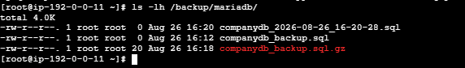

13. Important: Backup vs Restore
The command:
mysqldump
is used to take the backup.
MariaDB
↓
mysqldump
↓
companydb_backup.sql
To restore the backup, you use the .sql file:
companydb_backup.sql
↓
MariaDB
↓
companydb
For example:
mariadb -u appuser -p companydb < /backup/mariadb/companydb_backup.sql
Don't run the restore command now if your goal is only to take the backup.

14. Final Result
Your backup workflow is:
EC2
│
├── MariaDB
│ │
│ └── companydb
│ │
│ └── employees
│ │
│ └── Dummy Data
│
└── /backup/mariadb/
│
└── companydb_backup.sql

Main command to remember
sudo mysqldump -u appuser -p companydb > /backup/mariadb/companydb_backup.sql
This creates a logical backup of the companydb database, including its table definitions and data.

4. Launch MariaDB RDS instance.

Objective :
To create a managed Amazon RDS for MariaDB database instance and configure it so that an EC2 instance can securely connect to it.
we will move the database service to:
AWS
|
+----------------+
| RDS |
| MariaDB |
| |
| companydb |
+----------------+
↑
|
Port 3306
|
+----------------+
| EC2 |
| Application |
+----------------+
RDS manages many database administration tasks for you, including backups, patching, monitoring, and options such as Multi-AZ and read replicas. (AWS Documentation)

Prerequisites :
Before creating the RDS instance, you should have:

AWS requirements
- AWS account
- Permission to use Amazon RDS
- AWS Region selected
- Existing VPC
- EC2 instance in the VPC
- Security Group

Networking requirements
For a proper private RDS deployment, you need:
- VPC
- At least two subnets in different Availability Zones
- DB subnet group containing those subnets
- Security Group allowing MariaDB traffic on port 3306
AWS recommends using a DB subnet group with subnets in at least two Availability Zones. (AWS Documentation)

Step by step implementation :

Step 1 — Open Amazon RDS
Go to the AWS Console and open:
Amazon RDS Console
Select the same AWS Region where your EC2 instance is running.
For example:
Region: Asia Pacific (Mumbai)
Region code: ap-south-1
AWS recommends using the same Region as the EC2 instance for this type of setup. (AWS Documentation)

Step 2 — Create Database
In the RDS console:
RDS
↓
Databases
↓
Create database
Select:
Creation method:
Standard create
AWS provides Easy create and Standard create. Standard create gives you control over networking, security, backups, availability, and other settings. (AWS Documentation)

Step 3 — Select Database Engine
Under Engine options, choose:
Engine type:
MariaDB
Then select an available MariaDB version.
Your exact available versions can differ by Region and AWS updates.

Step 4 — Select Template
For a learning/lab environment:
Templates
↓
Dev/Test
or the available Sandbox/Free tier option if your account offers it.
For production, you would normally select settings appropriate for production availability and durability rather than simply using a low-cost lab configuration. AWS's production template can preselect features such as Multi-AZ, Provisioned IOPS, and deletion protection. (AWS Documentation)

Step 5 — Configure RDS Instance
Under Settings, enter something like:
DB instance identifier:
mariadb-rds

Master username:
admin
For example:
DB identifier: mariadb-rds
Master username: admin

Password
You can either:
Auto generate a password
or create your own strong password.
Important: Save the password securely. AWS notes that the master password cannot simply be viewed again after creation if you don't retain it. (AWS Documentation)

Step 6 — Instance Configuration
For a learning environment, choose a small burstable instance class that is available in your Region/account, such as:
Burstable classes
↓
db.t3.micro
or another eligible small class offered by the console.
Don't choose a large production instance for this lab unnecessarily.

9. Step 7 — Storage
For a basic lab:
Storage type:
General Purpose SSD

Allocated storage:
20 GiB
Keep the default storage settings if they are appropriate for your exercise.

10. Step 8 — Availability & Durability
For this lab:
Single-AZ
is sufficient.
For production applications where database availability is important, consider:
Multi-AZ
Multi-AZ provides a standby DB instance in another Availability Zone for failover.

Step 9 — Connectivity
This is one of the most important sections.
Under:
Connectivity
select your:
VPC
Use the VPC where your EC2 instance resides.

Step 10 — DB Subnet Group
Select an appropriate DB subnet group.
A DB subnet group identifies the subnets that RDS can use for the DB instance. For a VPC deployment, AWS requires a DB subnet group with subnets in at least two Availability Zones. (AWS Documentation)
For example:
VPC
|
+-- Private Subnet - AZ1
|
+-- Private Subnet - AZ2
The RDS database can then be placed within this network.

13. Step 11 — Public Access
You will see:
Public access
For a normal EC2 → RDS architecture, select:
No
So the architecture becomes:
Internet
X
|
| No direct access
|
RDS MariaDB
↑
|
Private network
↑
|
EC2
This is much safer than exposing the database directly to the Internet.
AWS's MariaDB getting-started guidance recommends a private DB instance for this type of EC2-to-RDS setup. (AWS Documentation)

Step 12 — Create/Select Security Group
Under:
VPC security group
create a new Security Group or select an existing dedicated RDS Security Group.
For example:
Security Group name:
rds-mariadb-sg

Inbound rule
Allow:
Type: MySQL/Aurora
Protocol: TCP
Port: 3306
Source: EC2 Security Group
Do NOT use:
0.0.0.0/0
for your database.
The ideal architecture is:
EC2 Security Group
|
| TCP 3306
↓
RDS Security Group
This means the RDS database accepts connections from the authorized EC2 application/server security group.

Step 13 — Additional Configuration
Expand:
Additional configuration
For the initial database name, enter:
companydb
This means RDS will create the database when the DB instance is created. AWS supports specifying the initial database name for MariaDB. (AWS Documentation)
Set:
Initial database name:
companydb

16. Step 14 — Backup
Under Backup:
For a lab you can use a short retention period allowed by the console.
For example:
Backup retention:
1 day
For production, choose a retention period according to your recovery requirements.
RDS supports automated backups and snapshots, which is one of the advantages over manually managing MariaDB on EC2. (AWS Documentation)

17. Step 15 — Monitoring
For a basic lab, keep the default monitoring settings unless your exercise requires enhanced monitoring.
You can later use:
RDS
↓
Monitoring
to observe database metrics.

18. Step 16 — Deletion Protection
For a lab:
Deletion protection:
Disabled
For production:
Deletion protection:
Enabled
This helps prevent accidental deletion of the database.

19. Step 17 — Create RDS
Review your configuration.
You should have something approximately like:
Engine:
MariaDB

DB identifier:
mariadb-rds

Master username:
admin

Database:
companydb

Instance:
Small burstable class

Storage:
20 GiB

Public access:
No

Port:
3306

Security Group:
rds-mariadb-sg

Backup:
Enabled
Then click:
Create database

Step 18 — Wait for RDS to Become Available
Go to:
RDS
↓
Databases
You will initially see:
Status: Creating
Wait until:
Status: Available
AWS documents that the DB instance remains in Creating status until it is ready, after which it changes to Available. (AWS Documentation)
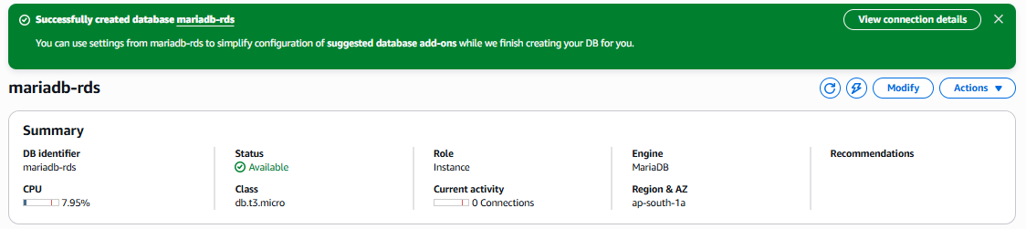

21. Step 19 — Find the RDS Endpoint
Click your RDS instance:
mariadb-rds
Go to:
Connectivity & security
You will find:
Endpoint:
mariadb-rds.xxxxxxxxx.ap-south-1.rds.amazonaws.com

Port:
3306
The endpoint is the DNS address of your RDS database.
You will use this instead of the EC2 private IP.
AWS specifically identifies the endpoint and port as the information needed to connect to the DB instance. (AWS Documentation)
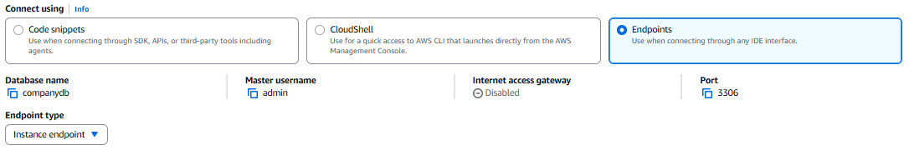

22. Step 20 — Connect from EC2 to RDS
SSH into your EC2 instance:
ssh -i mykey.pem ec2-user@<EC2-Public-IP>
If the MariaDB/MySQL client isn't installed:
sudo dnf install mariadb105 -y
Then connect:
mariadb -h <RDS-ENDPOINT> -P 3306 -u admin -p
Example:
mariadb -h mariadb-rds.xxxxx.ap-south-1.rds.amazonaws.com -P 3306 -u admin -p
Enter your RDS master password.
If everything is configured correctly, you should see:
Welcome to the MariaDB monitor.

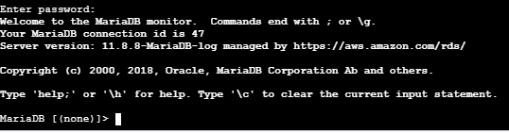
AWS documents the same basic connection pattern using the RDS endpoint, port 3306, username, and password. (AWS Documentation)

23. Step 21 — Verify the Database
Inside MariaDB:
SHOW DATABASES;
You should see:
+--------------------+
| Database |
+--------------------+
| companydb |
| information_schema |
| mysql |
| performance_schema |
| sys |
+--------------------+
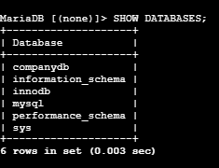
Then:
USE companydb;
Check:
SHOW TABLES;
At this point, companydb exists in RDS, but your old employees table/data from the EC2 MariaDB server will not automatically appear.
That's important:
EC2 MariaDB
|
| Existing companydb
| Existing employees data
↓
❌ NOT automatically copied

RDS MariaDB
|
└── New companydb
If your next objective is "Migrate the dummy data from EC2 MariaDB to RDS MariaDB", the backup you created earlier with mysqldump is exactly what we can use.

Overall architecture
AWS VPC
┌─────────────────────────────────────────────┐
│ │
│ EC2 │
│ ┌──────────────┐ │
│ │ Application │ │
│ │ / MariaDB │ │
│ └──────┬───────┘ │
│ │ │
│ │ TCP 3306 │
│ ↓ │
│ ┌──────────────────┐ │
│ │ RDS MariaDB │ │
│ │ │ │
│ │ companydb │ │
│ └──────────────────┘ │
│ │
└─────────────────────────────────────────────┘
Key interview point: RDS is a managed database service. You don't SSH into the RDS server and manually install MariaDB; AWS manages the underlying database infrastructure for you.

5. Migrate database from EC2 to RDS

Objective :
The objective is to move the MariaDB database and its data from your EC2 server to Amazon RDS for MariaDB.
EC2 MariaDB
↓
Take database backup
↓
Transfer backup to RDS
↓
Restore database
↓
Verify data

Prerequisites :
You need:
- EC2 instance with MariaDB installed
- Existing database and data on EC2
- Running MariaDB RDS instance
- RDS endpoint
- RDS username/password
- EC2 Security Group allowed to connect to RDS on TCP 3306
- SSL/TLS enabled if your RDS has require_secure_transport=ON
So let's migrate companydb from EC2 → RDS.

Step 1: Check companydb on EC2
You are already inside MariaDB. Run:
USE companydb;
Then:
SHOW TABLES;
For example, you might see:
+---------------------+
| Tables_in_companydb |
+---------------------+
| employees |
| departments |
+---------------------+
Check your data:
SELECT * FROM employees;
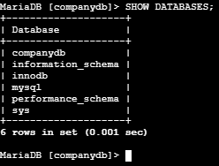
If your table has a different name, use that table name.

Step 2: Exit MariaDB
EXIT;
You should return to:
[root@ip-192-0-0-11 ~]#

Step 3: Take a backup of companydb
Run:
mysqldump -u root -p companydb > companydb.sql
Enter your EC2 MariaDB root password.
Then verify:
ls -lh companydb.sql
You should see something like:
-rw-r--r-- 1 root root 5.2K Aug 27 12:30 companydb.sql
Your backup is now:
EC2
└── companydb.sql
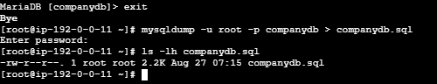

Step 4: Connect to your RDS MariaDB
Your RDS endpoint is:
mariadb-rds.czuoc8gc62bo.ap-south-1.rds.amazonaws.com
Because your RDS has:
require_secure_transport = ON
use SSL:
mariadb -h mariadb-rds.czuoc8gc62bo.ap-south-1.rds.amazonaws.com \
-P 3306 \
-u admin \
-p \
--ssl
Enter the RDS admin password.
If you successfully enter RDS, check:
SHOW DATABASES;
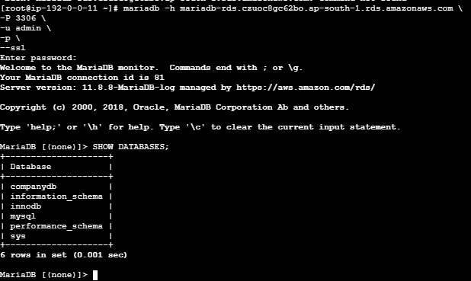

Step 5: Create companydb on RDS
Inside RDS MariaDB:
CREATE DATABASE companydb;
Verify:
SHOW DATABASES;
You should now see:
companydb
information_schema
mysql
performance_schema
sys

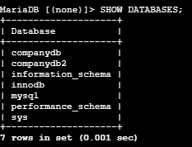
Then exit:
EXIT;

Step 6: Import the EC2 backup into RDS
This is the important migration step.
From your EC2 Linux terminal, run:
mariadb -h mariadb-rds.czuoc8gc62bo.ap-south-1.rds.amazonaws.com \
-P 3306 \
-u admin \
-p \
--ssl \
companydb < companydb.sql
Enter the RDS password.
If the command finishes without an error, your database has been imported.

Step 7: Verify the migration
Connect to RDS again:
mariadb -h mariadb-rds.czuoc8gc62bo.ap-south-1.rds.amazonaws.com \
-P 3306 \
-u admin \
-p \
--ssl
Then:
SHOW DATABASES;
Select the database:
USE companydb;
Check tables:
SHOW TABLES;
Finally, check your data:
SELECT * FROM employees;
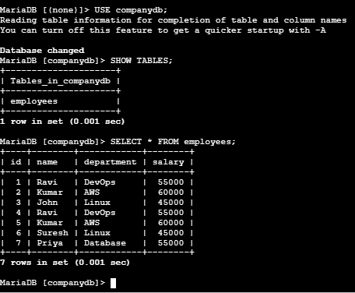

Your complete EC2 → RDS migration
EC2 MariaDB
│
│ companydb
↓
mysqldump
│
↓
companydb.sql
│
│ SSL connection
↓
RDS MariaDB
│
↓
CREATE DATABASE companydb
│
↓
Import companydb.sql
│
↓
Verify tables & data
Bottom of Form
Bottom of Form

6. Install MySQL DB on EC2.

Install MySQL DB on EC2

Objective :
The objective is to install and configure MySQL Database Server on an Amazon EC2 instance, create a sample database and verify that MySQL is working correctly.
By the end, you will have:
EC2 Instance
↓
MySQL Server
↓
Database
↓
Tables
↓
Sample Data

Prerequisites
Before starting, make sure you have:
- An AWS account
- An EC2 instance
- Amazon Linux 2023 / Amazon Linux 2 or Ubuntu
- SSH access to the EC2 instance
- EC2 Security Group configured for SSH:
- Port: 22
- Protocol: TCP
Source: Your IP
- Internet connectivity from the EC2 instance
- A PEM key file to connect to the instance

Step-by-Step Implementation

Step 1: Launch EC2
Go to AWS Console → EC2 → Instances → Launch instance.
Configure:
Name: mysql-server
AMI: Amazon Linux 2023
Instance type: t3.micro
Select or create a key pair.
Security Group:
SSH
TCP
22
Source: My IP
Launch the instance.
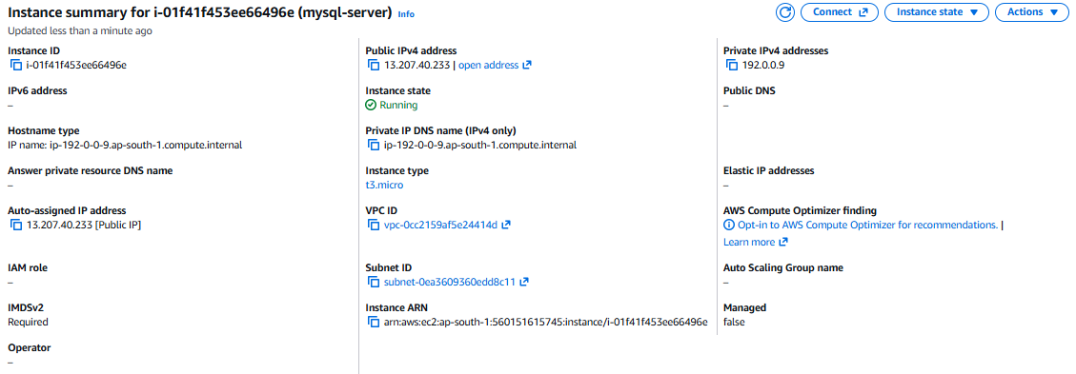

Step 2: Connect to EC2
From your local system:
ssh -i mykey.pem ec2-user@<EC2-PUBLIC-IP>
Example:
ssh -i aws-key.pem ec2-user@13.234.XX.XX
After connecting, verify the OS:
cat /etc/os-release

Step 3: Update the packages
Run:
sudo dnf update -y

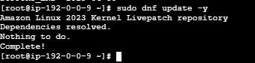

Step 4: Install MySQL
On Amazon Linux 2023, install the MySQL client/server package available through the configured repositories:
sudo dnf install mariadb105-server -y
Amazon Linux commonly provides MariaDB, which is MySQL-compatible. If your assignment specifically requires Oracle MySQL Server, tell me your EC2 OS/version and I'll give you the exact MySQL 8 installation procedure.

Step 5: Check the installation
Run:
mysql --version
You should get output similar to:
mysql Ver 15.1 Distrib 10.5.x-MariaDB

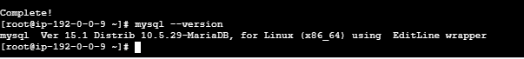

Step 6: Start the Database Service
Start MariaDB:
sudo systemctl start mariadb
Check its status:
sudo systemctl status mariadb
You should see:
Active: active (running)

Step 7: Enable the service at boot
Run:
sudo systemctl enable mariadb
This ensures the database automatically starts when the EC2 instance is rebooted.
Verify:
sudo systemctl is-enabled mariadb
Expected:
enabled

Step 8: Secure the Database
Run:
sudo mysql_secure_installation
You will be asked several questions.
For a practice environment, you can generally:
Switch to unix_socket authentication? → Y/N depending on your setup
Set root password → Configure as appropriate
Remove anonymous users → Y
Disallow remote root login → Y
Remove test database → Y
Reload privilege tables → Y
The exact prompts can vary by MariaDB version.
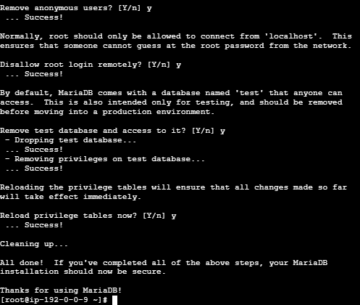

Step 9: Login to the Database
Run:
sudo mysql
You should see:
MariaDB [(none)]>
or a MySQL prompt depending on the installed server.

Step 10: Check existing databases
Run:
SHOW DATABASES;
You may see:
+--------------------+
| Database |
+--------------------+
| information_schema |
| mysql |
| performance_schema |
| sys |
+--------------------+
These are system databases.
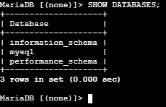

Step 11: Create a Database
Create a sample database:
CREATE DATABASE companydb;
Verify:
SHOW DATABASES;
You should now see:
companydb

Step 12: Use the Database
Run:
USE companydb;
Expected:
Database changed

Step 13: Create a Table
Create an employee table:
CREATE TABLE employees (
id INT PRIMARY KEY AUTO_INCREMENT,
name VARCHAR(100),
department VARCHAR(100),
salary INT
);
Check the table:
SHOW TABLES;
Expected:
+---------------------+
| Tables_in_companydb |
+---------------------+
| employees |
+---------------------+

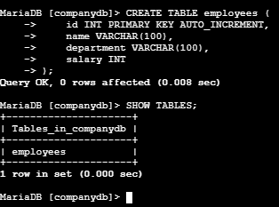

Step 14: Insert Sample Data
Run:
INSERT INTO employees (name, department, salary)
VALUES
('Ravi', 'IT', 50000),
('Suresh', 'HR', 45000),
('Kiran', 'Finance', 55000);

Step 15: Verify the Data
Run:
SELECT * FROM employees;
Example output:
+----+--------+------------+--------+
| id | name | department | salary |
+----+--------+------------+--------+
| 1 | Ravi | IT | 50000 |
| 2 | Suresh | HR | 45000 |
| 3 | Kiran | Finance | 55000 |
+----+--------+------------+--------+

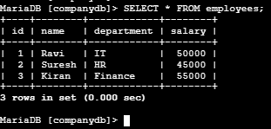

Step 16: Exit MySQL
EXIT;
You will return to:
[ec2-user@ip-xxx-xxx-xxx-xxx ~]$

Step 17: Verify the Service
Run:
sudo systemctl status mariadb
You should have:
Active: active (running)
You can also check which port the database is listening on:
sudo ss -lntp | grep 3306
Expected:
LISTEN ... 3306 ...

Final Architecture
AWS
│
▼
┌───────────────┐
│ EC2 │
│ Amazon Linux │
│ │
│ ┌───────────┐ │
│ │ MySQL/ │ │
│ │ MariaDB │ │
│ └─────┬─────┘ │
│ │ │
│ companydb │
│ │ │
│ employees │
└───────────────┘

Important
For your EC2 → RDS migration practice, you can use the companydb database you create here. The overall flow will be:
EC2 MariaDB
│
│ mysqldump
▼
companydb.sql
│
│
▼
RDS MariaDB
│
│ restore
▼
companydb
This gives you a complete practical workflow: Install DB → Create database → Insert data → Backup → Migrate to RDS.

7. Launch MySQL RDS image.

Objective :
The objective is to launch a managed MySQL database using Amazon RDS.
Instead of installing and maintaining MySQL manually on an EC2 instance, Amazon RDS manages tasks such as:
- Database software installation
- Automated backups
- Patching
- Monitoring
- Storage management
- High availability options
The final setup will look like:
AWS
│
└── Amazon RDS
│
└── MySQL
│
└── MySQL Database

Prerequisites :
Before launching the RDS instance, make sure you have:
- An AWS account
- Access to the AWS Management Console
- An existing VPC
- At least one suitable subnet
- A Security Group
- An EC2 instance if you want to connect to RDS from EC2
- MySQL username and password that you will create during RDS setup
- AWS Region selected — for example:
Asia Pacific (Mumbai) – ap-south-1

Recommended Security Group rule
If your EC2 server needs to connect to RDS:
Type: MySQL/Aurora
Protocol: TCP
Port: 3306
Source: EC2 Security Group
Do not use 0.0.0.0/0 for a production database.

Step-by-Step Implementation

Step 1: Open Amazon RDS
Login to AWS Console.
Search for:
RDS
Open:
Amazon RDS
Then select:
Databases
↓
Create database

Step 2: Select Creation Method
Select:
Standard create

Why Standard create?
It gives you control over:
- VPC
- Subnets
- Security Groups
- Storage
- Availability
- Backup
- Monitoring
- Connectivity
For hands-on AWS training, Standard create is the better choice.

Step 3: Choose Engine
Under:
Engine options
Select:
MySQL
You may see an engine version such as:
MySQL 8.0
Choose the version required by your training or application.

Step 4: Choose Template
You may see:
Production
Dev/Test
Free tier
For learning/practice:
Dev/Test
or, if your account offers it and your workload qualifies:
Free tier

For your hands-on practice
Use the lowest-cost option available to you rather than production settings.

Step 5: Configure DB Instance
Under:
DB instance identifier
Enter something like:
mysql-rds
This is the name used to identify your RDS instance.

Step 6: Configure Credentials
Under:
Master username
Enter:
admin
Then configure the master password.
For example:
Username: admin
Password: ********
Remember this password.
You will need it when connecting from EC2.

Step 7: Select Instance Class
Under:
DB instance class
Choose an appropriate small instance for practice.
For example, depending on what AWS currently offers in your account/region:
Burstable classes
Choose the smallest suitable option.
For training, you normally don't need a large database instance.

Step 8: Configure Storage
Select:
General Purpose SSD
For practice, a small amount of storage is sufficient.
For example:
Allocated storage: 20 GiB
If available, leave:
Storage autoscaling
enabled if you want RDS to automatically increase storage when needed.

Step 9: Configure Availability
For a simple practice database, select:
Single-AZ
You don't need Multi-AZ for this basic exercise.

Single-AZ
RDS
│
└── Availability Zone
└── MySQL

Multi-AZ
RDS
│
┌──────┴──────┐
▼ ▼
AZ-1 AZ-2
Primary Standby
Multi-AZ is mainly used for high availability/failover, not basic practice.

Step 10: Configure Connectivity
Find:
Connectivity
Select:
Virtual private cloud (VPC)
Choose your VPC.
Then configure:
DB subnet group
Select an appropriate DB subnet group.
For a production architecture, RDS should normally use private subnets.

Step 11: Configure Public Access
You may see:
Public access
For a secure architecture:
No
is preferred.
If your EC2 instance is inside the same VPC, you do not need to make RDS publicly accessible.
The architecture should be:
Internet
│
▼
EC2
│
│ Private network
▼
RDS MySQL

Step 12: Configure Security Group
Under:
VPC security group
Choose an existing security group or create a new one.
For example:
mysql-rds-sg
Add an inbound rule:
Type: MySQL/Aurora
Port: 3306
Source: EC2-Security-Group
The important concept is:
EC2 Security Group
│
│ TCP 3306
▼
RDS Security Group
This allows your EC2 server to connect to the RDS database.

Step 13: Configure Database Authentication
Use the default authentication method for a basic practice setup:
Password authentication
You will connect using:
Username + Password

Step 14: Configure Additional Settings
Under:
Additional configuration
Set:
Initial database name: companydb
This is optional.
If you enter:
companydb
RDS will create that database during setup.
You can later verify it using:
SHOW DATABASES;

Step 15: Backup
Configure:
Automated backups: Enabled
Backup retention: 7 days
For a practice environment, you can use a short retention period if appropriate.
Backups allow you to recover the database to a previous point in time.

Step 16: Monitoring
For basic practice, you can keep the default monitoring settings.
You don't need advanced monitoring initially.
Later, you can learn:
CloudWatch
Performance Insights
Enhanced Monitoring

Step 17: Create the Database
Review your configuration.
Then click:
Create database
RDS will begin provisioning your MySQL instance.
You may see:
Status: Creating
Wait until it becomes:
Available

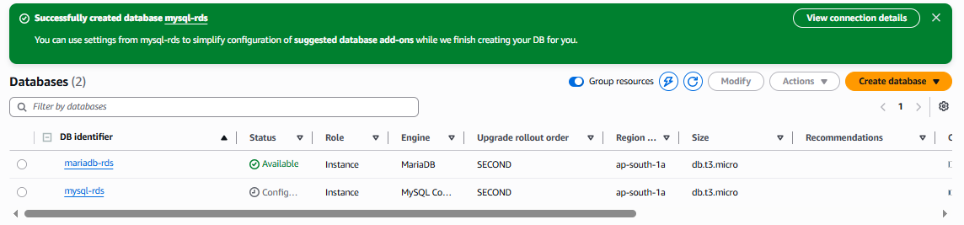

Step 18: Get the RDS Endpoint
After the status becomes:
Available
Click the database:
mysql-rds
Find:
Connectivity & security
You will see:
Endpoint
It will look similar to:
mysql-rds.xxxxxxxxxxxx.ap-south-1.rds.amazonaws.com
And:
Port: 3306
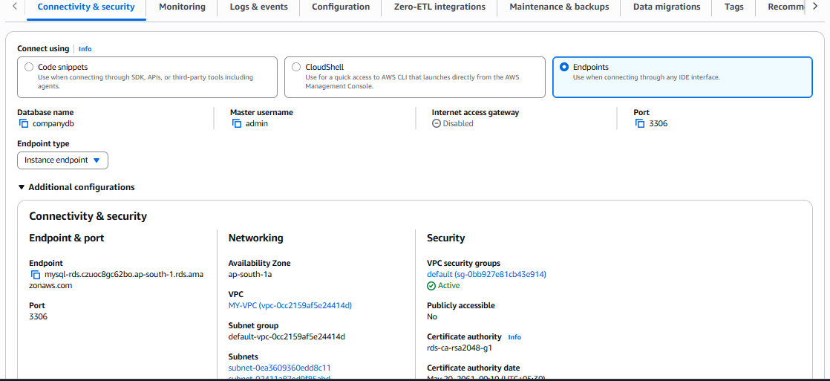

Step 19: Connect from EC2
SSH into your EC2 instance.
If the MySQL client is installed:
mysql -h <RDS-ENDPOINT> -P 3306 -u admin -p
For example:
mysql -h mysql-rds.xxxxxxxxx.ap-south-1.rds.amazonaws.com -P 3306 -u admin -p
Enter the RDS master password.
If successful, you will get:
mysql>

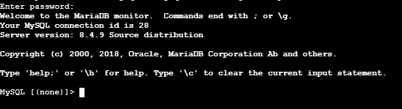

Step 20: Verify the RDS Database
Run:
SHOW DATABASES;
If you specified companydb during RDS creation, you should see:
companydb
Select it:
USE companydb;
Check tables:
SHOW TABLES;

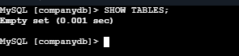

Final Architecture
AWS VPC
│
┌─────────┴─────────┐
│ │
▼ ▼
EC2 RDS
Application MySQL
│ │
│ TCP 3306 │
└──────────────────►│
│
companydb

Important points to remember
Item | Value
lService | Amazon RDS
Database Engine | MySQL
Port | 3306
Authentication | Username + Password
Practice Availability | Single-AZ
Public Access | Prefer No
Connection | EC2 → RDS
RDS Endpoint | Provided by AWS
Security | Security Group
Database | Companydb

Your hands-on sequence
Since you're practicing EC2 → RDS migration, a good sequence is:
1. Install MySQL/MariaDB on EC2
↓
2. Create companydb
↓
3. Insert dummy data
↓
4. Take mysqldump backup
↓
5. Launch MySQL RDS
↓
6. Configure EC2 → RDS connectivity
↓
7. Create companydb on RDS
↓
8. Import backup
↓
9. Verify tables and data
That is the complete practical workflow for migrating a database from EC2 to RDS.

8. Configure Multi-AZ.

Configure Multi-AZ for Amazon RDS MariaDB

Objective :
The objective is to configure Multi-AZ (Availability Zone) for an Amazon RDS MariaDB database to provide high availability and automatic failover.
With Multi-AZ:
AWS Region
|
┌─────────┴─────────┐
| |
AZ-1 AZ-2
| |
Primary DB Standby DB
| |
└────── RDS ────────┘
|
DB Endpoint
If the primary database fails, RDS automatically performs a failover to the standby in another Availability Zone.
Important: The standby is for high availability/failover. It is not intended for read scaling. For read scaling, use a Read Replica.

Prerequisites :
Before configuring Multi-AZ, make sure you have:

AWS requirements
- AWS account
- RDS MariaDB instance
- VPC
- At least 2 Availability Zones
- DB subnet group containing subnets in at least 2 AZs
- Security Group allowing MariaDB traffic on TCP 3306
- Database credentials
- Existing database should preferably be in a healthy/available state

Example
Suppose your VPC has:
VPC: 10.0.0.0/16

AZ-1
└── Private Subnet: 10.0.1.0/24

AZ-2
└── Private Subnet: 10.0.2.0/24
Your RDS DB subnet group should contain both subnets.

Step-by-step implementation

Step 1 — Open RDS
Go to the AWS Management Console.
Open:
RDS
↓
Databases
You will see your MariaDB database.
For example:
database-1
Engine: MariaDB
Status: Available

Step 2 — Select the MariaDB database
Click your MariaDB DB instance.
Then click:
Modify

Step 3 — Find Multi-AZ configuration
In the Modify DB instance page, look for:
Availability & durability

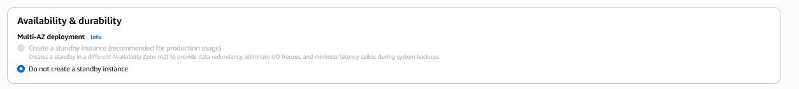
You should see an option similar to:
Multi-AZ deployment
Select:
Create a standby instance
or the current equivalent Multi-AZ option presented by the console.
Do not select a single-AZ deployment if your objective is high availability.

Step 4 — Check DB subnet group
Make sure your DB subnet group contains subnets from at least two Availability Zones.
For example:
DB Subnet Group
|
├── subnet-1 → ap-south-1a
|
└── subnet-2 → ap-south-1b
This allows RDS to place the standby in a different AZ.
You can check this from:
RDS
↓
Subnet groups
↓
Your DB subnet group

Step 5 — Review the modification
Scroll to the bottom of the Modify page.
You should see the changes that will be applied.
Choose:
Continue

Step 6 — Choose when to apply
AWS will normally provide options such as:
Apply immediately
or
Apply during the next maintenance window

For a hands-on lab
You can select:
Apply immediately
Then click:
Modify DB instance

4. What happens after you click Modify?
RDS starts creating a standby database in another Availability Zone.
For example:
Before:

AZ-1
|
└── MariaDB
Primary
After Multi-AZ:
RDS
|
┌───────┴───────┐
| |
AZ-1 AZ-2
| |
Primary DB Standby DB
The standby is maintained by RDS.
You normally do not connect directly to the standby.

5. Monitor the modification
Go to:
RDS
↓
Databases
↓
Your MariaDB instance
Watch the status.
Initially you may see something like:
Modifying
After the configuration completes:
Available

6. Verify Multi-AZ
Open your database and check the Connectivity & security or Configuration information.
Look for:
Multi-AZ: Yes
or equivalent wording indicating a Multi-AZ deployment.
You can also check the Availability Zone information.
You should see that RDS has a standby in another AZ.

7. Test the database connection
From your EC2 instance:
mysql -h <RDS-ENDPOINT> -P 3306 -u admin -p
Then:
SHOW DATABASES;
You can also check your application/database data.

8. Understand the failover
Suppose the primary DB is running in:
ap-south-1a
and the standby is in:
ap-south-1b
If the primary fails:
RDS
|
Primary fails
↓
Automatic failover
↓
Standby promoted
↓
New Primary DB
Your application continues using the same RDS endpoint.
You generally don't need to manually change the database endpoint.
There can still be a short interruption during failover.

9. Multi-AZ vs Read Replica
This is very important for interviews.
Feature | Multi-AZ | Read Replica
Main purpose | High availability | Read scaling
Standby | Yes | Replica
Automatic failover | Yes | Generally no automatic promotion as part of normal replica operation
Used for reads | No | Yes
Different AZ possible | Yes | Yes
Protects against AZ failure | Yes | Can help, depending on configuration
Data replication | Synchronous | Asynchronous

Easy way to remember
Multi-AZ
↓
High Availability
↓
Automatic Failover
Read Replica
↓
Read Scaling
↓
Offload SELECT queries

10. Important interview point
Multi-AZ does not mean two databases that your application actively reads from.
It is primarily:
Primary
↓
Synchronous replication
↓
Standby
The standby exists to provide high availability and failover.

Final architecture
Application / EC2
|
|
RDS Endpoint
|
┌───────┴───────┐
| |
AZ-1 AZ-2
| |
PRIMARY STANDBY
| |
└──── RDS ──────┘
|
Automatic Failover

9. Take backup of DB and restore the DB.

Objective :
The objective is to:
- Take a backup/snapshot of an Amazon RDS MariaDB database.
- Restore that backup into a new RDS MariaDB DB instance.
- Verify that the restored database and its data are available.
The basic workflow is:
Existing RDS MariaDB
|
↓
Create DB Snapshot
|
↓
Snapshot stored by RDS
|
↓
Restore Snapshot
|
↓
New RDS MariaDB instance
|
↓
Verify Database & Data

Prerequisites
Before starting, make sure you have:
- AWS account
- Existing RDS MariaDB instance
- RDS instance should be in Available state
- Database name and credentials
- Some test/dummy data in the database
- VPC
- DB subnet group
- Security Group allowing TCP 3306 from your EC2/client
- EC2 instance or MySQL/MariaDB client for testing the restored database

Step by step implementation :

Step 1 — Open RDS
Go to:
AWS Console
↓
RDS
↓
Databases
You should see your MariaDB instance.
For example:
database-1
Engine: MariaDB
Status: Available

Step 2 — Select the database
Select your MariaDB database.
Then click:
Actions
↓
Take snapshot

Step 3 — Enter snapshot name
AWS will ask for a snapshot identifier.
For example:
mariadb-backup-01
Use a meaningful name such as:
companydb-backup-2026
Then click:
Take snapshot
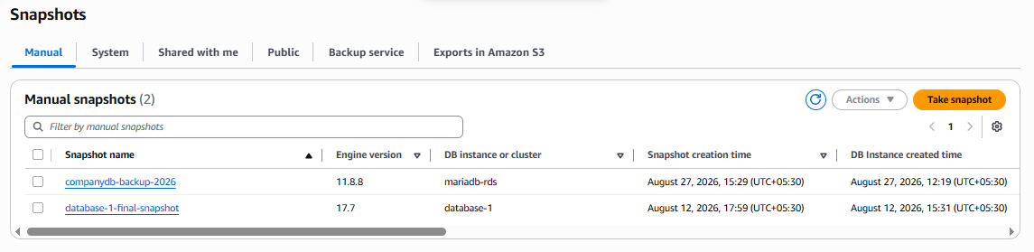

Step 4 — Monitor the snapshot
Go to:
RDS
↓
Snapshots
You should see:
mariadb-backup-01
Initially the status may show:
Creating
Wait until it becomes:
Available

Important
Don't try to restore the snapshot while it is still:
Creating
Wait for:
Available

Step 5 — Restore the database
Once the snapshot is available:
RDS
↓
Snapshots
↓
Select mariadb-backup-01
Click:
Actions
↓
Restore snapshot
AWS will open the Restore DB instance page.
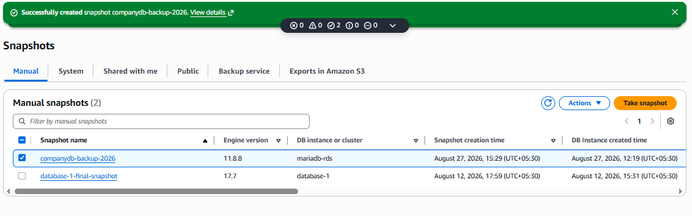
ACTIONS No access for FREE-TIRE

Step 6 — Configure the restored database
You are creating a new DB instance from the snapshot.

DB instance identifier
Give it a new name:
mariadb-restored
So:
Original:
database-1

Restored:
mariadb-restored
The original database is not overwritten.

Step 7 — Select instance configuration
For a hands-on lab, select an appropriate small instance class available in your account/region.
For example, if offered:
db.t3.micro
or another low-cost supported class.
Also check the storage and other settings.

Step 8 — Configure connectivity
Select the same VPC where your application/EC2 is running.
For example:
VPC:
My-VPC
Select the appropriate:
DB subnet group
and:
VPC Security Group
Your Security Group should allow:
Type : Custom TCP
Protocol : TCP
Port : 3306
Source : EC2 Security Group
For a lab where you're connecting from your own computer, you could temporarily use My IP, if appropriate.

Step 9 — Configure availability
For this restore exercise, you can use:
Single-AZ
unless your objective specifically requires restoring as Multi-AZ.
Remember:
Backup/Restore
≠
Multi-AZ
They are separate concepts.

Step 10 — Restore
Scroll to the bottom and click:
Restore DB instance
AWS will start creating the new database.
You may see:
mariadb-restored
Status: Creating
Wait until:
Status: Available

Step 11 — Get the restored endpoint
Click:
RDS
↓
Databases
↓
mariadb-restored
Go to:
Connectivity & security
Find:
Endpoint
For example:
mariadb-restored.xxxxxxxxxxxx.ap-south-1.rds.amazonaws.com
Copy this endpoint.

Step 12 — Connect to the restored DB
From your EC2 instance:
mysql -h <RESTORED-RDS-ENDPOINT> -P 3306 -u admin -p
Example:
mysql -h mariadb-restored.xxxxx.ap-south-1.rds.amazonaws.com -P 3306 -u admin -p
Enter the database password.

Step 13 — Verify the databases
Run:
SHOW DATABASES;
You should see the databases that existed when the snapshot was taken.
For example:
+--------------------+
| Database |
+--------------------+
| companydb |
| information_schema |
| mysql |
| performance_schema |
+--------------------+

Step 14 — Verify your data
Select your database:
USE companydb;
Check the tables:
SHOW TABLES;
Then check your dummy data:
SELECT * FROM employees;
If the data is present, your restore was successful.

Complete hands-on flow
You can remember the process like this:
RDS MariaDB
|
↓
Take Snapshot
|
↓
mariadb-backup-01
|
↓
Status = Available
|
↓
Restore Snapshot
|
↓
mariadb-restored
|
↓
Status = Available
|
↓
Get RDS Endpoint
|
↓
Connect using
MariaDB client
|
↓
SHOW DATABASES;
|
↓
Verify your data

Backup vs Restore
Operation | What it does
Take snapshot | Creates a backup of the RDS DB instance
Snapshot | Point-in-time backup that can be retained
Restore snapshot | Creates a new RDS DB instance from the snapshot
Original DB | Remains unchanged
Restored DB | Separate DB instance

Key interview point
Restoring an RDS snapshot does not restore data into the existing DB instance. It creates a new RDS DB instance from the snapshot.
Also, for production environments, distinguish between automated backups and manual DB snapshots: automated backups support point-in-time recovery, while a manual snapshot is retained until you delete it.

10. Create read replica

Objective
The objective is to create an RDS Read Replica for a MariaDB database.
A Read Replica maintains a copy of the source database and is primarily used to:
- Scale read traffic
- Reduce the read workload on the primary database
- Improve application performance
- Provide an additional database that can later be promoted to standalone DB instance if needed

Basic architecture
Application
|
┌──────┴──────┐
↓ ↓
Write Read
↓ ↓
Primary RDS Read Replica
MariaDB MariaDB
|
| Replication
↓
───────────────►

Important
Multi-AZ and Read Replica are different.
Multi-AZ
↓
High Availability
↓
Automatic Failover
Read Replica
↓
Read Scaling
↓
Offload SELECT/read traffic

Prerequisites :
Before creating the Read Replica, make sure you have:

AWS requirements
- AWS account
- Existing RDS MariaDB DB instance
- Source DB should be in Available state
- Source DB must support Read Replicas
- Sufficient AWS service quota/resources
- Appropriate VPC and networking configuration
- Security Group allowing MariaDB traffic on TCP 3306

Database requirements
Your source database should contain some data so that you can verify replication.
For example:
SHOW DATABASES;
Then:
USE companydb;
SHOW TABLES;
And:
SELECT * FROM employees;

Step by step implementation :

Step 1 — Open RDS
Go to:
AWS Console
↓
RDS
↓
Databases
You should see your existing MariaDB database.
Example:
database-1
Engine: MariaDB
Status: Available

Step 2 — Select the source database
Click your MariaDB database.
For example:
database-1
Then click:
Actions
↓
Create read replica
AWS will open the Read Replica configuration page.

Step 3 — Enter Read Replica identifier
You need to give the replica a unique DB identifier.
For example:
DB instance identifier:

mariadb-read-replica
Your architecture will now be:
Source:
database-1

Replica:
mariadb-read-replica

Step 4 — Choose DB instance class
Select an appropriate instance class.
For a hands-on lab, choose a small supported instance class available for your selected MariaDB version and region.
For example, AWS may offer something such as:
db.t3.micro
Do not assume a particular class will always be available; the choices depend on the engine/version/region.

Step 5 — Configure storage
You will see storage settings inherited from or configurable for the replica.
For example:
Allocated storage
Storage type
For your lab, you can normally keep the default values unless you have a specific requirement.

Step 6 — Configure Availability
You may see:
Availability & durability
For example:
Multi-AZ deployment
Remember that Read Replica and Multi-AZ solve different problems.
For this particular hands-on exercise, your objective is:
Create Read Replica
So don't confuse this with the previous Multi-AZ exercise.

Step 7 — Configure connectivity
Check the networking settings.
You may need to select:
VPC
DB subnet group
Security group
Use the appropriate VPC and DB subnet group.
The Security Group should allow:
Type : Custom TCP
Protocol : TCP
Port : 3306
Source : EC2 Security Group
For example:
EC2
|
| TCP 3306
↓
Read Replica

Step 8 — Create the Read Replica
Review the configuration.
Then click:
Create read replica
AWS starts creating the replica.
Initially you may see:
Status: Creating
Wait until it becomes:
Status: Available
Depending on the database size and configuration, this can take some time.

Step 9 — Verify the Read Replica
Go to:
RDS
↓
Databases
You should now see something similar to:
database-1
mariadb-read-replica
Click:
mariadb-read-replica
Look at the database details.
You should be able to see that it is associated with the source DB/read-replica configuration.

Step 10 — Copy the Read Replica endpoint
Open:
mariadb-read-replica
Go to:
Connectivity & security
Find:
Endpoint
It will have a different endpoint from the source database.
For example:
Primary:
database-1.xxxxx.ap-south-1.rds.amazonaws.com

Read Replica:
mariadb-read-replica.xxxxx.ap-south-1.rds.amazonaws.com
Do not use the primary endpoint when testing the replica.

Step 11 — Connect to the Read Replica
From your EC2 instance:
mysql -h <READ-REPLICA-ENDPOINT> -P 3306 -u admin -p
For example:
mysql -h mariadb-read-replica.xxxxx.ap-south-1.rds.amazonaws.com -P 3306 -u admin -p
Enter the appropriate password.

Step 12 — Verify the replicated data
Run:
SHOW DATABASES;
Then:
USE companydb;
Check the tables:
SHOW TABLES;
Then:
SELECT * FROM employees;
You should see the data that was present on the source database.

Step 13 — Test replication
This is the important hands-on part.

On the PRIMARY database
Connect to the primary RDS endpoint:
mysql -h <PRIMARY-ENDPOINT> -P 3306 -u admin -p
Then insert a test record:
USE companydb;

INSERT INTO employees
VALUES (101, 'TestUser', 'DevOps');
Check:
SELECT * FROM employees;

Now check the READ REPLICA
Connect to the replica:
mysql -h <READ-REPLICA-ENDPOINT> -P 3306 -u admin -p
Run:
USE companydb;

SELECT * FROM employees;
The new record should eventually appear on the replica.
There can be a replication delay, so don't expect the change to appear necessarily instantaneously.

Important: Don't use the replica for writes
The normal use case is:
PRIMARY
|
+── INSERT
+── UPDATE
+── DELETE
while:
READ REPLICA
|
+── SELECT
+── SELECT
+── SELECT
A Read Replica is intended primarily for read traffic.
Your application can therefore be designed like:
Application
|
┌───────┴───────┐
↓ ↓
Writes Reads
↓ ↓
Primary Read Replica
RDS RDS
|
| Replication
└──────────────►

Check Replica Lag
RDS provides a metric called:
ReplicaLag
You can monitor it through:
RDS
↓
Databases
↓
Read Replica
↓
Monitoring
You can also use CloudWatch to monitor replica-related metrics.
If replica lag increases significantly, it means the replica is falling behind the source.

Read Replica vs Multi-AZ vs Backup
This is very important for interviews:
Feature | Read Replica | Multi-AZ | Snapshot
Main purpose | Read scaling | High availability | Backup
Copies data | Yes | Yes | Yes
Read traffic | Yes | No | No
Automatic failover | Not as the primary purpose | Yes | No
Different AZ | Possible | Yes | N/A
Replication | Asynchronous | Synchronous standby | Snapshot
Creates separate DB instance | Yes | Standby | Restore creates one
Application reads from it | Yes | Normally no | No

Easy memory trick
BACKUP
↓
Protect my data
MULTI-AZ
↓
Protect my availability
READ REPLICA
↓
Scale my reads

Complete Hands-on Flow
Existing RDS MariaDB
|
↓
Select DB
|
↓
Actions
|
↓
Create read replica
|
↓
Give replica identifier
|
↓
Configure instance/network
|
↓
Create read replica
|
↓
Wait for Available
|
↓
Copy replica endpoint
|
↓
Connect from EC2
|
↓
SHOW DATABASES;
|
↓
Verify companydb
|
↓
Insert data on Primary
|
↓
Check data on Replica
|
↓
Replication verified

One-line interview answer
An RDS Read Replica is a separate DB instance that asynchronously replicates data from a source database and is primarily used to scale read workloads and improve application performance.

