First Challenge
- Launch oneEC2 instanceusingAmazon Linux 2.
- 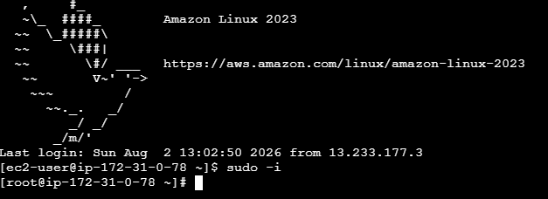
- InstallDocker.
- 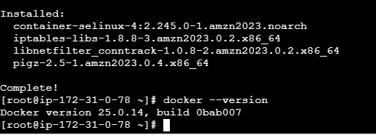

. InstallJenkins.
- 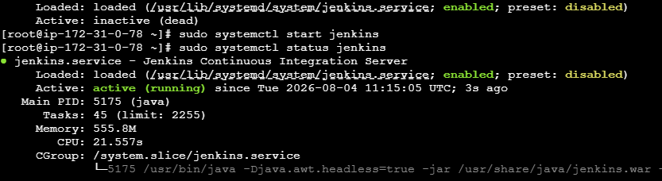
- InstallApache
- 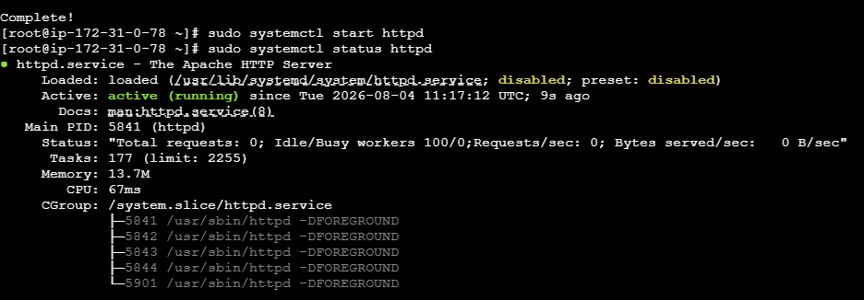.
- InstallNginx.
- 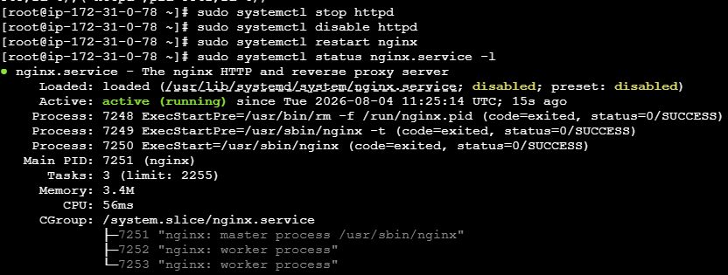
- InstallApache Tomcat.
- 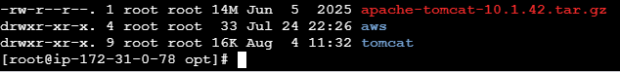
Everything needs to be setup and running on the same EC2.
You can change the port numbers as required.

