LINUX
1.Create user with name Techie and provide sudo access to user.
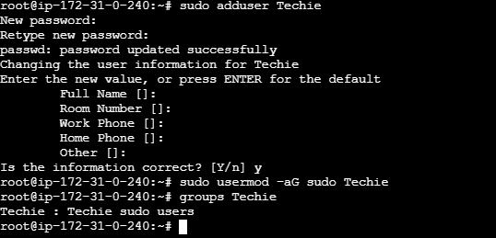
2.Navigate to the home directory.
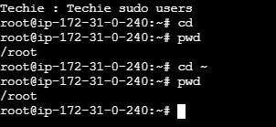
3.Create a new directory.
Cmd : mkdir <directory_name>
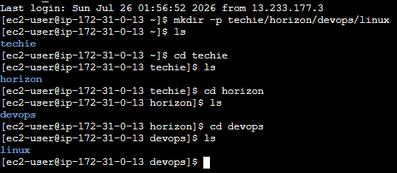

4.List the contents of a directory.

Short list ls
Long list ll
Short list + hidden files ls -a
Long list + permissions + owner + size + date ls -l
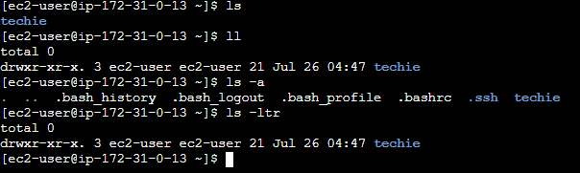

5.Change the current directory.
Cd
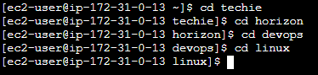

6.Create a new empty file.

touch <file_name> And it creates zero-size file

7.View the contents of a file
cat <file_name>.
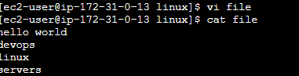

8.Copy a file to another location.

cp <source_file> <destination_file>
To copy a directory use the -r (recursive)
cp -r <directory_name> /path/
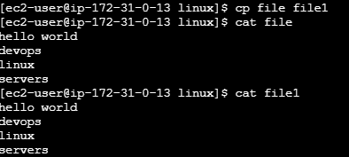

9.Move a file to another location.

mv <source_file> <destination_directory>
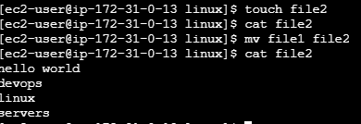

10.Rename a file

mv <file_name> <new_file_name>
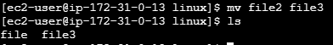

11.Delete a file.
rm <file_name>
rmdir <dir_name> deletes an empty directory
rm -rf <directory_name>
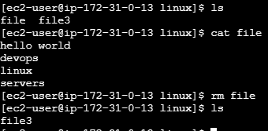

12.Grant or revoke permissions on a file or directory.
Permissions read(r)-4 write(w)-2 execute(x)-1
Chmod – cmd to change the permissions
Chmod <permissions> <file or directory>
Read , write and execute permissions
Chmod 700 file.txt
Revoke permissions
Remove execute permissions for others
Chmod 0-x file.txt
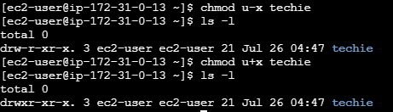

13.View the current date and time.
Cmd : date
Day month date time year
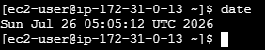

14.Check the system uptime.
Cmd : uptime -p
O/P : Up Xdays Xhours Xminutes

15.View the running processes.
Cmd : Ps => running process of current terminal
Cmd : ps -ef => list all running process
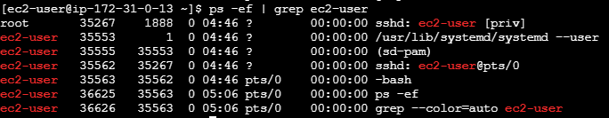

16.Kill a running process.
Kill <PID>
Kill -9 <PID> forcefully kill the process

17.Install a package using the package manager (e.g., apt or yum).

Cmd : sudo apt update -y && sudo apt upgrade -y
Cmd : sudo yum update -y for RHEL/CENTOS/AMAZON LINUX
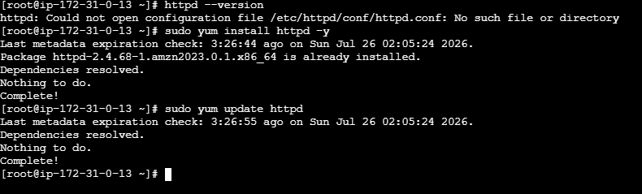

18.Update the system packages.
Cmd : sudo apt update -y && sudo apt upgrade -y

19.Create a symbolic link.
Cmd : ln -s <target_file_name/directory_name> <symbolic_link_name>
Cmd : ln -s /home/techie/file.txt file_link.txt create a symbolic link to a file
Cmd : ln -s /home/techie/project project_link create a symbolic link to a directory
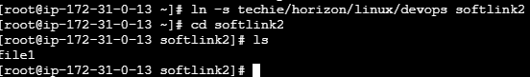

20.Search for files using the find command.
Cmd : find . -name “file.txt” find from current dir
Cmd : find /home -name “file.txt” find from home dir
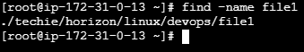

21.Compress and decompress files using tar.
Cmd : tar -czvf archive.tar.gz folder_name create a tar archive
Cmd : tar -xvf archive.tar extract a tar archive
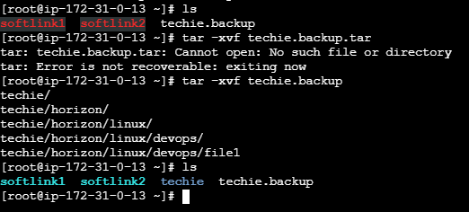

22.Monitor system resources with top or htop
Cmd : top => Displays Cpu usage , memory usage , running processes, system uptime and load average
Cmd : htop => displays colourful view of system resources
If htop not installed
Sudo apt install htop -y for ubuntu
Sudo yum install htop -y for RHEL/CENOS/AWSLINUX
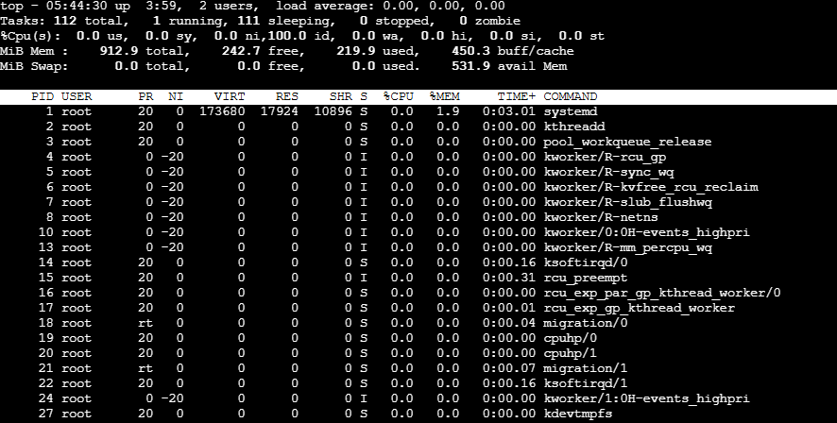

23.Create and manage user groups.
Cmd : sudo groupadd <group_name> create a new group
Cmd : getent group <group_name> verify the group exits
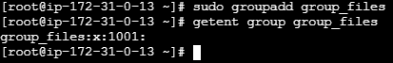
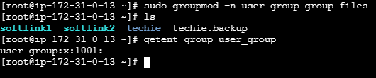

24.Set up SSH password less authentication.
Communicate from local server to Remote server which they are in two different Regions
Local server Mumbai region Remote server Hyderabad region
Test : created zero-size files from one region ec2 – other region ec2
Step 1: Generate an SSH Key Pair (on the client machine)
Cmd : ssh-keygen -t rsa
Step 2: Cmd : ls -l ~/.ssh
Step 3: id_rsa # Private key (Never share this)
id_rsa.pub # Public key (Can be shared)
Step 4 : Copy the Public Key to the Remote Server
Step 5 : Login to Remote Server Cmd : mkdir -p ~/.ssh
Step 6 : Cmd : vi ~/.ssh/authorized_keys
Step 7 : Paste the public key in this path /.ssh/authorized_keys
Step 8 : chmod 700 ~/.ssh
Step 9 : chmod 600 ~/.ssh/authorized_keys
Step 10 : login through ssh ubuntu@public ip-address from client server without any password
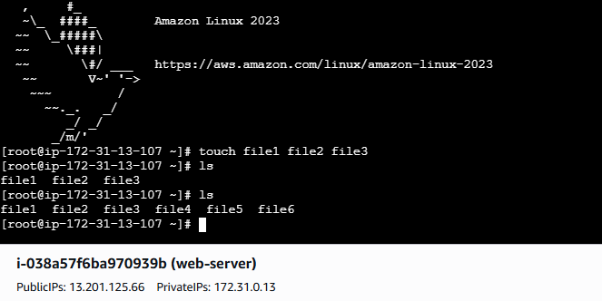
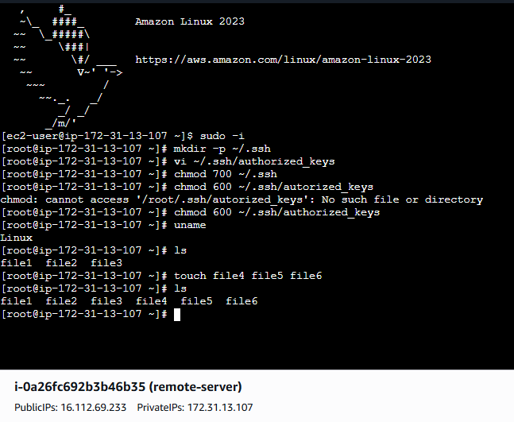
25.Monitor log files using tail or grep.
Cmd : tail -f /var/log/syslog
O/P : Jul 18 20:15:01 server sshd[1234]: Accepted password for user
Jul 18 20:15:05 server systemd: Started nginx service.
To list last 50 lines
Cmd : tail -n 50 /var/log/messages
Cmd : grep <keyword> <log_file> to search specific log entries
Display new log entries and filter for error
Cmd : tail -f /var/log/messages | grep "error"

26.Set up a web server (e.g., Apache or Nginx).
Set Up Apache Web Server
Step 1 : Install Apache On RHEL/CentOS/Amazon Linux
sudo yum install httpd -y
On Ubuntu
Cmd : sudo apt update
sudo apt install apache2 -y
Step 2 : Start the service
Sudo systemctl start httpd [amazon linux]
Sudo systemctl st
art apache2 [Ubuntu]
Step 3 : enable the service
Sudo systemctl enable httpd [amazon linux]
Sudo systemctl enable apache2 [Ubuntu]
Step 4 : check the status
Sudo systemctl status httpd [amazon linux]
Sudo systemctl status apache2[Ubuntu]
Step 5 : enabled Port(80)
sudo firewall-cmd --permanent --add-service=http
sudo firewall-cmd --reload
for Ubutnu
sudo ufw allow 80/tcp
sudo ufw reload
step 6 : create a test web page
echo "<h1>Apache Web Server is Running!</h1>" | sudo tee /var/www/html/index.html
step 7 : Access the web server
http://<EC2-Public-IP>

27.Configure and secure a MySQL Database.
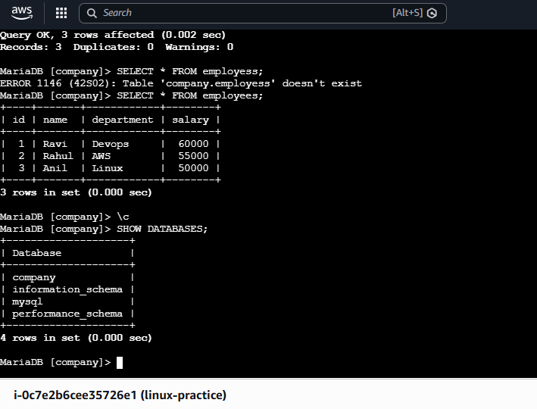

28.Set up a Application Server (e.g.,Apache Tomcat)
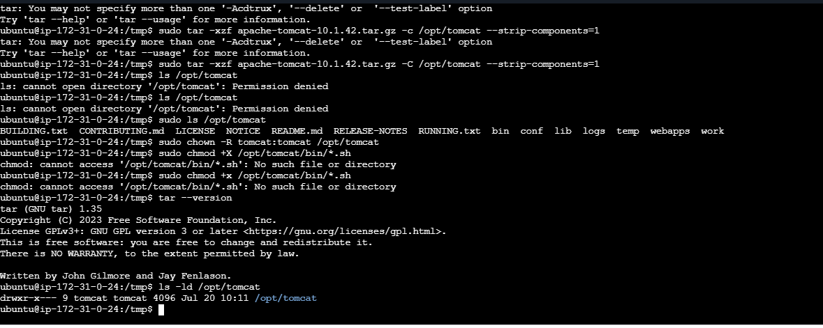

29.create a service file for Apache Tomcat.(Should execute by using systemtctl command)
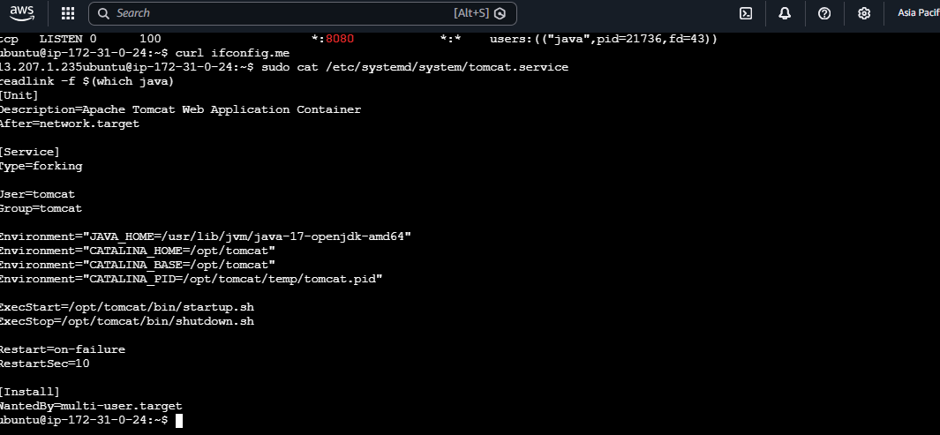

30.Print specific columns from a delimited file.
To print columns we have cmd’s to use
1.cut 2.awk
Cmd : cut -d':' -f2 employees.txt
Cmd : awk -F':' '{print $2}' employees.txt
Cmd : awk -F':' '{print $1,$4}' employees.txt

31.Filter and print lines based on a specific pattern or condition.
Cmd : grep "KeyWord" file_name.txt
Cmd ; awk '$n > xxx' file_name.txt [pattern + conditions]
Cmd : grep "DevOps" employees.txt | awk '{print $2}'

32.Calculate and print the average, sum, or other statistics of a column.
Cmd : awk '{sum += $4} END {print "Total Salary =", sum}' file_name.txt [SUM]
Cmd : awk '{sum += $4; count++} END {print "Average Salary =", sum/count}' file_name.txt[AVERAGE]
Cmd : awk 'NR==1 {max=$4} $4>max {max=$4} END {print "Maximum Salary =", max}' file_name.txt[MAXIMUM]
Cmd : awk 'NR==1 {min=$4} $4<min {min=$4} END {print "Minimum Salary =", min}' employees.txt [MINIMUM]
Cmd : awk 'END {print "Total Employees =", NR}' employees.txt [count]
Cmd : awk '{print $2, $4; sum += $4} END {print "Total Salary =", sum}' employees.txt [NAME & SALARY]
Cmd : awk '{sum += $4} END {print "Sum =", sum; print "Average =", sum/NR}' employees.txt [SUM & AVERAGE]
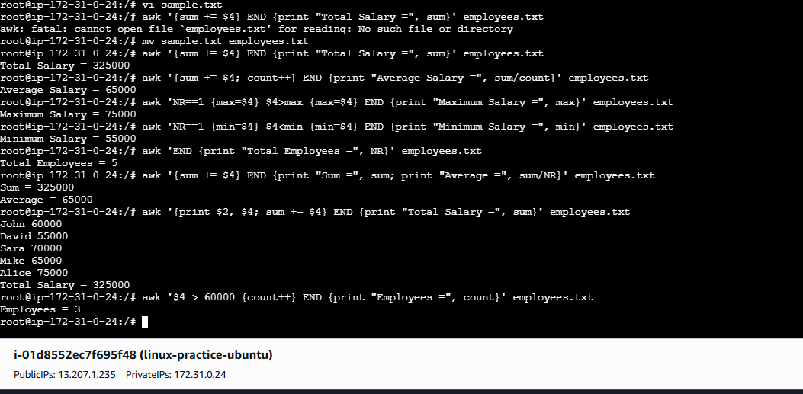

33.Perform string manipulation, such as extracting substrings or changing case.
String manipulation in Linux can be performed using commands like awk, cut, sed, tr, and Bash parameter expansion.
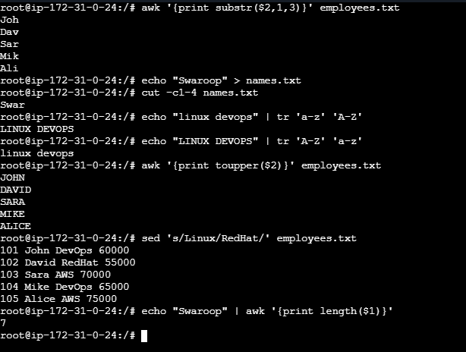

34.Count the occurrences of a specific pattern in a file.
To count the occurrences of a specific pattern in a file, Linux provides several commands such as grep, awk, and wc
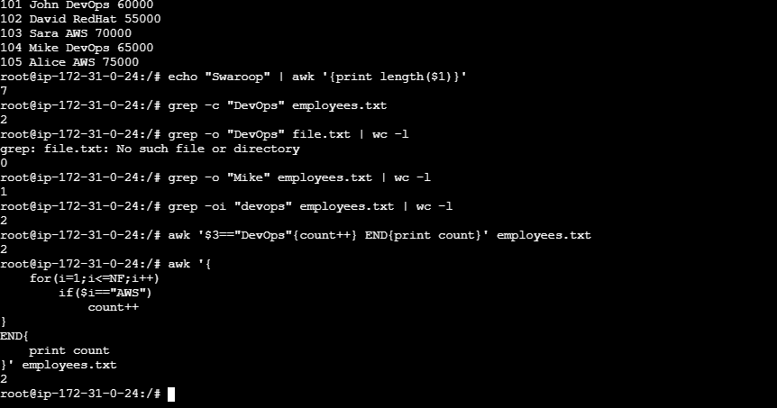

35.Sort lines based on a specific field or column.
In Linux, you can sort lines based on a specific field or column using the sort command.
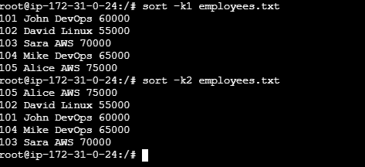

36.merge multiple files based on a common field or column.
The JOIN command merges two files using a common field
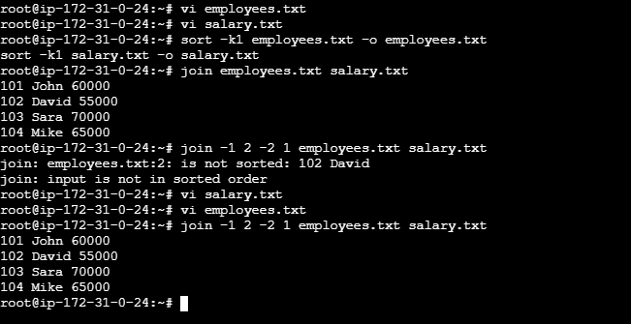

37.Substitute text in a file using search and replace.
The primary Linux command used to substitute (search and replace) text in a file is sed (Stream Editor
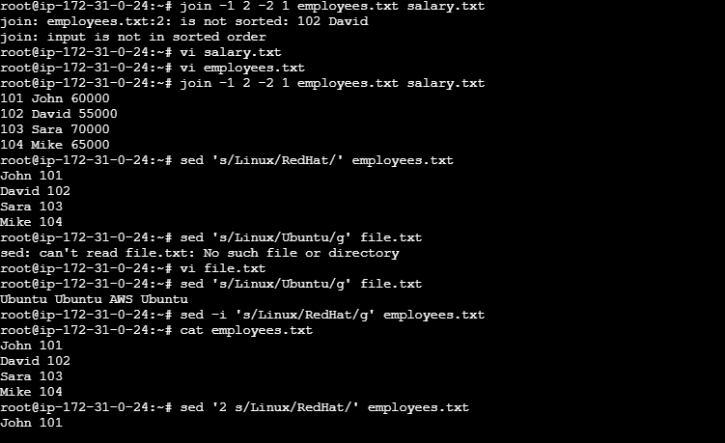

38.Delete specific lines based on a pattern or line number.
Delete specific line Number
Cmd : sed '3d' employees.txt
Delete Multiple Line Numbers
Cmd : sed '2,4d' employees.txt
Delete last line
Cmd : sed '$d' employees.txt
Delete First Line
Cmd : sed '1d' employees.txt
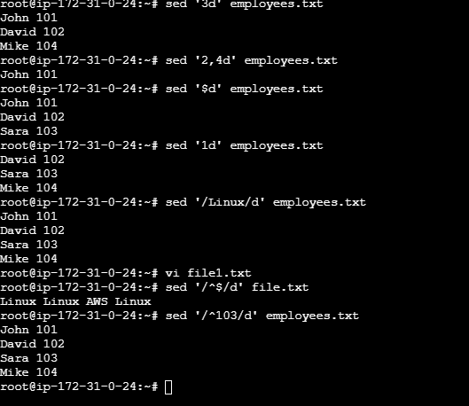

39.Append or insert text before or after a specific pattern or line.
Insert Text Before a Specific Line Number
Cmd : sed '3i\New Employee List' employees.txt
Append a text after a specific line number
Cmd : sed '2a\Department Updated' employees.txt
Insert a text before a pattern
Cmd : sed '/AWS/i\Cloud Department' employees.txt
Append a text after pattern
Cmd : sed '/Linux/a\OS Team' employees.txt
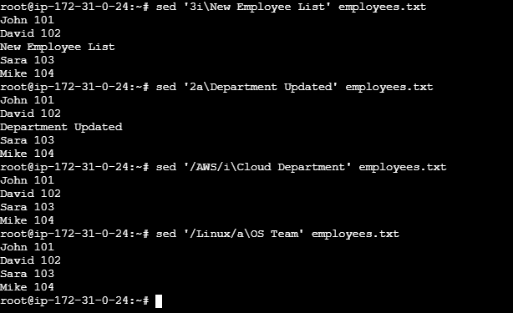

40.Print only specific lines from a file.
To print only specific lines from a file, Linux provides several commands such as sed, awk, and head/tail.
Cmd : sed -n '3p' employees.txt
Cmd : sed -n '2,4p' employees.txt
Cmd : awk 'NR==4' employees.txt
Cmd : head -3 employees.txt
Cmd : tail -2 employees.txt

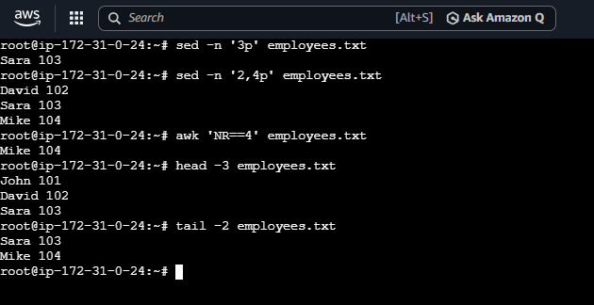

41.Copy file from linux to windows machine
There are several ways to copy a file from a Linux machine to a Windows machine. The most common methods are SCP, WinSCP, and SFT.
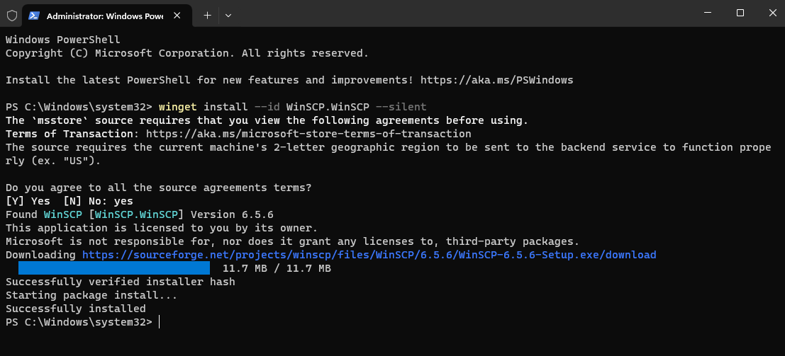
INSTALL winscp in windows machine

42.5 use cases for AWK and 5 use cases for sed
5-Uses cases for AWK
1.Print a specific column
Cmd : awk '{print $1}' file.txt
2.Print Multiple-Lines
Cmd : awk '{print $1, $3}' file.txt
3.Flow rows based on conditions
Cmd : awk '$2 > 25 {print $1,$2}' file.txt
4.count Lines
Cmd : awk 'END {print NR}' file.txt
5.Calculate the sum of coloumn
Cmd : awk '{sum += $2} END {print sum}' salary.txt

5-use cases for SED
1.Replace a word
Replace "AWS" with "Azure".
Cmd : sed 's/AWS/Azure/' file.txt
2.Replace all Occurences in a line
g = Global (replace every occurrence)
Cmd : sed 's/AWS/Azure/g' file.txt
3.Delete a line
Delete line number 5.
Cmd : sed '5d' file.txt
4.Print only a specific Line
Print line 10
Cmd : sed -n '10p' file.txt
5.Edit a file directory
Replace dev with prod inside a file
sed -i 's/dev/prod/g' file.txt

