TERRAFORM -1
1). Install Terraform on your PC

Objective
To install Terraform on a Windows PC, configure the system environment variables, and verify the installation by running Terraform commands from the Command Prompt or PowerShell.
Expected outcome: Terraform should be installed successfully and ready to use for Infrastructure as Code (IaC), such as provisioning AWS EC2 instances, S3 buckets, and VPCs.

Prerequisites
- A Windows 10/11 PC.
- Internet connection.
- Administrator access to install software and modify system environment variables.
- Basic knowledge of Command Prompt or PowerShell.
- An AWS account is optional for installation; it is needed later if you want to provision AWS infrastructure.

Step-by-step implementation

Step 1: Download Terraform
- Open the official HashiCorp installation page: Download Terraform.
- Find the Windows section.
- Download the ZIP file that matches your PC architecture:
  - AMD64 — most standard Intel/AMD 64-bit PCs.
  - ARM64 — Windows PCs with ARM processors.
Reference: Official Terraform installation guide.

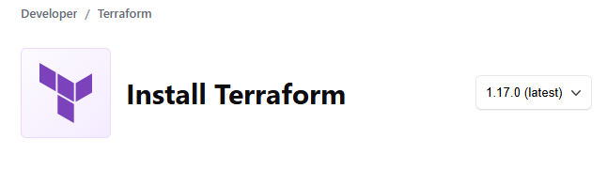

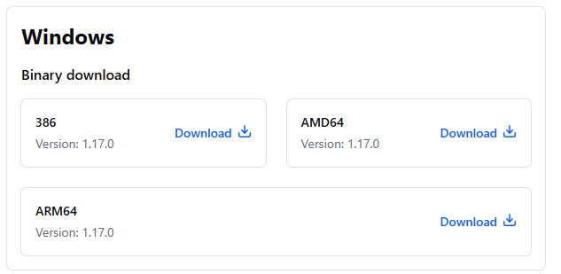

Step 2: Extract the ZIP file
- Open your Downloads folder.
- Right-click the Terraform ZIP file.
- Select Extract All.
- Locate the extracted terraform.exe file.

Step 3: Create a permanent folder
Create a folder on your C drive:
C:\terraform
Move or copy terraform.exe into this folder.
Your folder should look like this:
C:\terraform
terraform.exe

Step 4: Configure the PATH environment variable
This is an important step. It allows you to execute Terraform commands from any directory in the terminal.
- Press Windows + S.
- Search for Environment Variables.
- Select Edit the system environment variables.
- Click Environment Variables.
- Under System variables or User variables, select Path.
- Click Edit → New.
- Add this path:
C:\terraform
8. Click OK on all open windows.

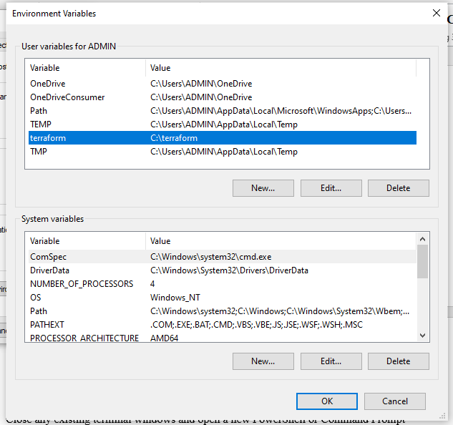

Step 5: Verify the installation
Open PowerShell or CMD and run:
terraform -version
Expected output will look similar to:
Terraform v1.x.x
on windows_amd64
The exact version may differ.
Check that Windows can find the executable:
where.exe terraform
Expected output:
C:\terraform\terraform.exe

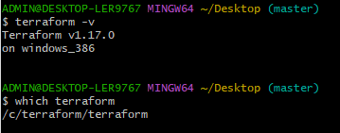

Step 6: Run basic Terraform commands
Test these commands one by one:
terraform -help
terraform fmt -help
terraform validate

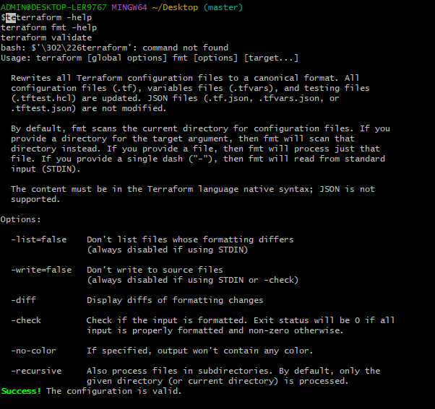

2). Execute all the templates shown in video.

How to install it
- Open VS Code.
- Click the Extensions icon on the left, or press Ctrl + Shift + X.
- Search for HashiCorp Terraform.
- Select the extension published by HashiCorp and click Install.
- Open your Terraform project folder containing .tf files.
These are two different things.
Terraform extension
Helps you write and edit Terraform code inside VS Code.
Terraform CLI
The actual executable that runs commands such as
terraform init
terraform plan
terraform apply.

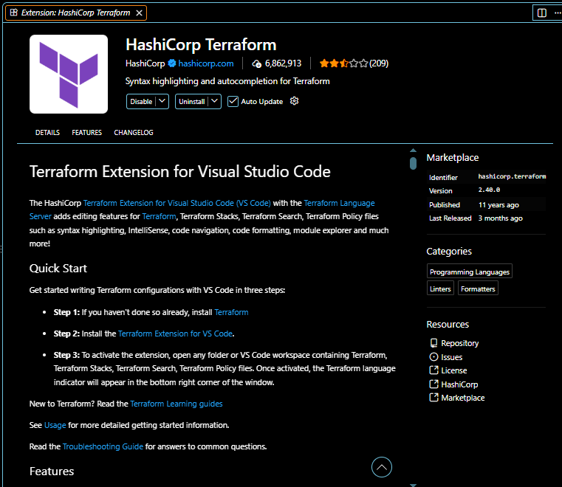
Create a terraform_basic folder
Open it in a Visual studio
Create a file called main.tf
Inside the main.tf :
resource "local_file" "my_pet" {
filename = "pets.txt"
content = "I HATE PETS"
}

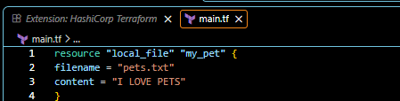

Open a new terminal here , in visual studio
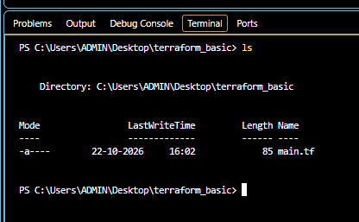

Run the command terraform init
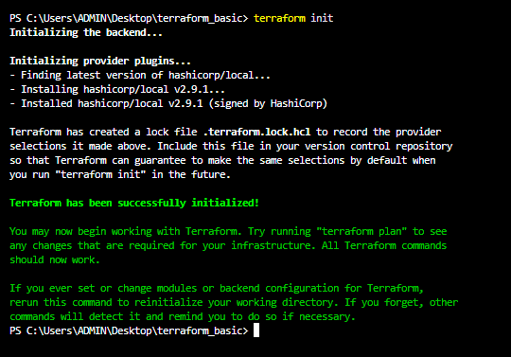

Run the commad “terraform plan” to read the main.tf
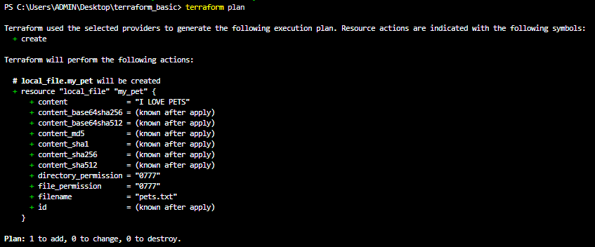

Inside a terraform state file
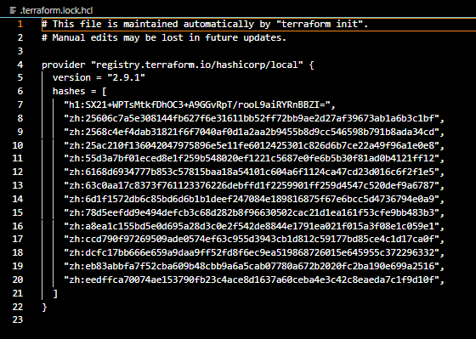

Run the command “ terraform apply “
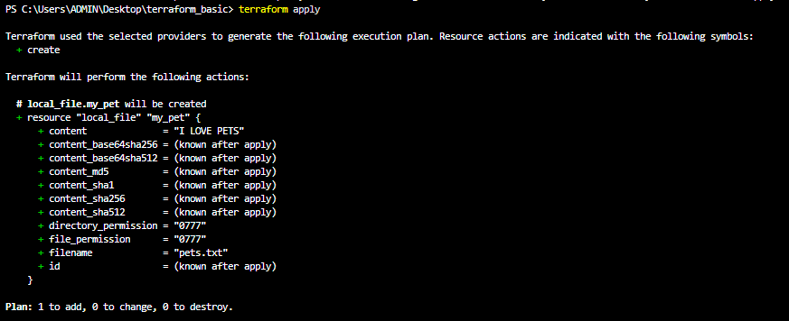

3). Note down below points, Terraform Init Terraform Plan Terraform Apply Terraform Provider.

Terraform Init (terraform init)
  - Initializes the Terraform working directory.
  - Downloads required providers and modules.
  - Prepares the backend for state storage.
terraform init
- Terraform Plan (terraform plan)
  - Shows what changes Terraform will make to your infrastructure.
  - Does not create, modify, or delete infrastructure by itself.
terraform plan
- Terraform Apply (terraform apply)
  - Executes the planned changes.
  - Creates, updates, or deletes infrastructure based on your configuration.
terraform apply
- Terraform Providers
  - Providers allow Terraform to communicate with cloud platforms and other services.
  - Examples: AWS, Azure, Google Cloud, Kubernetes.
Example AWS provider configuration:
provider "aws" {
region = "ap-south-1"
}
Initialize the provider with:
terraform init
Remember the workflow: terraform init → terraform plan → terraform apply

4). Integrate a sample Terraform template in Jenkins.

Objective
Integrate Terraform with Jenkins to automate infrastructure validation and deployment through a Jenkins Pipeline.
In this lab, we will create a sample Terraform configuration, store it in GitHub, and configure Jenkins to execute Terraform commands automatically.
Real-time DevOps workflow:
GitHub Repository
Terraform configuration: main.tf
Jenkins Pipeline
Checkout → Init → Validate → Plan
Terraform CLI
Validates the configuration and prepares a plan
For the first lab, we will use a safe validation-only pipeline. It will not create or modify AWS resources. After that works, you can extend it to deploy infrastructure.

2. Prerequisites
- Jenkins controller with access to a Jenkins agent or execution node.
- Terraform CLI installed on the machine where the pipeline runs.
- Git installed on that machine.
- A GitHub repository containing main.tf and Jenkinsfile.
- A Jenkins Pipeline job.
- AWS credentials only if you later provision AWS resources; they are not required for this validation-only lab.
Important: Installing Terraform on your Windows PC or in the VS Code extension does not install it on the Jenkins server. Terraform must be available on the Jenkins node that executes the pipeline.

3. Create the sample Terraform template
In your GitHub repository, create a file named main.tf.
terraform {
required_version = ">= 1.4.0"
}

resource "terraform_data" "jenkins_demo" {
input = "Terraform executed successfully from Jenkins"
}
This example uses Terraform's built-in terraform_data resource. It does not create AWS infrastructure, so it is suitable for your first Jenkins integration lab.

4. Create the Jenkinsfile
Create another file in the same GitHub repository named Jenkinsfile — without any file extension.
pipeline {
agent any

stages {
stage('Checkout') {
steps {
checkout scm
}
}

stage('Terraform Version') {
steps {
sh 'terraform -version'
}
}

stage('Terraform Format') {
steps {
sh 'terraform fmt -check -recursive'
}
}

stage('Terraform Init') {
steps {
sh 'terraform init -backend=false -input=false'
}
}

stage('Terraform Validate') {
steps {
sh 'terraform validate'
}
}

stage('Terraform Plan') {
steps {
sh 'terraform plan -input=false'
}
}
}

post {
success {
echo 'Terraform pipeline completed successfully!'
}

failure {
echo 'Terraform pipeline failed. Check the console output.'
}
}
}
This pipeline uses Linux shell commands (sh), so the Jenkins execution node must be Linux-based and have Git and Terraform installed.
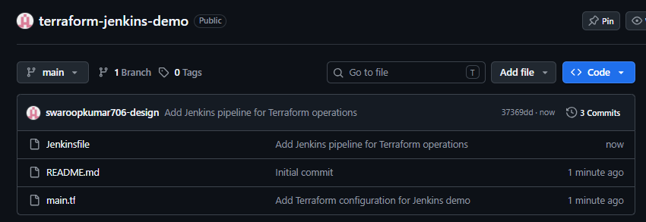

5. Push the files to GitHub
Your repository structure should look like this:
terraform-jenkins-demo/
main.tf
Jenkinsfile
If you are using Git locally, run these commands from the project directory:
git init
git add main.tf Jenkinsfile
git commit -m "Add Terraform Jenkins pipeline"
git branch -M main
git remote add origin https://github.com/YOUR_USERNAME/terraform-jenkins-demo.git
git push -u origin main
Replace YOUR_USERNAME with your GitHub username. If the repository already has a Git remote, do not add it again.

6. Configure Jenkins

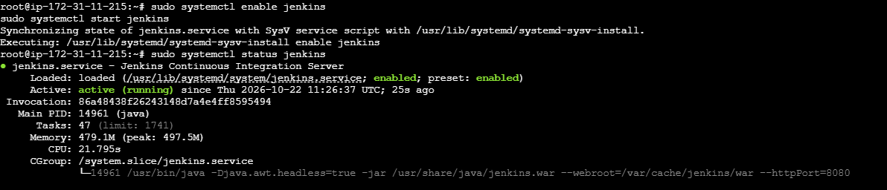
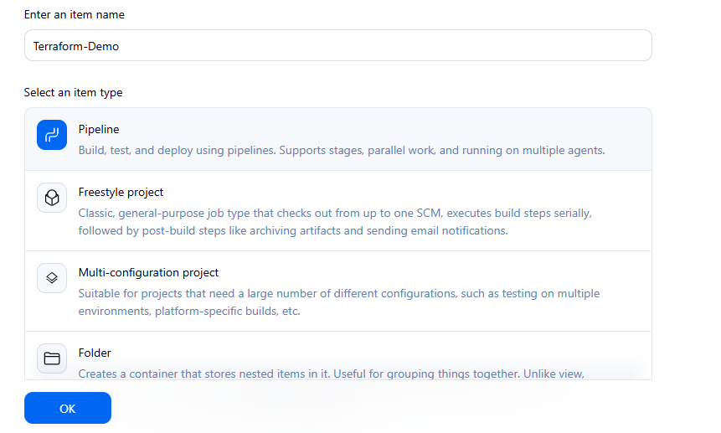
Step 1 — Create a job
Open Jenkins → New Item → enter Terraform-Demo → select Pipeline → click OK.
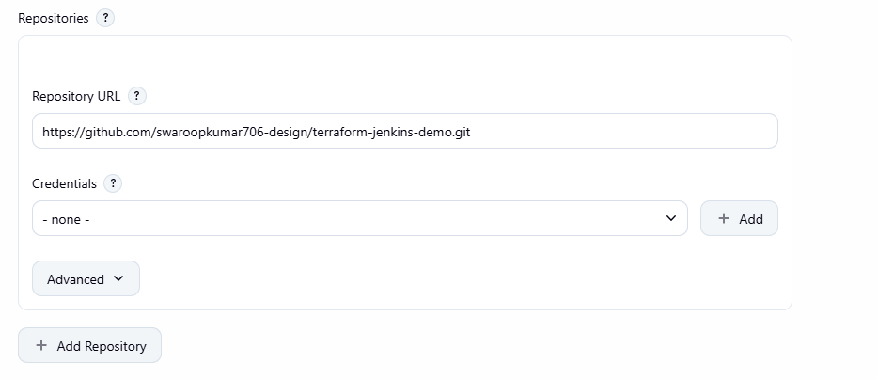
Step 2 — Connect GitHub
In the job configuration, find the Pipeline section.
- Definition: Pipeline script from SCM
- SCM: Git
- Repository URL: your GitHub repository URL
- Branch: */main
- Script Path: Jenkinsfile
If the repository is private, configure Jenkins credentials for GitHub access.
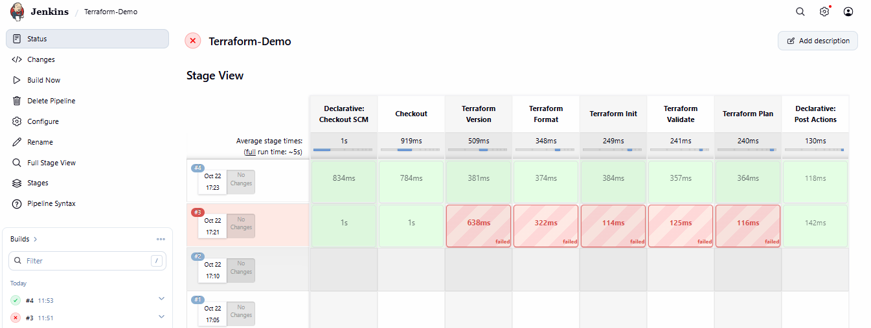
Step 3 — Run the pipeline
Click Save, then Build Now. Open the build number and select Console Output to monitor the stages.

7. Verify the output
Your Jenkins build should execute these stages in order:
Stage | Expected result
Checkout | Repository downloaded
Terraform Version | Terraform version displayed
Terraform Format | Formatting check passes
Terraform Init | Initialization succeeds
Terraform Validate | Configuration is valid
Terraform Plan | Plan generated successfully
The plan should indicate that Terraform will add one terraform_data resource. No AWS resources will be created.

8. Troubleshooting
Error | What to check
terraform: not found | Install Terraform on the Jenkins execution node and configure its PATH.
git: not found | Install Git on the execution node.
terraform fmt fails | Run terraform fmt locally, commit the formatted files, and rebuild.
terraform init fails | Check network access to the Terraform Registry and provider/plugin configuration.
Git checkout fails | Check repository URL, branch name, and Jenkins credentials.
sh step fails on Windows | Use a Windows agent and replace shell steps with appropriate bat commands.

9. Real-time DevOps improvement
Once the basic pipeline succeeds, you can extend it with:
- GitHub webhooks for automatic builds on code changes.
- terraform plan artifact archiving and approval before deployment.
- Secure Jenkins credentials for AWS authentication.
- Separate development, UAT, and production configurations.
- A controlled terraform apply stage with manual approval.
For production, use a remote Terraform backend with state locking where supported, and restrict who can approve or execute infrastructure changes.
Interview explanation: “I integrated Terraform with Jenkins by storing the Terraform configuration and Jenkinsfile in GitHub. Jenkins checks out the repository, initializes Terraform, validates the configuration, checks formatting, and generates an execution plan. For actual infrastructure provisioning, I would add secure cloud credentials and an approval-controlled apply stage.”

