**Step 1:** Download Eclipse Photon from below link to local machine

<https://www.eclipse.org/downloads/packages/release/photon/r>

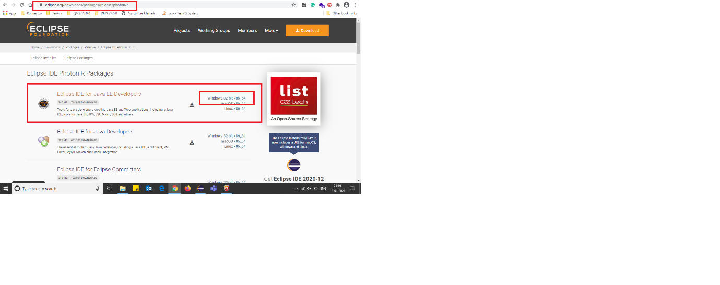

**Step 2:** Open eclipse.exe from eclipse-jee-photon-R-win32-x86_64



**Step 3:** Import the Project into Project Explorer



**Step 4:** Go to Build Path and Add External JARS from Selenium jar files folder

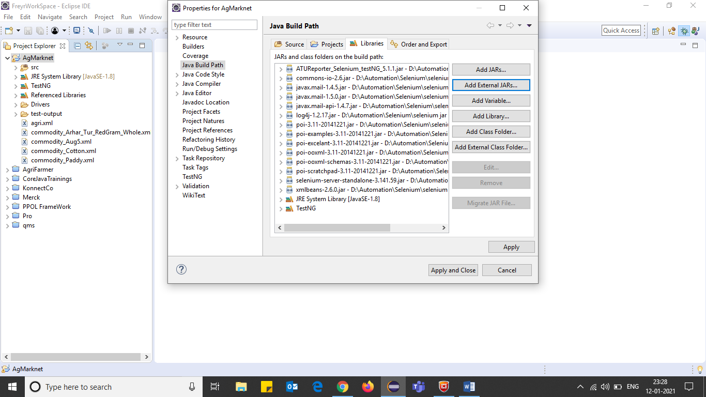

Step 5: Execute agri.xml

