Software Engineering with Data Analytics

Lab assignment

NAME: TEJA SWAROOP MALLAPU

REG NO: 192211449

DAY: 1

1. Draw a USE-CASE diagram for Online Voting System using CASE tools

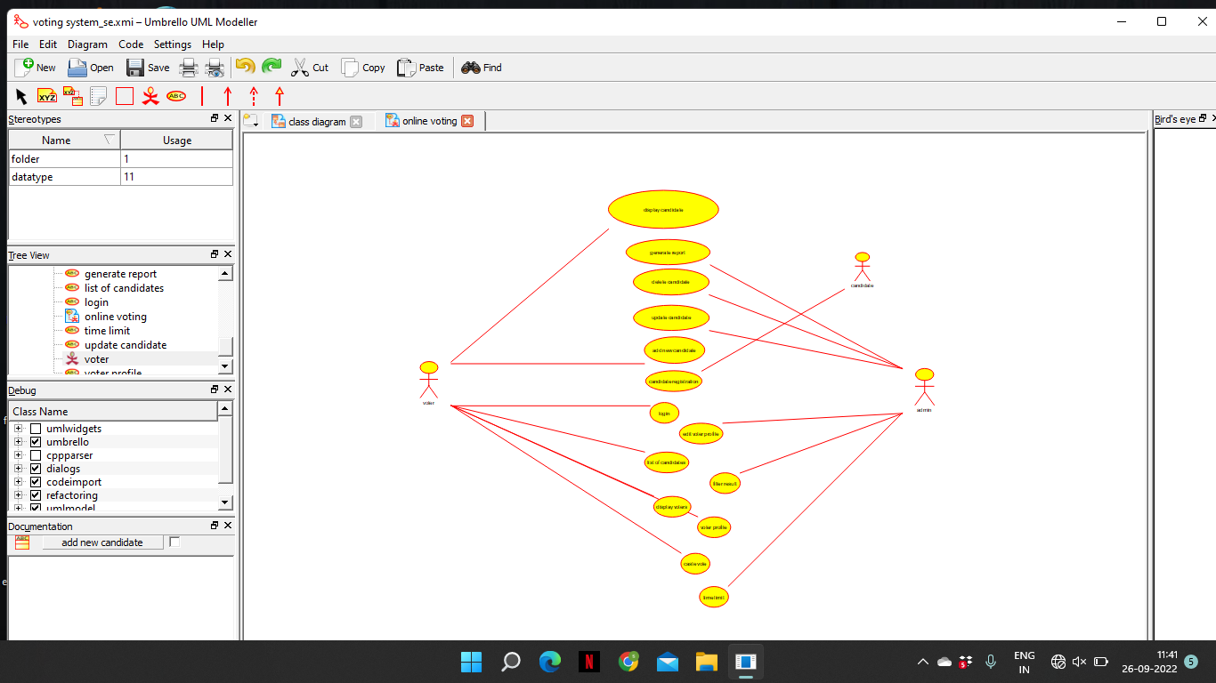

2.Draw a USE-CASE diagram for Library Management System using CASE tools.

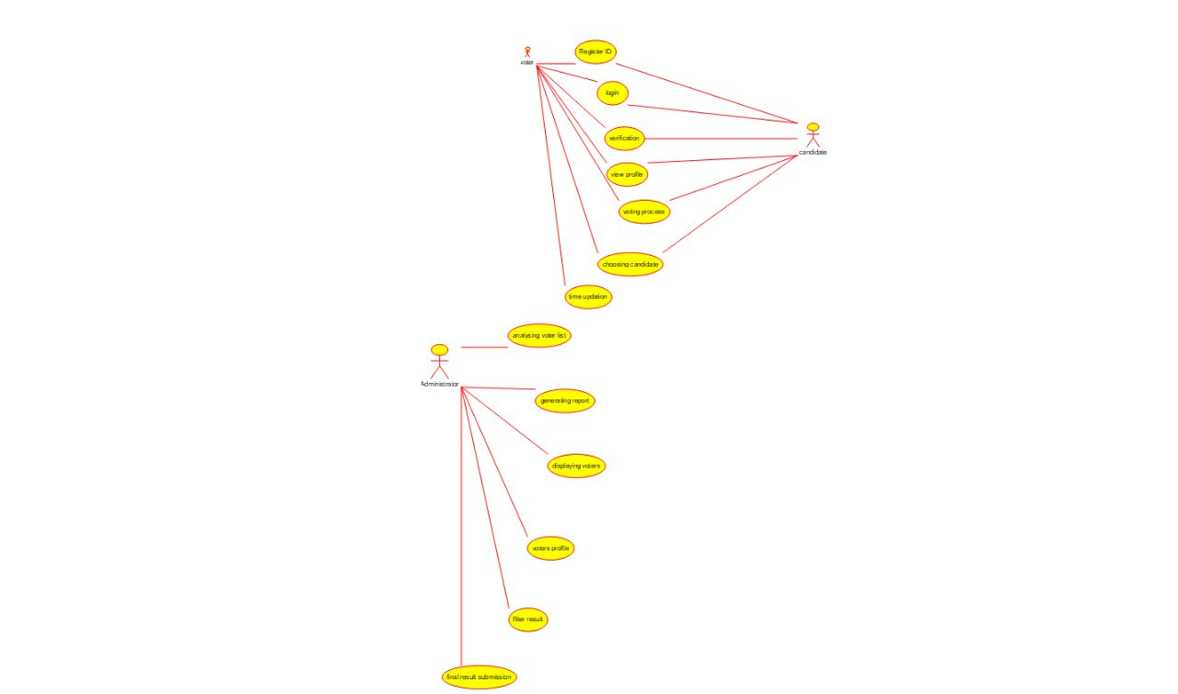

3.Draw and validate the flowchart to compute the quotient and remainder

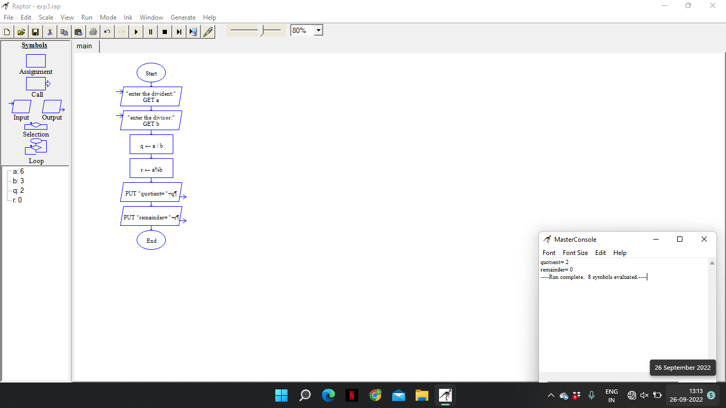

4. Draw a USE-CASE diagram for Online Shopping system using CASE tools

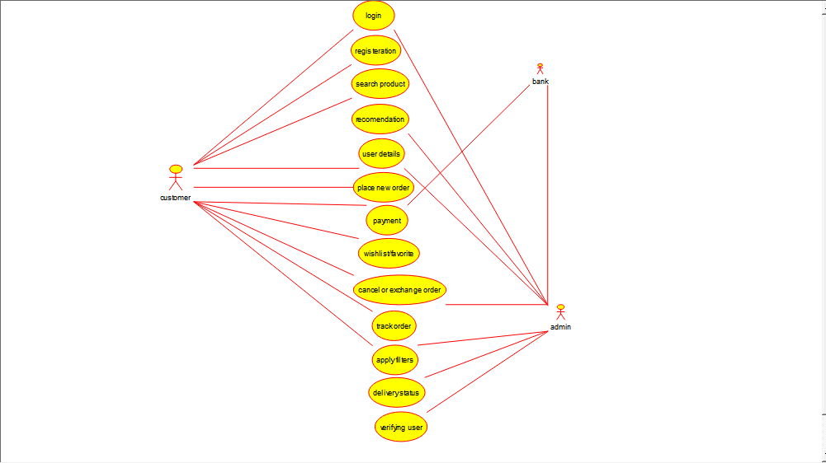

5.Draw a USE-CASE diagram for Online Railway Reservation System using CASE tools.

