**## Project**

This Testing framework is designed as a POC for implementing a Test Automation Solution.

**## Requirement**

The design of this Testing Framework is in keeping with the requirements of the Home Assignment,( as per the email received from the Janison recruitment Lead(dated 25th September 2020), for the role of ‘SIT Test Automation Engineer’.

**## Home Assignment(as quoted in the email)**

Trip Planner” is a web application for planning trips within New South Wales using the public transport network. As a Test automation consultant you are required to create a quick Proof off Concept [POC] for implementing a test automation solution.

For the purpose of this exercise we suggest limiting the time spent to around 2 hours.

Create an automated test for the scenario below using open-source tooling [e.g Selenium] in the language [C#, Java etc] and framework [xUnit, BDD etc] of your choice

Use the exercise to showcase best practice software development and test automation techniques

**## Downloads**

1. Download Java.

Source: <https://www.java.com/en/download/>

1. Maven download

Source: <https://maven.apache.org/download.cgi>

1. Eclipse download

Source: <https://www.eclipse.org/downloads/>

**## Pre-requisites**

The necessary software, as given in the download-section are downloaded and installed accordingly. The environment variables for the JAVA_HOME, MVN_HOME are set as shown below:

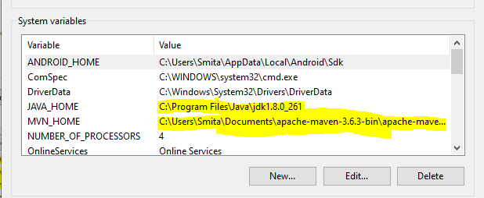

The Path environment variables are set as shown below:

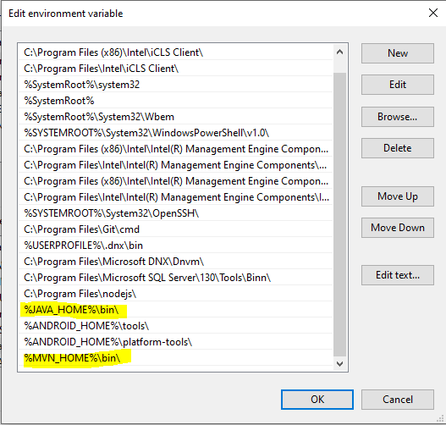

Note:

The configuration shown above, is considering the fact, that we’ve a Windows 10, 64-bit system in place to run the framework.

Note:

The Framework was developed and built on Eclipse IDE.

**## Framework**

The framework, which we’ve designed, is a **TestNG framework**, implemented as a Maven Project. And the libraries could be configured by quoting the dependencies in the POM.xml.

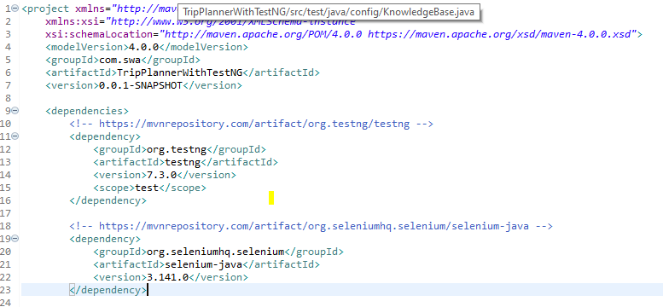

**## Running the Framework**

To run the Framework, right click on the ‘testNG.xml, of the ‘TripPlannerWithTestNG’ project as shown in the below pic.

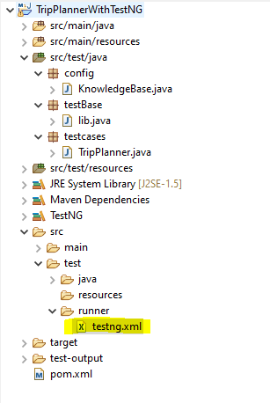

Right click on the ‘Run As’ and TestNG Suite as shown in the below screenshot.

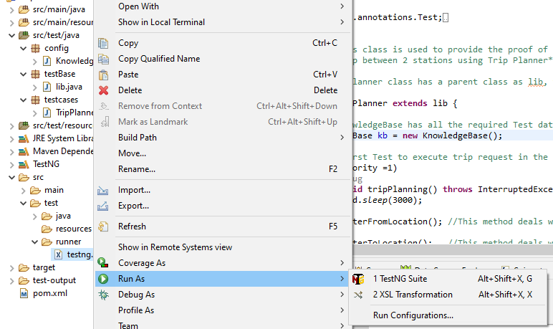

**## Reports Generated**

The TestNG framework, that we’ve used has automatic reporting enabled, so whenever we run the Framework, the reports generated could be examined by right clicking on the ‘TripPlannerWithTestNG’ framework, clicking on refresh and clicking on the test-output as shown in the screenshot below.

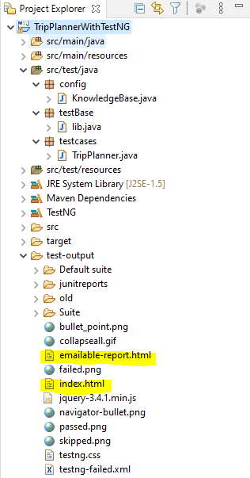

As shown in the above pic, we need to open the index.html/emailable-report, wherein we can see the detailed report of each test case run. Please refer the below pic for the same.

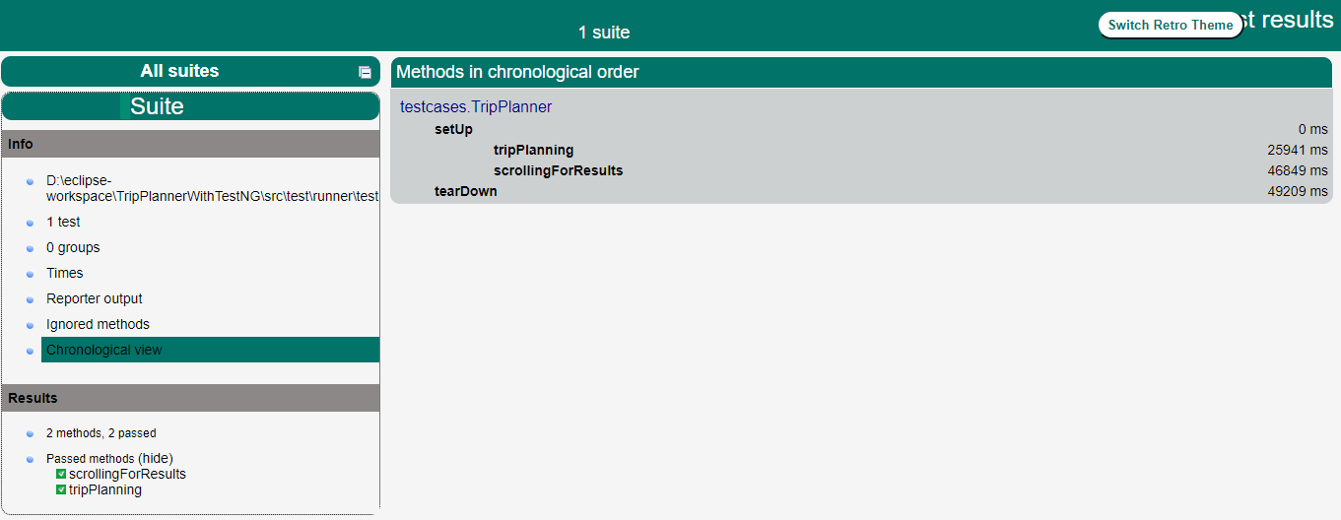

**## The Test Cases location**

The location of the Test Case in the Framework, is as shown in the below screenshot. The ‘TripPlanner.java’ could be opened to see the work done. The comments are included where ever necessary to understand the workflow of the Framework.

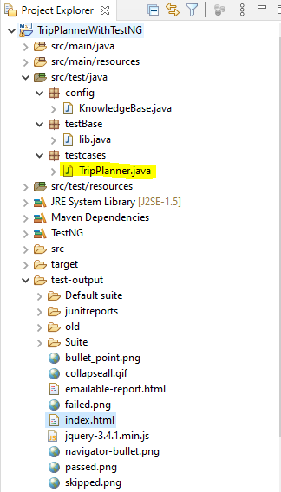

**## Further improvements/enhancements to the Framework.**

While, every care and effort is taken to ensure, that the Framework is robust and runs smoothly, yet there is always a room for improvement in any Testing Framework.

Additional reporting features could be incorporated in the Framework, such as ReportNG. Logging could be enabled using Log4j.

The Framework was prominently tested on the Chrome browser, as it is the most stable for our testing needs. However further modifications could be made to the Framework, so as to accommodate the need of Firefox and InternetExplorer browsers as well.

And any more suggestions to improve on the Framework, are most welcome.

**## Thanks giving note**

Here, I’d like to sincerely thank you, for taking time to go thru my hard work done.