July 24, 2 0 1 8 B Y S W A R O O P K S

Control of 3D Quadrotor
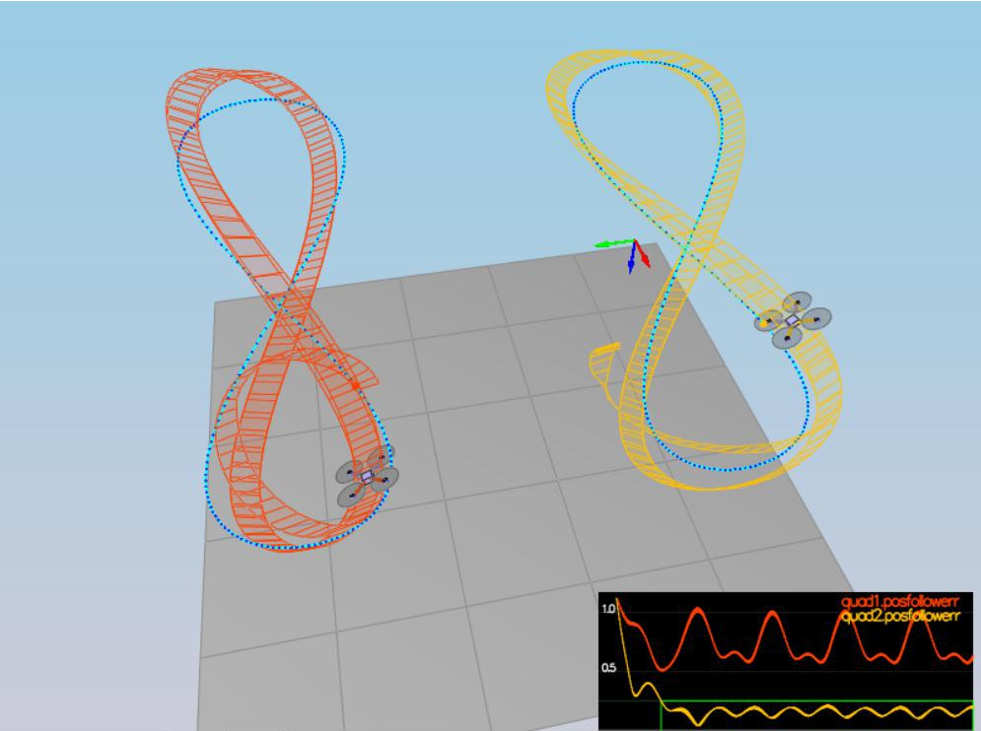

The third project is about implementing individual control loops in C++. This code will control a drone in an entirely new simulator. This project is broken into a series of "scenarios". These assist with tuning of your controller, the simulator also contains real time performance evaluation.
Prerequisites for project (windows)
Regardless of your development platform, the first step is to download or clone the C++ simulator repository.
gitclonehttps://github.com/udacity/FCND-Controls-CPP.git

Once you have the code for the simulator, you will need to install the necessary compiler and IDE necessary for running the simulator.

For Windows, the recommended IDE is Visual Studio. Here are the steps required for getting the project up and running using Visual Studio.

Download and install Visual Studio

Select Open Project / Solution and open <simulator>/Simulator.sln

From the Project menu, select the Retarget solution option and select the Windows SDK that is installed on your computer (this should have been installed when installing Visual Studio or upon opening of the project).

To compile and run the project / simulator, simply click on the green play button at the top of the screen. When you run the simulator, you should see a single quadcopter, falling down.
Project description

This project originally had two parts. In the first part we asked students to implement a controller in Python. We've since removed that portion of the project, but you may find theT solution implementationhelpful to consult as a reference.

Make sure you have cloned the repository and gotten familiar with the C++ environment as outlined in C++

Setup.

Complete each of the scenarios outlined in the C++ project readme. This will involve implementing and tuning controllers incrementally:

Intro (scenario 1)

Body rate and roll/pitch control (scenario 2) Position/velocity and yaw angle control (scenario 3) Non-idealities and robustness (scenario 4)

For this project, you will be building a controller in C++. You will be implementing and tuning this controller in several steps.

You may find it helpful to consult the Python controller code as a reference when you build out this controller in C++.

Notes on Parameter Tuning

Comparison to Python: Note that the vehicle you'll be controlling in this portion of the project has different parameters than the vehicle that's controlled by the Python code linked to above. The tuning parameters that work for the Python controller will not work for this controller

Parameter Ranges: You can find the vehicle's control parameters in a file called QuadControlParams.txt. The default values for these parameters are all too small by a factor of somewhere between about 2X and 4X. So if a parameter has a starting value of 12, it will likely have a value somewhere between 24 and 48 once it's properly tuned.

Parameter Ratios: In this one-page document you can find a derivation of the ratio of velocity proportional gain to position proportional gain for a critically damped double integrator system. The ratio of kpV / kpP should be 4.
Intro (Scenario 1);

In this scenario, we adjust the mass of the drone in /cpp/config/QuadControlParams.txt until it hovers for a bit:

When the scenario is passing the test, you should see this line on the standard output:
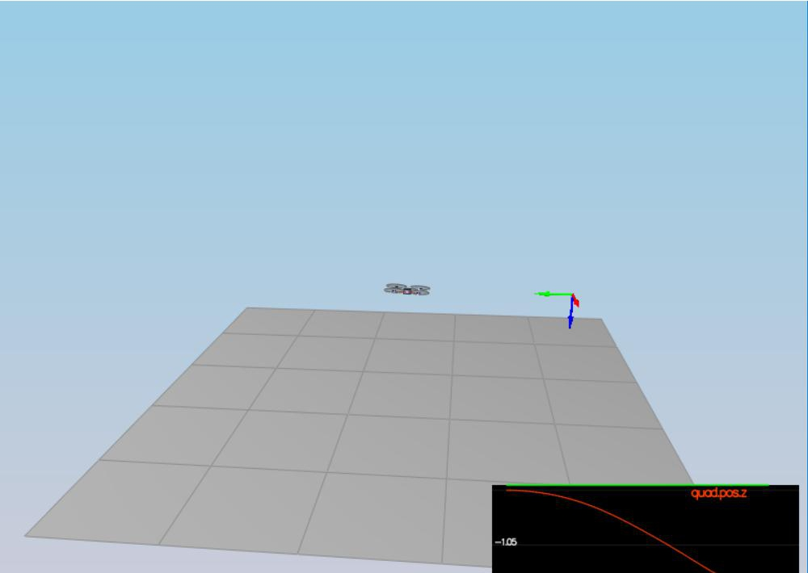

Results of scenario 1

Body rate and roll/pitch control (scenario 2)

First, you will implement the body rate and roll / pitch control. For the simulation, you will use Scenario 2. In this scenario, you will see a quad above the origin. It is created with a small initial rotation speed about its roll axis. Your controller will need to stabilize the rotational motion and bring the vehicle back to level attitude.

To accomplish this, you will:

Implement body rate control

- implement the code in the function GenerateMotorCommands()

- implement the code in the function BodyRateControl()

- Tune kpPQR in QuadControlParams.txt to get the vehicle to stop spinning quickly but not overshoot

If successful, you should see the rotation of the vehicle about roll (omega.x) get controlled to 0 while other rates remain zero. Note that the vehicle will keep flying off quite quickly, since the angle is not yet being controlled back to 0. Also note that some overshoot will happen due to motor dynamics!.

If you come back to this step after the next step, you can try tuning just the body rate omega (without the outside angle controller) by setting QuadControlParams.kpBank = 0.

Implement roll / pitch control We won't be worrying about yaw just yet.

- implement the code in the function RollPitchControl()

- Tune kpBank in QuadControlParams.txt to minimize settling time but avoid too much overshoot

The roll-pitch controller is a P controller responsible for commanding the roll and pitch rates in the body frame. First, it sets the desired rate of change of the given matrix elements using a P controller.
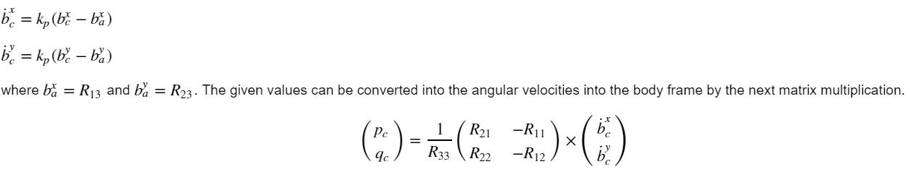

If successful you should now see the quad level itself (as shown below), though it’ll still be flying away slowly since we’re not controlling velocity/position! You should also see the vehicle angle (Roll) get controlled to 0.

