August 4, 2 0 1 8 B Y S W A R O O P K S

Building an Estimator
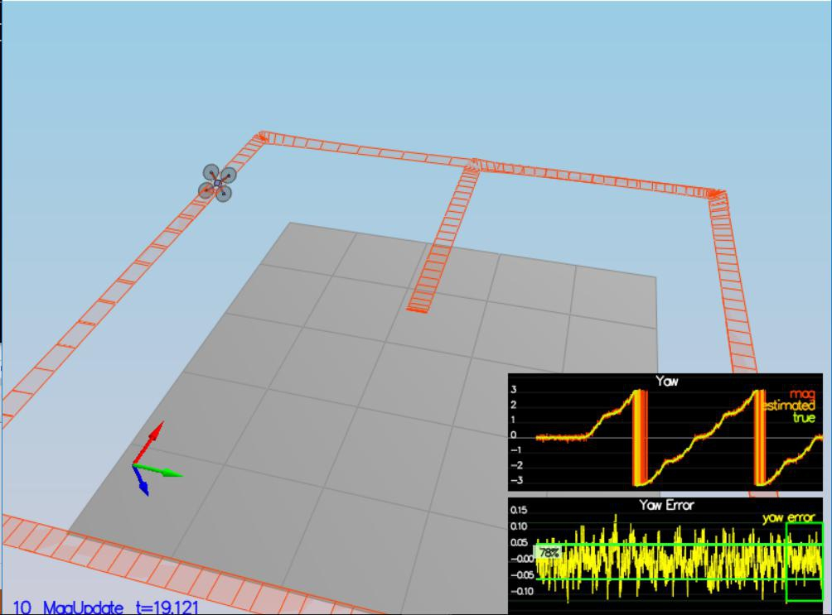

The fourth and final project is about building a estimation project on top of controller project to get close to th reality with existence of noise . In this project , we are using Extended kalman filter by fusing noisy GPS , IMU and compass (magnetometer) to estimate current drone position , velocity and yaw . EKF filter is implemented using c++ with basic code provided by Udacity.

Prerequisites for project (windows)
This project will continue to use the C++ development environment you set up in the Controls C++ project.Clone the repository

gitclonehttps://github.com/udacity/FCND-Estimation-CPP.git
Import the code into your IDE like done in the Controls C++ project

We should now be able to compile and run the estimation simulator just as you did in the controls project

Project description

The steps of this project are following :

- Sensor Noise : Collect simulated noisy sensor data and determine standard deviation of the quad's sensor.

- Attitude Estimation: Implement a better integration method that uses the current attitude estimate
(rollEst, pitchEst and ekfState(6)) to integrate the body rates into new Euler angles. The only thing we need to do is to integrate pqr from the gyroscope into the estimated pitch and roll

- Prediction step : Implementation of prediction filter based on the acceleration measurement by using
Dead Reckoning method.

- Magnetometer update: the information from the magnetometer is added to improve filter's performance in estimating the vehicle's heading.

- Closed loop & GPS Update : GPS update is implemented into estimator.

- Adding Your Controller : Tuning Control parameter to overall improve performance in all scenarios

Sensor Noise:

In this step , collecting some simulated noisy sensor data (GPS and IMU measurements) and estimate the standard deviation of those sensors. I wrote a small python code to parse data from text file of respective sensors to calculate standard deviation. Later these measurement are updated to parameter file

config/6_Sensornoise.txt.

MeasuredStdDev_GPSPosXY = 0.6569747495144732

MeasuredStdDev_AccelXY = 0.4909264198233001
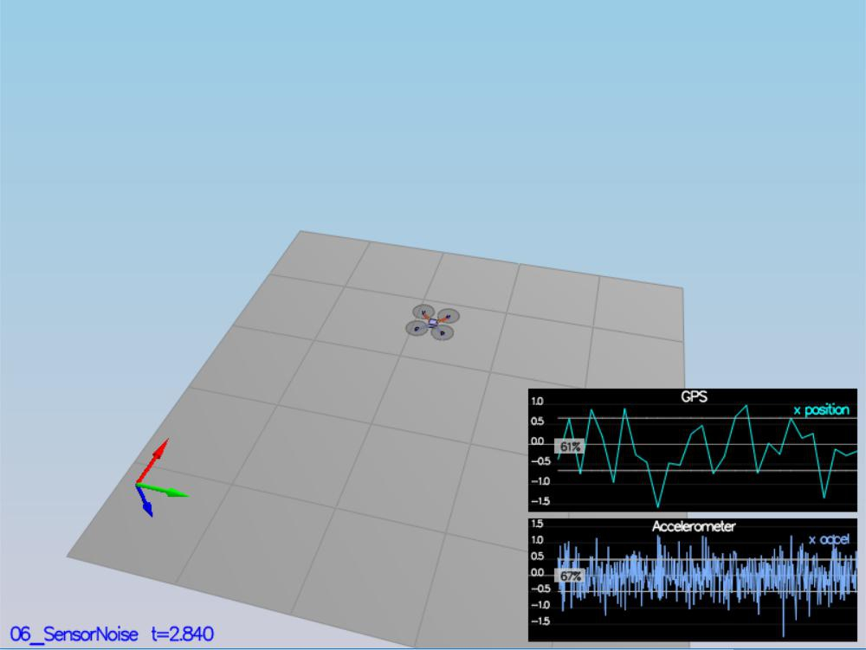

Results :

Attitude Estimation:

In this step , the complementary filter-type attitude filter is improved by integrating body rate p,q,r which obtained from rate gyro into the estimated pitch and roll angle.

By using below mentioned equation , an instantaneous change in euler angles (World frame) is obtained from turn rate in body frame ,
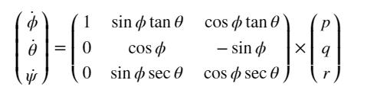

This step is followed by integrating Euler Rate into the estimated pitch and roll angle.
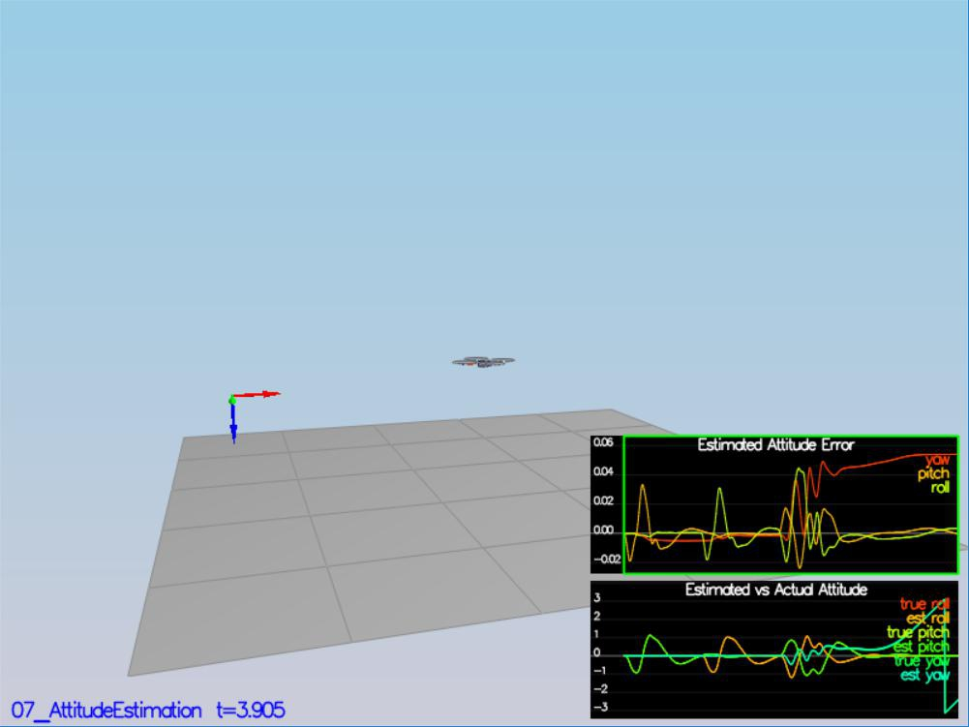

Results of scenario 2:

Prediction step :

Predict the current state forward by time dt using current accelerations and body rates as input. Use attitude.Rotate_BtoI(<V3F>) to rotate a vector from body frame to inertial frame

Calculating the partial derivative of the body-to-global rotation matrix in the function GetRbgPrime() by using equation,
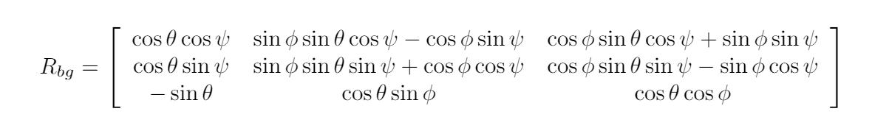

Covariance Prediction

Obtaining Jacobian Matrix by using GetRbgPrime() and after iplementing prediction step (predict the state covariance forward) to update the covariance matrix cov according to the EKF equation.
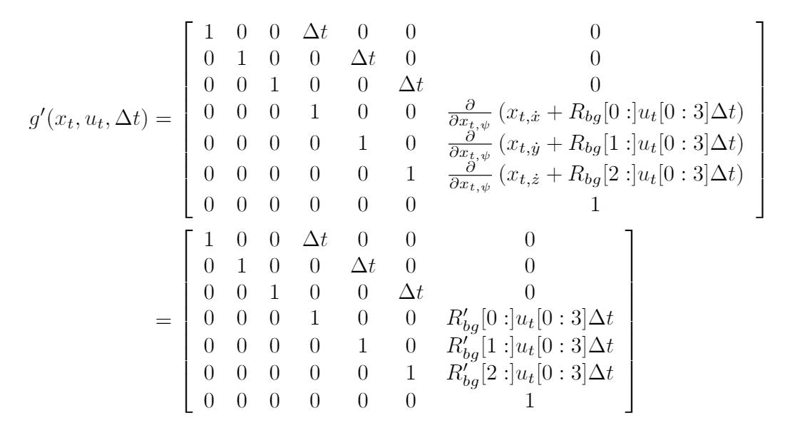
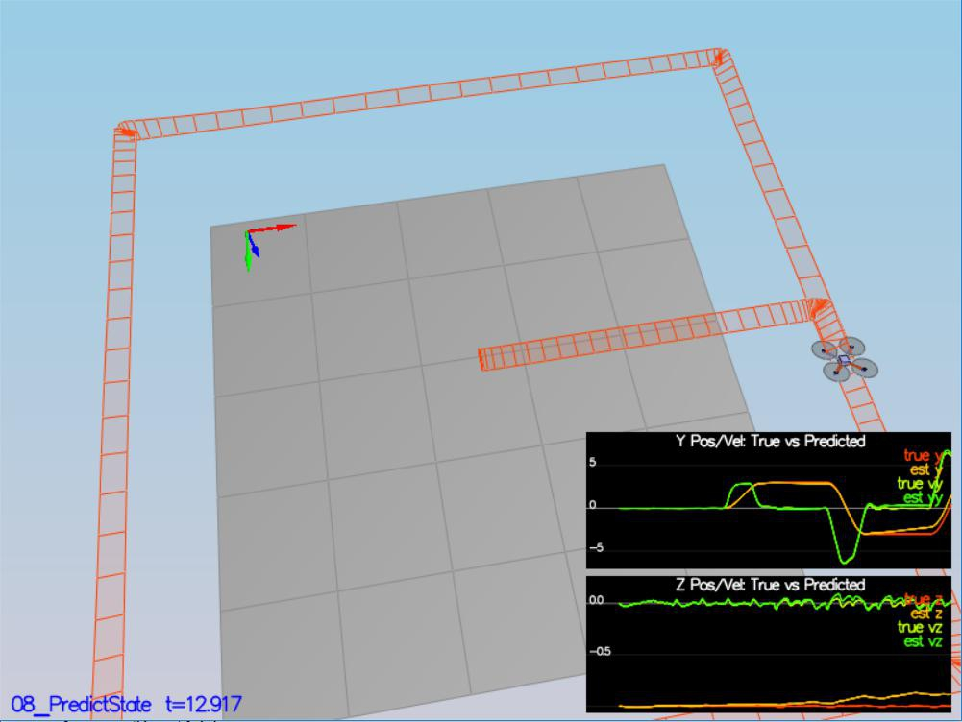

To capture the magnitude of error more precisely, I also tuned the parameters in QuadEstimatorEKF.txt

QPosXYStd = .01

QVelXYStd = .2

prediction equations as shown below,
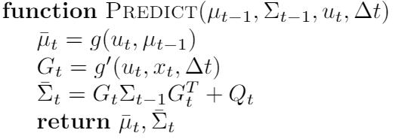

Thisstepdoesn'thaveanyspecificmeasurablecriteriabeingchecked.

