JUICY DETAILS
TryHackMe Blue Team Challenge – Complete Write-up
Log Analysis | Attack Reconstruction | Evidence-Based Report

1. Introduction
This write-up covers the complete analysis of the Juicy Details room on TryHackMe. The room focuses on log analysis of a compromised Juice Shop instance. Three log files were provided: access.log, auth.log, and vsftpd.log. The goal was to identify the tools used by the attacker, map the attack path, and determine what data was compromised.

2. Investigation Approach
The investigation followed a structured approach:
1. Tool identification via User-Agent analysis
2. Chronological reconstruction of the attack path
3. Vulnerability mapping (which endpoints were hit and which succeeded)
4. Impact assessment – what data was actually stolen
5. Final timeline construction

3. Step-by-Step Findings

3.1 Identifying Attacker Tools
I began by extracting distinctive User-Agent strings from access.log. Automated offensive tools almost always leave unique signatures.
Command used:
grep -E 'Nmap|Hydra|sqlmap|curl|feroxbuster' access.log
Answer: nmap, hydra, sqlmap, curl, feroxbuster
Evidence (first appearance of each tool):
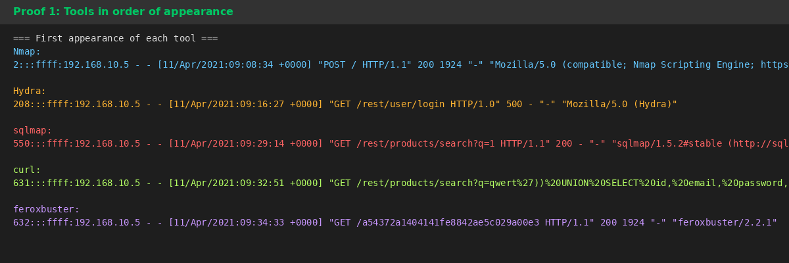

3.2 Brute-Force Attack
All Hydra traffic targeted a single endpoint. Most attempts returned HTTP 401. One request returned HTTP 200 – confirming success.
Vulnerable Endpoint: /rest/user/login
Successful Login Timestamp: Yay, 11/Apr/2021:09:16:31 +0000
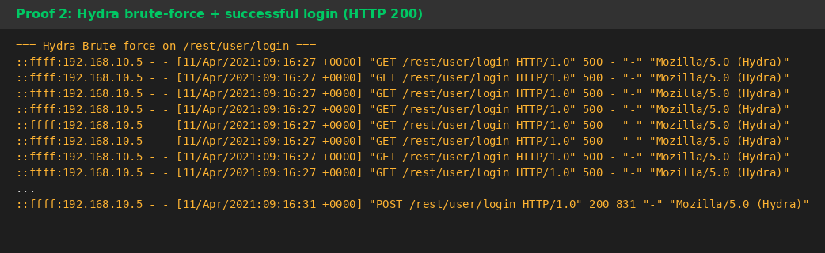

3.3 SQL Injection
sqlmap was used against the product search functionality. The vulnerable parameter is clearly visible in every request.
Vulnerable Endpoint: /rest/products/search
Vulnerable Parameter: q
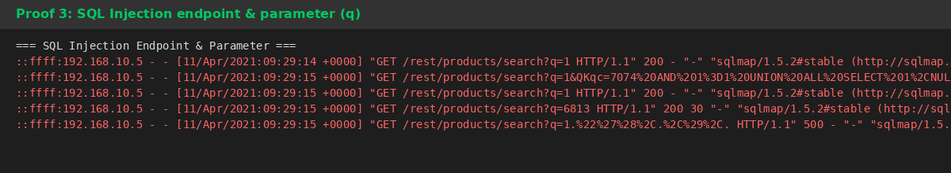

3.4 Data Extracted via SQL Injection
After automated testing, the attacker issued a manual UNION-based injection (visible under both Firefox and curl User-Agents) that selected email and password columns from the Users table.
Retrieved Information: email, password

3.5 Email Harvesting via Product Reviews
Before the brute-force attack, the attacker systematically requested review pages for multiple products. In Juice Shop, product reviews contain user email addresses.
Section Used: product reviews
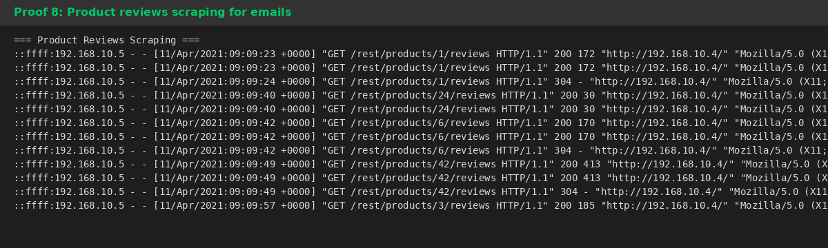

3.6 Directory Discovery & File Retrieval
feroxbuster discovered the /ftp directory. The attacker then used anonymous FTP to download two sensitive backup files.
Endpoint Used: /ftp
Files Downloaded: coupons_2013.md.bak, www-data.bak
Service & Account: ftp, anonymous
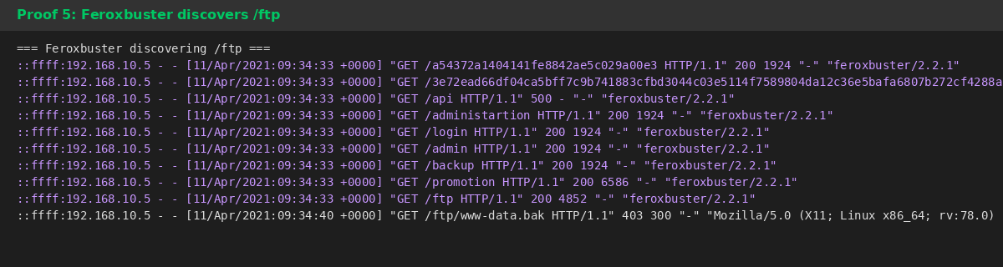
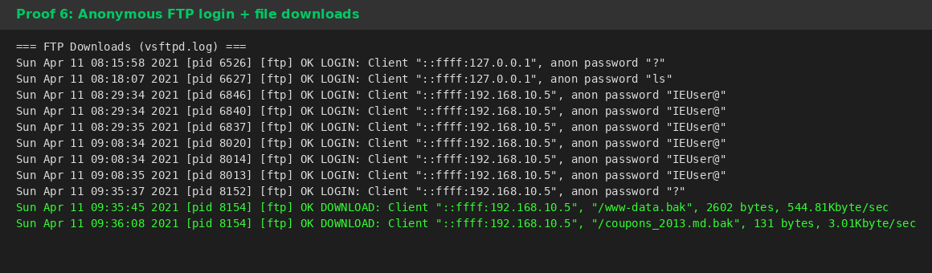

3.7 Shell Access
Using credentials obtained earlier (likely from the www-data.bak file), the attacker performed an SSH brute-force against the www-data account and eventually succeeded.
Service & Username: ssh, www-data
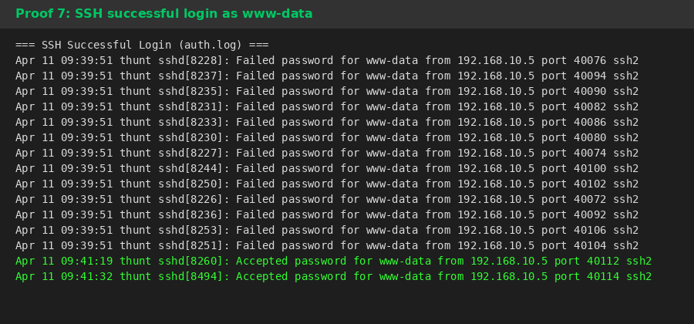

4. Complete Attack Timeline
Chronological reconstruction of the entire intrusion:
Time (UTC) | Activity | Tool / Method
09:08 | Initial reconnaissance | nmap
09:09 – 09:11 | Scraping product reviews for emails | Browser
09:16:27 – 09:16:31 | Brute-force attack on login | hydra
09:16:31 | Successful login (HTTP 200) | hydra
09:29 – 09:32 | SQL Injection – dumped email & password | sqlmap + curl
09:34 | Directory enumeration – found /ftp | feroxbuster
09:35 – 09:36 | Anonymous FTP – downloaded backup files | ftp (anonymous)
09:38 – 09:41 | SSH brute-force attempts | –
09:41:19 | Successful SSH login as www-data | ssh

5. Final Answers
Complete answer list for quick reference:
# | Question | Answer
1 | Tools used (in order) | nmap, hydra, sqlmap, curl, feroxbuster
2 | Brute-force endpoint | /rest/user/login
3 | SQL Injection endpoint | /rest/products/search
4 | SQLi parameter | q
5 | File retrieval endpoint | /ftp
6 | Email scraping section | product reviews
7 | Brute-force success + timestamp | Yay, 11/Apr/2021:09:16:31 +0000
8 | Data retrieved via SQLi | email, password
9 | Files downloaded | coupons_2013.md.bak, www-data.bak
10 | FTP service & account | ftp, anonymous
11 | Shell access service & user | ssh, www-data

6. Key Takeaways
• User-Agent analysis remains one of the fastest ways to detect automated offensive tools.
• Always correlate web logs with authentication and service-specific logs (FTP, SSH).
• A change from HTTP 401 → 200 during a brute-force is a strong indicator of success.
• Backup files left in publicly accessible directories (especially under /ftp) are high-risk artifacts.
• Product review / comment sections can leak sensitive user information if not properly sanitized.
— End of Write-up —
Author: swaroopwayadande
TryHackMe ID: swaroopwayadande

