ARCHITECTURE DIAGRAM

**Segmentation Module**

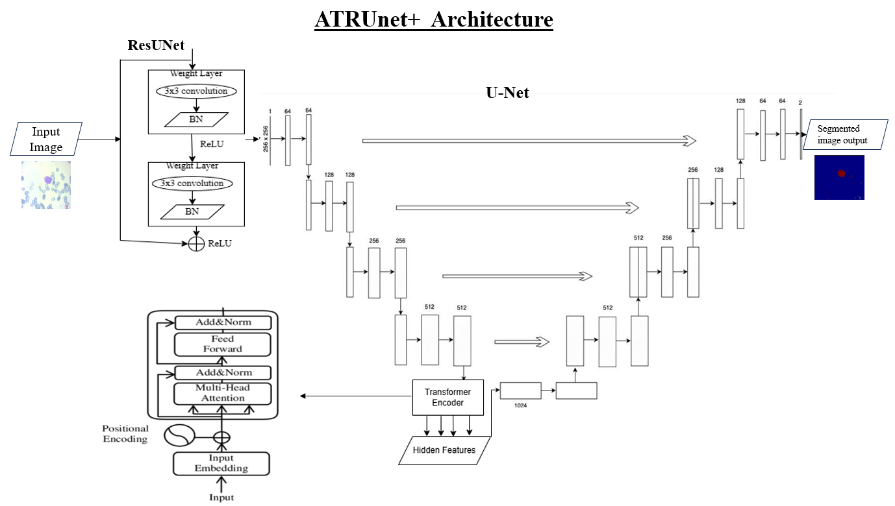

CLASSIFICATION MODULE ResNet 50

