Results Summary: Does Learned Pruning Beat Simple Heuristics?
GAT + RL edge-pruning for botnet containment in Social IoT graphs, benchmarked against a full structural-baseline suite. All numbers are means over 40 independent scale-free graph instances (Barabasi-Albert), with a feature-driven infection model so pruning risky edges measurably changes outcomes.
Headline finding
Simple degree-centrality pruning ties or beats the learned GAT+RL pipeline on containment, at a fraction of the cost. RL loses significantly (Holm-corrected p<0.05) to every structural baseline tested -- including the spectral/eigenvalue method (eigenscore) the epidemic-containment literature treats as its principled standard. There is no single winner: it is a genuine containment-vs-utility trade-off (Pareto frontier), not a ranking with one method on top.
All nine methods compared (n = 40 graphs each)
Method | Containment ratio (mean +/- std) | Utility (frozen F1) | Compute cost/graph
Degree-centrality | 0.0331 +/- 0.0061 | 0.562 | 0.0108 s
Eigenscore (spectral) | 0.0332 +/- 0.0064 | 0.458 | 0.034 s
Betweenness-centrality | 0.0361 +/- 0.0058 | 0.455 | 0.611 s
Highest-p_uv (direct risk) | 0.0365 +/- 0.0050 | 0.423 | 0.008 s
GAT top-k | 0.0372 +/- 0.0060 | 0.532 | 0.881 s
GAT threshold | 0.0547 +/- 0.0126 | 0.544 | 0.161 s
Greedy simulation-guided | 0.0659 +/- 0.0344 | 0.634 | 45.41 s
RL (adaptive policy) | 0.0719 +/- 0.0430 | 0.543 | 38.72 s
Random | 0.1218 +/- 0.0183 | 0.466 | 0.024 s
Sorted by containment ratio (lower = better, fewer nodes end up compromised). Green row = best containment. 14 pre-registered paired comparisons, Holm-Bonferroni corrected.
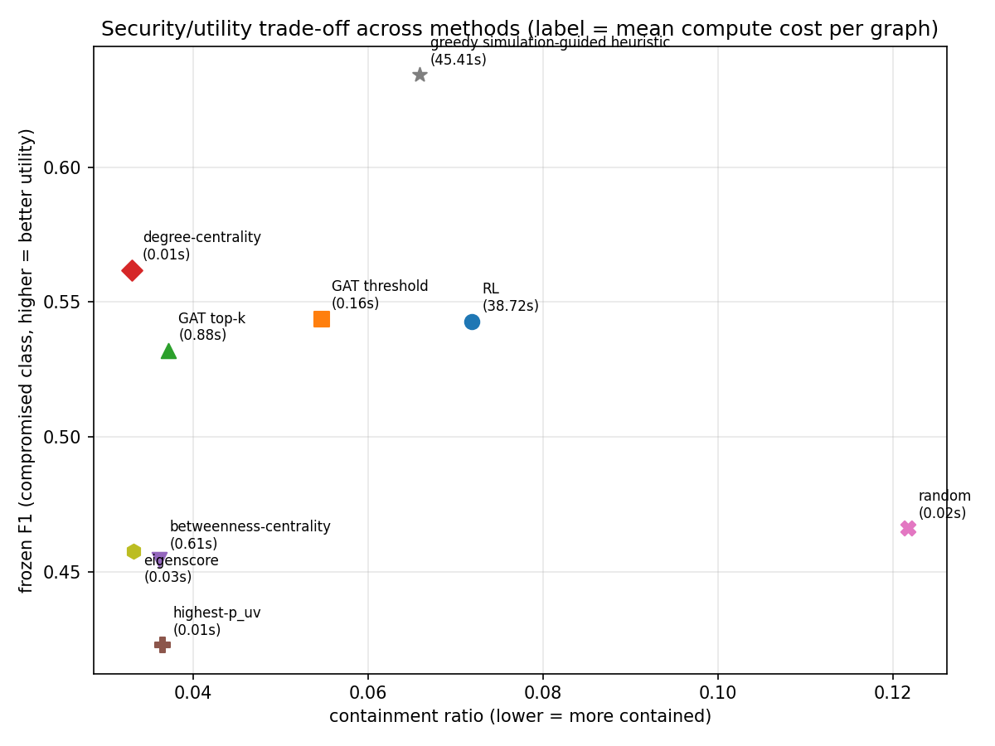 | Key takeaways  • Degree-centrality wins on containment AND cost (about 3,600x cheaper than RL).  • Greedy simulation-guided heuristic wins on utility (frozen F1 0.634) but costs about 4,200x more than degree.  • Eigenscore (the field's spectral "gold standard") only ties degree -- doesn't beat it.  • RL beats only random pruning; ties the greedy heuristic; loses to every structural method.  • A myopia diagnostic (n=10 graphs) confirms the greedy heuristic's shortfall is structural (one-step-at-a-time), not a noisy search signal -- 5x more search accuracy made results worse, not better.  • GAT+RL's containment result is architecture-conditional (only holds at heads=4, depth=2) but robust to feature noise/missingness.
Full numbers, statistical tests, ablations, and every caveat: NOTES.md and harness_summary.csv / harness_paired_tests.csv in the project repository.

