**Common Name:** Ashseora

**English Name:** Orangeberry

**Scientific Name:** *Glycosmis pentaphylla*

**Taxonomy:**

**Kingdom:** Plantae

**Phylum:** Tracheophyta

**Class:** Dicotyledon

**Order:** Sapindales

**Family:** Rutaceae

**Genus:** Glycosmis

**Species:** *Glycosmis pentaphylla*

**Morphology:**

**Habit:** A large evergreen shrub or small tree

**Root:** Tap, branched

**Stem:** Erect, woody, solid, cylindrical, branched, glabrous.

**Leaf:** shiny, with numerous oil glands, alternate -spiral, imparipinnate, elliptic-oblong,

**Bearing habit:**

**Inflorescence:** compound, often densely racemose

**Sex type:** bisexual

**Flower:** In auxillary or terminal panicles; greenish-white, fragrant.

**Fruit:** A pulpy berry; white to reddish.

**Seed:** 1-3, globose, depressed.

**Picture:**

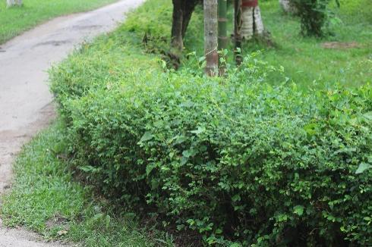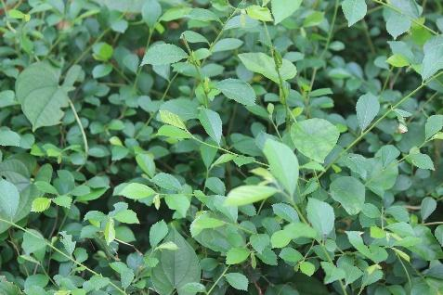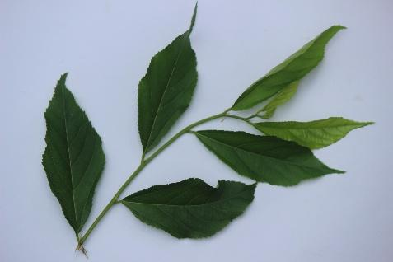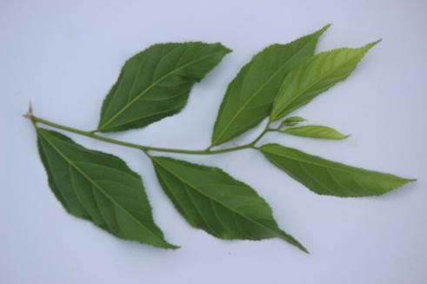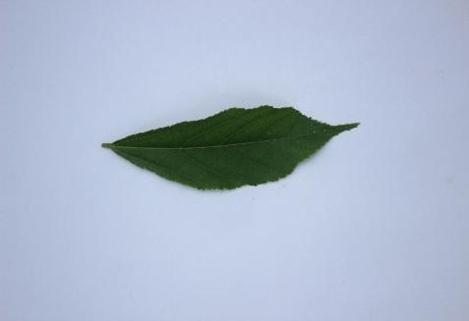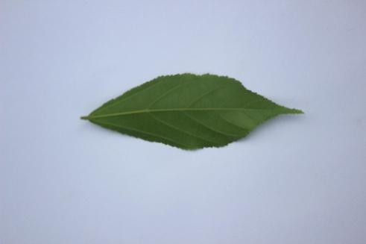

**Reference:**

1. Google
2. Wikipedia.com