- FarmApp: An online real time trading platform for Farmers

FarmApp attempts to give farmers an online platform for selling fresh vegetables from their smartphones. mKisan is one such already existing app, but not many farmers use this for selling their fresh vegetables because it doesn’t operate in real time.
FarmApp is a real time trading app where the Whole Sale Buyers will list down their requirements (of Fresh Vegetables) and the price at which they’re comfortable to buy and the Farmers will pick one Buyer (based on location of the Buyer and the price offered by the Buyer) to sell the product. The Buyer will be able to update the price and requirement in real time based on the availability of the product in the market.
The Farmer will also be able to declare that he wants to sell some item (say 50kg of Brinjal) and this can be seen by the Buyers. Also, a notification will be sent to the Buyers who are say within a distance of 5km from the Farmer and wants to buy more than 50kg of Brinjal.
The deal will be completed in the app but the delivery of the product will be done by the Farmer.

- FarmApp will solve “Kya maine kabhi aapko kam mulya diya hai?”

Before we jump into the technical details of the app, let’s take a look at the problem that we’re going to solve.
I’m from a village where the primary occupation of the people is Cultivation. They produce fresh vegetables. Most of the times, they have more than one choice of market to sell their product, but they choose one randomly, without even knowing the price offered by the buyers in that market. In addition to that, they sell their goods to the same buyer even if the buyer gives lesser price because of the lack of transparency in the market. When a farmer asks the price, the buyers often use phrases like “Kya maine kabhi aapko kam mulya diya hai?” Sometimes the farmers come to know the actual price only after agreeing to deal.
In a nutshell, FarmApp is going to introduce transparency in the fresh vegetables market so that the farmers can check the price from their smartphones, choose the market/buyer accordingly and make a deal before actually going to the market.

- Key Features

Following are the key features of the app:
- The Buyers will be able to list down their requirements and price and update them in real time.
- The farmers will be able to search for nearby buyers and sort them based on offering price and location.
- The farmer will be able to declare that he wants to sell something. Nearby buyers will be able to see this and they’ll also get notified.
- The deal can be initiated both by a Farmer or a Buyer. And the requested deal can be accepted or rejected, or an alternate price can be proposed.
- Once the deal is accepted by the 2nd party, it will be saved and the Farmer/Buyer will be able to raise an issue if the other party denies the deal later.

- Development Progress

Technologies Used: Flutter SDK is used for developing the frontend (UI) of the app and Firebase is used as the backend.
Modules:
- Login/Register Screen

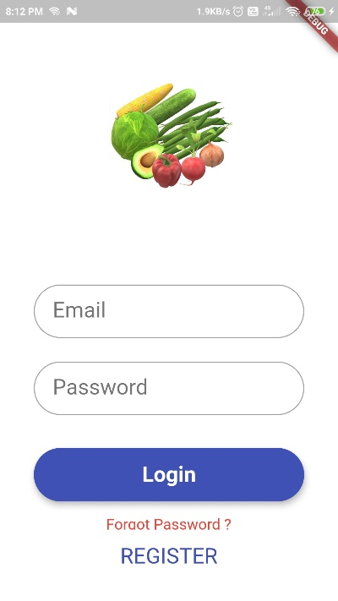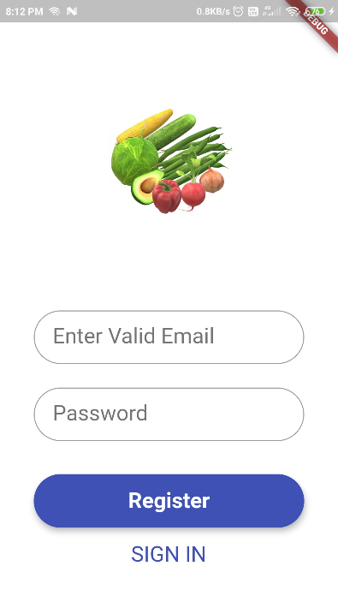
- In these screens, the user will be able to login to the app or register if new.
- Pending Work (ETA: 1 week):
  - Phone number verification for quick login.

- Search Screen

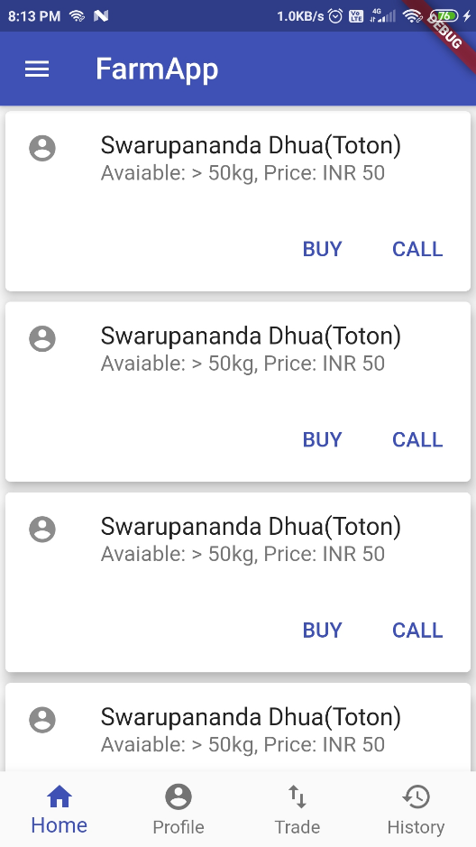
- In this screen, the user will be able to search for buying or selling a particular product.
- Pending Work (ETA: 1 week):
  - Sort the search results based on price.
  - Filter the search results based on location.
  - Sort the search results based on location.

- Profile Screen

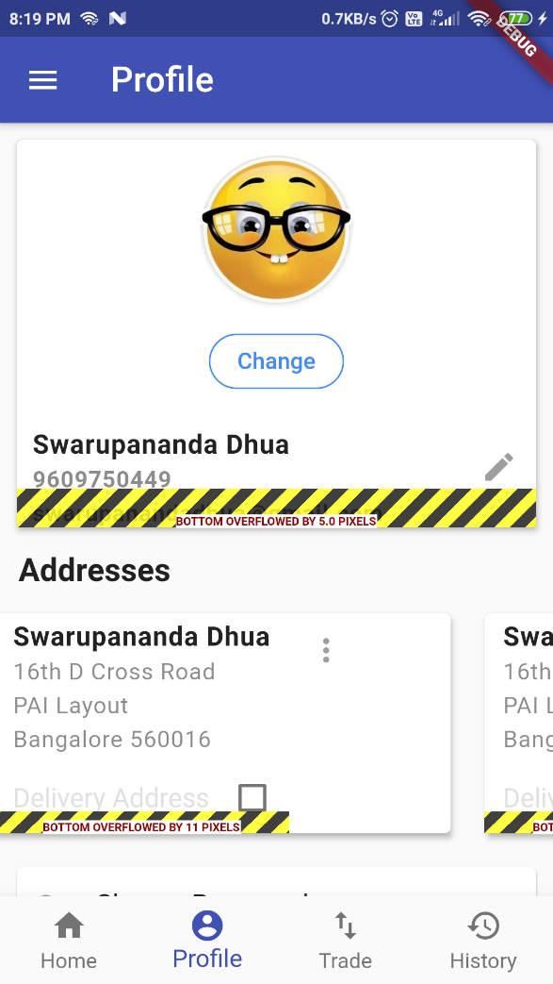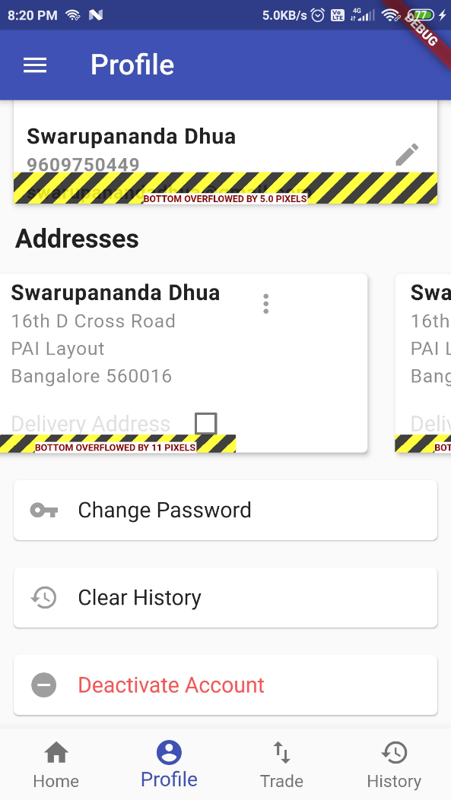
- In this screen, the user will be able to manage multiple addresses, set preferred address, change password/name/picture etc.
- Pending Work (ETA: 1 week):
  - UI needs to be fixed.

- Transaction History Screen

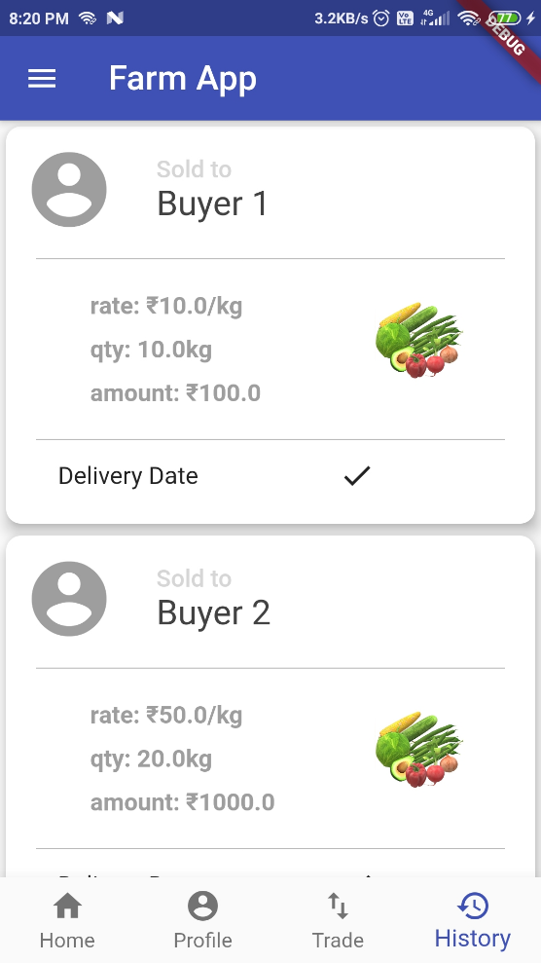

- In this screen, the user will be able to see Completed transactions.
- Failed or Rejected transactions can also be seen here.
- The user will also be able to raise an issue, e.g. the Buyer refused a transaction, the farmer entered wrong quantity of the product etc.
- Pending Work:
  - UI needs to be fixed. (ETA: 1 week)

- Left Navigation Pane

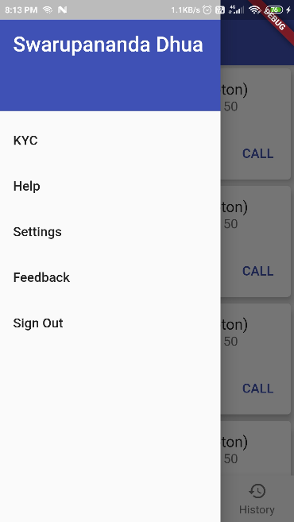
- In this screen, the user will be able to sign out, give feedback, change app settings, get help, check or update KYC details.
- Pending Work:
  - Except SignOut other items are pending. (ETA: 3 weeks)

- Trade Screen (working on it)

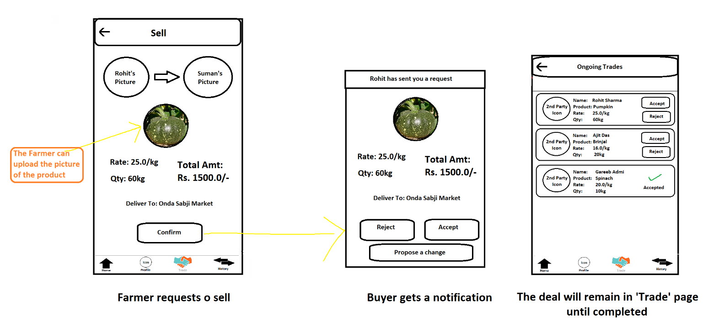

- When a farmer (1st party) shows interest to sell a product to a buyer (2nd party), or a buyer (1st party) shows interest to buy a product from a farmer (2nd party), the 1st party will initiate a transaction and the 2nd party will get a notification regarding the deal which he can accept/reject/propose an edit.
- A transaction can be in one of the following states:
  - Requested
  - Accepted (agreed but actual delivery of the product is not yet done)
  - Rejected (by the 2nd party)
  - Failed (due to technical problems)
  - Completed (product is delivered)
- All transactions in Requested or Accepted state will be listed in this screen and the user can Accept/Reject or mark as Completed (this has to be again confirmed by the other party).
- Pending Work:
  - Developing the UI and logic of this screen. (ETA: 3 weeks)

- Potential problems and explanations
  - Will the whole sale buyers incur a loss & will they refuse to use the app?
    - Because of this app, small scale vendors will come into picture and they’ll start competing with the Whole Sale Buyers. Often, small vendors tend to give slightly higher price and farmers matching their requirements will not go to the whole sale buyers. This will introduce a scarcity which in turn will lead the whole sale buyers to list down their requirements.
  - Farmers can call the buyers directly, why need an app?
    - Buyers often refuse to tell the price at which they want to buy until the farmer comes to the market. Once the farmer comes to the market, he doesn’t go to another market even if he receives lesser price. With this app, there’ll be an open competition among the buyers.
  - Will the farmers be able to use the app?
    - Yes, we’ll make this happen. The app will be published in native languages to handle this problem

- Resources
  - Source Code: https://github.com/swarupanandadhua/farmapp/

