Choose the Right Hardware

Proposal Template

# Scenario 1: Manufacturing

Client Requirements and Potential Hardware Solution

Look through the scenario and find any relevant client requirements. Then, suggest a potential hardware type and explain how this hardware would satisfy each of the requirements.

|  |
| --- |
| **Which hardware might be most appropriate for this scenario?**  **(CPU / IGPU / VPU / FPGA)** |
| FPGA |

|  |  |
| --- | --- |
| **Requirement Observed**  **(Include at least two.)** | **How does the chosen hardware meet this requirement?** |
| Camera records video at 30-35 FPS and image processing task needs to be completed five times per second | FPGA is good enough to run multiple tasks in parallel. FPGA run entire neural network on the same device which reduces latency of going back and forth to CPU and FPGA |
| Client also want the flexibility of reprogramming the hardware to support different chip designs | FPGA has a programmable interconnect which can be used to program the logics. FPGA also have various precision options. Since FPGA uses bitstreams we can update the bitstream without changing any hardware. |
| Client require the system to be last for at least 5 – 10 years | FPGAs have a long lifespan |

## Queue Monitoring Requirements

|  |  |
| --- | --- |
| **Maximum number of people in the queue** | 2 |
| **Model precision chosen (FP32, FP16, or Int8)** | FP16 |

## 

## Test Results

After you've tested your application on all four hardware types (CPU, IGPU, VPU, and FPGA), copy the matplotlib output showing the comparison into the spaces below. You should have three graphs (for model load time, inference time, and FPS).

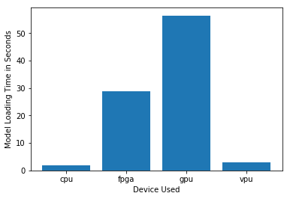

***Model Load Time***

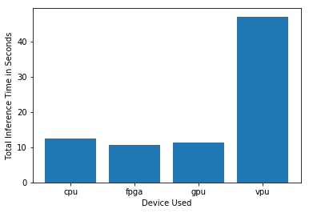

***Inference Time***

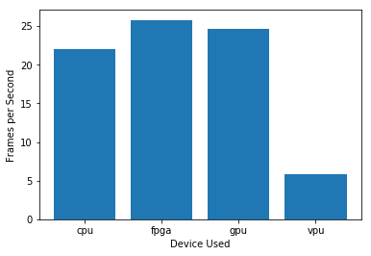

***FPS***

## Final Hardware Recommendation

Now synthesize your points from above and provide a brief write-up describing why the chosen hardware is the best choice for this scenario. Be sure to discuss the client's requirements, the test results, and how these relate to one another (e.g., perhaps one of the devices performed better than the rest, but does not meet one of the client's requirements).

|  |
| --- |
| **Write-up: Final Hardware Recommendation** |
| Client’s requirement was to have long term solution system and another major requirement was to have flexibility to reprogram the system. So, both can meet by providing FPGA based solution.   Client also wanted to process a greater number of images in parallel and above graph gives clear picture that FPGA are better over other systems. |

# 

# Scenario 2: Retail

Client Requirements and Potential Hardware Solution

Look through the scenario and find any relevant client requirements. Then, suggest a potential hardware type and explain how this hardware would satisfy each of the requirements.

|  |
| --- |
| **Which hardware might be most appropriate for this scenario?**  **(CPU / IGPU / VPU / FPGA)** |
| IGPU |

|  |  |
| --- | --- |
| **Requirement Observed**  **(Include at least two.)** | **How does the chosen hardware meet this requirement?** |
| Client does not want to invest extra money for additional hardware. | Since client already has i7 core processor, it will have IGPU which can be used for the edge computing. |
| Client want to save as much as power possible | Core i7 7th gen processor has 35- 45W TDP. So it is affordable since the client already using the core i7 for other tasks. |

## Queue Monitoring Requirements

|  |  |
| --- | --- |
| **Maximum number of people in the queue** | 2 |
| **Model precision chosen (FP32, FP16, or Int8)** | FP16 |

## Test Results

After you've tested your application on all four hardware types (CPU, IGPU, VPU, and FPGA), copy the matplotlib output showing the comparison into the spaces below. You should have three graphs (for model load time, inference time, and FPS).

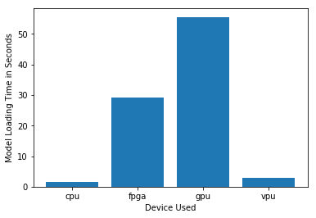

***Model Load Time***

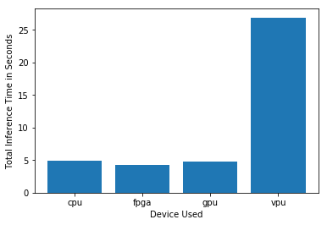

***Inference Time***

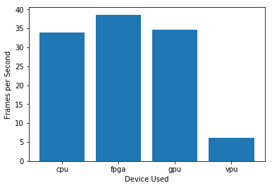

***FPS***

## Final Hardware Recommendation

Now synthesize your points from above and provide a brief write-up describing why the chosen hardware is the best choice for this scenario. Be sure to discuss the client's requirements, the test results, and how these relate to one another (e.g., perhaps one of the devices performed better than the rest, but does not meet one of the client's requirements).

|  |
| --- |
| **Write-up: Final Hardware Recommendation** |
| We can see that FPGA based solution is best but, client doesn’t want to invest on extra hardware. Also, client wants to save power cost. Since client already have i7 core processor which will have integrated GPU which can be used for computing. |

# 

# Scenario 3: Transportation

Client Requirements and Potential Hardware Solution

Look through the scenario and find any relevant client requirements. Then, suggest a potential hardware type and explain how this hardware would satisfy each of the requirements.

|  |
| --- |
| **Which hardware might be most appropriate for this scenario?**  **(CPU / IGPU / VPU / FPGA)** |
| VPU |

|  |  |
| --- | --- |
| **Requirement Observed**  **(Include at least two.)** | **How does the chosen hardware meet this requirement?** |
| Hardware solution should accommodate in the security booth | VPU or NCS2 is only about 27.40 mm in size which will easily accommodate in the provided security booth |
| Client wants to save as much as possible on Power consumption | Since NCS2 will additionally cause around 1W of power which seems to be under budget. |
| Client has a maximum budget of $300 per machine and want to save as much as possible with hardware. | VPU (NCS2) will cost around $100 which comes under budget. |

## Queue Monitoring Requirements

|  |  |
| --- | --- |
| **Maximum number of people in the queue** | 5 |
| **Model precision chosen (FP32, FP16, or Int8)** | FP16 |

## Test Results

After you've tested your application on all four hardware types (CPU, IGPU, VPU, and FPGA), copy the matplotlib output showing the comparison into the spaces below. You should have three graphs (for model load time, inference time, and FPS).

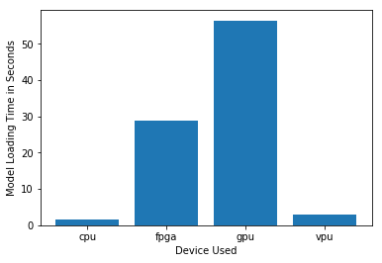

***Model Load Time***

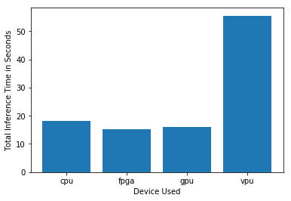

***Inference Time***

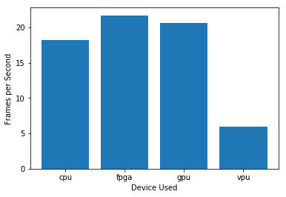

***FPS***

## Final Hardware Recommendation

Now synthesize your points from above and provide a brief write-up describing why the chosen hardware is the best choice for this scenario. Be sure to discuss the client's requirements, the test results, and how these relate to one another (e.g., perhaps one of the devices performed better than the rest, but does not meet one of the client's requirements).

|  |
| --- |
| **Write-up: Final Hardware Recommendation** |
| When we see the performance FPGA is better but client has restrictions like he wants to save as much as power and also wants to accommodate in existing security booth. And there is budget limit of $300 so when we consider all the requirements VPU seems reasonable. |

# 