**B. Tech PROJECT SUMMARY (MPS) SHEET**

**Title of project**: **Hyperledger for Public Data Management: Connecting Identities and Streamlining Updates**

**Name of the Supervisor/s:** Dr. A. C. Adamuthe

**Name of the Students**: 1. Mane Swarup Chandrakant (2010015)

2. Pawar Chinmay Santosh (2010005)

3. Mujawar Malik Sajid (2010008)

4. Mali Samrat Shivaji (2010018)

**Brief description**:

Traditional government document management systems often suffer from several shortcomings such as lack of transparency, data inconsistency, and limited accessibility. These shortcomings can cause significant problems, such as fraudulent activities, inefficient and slow processes, and difficulty in ensuring the accuracy of the data. In traditional document management systems, there are multiple copies of the same document maintained by different departments, which can lead to inconsistencies and errors. Updating the information on these documents can also be a slow and time-consuming process. This is where Hyperledger blockchain technology can come in handy. By using a decentralized, immutable ledger, the data on the government documents can be stored securely, and any changes made to them can be replicated across all other copies of other documents in real-time. This ensures that the data is accurate and consistent across all departments. The Hyperledger blockchain can provide an audit trail of all changes made to the documents, making it easier to track and detect any fraudulent activities. The use of smart contracts can also automate the process of document verification and validation, ensuring that only authorized parties have access to the data. Overall, Hyperledger blockchain technology in the government sector can lead to more efficient, secure, and transparent document management systems. It can help to reduce the likelihood of fraudulent activities, ensure the accuracy and consistency of the data, and improve the accessibility of the documents to authorized parties.

**Objectives:**

The objective of this research paper is to investigate the inadequacies of conventional approaches employed by the government sector for managing common public documents such as Aadhaar Card, PAN Card, Driving License, and Voter ID Card. The conventional method involves a centralized database system that is vulnerable to cyberattacks and data breaches, posing a significant risk to the privacy and security of sensitive information.

* To evaluate the need for blockchain technology in Public Data Management, identifying flaws in the traditional system.
* To implement Hyperledger Fabric in Public Data Management to analyze its performance and suitability.
* To improve the process of government document updation increasing the efficiency and making it more secure and accessible to authorized entities/users.
* To enhance trust and transparency within the system by executing Hyperledger Transactions and distributed ledgers to ensure the accuracy and integrity of public data.

**Outcomes**:

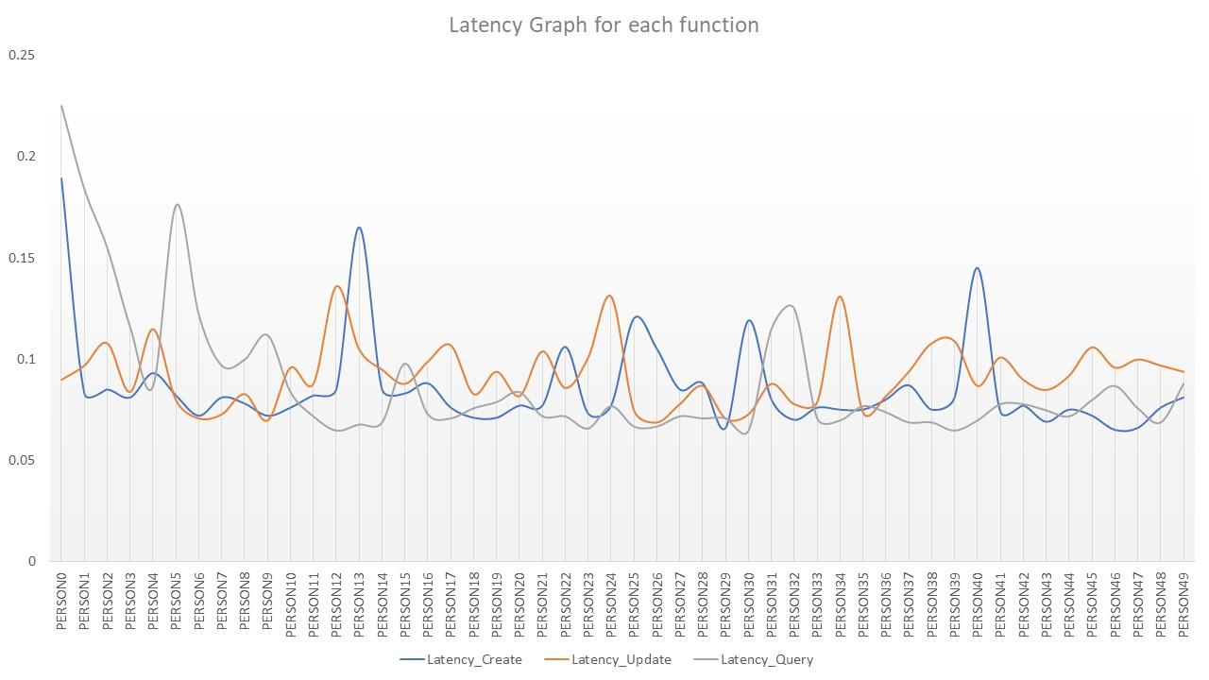 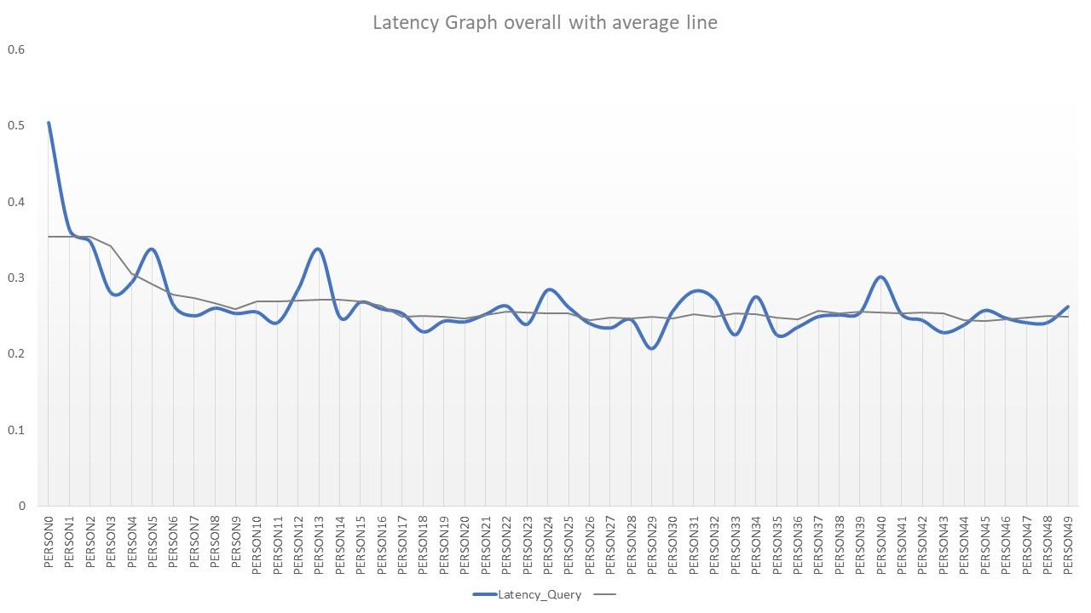

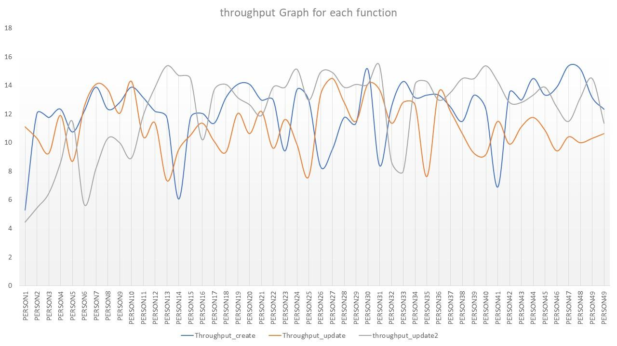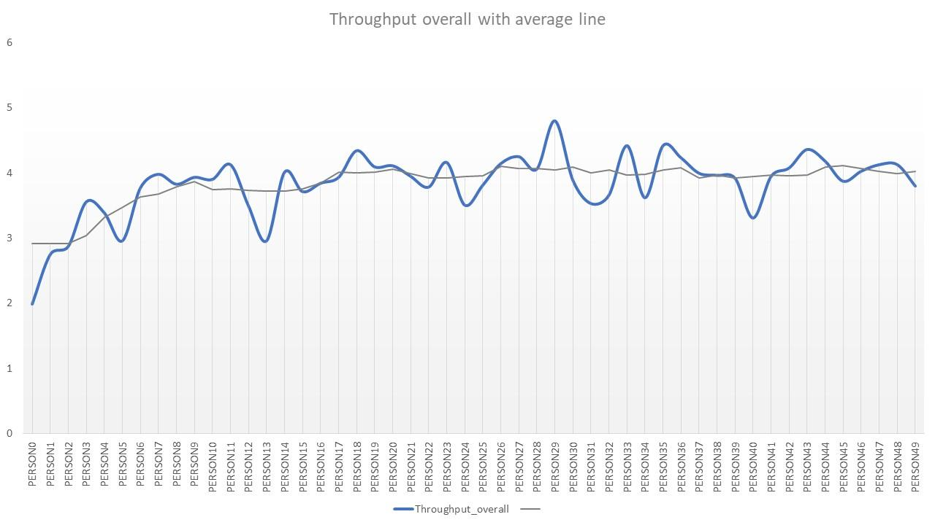

* **Latency_Create: 4.29s**
* **Latency_Update: 4.61s**
* **Latency_Query: 4.421s**
* **Latency_overall: 13.321s**
* **Throughput_Create: 0.233 TPS**
* **Throughput_Update: 0.217 TPS**
* **Throughput_Query: 0.226 TPS**
* **Overall Throughput: 0.676 TP**

**Photograph of Working Model:**

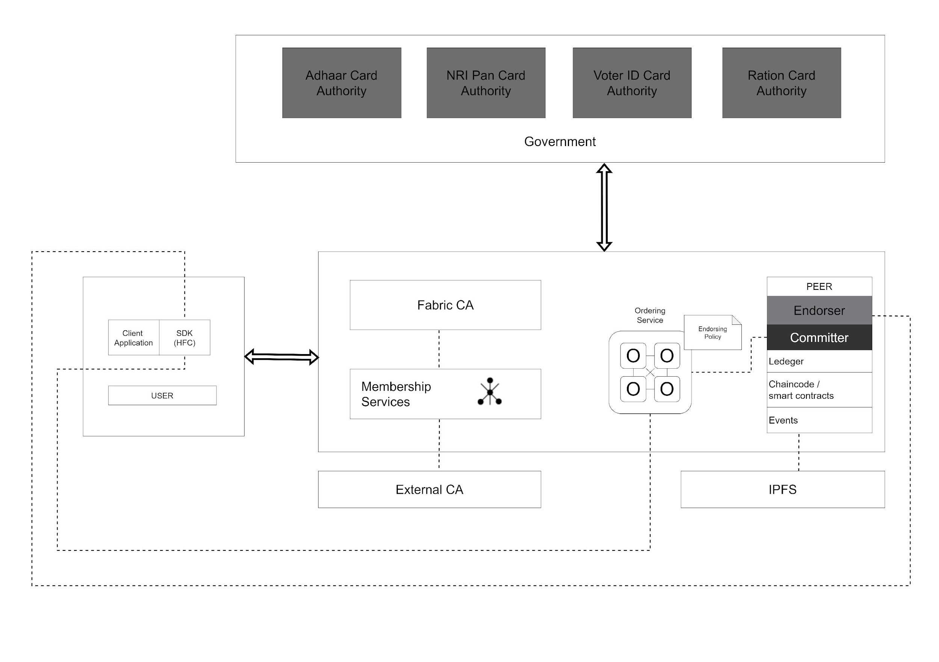 ***Figure. Framework Architecture***

Signature of Supervisor/s:__________________________________________________