MySQL DATABASE PROJECT
E-COMMERCE
MANAGEMENT SYSTEM
Customers • Products • Orders • Payments • Reviews

SUBMITTED FOR IT Vedant — MySQL Module
PROJECT BY Swarup Vishe
GUIDED BY ______________________________
BATCH ID ______________________________
SUBMISSION DATE ______________________________

1. Abstract

An E-Commerce Management System stores and manages the data of an online shopping website — customers, products, orders, payments and reviews. This project builds the MySQL database behind such a website and uses SQL queries to answer business questions such as total revenue, best-selling categories and top customers.

2. Project Description

The database ecommerce_db contains 7 related tables connected through primary and foreign keys.
Table | Purpose
categories | Product categories such as Electronics, Mobiles and Fashion
customers | Registered customers with city and contact details
products | Items for sale with brand, price and stock
orders | Each order placed by a customer, with status and total
order_items | Products inside each order (links orders and products)
payments | Payment method, date and status of every order
reviews | Customer ratings and comments for products

Business flow: Customer → Order → Order Items → Payment → Review

3. ER Diagram

Primary keys are shown in gold and foreign keys in blue. Every relationship is one-to-many (1 : N); order_items is the bridge between orders and products.
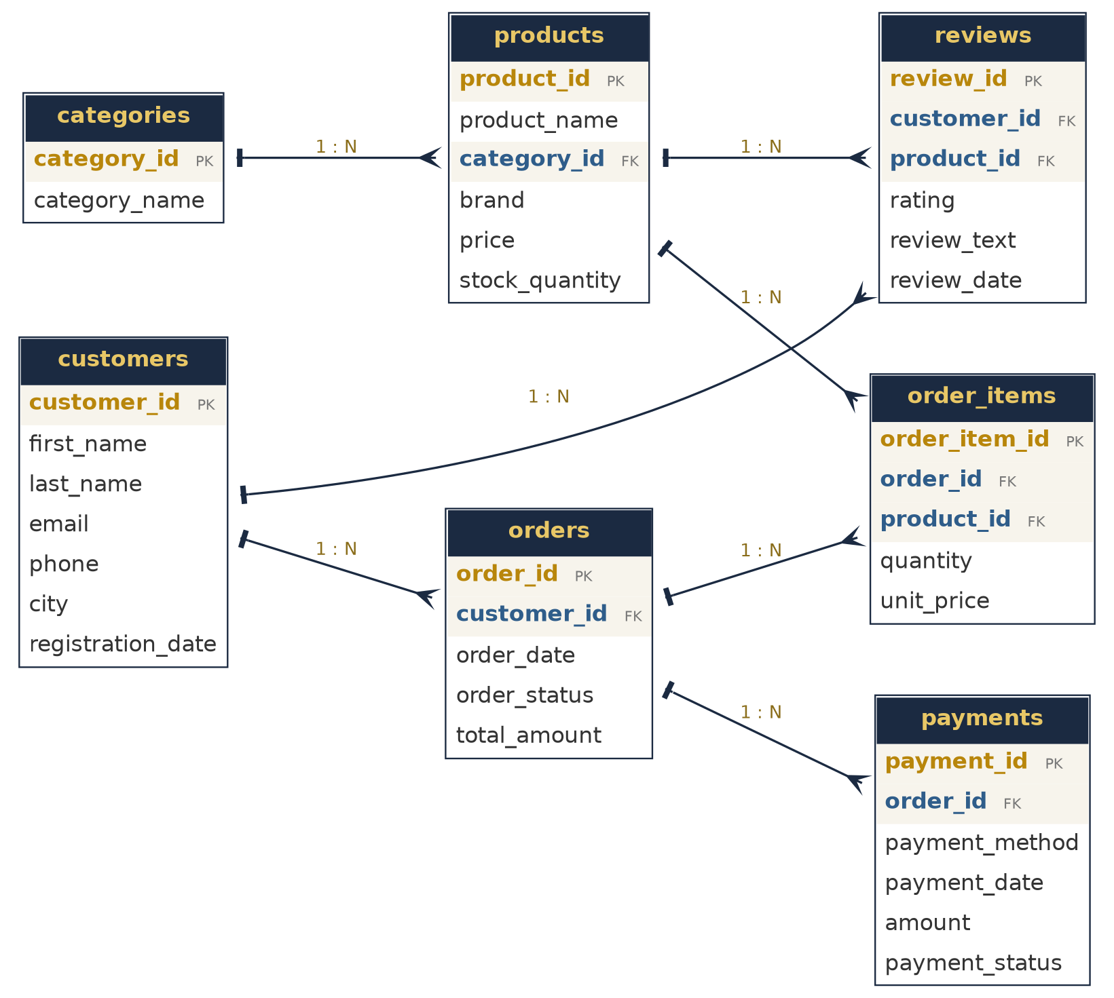

4. Table Description

categories
Column | Data type / constraint
category_id | INT AUTO_INCREMENT PRIMARY KEY
category_name | VARCHAR(50) NOT NULL UNIQUE

customers
Column | Data type / constraint
customer_id | INT AUTO_INCREMENT PRIMARY KEY
first_name | VARCHAR(40) NOT NULL
last_name | VARCHAR(40) NOT NULL
email | VARCHAR(100) NOT NULL UNIQUE
phone | VARCHAR(15)
city | VARCHAR(50)
registration_date | DATE

products
Column | Data type / constraint
product_id | INT AUTO_INCREMENT PRIMARY KEY
product_name | VARCHAR(100) NOT NULL
category_id | INT NOT NULL
brand | VARCHAR(50)
price | DECIMAL(10,2) NOT NULL
stock_quantity | INT NOT NULL DEFAULT 0
FOREIGN KEY | (category_id) REFERENCES categories(category_id)

orders
Column | Data type / constraint
order_id | INT AUTO_INCREMENT PRIMARY KEY
customer_id | INT NOT NULL
order_date | DATE NOT NULL
order_status | ENUM('Pending','Shipped','Delivered','Cancelled') DEFAULT 'Pending'
total_amount | DECIMAL(10,2) NOT NULL
FOREIGN KEY | (customer_id) REFERENCES customers(customer_id)

order_items
Column | Data type / constraint
order_item_id | INT AUTO_INCREMENT PRIMARY KEY
order_id | INT NOT NULL
product_id | INT NOT NULL
quantity | INT NOT NULL
unit_price | DECIMAL(10,2) NOT NULL
FOREIGN KEY | (order_id) REFERENCES orders(order_id)
FOREIGN KEY | (product_id) REFERENCES products(product_id)

payments
Column | Data type / constraint
payment_id | INT AUTO_INCREMENT PRIMARY KEY
order_id | INT NOT NULL
payment_method | VARCHAR(30) NOT NULL
payment_date | DATE
amount | DECIMAL(10,2) NOT NULL
payment_status | ENUM('Success','Pending','Refunded') DEFAULT 'Pending'
FOREIGN KEY | (order_id) REFERENCES orders(order_id)

reviews
Column | Data type / constraint
review_id | INT AUTO_INCREMENT PRIMARY KEY
customer_id | INT NOT NULL
product_id | INT NOT NULL
rating | INT NOT NULL
review_text | VARCHAR(200)
review_date | DATE
FOREIGN KEY | (customer_id) REFERENCES customers(customer_id)
FOREIGN KEY | (product_id) REFERENCES products(product_id)

5. Commands — Create Database & Tables

- ------------------------------------------------------------
-- STEP 1 : CREATE DATABASE
-- ------------------------------------------------------------
DROP DATABASE IF EXISTS ecommerce_db;
CREATE DATABASE ecommerce_db;
USE ecommerce_db;

-- ------------------------------------------------------------
-- STEP 2 : CREATE TABLES (7 tables)
-- ------------------------------------------------------------
CREATE TABLE categories (
category_id INT AUTO_INCREMENT PRIMARY KEY,
category_name VARCHAR(50) NOT NULL UNIQUE
);

CREATE TABLE customers (
customer_id INT AUTO_INCREMENT PRIMARY KEY,
first_name VARCHAR(40) NOT NULL,
last_name VARCHAR(40) NOT NULL,
email VARCHAR(100) NOT NULL UNIQUE,
phone VARCHAR(15),
city VARCHAR(50),
registration_date DATE
);

CREATE TABLE products (
product_id INT AUTO_INCREMENT PRIMARY KEY,
product_name VARCHAR(100) NOT NULL,
category_id INT NOT NULL,
brand VARCHAR(50),
price DECIMAL(10,2) NOT NULL,
stock_quantity INT NOT NULL DEFAULT 0,
FOREIGN KEY (category_id) REFERENCES categories(category_id)
);

CREATE TABLE orders (
order_id INT AUTO_INCREMENT PRIMARY KEY,
customer_id INT NOT NULL,
order_date DATE NOT NULL,
order_status ENUM('Pending','Shipped','Delivered','Cancelled') DEFAULT 'Pending',
total_amount DECIMAL(10,2) NOT NULL,
FOREIGN KEY (customer_id) REFERENCES customers(customer_id)
);

CREATE TABLE order_items (
order_item_id INT AUTO_INCREMENT PRIMARY KEY,
order_id INT NOT NULL,
product_id INT NOT NULL,
quantity INT NOT NULL,
unit_price DECIMAL(10,2) NOT NULL,
FOREIGN KEY (order_id) REFERENCES orders(order_id),
FOREIGN KEY (product_id) REFERENCES products(product_id)
);

CREATE TABLE payments (
payment_id INT AUTO_INCREMENT PRIMARY KEY,
order_id INT NOT NULL,
payment_method VARCHAR(30) NOT NULL,
payment_date DATE,
amount DECIMAL(10,2) NOT NULL,
payment_status ENUM('Success','Pending','Refunded') DEFAULT 'Pending',
FOREIGN KEY (order_id) REFERENCES orders(order_id)
);

CREATE TABLE reviews (
review_id INT AUTO_INCREMENT PRIMARY KEY,
customer_id INT NOT NULL,
product_id INT NOT NULL,
rating INT NOT NULL,
review_text VARCHAR(200),
review_date DATE,
FOREIGN KEY (customer_id) REFERENCES customers(customer_id),
FOREIGN KEY (product_id) REFERENCES products(product_id)
);

-

6. Sample Data

Table | Rows
categories | 6
customers | 15
products | 24
orders | 30
order_items | 63
payments | 30
reviews | 25

All INSERT statements are included in the accompanying .sql file.

7. SQL Queries

Basic Queries
Q1 Show all products costing more than Rs.10,000, highest price first.
SELECT product_name, brand, price FROM products WHERE price > 10000 ORDER BY price DESC;

Q2 Find customers who live in Mumbai or Pune.
SELECT first_name, last_name, city FROM customers WHERE city IN ('Mumbai','Pune');

Q3 Find the 5 cheapest products.
SELECT product_name, price FROM products ORDER BY price ASC LIMIT 5;

Q4 Find all orders that are still Pending.
SELECT order_id, customer_id, order_date, total_amount FROM orders WHERE order_status = 'Pending';

Q5 List all distinct cities our customers come from.
SELECT DISTINCT city FROM customers ORDER BY city;

Aggregate Queries
Q6 Count total customers, products and orders.
SELECT (SELECT COUNT(*) FROM customers) AS total_customers,
(SELECT COUNT(*) FROM products) AS total_products,
(SELECT COUNT(*) FROM orders) AS total_orders;

Q7 What is the total revenue from non-cancelled orders?
SELECT SUM(total_amount) AS total_revenue FROM orders WHERE order_status <> 'Cancelled';

Q8 What is the average order value?
SELECT ROUND(AVG(total_amount), 2) AS average_order_value FROM orders;

Q9 Count how many orders are in each status.
SELECT order_status, COUNT(*) AS number_of_orders FROM orders GROUP BY order_status;

Q10 Show categories whose total sales are above Rs.50,000.
SELECT c.category_name, SUM(oi.quantity * oi.unit_price) AS total_sales
FROM categories c
JOIN products p ON c.category_id = p.category_id
JOIN order_items oi ON p.product_id = oi.product_id
GROUP BY c.category_name HAVING SUM(oi.quantity * oi.unit_price) > 50000;

Join Queries
Q11 Show each product with its category name.
SELECT p.product_name, c.category_name, p.price
FROM products p JOIN categories c ON p.category_id = c.category_id;

Q12 Show each order with the customer's name.
SELECT o.order_id, CONCAT(c.first_name, ' ', c.last_name) AS customer_name, o.order_date, o.total_amount
FROM orders o JOIN customers c ON o.customer_id = c.customer_id;

Q13 Show the products inside every order.
SELECT o.order_id, p.product_name, oi.quantity, oi.unit_price, (oi.quantity * oi.unit_price) AS line_total
FROM order_items oi
JOIN orders o ON oi.order_id = o.order_id
JOIN products p ON oi.product_id = p.product_id
ORDER BY o.order_id;

Q14 Show each order with its payment method and payment status.
SELECT o.order_id, pay.payment_method, pay.amount, pay.payment_status
FROM orders o JOIN payments pay ON o.order_id = pay.order_id;

Q15 Revenue earned by each category.
SELECT c.category_name, SUM(oi.quantity * oi.unit_price) AS category_revenue
FROM order_items oi
JOIN products p ON oi.product_id = p.product_id
JOIN categories c ON p.category_id = c.category_id
GROUP BY c.category_name ORDER BY category_revenue DESC;

Q16 Customers with the number of orders they placed (including customers with zero orders).
SELECT c.first_name, c.last_name, COUNT(o.order_id) AS orders_placed
FROM customers c LEFT JOIN orders o ON c.customer_id = o.customer_id
GROUP BY c.customer_id, c.first_name, c.last_name ORDER BY orders_placed DESC;

Q17 Average rating of each product that has reviews.
SELECT p.product_name, COUNT(r.review_id) AS total_reviews, ROUND(AVG(r.rating), 2) AS average_rating
FROM products p JOIN reviews r ON p.product_id = r.product_id
GROUP BY p.product_id, p.product_name ORDER BY average_rating DESC;

Subqueries
Q18 Products priced above the average product price.
SELECT product_name, price FROM products WHERE price > (SELECT AVG(price) FROM products);

Q19 Customers who have placed at least one order.
SELECT first_name, last_name FROM customers
WHERE customer_id IN (SELECT customer_id FROM orders);

Q20 Products that have never been ordered.
SELECT product_name FROM products
WHERE product_id NOT IN (SELECT product_id FROM order_items);

Q21 Orders whose value is higher than the average order value.
SELECT order_id, total_amount FROM orders
WHERE total_amount > (SELECT AVG(total_amount) FROM orders) ORDER BY total_amount DESC;

View
Q22 Create a view that summarises every customer's spending, then use it.
CREATE VIEW customer_spending AS
SELECT c.customer_id, CONCAT(c.first_name, ' ', c.last_name) AS customer_name, c.city,
COUNT(o.order_id) AS total_orders, COALESCE(SUM(o.total_amount), 0) AS total_spent
FROM customers c LEFT JOIN orders o ON c.customer_id = o.customer_id AND o.order_status <> 'Cancelled'
GROUP BY c.customer_id, c.first_name, c.last_name, c.city;

SELECT * FROM customer_spending ORDER BY total_spent DESC;

Stored Procedure
Q23 Procedure that shows all orders of one customer.
DELIMITER $$
CREATE PROCEDURE get_customer_orders(IN p_customer_id INT)
BEGIN
SELECT order_id, order_date, order_status, total_amount
FROM orders WHERE customer_id = p_customer_id ORDER BY order_date;
END$$
DELIMITER ;

CALL get_customer_orders(1);

8. Conclusion

The project shows how a compact relational database with proper keys can run a complete online store and answer real business questions using SELECT, JOIN, GROUP BY, subqueries, a view and a stored procedure.

