

LAB TASK #3

# OBJECT ORIENTED SOFTWARE ENGINEERING

**SUBMITTED TO: JAWAD KHAN**

SUBMITTED BY:

AMIR ALI, FA20-BSE-131

TEAM MEMBERS:

|  |  |
| --- | --- |
| MAHA BABAR | FA20-BSE-160 |
| AREEB AJAB | FA20-BSE-132 |
| MUHAMMAD ZAMIN | FA20-BSE-140 |

# Introduction to Problem Domain

* **Introduction:**

This application is used for the purposes of managing the tasks of the hospital. It helps organize the duties and tasks in an efficient way. It makes it easier for patients to book an appointment and find out visiting hours.

## Statements about Hospital Management System

* Patients are usually admitted in the hospital to get treated
* There are different doctors available during different timings to accommodate the patients
* Patients are assigned to doctors based on their issues
* If the illness is of long-term the patients are submitted in the hospital for more than a day
* After being treated the patients are dismissed
* The patients then are sent to the reception to clear their dues

# OBJECTS IN PROBLEM DOMAIN

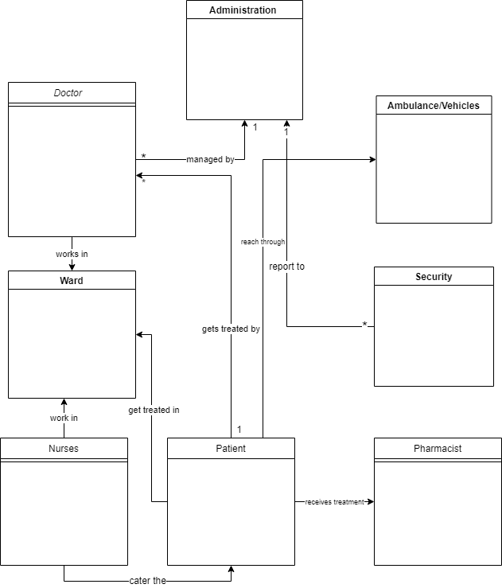

# Major Stakeholders of the Software

|  |  |
| --- | --- |
| Board of trustees | Interface |
| Civil Servants | External |
| Corporate office | Interface |
| CEO | Internal |
| CFO | Internal |

# List of Objects

1. Doctors
2. Patients
3. Nurses
4. Administration
5. Security
6. Pharmacist
7. Ambulance/Vehicles
8. Appointment
9. Medicines
10. Users

# Object Oriented Analysis

The proposed software product is the Hospital Management system (HMS). The system will be used in any hospital, clinic, dispensary or pathology labs. Clinic, dispensary or pathology to get the information from the patients and then storing that data for future usages. The current system in use is a paper based system. It is too slow and cannot provide updated lists of patients within reasonable timeframe. The intention of the system is to reduce over-time pay and increase the number of patients that can be treated accurately. Requirement statements in these documents are both functional and non-functional.

***LIST OF USECASES:***

1. Admit patients
2. Book appointment
3. Cancel appointment
4. Create bill
5. Maintain staff
6. Consult patient (include) treat patient
7. Give patient treatment (include) provide medicine
8. Record office visit information
9. Get treatment
10. View patient history
11. Buy medicine
12. Pay bills
13. Manage application

14. Handle system

***LIST OF ACTORS:***

1. Receptionist (primary actor)
2. Doctor (primary actor)
3. Nurse (secondary)
4. Patient (secondary)
5. Administration (secondary)

***Group Leader Github Link:***

<https://github.com/mahababar/mahababar>

***END***