CSS Notes

CSS Intro

CSS Rule Syntax
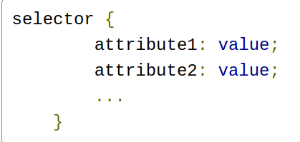
- CSS Rule Set
  - defines the style of HTML elements
- CSS Declaration
  - eg: color:red;
- CSS Property/attribute
  - element being styled
- CSS Value
  - value of property, eg red
- CSS Comments
  - /* color: red; */

CSS Selectors

Applying CSS to multiple elements on a page
- Define within <style>...</style>
- place in head
- id selectors:
- <style>
#product2
{
border: 3px red dashed;
}
</style>
- Class selectors
  - <style>
.warning {
display: none;
}
</style>
  - <p class="warning">First Name is required.</p>
- Applying a rule to morethan one selector
  - #product1, #product3 {
color: blue;
}
- Combine class and element selector
  - div.warning {
font-style: italic;
}
  - Will only select the div with warning class

Style Sheets

Styling
- 3 type of styles
- Inline
  - For objects that need specific styling
- Internal (at the top of each page)
  - one specific page
- External(separate css file)
  - Consistent look across all pages
  - <link rel="stylesheet"
type="text/css"
href="sampleStyles.css" />

CSS Box Model
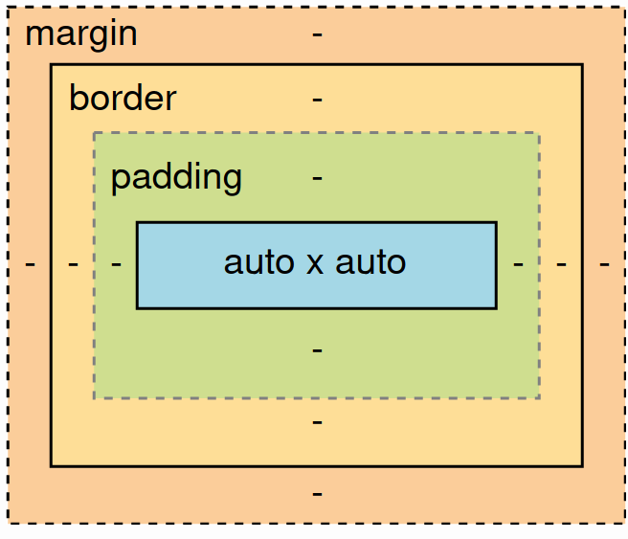
  - Auto x auto is content
  - Padding: whitespace between content and border
    - Transparent area around the content,
  - border: Visual separation between box’s content and the content around it
    - The border encloses the padding and the content.
    - Thickness, colour, style
    - can be defined individually or collapsed
  - margin: Whitespace between border and the content
    - Similar to padding, except transparent area
    - Takes properties of fixed length
  - Can use CSS to define width and height of a block element but not an inline element.

Background, Text and Fonts
Differentiating containers

Backgrounds
- Background Colours
  - Color value: RGB(A), color names and hexadecimal values
- RGB(A) values
  - amount of red, green, blue (0 – 255)
- Hexadecimal value
  - Equivelant to RGB values

Background Images
- Background-img
  - image:url("image-address.png");
- Background Repeat
  - Determines whether the background image repeats in the background and, if it does, which way it repeats.
    - No-repeat
    - repeat-x: horizontally repeats
    - repeat-y:vertically repeats
    - repeat: both

- background-attachment
  - determines whether background image is fixed or moves when scrolling
    - scroll
    - fix
- Background position
  - X
    - right
    - left
    - center
  - Y
    - top
    - bottom
    - center
- Background Shorthand
  - background: color image repeat attachment position;

Text
- Colour
  - <div style="color:red;">
- Alignment
  - tyle="text-align: justify;
  - right,left,center,justify
- Indentation
  - text-indent: 15%;
- Capatilization
  - Capatilize
  - uppercase
  - lowercsae
  - none
  - style="text-transform: uppercase;”
- Decoration
  - Underline, overline,strikethrough
  - style="text-decoration:underline;”
- Font
  - Size, weight and style
- Style
  - italic
  - oblique
  - normal
- Size
  - Absolute – xx-small to xx-larger
  - Length – em, ex px, cm, mm, in, pt, pr
  - Percentage - %
  - Relative – smaller, larger
  - Em and En are relative sizes (default width of N and M)
- Weight
  - Thickness
    - Numeric values
    - normal
    - bold
    - Relative – bolder, lighter
- Family
  - typeface
    - serif - Garamond, Georgia, New York, Times, and Times New Roman
    - sans-serif - Arial, Geneva, Helvetica, Lucida Sans, Trebuchet, and Verdana
    - monospace - Courier, Consolas, Lucida Console, and Monaco
    - Cursive - Comic Sans MS, Lucida Handwriting, and Zapf Chancery
    - fantasy – (decorative fonts) Copperplate, Desdemona, Impact, and Kino
  - Can use specific font
    - option to tell browser where to find font family
    - provided by server or external server( google fonts)

Links and Tables

Pseudo-Classes
- Used for styling special states
- selector:pseudo-class {
/* CSS declarations */
}
- Cannot be used in inlie styles

Links
- Links pseudo-classes
  - link: unvisited
  - visited
  - hover
  - active
- a {
font-family: monospace;
text-decoration: underline;
font-weight: none;
}

a:link {
color: green;
}
a:visited {
color: red;
}

Tables
- table, th, td {
border: 1px solid black;
border-collapse: collapse;
}
- Padding the space
  - padding-top: 5px;
padding-right: 0px;
padding-bottom: 5px;
padding-left: 10px
  - padding: 5px 0px 5px 10px;
- Widths and Heights
  - table {
width: 100%;
}

th {
height: 25px;
}
- Text Alignment
  - tfoot td {
text-align: center;
}
- Styling Table Row Backgrounds
  - tbody tr:nth-child(even) {
background-color: lemonchiffon;
}

tbody tr:nth-child(odd) {
background-color: lawngreen;
}

How to colour the website
- Choose a primary color: Pick a color that suits the energy of your product or service.
- Choose your additional colors: Pick one or two additional colors that complement your primary color, ideally colors that make your primary color “pop.”
- Choose a background color: Choose a color for the background of your website – possibly less “aggressive” than your primary color.
- Choose a typeface color: Choose a color for the text that is going to be on your website – remember that a solid black typeface is rare and not recommended.

CSS Bootstrap
- Framework for stylesheets
- Rapid development of websites
- Mobile first approach
- Meta Elements
  - Provides information to browser
- Put Bootstrap at the top of the list, and your own css files under Bootstrap so that your selected styles take precedence.
- Javascript files added in body
  - Can load content before loading files

Bootstrap Grid System

Responsive design
- Bootstrap: resizable grid system
- Design for all use cases and audience
- Allow browser to adapt to screen size automatically
- HTML must be surrounded in a dive with a container(fixed width) or container-fluid(accross page) CSS class
- laid out in bootstrap12 cloumn grid system

Responsive design with Grid System
- Use 12 cloumn’s to position content
- CSS classes for rows and columns
  - Group content into either rows or columns
  - Specify span
  - Sm,md and lg refer to target device

CSS Media Queuries
- Styles applied based on certain conditions
  - width
  - type
- noted by @media
- @media type and (property:value) {
selector {
property:value;
property:value;
}
selector2{
property:value;
property:value;
}
}

Code-Along Notes
- Container that applies to whole page
  - .container
    - Fixed column size
    - only stack
  - .container-fluid:
    - column can stack and resized
- img-fluid class
  - tries to fill horizontal space
- Using Smaller width settings
  - Specify content to takeup different amount of columns bsaed on window size
  - Apply multiple class properties
    - <div class="col-lg-9 col-md-8">
- Automatic Column Sizing
  - If number of columns not spcified, equal number of columns for content

Bootstrap and CSS

Typography
- Styling and positioning text
- Bootstrap overides common HTML elements

Table styling
- Use .table-responsive class
  - becomes scrollable

Forms
- inputs, labels, and buttons.
- Additional form features offered by bootstrap
  - control state
  - Explicit Control sizes
  - help text

Images
- Simpler with bootstrap
- Can add border
- .img-fluid class
  - scales well with parent

Utilities
- Can mix bootstrap classes to get desired effect
- borders
- colors
- flex and float layouts
- position
- sizes

Bootstrap Components
- Components to provide consistant look and feel
  - Icons
  - Form Components
  - Formatting components
    - Jumbotron: showcasing content
    - Badges
      - eg unread messages
  - Navigations Components

