Javascript
Javascript and the browser

Document Object Model
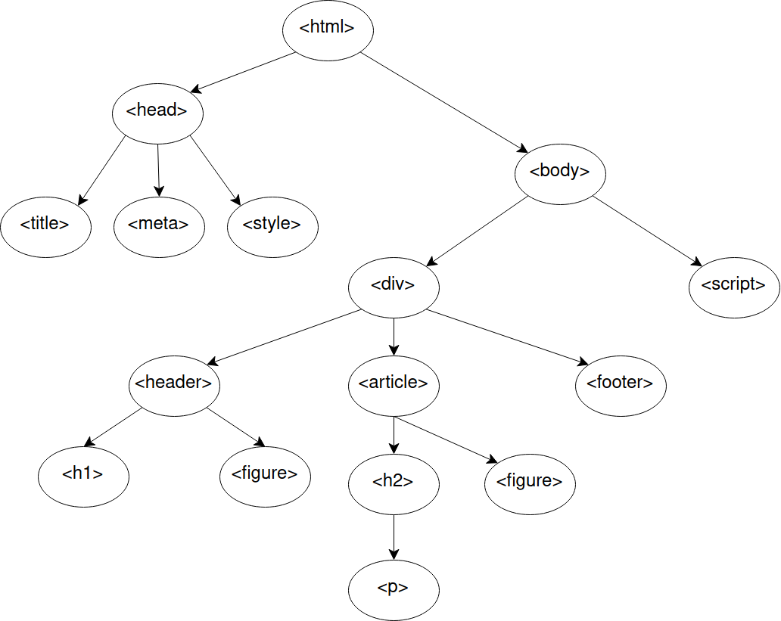
- Browser parses HTML into software objects: DOM
- each obj in DOM represents an element called a node
- nodes from one-way hierachy

Document
- Browser preloads web API’s when JS run.
- Allows interaction with current document
  - DOM API’s workhorse: document
    - respond to interactions
    - alter content
    - current state
- document.getElementById("theId"): find the DOM element with the id of theId
- document.getElementsByName("elementName"): find the DOM elements with the name of elementName
- document.getElementsByTagName("tagName"): find the DOM elements of a particular HTML tag
- document.getElementsByClassName("cssClassName"): find the DOM elements with a class attribute of cssClassName

DOM Collections
- Doc obj properties to access HTML element collections
  - cookie
  - embeds
  - forms
  - images
  - links
  - scripts
- accessed by document.propertyName
  - ie documents.links

Events
- Trigger call to JS
- doc events, mouse events, keyboard events, form events, window events

The onload Event
- When object is loaded

Bootstrap Javascript Components

Bootstrap Javascript Components

