Project Report
On
“Implementation of a Self-Healing Factory Sensor Network Using
Adaptive Routing and Link Quality Estimation”
Submitted in partial fulfillment of the requirements for the IV semester
Mini Project Work [213ECE2463]
Bachelor of Engineering In
Electronics and Communication Engineering
Of
Kalasalingam Academy of Research and Education
By
SRI SWASTHI S (9924005031)
HARIKRISHNAN VEERAPAN (9924005267)
AJAY KRISHNAN (9924005013)
SREE LEKSHMI (9924005373)
Mr. Bhargav  External Guide  Senior design engineer  Company - Simask Pvt Ltd | Prof. Mrs. Loyola Jasmine  Internal Guide  Assistant Professor  Dept. of ECE, KARE

Department of Electronics and Communication Engineering
Kalasalingam Academy of Research and Education
2025-2026
Kalasalingam Academy of Research and Education
Krishnankoil, Srivilliputhur, Tamil Nadu 626126
Department of Electronics and Communication Engineering
CERTIFICATE
It is Certified that Ms. Sri Swasthi S, Mr. Harikrishnan Veerapan, Mr. Ajay Krishnan and Ms. Sree Lekshmi S bearing REG NUM: 9924005031, 9924005267, 9924005013, 9924005373 respectively, are bonafide students of Kalasalingam Academy of Research and Education, and have completed requirements of the project entitled “Implementation of a Self-Healing Factory Sensor Network Using Adaptive Routing and Link Quality Estimation” in partial fulfillment of the requirements for IV semester Bachelor of Engineering in Electronics and Communication Engineering during academic year 2025-26. It is certified that all Corrections/Suggestions indicated for Project Assessment have been incorporated in the report. The project report has been approved as it satisfies the academic requirements in respect of project work Phase-2 prescribed for the Bachelor of Engineering degree.

Mr. Bhargav  External Guide  Senior design engineer  Company - Simask Pvt Ltd | Prof. Mrs. Loyola Jasmine  Internal Guide  Assistant Professor  Dept. of ECE, KARE

Dr. J. Charles Pravin
Head of the Dept.
Dept. of ECE, KARE
External Viva
Name of the Examiners Signature with date
1.
2.
DECLARATION
It is Certified that Ms. Sri Swasthi S, Mr. Harikrishnan Veerapan, Mr. Ajay Krishnan and Ms. Sree Lekshmi S bearing REG NUM: 9924005031, 9924005267, 9924005013, 9924005373 respectively, are bonafide students of Kalasalingam Academy of Research and Education, and have completed requirements of the project entitled “Implementation of a Self-Healing Factory Sensor Network Using Adaptive Routing and Link Quality Estimation” in partial fulfillment of the requirements for IV semester Bachelor of Engineering in Electronics and Communication Engineering during academic year 2025-26.
We also declare that, to the best of our knowledge and belief, the work reported here does not form part of any other report on the basis of which a degree or award was conferred on an earlier occasion on this by any other student.

Date:
Place:
ABSTRACT
This project presents, a self-healing wireless sensor mesh for Industry 4.0 condition monitoring, built on the ESP-NOW protocol of the ESP32 with an STM32F446RE as the wired gateway controller. Three sensor nodes – Node A (DHT11 temperature), Node B (SW-420 vibration) and Node C (MQ-2 gas/smoke) – report to a gateway ESP32 (Node G), which also carries a flame sensor. No access point, router or cloud service is used; the nodes communicate directly over the raw radio using short text packets.
Each sensor node measures its own link quality using a ten-packet sliding window of acknowledgement results. If the packet-delivery ratio falls below 0.7 over at least five samples, the node silently reroutes its packets through a backup neighbour in the ring A → B → C → A, tagging them as relayed (R). While relaying, it probes the gateway directly, and a single acknowledged probe restores the direct route.
The gateway validates each packet and passes it by UART to the STM32F446RE, whose interrupt-driven USART1 receiver assembles lines, mirrors them to a PC through the ST-LINK virtual COM port and lights the on-board LED LD2 whenever a relayed packet is seen. A browser dashboard using the Web Serial API displays live readings, a colour-coded topology, a packet log and a count of self-healing events. A fault-injection test – breaking a link and then restoring it – confirms the behaviour on three independent indicators: the dashboard, the node LED and LD2. The result is a low-cost, infrastructure-free monitoring network that keeps delivering data through temporary link failures and makes every reroute visible to the operator.
Contents
Chapter 1: Introduction
Chapter 2: Case study
Chapter 3: Methodology
Chapter 4: Literature Survey
Chapter 5: Implementation
Chapter 6: Flow chart/Algorithm
Chapter 7: Simulation/result analysis
Chapter 8: Conclusion and Future Scope
Chapter 9: References
Software and Hardware Used (with source code)

CHAPTER-1
INTRODUCTION
  - Background
The rapid evolution of Industry 4.0 has turned conventional factories into interconnected systems in which machines sense, communicate and react with very little human intervention. The Industrial Internet of Things (IIoT) sits at the centre of this change: low-cost sensor nodes continuously report temperature, vibration, gas concentration and similar quantities so that faults can be detected before they become failures. In such a system, however, the value of a sensor reading depends entirely on whether it actually reaches the operator. A node that silently loses its radio link is, from the operator’s point of view, indistinguishable from a node that has failed.
Most low-cost wireless deployments use a star topology: every node talks directly to one gateway, and any obstruction, interference or fading on that single link means lost data. Router-based Wi-Fi and cloud brokers add further dependencies (access point, DHCP, internet access) that are unnecessary for a local monitoring cell. This project, takes a different approach. It builds a small factory-floor sensor network on the raw ESP-NOW radio protocol of the ESP32 — no access point, no router, no broker — and gives every node the ability to detect the degradation of its own link and reroute through a backup neighbour automatically. Recovery is equally automatic: as soon as the direct link works again the node returns to it.
The prototype consists of four ESP32 boards and one STM32 Nucleo board. Three ESP32 sensor nodes measure temperature (DHT11), vibration (SW-420) and gas/smoke (MQ-2). A fourth ESP32 acts as the mesh root (gateway, node G) and also carries its own flame sensor. The gateway is wired by UART to an STM32F446RE controller written in HAL C, which assembles the incoming byte stream into lines, mirrors them to a PC over the ST-LINK virtual COM port, and lights its on-board LED whenever a relayed packet is seen. A browser-based dashboard reads the same serial port and shows the live state of the whole mesh, including which nodes are currently self-healing.

1.2 Problem Statement
Wireless sensor nodes in an industrial cell are exposed to moving machinery, metal enclosures and electromagnetic noise, so individual radio links degrade or fail intermittently. In a simple star network each such event produces data loss that is invisible until someone notices the dashboard has gone stale. The problem addressed here is to design a low-cost, infrastructure-free sensor network that (i) measures its own per-node delivery quality, (ii) reroutes traffic around a weak link without operator action, (iii) restores the direct route when the link recovers, and (iv) makes every reroute visible to the operator through several independent indicators.

1.3 Objectives
- Build a three-node ESP-NOW sensor network (temperature, vibration, gas/smoke) plus a gateway node that carries a flame sensor.
- Implement per-node link-quality estimation using a ten-packet sliding window and a packet-delivery-ratio (PDR) threshold of 0.7.
- Implement automatic rerouting through a backup neighbour (ring A → B → C → A) and automatic recovery using a direct PROBE to the gateway.
- Develop STM32F446RE firmware (USART1 interrupt-driven reception, USART2 ST-LINK mirror, LD2 self-healing indicator) that acts as the wired gateway controller.
- Develop a browser dashboard (Web Serial API) that shows readings, route status, topology, packet log and self-healing event count in real time.
- Demonstrate the system with a fault-injection test in which a link is deliberately broken and then restored.

1.4 Scope of the Project
The project covers the complete hardware-software chain: sensor interfacing, MicroPython firmware for four ESP32 boards, the ESP-NOW packet protocol and its validation, the self-healing algorithm, the STM32 HAL firmware, the serial link to the PC, and the dashboard. The system is demonstrated on a bench prototype. It is limited to a single backup hop per node (a ring, not a full mesh), to 2.4 GHz ESP-NOW communication on one fixed channel, and to read-only monitoring; actuation and cloud connectivity are listed as future work.

1.5 Organization of the Report
Chapter 2 presents a case study that motivates the design. Chapter 3 describes the methodology: architecture, protocol and algorithms. Chapter 4 surveys relevant literature. Chapter 5 describes the implementation of each firmware and the dashboard. Chapter 6 gives the flowchart and step-by-step algorithms. Chapter 7 analyses the test procedure and results. Chapter 8 concludes the report and lists future scope, and Chapter 9 lists the references. The complete source code and the hardware/software list are given at the end of the report.

CHAPTER-2
CASE STUDY

2.1 Condition Monitoring on a Small Manufacturing Cell
Consider a small manufacturing cell containing a motor-driven machine, a heat-producing process, and stored solvents or fuel gas. Four hazards matter to the operator at all times: rising temperature, abnormal vibration of the rotating equipment, accumulation of combustible gas or smoke, and the presence of a flame. Each hazard maps naturally to a low-cost sensor and each sensor to a node, as summarised in Table 2.1.
Table 2.1 – Hazards, sensors and nodes in the prototype
Node | Sensor | Quantity reported | Hazard / purpose
A | DHT11 | Temperature in °C (integer) | Overheating of process or enclosure
B | SW-420 | Vibration level 0–1000 | Loose, unbalanced or knocking machinery
C | MQ-2 | Gas / smoke (digital or ADC) | Leak, smoke, combustible gas
G (gateway) | IR flame module | Flame 0 / 1 | Fire at the gateway location

2.2 Why a Self-Healing Link Matters
Machine halls are hostile radio environments: forklifts, moving metal panels and variable electrical load all change signal strength from minute to minute. A star network treats every dropped packet on a node’s only link as lost data. Router-based Wi-Fi improves coverage but adds an access point that is itself a single point of failure and an extra configuration burden. Wired fieldbus avoids the problem but costs cabling and flexibility. A small ESP-NOW network with local rerouting keeps the low cost and flexibility of wireless while removing the single-link weakness for the common case of a temporary link impairment.

2.3 Case: LUMEN CORE Prototype
LUMEN CORE implements this idea with four ESP32 boards and an STM32 gateway controller. Table 2.2 compares a conventional single-path wireless star with the proposed self-healing design.
Table 2.2 – Conventional wireless star versus Self healing
Parameter | Conventional star (single link)
Infrastructure | Access point / router, often broker or cloud | None – raw ESP-NOW between boards
Link failure | Data lost until link returns | Node reroutes via backup neighbour
Link-quality awareness | None at the node | Per-node 10-packet PDR window
Recovery | Manual or reconnect delay | Automatic after one acknowledged PROBE
Operator visibility | Stale data only | Route status on dashboard, node LED and STM32 LD2
Wired controller | Usually absent | STM32F446RE mirrors and flags every line
Approximate packet size | Protocol-dependent | Under 20 bytes (limit 250 B for ESP-NOW)

2.4 Expected Impact
Because the project is a functional prototype rather than a long-term field trial, the expected benefits are stated qualitatively and from the firmware logic rather than as production statistics:
- A node whose direct link degrades is rerouted after four consecutive failed sends from a clean window, instead of losing data indefinitely.
- The operator can see a reroute on three independent indicators: dashboard status column, the node’s own LED, and LD2 on the Nucleo board.
- The deployment needs no router, no cloud account and no internet access, so it can be installed and demonstrated anywhere with USB power.
- The entire network – four ESP32 boards, one Nucleo and three/four inexpensive sensor modules – remains low-cost.

CHAPTER – 3
METHODOLOGY

3.1 System Architecture
LUMEN CORE has three layers. At the bottom are three sensor nodes (A, B, C) that sample their sensors and transmit short text packets over ESP-NOW. In the middle is the gateway ESP32 (node G), the mesh root, which receives the packets, validates them, adds its own flame reading and forwards each line to the STM32 over UART. At the top is the STM32F446RE gateway controller, which mirrors the lines to a laptop over the ST-LINK virtual COM port, where a browser dashboard displays them. Figure 3.1 shows the complete architecture.
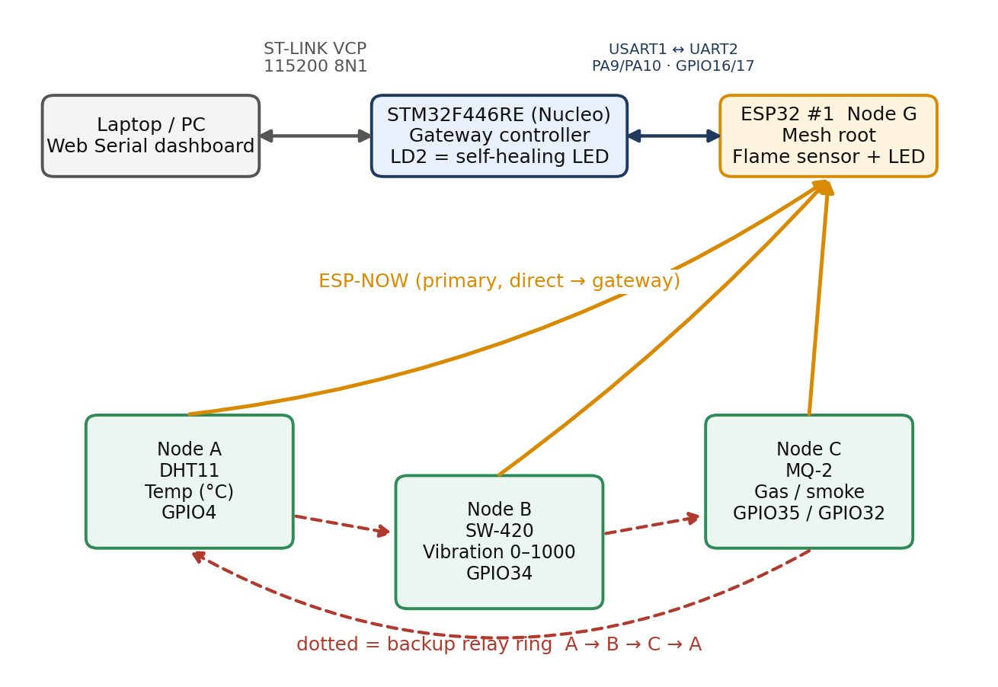
Figure 3.1 – LUMEN CORE system architecture
Solid arrows are wired UART links; amber arrows are the primary ESP-NOW paths from each node to the gateway; dotted red arrows form the backup relay ring A → B → C → A. A ring was chosen instead of a full mesh because one backup neighbour per node keeps the peer list short and the MAC-address bookkeeping manageable, while still giving every node a second path.

3.2 Hardware Architecture

Gateway (Node G, ESP32 #1, MAC D4:E9:F4:A3:F1:5C)
- UART2 on GPIO17 (TX) and GPIO16 (RX), 115200 baud, connected to the STM32 USART1 (PA10 RX, PA9 TX) with common ground.
- Flame sensor digital output on GPIO34 (input only); indicator LED on GPIO5 through a 220 Ω resistor.
- Receives ESP-NOW packets from all nodes; powered from its own USB port.

Node A – Temperature (DHT11)
- DHT11 data line on GPIO4 with a pull-up (internal pull-up enabled in firmware; 10 kΩ external pull-up specified in the build guide).
- On-board LED on GPIO2 indicates relay mode. Backup neighbour: Node B (MAC D4:E9:F4:A4:35:70).

Node B – Vibration (SW-420)
- SW-420 digital output on GPIO34; on-board LED on GPIO2 indicates relay mode. Backup neighbour: Node C.
- Node B also forwards Node A’s relayed packets to the gateway, because A uses B as its backup.

Node C – Gas / Smoke (MQ-2)
- MQ-2 digital output on GPIO35 or analogue output on ADC GPIO32. Backup neighbour: Node A.

STM32F446RE (Nucleo-64) gateway controller
- USART1 on PA9/PA10 at 115200-8-N-1 for the ESP32 gateway; USART2 (PA2/PA3) is the ST-LINK virtual COM port to the PC; LD2 on PA5 is the self-healing indicator.
- System clock: HSI with PLL (M = 16, N = 336, P = 4) giving an 84 MHz SYSCLK; APB1 = 42 MHz, APB2 = 84 MHz.
Power note. All sensor modules are powered from the ESP32 3.3 V pin and not from 5 V. ESP32 GPIO pins are not 5 V tolerant, and a 5 V comparator output (SW-420, MQ-2) would otherwise drive 5 V straight into a 3.3 V input; at 3.3 V only a little sensitivity is lost.

3.3 Communication Protocol and Packet Format
All boards use the ESP32 in station mode but not connected to any access point, so the radio channel stays fixed and ESP-NOW peers can exchange frames without association. Wi-Fi power-save is disabled (PM_NONE) on every board so that packets are not missed. Every packet is a short ASCII line:
N<id>,<seq>,<value>,<route>
Table 3.1 – Packet fields
Field | Example | Meaning
N<id> | NA, NB, NC, NG | Letter N followed by node identifier A, B, C or G
<seq> | 41 | Running sequence number of that node’s packets
<value> | 27 / 412 / 0 | Sensor reading: °C (A), vibration level 0–1000 (B), gas value (C), flame 0/1 (G)
<route> | D or R | D = sent directly to the gateway; R = sent through the backup neighbour (self-healing active)

The gateway accepts a line only if it has exactly four comma-separated fields, the tag is “N” followed by A, B or C, the route is D or R, and the sequence and value parse as numbers. Anything else – the PROBE frame, noise or foreign traffic – is silently dropped. The gateway’s own reading is emitted directly in the same format with identifier G and route D.

3.4 Self-Healing Mechanism
Self-healing is performed independently by each sensor node using a sliding window of delivery results; no central coordinator is involved.
Table 3.2 – Self-healing parameters (as implemented)
Parameter | Value | Role
WINDOW | 10 | Number of most recent send results kept
THRESHOLD | 0.7 | Reroute when PDR falls below this value
Minimum samples | 5 | Window must hold at least 5 results before a decision
Send mode | ESP-NOW with ack | e.send(target, packet, True) returns True only if acknowledged
Backup target | NEIGHBOR_MAC | Next node in the ring A → B → C → A
Probe | b"PROBE" to gateway | Sent each cycle while relaying; one acked probe restores direct mode

1. Measure. Every send returns an acknowledgement flag; the node appends it to the window and computes PDR = successes / window length.
2. Decide. If the node is in direct mode, PDR < 0.7 and at least five samples exist, it sets use_relay = True.
3. Reroute. Packets are now sent to the neighbour, tagged R; the neighbour’s receive callback forwards them to the gateway with an acknowledged send.
4. Recover. While relaying, the node sends a PROBE straight to the gateway after each report. The first acknowledged probe sets use_relay = False and resets the window to [True], so a minimum of five fresh samples is needed before another reroute can be triggered (hysteresis).

3.5 Sensor Processing

SW-420 vibration level (Node B)
The SW-420 is a spring-type switch with a comparator, so its output is digital. To obtain a graded value the firmware watches the pin for a 500 ms report window, sampling every 1 ms, and computes two measures:
- active_pm = active samples × 1000 / total samples, the fraction of the window for which the pin differed from its rest level.
- chatter = min(1000, changes × 1000 / 25), where changes is the number of level transitions; 25 changes per 0.5 s (50 per second) is treated as full-scale shaking.
The level is level = (6 × chatter + 4 × active_pm) / 10, then max(level, active_pm) so that a switch held on counts fully, then capped at 1000. A single noise glitch (fewer than 2 changes and active_pm below 20) is forced to 0. The rest level is learned in the first second after power-on and is re-learned automatically if the pin stays at the opposite level for more than 5 s.

DHT11 temperature (Node A)
The DHT11 is read with interrupts disabled during the measurement because its single-wire protocol has tight timing. Up to five attempts are made, with a two-second wait between failures; if all fail the value −1 is reported, which makes a sensor failure visible rather than silent.

Flame (Gateway)
The flame module output is active-low (DO goes low when flame is detected), so the firmware reports 1 when the pin reads 0. The gateway reports this value every 2 s.

MQ-2 gas / smoke (Node C)
The MQ-2 digital output (GPIO35) or analogue output (ADC on GPIO32) is read each cycle and transmitted in the same packet format. Node C uses the same program structure as nodes A and B, differing only in the sensor-read function and the backup-neighbour MAC.

3.6 STM32 Gateway Controller
The STM32 receives the gateway’s UART stream one byte at a time using interrupt-driven reception (HAL_UART_Receive_IT). Bytes are assembled into a line buffer of 64 bytes; on a newline (or buffer full) the line is terminated and transmitted unchanged to the PC through USART2, followed by CR-LF. If the line contains the character ‘R’ the on-board LED LD2 (PA5) is switched on, otherwise it is switched off. Because node identifiers are only A, B, C and G, the character ‘R’ can appear only in the route field.

3.7 Dashboard Architecture
The dashboard is a single HTML/CSS/JavaScript page that uses the browser’s Web Serial API (Chrome or Edge) to open the Nucleo’s ST-LINK COM port at 115200 baud. A read loop decodes the stream, splits it on newlines and parses each line into node, sequence, value and route. For each node it keeps the last value, route, last-seen time, packet count and a 30-point history used for a sparkline. A node is shown as offline if nothing is received for 12 s. A topology diagram colours each spoke green (direct), amber and dashed (relay) or grey (no data), and the page also reports total packets, nodes online out of four, the number of self-healing events (direct-to-relay transitions) and session time.

CHAPTER-4
LITERATURE SURVEY

4.1 Industry 4.0 and the Industrial Internet of Things
Lee, Bagheri and Kao (2015) proposed a cyber-physical systems architecture for Industry 4.0 manufacturing in which a connection level of smart sensors feeds higher levels of conversion, cyber, cognition and configuration. The sensing-and-transmission tier of LUMEN CORE corresponds to this connection level. Al-Fuqaha et al. (2015) surveyed the enabling technologies, protocols and applications of the Internet of Things and identified reliability and interoperability of low-power links as recurring design concerns. Zanella et al. (2014) analysed IoT system architectures and the technologies available for urban and industrial deployments, motivating the layered node–gateway–application structure adopted here.

4.2 Wireless Sensor Networks in Industrial Environments
Akyildiz et al. (2002) gave an early comprehensive survey of wireless sensor networks, covering topology, communication architecture and fault tolerance as core design factors. Willig, Matheus and Wolisz (2005) examined wireless technologies in industrial networks and highlighted that radio links in plants suffer from fading, interference and obstruction, making reliability a first-order requirement. Gungor and Hancke (2009) reviewed industrial wireless sensor networks and discussed harsh-environment channel behaviour, reliability and the need for resilience mechanisms. These works motivate a node that monitors its own link quality instead of assuming a fixed reliable path.

4.3 Routing and Self-Healing
Perkins and Royer (1999) introduced ad-hoc on-demand distance-vector (AODV) routing, in which routes are discovered when needed and repaired after link breaks. Full routing protocols require routing tables and control traffic that are heavy for very small nodes. LUMEN CORE adopts the underlying idea – detect a broken or weak path and use an alternative – in a deliberately minimal form: a fixed backup neighbour per node, a ten-sample delivery window, and a single probe packet for recovery.

4.4 ESP-NOW, MicroPython and STM32 HAL
ESP-NOW is a connectionless protocol from Espressif that lets ESP32 devices exchange short frames (up to 250 bytes) directly over the 2.4 GHz radio without an access point, with a link-layer acknowledgement indicating delivery to the peer (Espressif, 2024). MicroPython provides an ESP-NOW module and a Python runtime that allow rapid development of such firmware on the ESP32 (George, 2024). On the controller side, the STM32 HAL library offers interrupt-driven UART reception, and the STM32F446 reference manual and Nucleo-64 user manual describe the USART peripherals and the ST-LINK virtual COM port used in this project (STMicroelectronics, 2021a, 2021b).

4.5 Browser-Based Monitoring
The Web Serial API allows a web page, with user permission, to communicate with serial devices from Chrome or Edge (WICG, 2024). This removes the need for a separate desktop program or a PC-side script, and has been used here so that the dashboard opens the ST-LINK COM port directly.

4.6 Research Gap Addressed
Existing work covers industrial sensor networks and general routing protocols, and many hobby ESP-NOW examples use fixed star links. Fewer demonstrations combine (i) router-free ESP-NOW communication, (ii) a lightweight per-node, locally decided reroute and recovery mechanism, (iii) a hardware STM32 gateway controller that independently flags relayed traffic, and (iv) a browser dashboard that exposes every reroute. LUMEN CORE addresses this combination with inexpensive, widely available components.

CHAPTER-5
IMPLEMENTATION

5.1 System Overview
The implementation comprises MicroPython firmware for four ESP32 boards, HAL C firmware for the STM32F446RE and a single-page dashboard. All four ESP32 boards run the same generic MicroPython image; only main.py differs. The build proceeds in five independently testable steps: flash MicroPython, program the STM32, load the mesh firmware, run the dashboard, and perform fault injection.

5.2 Step 1 – Flashing MicroPython and Recording MAC Addresses
MicroPython is flashed with Thonny (which bundles esptool): the flash is erased and the generic ESP32 image written to each board in turn. After flashing, the REPL prompt is confirmed and “import espnow” is checked to raise no error. The MAC address of every board is printed and recorded, because ESP-NOW peers are identified by MAC address:
import network; sta = network.WLAN(network.STA_IF); sta.active(True); print(sta.config('mac'))
Table 5.1 – Board roles and MAC addresses
Board | Role | MAC address | Backup neighbour
Node G | Gateway / mesh root | D4:E9:F4:A3:F1:5C | —
Node A | DHT11 temperature | recorded in Step 1 | Node B
Node B | SW-420 vibration | D4:E9:F4:A4:35:70 | Node C
Node C | MQ-2 gas / smoke | recorded in Step 1 | Node A

5.3 Gateway Firmware (Node G)
- Activates station mode, disconnects from any network, disables power-save, and prints the board MAC; a warning is printed if it is not the expected gateway MAC so that nodes configured with the wrong GATEWAY_MAC are noticed.
- Opens UART2 (GPIO17 TX, GPIO16 RX) at 115200 baud. The gateway only receives, so the nodes need not be registered as peers.
- The main loop waits up to 100 ms for an ESP-NOW frame, decodes it, validates it with the format check of Section 3.3 and, if valid, emits the line to UART with a trailing newline (the STM32 splits on ‘\n’) and to the USB console.
- Every 2 s it reads the flame sensor (active-low) and emits its own “NG,<seq>,<0|1>,D” line.
- The indicator LED on GPIO5 stays on for 8 s after the last valid relayed packet (route R) so that a self-healing event remains visible even though relayed packets arrive only occasionally.

5.4 Node A Firmware – DHT11 Temperature
- Registers the gateway and Node B as peers; the DHT11 is on GPIO4 with the internal pull-up enabled.
- read_sensor() disables interrupts around sensor.measure(), retries up to five times, and returns −1 if every attempt fails.
- Each cycle builds the packet “NA,<seq>,<temp>,<D|R>”, sends it to the gateway (or to Node B in relay mode), records the acknowledgement, and applies the self-healing rule of Section 3.4. The cycle repeats after a 3 s delay.
- An interrupt-driven receive callback forwards to the gateway any frame arriving from its neighbour, so A also acts as a relay for the node that uses A as its backup (Node C).

5.5 Node B Firmware – SW-420 Vibration
- Learns the switch rest level during the first second, then every 500 ms runs read_sensor(), which samples the pin every millisecond and returns the 0–1000 level described in Section 3.5.
- Reports once per 0.5 s, so the dashboard reacts quickly to knocks; the read time itself provides the reporting delay.
- The self-healing logic is identical to Node A, with the main loop wrapped in try/except so that a transient error never stops the node; send failures are caught as OSError and counted as lost packets.
- The receive callback forwards to the gateway any frame that begins with ‘N’ and did not come from the gateway, which is how Node A’s relayed packets are carried (A’s backup is B).
- The NEIGHBOR_MAC constant is a placeholder (CC:CC:CC:CC:CC:CC) in the supplied listing and must be replaced with Node C’s MAC address once it is known.

5.6 Node C Firmware – MQ-2 Gas / Smoke
Node C follows the same template as Nodes A and B. The only differences are the sensor-read function – Pin(35).value() for the digital output or ADC(Pin(32)).read() for the analogue output – the node identifier “C”, and the backup neighbour, which is Node A.

5.7 STM32 Firmware
- The project was created in STM32CubeIDE with USART1 and USART2 at 115200-8-N-1, GPIOA clocks enabled and PA5 (LD2) as push-pull output; all application code lives inside the USER CODE markers so regenerating the project does not erase it.
- In USER CODE 2, HAL_UART_Receive_IT(&huart1, &rxByte, 1) arms reception of the first byte.
- HAL_UART_RxCpltCallback assembles bytes into lineBuf; on newline it mirrors the line to USART2, sets LD2 if the line contains ‘R’ (otherwise clears it), resets the index and re-arms reception for the next byte.

5.8 Dashboard Implementation
Table 5.2 – Dashboard components
Component | Function
Connection bar | Connect / Disconnect buttons and a status pill (Live, Not connected, error messages such as “Web Serial not supported”)
Statistics tiles | Packets received, nodes online (out of 4), self-healing events, session time
Mesh topology | SVG diagram PC → STM32 → Gateway with one spoke per node; colour and dash style show direct, relay or no data
Node cards | Latest value, route badge (direct / relay · self-healing / offline), packet number, time and a 30-point sparkline for each of NG, NA, NB and NC
Live packet log | Most recent 60 lines with time, node, sequence, value and route

A self-healing event is counted whenever a node that was last seen on route D is next seen on route R. A node is marked offline when no packet has arrived for 12 s, which comfortably exceeds the slowest reporting interval (Node A, about 3 s).
Figure 5.1 – Insert photograph of the assembled prototype (4 × ESP32, Nucleo, sensors)

CHAPTER-6
FLOWCHART / ALGORITHM

6.1 Sensor-Node Flowchart
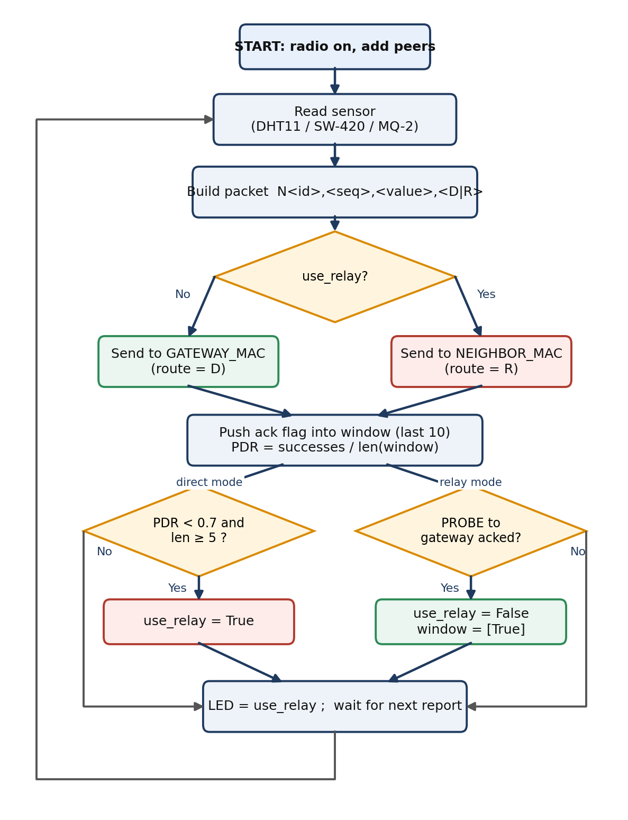
Figure 6.1 – Flowchart of a sensor node with self-healing

6.2 Algorithms

Algorithm 1 – Sensor node (A, B, C)
1. Activate Wi-Fi in station mode, disconnect, disable power-save; activate ESP-NOW.
2. Add GATEWAY_MAC and NEIGHBOR_MAC as peers; set window = [ ], use_relay = False, seq = 0.
3. Register the receive interrupt: forward any neighbour frame to the gateway.
4. Loop: seq = seq + 1; value = read_sensor().
5. route = “R” if use_relay else “D”; packet = “N<id>,<seq>,<value>,<route>”.
6. target = NEIGHBOR_MAC if use_relay else GATEWAY_MAC; ok = send(target, packet) with acknowledgement.
7. Append ok to window; if the window exceeds 10 entries remove the oldest; pdr = sum(window) / len(window).
8. If not use_relay and pdr < 0.7 and len(window) ≥ 5: set use_relay = True.
9. Else if use_relay and send(GATEWAY_MAC, “PROBE”) is acknowledged: set use_relay = False and window = [True].
10. LED = use_relay; wait for the next report period and go to step 4.

Algorithm 2 – SW-420 vibration level (Node B)
1. Over a 500 ms window sample the pin every 1 ms; count transitions (changes) and samples differing from the rest level IDLE (active).
2. If the pin has held a level other than IDLE for more than 5 s, set IDLE to that level.
3. active_pm = active × 1000 / samples; chatter = min(1000, changes × 1000 / 25).
4. level = (6 × chatter + 4 × active_pm) / 10; level = max(level, active_pm); level = min(level, 1000).
5. If changes < 2 and active_pm < 20, set level = 0; return level.

Algorithm 3 – Gateway (Node G)
1. Set up the radio, ESP-NOW and UART2; set last_report so the first flame report is immediate.
2. Wait up to 100 ms for a frame; decode it as text.
3. If the text matches N<A|B|C>,<int>,<number>,<D|R>: write it to UART; if it ends with “,R” record the time as last_relay.
4. Every 2 s increment seq and emit “NG,<seq>,<flame>,D”.
5. LED = 1 while time since last_relay is below 8 s, otherwise 0; repeat from step 2.

Algorithm 4 – STM32 receive callback
1. On each received byte on USART1: if it is ‘\n’ or the buffer is full, terminate the string; otherwise store the byte.
2. On line end: transmit the line and CR-LF to USART2 (PC).
3. If the line contains ‘R’ set PA5 (LD2), else reset PA5; reset the index.
4. Re-arm HAL_UART_Receive_IT for the next byte.

Algorithm 5 – Dashboard line handling
1. Accumulate decoded serial text; split on newline and keep the incomplete remainder.
2. Split each line on commas; ignore it unless it has exactly four fields and a known node tag (NA, NB, NC, NG).
3. If the node was last seen on D and this line says R, increment the self-healing event counter.
4. Update value, route, last-seen, packet count and history; append a log row; refresh the card, spoke colour and statistics.

6.3 SOFTWARE AND HARDWARE USED:

Hardware
No. | Component | Qty | Use
1 | ESP32 development board | 4 | Gateway (G) and sensor nodes A, B, C
2 | STM32 Nucleo-F446RE (Nucleo-64) | 1 | Gateway controller, ST-LINK VCP to PC
3 | DHT11 temperature / humidity sensor | 1 | Node A (GPIO4, pull-up)
4 | SW-420 vibration sensor module | 1 | Node B (GPIO34)
5 | MQ-2 gas / smoke sensor module | 1 | Node C (GPIO35 / GPIO32)
6 | IR flame sensor module | 1 | Gateway (GPIO34)
7 | LED, 220 Ω resistor, 10 kΩ resistor | as needed | Gateway indicator, DHT11 pull-up
8 | USB cables, jumper wires, breadboards, laptop | as needed | Power, wiring, dashboard host

Software
- MicroPython generic ESP32 firmware image; Thonny IDE and esptool for flashing and file upload.
- STM32CubeIDE with the STM32 HAL library (C).
- Dashboard: HTML, CSS and JavaScript using the Web Serial API (Google Chrome or Microsoft Edge).

Pin Reference
Signal | STM32F446RE (Nucleo) | ESP32 #1 – Gateway
UART TX / RX | USART1 TX PA9 → GPIO16 (RX2); RX PA10 ← GPIO17 (TX2) | UART2 TX GPIO17, RX GPIO16
Ground | Common with gateway GND | Common with STM32 GND
Indicator | LD2 on PA5 (self-healing) | LED on GPIO5 + 220 Ω to GND
PC link | USART2 PA2/PA3 via ST-LINK VCP | Flame DO on GPIO34

6.3.1 ESP32 WROOM
ESP32-WROOM-32 Development Board is a low-cost, feature-packed wireless microcontroller platform built for Internet of Things (IoT), automation, and embedded projects.

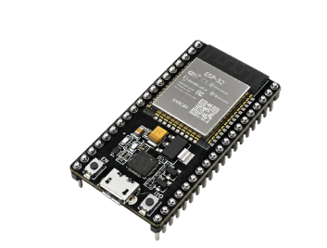
Figure 6.1: ESP32 development board

STM32 NUCLEO-F446RE (STM32F446RE)
A low-cost 32-bit ARM Cortex-M4 development board with a floating-point unit. It reads the sensors, runs the anomaly model and drives the alarm. The on-board ST-LINK gives USB power, programming and a virtual COM port, so no separate communication module is required.
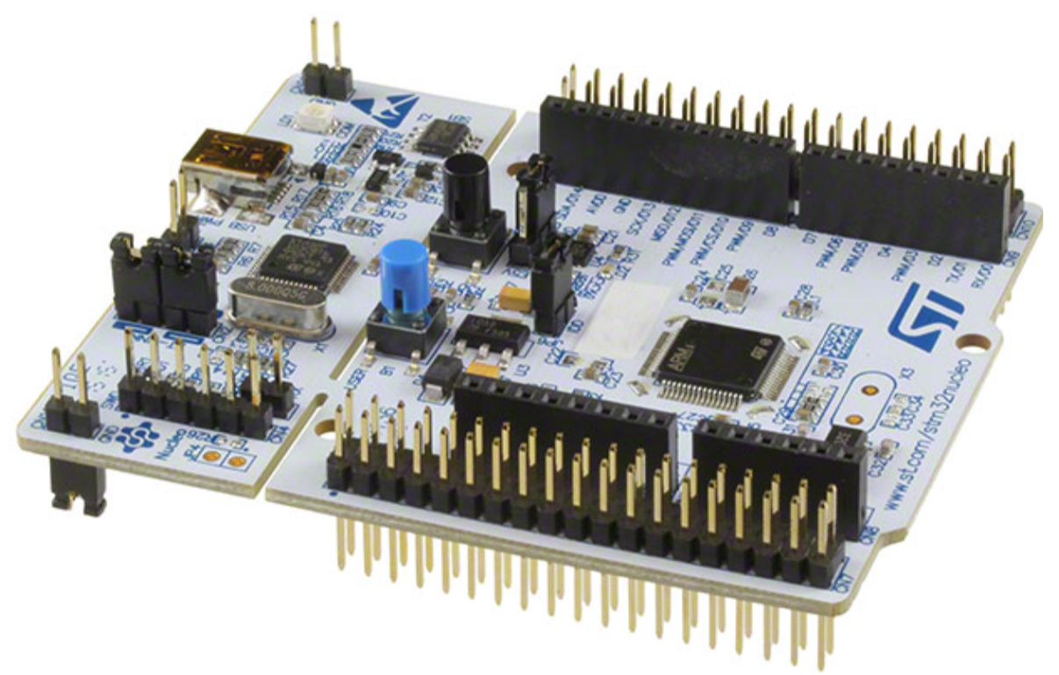
Figure 6.2: STM32 NUCLEO-F446RE development board

DHT11 Temperature and Humidity Sensor
A digital sensor that provides temperature and relative humidity through a single data wire. It is inexpensive and easy to interface, and its limited accuracy is acceptable for a prototype.
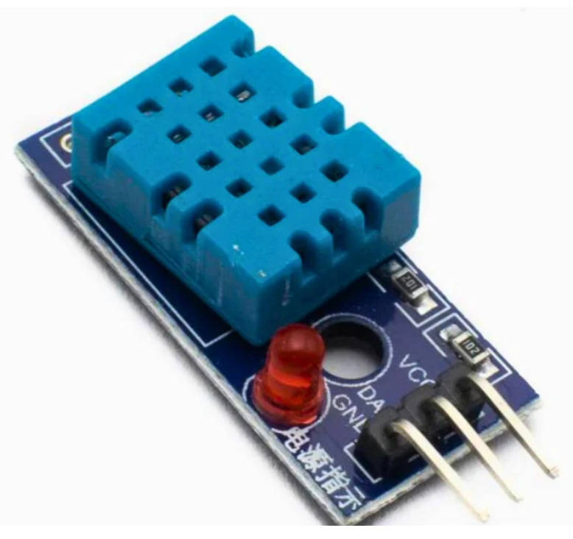
Figure 6.3: DHT11 temperature and humidity sensor module

SW-420 Vibration Sensor
A vibration switch module with a digital output and an adjustable sensitivity. It reports whether vibration above the set level has occurred.
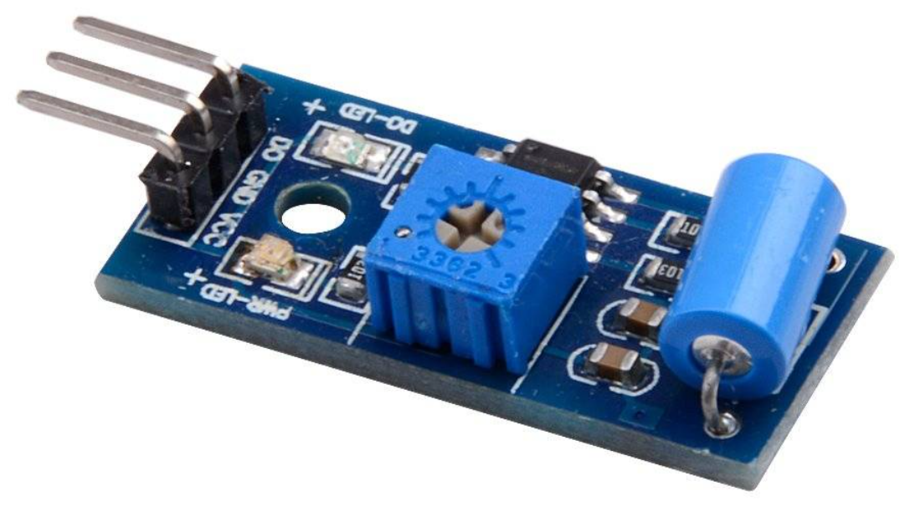
Figure 6.4: SW-420 vibration sensor module

MQ-2 GAS SENSOR

The MQ-2 gas sensor is a metal oxide semiconductor (MOS) device used to detect combustible gases, LPG, propane, methane, hydrogen, alcohol, and smoke
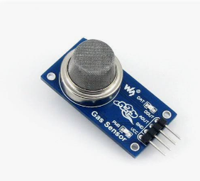

Figure 6.5: MQ-2 gas sensor

Breadboard, Jumper Wires, USB Cable and Power Supply
These connect the components. The USB cable powers the board and carries the serial data to the PC. Good-quality wires and a stable supply prevent loose contacts and voltage problems.
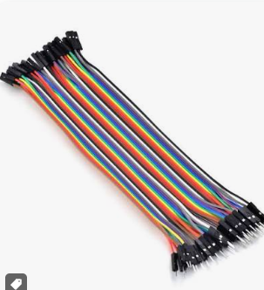
Figure 6.6: jumper wires

6.4 SOURCE CODE

Node A – DHT11 temperature (MicroPython, main.py)

import network, espnow, time
from machine import Pin
import dht
import machine

sta = network.WLAN(network.STA_IF)
sta.active(True)
sta.disconnect()
try:
sta.config(pm=network.WLAN.PM_NONE) # no Wi-Fi power-save (also helps DHT timing)
except Exception:
pass
print("This board MAC:", ":".join("{:02X}".format(b) for b in sta.config('mac')))

e = espnow.ESPNow()
e.active(True)

NODE_ID = "A"
GATEWAY_MAC = b'\xd4\xe9\xf4\xa3\xf1\x5c' # Node G D4:E9:F4:A3:F1:5C
NEIGHBOR_MAC = b'\xd4\xe9\xf4\xa4\x35\x70' # Node B D4:E9:F4:A4:35:70 (relay)
e.add_peer(GATEWAY_MAC)
e.add_peer(NEIGHBOR_MAC)

led = Pin(2, Pin.OUT)
Pin(4, Pin.IN, Pin.PULL_UP)
sensor = dht.DHT11(Pin(4))

# ---------------- relay switch: BOOT button (GPIO0) ----------------
btn = Pin(0, Pin.IN, Pin.PULL_UP)
fault = False
last_btn = time.ticks_ms()

def on_btn(p):
global fault, last_btn
now = time.ticks_ms()
if time.ticks_diff(now, last_btn) > 300: # debounce
last_btn = now
fault = not fault
btn.irq(trigger=Pin.IRQ_FALLING, handler=on_btn)
# --------------------------------------------------------------------

def send_to(mac, data):
try:
return e.send(mac, data, True)
except OSError:
return False

def send_gw(data):
"""Own direct send to the gateway; blocked while the demo fault is ON."""
if fault:
return False
return send_to(GATEWAY_MAC, data)

# Forward packets from other nodes (B or C) to the gateway.
# (The fault only breaks this node's OWN link, so forwarding keeps working.)
def on_recv(e):
for host, msg in e:
if msg and host != GATEWAY_MAC and msg[:1] == b'N':
try:
e.send(GATEWAY_MAC, msg, True)
except OSError:
pass
e.irq(on_recv)

WINDOW, THRESHOLD = 10, 0.7
window = [] # recent results of the DIRECT link to the gateway
use_relay = False
REPORT_S = 2

def pdr_ratio():
return sum(window) / len(window) if window else 1.0

def record(ok):
window.append(ok)
if len(window) > WINDOW:
window.pop(0)

def read_sensor():
for attempt in range(5):
state = machine.disable_irq()
try:
sensor.measure()
machine.enable_irq(state)
return sensor.temperature()
except OSError:
machine.enable_irq(state)
time.sleep(2)
return -1

seq = 0
shown_fault = False
while True:
try:
if fault != shown_fault:
shown_fault = fault
print(">>> FAULT", "ON (direct link to gateway broken)" if fault else "OFF (direct link restored)")

seq += 1
val = read_sensor()
route = "R" if use_relay else "D"
pdr = int(pdr_ratio() * 100)
packet = "N{},{},{},{},{}".format(NODE_ID, seq, val, route, pdr).encode()

if use_relay:
ok = send_to(NEIGHBOR_MAC, packet) # data goes through the neighbour
if send_gw(b'PROBE'): # is the direct link back?
use_relay = False
window[:] = [True]
else:
record(False) # direct link still bad
else:
ok = send_gw(packet)
record(ok)
if len(window) >= 5 and pdr_ratio() < THRESHOLD:
use_relay = True

print("Sent:", packet, "-> ack:", ok, " PDR:", int(pdr_ratio() * 100), "% mode:", "RELAY" if use_relay else "DIRECT")
led.value(1 if use_relay else 0)
time.sleep(REPORT_S)
except Exception as err:
print("loop error:", err) # never let the main loop die
time.sleep(1)

Node B – SW-420 vibration (MicroPython, main.py)

import network, espnow, time
from machine import Pin

sta = network.WLAN(network.STA_IF)
sta.active(True)
sta.disconnect()
try:
sta.config(pm=network.WLAN.PM_NONE) # no Wi-Fi power-save
except Exception:
pass
print("This board MAC:", ":".join("{:02X}".format(b) for b in sta.config('mac'))) # D4:E9:F4:A4:35:70

e = espnow.ESPNow()
e.active(True)

NODE_ID = "B"
GATEWAY_MAC = b'\xd4\xe9\xf4\xa3\xf1\x5c' # Node G D4:E9:F4:A3:F1:5C
NEIGHBOR_MAC = b'\xd4\xe9\xf4\xe2\xa4\x5c' # Node C D4:E9:F4:E2:A4:5C (relay)
e.add_peer(GATEWAY_MAC)
e.add_peer(NEIGHBOR_MAC)

led = Pin(2, Pin.OUT)

# ---------------- relay switch: BOOT button (GPIO0) ----------------
btn = Pin(0, Pin.IN, Pin.PULL_UP)
fault = False
last_btn = time.ticks_ms()

def on_btn(p):
global fault, last_btn
now = time.ticks_ms()
if time.ticks_diff(now, last_btn) > 300: # debounce
last_btn = now
fault = not fault
btn.irq(trigger=Pin.IRQ_FALLING, handler=on_btn)
# --------------------------------------------------------------------

def send_to(mac, data):
try:
return e.send(mac, data, True)
except OSError:
return False

def send_gw(data):
"""Own direct send to the gateway; blocked while the demo fault is ON."""
if fault:
return False
return send_to(GATEWAY_MAC, data)

# ---------------- SW-420 on GPIO34 ----------------
vib = Pin(34, Pin.IN)

REPORT_MS = 500 # one report every 0.5 s -> dashboard reacts fast
SAMPLE_MS = 1 # sample the pin every 1 ms (~500 samples per report)
MAX_LEVEL = 1000
FULL_CHATTER_PER_S = 50 # switch changes per second = max level
FULL_CHATTER = FULL_CHATTER_PER_S * REPORT_MS // 1000 # = 25 changes per 0.5 s window
SETTLE_MS = 5000 # pin unchanged this long -> that level is the new "rest" level

# Initial guess of the rest level (keep sensor still for 1 s at power-on)
ones = 0
for _ in range(200):
ones += vib.value()
time.sleep_ms(5)
IDLE = 1 if ones > 100 else 0
last_change = time.ticks_ms()
print("SW-420 rest level:", IDLE)

def read_sensor():
"""Watch the pin for REPORT_MS and return a vibration level 0..1000.
0 = still
1..200 = light tap / small vibration
200..600 = medium knocking
600..1000 = strong / continuous shaking"""
global IDLE, last_change
changes = 0
active = 0
samples = 0
last = vib.value()
start = time.ticks_ms()
while time.ticks_diff(time.ticks_ms(), start) < REPORT_MS:
v = vib.value()
now = time.ticks_ms()
if v != last:
changes += 1
last = v
last_change = now
elif time.ticks_diff(now, last_change) > SETTLE_MS and v != IDLE:
IDLE = v # self-correct the rest level
print(" rest level re-learned:", IDLE)
if v != IDLE:
active += 1
samples += 1
time.sleep_ms(SAMPLE_MS)

active_pm = active * MAX_LEVEL // samples
chatter = min(MAX_LEVEL, changes * MAX_LEVEL // FULL_CHATTER)
level = (chatter * 6 + active_pm * 4) // 10 # blend: chatter weighted more
level = max(level, active_pm) # held-on switch still counts fully
if level > MAX_LEVEL:
level = MAX_LEVEL
if changes < 2 and active_pm < 20: # ignore a single noise glitch
level = 0
print(" changes:", changes, " active:", active_pm, "/1000 chatter:", chatter, " -> level:", level)
return level
# --------------------------------------------------

# Forward packets from other nodes (A or C) to the gateway.
# (The fault only breaks this node's OWN link, so forwarding keeps working.)
def on_recv(e):
for host, msg in e:
if msg and host != GATEWAY_MAC and msg[:1] == b'N':
try:
e.send(GATEWAY_MAC, msg, True)
except OSError:
pass
e.irq(on_recv)

WINDOW, THRESHOLD = 10, 0.7
window = [] # recent results of the DIRECT link to the gateway
use_relay = False

def pdr_ratio():
return sum(window) / len(window) if window else 1.0

def record(ok):
window.append(ok)
if len(window) > WINDOW:
window.pop(0)

seq = 0
shown_fault = False
while True:
try:
if fault != shown_fault:
shown_fault = fault
print(">>> FAULT", "ON (direct link to gateway broken)" if fault else "OFF (direct link restored)")

seq += 1
val = read_sensor() # takes 0.5 s - this is also the report delay
route = "R" if use_relay else "D"
pdr = int(pdr_ratio() * 100)
packet = "N{},{},{},{},{}".format(NODE_ID, seq, val, route, pdr).encode()

if use_relay:
ok = send_to(NEIGHBOR_MAC, packet) # data goes through the neighbour
if send_gw(b'PROBE'): # is the direct link back?
use_relay = False
window[:] = [True]
else:
record(False) # direct link still bad
else:
ok = send_gw(packet)
record(ok)
if len(window) >= 5 and pdr_ratio() < THRESHOLD:
use_relay = True

print("Sent:", packet, "-> ack:", ok, " PDR:", int(pdr_ratio() * 100), "% mode:", "RELAY" if use_relay else "DIRECT")
led.value(1 if use_relay else 0)
except Exception as err:
print("loop error:", err) # never let the main loop die
time.sleep(1)

NODE C

import network, espnow, time
from machine import Pin, ADC

# ---------------- radio: station mode, not connected to any AP ----------------
sta = network.WLAN(network.STA_IF)
sta.active(True)
sta.disconnect()
try:
sta.config(pm=network.WLAN.PM_NONE) # no Wi-Fi power-save: don't miss packets
except Exception:
pass
print("This board MAC:", ":".join("{:02X}".format(b) for b in sta.config('mac'))) # D4:E9:F4:E2:A4:5C

e = espnow.ESPNow()
e.active(True)

NODE_ID = "C"
GATEWAY_MAC = b'\xd4\xe9\xf4\xa3\xf1\x5c' # Node G D4:E9:F4:A3:F1:5C
NEIGHBOR_MAC = b'\xd4\xe9\xf4\xa4\x35\x70' # Node B D4:E9:F4:A4:35:70 (relay)
e.add_peer(GATEWAY_MAC)
e.add_peer(NEIGHBOR_MAC)

led = Pin(2, Pin.OUT)
led.value(0)

# ---------------- relay switch: BOOT button (GPIO0) ----------------
btn = Pin(0, Pin.IN, Pin.PULL_UP)
fault = False
last_btn = time.ticks_ms()

def on_btn(p):
global fault, last_btn
now = time.ticks_ms()
if time.ticks_diff(now, last_btn) > 300: # debounce
last_btn = now
fault = not fault
btn.irq(trigger=Pin.IRQ_FALLING, handler=on_btn)
# --------------------------------------------------------------------

def send_to(mac, data):
try:
return e.send(mac, data, True)
except OSError:
return False

def send_gw(data):
"""Own direct send to the gateway; blocked while the demo fault is ON."""
if fault:
return False
return send_to(GATEWAY_MAC, data)

# Forward packets from other nodes (A or B) to the gateway.
# (The fault only breaks this node's OWN link, so forwarding keeps working.)
def on_recv(e):
for host, msg in e:
if msg and host != GATEWAY_MAC and msg[:1] == b'N':
try:
e.send(GATEWAY_MAC, msg, True)
except OSError:
pass
e.irq(on_recv)

# ---------------- MQ-2 on GPIO32 (analog) / GPIO35 (digital) ----------------
adc = ADC(Pin(32))
adc.atten(ADC.ATTN_11DB) # full 0..3.3 V range
try:
adc.width(ADC.WIDTH_12BIT) # 0..4095
except Exception:
pass
gas_do = Pin(35, Pin.IN) # LOW = gas above the module's potentiometer threshold

SAMPLES = 32
MAX_LEVEL = 1000
FULL_SCALE_MV = 3300 # level 1000 = 3.3 V at GPIO32
DO_ALARM_LEVEL = 800 # when the module's D0 trips (LOW) the level is at least this
zero_count = 0

def read_mv():
"""One reading in millivolts. read_uv() is factory-calibrated and far better than
read() near 0 V, where the raw ESP32 ADC is dead (reads 0 below ~100 mV)."""
try:
return adc.read_uv() // 1000
except Exception:
return adc.read() * FULL_SCALE_MV // 4095

def read_sensor():
"""Average 32 samples (~160 ms) and scale to a gas level 0..1000."""
global zero_count
total = 0
for _ in range(SAMPLES):
total += read_mv()
time.sleep_ms(5)
mv = total // SAMPLES
level = mv * MAX_LEVEL // FULL_SCALE_MV

do_alarm = (gas_do.value() == 0) # most MQ-2 modules pull D0 LOW on gas
if do_alarm and level < DO_ALARM_LEVEL:
level = DO_ALARM_LEVEL
if level > MAX_LEVEL:
level = MAX_LEVEL

if mv < 5: # pin is at ~0 V: wiring / power problem
zero_count += 1
if zero_count == 5:
print(" !!! A0 reads 0 V - check A0->GPIO32, GND, and MQ-2 VCC")
else:
zero_count = 0

print(" MQ-2 pin:", mv, "mV level:", level, "/1000 DO:", gas_do.value())
return level
# ---------------------------------------------------------------------------

WINDOW, THRESHOLD = 10, 0.7
window = [] # recent results of the DIRECT link to the gateway
use_relay = False
REPORT_S = 2

def pdr_ratio():
return sum(window) / len(window) if window else 1.0

def record(ok):
window.append(ok)
if len(window) > WINDOW:
window.pop(0)

# MQ-2 heater warm-up: discard the first readings (forwarding keeps working via irq).
# A real MQ-2 needs minutes to fully stabilise; this is only a short demo warm-up.
print("MQ-2 warming up...")
for _ in range(5):
adc.read()
time.sleep(1)
print("Node C ready")

seq = 0
shown_fault = False
while True:
try:
if fault != shown_fault:
shown_fault = fault
print(">>> FAULT", "ON (direct link to gateway broken)" if fault else "OFF (direct link restored)")

seq += 1
val = read_sensor()
route = "R" if use_relay else "D"
pdr = int(pdr_ratio() * 100)
packet = "N{},{},{},{},{}".format(NODE_ID, seq, val, route, pdr).encode()

if use_relay:
ok = send_to(NEIGHBOR_MAC, packet) # data goes through the neighbour
if send_gw(b'PROBE'): # is the direct link back?
use_relay = False
window[:] = [True]
else:
record(False) # direct link still bad
else:
ok = send_gw(packet)
record(ok)
if len(window) >= 5 and pdr_ratio() < THRESHOLD:
use_relay = True

print("Sent:", packet, "-> ack:", ok, " PDR:", int(pdr_ratio() * 100), "% mode:", "RELAY" if use_relay else "DIRECT")
led.value(1 if use_relay else 0)
time.sleep(REPORT_S)
except Exception as err:
print("loop error:", err) # never let the main loop die
time.sleep(1)

Gateway – Node G (MicroPython, main.py)

import network, espnow, time
from machine import Pin, UART

# --- Radio: station mode, NOT connected to any AP, so the channel stays fixed
sta = network.WLAN(network.STA_IF)
sta.active(True)
sta.disconnect()
try:
sta.config(pm=network.WLAN.PM_NONE) # no power-save: don't miss packets
except Exception:
pass

MY_MAC = b'\xd4\xe9\xf4\xa3\xf1\x5c' # D4:E9:F4:A3:F1:5C - nodes must use this as GATEWAY_MAC
mac = sta.config('mac')
print("Gateway MAC:", ":".join("{:02X}".format(b) for b in mac))
if mac != MY_MAC:
print("WARNING: this is not the board D4:E9:F4:A3:F1:5C - nodes will not reach it!")

e = espnow.ESPNow()
e.active(True)
# Gateway only receives (and auto-acks), so nodes don't need to be added as peers.

# --- UART2 to STM32
uart = UART(2, baudrate=115200, tx=17, rx=16)

NODE_ID = "G"
REPORT_MS = 2000 # own flame report every 2 s
RELAY_HOLD_MS = 8000 # LED stays on 8 s after the last relayed packet
VALID_IDS = ("A", "B", "C")

flame = Pin(34, Pin.IN) # GPIO34 input-only
led = Pin(5, Pin.OUT)
led.value(0)

def emit(line):
uart.write(line + "\n") # STM32 splits lines on '\n'
print(line)

def valid(text):
"""Accept N<id>,<seq>,<value>,<D|R> or N<id>,<seq>,<value>,<D|R>,<pdr 0..100>."""
parts = text.split(",")
if len(parts) not in (4, 5):
return False
tag, seq, val, route = parts[0], parts[1], parts[2], parts[3]
if len(tag) != 2 or tag[0] != "N" or tag[1] not in VALID_IDS:
return False
if route not in ("D", "R"):
return False
try:
int(seq)
float(val)
if len(parts) == 5:
p = int(parts[4])
if p < 0 or p > 100:
return False
except ValueError:
return False
return True

def read_flame():
# Most flame modules pull DO LOW when flame is detected. Flip if yours is opposite.
return 1 if flame.value() == 0 else 0

seq = 0
last_report = time.ticks_add(time.ticks_ms(), -REPORT_MS)
last_relay = None

while True:
try:
host, msg = e.recv(100) # wait up to 100 ms for a mesh packet
except OSError:
host, msg = None, None

if msg:
try:
text = msg.decode().strip()
except Exception:
text = ""
if valid(text):
emit(text)
if text.split(",")[3] == "R":
last_relay = time.ticks_ms()
# b'PROBE' and noise are dropped

now = time.ticks_ms()

if time.ticks_diff(now, last_report) >= REPORT_MS:
last_report = now
seq += 1
emit("N{},{},{},D".format(NODE_ID, seq, read_flame()))

healing = last_relay is not None and time.ticks_diff(now, last_relay) < RELAY_HOLD_MS
led.value(1 if healing else 0)

STM32F446RE gateway controller (HAL C, USER CODE sections)

stm32 code ;
/* USER CODE BEGIN Header */
/**
******************************************************************************
* @file : main.c
* @brief : Main program body
******************************************************************************
* @attention
*
* Copyright (c) 2026 STMicroelectronics.
* All rights reserved.
*
* This software is licensed under terms that can be found in the LICENSE file
* in the root directory of this software component.
* If no LICENSE file comes with this software, it is provided AS-IS.
*
******************************************************************************
*/
/* USER CODE END Header */
/* Includes ------------------------------------------------------------------*/
#include "main.h"

/* Private includes ----------------------------------------------------------*/
/* USER CODE BEGIN Includes */
#include <string.h>
/* USER CODE END Includes */

/* Private typedef -----------------------------------------------------------*/
/* USER CODE BEGIN PTD */

/* USER CODE END PTD */

/* Private define ------------------------------------------------------------*/
/* USER CODE BEGIN PD */

/* USER CODE END PD */

/* Private macro -------------------------------------------------------------*/
/* USER CODE BEGIN PM */

/* USER CODE END PM */

/* Private variables ---------------------------------------------------------*/
UART_HandleTypeDef huart1;
UART_HandleTypeDef huart2;

/* USER CODE BEGIN PV */
uint8_t rxByte;
#define RX_BUF_LEN 64
char lineBuf[RX_BUF_LEN];
uint8_t lineIdx = 0;

/* USER CODE END PV */

/* Private function prototypes -----------------------------------------------*/
void SystemClock_Config(void);
static void MX_GPIO_Init(void);
static void MX_USART2_UART_Init(void);
static void MX_USART1_UART_Init(void);
/* USER CODE BEGIN PFP */

/* USER CODE END PFP */

/* Private user code ---------------------------------------------------------*/
/* USER CODE BEGIN 0 */

/* USER CODE END 0 */

/**
* @brief The application entry point.
* @retval int
*/
int main(void)
{

/* USER CODE BEGIN 1 */

/* USER CODE END 1 */

/* MCU Configuration--------------------------------------------------------*/

/* Reset of all peripherals, Initializes the Flash interface and the Systick. */
HAL_Init();

/* USER CODE BEGIN Init */

/* USER CODE END Init */

/* Configure the system clock */
SystemClock_Config();

/* USER CODE BEGIN SysInit */

/* USER CODE END SysInit */

/* Initialize all configured peripherals */
MX_GPIO_Init();
MX_USART2_UART_Init();
MX_USART1_UART_Init();
/* USER CODE BEGIN 2 */
HAL_UART_Receive_IT(&huart1, &rxByte, 1); // arm the first byte
/* USER CODE END 2 */

/* Infinite loop */
/* USER CODE BEGIN WHILE */
while (1)
{
/* USER CODE END WHILE */

/* USER CODE BEGIN 3 */
}
/* USER CODE END 3 */
}

/**
* @brief System Clock Configuration
* @retval None
*/
void SystemClock_Config(void)
{
RCC_OscInitTypeDef RCC_OscInitStruct = {0};
RCC_ClkInitTypeDef RCC_ClkInitStruct = {0};

/** Configure the main internal regulator output voltage
*/
__HAL_RCC_PWR_CLK_ENABLE();
__HAL_PWR_VOLTAGESCALING_CONFIG(PWR_REGULATOR_VOLTAGE_SCALE3);

/** Initializes the RCC Oscillators according to the specified parameters
* in the RCC_OscInitTypeDef structure.
*/
RCC_OscInitStruct.OscillatorType = RCC_OSCILLATORTYPE_HSI;
RCC_OscInitStruct.HSIState = RCC_HSI_ON;
RCC_OscInitStruct.HSICalibrationValue = RCC_HSICALIBRATION_DEFAULT;
RCC_OscInitStruct.PLL.PLLState = RCC_PLL_ON;
RCC_OscInitStruct.PLL.PLLSource = RCC_PLLSOURCE_HSI;
RCC_OscInitStruct.PLL.PLLM = 16;
RCC_OscInitStruct.PLL.PLLN = 336;
RCC_OscInitStruct.PLL.PLLP = RCC_PLLP_DIV4;
RCC_OscInitStruct.PLL.PLLQ = 2;
RCC_OscInitStruct.PLL.PLLR = 2;
if (HAL_RCC_OscConfig(&RCC_OscInitStruct) != HAL_OK)
{
Error_Handler();
}

/** Initializes the CPU, AHB and APB buses clocks
*/
RCC_ClkInitStruct.ClockType = RCC_CLOCKTYPE_HCLK|RCC_CLOCKTYPE_SYSCLK
|RCC_CLOCKTYPE_PCLK1|RCC_CLOCKTYPE_PCLK2;
RCC_ClkInitStruct.SYSCLKSource = RCC_SYSCLKSOURCE_PLLCLK;
RCC_ClkInitStruct.AHBCLKDivider = RCC_SYSCLK_DIV1;
RCC_ClkInitStruct.APB1CLKDivider = RCC_HCLK_DIV2;
RCC_ClkInitStruct.APB2CLKDivider = RCC_HCLK_DIV1;

if (HAL_RCC_ClockConfig(&RCC_ClkInitStruct, FLASH_LATENCY_2) != HAL_OK)
{
Error_Handler();
}
}

/**
* @brief USART1 Initialization Function
* @param None
* @retval None
*/
static void MX_USART1_UART_Init(void)
{

/* USER CODE BEGIN USART1_Init 0 */

/* USER CODE END USART1_Init 0 */

/* USER CODE BEGIN USART1_Init 1 */

/* USER CODE END USART1_Init 1 */
huart1.Instance = USART1;
huart1.Init.BaudRate = 115200;
huart1.Init.WordLength = UART_WORDLENGTH_8B;
huart1.Init.StopBits = UART_STOPBITS_1;
huart1.Init.Parity = UART_PARITY_NONE;
huart1.Init.Mode = UART_MODE_TX_RX;
huart1.Init.HwFlowCtl = UART_HWCONTROL_NONE;
huart1.Init.OverSampling = UART_OVERSAMPLING_16;
if (HAL_UART_Init(&huart1) != HAL_OK)
{
Error_Handler();
}
/* USER CODE BEGIN USART1_Init 2 */

/* USER CODE END USART1_Init 2 */

}

/**
* @brief USART2 Initialization Function
* @param None
* @retval None
*/
static void MX_USART2_UART_Init(void)
{

/* USER CODE BEGIN USART2_Init 0 */

/* USER CODE END USART2_Init 0 */

/* USER CODE BEGIN USART2_Init 1 */

/* USER CODE END USART2_Init 1 */
huart2.Instance = USART2;
huart2.Init.BaudRate = 115200;
huart2.Init.WordLength = UART_WORDLENGTH_8B;
huart2.Init.StopBits = UART_STOPBITS_1;
huart2.Init.Parity = UART_PARITY_NONE;
huart2.Init.Mode = UART_MODE_TX_RX;
huart2.Init.HwFlowCtl = UART_HWCONTROL_NONE;
huart2.Init.OverSampling = UART_OVERSAMPLING_16;
if (HAL_UART_Init(&huart2) != HAL_OK)
{
Error_Handler();
}
/* USER CODE BEGIN USART2_Init 2 */

/* USER CODE END USART2_Init 2 */

}

/**
* @brief GPIO Initialization Function
* @param None
* @retval None
*/
static void MX_GPIO_Init(void)
{
GPIO_InitTypeDef GPIO_InitStruct = {0};
/* USER CODE BEGIN MX_GPIO_Init_1 */

/* USER CODE END MX_GPIO_Init_1 */

/* GPIO Ports Clock Enable */
__HAL_RCC_GPIOC_CLK_ENABLE();
__HAL_RCC_GPIOH_CLK_ENABLE();
__HAL_RCC_GPIOA_CLK_ENABLE();
__HAL_RCC_GPIOB_CLK_ENABLE();

/*Configure GPIO pin Output Level */
HAL_GPIO_WritePin(LD2_GPIO_Port, LD2_Pin, GPIO_PIN_RESET);

/*Configure GPIO pin : B1_Pin */
GPIO_InitStruct.Pin = B1_Pin;
GPIO_InitStruct.Mode = GPIO_MODE_IT_FALLING;
GPIO_InitStruct.Pull = GPIO_NOPULL;
HAL_GPIO_Init(B1_GPIO_Port, &GPIO_InitStruct);

/*Configure GPIO pin : LD2_Pin */
GPIO_InitStruct.Pin = LD2_Pin;
GPIO_InitStruct.Mode = GPIO_MODE_OUTPUT_PP;
GPIO_InitStruct.Pull = GPIO_NOPULL;
GPIO_InitStruct.Speed = GPIO_SPEED_FREQ_LOW;
HAL_GPIO_Init(LD2_GPIO_Port, &GPIO_InitStruct);

/* USER CODE BEGIN MX_GPIO_Init_2 */

/* USER CODE END MX_GPIO_Init_2 */
}

/* USER CODE BEGIN 4 */
/* USER CODE BEGIN 4 */
void HAL_UART_RxCpltCallback(UART_HandleTypeDef *huart)
{
if (huart->Instance == USART1)
{
if (rxByte == '\n' || lineIdx >= RX_BUF_LEN - 1)
{
lineBuf[lineIdx] = '\0';

/* Mirror the line to the PC over the ST-LINK VCP (USART2) */
HAL_UART_Transmit(&huart2, (uint8_t*)lineBuf, strlen(lineBuf), 100);
HAL_UART_Transmit(&huart2, (uint8_t*)"\r\n", 2, 10);

/* Packet format: N<id>,<seq>,<value>,<D|R> (R = relaying = self-healing active) */
if (strchr(lineBuf, 'R') != NULL)
HAL_GPIO_WritePin(GPIOA, GPIO_PIN_5, GPIO_PIN_SET);
else
HAL_GPIO_WritePin(GPIOA, GPIO_PIN_5, GPIO_PIN_RESET);

lineIdx = 0;
}
else
{
lineBuf[lineIdx++] = rxByte;
}
HAL_UART_Receive_IT(&huart1, &rxByte, 1);
}
}
/* USER CODE END 4 */
/* USER CODE END 4 */

/**
* @brief This function is executed in case of error occurrence.
* @retval None
*/
void Error_Handler(void)
{
/* USER CODE BEGIN Error_Handler_Debug */
/* User can add his own implementation to report the HAL error return state */
__disable_irq();
while (1)
{
}
/* USER CODE END Error_Handler_Debug */
}
#ifdef USE_FULL_ASSERT
/**
* @brief Reports the name of the source file and the source line number
* where the assert_param error has occurred.
* @param file: pointer to the source file name
* @param line: assert_param error line source number
* @retval None
*/
void assert_failed(uint8_t *file, uint32_t line)
{
/* USER CODE BEGIN 6 */
/* User can add his own implementation to report the file name and line number,
ex: printf("Wrong parameters value: file %s on line %d\r\n", file, line) */
/* USER CODE END 6 */
}
#endif /* USE_FULL_ASSERT */

CHAPTER-7
SIMULATION / RESULT ANALYSIS

7.1 Test Setup
All five boards are powered, the Nucleo is connected to the laptop by USB, and the dashboard is connected to the ST-LINK COM port with every other serial terminal closed. The three sensor nodes are placed within range of the gateway. One node is chosen to be isolated on cue and a plan is prepared to bring it back.

7.2 Fault-Injection Test
Table 7.1 – Test procedure and expected indications
No. | Stage | Action | Expected indication
1 | Baseline | All boards running, links clear | Every node shows “direct”; node LEDs off; LD2 off; 0 self-healing events
2 | Break link | Power off the gateway path of one node, move it out of range, or wrap it in foil | Acknowledgements fail; window PDR falls
3 | Observe | Wait a few reporting cycles | After four consecutive failures PDR < 0.7 and the node switches to relay mode
4 | Confirm | Watch all indicators | Dashboard shows RELAY (amber dashed spoke), node LED on, STM32 LD2 on, event counter +1
5 | Recover | Restore the link | One acknowledged PROBE returns the node to “direct”; LED and LD2 go off

Three independent indicators agree on every reroute: the dashboard status column, the node’s own LED and LD2 on the Nucleo. Agreement between them verifies the whole chain from the node’s decision, through ESP-NOW, the gateway and the UART, to the STM32 and the PC.

7.3 Analysis of Detection and Recovery Time
The timing of the self-healing mechanism follows directly from the firmware parameters. Starting from a full window of ten successful sends, k consecutive failures give PDR = (10 − k) / 10. This stays at 0.7 for k = 3 and drops to 0.6 for k = 4, so the reroute occurs on the fourth consecutive failed send. Recovery needs a single acknowledged PROBE, so the node returns to the direct route within one reporting period of the link being restored.
Table 7.2 – Expected reroute and recovery timing per node
Node | Report period | Reroute after 4 failed sends | Recovery after link restored
A (DHT11) | about 3 s | about 12 s plus ack time-outs | within one cycle (about 3 s)
B (SW-420) | 0.5 s | about 2 s plus ack time-outs | within one cycle (about 0.5 s)
C (MQ-2) | same template | four periods plus ack time-outs | within one cycle

These are values derived from the code and nominal periods; the actual figures depend on the acknowledgement time-out of each failed send and should be confirmed by timing the dashboard during the fault-injection run. Because the window is reset to a single True on recovery and a decision requires at least five samples, a node cannot oscillate between modes faster than every five reports.

7.4 Vibration Level Mapping
Table 7.3 gives worked examples of the SW-420 level formula for typical conditions over one 500 ms window.
Table 7.3 – Worked examples of the vibration level (Node B)
Condition | Changes | active_pm | chatter | Blend | Level
Still | 0 | 0 | 0 | 0 | 0
Single noise glitch | 1 | 5 | 40 | 26 | 0 (filtered)
Light tap | 4 | 40 | 160 | 112 | 112
Medium knocking | 12 | 300 | 480 | 408 | 408
Strong shaking | 25 | 700 | 1000 | 880 | 880
Switch held on | 0 | 1000 | 0 | 400 | 1000 (max rule)

The values fall within the ranges described in the firmware: 1–200 for light taps, 200–600 for medium knocking and 600–1000 for strong or continuous shaking.

7.5 Measured Results
The dashboard screenshots and serial logs captured during the baseline, fault and recovery stages of the test are to be inserted here.
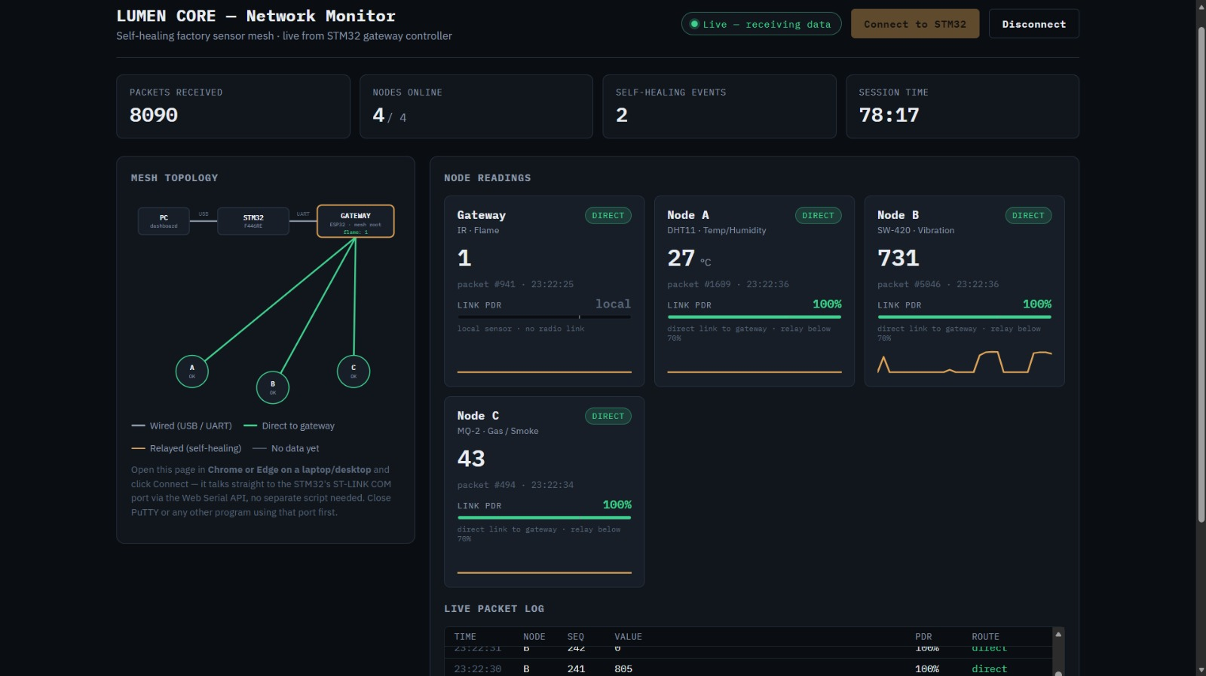

7.6 Discussion and Limitations
- LD2 follows the most recent line. The STM32 sets or clears LD2 on every line, so with several nodes reporting, LD2 can flicker between lines of different nodes; the gateway LED, which holds for 8 s after the last relayed packet, and the dashboard counters provide a steadier indication.
- Blocking UART transmit in the interrupt callback. The mirror uses HAL_UART_Transmit with time-outs inside the receive callback; this is adequate at the present packet rate but would be moved to interrupt or DMA transmit for higher rates.
- Single backup hop. A node can reroute through exactly one neighbour; if both the direct link and the neighbour’s link fail, data is lost.
- No link-layer encryption. Peers are added without encryption keys, so frames are unauthenticated; this is acceptable for a bench demonstration but not for a plant.
- Sensor accuracy. The DHT11 reports integer degrees and is slow and coarse; a reading of −1 indicates a failed read. The SW-420 and MQ-2 outputs are comparator based and indicate presence rather than calibrated quantities.

CHAPTER-8
CONCLUSION AND FUTURE SCOPE

8.1 Conclusion
LUMEN CORE demonstrates a small, infrastructure-free sensor network in which each node monitors the quality of its own link and reroutes through a backup neighbour when the packet-delivery ratio over its last ten sends falls below 0.7, then returns to the direct route after a single acknowledged probe. Three sensor nodes and a gateway report temperature, vibration, gas/smoke and flame over ESP-NOW; an STM32F446RE gateway controller receives the stream by interrupt-driven UART, mirrors it to a PC and flags relayed traffic on its LD2 LED; and a browser dashboard presents live readings, topology and self-healing events. Every reroute is visible on three independent indicators, which makes the behaviour easy to verify and to demonstrate. The complete system uses inexpensive components and needs no router, broker or cloud service.

8.2 Future Scope
- Extend the ring to multi-hop routing or a full mesh so that a node can choose among several neighbours.
- Use signal strength (RSSI) as an additional input so that rerouting can start before packets are lost.
- Enable ESP-NOW encryption with per-peer keys and add message authentication.
- Add actuation: threshold alarms, relay outputs or a buzzer driven by the STM32 when vibration, gas or flame values cross limits.
- Log data to a database and add an MQTT or cloud uplink for long-term analytics, keeping the local mesh independent of it.
- Use deep-sleep scheduling and battery operation for the sensor nodes, and move the design to a custom PCB.
- Replace the DHT11 with a higher-accuracy sensor and calibrate the gas sensor.
- Replace polled blocking UART transmit on the STM32 with DMA, and make LD2 latch for a hold time like the gateway LED.

CHAPTER-9
REFERENCES
[1] J. Lee, B. Bagheri and H.-A. Kao, “A cyber-physical systems architecture for Industry 4.0-based manufacturing systems,” Manufacturing Letters, vol. 3, pp. 18–23, 2015.
[2] A. Al-Fuqaha, M. Guizani, M. Mohammadi, M. Aledhari and M. Ayyash, “Internet of Things: A survey on enabling technologies, protocols, and applications,” IEEE Communications Surveys & Tutorials, vol. 17, no. 4, pp. 2347–2376, 2015.
[3] A. Zanella, N. Bui, A. Castellani, L. Vangelista and M. Zorzi, “Internet of Things for smart cities,” IEEE Internet of Things Journal, vol. 1, no. 1, pp. 22–32, 2014.
[4] I. F. Akyildiz, W. Su, Y. Sankarasubramaniam and E. Cayirci, “Wireless sensor networks: a survey,” Computer Networks, vol. 38, no. 4, pp. 393–422, 2002.
[5] A. Willig, K. Matheus and A. Wolisz, “Wireless technology in industrial networks,” Proceedings of the IEEE, vol. 93, no. 6, pp. 1130–1151, 2005.
[6] V. C. Gungor and G. P. Hancke, “Industrial wireless sensor networks: challenges, design principles, and technical approaches,” IEEE Transactions on Industrial Electronics, vol. 56, no. 10, pp. 4258–4265, 2009.
[7] C. E. Perkins and E. M. Royer, “Ad-hoc on-demand distance vector routing,” in Proc. 2nd IEEE Workshop on Mobile Computing Systems and Applications (WMCSA), 1999, pp. 90–100.
[8] Espressif Systems, “ESP-NOW,” ESP-IDF Programming Guide, https://docs.espressif.com (accessed 2026).
[9] D. P. George et al., “MicroPython documentation – espnow module and ESP32 quick reference,” https://docs.micropython.org (accessed 2026).
[10] STMicroelectronics, RM0390: STM32F446xx Reference Manual, 2021.
[11] STMicroelectronics, UM1724: STM32 Nucleo-64 boards User Manual, 2021.
[12] Web Incubator Community Group, “Web Serial API,” https://wicg.github.io/serial/ (accessed 2026).
[13] Aosong, DHT11 Humidity & Temperature Sensor Datasheet; Hanwei Electronics, MQ-2 Gas Sensor Datasheet.

