This is the most important part of your research. The challenge is that there is no existing dataset with "ambiguity scores" for most images, so you first need to create labels, then train a model to predict them.

Step 1: Choose a Dataset
You don't need to create your own image dataset. Use an existing one.
Examples:
- MS COCO ⭐⭐⭐ (Best choice)
- Flickr30k
- Visual Genome
Why MS COCO?
Each image already has 5 human-written captions.
Example:
Image 1:
Caption 1:
A man riding a bicycle.
Caption 2:
A person cycling on the road.
Caption 3:
A biker wearing a helmet.
Caption 4:
A man rides through the city.
Caption 5:
A cyclist on a street.

Step 2: Generate More Captions
Instead of only using the five captions,
Generate additional captions using models like
- BLIP-2
- LLaVA
- Qwen2.5-VL
Now each image may have
5 human captions
+
5 AI captions
=
10 captions

Step 3: Calculate Caption Diversity
Now compare every caption with every other caption.
Use Sentence-BERT embeddings.
Example
Caption A → embedding

Caption B → embedding
Calculate
Cosine Similarity
Example
Pair | Similarity
1-2 | 0.91
1-3 | 0.88
1-4 | 0.86
1-5 | 0.90
Average
0.89
Very similar captions
↓
Low ambiguity.

Another image
Captions
Busy street

Pedestrian crossing

Tokyo city

Cars waiting

Night traffic

Neon shopping district

People walking
Similarity
0.45
Much lower
↓
High ambiguity.

Step 4: Convert Diversity into Ambiguity Score
Suppose
Average Similarity
0.92
Then
Ambiguity Score

=

1−0.92

=

0.08
Very low ambiguity.
Another image
Similarity
0.37
Then
1−0.37

=

0.63
High ambiguity.
Now every image has a label.
Example
Image | Score
Image1 | 0.08
Image2 | 0.71
Image3 | 0.53
Image4 | 0.12
These become your ground-truth labels.

Step 5: Build the Training Dataset
Now you have
Image

↓

Ambiguity Score
Exactly what supervised learning needs.

Step 6: Train a Deep Learning Model
Now use only the image as input.
Image

↓

Vision Encoder

↓

Regression Head

↓

Predicted Score
Good backbone models include:
- ResNet50 (simple baseline)
- EfficientNet-B3
- ConvNeXt
- Vision Transformer (ViT-B/16) ⭐ Recommended
- CLIP ViT-B/32 ⭐⭐⭐ Excellent because it captures semantic information.

Model Architecture
Input Image

↓

Vision Transformer

↓

768-dimensional feature vector

↓

Linear Layer

↓

ReLU

↓

Dropout

↓

Linear Layer

↓

1 Output

↓

Sigmoid

↓

Ambiguity Score (0–1)

Step 7: Loss Function
Since ambiguity is a continuous value,
Use regression.
Loss
Mean Squared Error (MSE)
or
Huber Loss
Example
Ground Truth
0.81
Prediction
0.74
Loss
(0.81−0.74)^2
The model learns to minimize this.

Step 8: Training
Dataset

↓

Train

↓

Validation

↓

Test
Example
80%

10%

10%
Train for
20–50 epochs
Optimizer
AdamW
Learning Rate
1e−4

Step 9: Prediction
After training
Input
New Image
↓
Model
↓
Output
0.84
Interpretation
0.00–0.30

Low ambiguity

0.30–0.60

Medium ambiguity

0.60–1.00

High ambiguity

Step 10: Explain Why
Use Grad-CAM or attention visualization.
Output
Ambiguity

0.81

Reason

✓ Crowd

✓ Multiple Objects

✓ Night

✓ Occlusion

✓ Text

✓ Traffic
This makes your project explainable.

Complete Research Pipeline
MS COCO Dataset
│
▼
Existing Human Captions (5)
│
▼
Generate More Captions (BLIP-2 / LLaVA)
│
▼
Sentence-BERT Embeddings
│
▼
Caption Similarity Matrix
│
▼
Average Similarity
│
▼
Ambiguity Score = 1 - Similarity
│
▼
Create Training Labels
│
▼
Train Vision Transformer (ViT/CLIP)
│
▼
Predict Ambiguity Score
│
▼
Explain Prediction (Grad-CAM/Attention)
│
▼
Web App (Upload Image → Score + Explanation)
A research improvement to increase novelty
A reviewer may ask: "If the ambiguity score is computed from caption similarity, why train another model?"
Your answer is:
- Computing the score requires generating multiple captions and comparing them, which is computationally expensive.
- Your trained model learns to predict the ambiguity directly from the image, making inference much faster.
- This enables real-time applications where generating many captions for every image would be impractical.
That distinction—using caption diversity only to create training labels, then training a vision model to predict ambiguity directly—is what gives your project a clear research contribution.

new
This is an important research question. The answer depends on what level of research paper you want.
For your one-month project, my recommendation is:
- No, you do not need to create a new deep learning model.
- No, you do not need to manually annotate thousands of images.
Instead, create a new methodology using existing datasets and pre-trained models.

What do you need to create?
1. Your own methodology ✅
This is the main contribution.
Example:
MS COCO Images
↓
5 Human Captions
↓
Sentence-BERT
↓
Caption Diversity Score
↓
OpenCV Feature Extraction
↓
Feature Fusion
↓
Random Forest
↓
Ambiguity Prediction
↓
SHAP Explanation
The pipeline itself is your contribution.

2. Your own processed dataset ✅
You are not creating new images.
You are creating a new feature dataset.
Example:
Image ID | Caption Diversity | Edge Density | Entropy | Brightness | Object Count | Ambiguity
This table is created by you.

3. Your own ML model (trained on your features) ✅
You will train:
- Random Forest
- XGBoost
These are your trained models for the ambiguity prediction task.

Do you need annotation?
Option 1 (Recommended) — No manual annotation
Since MS COCO already has five human-written captions, you can compute ambiguity automatically:
5 Captions
↓
Sentence-BERT
↓
Cosine Similarity
↓
Ambiguity Score
No manual labeling is required.

Option 2 (Research improvement)
If you want to make the paper stronger, annotate a small validation set.
For example:
- Select 100–200 images.
- Ask 5–10 people to rate ambiguity as:
  - Low
  - Medium
  - High
Then compare:
- Human labels
- Your predicted labels
This becomes a validation experiment, not the main training dataset.
You do not need to annotate all 1,000 images.

Do you need to create a new deep learning model?
No.
Research is not only about inventing new neural networks.
A paper can contribute through:
- A new feature engineering method.
- A new scoring algorithm.
- A new pipeline.
- A new evaluation strategy.
- A combination of existing methods applied to a new problem.
That is completely acceptable.

What I would do if I were your supervisor
Component | Recommendation
Dataset | ✅ Use MS COCO
Image Annotation | ❌ Don't create your own image annotations
Captions | ✅ Use existing human-written captions
Deep Learning Model | ✅ Use Sentence-BERT (pre-trained)
Feature Extraction | ✅ Create your own OpenCV features
ML Model | ✅ Train Random Forest/XGBoost yourself
Validation | ✅ Optionally annotate 100–200 images manually

My recommendation
If your goal is to publish a good student research paper in one month, your contribution should be:
- A new ambiguity prediction pipeline (your methodology).
- A new processed ambiguity dataset generated from MS COCO.
- A trained ambiguity prediction model (Random Forest/XGBoost).
- A small human validation study (100–200 images) to show that your automatic ambiguity scores align with human judgment.
This is a realistic scope, demonstrates genuine research work, and is much more achievable than trying to invent a brand-new deep learning architecture or manually annotate an entire dataset.
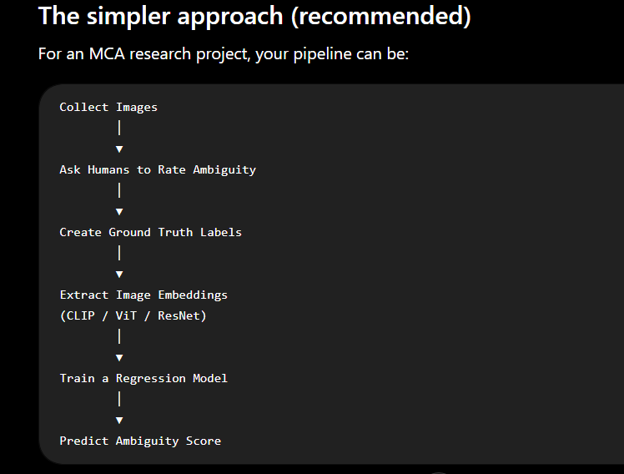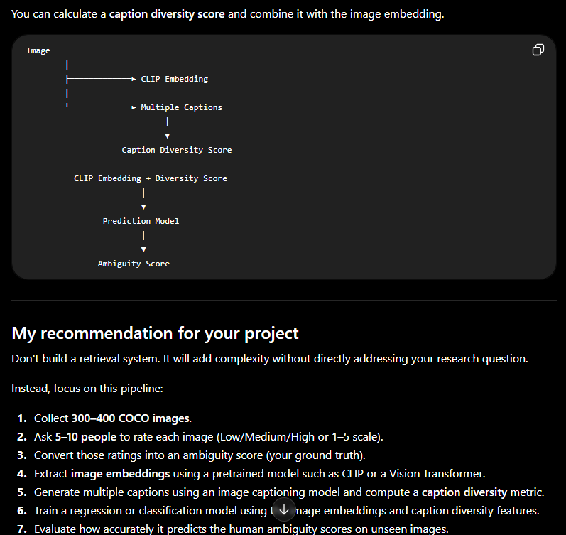

FINAL SETUP
Yes. After all our discussions, I think this is the best pipeline for your project. It is realistic, research-oriented, and can be completed in one month.
Final Research Pipeline
MS COCO Dataset
(Images + 5 Human Captions)
│
▼
Select 300–500 Images
│
▼
Data Preprocessing
(Resize Images, Read Captions, Clean Text)
│
▼
Sentence-BERT Embedding Generation
│
▼
Calculate Caption Diversity Score
(Cosine Similarity / Average Diversity)
│
▼
OpenCV Feature Extraction
┌────────────────────────────────────┐
│ Edge Density │
│ Entropy │
│ Brightness │
│ Contrast │
│ Color Variance │
│ Texture │
└────────────────────────────────────┘
│
▼
Create Feature Dataset (CSV)
│
▼
Generate Ambiguity Labels (Low/Med/High)
│
▼
Train Machine Learning Models
(Random Forest / XGBoost Compare)
│
▼
Evaluate Performance
Accuracy • Precision • Recall • F1 Score
│
▼
Explain Predictions (SHAP)
│
▼
FastAPI Prediction API
│
▼
React Dashboard
│
▼
Research Paper + GitHub Project

Step-by-Step Explanation
Step 1 – Download MS COCO
Input
- 300–500 images
- 5 human-written captions per image
Learn:
- What is MS COCO?
- How captions are stored in JSON?
Output:
Image
5 captions

Step 2 – Preprocessing
Learn:
- Read JSON
- Read images
- Resize images
- Clean captions
Output:
Image
↓

Clean Captions

Step 3 – Caption Diversity
This is the heart of your project.
Example
Caption 1

A dog playing.

Caption 2

A dog catching a frisbee.

Caption 3

A brown dog outdoors.

Caption 4

A pet jumping.

Caption 5

A dog in the park.
Sentence-BERT converts every caption into numbers.
Then compute
Cosine Similarity
Finally
Caption Diversity Score

↓

0.81

Step 4 – Computer Vision Features
Extract
Edge Density

Entropy

Brightness

Contrast

Color Variance

Texture
Example
Edge Density

0.74

Entropy

5.21

Brightness

131

Step 5 – Build Dataset
Create
Image | Caption Diversity | Edge | Entropy | Brightness | Contrast | Texture
This CSV is your dataset.

Step 6 – Ambiguity Labels
This is the only part that needs a decision.
Option A (Recommended for one month)
Create labels automatically.
Example
Caption Diversity

0.0–0.35

↓

Low

0.35–0.65

↓

Medium

0.65–1.0

↓

High
This is simple and reproducible.

Option B (Research Improvement)
Take 50–100 images.
Ask 5–10 people:
How ambiguous is this image?

○ Low

○ Medium

○ High
Then compare
Human Rating

↓

High

Model Prediction

↓

High
This becomes your validation experiment.
Do not ask people to label all 300–500 images. That is unnecessary for your timeline.

Step 7 – Train ML
Train
Random Forest

XGBoost
Compare
- Accuracy
- Precision
- Recall
- F1
Choose the better model.

Step 8 – Explainability
Use SHAP.
Instead of
High
show
Reason

✓ High Caption Diversity

✓ High Edge Density

✓ High Entropy

Step 9 – FastAPI
API
Upload Image

↓

Prediction

↓

JSON

Step 10 – React
Dashboard
Upload Image

↓

Prediction

↓

Reason

↓

Feature Values

Technologies You'll Learn
Technology | Purpose
Python | Programming
NumPy | Numerical computing
Pandas | Dataset handling
OpenCV | Image feature extraction
Sentence-BERT | Caption embeddings
Scikit-learn | ML models
SHAP | Explainability
FastAPI | Backend API
React | Frontend

Final Research Contribution
Your paper should not claim:
"I created a new AI model."
Instead, your contribution is:
"We propose an explainable image ambiguity prediction pipeline that combines caption diversity derived from Sentence-BERT embeddings with handcrafted computer vision features to classify images into Low, Medium, and High ambiguity levels using machine learning."
That is a valid and achievable research contribution.

One Important Improvement
I would slightly modify your original title to better match the actual work:
Explainable Image Ambiguity Prediction Using Caption Diversity and Computer Vision Features
This title tells readers that your work is not just predicting ambiguity—it also explains why an image is considered ambiguous, which makes the contribution stronger and aligns well with your planned use of SHAP.

