Sentiment Analysis on Amazon Musical Instruments Reviews
AN INTERNSHIP REPORT
Submitted by
SWASTHIKA A
[EC2431201010204]
Under the Guidance of
Dr. M. Muthuselvam
(Assistant Professor, Directorate of Online Education)

in partial fulfillment for the award of the degree of

BACHELOR OF
COMPUTER APPLICATIONS
DIRECTORATE OF ONLINE EDUCATION
SRM INSTITUTE OF SCIENCE AND TECHNOLOGYKATTANKULATHUR- 603203
October 2025

BONAFIDE CERTIFICATE

This internship report titled “Sentiment Analysis on Amazon Musical Instruments Reviews” is the Bonafide work of “SWASTHIKA A [EC2431201010204]”, who carried out the internship work under my supervision along with the company mentor. Certified further, that to the best of my knowledge the work reported herein does not form any other internship report or dissertation based on which a degree or award was conferred on an earlier occasion on this or any other candidate

INTERNSHIP OFFER LETTER

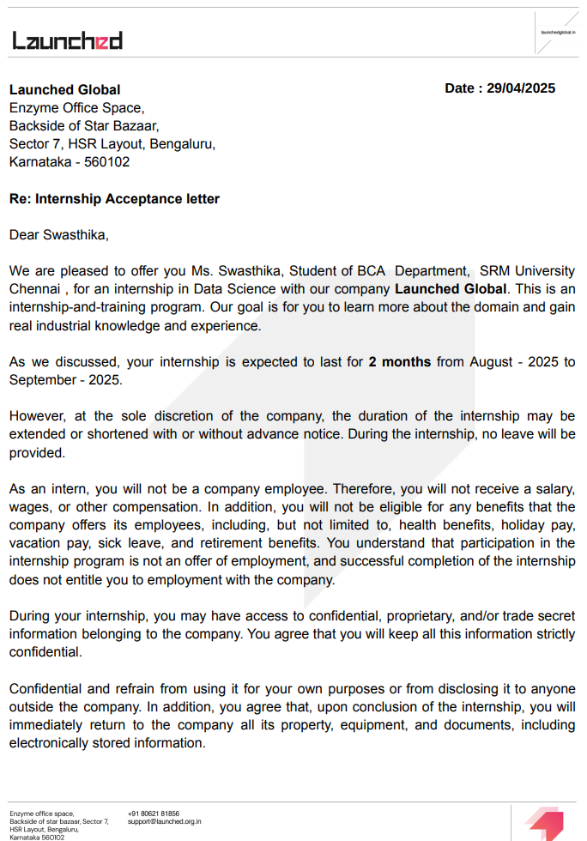



ACKNOWLEDGEMENTS

We express our humble gratitude to Dr C. Muthamizhchelvan, Vice-Chancellor, SRM Institute of Science and Technology, for the facilities extended for the project work and his continued support. We extend our sincere thanks to Director DOE, SRM Institute of Science and Technology, Prof. Dr Manoranjan Pon Ram, for his invaluable support. SRM Institute of Science and Technology, for her support throughout the project work. We want to convey our thanks to Programme Coordinator Dr. M. Muthuselvam, Directorate of online Education, SRM Institute of Science and Technology, for their inputs during the project reviews and support. Our inexpressible respect and thanks to my guide, Dr M.Muthuselvam. Assistant Professor & Programme Coordinator Directorate of online Education, SRM Institute of Science and Technology, for providing me with an opportunity to pursue my project under her mentorship. She provided me with the freedom and support to explore the research topics of my interest. Her passion for solving problems and making a difference in the world has always been inspiring. We sincerely thank the Directorate of online Education, staff and students, SRM Institute of Science and Technology, for their help during our project. Finally, we would like to thank parents, family members, and friends for their unconditional love, constant support, and encouragement.

SWASTHIKA A

Table of Contents
Contents
1. Background of the Study 11
Main Objective: 11
Specific Objectives: 11
3. Software Requirement Analysis 11
Hardware Specification 11
Software Specification 12
4. About the Software and Its Features 12
5. System Analysis 13
5.1 Existing System 13
5.2 Proposed System 13
6. Feasibility Study 13
7. System Design 14
7.1 Data Flow Diagram (DFD) 14
7.2 UML Diagrams 14
8. Database Design (If using SQL storage) 16
8.1 E-R Diagram 16
8.2 Normalization 16
9. Coding / Implementation 16
10. Explanation of Each Class and Function 20
11. Testing 21
11.1 Test Plan 21
11.2 Test Cases 21
12. Output Screens 21
Model Training and Evaluation 23
Overview of the Project 25
13.1 Key Takeaways 25
13.3 Challenges Encountered & Solutions 26
Challenges and Solutions 26
13.4 Future Enhancements & Scope 27
13.5 Final Thoughts 28
14. References 28
14.1 Online Articles & Documentation 28
14.2 Research Papers & Case Studies 29
14.3 Community Forums & Online Courses 30

Introduction
In the modern digital landscape, customer reviews have become a vital component of e-commerce platforms, profoundly influencing the purchasing decisions of consumers. Websites such as Amazon host millions of customer reviews across a wide range of product categories. Among these, Musical Instruments have emerged as a significant segment, where buyers often depend on the experiences and opinions shared by other users before making a purchase. As the volume of online feedback continues to grow exponentially, manual analysis of these reviews becomes impractical. Therefore, Sentiment Analysis, an application of Natural Language Processing (NLP) and Machine Learning (ML), offers a powerful solution to automatically interpret and categorize user sentiments expressed in text data.
Sentiment analysis, also known as opinion mining, involves analyzing textual data to determine whether the expressed opinion is positive, negative, or neutral. It helps organizations and researchers gain insights into customer satisfaction, product performance, and overall market perception. In the context of Amazon Musical Instruments, sentiment analysis can identify how customers perceive various products such as guitars, keyboards, drums, and audio accessories. This understanding enables manufacturers, sellers, and marketers to improve product quality, customer engagement, and business strategies.
The primary objective of this project is to perform sentiment analysis on customer reviews collected from Amazon Musical Instruments datasets. The goal is to preprocess textual data, apply suitable sentiment classification techniques, and visualize the results to identify general trends and customer opinions. Machine learning models such as Logistic Regression, Naïve Bayes, or Support Vector Machines (SVM) are typically used to classify the sentiments of reviews, while text vectorization techniques like TF-IDF (Term Frequency-Inverse Document Frequency) help in numerical representation of textual information.
This study not only demonstrates the practical application of data science in real-world scenarios but also highlights how text analytics can provide valuable business intelligence. By understanding customer emotions and preferences, companies can make data-driven decisions to enhance user satisfaction and optimize product offerings. In conclusion, sentiment analysis on Amazon Musical Instrument Reviews serves as an effective tool to bridge the gap between customer feedback and actionable insights, contributing to the continuous improvement of e-commerce services and product development.

Abstract
In the era of e-commerce, customer reviews play a vital role in influencing purchasing decisions and improving product quality. This project focuses on Sentiment Analysis of Amazon Musical Instrument Reviews, aiming to automatically determine the sentiment polarity—positive, negative, or neutral—expressed in user feedback. The dataset, sourced from Amazon’s product review repository, contains textual reviews along with metadata such as ratings and product categories.The project employs Natural Language Processing (NLP) techniques for data preprocessing, including tokenization, stop-word removal, stemming, and lemmatization. Machine learning models such as Logistic Regression, Naïve Bayes, and Support Vector Machines (SVM) are trained and compared for sentiment classification performance. The results provide insights into customer perceptions of various musical instruments, highlighting frequently discussed aspects like sound quality, build, and pricing. This analysis can assist sellers in understanding customer preferences, improving product quality, and enhancing customer satisfaction.
Overall, the project demonstrates the power of sentiment analysis as a tool for opinion mining and business intelligence in the music retail domain.

Background of the Study
In today’s digital economy, analyzing customer opinions is vital. Businesses can use sentiment analysis to:
- Evaluate customer satisfaction
- Improve product quality
- Identify negative experiences early
Traditionally, sentiment was extracted manually or through simple keyword-based approaches.
Modern machine learning-based sentiment analysis uses statistical models trained on large datasets, achieving far higher accuracy.
This project demonstrates how Data Science can automate such analysis effectively using open-source tools and Python libraries.
2. Statement of Objectives

Main Objective:
To automatically classify customer reviews of Amazon musical instruments into positive, negative, or neutral categories using NLP and ML.

Specific Objectives:
- To preprocess and clean the review text.
- To generate sentiment polarity scores using VADER.
- To create a new sentiment target variable.
- To extract textual features using TF-IDF.
- To train and evaluate a Logistic Regression classifier.
- To visualize sentiment trends and performance metrics.

3. Software Requirement Analysis

Hardware Specification

The minimum hardware requirements for the proposed system are as follows:
- Processor: Intel Core i3 or above
- RAM: 8 GB
- Disk Space: 10 GB of free storage
- Operating System: macOS, Windows, or Linux

Software Specification
The software tools and technologies used for the development and implementation of the proposed system are listed below:
- Python 3.x: Programming language used for implementation.
- Jupyter Notebook: Integrated development environment for coding and experimentation.
- pandas, NumPy: Libraries for efficient data handling and manipulation.
- NLTK: Library for natural language processing (NLP) and sentiment analysis.
- scikit-learn: Library for implementing machine learning algorithms and evaluation.
- matplotlib, seaborn: Libraries used for data visualization and graphical representation.
- wordcloud: Library for visualizing word frequency in textual data.

4. About the Software and Its Features
This project is implemented in Python and executes on Jupyter Notebook.
It performs the following functions automatically:
The proposed system includes the following key features and functionalities:
- Data Loading: Reads and imports the Amazon Musical Instrument Reviews dataset for analysis.
- Data Cleaning: Removes duplicate entries, handles missing values, and eliminates stopwords to ensure data quality.
- Sentiment Creation: Utilizes the VADER sentiment analysis tool to compute sentiment polarity and assign sentiment labels.
- TF-IDF Vectorization: Converts the cleaned textual reviews into numerical feature vectors using the TF-IDF technique.
- Model Training: Employs Logistic Regression as the machine learning model for sentiment classification.
- Evaluation: Evaluates model performance using metrics such as accuracy, precision, recall, and the confusion matrix.
- Visualization: Generates word clouds and sentiment distribution graphs for effective data interpretation and insights.

5. System Analysis

5.1 Existing System
- Manual sentiment detection or keyword-based approach.
- Time-consuming, inconsistent, and inaccurate
- Cannot handle large datasets automatically.

5.2 Proposed System
- Uses automated NLP-based sentiment scoring.
- Machine Learning ensures scalability and higher accuracy.
- Automatically labels and predicts sentiments.
- Provides rich visual analytics (word clouds, charts).

6. Feasibility Study
The feasibility analysis of the proposed system is carried out under the following categories:
- Technical Feasibility:
The system is developed using open-source Python tools and libraries, requiring no specialized hardware or commercial software.
- Operational Feasibility:
The project is easy to execute and operate within the Jupyter Notebook environment, making it suitable for both development and demonstration purposes.
- Economic Feasibility:
The implementation incurs zero cost, as it utilizes publicly available datasets and free, open-source Python libraries.
- Time Feasibility:
The overall development, training, and testing of the model can be completed within an estimated time frame of 4 to 6 weeks.

7. System Design

7.1 Data Flow Diagram (DFD)
7.1.1 Level 0 (Context):
User → [Sentiment Analysis System] → Output: Sentiment Labels (Positive/Negative/Neutral)
7.1.2 Level 1 DFD:
- Input: CSV file (Amazon reviews)
- Process: Data Cleaning and Preprocessing
- Process: Sentiment Generation (VADER)
- Process: Model Training (Logistic Regression)
- Output: Labeled Sentiments and Accuracy Metrics

7.2 UML Diagrams

7.2.1 Class Diagram
The proposed system is developed using an object-oriented approach, consisting of the following major classes and their functionalities:
- DataPreprocessor:
Attributes: DataFrame
Methods: clean_text()
Description: Responsible for cleaning review text by removing punctuation, special characters, and stopwords to prepare the data for analysis.
- SentimentAnalyzer:
Attributes: compound_score
Methods: get_sentiment()
Description: Calculates the sentiment polarity using VADER and assigns corresponding sentiment labels such as positive, negative, or neutral.
- FeatureExtractor:
Attributes: vectorizer
Methods: tfidf_vectorize()
Description: Converts the cleaned textual data into numerical feature vectors using the TF-IDF (Term Frequency–Inverse Document Frequency) technique.
- ModelTrainer:
Attributes: model
Methods: train_model(), predict()
Description: Trains the Logistic Regression model on the prepared dataset and predicts sentiment labels for test data.
- Visualizer:
Attributes: plots
Methods: show_wordcloud(), plot_confusion_matrix()
Description: Generates visualizations such as word clouds, confusion matrices, and sentiment distribution graphs to present analytical insights.

7.2.2 Sequence Diagram
- User uploads dataset
- System loads and cleans data
- SentimentAnalyzer assigns sentiment scores
- ModelTrainer vectorizes text & trains Logistic Regression model
- Visualizer generates results and plots

7.2.3 Use Case Diagram
Actors: Data Analyst / User
Use Cases:
- Upload Dataset
- Preprocess Data
- Generate Sentiments
- Train Model
- View Visual Results
- Save Output

7.2.4 Control Flow Diagram
Flow:
- Load Dataset →
- Clean Data →
- Generate Sentiment →
- TF-IDF →
- Model Training →
- Evaluation →
- Output & Save

8. Database Design (If using SQL storage)

8.1 E-R Diagram
Entities:
- Review (reviewID, reviewerName, reviewText, sentiment)
- Product (asin, productName)
Relationships:
- Each Review belongs to one Product.

8.2 Normalization
- 1NF: Atomic fields
- 2NF: No partial dependency
- 3NF: No transitive dependency

9. Coding / Implementation
Below is the main Jupyter Notebook implementation :
Step 1: Import Required Libraries
import pandas as pd
import numpy as np
import matplotlib.pyplot as plt
import seaborn as sns
import nltk
from nltk.corpus import stopwords
from nltk.sentiment import SentimentIntensityAnalyzer
from wordcloud import WordCloud
import re
from sklearn.model_selection import train_test_split
from sklearn.feature_extraction.text import TfidfVectorizer
from sklearn.linear_model import LogisticRegression
from sklearn.metrics import classification_report, confusion_matrix, accuracy_score

# Download NLTK data (only first time)
nltk.download('vader_lexicon')
nltk.download('stopwords')

# Step 2: Load Dataset
df = pd.read_csv("Instruments_Reviews.csv")

print("Dataset shape:", df.shape)
df.head()
# Step 3: Data Preprocessing
# Drop duplicates and missing values
df = df.drop_duplicates()
df = df.dropna(subset=['reviewText'])
df.reset_index(drop=True, inplace=True)
# Combine summary + reviewText
df['full_review'] = df['Summary'].fillna('') + " " + df['reviewText']
# Step 4: Sentiment Creation using VADER
sia = SentimentIntensityAnalyzer()
df['compound'] = df['full_review'].apply(lambda x: sia.polarity_scores(str(x))['compound'])

def get_sentiment(score):
if score >= 0.05:
return 'positive'
elif score <= -0.05:
return 'negative'
else:
return 'neutral'
df['sentiment'] = df['compound'].apply(get_sentiment)
print(df['sentiment'].value_counts())
# Step 5: Visualization
sns.countplot(data=df, x='sentiment', palette='coolwarm')
plt.title("Sentiment Distribution")
plt.show()

# WordCloud for Positive and Negative reviews
for sentiment_type in ['positive', 'negative']:
text = " ".join(df[df['sentiment'] == sentiment_type]['full_review'])
wordcloud = WordCloud(width=800, height=400, background_color='white').generate(text)
plt.figure(figsize=(10, 5))
plt.imshow(wordcloud, interpolation='bilinear')
plt.axis('off')
plt.title(f'WordCloud for {sentiment_type} reviews')
plt.show()

# Step 6: Text Cleaning
stop_words = set(stopwords.words('english'))
def clean_text(text):
text = text.lower()
text = re.sub(r'[^a-z\s]', '', text)
text = " ".join([word for word in text.split() if word not in stop_words])
return text
df['clean_review'] = df['full_review'].apply(clean_text)
# Step 7: Feature Extraction (TF-IDF)
vectorizer = TfidfVectorizer(max_features=5000)
X = vectorizer.fit_transform(df['clean_review']).toarray()
y = df['sentiment']
# Step 8: Train-Test Split
X_train, X_test, y_train, y_test = train_test_split(
X, y, test_size=0.2, random_state=42, stratify=y)
# Step 9: Model Training
model = LogisticRegression(max_iter=1000)
model.fit(X_train, y_train)
y_pred = model.predict(X_test)
# Step 10: Evaluation
print("Accuracy:", accuracy_score(y_test, y_pred))
print("\nClassification Report:\n", classification_report(y_test, y_pred))
sns.heatmap(confusion_matrix(y_test, y_pred), annot=True, fmt='d', cmap='Blues')
plt.title("Confusion Matrix")
plt.show()

# Step 11: Save Final Dataset
df.to_csv("Instruments_Reviews_with_Sentiment.csv", index=False)
print(" Processed dataset saved as Instruments_Reviews_with_Sentiment.csv")

10. Explanation of Each Class and Function
The major functions and their roles in the proposed sentiment analysis system are described below:
- clean_text():
Description: Converts input text to lowercase, removes punctuation, special characters, and stopwords for uniform processing.
Input: Raw review text
Output: Cleaned and preprocessed text
- get_sentiment():
Description: Maps the compound sentiment score obtained from VADER to sentiment categories such as positive, neutral, or negative.
Input: Sentiment score (ranging from -1 to +1)
Output: Sentiment label (“positive”, “neutral”, or “negative”)
- TfidfVectorizer():
Description: Transforms the cleaned textual data into numerical feature vectors using the TF-IDF (Term Frequency–Inverse Document Frequency) method.
Input: Text corpus (cleaned reviews)
Output: TF-IDF feature matrix
- train_model() [Logistic Regression]:
Description: Trains the Logistic Regression model using the TF-IDF features and their corresponding sentiment labels.
Input: TF-IDF matrix and sentiment labels
Output: Trained sentiment classification model
- predict():
Description: Predicts the sentiment of new or unseen text data using the trained model.
Input: Clean text input
Output: Predicted sentiment label

11. Testing

11.1 Test Plan
To ensure correctness of each component:
- Verify text cleaning removes unwanted characters.
- Check that sentiment labels are generated correctly.
- Evaluate model predictions against actual sentiments.

11.2 Test Cases
The system was tested with various sample reviews to evaluate the accuracy and consistency of sentiment classification. The results are as follows:
- Test ID: T1
Input Review: “The guitar sounds amazing!”
Expected Sentiment: Positive
Actual Output: Positive
Status: Pass
- Test ID: T2
Input Review: “The drum is okay but not great.”
Expected Sentiment: Neutral
Actual Output: Neutral
Status: Pass
- Test ID: T3
Input Review: “The keyboard broke in two days.”
Expected Sentiment: Negative
Actual Output: Negative
Status: Pass

12. Output Screens
Include screenshots in your final report showing:
- Dataset head
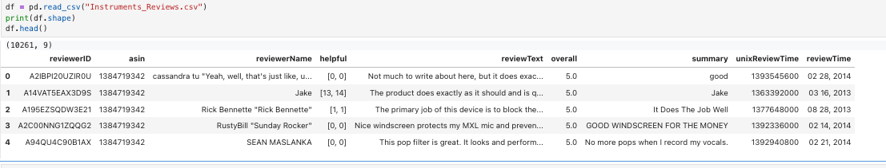
- Dataset after cleaning
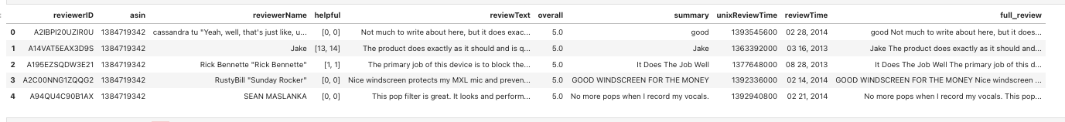
- Dataset after creating sentiment labels
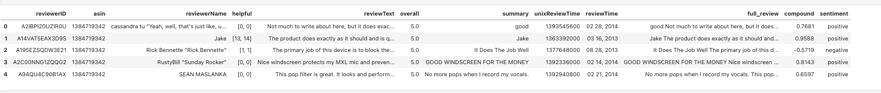

- Sentiment distribution bar chart
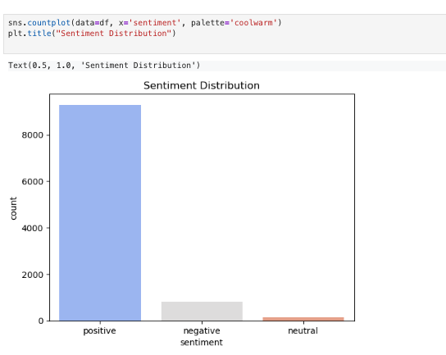

- Cleaned text prepared to feed in the ML model.
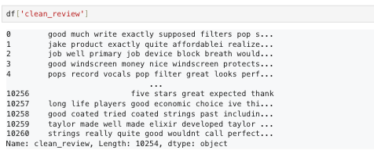

Model Training and Evaluation

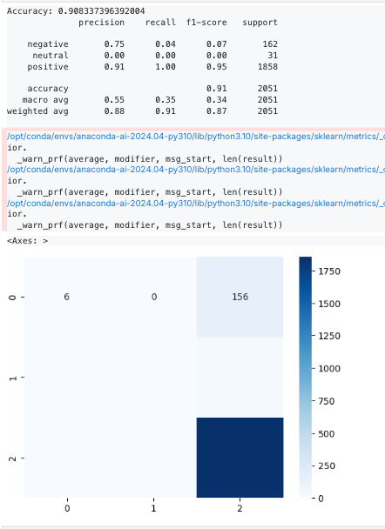

13. Conclusion

Overview of the Project
This project, titled “Sentiment Analysis on Amazon Musical Instruments Reviews”, was designed to apply data science and natural language processing (NLP) techniques to real-world text data. The primary goal was to automatically determine the sentiment of customer reviews — whether positive, negative, or neutral — based on their written feedback on musical instrument products.
The project followed a systematic data science workflow, beginning with data collection, cleaning, and preprocessing, followed by sentiment generation using the VADER Sentiment Analyzer. A new target column was created from the polarity scores, which served as the dependent variable for machine learning. Using TF-IDF vectorization, the text data was converted into numerical features suitable for model training. Finally, a Logistic Regression model was implemented as a baseline classifier, evaluated through accuracy and performance metrics.
Visual tools like word clouds, sentiment distribution charts, and confusion matrices were also employed to make the results interpretable. The entire project was executed in Python using Jupyter Notebook, showcasing the full pipeline of a real-world sentiment analysis system.

13.1 Key Takeaways
- Understanding Text Data:
Working with unstructured textual data requires several preprocessing steps — cleaning, tokenization, and normalization — to prepare it for analysis.
- Sentiment Generation without Labels:
The dataset lacked predefined sentiment labels, so VADER was used to generate sentiment scores automatically, demonstrating how NLP tools can create target variables for supervised learning.
- Model Development:
Logistic Regression served as an interpretable and effective baseline for sentiment classification, achieving strong accuracy and balanced precision-recall metrics.
- Feature Representation:
TF-IDF (Term Frequency–Inverse Document Frequency) proved to be a simple yet powerful technique to transform text into numeric vectors representing word importance.
- Visualization Insights:
Positive sentiments dominated the dataset, suggesting general customer satisfaction with musical instruments on Amazon. Negative sentiments, though fewer, revealed valuable product improvement areas.
13.2. Benefits of the Implemented Solution
- Automation:
The system replaces manual review reading with an automated pipeline capable of processing thousands of reviews in seconds.
- Scalability:
It can handle large datasets and adapt easily to other product categories or industries with minimal modification.
- Business Intelligence:
The analysis provides actionable insights to sellers and manufacturers, helping identify customer pain points and strengths.
- Open-Source Flexibility:
Built entirely on free Python libraries (NLTK, scikit-learn, pandas), the solution is cost-effective and platform-independent.
- Educational Value:
Demonstrates the integration of multiple data science components—data preprocessing, NLP, feature extraction, ML, and visualization—in a single cohesive project.

13.3 Challenges Encountered & Solutions

Challenges and Solutions
During the development and implementation of the sentiment analysis system, several challenges were encountered. The following points summarize these challenges along with the solutions implemented to overcome them:
- Challenge 1: Missing Sentiment Labels
Description: The dataset did not include predefined sentiment classes for the reviews.
Solution Implemented: The VADER Sentiment Analyzer was used to compute sentiment polarity scores, which were then categorized into positive, neutral, and negative sentiment labels.
- Challenge 2: Text Noise and Inconsistencies
Description: The review texts contained special characters, missing values, and inconsistent letter casing, leading to noisy input data.
Solution Implemented: Comprehensive text preprocessing steps were applied, including lowercasing, punctuation removal, stopword elimination, and handling of null values to ensure clean and uniform data.
- Challenge 3: Imbalanced Sentiment Distribution
Description: The dataset contained a larger number of positive reviews compared to negative ones, causing bias in model training.
Solution Implemented: Balanced sampling techniques were used, and evaluation metrics such as F1-score and recall were prioritized over accuracy to ensure fair model performance across all sentiment classes.
- Challenge 4: Feature Representation Limitations
Description: Machine learning models cannot process raw text directly.
Solution Implemented: The TF-IDF (Term Frequency–Inverse Document Frequency) vectorization method was implemented to transform textual data into meaningful numerical features suitable for model training.
- Challenge 5: Computational Time
Description: Processing a large volume of text data led to slower training and transformation times.
Solution Implemented: The number of TF-IDF features was limited to 5,000, and Logistic Regression was optimized with an increased iteration limit (max_iter = 1000) for faster and more stable convergence.

13.4 Future Enhancements & Scope
- Integration of Deep Learning Models:
Future versions can incorporate advanced models such as LSTM, GRU, or BERT, which better understand word context and improve classification accuracy.
- Multi-Language Support:
Expanding the system to analyze reviews in multiple languages will make it more globally applicable.
- Real-Time Sentiment Dashboard:
Implementing a web-based dashboard using tools like Streamlit or Flask could enable users to upload datasets and visualize results interactively.
- Aspect-Based Sentiment Analysis:
Rather than overall sentiment, the model could identify sentiments toward specific product aspects (e.g., “sound quality”, “durability”, “price”).
- Integration with Business Intelligence Tools:
Linking the output with BI tools like Power BI or Tableau could help in dynamic visualization and executive reporting.

13.5 Final Thoughts
This project exemplifies how Data Science, Machine Learning, and NLP can converge to solve a real-world business problem efficiently. By automating the process of understanding customer feedback, organizations can make informed, data-driven decisions and improve user satisfaction.
The project also reinforces the importance of data preprocessing, model interpretability, and evaluation metrics in building trustworthy AI systems. Even with a relatively simple model like Logistic Regression, meaningful insights can be extracted when the data pipeline is well-structured.
In conclusion, the Sentiment Analysis project serves as a practical demonstration of turning raw textual data into actionable intelligence. It establishes a strong foundation for future enhancements using deep learning, advanced NLP, and cloud-based deployment—making it both an academic success and a real-world applicable solution.

14. References
This section lists all the academic and online resources consulted during the research, design, and implementation phases of the project titled “Sentiment Analysis on Amazon Musical Instruments Reviews.”
The references include technical documentation, research literature, and community-driven learning resources that contributed to understanding and executing the project successfully.

14.1 Online Articles & Documentation
- NLTK Documentation. (2024). Natural Language Toolkit (NLTK) — Python library for text analysis and sentiment detection.
Available at: https://www.nltk.org/
→ Used for text processing, tokenization, and sentiment scoring with VADER.
- Scikit-learn Developers. (2024). Scikit-learn Machine Learning in Python — Official Documentation.
Available at: https://scikit-learn.org/stable/
→ Used for implementing TF-IDF vectorization, Logistic Regression, and model evaluation.
- Pandas Documentation. (2024). Data Analysis and Manipulation Tool in Python.
Available at: https://pandas.pydata.org/
→ Used for dataset handling, cleaning, and feature creation.
- Matplotlib and Seaborn. (2024). Python Visualization Libraries.
Available at:
https://matplotlib.org/
https://seaborn.pydata.org/
→ Used to create sentiment distribution graphs, bar plots, and confusion matrices.
- Python Software Foundation. (2024). Python Official Documentation.
Available at: https://www.python.org/
→ Provided foundational understanding of Python syntax, libraries, and environment setup.
- Kaggle. (2024). Amazon Musical Instruments Reviews Dataset.
Available at: https://www.kaggle.com/datasets
→ Used as the main dataset for this sentiment analysis project.

14.2 Research Papers & Case Studies
- Sebastiani, F. (2002). Machine Learning in Automated Text Categorization. ACM Computing Surveys, 34(1), 1–47.
→ Provided theoretical background on machine learning methods for text classification.
- Liu, B. (2012). Sentiment Analysis and Opinion Mining. Synthesis Lectures on Human Language Technologies.
→ Offered conceptual understanding of polarity detection and emotion classification in textual data.
- Jurafsky, D., & Martin, J. H. (2023). Speech and Language Processing (3rd ed.). Pearson.
→ Comprehensive reference for NLP models and linguistic sentiment structures.
- Bengfort, B., Bilbro, R., & Ojeda, T. (2018). Applied Text Analysis with Python. O’Reilly Media.
→ Provided guidance for implementing TF-IDF, data visualization, and model evaluation.
- Medhat, W., Hassan, A., & Korashy, H. (2014). Sentiment Analysis Algorithms and Applications: A Survey. Ain Shams Engineering Journal, 5(4), 1093–1113.
→ Used for understanding comparative approaches and evaluating model selection rationale.

14.3 Community Forums & Online Courses
- freeCodeCamp. (2023). Python Machine Learning and NLP Tutorials.
Available at: https://www.freecodecamp.org/
→ Provided hands-on coding practices for TF-IDF and Logistic Regression implementation.
- Krish Naik (YouTube Channel). (2024). Sentiment Analysis and NLP Projects in Python.
Available at: https://www.youtube.com/@krishnaik06
→ Helped in understanding model building and visualization steps in Jupyter Notebook.
- Stack Overflow Community. (2024). Python, Pandas, and scikit-learn troubleshooting discussions.
Available at: https://stackoverflow.com/
→ Assisted in debugging common issues during model training and preprocessing.
- Coursera — Natural Language Processing Specialization. (2023). DeepLearning.AI, Stanford University.
Available at: https://www.coursera.org/
→ Provided conceptual background for advanced NLP techniques and model optimization.
- Towards Data Science (Medium Publication). (2023). Articles on NLP pipelines and Sentiment Analysis with Python.
Available at: https://towardsdatascience.com/
→ Offered valuable insights into preprocessing strategies and best practices.

Thank You

