CHAPTER 1
INTRODUCTION
  - Project Description
The rapid growth of Artificial Intelligence (AI) and Natural Language Processing (NLP) technologies has significantly changed the way users access and interact with information systems. Educational institutions generate large volumes of information related to admissions, courses, examination schedules, academic regulations, placement activities, and student services. Students often face difficulties in obtaining accurate information quickly due to dependence on manual communication methods or traditional keyword-based search systems. Conventional chatbot systems used in educational environments generally provide predefined responses and lack contextual understanding, which limits their ability to deliver meaningful and relevant answers to user queries.

To address these limitations, the proposed project titled “College Information Chatbot using Large Language Models and Retrieval-Augmented Generation with Multi-Agent Architecture” focuses on developing an intelligent conversational system capable of understanding user queries and providing context-aware responses. The system utilizes Large Language Models (LLMs) along with Retrieval-Augmented Generation (RAG) to improve response accuracy by retrieving relevant information from institutional documents before generating responses. This approach enables the chatbot to provide more reliable and semantically relevant answers compared to traditional rule-based systems.

The proposed system incorporates a multi-agent architecture consisting of a Supervisor Agent, Document Agent, and FAQ Agent. The Supervisor Agent is responsible for analyzing user queries and routing them to the appropriate agent. The Document Agent handles retrieval-based queries by accessing document embeddings stored in a FAISS (Facebook AI Similarity Search) vector database, while the FAQ Agent manages frequently asked or predefined questions. The system supports both text and voice-based interaction, thereby improving accessibility and user experience.

The chatbot is designed using Flask as the backend framework and React.js for the frontend user interface. Institutional documents uploaded by the administrator are processed using text extraction and chunking techniques. The extracted text is converted into vector embeddings and stored in the FAISS vector database to enable semantic search and efficient retrieval. LangChain is utilized for orchestration of the retrieval pipeline and interaction with the LLM.
The primary objective of the project is to reduce the time and effort required to access academic information while improving the efficiency and responsiveness of student support services. The system aims to provide accurate, context-aware, and user-friendly interaction for students and administrators within an educational environment.
1.2 Company Profile
This project was developed as part of the Master of Computer Applications (MCA) curriculum under the Department of MCA, RV College of Engineering, Bengaluru. RV College of Engineering is one of the premier autonomous engineering institutions affiliated with Visvesvaraya Technological University (VTU), Belagavi. The institution is known for promoting innovation, technical excellence, and research-oriented learning among students.

The Department of MCA provides students with strong foundations in software development, artificial intelligence, data science, cloud computing, and emerging technologies. The department encourages students to work on real-world problems through project-based learning and research activities. This project was undertaken with the objective of applying modern AI technologies such as Large Language Models, Retrieval-Augmented Generation, and semantic search techniques to solve practical problems in academic information retrieval.

The project reflects the institution’s emphasis on innovation-driven education and the application of advanced technologies to improve user experience and system efficiency in educational environments.

  - Dissertation Organization
The dissertation is organized into multiple chapters to provide a structured explanation of the project development process and implementation details.
- Chapter 1 – Introduction:
Presents the project overview, objectives, motivation, and organization of the dissertation.
- Chapter 2 – Literature Review:
Discusses existing research works, literature survey, existing and proposed systems, tools, technologies, and system requirements.
- Chapter 3 – Software Requirement Specifications:
Describes functional requirements, non-functional requirements, external interface requirements, and design constraints of the proposed system.
- Chapter 4 – System Design:
Explains the architectural design, system perspective, and context diagram of the chatbot system.
- Chapter 5 – Detailed Design:
Includes UML diagrams such as class diagram, use case diagram, sequence diagram, activity diagram, data flow diagrams, and module-level design details.
- Chapter 6 – Implementation:
Describes the implementation process, technologies used, and important code snippets related to the project.
- Chapter 7 – Software Testing:
Covers testing methodologies, test cases, validation procedures, and performance evaluation of the system.
- Chapter 8 – Conclusion:
Summarizes the outcomes and achievements of the project.
- Chapter 9 – Future Enhancements:
Discusses possible improvements and future extensions that can enhance the functionality and performance of the system.
- Bibliography:
Contains references to journals, research papers, books, and online resources used during the project development process.

CHAPTER 2

LITERATURE REVIEW
2.1 Literature Survey
The advancement of Artificial Intelligence (AI), Natural Language Processing (NLP), and Large Language Models (LLMs) has significantly influenced the development of intelligent conversational systems across multiple domains, including education. Educational institutions increasingly rely on digital platforms to manage academic information, resulting in the need for efficient systems capable of providing accurate and context-aware responses to user queries. Traditional information retrieval systems and rule-based chatbots often fail to understand the semantic meaning of user queries, leading to irrelevant or incomplete responses.

Several researchers have explored the use of chatbot systems in educational environments to automate student support and improve accessibility to institutional information. Early chatbot systems were primarily based on rule-based or keyword-matching approaches, where predefined responses were triggered using manually created patterns. Although these systems were simple to implement, they lacked flexibility and contextual understanding, making them ineffective for handling complex or dynamic queries.

Recent developments in Large Language Models such as GPT-based architectures have improved the capabilities of conversational systems by enabling better language understanding and natural response generation. However, standalone LLMs may generate inaccurate or hallucinated information when they do not have access to domain-specific knowledge. To overcome this limitation, Retrieval-Augmented Generation (RAG) has emerged as an effective approach that combines retrieval mechanisms with generative AI models. In RAG-based systems, relevant information is first retrieved from external knowledge sources and then provided to the LLM to generate more accurate and context-aware responses.

Research studies have also highlighted the importance of semantic search techniques in improving information retrieval efficiency. Vector databases such as FAISS (Facebook AI Similarity Search) are widely used for storing embeddings generated from textual data and performing similarity-based retrieval. Unlike traditional keyword-based search, semantic search identifies contextually relevant information based on meaning rather than exact keyword matching.

In recent years, multi-agent architectures have gained attention in intelligent system design due to their ability to distribute tasks among specialized agents. Multi-agent systems improve scalability, modularity, and decision-making efficiency by assigning different responsibilities to individual agents. In educational chatbot systems, agent-based architectures can be used to manage query routing, document retrieval, and FAQ handling more effectively.

Several studies have demonstrated that combining LLMs, semantic retrieval, vector databases, and multi-agent systems can improve the reliability and performance of conversational AI applications. Motivated by these developments, the proposed project focuses on designing a College Information Chatbot using LLM and RAG with Multi-Agent Architecture to provide efficient and context-aware academic information retrieval.
2.2 Existing and Proposed System
Existing System
Traditional college information systems primarily depend on websites, manual help desks, static FAQs, or keyword-based chatbots for information dissemination. These systems often require users to manually search through multiple pages or documents to obtain relevant information. Existing chatbot systems generally rely on predefined rules and fixed response patterns, limiting their ability to understand natural language queries.
In many cases, keyword-based systems fail to provide accurate responses when user queries are phrased differently or contain contextual variations. Additionally, traditional systems are not capable of performing semantic understanding or retrieving information from dynamically updated institutional documents. As a result, users may experience delays, irrelevant responses, or incomplete information retrieval.
Some AI-based chatbot systems utilize Large Language Models for conversational interaction. However, standalone LLM-based systems may generate responses without verifying institutional data, resulting in hallucinated or inaccurate outputs. Most existing systems also lack modularity and intelligent query routing mechanisms.
Limitations of Existing System
- Limited contextual understanding of user queries
- Dependency on predefined rules and keyword matching
- Inability to retrieve information from institutional documents dynamically
- Higher probability of irrelevant or inaccurate responses
- Lack of semantic search capability
- No intelligent query routing mechanism
- Limited scalability and flexibility
Proposed System
The proposed system aims to develop a College Information Chatbot using Large Language Models and Retrieval-Augmented Generation with Multi-Agent Architecture. The chatbot is designed to provide accurate, context-aware, and user-friendly responses to academic-related queries by retrieving relevant information from institutional documents.
The system incorporates a multi-agent architecture consisting of:
- Supervisor Agent
- Document Agent
- FAQ Agent
The Supervisor Agent analyzes user queries and routes them to the appropriate agent based on the query type. The Document Agent retrieves relevant information from institutional documents using semantic search techniques and FAISS vector database. The FAQ Agent handles predefined or commonly asked questions efficiently.
The proposed system uses Retrieval-Augmented Generation (RAG), where document embeddings are generated and stored in FAISS for efficient semantic retrieval. Retrieved context is then passed to the Large Language Model to generate meaningful responses. The chatbot also supports voice-based interaction in addition to text-based communication.
Advantages of Proposed System
- Provides context-aware and semantically relevant responses
- Supports dynamic retrieval from institutional documents
- Improves response accuracy using RAG architecture
- Enables efficient semantic search using FAISS
- Supports modular multi-agent architecture
- Reduces manual effort in accessing academic information
- Supports both text and voice interaction
- Enhances user experience and accessibility

2.3 Tools and Technologies Used
Sl. No | Tool / Technology | Purpose
1 | Python | Used as the primary programming language for backend development and AI integration
2 | Flask | Used to develop backend APIs and handle server-side operations
3 | React.js | Used for developing the frontend user interface
4 | Tailwind CSS | Used for designing responsive and modern UI components
5 | LangChain | Used for orchestrating the Retrieval-Augmented Generation (RAG) pipeline and LLM interaction
6 | OpenAI API | Used for generating conversational responses using Large Language Models
7 | FAISS (Facebook AI Similarity Search) | Used as a vector database for semantic similarity search and retrieval
8 | Sentence Transformers | Used for generating vector embeddings from textual data
9 | SQLite / MySQL | Used for storing user credentials and application-related data
10 | Speech Recognition | Used for enabling voice-based query input
11 | PyPDF / pdfplumber | Used for extracting text from uploaded PDF documents
13 | Vite | Used as the frontend build and development tool for React.js
14 | Visual Studio Code | Used as the integrated development environment (IDE)
Table 2.3.1 : Tools and Technologies used

2.4 Hardware and Software Requirements
Hardware Requirements:
Component | Minimum Requirement | Recommended Requirement
Processor | Intel Core i3 | Intel Core i5 or above
RAM | 8 GB | 16 GB
Storage | 256 GB SSD | 512 GB SSD
Internet Connectivity | Broadband Connection | High-Speed Internet
Microphone | Standard Microphone | Noise-Cancellation Microphone
Table 2.4.1 : Hardware Requirements

Software Requirements:
Software | Specification
Operating System | Windows 10 / Linux / macOS
Programming Language | Python 3.x
Backend Framework | Flask
Frontend Framework | React.js
Database | SQLite / MySQL
AI Framework | LangChain
Vector Database | FAISS
Embedding Model | Sentence Transformers
Development Tools | VS Code
API Services | OpenAI API
Browser | Google Chrome / Microsoft Edge
Table 2.4.2 : Software Requirements
System Limitations
- Requires internet connectivity for API-based LLM access
- Response quality depends on uploaded document quality
- Performance may vary based on hardware configuration
- OpenAI API usage may involve operational cost limitations
CHAPTER 3
SOFTWARE REQUIREMENT SPECIFICATIONS
3.1 Introduction
Software Requirement Specification (SRS) is a formal document that describes the functional and non-functional requirements of a software system in a structured manner. It serves as a foundation for system design, implementation, testing, and maintenance activities. The SRS document helps developers, testers, and users clearly understand the expected behavior, functionalities, constraints, and performance requirements of the proposed system. It also acts as a communication medium between stakeholders and developers during the software development lifecycle.

The proposed project, “College Information Chatbot using Large Language Models and Retrieval-Augmented Generation with Multi-Agent Architecture”, is designed to provide an intelligent and interactive platform for accessing academic and institutional information. The system enables students and users to communicate with the chatbot through natural language queries and receive context-aware responses generated using modern Artificial Intelligence technologies. The chatbot reduces dependency on manual support systems by automating information retrieval related to academics, courses, schedules, regulations, and institutional services.

Traditional information systems and rule based chatbots generally rely on keyword matching and predefined responses, which often result in inaccurate or incomplete answers when users phrase queries differently. To overcome these limitations, the proposed system incorporates Retrieval-Augmented Generation (RAG), semantic search techniques, and a multi agent architecture. The RAG mechanism improves response generation by retrieving relevant contextual information from uploaded institutional documents before generating responses using Large Language Models (LLMs).

The system consists of multiple intelligent modules including the Supervisor Agent, Document Agent, and FAQ Agent. The Supervisor Agent is responsible for analyzing and routing user queries to the appropriate module. The Document Agent handles retrieval-based responses using semantic similarity search through the FAISS vector database, while the FAQ Agent processes predefined and commonly asked questions efficiently. The chatbot also supports voice-based interaction to improve accessibility and user experience.

This chapter describes the software requirements of the proposed system, including system functionalities, interface requirements, design constraints, and performance expectations. The requirements specified in this document provide a detailed understanding of how the system is expected to operate and interact with users and external services.

3.2 General Description
The proposed system, “College Information Chatbot using Large Language Models and Retrieval-Augmented Generation with Multi-Agent Architecture,” is designed to provide an intelligent and user-friendly platform for accessing academic and institutional information. The chatbot enables students and users to interact with the system using natural language queries through both text and voice-based communication. The system aims to simplify the process of retrieving information related to academics, examinations, admissions, courses, schedules, rules, and other institutional activities.
The chatbot utilizes Large Language Models (LLMs) along with Retrieval-Augmented Generation (RAG) to provide context-aware and semantically relevant responses. Instead of relying only on predefined answers, the system retrieves relevant information from uploaded institutional documents and uses that context to generate meaningful responses. This approach improves the accuracy, relevance, and flexibility of the chatbot compared to traditional rule-based systems.

The proposed system follows a multi-agent architecture consisting of specialized agents that perform different tasks within the chatbot environment. The Supervisor Agent is responsible for analyzing incoming user queries and routing them to the appropriate processing module. The Document Agent handles queries that require retrieval of information from institutional documents, while the FAQ Agent processes commonly asked or predefined questions. This modular architecture improves system organization, scalability, and query-handling efficiency.
The system consists of several functional modules, each responsible for performing specific operations within the application. These modules include:
- User Authentication Module
- Admin Document Upload Module
- Document Processing Module
- Embedding and Vector Storage Module
- Multi-Agent Query Handling Module
- Chat Interface Module
- Voice Input Module
- Response Generation Module

The Admin Module allows authorized administrators to upload institutional documents such as academic regulations, timetables, circulars, and notices in PDF format. The uploaded documents are processed using text extraction and chunking techniques to convert large textual data into smaller manageable segments. These text chunks are then converted into vector embeddings using embedding models.

The generated embeddings are stored in the FAISS (Facebook AI Similarity Search) vector database, which enables efficient semantic similarity search during query processing. When a user submits a query, the system retrieves contextually relevant information from the vector database and forwards it to the Large Language Model to generate accurate and meaningful responses.

The frontend of the application is developed using React.js to provide an interactive and responsive user interface, while Flask is used as the backend framework for handling APIs, query processing, and communication between system components. LangChain is used for orchestration of the Retrieval-Augmented Generation workflow and integration with the language model.

The chatbot is designed to reduce manual effort in answering repetitive queries and improve accessibility to academic information within educational institutions. The system enhances user experience by providing faster, context-aware, and conversational responses through an intelligent AI-driven platform.

3.3 Functional Requirements
Module | Functional Requirement
User Authentication Module | The system shall allow students and administrators to securely log in and log out of the application.
Admin Module | The administrator shall be able to upload institutional documents such as PDFs containing academic information.
Document Processing Module | The system shall extract text from uploaded documents and divide the content into manageable chunks for processing.
Embedding Generation Module | The system shall generate vector embeddings from document chunks using embedding models.
Vector Database Module | The system shall store generated embeddings in the FAISS vector database for semantic retrieval.
Query Processing Module | The system shall accept user queries through text or voice input.
Supervisor Agent Module | The Supervisor Agent shall analyze user queries and route them to the appropriate agent.
Document Agent Module | The Document Agent shall retrieve relevant information from the vector database and generate context-aware responses.
FAQ Agent Module | The FAQ Agent shall handle predefined and frequently asked questions.
Chat Interface Module | The system shall provide an interactive chat interface for communication between users and the chatbot.
Voice Input Module | The system shall support speech-to-text conversion for voice-based interaction.
Response Generation Module | The system shall generate conversational responses using Large Language Models.
Search and Retrieval Module | The system shall perform semantic similarity search using FAISS.
Table 3.3.1 : Functional Requirements
The functional requirements discussed above collectively define the operational behavior of the proposed chatbot system. Each module has been designed to perform a dedicated task in order to ensure smooth communication, efficient document retrieval, and accurate response generation. The integration of document processing, semantic search, and multi-agent query handling enables the system to provide context-aware responses to user queries. These functional modules work together to improve information accessibility, reduce manual effort, and enhance the overall user experience within the academic environment.

3.4 External Interface Requirements
Interface Type | Description
User Interface | A web-based graphical interface developed using React.js for chatbot interaction and administration.
API Interface | Flask-based REST APIs used for communication between frontend and backend modules.
OpenAI API | Used for accessing Large Language Models for conversational response generation.
FAISS Interface | Used for semantic vector storage and similarity search operations.
Speech Recognition Interface | Used for converting voice input into textual queries.
File Upload Interface | Allows administrators to upload PDF documents into the system.
Browser Interface | The system supports execution on modern web browsers such as Google Chrome and Microsoft Edge.
Table 3.4.1 : External Interface Requirements
The external interfaces mentioned above play a significant role in ensuring smooth integration and communication among various components of the system. The frontend interface enables users to interact with the chatbot effectively, while backend APIs manage data processing and system operations. Integration with external AI services and vector databases enhances the chatbot’s ability to generate context-aware and semantically relevant responses. These interfaces collectively contribute to the efficiency, usability, and scalability of the proposed system.

3.5 Non-Functional Requirements
Requirement Type | Description
Performance | The system should generate responses within an acceptable response time.
Scalability | The system should support multiple users and document uploads efficiently.
Reliability | The chatbot should provide consistent and accurate responses based on uploaded data.
Security | User authentication and session management should be securely maintained.
Usability | The interface should be user-friendly and easy to navigate.
Maintainability | The system should be modular and easy to update or enhance.
Availability | The chatbot system should be accessible whenever internet connectivity is available.
Portability | The application should work across different operating systems and browsers.
Flexibility | The system should support future enhancements and integration of additional modules.
Table 3.5.1 : Non Functional Requirements

3.6 Design Constraints
Constraint | Description
API Dependency | The system depends on OpenAI API availability for response generation.
Internet Connectivity | Internet access is required for LLM interaction and API communication.
Hardware Limitation | System performance may vary depending on hardware specifications.
Document Quality | Retrieval accuracy depends on the quality and structure of uploaded documents.
Storage Constraint | Large document uploads may increase storage and processing requirements.
Browser Compatibility | The application is optimized for modern web browsers.
Response Latency | API response delays may affect chatbot response time.
API Rate Limitation | The response generation process depends on API usage limitations imposed by the external LLM service provider.
Table 3.6.1 : Design Constraints

The design constraints mentioned above highlight the practical limitations considered during the development of the chatbot system. Since the application depends on external APIs and internet connectivity, factors such as network availability and API response time can affect the overall system performance. In addition, the quality of uploaded documents, available hardware resources, storage capacity, and browser compatibility may influence the accuracy and efficiency of information retrieval. Considering these constraints during development helps in building a more reliable, stable, and user-friendly system suitable for real-world academic environments.

CHAPTER 4
SYSTEM DESIGN
4.1 Architectural Design
System design describes the overall structure, components, and interaction flow of the proposed chatbot system. The architectural design provides a high-level view of how different modules within the application communicate and work together to process user queries and generate context-aware responses. The proposed system follows a modular and scalable architecture that integrates Large Language Models (LLMs), Retrieval-Augmented Generation (RAG), semantic search, and multi-agent query handling mechanisms.

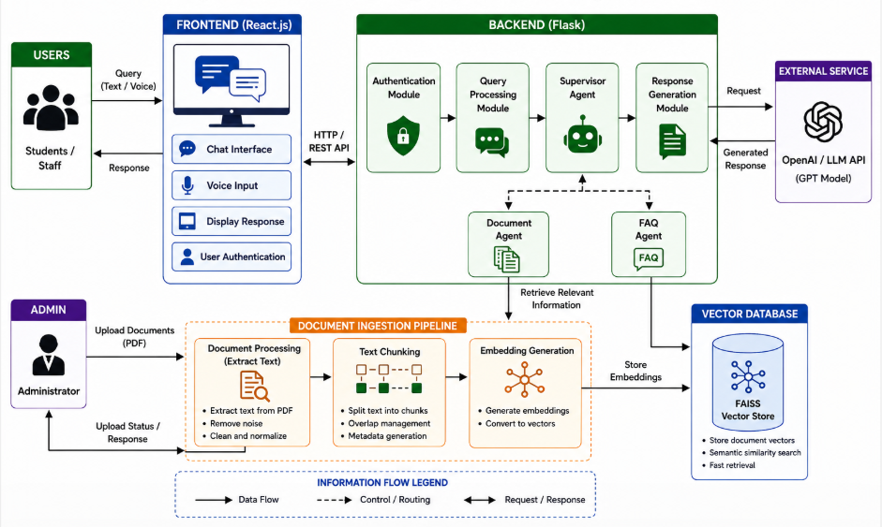
Figure 4.1.1 : Architecture Diagram

The system is designed using a client-server architecture where the frontend interface communicates with backend services through REST APIs. The frontend of the application is developed using React.js, which provides an interactive and user-friendly environment for students and administrators. The backend is implemented using Flask, which manages query processing, document handling, API integration, and response generation.

The proposed chatbot architecture consists of several major components including:
- User Interface Layer
- Authentication Module
- Admin Document Upload Module
- Document Processing Module
- Embedding and Vector Storage Module
- Multi-Agent Query Handling Module
- Large Language Model Integration
- Response Generation Module

The User Interface Layer allows users to interact with the chatbot through text or voice-based queries. The Authentication Module manages user login and access control functionalities for students and administrators. Administrators can upload institutional documents such as academic regulations, timetables, circulars, and notices through the Admin Module.
Once documents are uploaded, the Document Processing Module extracts textual information from the documents and divides the content into smaller chunks for efficient processing. These chunks are converted into vector embeddings using embedding models and stored in the FAISS (Facebook AI Similarity Search) vector database. The vector database enables semantic similarity search and efficient retrieval of contextually relevant information.
The chatbot uses a multi-agent architecture consisting of:
- Supervisor Agent
- Document Agent
- FAQ Agent

The Supervisor Agent acts as the central coordinator of the system by analyzing incoming user queries and routing them to the appropriate agent. The Document Agent handles queries that require semantic retrieval from institutional documents, while the FAQ Agent processes predefined and commonly asked questions.

The Retrieval-Augmented Generation (RAG) mechanism retrieves relevant contextual information from the FAISS vector database and passes it to the Large Language Model for response generation. This approach improves response accuracy and contextual understanding compared to traditional keyword-based systems.

The architectural design of the proposed system focuses on modularity, scalability, and efficient information retrieval. The integration of semantic search, multi-agent coordination, and conversational AI enables the system to provide accurate and user-friendly responses within an academic environment.

4.2 Context Diagram
A context diagram provides a high-level representation of the interaction between the proposed chatbot system and external entities such as users, administrators, and external services. It illustrates the flow of information into and out of the system without showing internal processing details.
In the proposed system, the primary external entities are:
- Student/User
- Administrator
- OpenAI API
- FAISS Vector Database

Students interact with the chatbot by submitting text or voice-based queries and receiving responses related to academic information. Administrators upload institutional documents that are processed and stored for retrieval purposes. The chatbot communicates with the OpenAI API for Large Language Model response generation and interacts with the FAISS vector database for semantic similarity search and document retrieval.
The context diagram helps in understanding the overall communication flow and system boundaries of the proposed application. It provides a simplified overview of how different external entities interact with the chatbot system and contribute to information exchange within the application.

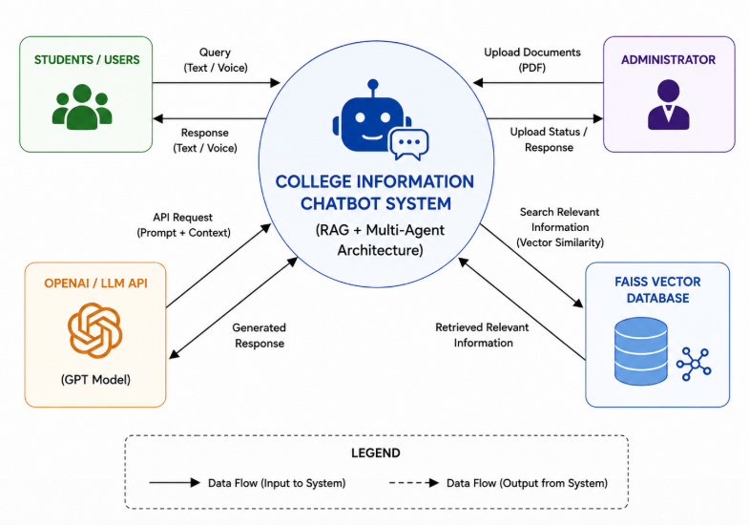
Figure 4.2.1 : Context Diagram
The context diagram shown above Figure 4.2.1 represents the overall interaction between the College Information Chatbot System and its external entities. The chatbot system acts as the central component that processes user requests, retrieves relevant information, and generates conversational responses.
Students and users interact with the system by submitting queries through text or voice input. These queries may include requests related to academic schedules, course information, examination details, notices, or institutional regulations. The chatbot processes these requests and returns context-aware responses to the users.
The administrator is responsible for uploading institutional documents such as academic regulations, timetables, circulars, and notices in PDF format. These documents are processed by the system and stored for semantic retrieval. The system also provides upload status and processing responses back to the administrator.
The chatbot communicates with the OpenAI API to generate natural language responses using Large Language Models. Relevant contextual information retrieved from the vector database is combined with the user query before being forwarded to the LLM for response generation.
The FAISS vector database stores document embeddings generated during the document processing stage. When a user submits a query, the chatbot performs semantic similarity search within the vector database to retrieve the most relevant information related to the query.

CHAPTER 5
DETAILED DESIGN
5.1 System Design
The detailed design phase describes the internal structure, behavior, and interaction of various modules within the proposed chatbot system. The system is designed using an object-oriented approach to improve modularity, maintainability, scalability, and efficient interaction among system components. The proposed College Information Chatbot integrates Retrieval-Augmented Generation (RAG), semantic search, and multi-agent architecture to provide context-aware academic information retrieval.
The detailed design includes UML diagrams and data flow representations that illustrate system functionality, communication flow, and database interactions. These diagrams help in understanding the architecture and operational behavior of the system during implementation and execution.
The following design diagrams are included in this chapter:
- Class Diagram
- Use Case Diagram
- Activity Diagram
- Sequence Diagram
- Data Flow Diagrams (Level 0, Level 1, and Level 2)
- Database Design (ER Diagram)
These diagrams collectively represent the structural and behavioral aspects of the proposed system.
Class Diagram
The class diagram shown below Figure 5.1.1 represents the object-oriented structure of the proposed College Information Chatbot System. It illustrates the major classes used in the application along with their attributes, methods, and relationships. The diagram helps in understanding how different modules within the system interact with each other to perform various operations related to user interaction, document management, semantic retrieval, and chatbot response generation.

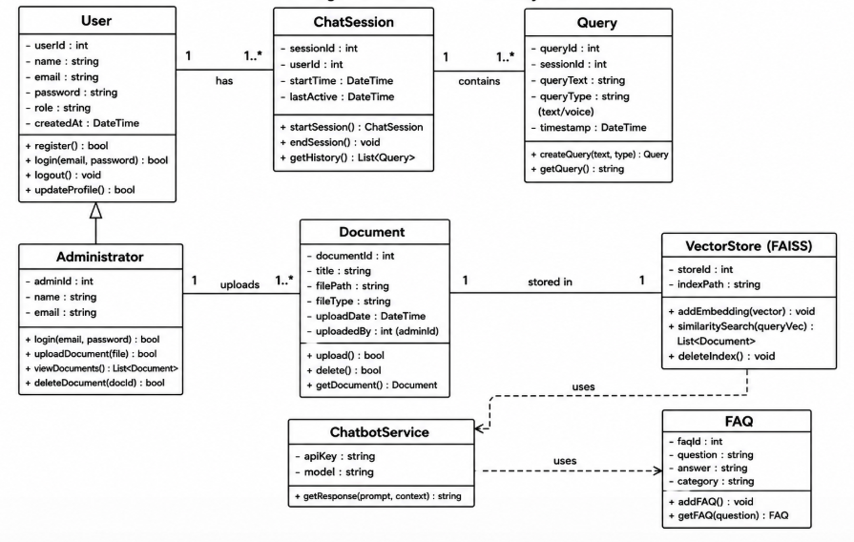
Figure 5.1.1 : Class Diagram

The User class represents students or users who interact with the chatbot system. It contains basic attributes such as user ID, name, email, password, role, and account creation details. The methods included in this class handle functionalities such as user registration, login, logout, and profile updates. A user can have one or more chat sessions within the application.

The ChatSession class is responsible for managing user conversations with the chatbot. It stores session-related details such as session ID, user ID, session start time, and last active time. This class helps maintain conversation history and track interactions between users and the chatbot system.

The Query class represents the questions or requests submitted by users. It stores information such as query ID, session ID, query text, query type, and timestamp. The chatbot processes these queries to generate relevant responses based on uploaded institutional documents and predefined FAQs.

The Administrator class represents the admin user responsible for managing institutional documents within the system. The administrator can upload, view, and delete documents used by the chatbot for semantic retrieval. This class maintains the relationship between the administrator and uploaded documents.

The Document class stores details of uploaded files such as document ID, title, file path, upload date, and uploaded user information. These documents are processed and converted into embeddings for semantic search operations.

The VectorStore (FAISS) class represents the vector database used to store embeddings generated from uploaded documents. It performs semantic similarity search operations to retrieve contextually relevant information based on user queries. This component plays an important role in the Retrieval-Augmented Generation (RAG) pipeline of the chatbot system.

The FAQ class stores frequently asked questions and predefined answers related to academic information. It helps the chatbot provide quick responses for common queries without performing document retrieval every time.

The ChatbotService class acts as the central processing component of the system. It communicates with the vector database and FAQ module to retrieve relevant information and generate responses using the integrated Large Language Model (LLM). This class handles the core conversational functionality of the chatbot.

Overall, the class diagram provides a simplified and structured representation of the chatbot system using object-oriented principles. It demonstrates how different classes collaborate to support authentication, document handling, semantic retrieval, and intelligent conversational response generation within the proposed application.

Use Case Diagram
Figure 5.1.2 illustrates the Use Case Diagram of the proposed College Information Chatbot System. The diagram represents the interaction between external actors and the functionalities provided by the chatbot application. It provides a high-level view of how users and administrators communicate with the system to perform different operations.

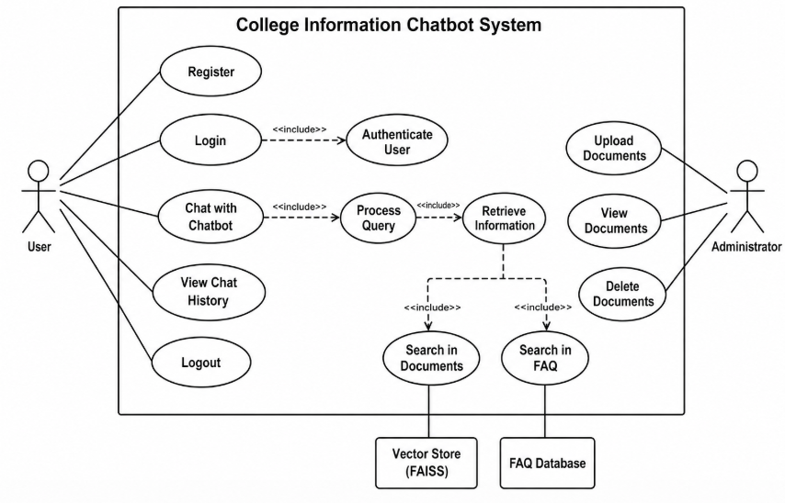
Figure 5.1.2 : Use Case Diagram
The system consists of two primary actors:
- User
- Administrator
The User actor represents students or individuals who interact with the chatbot to obtain academic and institutional information. The user can perform operations such as registration, login, chatting with the chatbot, viewing chat history, and logout.
The Register use case allows new users to create an account in the system. After successful registration, users can access the chatbot functionalities by performing the Login operation. The login process includes the Authenticate User functionality, where the system verifies the user credentials before granting access.
The Chat with Chatbot use case represents the primary functionality of the application. When a user submits a query, the system performs Process Query operations to analyze and understand the request. The processed query is then forwarded to the Retrieve Information module to fetch relevant information.

The Retrieve Information functionality further includes two important operations:
- Search in Documents
- Search in FAQ
The Search in Documents use case retrieves contextually relevant information from the institutional documents stored in the FAISS vector database. This semantic retrieval mechanism helps the chatbot provide accurate responses based on uploaded academic documents.
The Search in FAQ use case retrieves answers from the FAQ database containing predefined and commonly asked questions. This allows the chatbot to quickly respond to standard queries without performing complete document retrieval operations.
The View Chat History use case enables users to access previous chatbot conversations and interaction records. The Logout use case allows users to securely exit the system after completing their interaction.
The Administrator actor manages institutional documents used by the chatbot system. The administrator can perform operations such as:
- Upload Documents
- View Documents
- Delete Documents
The Upload Documents use case allows the administrator to upload academic documents such as regulations, notices, timetables, and circulars into the system. These uploaded documents are later processed and stored in the vector database for semantic retrieval purposes. The administrator can also view existing uploaded documents and remove outdated or unnecessary files using the delete functionality.
Overall, the use case diagram provides a clear understanding of the interaction flow between users, administrators, and the chatbot system. It highlights the major functionalities supported by the application and demonstrates how Retrieval-Augmented Generation (RAG), semantic search, and document-based information retrieval are integrated within the proposed system.

Activity Diagram
The activity diagram represents the workflow and sequence of activities involved in query processing and document management within the chatbot system.
The process begins when the administrator uploads institutional documents into the system. The uploaded documents undergo text extraction, chunking, embedding generation, and vector storage operations. When a user submits a query, the system processes the request, retrieves relevant contextual information using semantic search, and generates responses using the Large Language Model.
The activity diagram helps in visualizing the operational flow and decision-making process within the system.
The activity diagram shows the flow of program in two different view here:
- Administrative
- User
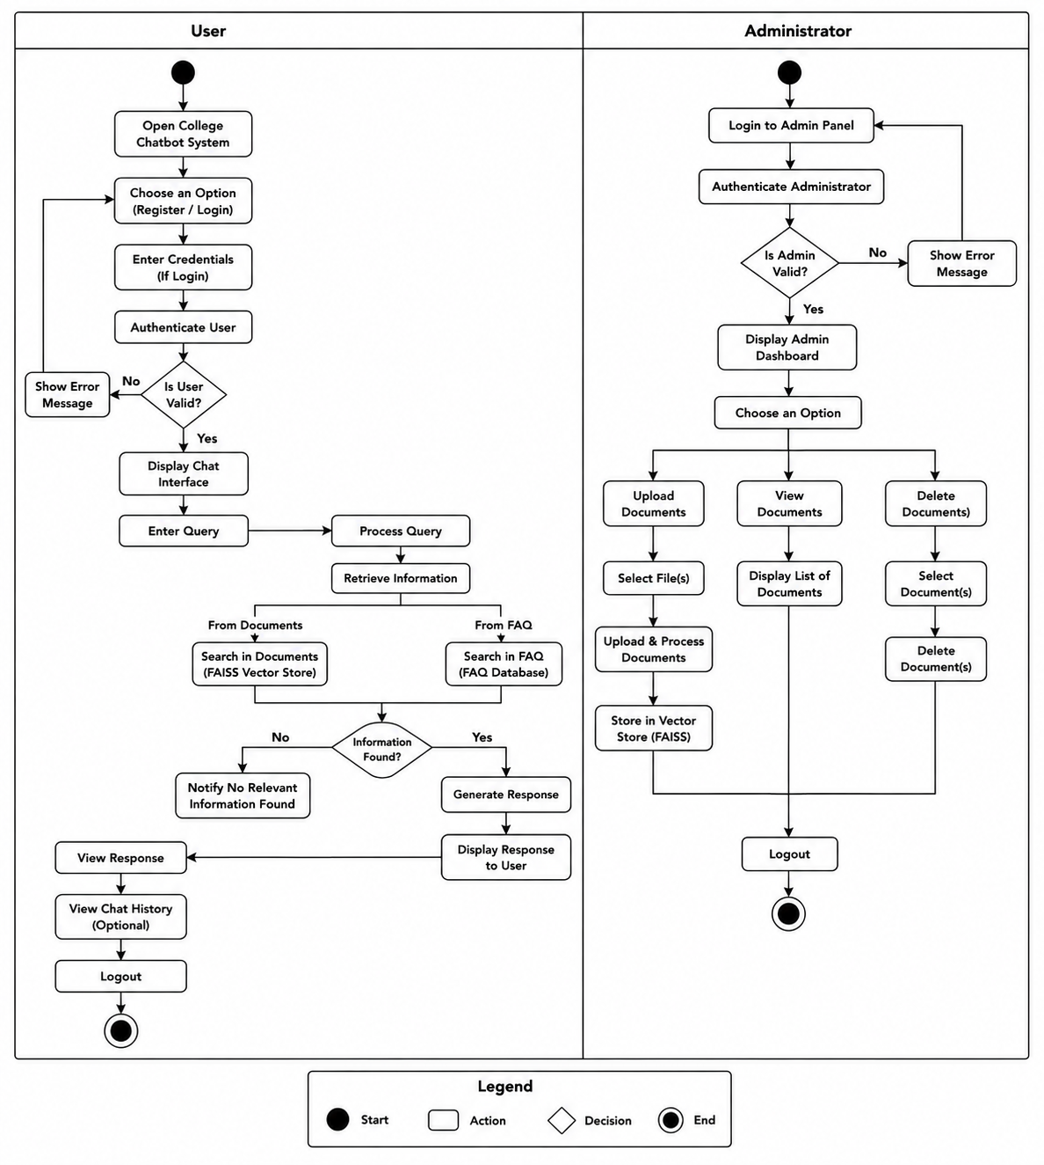
Figure 5.1.3 : Activity Diagram
Figure 5.1.3 illustrates the Activity Diagram of the proposed College Information Chatbot System. The diagram represents the overall workflow and sequence of activities performed by both the user and administrator within the system. It provides a clear understanding of how the chatbot processes user queries, retrieves relevant information, and manages institutional documents.
The activity diagram is divided into two major sections:
- User activities
- Administrator activities

The user workflow begins when the user opens the chatbot system and selects either the registration or login option. If the user chooses to log in, the system authenticates the provided credentials. A decision node checks whether the user credentials are valid. If the authentication fails, the system displays an error message and prompts the user to try again. If the authentication is successful, the chatbot interface is displayed.
After successful login, the user enters a query into the chatbot interface. The system processes the query and performs information retrieval operations. The retrieval process searches for relevant information from two major sources:
- Institutional documents stored in the FAISS vector database
- Frequently Asked Questions (FAQ) database
The system then checks whether relevant information is found. If suitable information is unavailable, the chatbot notifies the user that no relevant information was found. Otherwise, the system generates a response using the retrieved contextual information and displays the response to the user.
The user can then view the chatbot response, optionally access previous chat history, and finally log out from the system, which marks the end of the user activity flow.
The administrator workflow begins with logging into the admin panel. The administrator credentials are authenticated by the system. If the authentication fails, an error message is displayed. Upon successful authentication, the admin dashboard is displayed.
The administrator can perform multiple document management operations such as:
- Upload Documents
- View Documents
- Delete Documents

During the upload process, the administrator selects one or more institutional documents and uploads them into the system. The uploaded files undergo document processing and are stored in the FAISS vector database for semantic retrieval purposes. The administrator can also view the list of uploaded documents or remove unnecessary documents from the system.
Finally, the administrator logs out, which marks the completion of the administrative workflow.
Overall, the activity diagram provides a detailed representation of the operational flow, decision-making process, and interaction sequence within the proposed chatbot system. It helps in understanding how user requests, document management, authentication, and semantic retrieval functionalities are coordinated throughout the application.

Sequence Diagram
The sequence diagram illustrates the chronological interaction between different system components during query processing.

When a user submits a query, the frontend sends the request to the backend server through REST APIs. The Supervisor Agent analyzes the query and routes it to the appropriate processing agent. The Document Agent retrieves relevant information from the FAISS vector database and forwards contextual data to the Large Language Model through the OpenAI API. The generated response is then returned to the user interface.

The sequence diagram helps in understanding the communication sequence and message flow among system components.

Below Figure 5.1.4 illustrates the Sequence Diagram of the proposed College Information Chatbot System. The diagram represents the step-by-step interaction between the user and different system components during the query processing operation. It helps in understanding the sequence of communication and message flow within the chatbot system.

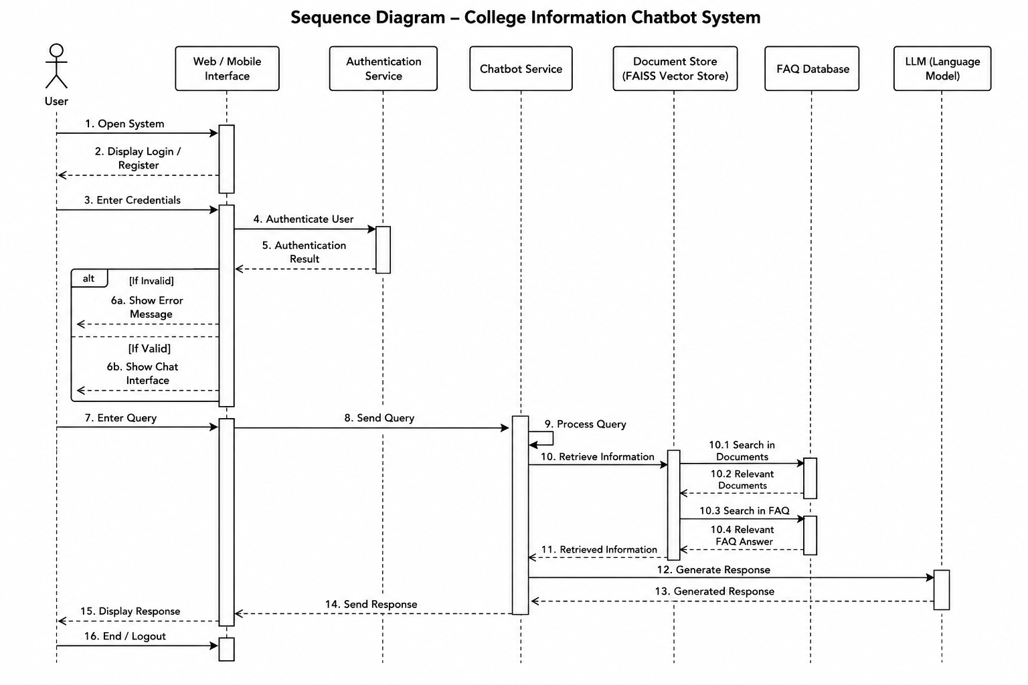
Figure 5.1.4 : Sequence Diagram

The sequence begins when the user opens the chatbot application through the web or mobile interface. The system displays the login or registration page, allowing the user to enter credentials for authentication. The entered credentials are sent to the Authentication Service, which verifies the user information and returns the authentication result.
If the authentication fails, the system displays an error message to the user. If the authentication is successful, the chatbot interface is displayed, allowing the user to interact with the system.
After successful login, the user enters a query into the chatbot interface. The query is forwarded to the Chatbot Service for processing. The Chatbot Service analyzes the query and performs information retrieval operations to obtain relevant academic information.
The retrieval process includes searching for relevant data from:
- Institutional documents stored in the FAISS Vector Store
- Frequently Asked Questions (FAQ) Database
The system first searches the vector database to retrieve contextually relevant document information. It also searches the FAQ database for predefined answers related to common queries. The retrieved information is then returned to the Chatbot Service.
After collecting relevant information, the Chatbot Service forwards the context and user query to the Large Language Model (LLM) for response generation. The LLM processes the input and generates a meaningful conversational response.
The generated response is returned to the Chatbot Service, which then sends the final response back to the user interface. The chatbot interface displays the response to the user. Finally, the user may end the session or log out from the system.
Overall, the sequence diagram provides a clear understanding of how different modules within the chatbot system communicate with each other during user authentication, query processing, semantic retrieval, and response generation operations.

Data Flow Diagrams (Level 0, Level 1, and Level 2)
The Data Flow Diagrams (DFDs) represent the movement of data within the chatbot system. The DFDs describe how information is processed, stored, and transferred between different entities and modules.

DFD Level 0
The Level 0 DFD provides a high-level overview of the chatbot system and external entities such as Students, Administrators, OpenAI API, and FAISS Vector Database.

DFD Level 1
The Level 1 DFD illustrates major internal modules including authentication, document processing, query handling, embedding generation, and response generation.

DFD Level 2
The Level 2 DFD provides a detailed representation of document ingestion, semantic retrieval, and multi-agent query routing operations.
The DFDs help in understanding the overall information processing and data movement within the application.

DFD Level 0:
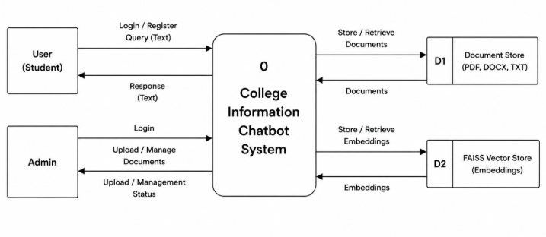
Figure 5.1.5 : DFD Level 0
Figure 5.1.5 illustrates the DFD Level 0 (Context Diagram) of the proposed College Information Chatbot System. The diagram provides a high-level representation of the overall system and shows how external entities interact with the chatbot application. It mainly focuses on the flow of information between users, administrators, and data storage components without describing the internal processing details.
The central process in the diagram is the College Information Chatbot System, which acts as the core component responsible for handling user queries, managing institutional documents, performing semantic retrieval, and generating chatbot responses.
The system interacts with two primary external entities:
- User (Student)
- Admin
The User (Student) interacts with the chatbot system by performing operations such as login, registration, and submitting text-based queries. The system processes these requests and returns chatbot responses containing academic or institutional information. The user communicates with the chatbot to retrieve details related to schedules, notices, regulations, events, and other college-related information.
The Admin entity is responsible for managing institutional documents used by the chatbot system. The administrator logs into the system and uploads or manages documents such as PDF, DOCX, and TXT files. The system processes these uploaded documents and provides upload or management status information back to the administrator.
The diagram also includes two important data stores:
- D1 – Document Store (PDF, DOCX, TXT)
- D2 – FAISS Vector Store (Embeddings)
The Document Store is used to store uploaded institutional documents in different formats. These documents are retrieved whenever required for processing and semantic search operations.
The FAISS Vector Store stores vector embeddings generated from the uploaded documents. These embeddings are used during semantic similarity search to retrieve contextually relevant information for user queries. The chatbot system stores and retrieves embeddings from the FAISS vector database to support Retrieval-Augmented Generation (RAG) functionality.
Overall, the DFD Level 0 diagram provides a simplified overview of the system boundary, external entities, data stores, and information flow within the proposed chatbot application. It helps in understanding the overall communication and interaction between users, administrators, and storage modules in the system.

DFD Level 1:
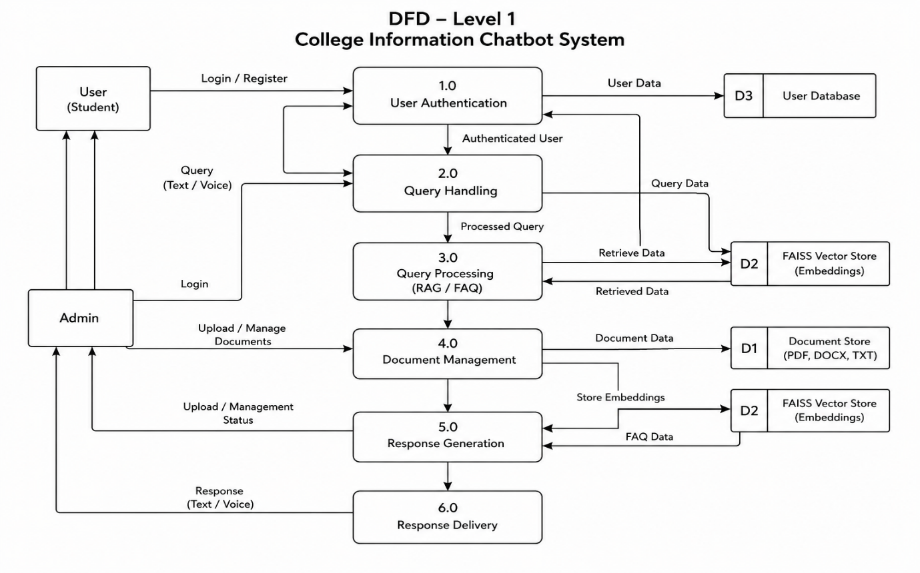
Figure 5.1.6 : DFD Level 1
Figure 5.1.6 illustrates the DFD Level 1 Diagram of the proposed College Information Chatbot System. The diagram provides a detailed representation of the major internal processes involved in user authentication, query handling, document management, semantic retrieval, and response generation within the chatbot application.
The Level 1 DFD decomposes the main chatbot system into multiple functional modules that interact with external entities and data stores. The primary external entities in the diagram are:
- User (Student)
- Admin
The user interacts with the chatbot system by performing login or registration operations and submitting text or voice-based queries. The admin manages institutional documents by uploading, updating, or maintaining document resources used by the chatbot.
The diagram contains six major processes:
1.0 User Authentication
This process handles user registration and login operations. User credentials are verified and authenticated using the User Database (D3). Once authentication is successful, the authenticated user can access chatbot functionalities.
2.0 Query Handling
The Query Handling module receives user queries in text or voice format. It preprocesses the input query and forwards the processed query to the Query Processing module for further semantic retrieval and response generation.
3.0 Query Processing (RAG / FAQ)
This module performs semantic retrieval operations using Retrieval-Augmented Generation (RAG) and FAQ-based retrieval methods. The system retrieves relevant contextual information from the FAISS Vector Store (D2) and processes the query using semantic similarity search techniques.
4.0 Document Management
The Document Management module handles document upload and maintenance operations performed by the administrator. Uploaded documents in formats such as PDF, DOCX, and TXT are stored in the Document Store (D1). The system also generates embeddings from these documents and stores them in the FAISS Vector Store.
5.0 Response Generation
This module generates chatbot responses using the retrieved contextual information from the vector database and FAQ data. The processed query and retrieved information are combined to generate meaningful and context-aware responses using the integrated Large Language Model (LLM).
6.0 Response Delivery
The final generated response is delivered back to the user in text or voice format through the chatbot interface. This module ensures proper communication between the chatbot backend and frontend interface.
The diagram also includes three important data stores:
- D1 – Document Store
- D2 – FAISS Vector Store (Embeddings)
- D3 – User Database
The Document Store maintains uploaded institutional documents, while the FAISS Vector Store stores vector embeddings used for semantic search operations. The User Database stores user credentials and authentication-related information.
Overall, the DFD Level 1 Diagram provides a detailed understanding of the internal workflow, data movement, and processing modules involved in the proposed chatbot system. It clearly illustrates how user queries, document management, authentication, semantic retrieval, and response generation are interconnected within the application.

DFD Level 2:
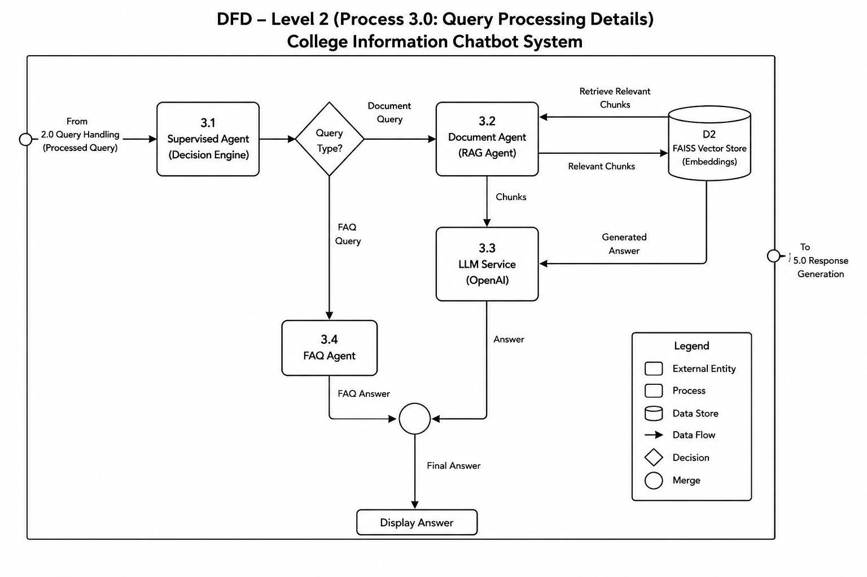
Figure 5.1.7 : DFD Level 2
Figure 5.1.7 illustrates the DFD Level 2 Diagram of the proposed College Information Chatbot System. This diagram provides a more detailed representation of the internal workflow involved in the query processing module of the chatbot system. It mainly focuses on how user queries are analyzed, routed, processed, and converted into meaningful responses using the multi-agent architecture and Retrieval-Augmented Generation (RAG) mechanism.
The Level 2 DFD is a decomposition of the 3.0 Query Processing module shown in the Level 1 DFD. It explains the detailed interaction between different agents, vector databases, and Large Language Model services used within the chatbot system.
The query processing workflow begins when a processed query is received from the 2.0 Query Handling module. The query is first forwarded to the 3.1 Supervised Agent (Decision Engine).
3.1 Supervised Agent (Decision Engine)
The Supervised Agent acts as the central coordinator of the chatbot system. It analyzes the incoming user query and determines the type of query received. Based on the query content, the agent decides whether the request should be handled through document retrieval using RAG or through the FAQ retrieval mechanism.
A decision node labeled “Query Type?” is used to classify the query into:
- Document Query
- FAQ Query
If the query requires contextual information from uploaded institutional documents, it is forwarded to the 3.2 Document Agent (RAG Agent).
3.2 Document Agent (RAG Agent)
The Document Agent performs semantic retrieval operations using the FAISS Vector Store. It sends retrieval requests to the D2 FAISS Vector Store (Embeddings) and retrieves the most relevant document chunks related to the user query. These retrieved chunks are then forwarded to the Large Language Model service for response generation.
D2 – FAISS Vector Store
The FAISS Vector Store stores embeddings generated from institutional documents. It enables semantic similarity search and helps retrieve contextually relevant document information for user queries.
3.3 LLM Service (OpenAI)
The LLM Service receives contextual document chunks from the Document Agent and generates meaningful conversational responses using the integrated Large Language Model. The generated answer is returned for final response preparation.
If the query is identified as a common or predefined question, the query is forwarded to the 3.4 FAQ Agent.
3.4 FAQ Agent
The FAQ Agent handles frequently asked questions stored within the system. It retrieves predefined answers related to standard institutional queries such as office timings, department details, admission procedures, or contact information.
The responses generated by both the LLM Service and FAQ Agent are merged together through the merge node to form the Final Answer. The final response is then sent to the response generation and display module for delivery to the user.
Overall, the DFD Level 2 diagram provides a detailed understanding of the internal query routing, semantic retrieval, multi-agent coordination, and response generation mechanisms used within the proposed chatbot system. It clearly demonstrates how the system integrates supervised agents, vector databases, FAQ retrieval, and Large Language Models to generate accurate and context-aware responses for users.

Database Design (ER Diagram)

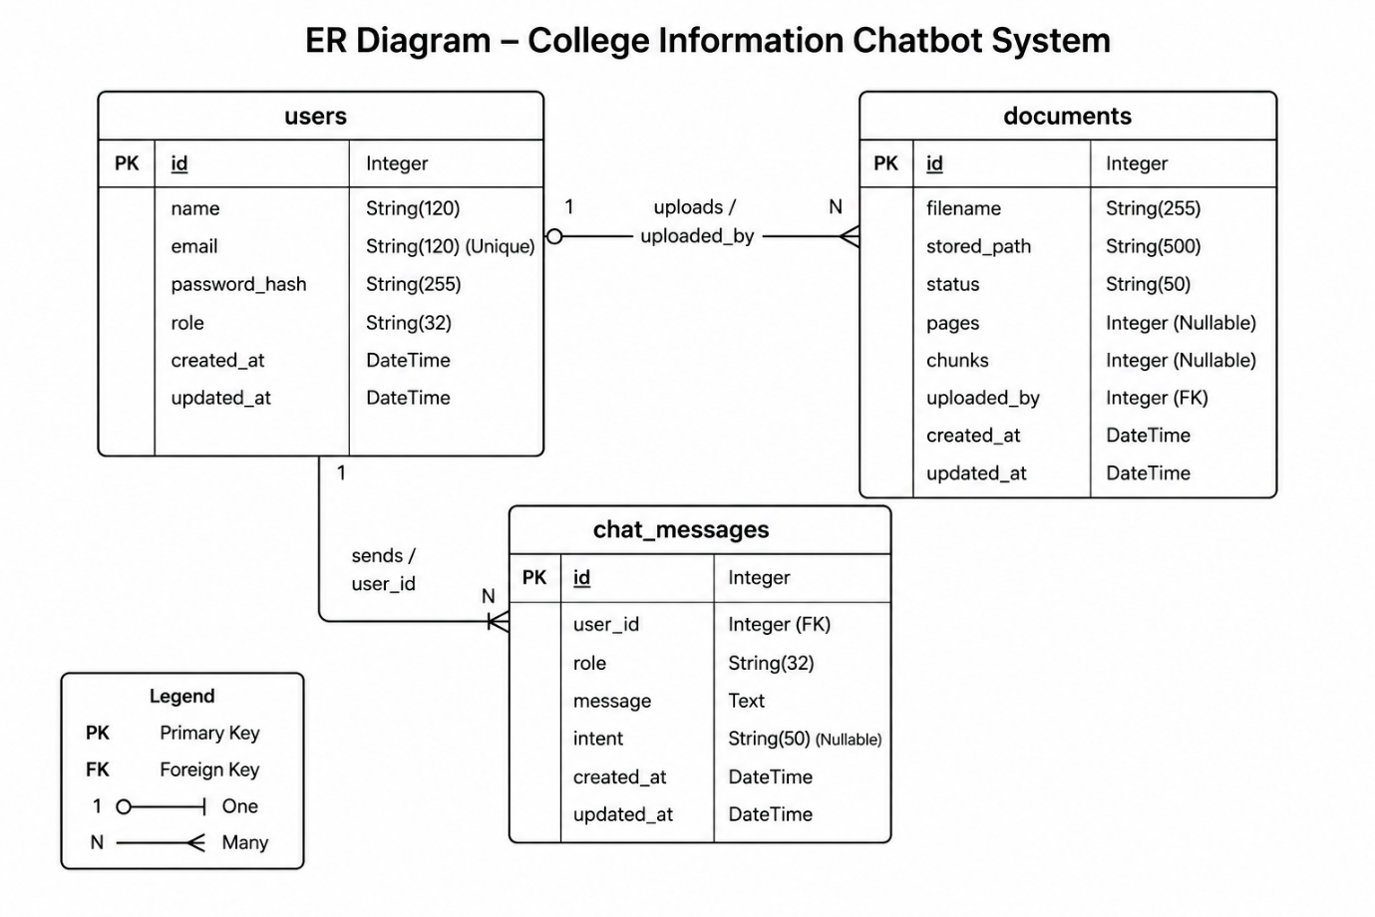
Figure 5.1.8 : ER Diagram
Figure 5.1.8 illustrates the Entity Relationship (ER) Diagram of the proposed College Information Chatbot System. The ER diagram represents the database structure of the application and shows the relationships between different entities used for storing user information, uploaded documents, and chatbot conversation records.
The proposed database design mainly consists of three entities:
- users
- documents
- chat_messages
These entities are connected using primary key and foreign key relationships to maintain proper data organization and integrity within the system database.
Users Entity
The users table stores information related to both students and administrators who access the chatbot system. The attributes included in this entity are:
- id – Primary Key
- name
- email
- password_hash
- role
- created_at
- updated_at
The id field uniquely identifies each user in the system. The email attribute is unique and used during user authentication. The password_hash field securely stores encrypted passwords, while the role attribute differentiates between student users and administrators. Timestamp fields are used to track account creation and update information.
Documents Entity
The documents table stores details related to institutional documents uploaded into the chatbot system. The attributes included are:
- id – Primary Key
- filename
- stored_path
- status
- pages
- chunks
- uploaded_by – Foreign Key
- created_at
- updated_at
The uploaded_by field acts as a foreign key that references the id field in the users table. This relationship helps identify which administrator uploaded a particular document. The status field stores the document processing state, while the pages and chunks fields maintain information related to document chunking and embedding generation used during semantic retrieval.
Chat Messages Entity
The chat_messages table stores chatbot conversation history and user interactions. The attributes included are:
- id – Primary Key
- user_id – Foreign Key
- role
- message
- intent
- created_at
- updated_at
The user_id field references the id field in the users table and establishes the relationship between users and their chatbot conversations. The role field identifies whether the message belongs to the user or chatbot. The intent field stores the detected category or purpose of the user query during query processing.
Relationships Between Entities
The ER diagram mainly contains the following relationships:
- One user can upload multiple documents
- One user can generate multiple chat messages
These relationships are represented using one-to-many associations between the users entity and the documents and chat_messages entities.
Overall, the ER diagram provides a structured representation of the relational database schema used in the proposed chatbot system. It helps in understanding how user accounts, uploaded documents, and chatbot conversations are stored, managed, and interconnected within the application database.

Assumption Made
The following assumptions were considered during the design and development of the proposed College Information Chatbot System:
- Users have basic knowledge of using web-based applications and chatbot interfaces.
- A stable internet connection is available for accessing the chatbot system and external API services.
- Institutional documents uploaded by the administrator are in supported formats such as PDF, DOCX, or TXT.
- Uploaded documents contain readable textual content for document processing and semantic retrieval operations.
- The OpenAI API service is available during chatbot execution for response generation.
- Administrators are responsible for periodically updating institutional documents to maintain accurate chatbot responses.
- Users provide queries in understandable text or voice format for efficient query processing.
- Modern web browsers such as Google Chrome or Microsoft Edge are available for accessing the application interface.
- The system is designed mainly for academic information retrieval and does not handle sensitive financial or confidential institutional operations.

5.2 Detailed design
The detailed design section describes the internal logic and operational flow of the major modules used in the proposed College Information Chatbot System. The system is designed using a modular approach where each module performs a specific functionality related to authentication, document processing, semantic retrieval, query handling, and response generation.
The module-wise logic helps in understanding the sequence of operations carried out within the application during runtime execution.
The major modules included in the system are:
- User Authentication Module
- Document Upload and Management Module
- Document Processing Module
- Embedding Generation Module
- Query Handling Module
- Supervisor Agent Module
- Document Agent Module
- FAQ Agent Module
- Response Generation Module
- Response Delivery Module
5.2.1 User Authentication Module
Purpose
The User Authentication Module handles user registration, login, and credential verification operations.

Module Logic :
START

Receive user registration or login request

IF user selects registration THEN
Collect user details
Validate input fields
Encrypt password
Store user data in database
Display registration success message
ELSE
Receive email and password
Verify credentials from database

IF credentials are valid THEN
Allow access to chatbot system
ELSE
Display invalid login message
ENDIF
ENDIF

END

5.2.2 Document Upload and Management Module
Purpose
This module allows administrators to upload, manage, and maintain institutional documents within the system.
Module Logic
START

Admin logs into system

Select document upload option

Choose document file

IF file format is supported THEN
Store document in document storage
Save document metadata in database
Trigger document processing module
Display upload success status
ELSE
Display unsupported file format message
ENDIF

END

5.2.3 Document Processing Module
Purpose
The Document Processing Module extracts textual content from uploaded institutional documents.
Module Logic
START

Receive uploaded document

Extract textual content from file

Split extracted text into smaller chunks

Clean and preprocess text

Send chunks to embedding generation module

END

5.2.4 Embedding Generation Module
Purpose
This module converts document chunks into vector embeddings for semantic retrieval operations.
Module Logic
START

Receive processed text chunks

Generate vector embeddings using embedding model

Store embeddings in FAISS vector database

Update document processing status

END

5.2.5 Query Handling Module
Purpose
The Query Handling Module receives and preprocesses user queries.
Module Logic
START

Receive user query

Check query type (Text or Voice)

IF query is voice input THEN
Convert voice to text
ENDIF

Clean and preprocess query

Forward query to Supervisor Agent

END

5.2.6 Supervisor Agent Module
Purpose
The Supervisor Agent acts as the decision-making component that routes user queries to appropriate agents.
Module Logic
START

Receive processed query

Analyze query intent

IF query requires document retrieval THEN
Forward query to Document Agent
ELSE
Forward query to FAQ Agent
ENDIF

END

5.2.7 Document Agent Module
Purpose
The Document Agent performs semantic retrieval using the Retrieval-Augmented Generation (RAG) mechanism.
Module Logic
START

Receive query from Supervisor Agent

Search relevant embeddings in FAISS vector database

Retrieve top matching document chunks

Send retrieved chunks to LLM service

Receive generated response

Forward response to Response Generation Module

END

5.2.8 FAQ Agent Module
Purpose
The FAQ Agent handles predefined and commonly asked questions.
Module Logic
START

Receive query from Supervisor Agent

Search FAQ database

Retrieve matching answer

Forward answer to Response Generation Module

END

5.2.9 Response Generation Module
Purpose
This module generates final chatbot responses using retrieved contextual information.
Module Logic
START

Receive contextual data or FAQ response

Generate conversational response using LLM

Validate generated response

Forward final response to delivery module

END

5.2.10 Response Delivery Module
Purpose
The Response Delivery Module displays generated responses to users through the chatbot interface.
Module Logic
START

Receive final chatbot response

Display response to user interface

Store chat message in database

Maintain conversation history

END

Overall, the detailed design and module-wise logic of the proposed College Information Chatbot System provide a clear understanding of how different components within the application interact to perform authentication, document management, semantic retrieval, and conversational response generation. The modular architecture improves system maintainability, scalability, and efficient query processing by separating functionalities into independent modules. The integration of Retrieval-Augmented Generation (RAG), FAISS vector search, multi-agent query handling, and Large Language Models enables the chatbot to provide context-aware and accurate academic information to users. The detailed design also helps in simplifying implementation, testing, and future enhancement of the system within an educational environment.
CHAPTER 6
IMPLEMENTATION

The implementation phase focuses on the practical development of the proposed College Information Chatbot System using modern web technologies, Artificial Intelligence frameworks, and semantic retrieval mechanisms. This phase involves converting the system design and module specifications into a fully functional application capable of handling user authentication, document processing, semantic search, and conversational response generation.
The proposed system was implemented using a modular client-server architecture. The frontend of the application was developed using React.js to provide an interactive and responsive user interface for students and administrators. The backend was implemented using Flask, which handled API communication, query processing, document management, authentication, and interaction with external AI services.
The chatbot system integrates Retrieval-Augmented Generation (RAG) with Large Language Models to improve the accuracy and contextual relevance of generated responses. Institutional documents uploaded by administrators are processed using text extraction and chunking techniques. The extracted content is converted into vector embeddings using Sentence Transformer models and stored in the FAISS vector database for semantic similarity search.
The implementation also incorporates a multi-agent architecture consisting of:
- Supervisor Agent
- Document Agent
- FAQ Agent
The Supervisor Agent analyzes incoming queries and routes them to the appropriate module. The Document Agent performs semantic retrieval from the FAISS vector database, while the FAQ Agent handles predefined and commonly asked questions. The retrieved contextual information is then forwarded to the Large Language Model through the OpenAI API to generate conversational responses.
The application supports both text-based and voice-based interaction. Speech recognition functionality is integrated to convert voice input into textual queries before processing. User authentication and document management functionalities are implemented using relational database models for secure storage and efficient data management.

The implementation phase mainly focuses on:
- User Authentication
- Admin Document Upload
- Document Processing and Chunking
- Embedding Generation
- Semantic Retrieval using FAISS
- Multi-Agent Query Routing
- Conversational Response Generation
- Chat History Management
- Voice-Based Interaction
The developed system was tested under different query scenarios to ensure proper functionality, response generation, and efficient information retrieval within the academic environment.

6.1 Code Snippets
This section presents important code snippets used in the implementation of the proposed College Information Chatbot System. The snippets demonstrate key functionalities such as user authentication, document upload, semantic retrieval, vector storage, and chatbot response generation. The implementation was carried out using Python, Flask, React.js, LangChain, FAISS, and OpenAI APIs.

User Authentication Model
The following code snippet represents the user authentication model used for storing user details and managing login credentials securely.
class User(TimestampMixin, db.Model):
__tablename__ = "users"

id = db.Column(db.Integer, primary_key=True)
name = db.Column(db.String(120), nullable=False)
email = db.Column(db.String(120), unique=True, nullable=False)
password_hash = db.Column(db.String(255), nullable=False)
role = db.Column(db.String(32), nullable=False, default="student")

def set_password(self, password):
self.password_hash = bcrypt.generate_password_hash(password).decode("utf-8")
Document Upload Model
The following code snippet stores uploaded institutional document information within the database.
class Document(TimestampMixin, db.Model):
__tablename__ = "documents"

id = db.Column(db.Integer, primary_key=True)
filename = db.Column(db.String(255), nullable=False)
stored_path = db.Column(db.String(500), nullable=False)
status = db.Column(db.String(50), nullable=False, default="uploaded")
pages = db.Column(db.Integer, nullable=True)
chunks = db.Column(db.Integer, nullable=True)

Chat Message Storage
The following snippet stores user queries and chatbot responses for maintaining conversation history.
class ChatMessage(TimestampMixin, db.Model):
__tablename__ = "chat_messages"

id = db.Column(db.Integer, primary_key=True)
user_id = db.Column(db.Integer, db.ForeignKey("users.id"), nullable=False)
role = db.Column(db.String(32), nullable=False)
message = db.Column(db.Text, nullable=False)
intent = db.Column(db.String(50), nullable=True)

Document Processing and Chunking
The following code performs document loading and text chunking operations.
loader = PyPDFLoader(file_path)
documents = loader.load()
text_splitter = RecursiveCharacterTextSplitter(
chunk_size=500,
chunk_overlap=50
)
chunks = text_splitter.split_documents(documents)

Embedding Generation and FAISS Storage
The following snippet generates vector embeddings and stores them in the FAISS vector database.
embedding_model = HuggingFaceEmbeddings(
model_name="sentence-transformers/all-MiniLM-L6-v2"
)
vector_store = FAISS.from_documents(
chunks,
embedding_model
)
vector_store.save_local("faiss_index")

Query Retrieval using RAG
The following code retrieves relevant document chunks based on user queries.
retriever = vector_store.as_retriever(search_kwargs={"k": 3})
relevant_docs = retriever.get_relevant_documents(user_query)

OpenAI Response Generation
The following snippet generates chatbot responses using the OpenAI API.
response = client.chat.completions.create(
model="gpt-4o-mini",
messages=[
{"role": "system", "content": system_prompt},
{"role": "user", "content": user_query}
]
)
answer = response.choices[0].message.content

Voice Input Handling
The following code snippet converts voice input into text using speech recognition.
recognizer = sr.Recognizer()
with sr.Microphone() as source:
audio = recognizer.listen(source)
query = recognizer.recognize_google(audio)
6.2 Implementation
The implementation phase of the proposed College Information Chatbot System focused on developing a practical and user-friendly application capable of providing academic information through conversational interaction. The system was built by integrating web development technologies, semantic search techniques, and Large Language Models to improve the quality and relevance of responses generated for users.
The frontend part of the application was developed using React.js along with Tailwind CSS to create a responsive and easy-to-use interface. The chatbot interface allows students to register, log in, ask queries, and receive responses in a conversational format. Users can also access their previous chat interactions through the chat history feature. Separate functionalities were provided for administrators to upload and manage institutional documents within the system.
The backend services were developed using the Flask framework. The backend manages important operations such as user authentication, document handling, query processing, API communication, and response generation. REST APIs were created to establish communication between the frontend and backend modules. The backend also interacts with external AI services for generating conversational responses using Large Language Models.
To support Retrieval-Augmented Generation (RAG), the system includes a document processing pipeline. Institutional documents uploaded by the administrator are first processed using text extraction techniques. The extracted content is then divided into smaller text chunks to improve semantic retrieval efficiency. These text chunks are converted into embeddings using Sentence Transformer models.
The generated embeddings are stored in the FAISS vector database, which performs semantic similarity search during query processing. Whenever a user submits a query, the system searches for contextually relevant information from the vector database and forwards the retrieved content to the language model for response generation. This approach helps the chatbot generate more meaningful and accurate responses compared to traditional keyword-based systems.
The chatbot architecture follows a multi-agent approach consisting of:
- Supervisor Agent
- Document Agent
- FAQ Agent

The Supervisor Agent acts as the central coordinator by analyzing user queries and deciding which module should handle the request. Queries related to uploaded institutional documents are processed through the Document Agent using semantic retrieval, while common or predefined questions are handled through the FAQ Agent.
The system also supports voice-based interaction by integrating speech recognition functionality. User voice input is converted into text before being processed by the chatbot system. This feature improves accessibility and enhances user interaction with the application.
After implementation, the system was tested using different academic query scenarios to evaluate response accuracy, semantic retrieval performance, and overall functionality. The chatbot was able to retrieve relevant information from uploaded institutional documents and generate context-aware responses successfully. The modular architecture and integration of semantic search techniques helped improve the efficiency and usability of the proposed system within an academic environment.

CHAPTER 7
SOFTWARE TESTING
Testing is one of the more important stages in building any software system. It's how you verify that what was built actually works the way it's supposed to under normal conditions and edge cases alike. For this project, the chatbot system was tested across all its major modules, starting with individual unit tests, then progressively combining modules for integration and system-level testing. Each module has its own test case numbering, and screenshots were captured during testing to document both passing and failing scenarios.

7.1 Test cases
Unit Test Cases
Unit testing was performed on each module independently. Each module was tested in isolation to confirm it behaved correctly before being combined with others.

Module 1: User Authentication
Type of Unit Testing: Black-box testing
Test Case ID | Test Scenario | Expected Result | Actual Result | Status | Remarks
AUTH-TC01 | Login with valid username and password | User redirected to dashboard | Dashboard loaded successfully | Passed | —
AUTH-TC02 | Login with an incorrect password | Invalid credentials error shown | Error message displayed correctly | Passed | —
AUTH-TC03 | Submit login form with empty fields | Form validation error triggered | No validation triggered initially; form submitted blank | Failed | Fixed by adding required field validation on the frontend
Table 7.1.1 : User Authentication Test Case

Module 2: User Registration
Type of Unit Testing: Black-box testing
Test Case ID | Test Scenario | Expected Result | Actual Result | Status | Remarks
REG-TC01 | Register with all valid details | New account created successfully | Account created and confirmed | Passed | —
REG-TC02 | Register with an already existing email | Duplicate account error displayed | No error shown; duplicate account was created | Failed | Fixed by adding a unique email constraint check in the backend
REG-TC03 | Register without entering a password | Password field validation error shown | Validation error displayed correctly | Passed | —
Table 7.1.2 : User Registration Test Case

Module 3: Document Upload
Type of Unit Testing: Boundary and black-box testing
Test Case ID | Test Scenario | Expected Result | Actual Result | Status | Remarks
DOC-TC01 | Upload a valid PDF document | File uploads and saved without errors | Upload completed successfully | Passed | —
DOC-TC02 | Upload a file in unsupported format (e.g., .mp4) | System rejects file with format warning | Unsupported format message displayed | Passed | —
Table 7.1.3 : Document Upload Test Case

Module 4: Document Processing and Embedding Generation
Type of Unit Testing: White-box testing
Test Case ID | Test Scenario | Expected Result | Actual Result | Status | Remarks
PROC-TC01 | Process an uploaded PDF document | Text extracted and split into chunks correctly | Chunking completed without errors | Passed | —
PROC-TC02 | Generate embeddings from document chunks | Embeddings created and stored in FAISS | Embeddings saved to FAISS successfully | Passed | —
Table 7.1.4 : Document Processing and Embedding Generation Test Case

Module 5: Query Processing and Semantic Retrieval
Type of Unit Testing: White-box and functional testing
Test Case ID | Test Scenario | Expected Result | Actual Result | Status | Remarks
QUERY-TC01 | Submit a valid academic question via text input | Chatbot returns a contextually relevant response | Relevant response generated correctly | Passed | —
QUERY-TC02 | Submit a query with no matching document content | System returns a fallback response | System returned an empty response with no message | Failed | Fixed by adding a fallback response handler when retrieval returns no results
Table 7.1.5 : Query Processing and Retrieval Test Case

Module 6: Voice Input
Type of Unit Testing: Functional testing
Test Case ID | Test Scenario | Expected Result | Actual Result | Status | Remarks
VOICE-TC01 | Submit a clear voice query | Voice transcribed accurately and response returned | Transcription correct, response generated | Passed | —
VOICE-TC02 | Submit voice input in a noisy environment | System shows partial transcription or prompts retry | Voice module threw an unhandled error with no user feedback | Failed | Fixed by speech recognition call in error handling.
Table 7.1.6 : Voice Input Test Case

Module 7: Chat History and Logout
Type of Unit Testing: Black-box testing
Test Case ID | Test Scenario | Expected Result | Actual Result | Status | Remarks
SESS-TC01 | View previous conversations from chat history panel | Past queries and responses load correctly | Chat history displayed accurately | Passed | —
SESS-TC02 | Log out from an active user session | Session ends and user redirected to login | Logout successful, login page shown | Passed | —
Table 7.1.7 : Chat History and Logout Test Case

CHAPTER 8
CONCLUSION
The College Information Chatbot System was developed to make academic information retrieval simpler, faster, and more interactive for students and institutional users. The project focused on creating a chatbot capable of understanding user queries and providing meaningful responses using modern Artificial Intelligence techniques such as Large Language Models (LLMs), Retrieval-Augmented Generation (RAG), semantic search, and multi-agent architecture.
Unlike traditional chatbot systems that mainly depend on keyword matching, the proposed system retrieves contextually relevant information from uploaded institutional documents before generating responses. This helped improve the accuracy and quality of responses provided to users. The integration of the FAISS vector database enabled efficient semantic retrieval, while the multi-agent approach improved query handling and response coordination within the chatbot system.
The developed application includes important functionalities such as user authentication, document upload and processing, embedding generation, semantic retrieval, chatbot response generation, chat history management, and voice-based interaction. Administrators can upload academic documents into the system, and users can interact with the chatbot through text or voice queries to retrieve institutional information in a conversational manner.
During implementation and testing, the chatbot system was evaluated using different academic query scenarios. The results showed that the system was able to retrieve relevant information successfully and generate context-aware responses with good accuracy. The integration of Retrieval-Augmented Generation with semantic similarity search improved the chatbot’s ability to provide more meaningful and reliable responses compared to conventional rule-based systems.
The modular structure of the application also makes the system easier to maintain, modify, and enhance in the future. Different modules such as authentication, document processing, semantic retrieval, and response generation worked together effectively during testing and validation.
Overall, the project successfully achieved its objectives by developing an intelligent and user-friendly academic support system. The proposed chatbot demonstrates how conversational Artificial Intelligence and semantic retrieval techniques can be applied in educational environments to improve accessibility to institutional information and enhance user interaction.

CHAPTER 9
FUTURE ENHANCEMENTS
The proposed College Information Chatbot System was successfully developed to provide academic information using conversational Artificial Intelligence and semantic retrieval techniques. Although the current system performs effectively for academic query handling and document-based information retrieval, there are several areas where the system can be further improved and expanded in the future. Future enhancements can help improve the overall performance, user experience, scalability, and intelligence of the chatbot application.

Advanced Large Language Model Integration
The current system uses Large Language Models for conversational response generation. In future development, more advanced OpenAI models and other modern LLMs can be tested to improve contextual understanding, response accuracy, and conversational quality. Comparing different models may also help identify better-performing solutions for educational chatbot applications.

Improved Response Speed and Optimization
As the number of uploaded documents and users increases, response generation and semantic retrieval operations may require additional optimization. Future improvements can focus on reducing retrieval time, improving embedding search performance, and optimizing backend processing to provide faster responses to users.

Enhanced Voice-Based Interaction
The present system supports basic voice-to-text interaction. Future enhancements can include advanced speech recognition techniques for handling noisy environments more effectively. Features such as multilingual voice support and text-to-speech response generation can also be integrated to make the chatbot more interactive and accessible for users.

Real-Time Data Integration
Currently, the chatbot mainly retrieves information from uploaded institutional documents. In future versions, the system can be integrated with real-time college databases and management systems such as:
- Attendance Management Systems
- Timetable Management Systems
- Examination Portals
- Notice Boards
- Student Information Systems
This integration would allow the chatbot to provide live updates and personalized academic information to students.

Mobile Application Support
The proposed chatbot is currently developed as a web-based application. In the future, dedicated mobile applications for Android and iOS platforms can be developed to improve accessibility and user convenience. Mobile support would allow students to access academic information more easily from smartphones and tablets.

Improved Security and Access Control
Future development can include stronger security mechanisms such as:
- Multi-factor authentication
- Advanced session management
- Role-based access control
- Activity monitoring and logging
These improvements can help enhance data protection and improve the overall reliability of the system.

Feedback-Based Learning
The chatbot can be enhanced with feedback-based learning mechanisms where user feedback is used to improve future responses. This would allow the system to gradually improve its response quality and conversational accuracy based on user interaction patterns.

Analytics and Monitoring Dashboard
An analytics dashboard can be developed for administrators to monitor chatbot usage, frequently asked questions, user activity, and system performance. This would help institutions better understand user requirements and improve the quality of information provided through the chatbot.

BIBLIOGRAPHY
[1] P. Lewis, E. Perez, A. Piktus, F. Petroni, V. Karpukhin, N. Goyal, H. Küttler, M. Lewis, W. Yih, T. Rocktäschel, S. Riedel, and D. Kiela, “Retrieval-Augmented Generation for Knowledge-Intensive NLP Tasks,” Advances in Neural Information Processing Systems, vol. 33, pp. 9459–9474, 2020.
[2] J. Johnson, M. Douze, and H. Jégou, “Billion-Scale Similarity Search with GPUs,” IEEE Transactions on Big Data, vol. 7, no. 3, pp. 535–547, 2021.
[3] M. Douze, A. Guzhva, C. Deng, J. Johnson, G. Szilvasy, P. Mazaré, M. Lomeli, L. Hosseini, and H. Jégou, “The Faiss Library,” IEEE Transactions on Pattern Analysis and Machine Intelligence, vol. 46, no. 5, pp. 3159–3176, 2024.
[4] A. Vaswani, N. Shazeer, N. Parmar, J. Uszkoreit, L. Jones, A. Gomez, Ł. Kaiser, and I. Polosukhin, “Attention Is All You Need,” in Proc. Advances in Neural Information Processing Systems, Long Beach, CA, USA, 2017, pp. 5998–6008.
[5] J. Devlin, M. Chang, K. Lee, and K. Toutanova, “BERT: Pre-training of Deep Bidirectional Transformers for Language Understanding,” in Proc. NAACL-HLT, Minneapolis, MN, USA, 2019, pp. 4171–4186.
[6] T. Brown, B. Mann, N. Ryder, M. Subbiah, J. Kaplan, P. Dhariwal, et al., “Language Models are Few-Shot Learners,” Advances in Neural Information Processing Systems, vol. 33, pp. 1877–1901, 2020.
[7] N. Reimers and I. Gurevych, “Sentence-BERT: Sentence Embeddings using Siamese BERT-Networks,” in Proc. EMNLP-IJCNLP, Hong Kong, China, 2019, pp. 3982–3992.
[8] V. Karpukhin, B. Oguz, S. Min, P. Lewis, L. Wu, S. Edunov, et al., “Dense Passage Retrieval for Open-Domain Question Answering,” in Proc. EMNLP, Online, 2020, pp. 6769–6781.
[9] T. Wolf, L. Debut, V. Sanh, J. Chaumond, C. Delangue, A. Moi, et al., “Transformers: State-of-the-Art Natural Language Processing,” in Proc. EMNLP: System Demonstrations, Online, 2020, pp. 38–45.
[10] V. Sanh, L. Debut, J. Chaumond, and T. Wolf, “DistilBERT, a Distilled Version of BERT,” in Proc. Fifth Workshop on Energy Efficient Machine Learning and Cognitive Computing, Vancouver, Canada, 2019, pp. 1–5.
[11] T. Mikolov, K. Chen, G. Corrado, and J. Dean, “Efficient Estimation of Word Representations in Vector Space,” in Proc. International Conference on Learning Representations Workshop, Scottsdale, AZ, USA, 2013.
[12] J. Pennington, R. Socher, and C. Manning, “GloVe: Global Vectors for Word Representation,” in Proc. EMNLP, Doha, Qatar, 2014, pp. 1532–1543.
[13] S. Hochreiter and J. Schmidhuber, “Long Short-Term Memory,” Neural Computation, vol. 9, no. 8, pp. 1735–1780, 1997.
[14] I. Goodfellow, Y. Bengio, and A. Courville, Deep Learning. Cambridge, MA, USA: MIT Press, 2016.
[15] S. Russell and P. Norvig, Artificial Intelligence: A Modern Approach, 4th ed. Pearson Education, 2021.
[16] D. Jurafsky and J. Martin, Speech and Language Processing, 3rd ed. Pearson Education, 2023.
[17] C. Manning, P. Raghavan, and H. Schütze, Introduction to Information Retrieval. Cambridge, U.K.: Cambridge University Press, 2008.
[18] Y. LeCun, Y. Bengio, and G. Hinton, “Deep Learning,” Nature, vol. 521, no. 7553, pp. 436–444, 2015.
[19] A. Graves, A. Mohamed, and G. Hinton, “Speech Recognition with Deep Recurrent Neural Networks,” in Proc. IEEE International Conference on Acoustics, Speech and Signal Processing (ICASSP), Vancouver, Canada, 2013, pp. 6645–6649.
[20] R. Collobert, J. Weston, L. Bottou, M. Karlen, K. Kavukcuoglu, and P. Kuksa, “Natural Language Processing (Almost) from Scratch,” Journal of Machine Learning Research, vol. 12, pp. 2493–2537, 2011.
[21] K. He, X. Zhang, S. Ren, and J. Sun, “Deep Residual Learning for Image Recognition,” in Proc. IEEE Conference on Computer Vision and Pattern Recognition (CVPR), Las Vegas, NV, USA, 2016, pp. 770–778.
[22] T. Chen and C. Guestrin, “XGBoost: A Scalable Tree Boosting System,” in Proc. ACM SIGKDD International Conference on Knowledge Discovery and Data Mining, San Francisco, CA, USA, 2016, pp. 785–794.
[23] G. Salton and C. Buckley, “Term-Weighting Approaches in Automatic Text Retrieval,” Information Processing & Management, vol. 24, no. 5, pp. 513–523, 1988.
[24] R. Baeza-Yates and B. Ribeiro-Neto, Modern Information Retrieval. New York, NY, USA: Addison-Wesley, 2011.
[25] I. Sutskever, O. Vinyals, and Q. Le, “Sequence to Sequence Learning with Neural Networks,” in Proc. Advances in Neural Information Processing Systems, Montreal, Canada, 2014, pp. 3104–3112.

