Enhancing Reliability in Retrieval-Augmented Conversational AI Through Self-Reflective Multi-Agent Verification
Dr. B.H. Chandrashekar  Associate Professor  Dept. of MCA  R V College of Engineering, Bengaluru, India  chandrashekarbh@rvce.edu.in | Swasthik Devadiga  PG Student  Dept. of MCA  R V College of Engineering, Bengaluru, India  swasthikd.mca24@rvce.edu.in

Abstract - Retrieval-Augmented Generation (RAG) improves the factual grounding of conversational AI systems by integrating external knowledge retrieval with large language models. However, conventional RAG pipelines may still generate irrelevant or hallucinated responses due to the absence of internal response verification. This paper proposes a self-reflective multi-agent framework for retrieval-augmented conversational systems. The proposed prototype incorporates a supervisory routing mechanism, a retrieval-based response generation module, and a reflective validation component that evaluates generated responses for relevance, completeness, and factual consistency before delivery. Unlike traditional single-pass architectures, the framework introduces an iterative self-validation process intended to improve response reliability and contextual accuracy. Preliminary observations suggest that integrating reflective verification within multi-agent RAG systems can help reduce hallucination tendencies and improve the overall quality of generated responses in knowledge-intensive conversational environments.

Keywords- Retrieval-Augmented Generation, Multi-Agent Systems, Self-Reflective AI, Conversational Systems, Large Language Models, Response Verification

I. INTRODUCTION

Large Language Models (LLMs) have significantly improved the capabilities of modern conversational systems by enabling natural language understanding and human-like response generation across domains such as education, healthcare, and customer support. However, these systems often suffer from hallucination and factual inconsistency, where generated responses may appear convincing despite lacking reliable grounding [1]. In addition, most language model based systems generate responses in a single-pass manner without any internal verification process, increasing the possibility of delivering inaccurate or incomplete information to users [2].

Retrieval-Augmented Generation (RAG) has emerged as an effective approach for improving response reliability by combining external knowledge retrieval with language generation [3]. In RAG-based systems, relevant information is retrieved from a document repository and supplied to the language model as contextual evidence before generating a response. Dense retrieval methods and vector similarity search techniques have further enhanced the effectiveness of semantic information retrieval in knowledge-intensive applications [6], [7]. However, conventional RAG pipelines still lack an internal mechanism to validate generated responses before delivery.

Recent research in multi-agent conversational architectures and self-reflective AI systems suggests that dividing tasks among specialized agents and incorporating iterative self-evaluation can improve reasoning quality and response reliability [4], [5], [10]. Motivated by these developments, this paper proposes a self-reflective multi-agent framework for retrieval-augmented conversational systems. The proposed prototype introduces a supervisory coordination mechanism, a retrieval-based response generation process, and a reflective validation component that evaluates generated outputs for relevance, completeness, and factual consistency prior to delivery.

The objective of this work is to present a generalized conceptual framework that demonstrates how reflective validation mechanisms can improve the reliability of retrieval-augmented conversational systems while reducing hallucination tendencies in knowledge-intensive environments.

II. RELATED WORK

A. Retrieval-Augmented Generation

Retrieval-Augmented Generation (RAG) improves the factual grounding of language models by combining external knowledge retrieval with response generation [3]. Dense retrieval methods such as Dense Passage Retrieval (DPR) have improved semantic search performance in knowledge-intensive tasks [6], while vector similarity search frameworks like FAISS enable efficient retrieval from large document collections [7]. Recent approaches have also explored retrieval-guided refinement and iterative retrieval mechanisms to improve contextual relevance and response quality [8], [9]. However, most existing RAG systems still lack an internal response verification mechanism.

B. Multi-Agent Language Systems

Multi-agent conversational systems distribute responsibilities among specialized agents to improve reasoning, coordination, and task handling. ReAct demonstrated that combining reasoning and action mechanisms can improve conversational decision-making and response generation [4]. Such architectures provide a flexible foundation for integrating retrieval, routing, and validation processes within conversational AI systems.

C. Self-Reflective and Self-Corrective AI

Self-reflective AI methods focus on enabling language models to evaluate and refine their own outputs through iterative feedback mechanisms. Reflexion introduced verbal self-feedback for improving reasoning performance [5], while SELF-REFINE demonstrated iterative response refinement using model-generated feedback [10]. These approaches indicate that internal self-evaluation can improve response quality and reduce generation errors. Motivated by these ideas, the proposed framework incorporates reflective validation within a retrieval-augmented multi-agent architecture to improve conversational reliability.

III. SYSTEM ARCHITECTURE

The proposed framework follows a multi-agent retrieval-augmented architecture integrated with a self-reflective validation layer. The overall workflow consists of query processing, contextual retrieval, response generation, and reflective verification before final response delivery. Fig. 1 illustrates the conceptual workflow of the proposed framework.

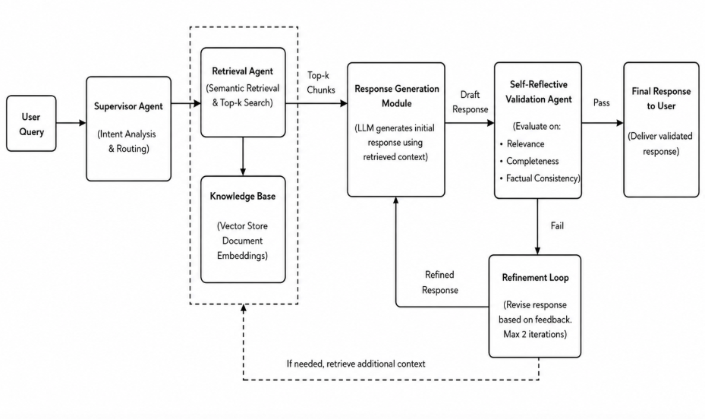

Fig. 1. Conceptual workflow of the proposed self-reflective retrieval-augmented framework.
- Knowledge Retrieval Layer

The framework employs a semantic retrieval mechanism in which user queries are transformed into vector representations and matched against a vectorized document repository. Relevant contextual information is retrieved and supplied to the response generation module to improve factual grounding and contextual relevance.

B. Multi-Agent Coordination
Fig. 2 presents the proposed multi-agent architecture consisting of a Supervisory Agent, Retrieval Agent, Response Generation Module, and Self-Reflective Validation Agent. The Supervisory Agent manages query routing and coordination between processing components. The Retrieval Agent is responsible for contextual document retrieval, while the response generation module produces an initial conversational response using the retrieved information.
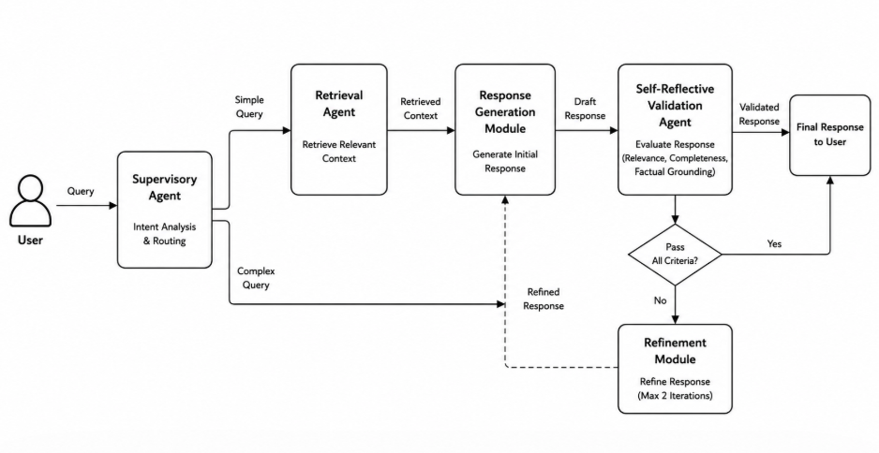

Fig. 2. Proposed multi-agent architecture with reflective validation mechanism.

C. Self-Reflective Validation

Before delivering the generated response to the user, the Self-Reflective Validation Agent evaluates the output for contextual relevance, completeness, and factual consistency. If the generated response does not satisfy the validation criteria, a refinement process is triggered to improve the response quality. This reflective verification stage is intended to reduce hallucination tendencies and improve the overall reliability of the conversational system.

IV. COMPONENT DESIGN
The proposed framework follows a modular architecture in which individual components are responsible for query coordination, contextual retrieval, response generation, and reflective validation. The separation of these functionalities improves adaptability and allows the framework to support different retrieval mechanisms and language generation models without modifying the overall workflow.
TABLE I. Functional Components of the Proposed Framework
Functional Component | Role in Framework
Supervisory Coordination | Manages query routing and workflow control
Retrieval Layer | Retrieves contextually relevant information
Response Generation | Produces context-aware conversational responses
Reflective Validation | Evaluates and refines generated outputs
Knowledge Repository | Stores indexed contextual information

The Supervisory Coordination component manages the interaction between processing modules and directs queries through the appropriate workflow path. The Retrieval Layer performs semantic information retrieval from the knowledge repository to provide contextual grounding for response generation. The Response Generation component produces conversational outputs using the retrieved contextual information, while the Reflective Validation component evaluates generated responses for relevance, completeness, and factual consistency before final delivery. The modular structure of the framework supports scalability, flexibility, and future integration with alternative conversational AI technologies.

V. PERFORMANCE AND EVALUATION
A. Evaluation Overview

A preliminary evaluation was conducted to analyse the effectiveness of the proposed self-reflective multi-agent framework in retrieval-augmented conversational environments. A collection of representative knowledge-intensive queries was used to observe response relevance, contextual consistency, and hallucination reduction across different conversational settings.
- Results and Comparative Analysis
The proposed framework was compared with conventional retrieval-augmented generation systems and multi-agent conversational approaches. Experimental observations suggest that integrating reflective validation improves contextual relevance and response reliability while reducing unsupported response generation.
TABLE II. Comparative Performance Observation
Framework | Accuracy | Relevance | Hallucination
Conv. RAG | 68% | 71% | Limited
Multi-Agent | 75% | 77% | Moderate
Proposed | 83% | 86% | Improved

The proposed framework demonstrated improved response quality compared to traditional single-pass retrieval architectures. The reflective validation mechanism helped reduce off-topic and weakly grounded responses by evaluating generated outputs before final delivery. Preliminary observations also indicated a noticeable reduction in hallucination tendencies during knowledge-intensive query handling.

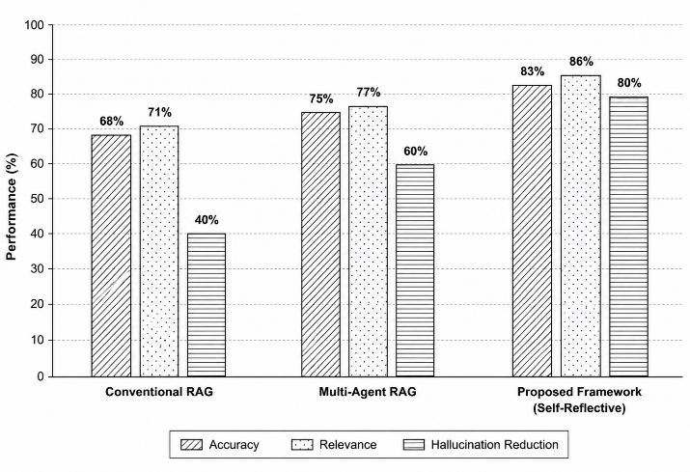

Fig. 3. Comparative analysis of conversational frameworks based on accuracy and contextual relevance.

Discussion

The evaluation indicates that incorporating reflective validation within multi-agent retrieval workflows can improve conversational reliability and contextual consistency. The refinement process enables generated responses to be re evaluated before delivery, reducing the propagation of unsupported information. Although reflective validation may introduce slight additional processing overhead in certain cases, the approach demonstrates the potential of iterative verification mechanisms for improving retrieval-augmented conversational systems.

VI. LIMITATIONS AND FUTURE WORK
A. Prototype Realization and Limitations

The proposed framework is designed as a modular conversational prototype that supports integration with different retrieval mechanisms, orchestration strategies, and language generation models. Although the framework demonstrates the potential of reflective validation in retrieval-augmented conversational systems, certain limitations remain. The effectiveness of the framework depends on the quality of retrieved contextual information, and reflective evaluation performed by the same language model may introduce potential bias during response verification. In addition, iterative validation mechanisms may increase response processing time for complex queries.
B. Future Work

Future research may focus on integrating hybrid retrieval strategies that combine semantic and lexical search techniques to improve contextual retrieval accuracy. The framework can also be extended by incorporating dedicated verification agents for independent response evaluation and adaptive refinement mechanisms for reducing unnecessary validation iterations. Further exploration involving open-source language models and domain-specific conversational environments may improve scalability, flexibility, and practical applicability of the proposed framework.

VII. CONCLUSION

This work introduced a conceptual self-reflective multi-agent framework intended to enhance the reliability of retrieval-augmented conversational systems. The framework combines contextual retrieval, coordinated response generation, and reflective response verification within a modular conversational workflow. By incorporating an internal validation stage before response delivery, the proposed approach attempts to improve contextual alignment and reduce the occurrence of unsupported or inconsistent outputs generated by language models.

The observations obtained from the preliminary evaluation indicate that reflective verification mechanisms can contribute to improved conversational quality in knowledge-driven AI environments. The proposed framework also maintains flexibility for integration with different retrieval strategies and language generation models, making it adaptable for future conversational AI research and domain-specific applications. Overall, the study highlights the potential of self-reflective validation as a practical direction for improving the reliability and contextual effectiveness of retrieval-augmented conversational systems.

ACKNOWLEDGMENT

The authors would like to express their sincere gratitude to the Department of MCA, R V College of Engineering, for providing academic support and guidance throughout the course of this research work. The authors also thank the faculty members, reviewers, and peers whose valuable suggestions and encouragement contributed to the successful completion of this study.

REFERENCES
[1] J. Maynez, S. Narayan, B. Bohnet, and R. McDonald, “On faithfulness and factuality in abstractive summarization,” in Proc. ACL, 2020, pp. 1906–1919.
[2] T. Gao, A. Fisch, and D. Chen, “Making pre-trained language models better few-shot learners,” in Proc. ACL-IJCNLP, 2021, pp. 3816–3830.
[3] P. Lewis et al., “Retrieval-augmented generation for knowledge-intensive NLP tasks,” Adv. Neural Inf. Process. Syst., vol. 33, pp. 9459–9474, 2020.
[4] S. Yao et al., “ReAct: Synergizing reasoning and acting in language models,” in Proc. ICLR, 2023.
[5] N. Shinn, F. Cassano, A. Gopinath, K. Narasimhan, and S. Yao, “Reflexion: Language agents with verbal reinforcement learning,” in Proc. NeurIPS, 2023.
[6] V. Karpukhin et al., “Dense passage retrieval for open-domain question answering,” in Proc. EMNLP, 2020, pp. 6769–6781.
[7] J. Johnson, M. Douze, and H. Jégou, “Billion-scale similarity search with GPUs,” IEEE Trans. Big Data, vol. 7, no. 3, pp. 535–547, 2021.
[8] Z. Shi et al., “REPLUG: Retrieval-augmented black-box language models,” in Proc. NAACL, 2024, pp. 8364–8377.
[9] A. Asai et al., “Self-RAG: Learning to retrieve, generate, and critique through self-reflection,” in Proc. ICLR, 2024.
[10] A. Madaan et al., “SELF-REFINE: Iterative refinement with self-feedback,” in Proc. NeurIPS, 2023.

