A Report On

##### “BLOCKCHAIN BASED VOTING WEBSITE”

*Submitted in partial fulfillment requirements for the award of the Degree*

BACHELOR OF ENGINEERING IN

INFORMATION SCIENCE AND ENGINEERING

By

##### BALEBAIL VARUN ACHARYA 4NM18IS025

##### DHANRAJ 4NM18IS039

##### H SWASTHIK SOMAYAJI 4NM18IS044

*Under the Guidance of*

##### Ms. Tanzila Nargis

Assistant Professor Gd I

Department of Information Science and Engineering



##### Department of Information Science and Engineering

NMAM Institute of Technology,Nitte

Karkala-574110

## CERTIFICATE

This is to certify that **Balebail Varun Acharya** ( **4nm18is025 )**,**Dhanraj (4nm18is039** ),**H Swasthik Somayaji (4nm18is044)** bonafede students of NMAM Institute of Technology, Nitte has submitted the report for the project entitled " **BLOCKCHAIN BASED VOTING WEBSITE** "impartial fulfillment of the requirements for the award of Bachelor of Engineering in Information Science and Engineering during the year 2021-22. It is verified that all corrections / suggestions indicated for internal assessment have been incorporated in the report deposited in the departmental library. The technical seminar report has been approved as it satisfies the academic requirements in respect of seminar work prescribed by Bachelor of Engineering degree.

|  |  |  |
| --- | --- | --- |
| **Signature of the guide** |  | **Signature of the HOD** |
| Ms Tanzila Nargis |  | Dr Karthik Pai |



## DECLARATION

We hereby declare that the entire work embodied in this Project report titled “**BLOCKCHAIN BASED VOTING WEBSITE**” has been carried out by us at NMAM Institute of Technology, Nitte under the supervision of **Ms Tanzila Nargis**  for Bachelor of Engineering in Information Science and Engineering. This report has not been submitted to this or any other University for the award of any other degree.

##### Balebail Varun Acharya(4nm18is025)

##### Dhanraj (4nm18is039 )

##### H Swasthik Somayaji (4nm18is044)

Department of ISE,NMAMIT,Nitte

Table of Contents

1 .Abstract 5

2. Introduction 6

3. Purpose 7

4. Tools 8

5. Implementation 5

6. Result 10

7. Conclusion 12

**Abstract**

Online voting is a trend that is gaining momentum in modern society. It has great potential to decrease organizational costs and increase voter turnout. It eliminates the need to print ballot papers or open polling stations—voters can vote from wherever there is an Internet connection. Despite these benefits, online voting solutions are viewed with a great deal of caution because they introduce new threats. A single vulnerability can lead to large-scale manipulations of votes. Electronic voting systems must be legitimate, accurate, safe, and convenient when used for elections. Nonetheless, adoption may be limited by potential problems associated with electronic voting systems. Blockchain technology came into the ground to overcome these issues and offers decentralized nodes for electronic voting and is used to produce electronic voting systems mainly because of their end-to-end verification advantages. This technology is a beautiful replacement for traditional electronic voting solutions with distributed, non-repudiation, and security protection characteristics.

**Introduction**

Blockchain technology offers a decentralized node for online voting or electronic voting. Recently distributed ledger technologies such blockchain were used to produce electronic voting systems mainly because of their end-to-end verification advantages . Blockchain is an appealing alternative to conventional electronic voting systems with features such as decentralization, non-repudiation, and security protection. It is used to hold both boardroom and public voting . A blockchain, initially a chain of blocks, is a growing list of blocks combined with cryptographic connections. Each block contains a hash, timestamp, and transaction data from the previous block. The blockchain was created to be data-resistant. Voting is a new phase of blockchain technology; in this area, the researchers are trying to leverage benefits such as transparency, secrecy, and nonrepudiation that are essential for voting applications . With the usage of blockchain for electronic voting applications, efforts such as utilizing blockchain technology to secure and rectify elections have recently received much attention .

Normally when you interact with a web application, you use a web browser to connect to a central server over a network. All the code of this web application lives on this central server, and all the data lives in a central database. Anytime you transact with your application, must communicate with this central server on the web. The data on the database could be changed: it could be counted more than once, or removed entirely. The source code on the web server could also be changed at any time.

**Purpose**

* Instead of a centralized database, all the transaction data that is shared across the nodes in the blockchain is contained in bundles of records called blocks, which are **chained together** to create the public ledger.
* This public ledger represents all the data in the blockchain.
* All the data in the public ledger is secured by cryptographic hashing, and validated by a consensus algorithm.
* Nodes on the network participate to ensure that all copies of the data distributed across the network are the same.
* Building our voting application on the blockchain, because we want to ensure that our vote was counted, and that it did not change.

**Tools**

* NodeJS: Node.js is an open source server environment. Node.js uses JavaScript on the server.
* Truffle Framework: Truffle framework is designed for the smart contract developer to deploy and test their contracts using some basic commands.
* Ganache: Ganache is used for setting up a personal Ethereum Blockchain for testing your Solidity contracts.
* Metamask Extenstion :Metamask is a cryptocurrency e-wallet that can be installed on any web browser as an extension.
* Visual Studio Code or any editor with ethereum package control: Blockchain Development Kit for Ethereum v1.6.2 Microsoft .

**Implementation**

* Solidity allows us to create our own structure types as we've done for our candidate here.
* The next thing we need is a place to store the candidates. We need a place to store one of the structure types that we've just created. We can do this with a Solidity mapping.
* Now we can add two candidates to our election by calling the "addCandidate" function twice inside the constructor function.
* Migrate contract using appropriate command. Make sure you have Ganache running first.
* Start building out the client-side application that will talk to our smart contract.
* **Set up web3:** [web3.js](https://web3js.readthedocs.io/en/1.0/) is a javascript library that allows our client-side application to talk to the blockchain.
* View the client-side application in the browser.
* start your development server from the command line like this: npm run dev
* Then connect to metamask and perform voting.

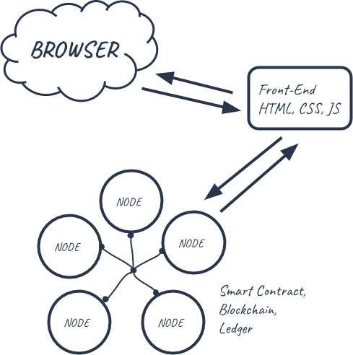

Fig 1. Architecture

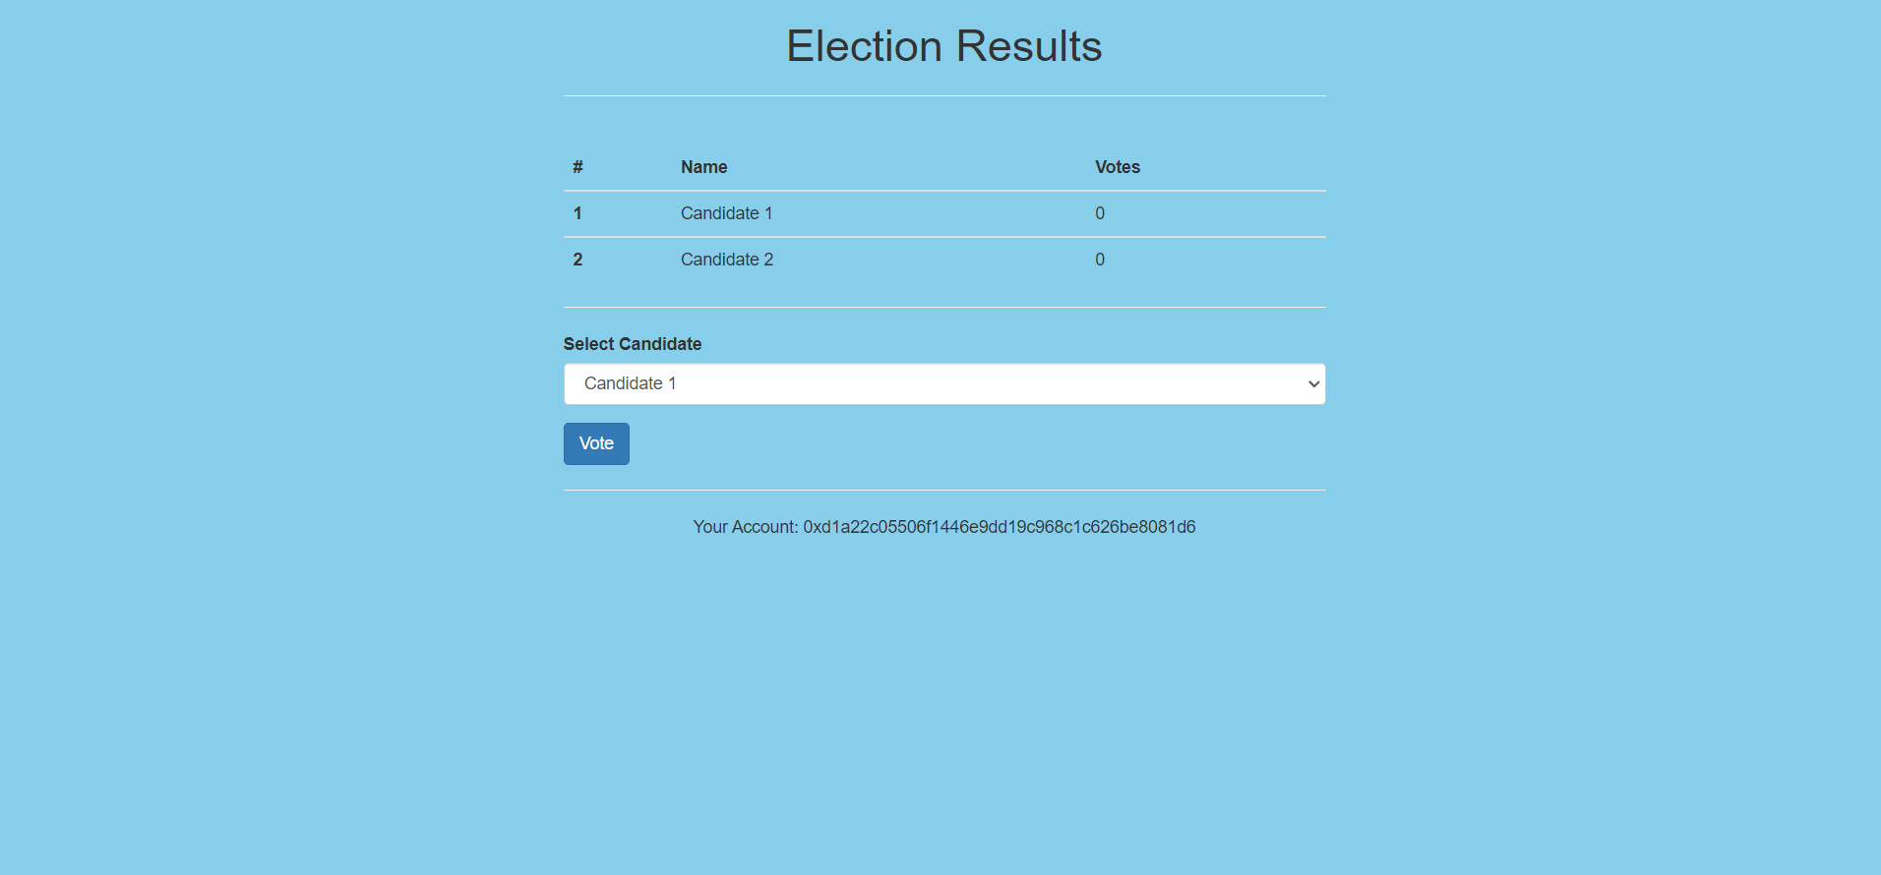**Results**

Fig 1:Before vote cast

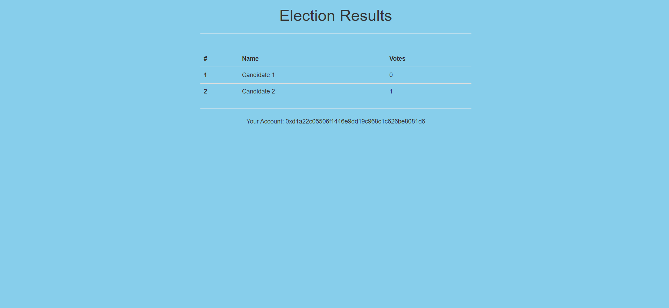

Fig 2:After vote cast

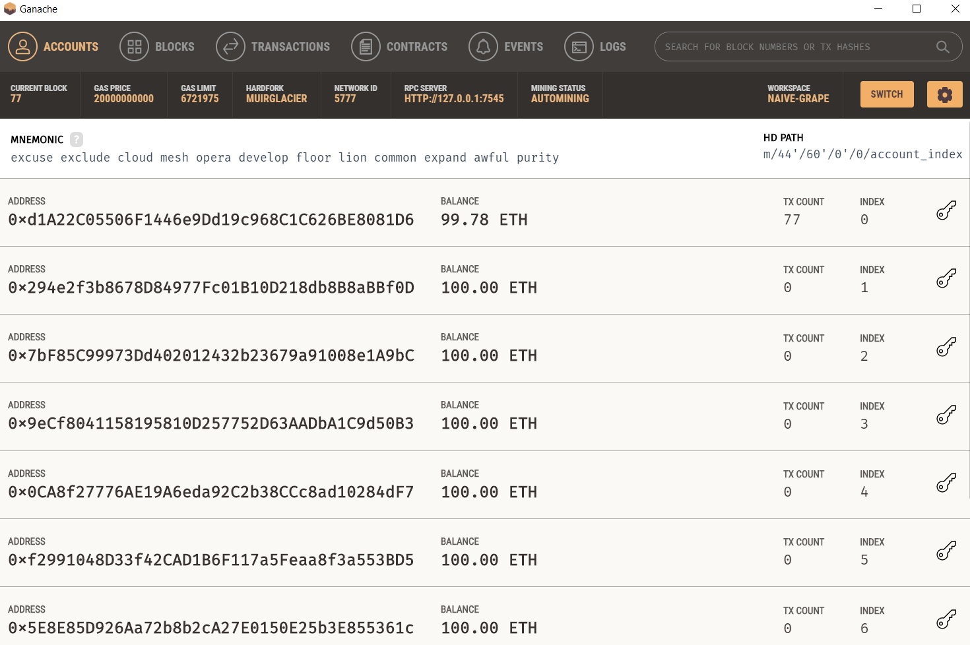

Fig 3:Ganache interface

**CONCLUSION**

The goal of this research is to analyze and evaluate current research on blockchainbased electronic voting systems. The article discusses recent electronic voting research using blockchain technology. The blockchain concept and its uses are presented first, followed by existing electronic voting systems. Then, a set of deficiencies in existing electronic voting systems are identified and addressed. The blockchain’s potential is fundamental to enhance electronic voting, current solutions for blockchain-based electronic voting, and possible research paths on blockchain-based electronic voting systems. Numerous experts believe that blockchain may be a good fit for a decentralized electronic voting system. Adopting blockchain voting methods may expose users to unforeseen security risks and flaws. Blockchain technologies require a more sophisticated software architecture as well as managerial expertise. As a result, electronic voting systems should initially be implemented in limited pilot areas before being expanded. Many security flaws still exist in the internet and polling machines. Building applications on Ethereum is pretty similar to a regular application calling a backend service. There can be a future enhancement by adding fingerprint ,cornea detection.This will make voting system more secure and simpler.