Parallel Stencil Computation for Real-Time Toxic Gas Dispersion Simulation
Oct 21, 2026 · @Swasti Gupta
Swasti Gupta, Arisha Jaiswal, Dhruvishi Amin, Manya Vishwanath
Department of Computer Science and Engineering
Manipal Institute of Technology Bengaluru, India
Parallel Computer Architecture and Programming, Course Project
Abstract — After a toxic gas release, emergency responders need to know which areas will exceed safe exposure limits before the gas reaches them. This paper presents a simulator that solves the two-dimensional advection–diffusion equation with a 5-point stencil and parallelises it in six versions: serial C, OpenMP, MPI with a two-dimensional block decomposition and optional overlap of communication with computation, and three CUDA kernels (naive, shared-memory tiled, and thread-coarsened). We show that the stability limit of the explicit scheme makes iterations per second a misleading target. At 1 m resolution, 49 steps are needed per simulated second, so we measure the real-time factor instead. A roofline analysis shows the stencil is memory-bound at an arithmetic intensity of 1.1 flop/byte. Every parallel version reproduces the serial result bit for bit, verified for OpenMP, MPI on 1–4 ranks, and the CUDA kernels under a CPU emulator of the CUDA execution model. The scheme matches an analytic solution to 0.01% for pure diffusion and converges at first order with wind. A three-dimensional extension couples a Lattice Boltzmann air-flow model to gas transport over real terrain to replay the 2020 Visakhapatnam styrene leak, and a web dashboard lets users place a leak and change the wind interactively.
Index Terms — stencil computation, advection–diffusion, CUDA, MPI, OpenMP, roofline model, shared memory, halo exchange, Lattice Boltzmann method, hazardous material dispersion.

I. Introduction
A dispersion forecast is only useful if it arrives before the gas does. On 7 May 2020, styrene vapour escaped from the LG Polymers plant near R. R. Venkatapuram, Visakhapatnam, during the night and spread into surrounding villages [1]. Responders in such an event need a map of where concentrations will cross harmful thresholds, and when, within minutes.
Numerically, dispersion over a city is a stencil computation: the concentration in each grid cell is updated from its neighbours at every time step. A 4 km × 4 km area at 1 m resolution has 16 million cells, and the stability of the explicit scheme forces about 49 steps per simulated second. That workload is too slow for a single CPU core and maps naturally onto parallel hardware, since every cell's update is independent within a step.
This paper makes four contributions:
- A 2D advection–diffusion solver implemented six ways (serial, OpenMP, MPI, and three CUDA kernels) on one shared stencil function, so every version can be checked against the serial result bit for bit.
- A roofline-based performance model that predicts throughput from memory bandwidth, and the real-time factor as the evaluation metric.
- A verification method for GPU kernels that needs no GPU: the kernels' per-thread code runs on the CPU under the CUDA execution model.
- A 3D extension that replays the 2020 Visakhapatnam release over real terrain, and an interactive dashboard.
Section II states the problem, Section III reviews background, Section IV derives the model, Sections V–VII describe the architecture, parallel implementation and performance model, Section VIII reports verification and results, Section IX describes the dashboard, Section X discusses limitations, and Section XI concludes. The source code is available at [16].

II. Problem Statement and Objectives
The target user is a hazardous-materials (HazMat) response team, a fire service or a municipal emergency planner. Given a leak location, a release rate and the current wind, they need the area above each exposure threshold over the next 30 minutes, delivered fast enough to act on.
The objectives were:
- Solve the 2D advection–diffusion equation on a 4000 × 4000 grid at 1 m resolution.
- Parallelise it for multicore CPUs (OpenMP), distributed memory (MPI) and GPUs (CUDA), and compare the versions.
- Reach a real-time factor of at least 30 (simulated seconds per second of computing), so that a 30-minute forecast takes under a minute.
- Verify that every parallel version computes the same result as the serial code, and that the serial code solves the equation correctly.
- Present the result as an interactive map with exposure bands.

III. Background and Related Work
Atmospheric dispersion models. Operational tools such as ALOHA, developed by NOAA and the US EPA, use Gaussian plume and heavy-gas models to estimate threat zones in seconds [2]. Gaussian models are fast but assume flat, uniform conditions. Grid-based advection–diffusion models trade speed for the ability to resolve spatial variation, and their analytic solutions for simple cases provide validation benchmarks [3].
Exposure thresholds. The US EPA's Acute Exposure Guideline Levels (AEGLs) define three tiers: AEGL-1 (notable discomfort), AEGL-2 (irreversible or serious effects) and AEGL-3 (life-threatening) [4]. For styrene over 60 minutes, the values used in this work are 20, 130 and 1,100 ppm.
Numerical schemes. Explicit finite-difference schemes are simple to parallelise but limited by a stability condition on the time step. First-order upwind differencing keeps advection stable and free of negative concentrations, at the cost of numerical diffusion [5].
Stencil optimisation. Stencils are memory-bound on almost all modern hardware. Datta et al. showed that their performance depends on cache blocking and minimising memory traffic [6], and the roofline model gives an upper bound from a kernel's arithmetic intensity and the machine's bandwidth [7]. On GPUs, Micikevicius showed that staging tiles in shared memory and streaming through one dimension with values held in registers reduces redundant global-memory reads [8]. Our shared-memory and coarsened kernels follow these two ideas.
Programming models. We use OpenMP for shared memory [9], MPI for distributed memory [10] and CUDA for GPUs [11].
Lattice Boltzmann method. The 3D extension models air flow with the Lattice Boltzmann method (LBM), which evolves particle distributions on a lattice and is itself a stencil computation well suited to GPUs [12]. Turbulence is represented with the Smagorinsky eddy-viscosity model [13].

IV. Mathematical Model

A. Governing equation
The model tracks the concentration C (mg/m³), averaged over a ground layer of depth H = 10 m. Gas is carried by a uniform wind (u, v), spread by turbulent eddies with diffusivity D, and fed by a source S:
$\frac{∂C}{∂t}+u\frac{∂C}{∂x}+v\frac{∂C}{∂y}=D\left(\frac{∂^{2}C}{∂x^{2}}+\frac{∂^{2}C}{∂y^{2}}\right)+S$ (1)
A leak of Q kg/s into one cell of size h adds Q · 10⁶ / (h² H) mg/m³ to that cell per second. The default values are h = 1 m and D = 10 m²/s.

B. Discretisation as a 5-point stencil
Time is advanced with forward Euler. Diffusion uses second-order central differences, and advection uses first-order upwind differences: each cell takes gas from the neighbour the wind blows from. Both terms then collapse into a weighted sum of a cell and its four neighbours:
$C_{i,j}^{n+1}=w_{0}C_{i,j}^{n}+w_{E}C_{i+1,j}^{n}+w_{W}C_{i−1,j}^{n}+w_{N}C_{i,j+1}^{n}+w_{S}C_{i,j−1}^{n}$ (2)

$w_{E}=\frac{Δt}{h}\left(\frac{D}{h}+max(−u,0)\right), w_{W}=\frac{Δt}{h}\left(\frac{D}{h}+max(u,0)\right)$ (3)

$w_{N}=\frac{Δt}{h}\left(\frac{D}{h}+max(−v,0)\right), w_{S}=\frac{Δt}{h}\left(\frac{D}{h}+max(v,0)\right)$ (4)

$w_{0}=1−Δt\left(\frac{4D}{h^{2}}+\frac{U}{h}\right)$ (5)
Here U = |u| + |v|, the sum of the magnitudes of the two wind components. The five weights are computed once per run on the host, so the kernel itself is a single weighted sum. They add up to exactly 1: a uniform field stays uniform, and no mass is created or destroyed inside the domain. Boundary cells are held at zero, which represents clean air flowing in and gas leaving the map.

C. Stability and its consequence for the evaluation metric
The update is stable, and never produces negative concentrations, when every weight is non-negative. The condition w₀ ≥ 0 gives
$Δt≤\frac{1}{4D/h^{2}+U/h}$ (6)
The implementation uses 0.9 times this limit and rejects anything larger. With h = 1 m, D = 10 m²/s and U = 4 m/s, Δt = 0.0205 s, so 49 time steps are needed per simulated second. A target stated in iterations per second therefore says nothing about usefulness on its own: at 30 iterations per second, this grid would simulate only 0.6 s per second, slower than the gas spreads. We therefore evaluate every implementation by its real-time factor, the number of simulated seconds computed per wall-clock second. Because the limit scales with h², halving the cell size multiplies the work per simulated second by roughly 8 to 16.

V. System Architecture
The system has three parts that share one design principle: every implementation of the 2D stencil calls the same inline function, so all of them compute the same arithmetic in the same order (Fig. 1).
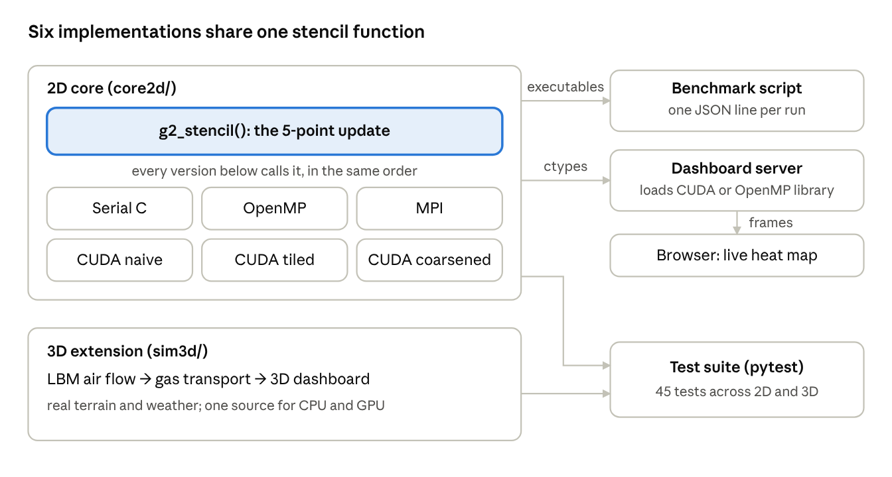
Fig. 1. System architecture
All six 2D versions call one stencil function; the benchmark script, dashboard and tests use the same compiled code. The 3D simulator is a separate code base tested by the same suite.
TABLE I. Components
Component | Contents | Role
2D core (core2d/) | C11 and CUDA C++: serial, OpenMP, MPI, three CUDA kernels, CUDA emulator | The benchmarked study
Dashboard (dashboard/) | Python FastAPI server; HTML canvas client over WebSockets | Interactive demonstration
3D simulator (sim3d/) | CUDA C++ LBM air flow and gas transport; Python server; 3D web client | Realistic extension: 2020 Visakhapatnam replay
Tests and scripts | pytest suite, benchmark and experiment scripts, Makefile | Verification and report figures
The executables share one command-line interface and print one JSON line per run, so a single benchmark script drives every variant. The dashboard loads the same core as a shared library through Python's ctypes, preferring the CUDA build and falling back to OpenMP when no GPU is present.

VI. Parallel Implementation
Within one time step every cell's update is independent, so the step is data-parallel. Between steps there is a strict dependency: step n + 1 reads every value written in step n. All versions therefore use two arrays ("ping-pong" buffers), reading one and writing the other, then swapping them. This removes write–read races within a step without locks.

A. OpenMP
Rows are divided into equal contiguous blocks, one per thread. Every cell costs the same, so static partitioning is perfectly balanced and adds no scheduling overhead. Each thread then calls the serial row sweep on its own block. We first wrapped the loop in #pragma omp parallel for and measured one OpenMP thread running about 1.5× slower than the serial code: inside the compiler-generated parallel region, the compiler no longer assumed the input and output arrays did not overlap, so it stopped vectorising the inner loop. Calling the already-vectorised serial sweep from each thread restored full speed and keeps results bit-identical.

B. MPI
The map is divided into a near-square grid of rectangular blocks, one per rank, using MPI_Dims_create and MPI_Cart_create. Each rank stores its block plus a one-cell ring of ghost cells. Before each step, ranks exchange their edge cells with up to four neighbours (Fig. 2):
- Rows are contiguous in memory and are sent directly.
- Columns are strided, so an MPI_Type_vector derived datatype describes them and no manual packing is needed.
- Ranks at the map edge have MPI_PROC_NULL as their outer neighbour; those calls do nothing and the ghost cells stay at zero.
- Each send is paired with its matching receive in MPI_Sendrecv, so the exchange cannot deadlock.
Square blocks exchange about 4N/√P cells per rank on an N × N grid with P ranks, against 2N for strips, so the share of time spent communicating falls as P grows. An optional overlapped mode posts non-blocking MPI_Isend and MPI_Irecv, updates the inner cells that need no ghost values while messages travel, and then updates the one-cell ring at the block edge. Only the waiting that cannot be hidden is reported as communication time.
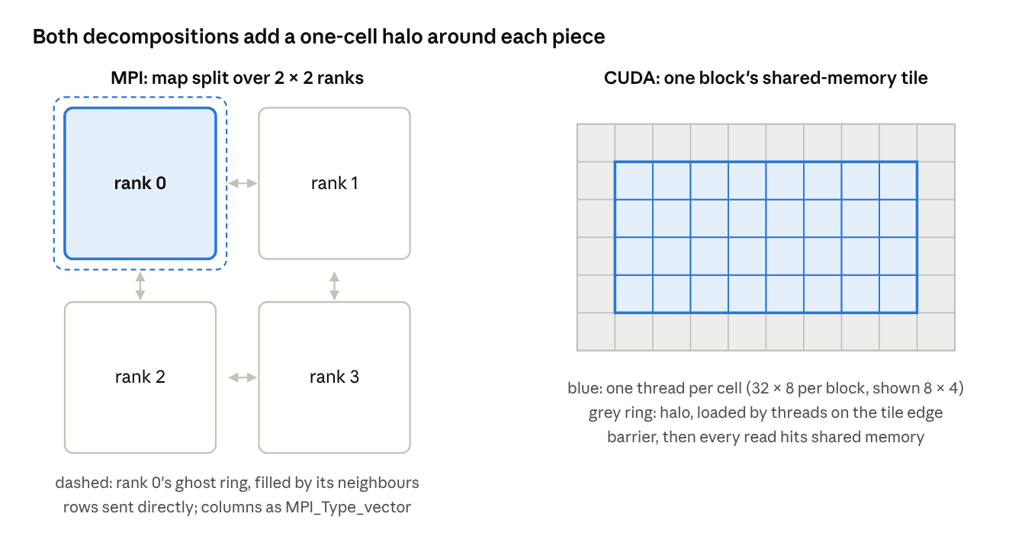
Fig. 2. Decomposition with halos
Left: the map is split into rectangular blocks, one per MPI rank, and each step exchanges edge cells with neighbours into a one-cell ghost ring. Right: each CUDA block stages its tile plus a one-cell halo in shared memory before computing.

C. CUDA
All three kernels launch once per time step; the boundary between launches is the global barrier between steps. Blocks are 32 × 8 threads, so each warp covers 32 consecutive floats and its loads combine into one 128-byte memory transaction (coalescing).
- Naive. One thread per cell, five global-memory loads per thread. Neighbouring threads load overlapping cells; the GPU's L1 and L2 caches serve many of these repeats.
- Shared-memory tiled. Each block first copies its 32 × 8 tile plus a one-cell halo (34 × 10 values, 1,360 bytes) into on-chip shared memory, waits at __syncthreads(), then computes from the tile. Each value is read from global memory once per block rather than up to five times. No thread may return before the barrier, so bounds checks are placed inside the load and compute phases.
- Thread-coarsened. Each thread updates 8 cells in a column, keeping the south, centre and north values in registers and sliding them upward. Moving one row north needs one new vertical load instead of three [8].
Compiled for compute capability 7.5, the kernels use 18, 22 and 19 registers per thread respectively (from ptxas -v), and the tiled kernel uses 1,360 bytes of shared memory per block. All three are low enough not to limit occupancy.

D. 3D simulator
The 3D extension couples two models on a 3D grid of 10 m cells. Air flow uses the D3Q19 Lattice Boltzmann method (19 velocity directions per cell) with Smagorinsky turbulence and a buoyancy term for the dense styrene vapour. Terrain and buildings are solid cells that reflect the flow. Gas concentration is then transported by the computed flow. Input data are Copernicus 90 m terrain, OpenStreetMap buildings and place names, and ERA5 hourly weather [14] for the night of the release. A compatibility header lets the same kernel source compile with nvcc for the GPU or with g++ and OpenMP for the CPU, so the GPU-versus-CPU comparison uses identical arithmetic. Its MPI version splits the map into strips and is checked against a single-process run.

VII. Performance Model
The stencil is limited by memory bandwidth, not arithmetic. Each cell update performs 9 floating-point operations (5 multiplications and 4 additions) and must move at least 8 bytes: one 4-byte read and one 4-byte write, assuming neighbour re-reads hit in cache. Its arithmetic intensity is therefore
$I=\frac{9\text{ flop}}{8\text{ B}}≈1.1\text{ flop/byte}$ (7)
By the roofline model [7], a kernel is memory-bound whenever I lies below the machine balance, peak compute divided by peak bandwidth. For an NVIDIA T4 (8.1 TFLOP/s FP32, 320 GB/s [15]) the balance is about 25 flop/byte, so the stencil sits far into the memory-bound region. The upper bound on throughput is bandwidth divided by 8 bytes:
$P_{\text{max}}=\frac{320\text{ GB/s}}{8\text{ B}}=40×{10}^{9}\text{ cell updates/s}$ (8)
This analysis gives three testable predictions:
- Real-time factor. Well-optimised stencil kernels typically reach 60–80% of peak bandwidth. On a T4, a 4000 × 4000 step would then take 0.50–0.67 ms, a real-time factor of about 30–40, which meets the objective.
- Kernel ranking. Because the naive kernel's neighbour re-reads mostly hit in the L1 and L2 caches, the shared-memory kernel may be little or no faster on recent GPUs. Shared memory pays off when re-reads would otherwise go to DRAM, as with wider or 3D stencils or smaller caches. The coarsened kernel should benefit more, since it cuts vertical loads from three to one per cell.
- CPU scaling. OpenMP speed-up should be close to linear while the working set fits in cache, then flatten once all cores share one memory bus. That is the bandwidth limit, not a defect of the parallelisation.
Each run reports its achieved bandwidth (bytes moved divided by time) and, on a GPU, that bandwidth as a percentage of the device's theoretical peak, so these predictions can be checked directly.

VIII. Verification and Results
All parallel versions reproduce the serial result exactly, and the serial result matches the analytic solution. Verification runs in an automated suite of 45 tests: 40 run on any machine and 5 require an NVIDIA GPU.

A. Equivalence of parallel versions
Floating-point addition is not associative, so parallel versions often differ from serial code by rounding. We prevent this by fixing the evaluation order inside the shared stencil function and compiling with -ffp-contract=off, which stops the compiler from fusing multiply–add pairs differently in different builds. This makes exact equality a valid test.
GPU kernels are tested without a GPU by a CPU emulator that executes the kernels' per-thread code under CUDA's execution model: outer loops over blocks, inner loops over threads, and a completed first phase for every thread before any thread starts the second (the guarantee of __syncthreads()). Shared-memory tiles are filled with NaN before each block, so any halo cell that should have been loaded but was not corrupts the output and fails the test. Odd grid sizes leave partially filled blocks at the edges.
TABLE II. Equivalence tests (all versus serial)
Version | Configurations tested | Result
OpenMP | 4 grid sizes, 2 threads | Bit-identical
MPI, blocking exchange | 1, 2, 3, 4 ranks; 97 × 61 and 40 × 130 grids | Bit-identical
MPI, overlapped exchange | 1, 2, 3, 4 ranks; same grids | Bit-identical
CUDA kernels, emulated (naive, tiled, coarsened) | 97 × 61, 64 × 64, 33 × 130, 1 × 7 | Bit-identical
CUDA kernels on a GPU | 1000 × 700, 400 steps | Pending: tolerance 10⁻⁴ of peak, as the GPU may fuse multiply–adds
3D simulator, MPI | 1, 2, 4 ranks (CPU build) | Matches single process
3D simulator, GPU versus CPU | Fixed test case | Pending GPU run

B. Accuracy against an analytic solution
An instantaneous release of M mg/m at (x₀, y₀) has the exact solution
$C(x,y,t)=\frac{M}{4πDt}exp\left(−\frac{(x−x_{0}−ut)^{2}+(y−y_{0}−vt)^{2}}{4Dt}\right)$ (9)
We start the simulation from this solution at t₀ = 10 s on a 400 m × 400 m domain, run it for 20 s, and compare with the exact solution at the final time.
TABLE III. Relative L2 error after 20 s
Cell size h | Diffusion only | Wind 3 m/s east, 1 m/s north
2 m | 0.06% | 8.2%
1 m | 0.01% | 4.5%
0.5 m | 0.01% | 2.4%
Pure diffusion is essentially exact. With wind, the error roughly halves each time h halves, the expected behaviour of a first-order scheme. Upwinding adds numerical diffusion of about |u|h/2 [5], which spreads the plume slightly and lowers its peak, by about 6% at h = 1 m. Across all six runs, total mass stayed within 0.006% of the amount released (single-precision rounding), and concentrations never went negative.

C. Performance
Pending: GPU timings require a run of make report on a machine with an NVIDIA GPU. Do not cite numbers in this section until that run is complete.
TABLE IV. Performance on the 4000 × 4000 grid (h = 1 m, Δt = 0.0205 s)
Version | Hardware | ms per step | Cell updates/s | % of peak bandwidth | Real-time factor | Speed-up over serial
Serial | CPU model | – | – | – | – | 1.0
OpenMP | CPU, N threads | – | – | – | – | –
MPI, overlapped | CPU, P ranks | – | – | – | – | –
CUDA naive | GPU model | – | – | – | – | –
CUDA tiled | GPU model | – | – | – | – | –
CUDA coarsened | GPU model | – | – | – | – | –
The benchmark also produces three figures to insert here: OpenMP strong scaling, MPI compute versus exposed communication time, and achieved GPU bandwidth across grid sizes. Discuss the measured kernel ranking against prediction 2 of Section VII: whichever way it falls, the bandwidth model should explain it.

IX. Interactive Dashboard
The dashboard runs the simulation continuously on a server and streams a heat map to the browser about 30 times per second. The user clicks the map to place a leak and moves sliders for wind speed, wind direction, release rate and playback speed. Each change takes effect on the next frame.
Design choices that keep it responsive and safe to read:
- Decoupled frame and step rates. Each frame advances as many simulation steps as the requested playback speed needs, capped at the number that fits in 70% of the frame time. If the hardware cannot keep up, the displayed real-time factor drops honestly rather than the display falling behind.
- Small transfers. The grid (4000 × 4000 on a GPU, 2000 × 2000 on a CPU) is reduced to a 500 × 500 image on the device before copying, and each pixel is encoded as one byte on a logarithmic scale, so a frame is 250 kB.
- Maximum, not average. Each image pixel takes the maximum of the cells it covers. Averaging would dilute a narrow plume, while for a safety display the worst value is the one that matters.
- Exposure bands. Concentrations are converted to ppm at 25 °C and 1 atm and coloured by the styrene AEGL tiers [4]: green below AEGL-1, then yellow, orange and red. The panel lists the area inside each tier, the peak concentration, the backend in use, and the live real-time factor.
- Thread safety. Simulation steps run in a worker thread so the server keeps receiving controls; a lock prevents a parameter change from landing in the middle of a batch of steps.
The 3D simulator has its own dashboard, which replays the night of the release against a timeline of recorded events and supports what-if scenarios with different weather and release rates.

X. Limitations
The 2D model is a teaching and benchmarking model, not an operational tool. Its main simplifications are:
- Well-mixed layer. There is no vertical structure. Dense gases such as styrene vapour stay close to the ground at night; the 3D simulator represents this, the 2D model does not.
- Flat ground and uniform wind. Buildings and terrain channel real plumes. The 3D simulator includes them.
- Constant diffusivity. Real turbulent mixing depends on atmospheric stability and changes during the night.
- First-order advection. Numerical diffusion lowers plume peaks by about 6% at 1 m resolution (Section VIII-B). A second-order scheme with a flux limiter would reduce this at the cost of a wider stencil.
- Absorbing edges. Gas that leaves the map is lost, so plumes must stay well inside the domain.
- MPI on one machine. All MPI runs so far share one computer, so they demonstrate correctness and the split between computation and communication rather than speed-up across a cluster.
- AEGL values. The styrene thresholds used are interim values; this work does not assess the toxicology.
Any operational use would require validation against field data and established tools such as ALOHA [2].

XI. Conclusion and Future Work
We built a toxic gas dispersion simulator in six parallel versions on one shared stencil function. Every version reproduces the serial result bit for bit, and the serial code matches an analytic solution to 0.01% for diffusion, with first-order convergence under wind. The stability limit of the explicit scheme showed that iterations per second is the wrong target. The real-time factor is the right one, and at 1 m resolution 49 steps make one simulated second. A roofline analysis places the stencil firmly in the memory-bound region, predicts a real-time factor of about 30–40 on a T4-class GPU, and predicts that shared-memory tiling may gain little over cache-assisted naive loads. [Replace with the measured outcome after the GPU run.]
Future work:
- Temporal blocking: compute several time steps per pass over memory, which raises arithmetic intensity, the one change that moves a memory-bound stencil up the roofline.
- A second-order advection scheme with a flux limiter, to reduce numerical diffusion.
- Multi-GPU runs with CUDA-aware MPI, and runs across a real cluster.
- Spatially varying wind from the 3D flow model to drive the fast 2D model.

Individual Contributions
Member | Responsibility | Sections
Swasti Gupta | GPU implementation: the three CUDA kernels (naive, shared-memory tiled, thread-coarsened), the CPU emulator of the CUDA execution model, GPU benchmarking, and the roofline performance model. Report editing. | VI-C, VII, VIII-C
Arisha Jaiswal | Mathematical model and CPU baseline: derivation of the 5-point stencil and stability limit, serial C implementation, OpenMP parallelisation, and validation against the analytic solution. | IV, VI-A, VIII-B
Dhruvishi Amin | Conceived, designed and built the entire 3D Visakhapatnam simulator: D3Q19 Lattice Boltzmann air flow with Smagorinsky turbulence and buoyancy, gas transport, the real terrain, building and weather data pipeline, the single-source CPU/GPU build, its MPI version, the 2020 replay, and the 3D dashboard. | III (LBM), VI-D, IX (3D dashboard)
Manya Vishwanath | Distributed memory and delivery: MPI 2D decomposition with derived datatypes and overlapped halo exchange, the equivalence test suite, the live 2D dashboard, and the build and continuous-integration setup. | VI-B, VIII-A, IX

References
[1] "Visakhapatnam gas leak," Wikipedia. [Online]. Available: https://en.wikipedia.org/wiki/Visakhapatnam_gas_leak (accessed Oct. 21, 2026).
[2] NOAA Office of Response and Restoration, "ALOHA." [Online]. Available: https://response.restoration.noaa.gov/aloha (accessed Oct. 21, 2026).
[3] J. M. Stockie, "The mathematics of atmospheric dispersion modeling," SIAM Rev., vol. 53, no. 2, pp. 349–372, 2011.
[4] U.S. Environmental Protection Agency, "Styrene results – AEGL program." [Online]. Available: https://www.epa.gov/aegl/styrene-results-aegl-program (accessed Oct. 21, 2026).
[5] R. J. LeVeque, Finite Volume Methods for Hyperbolic Problems. Cambridge, U.K.: Cambridge Univ. Press, 2002.
[6] K. Datta et al., "Stencil computation optimization and auto-tuning on state-of-the-art multicore architectures," in Proc. ACM/IEEE Conf. Supercomputing (SC08), Austin, TX, USA, 2008, pp. 1–12.
[7] S. Williams, A. Waterman, and D. Patterson, "Roofline: An insightful visual performance model for multicore architectures," Commun. ACM, vol. 52, no. 4, pp. 65–76, Apr. 2009.
[8] P. Micikevicius, "3D finite difference computation on GPUs using CUDA," in Proc. 2nd Workshop General Purpose Processing on Graphics Processing Units (GPGPU-2), Washington, DC, USA, 2009, pp. 79–84.
[9] OpenMP Architecture Review Board, "OpenMP Application Programming Interface, Version 5.2," Nov. 2021.
[10] Message Passing Interface Forum, "MPI: A Message-Passing Interface Standard, Version 4.0," Jun. 2021.
[11] NVIDIA, "CUDA C++ Programming Guide." [Online]. Available: https://docs.nvidia.com/cuda/cuda-c-programming-guide/ (accessed Oct. 21, 2026).
[12] S. Chen and G. D. Doolen, "Lattice Boltzmann method for fluid flows," Annu. Rev. Fluid Mech., vol. 30, pp. 329–364, 1998.
[13] J. Smagorinsky, "General circulation experiments with the primitive equations: I. The basic experiment," Mon. Weather Rev., vol. 91, no. 3, pp. 99–164, 1963.
[14] H. Hersbach et al., "The ERA5 global reanalysis," Q. J. R. Meteorol. Soc., vol. 146, no. 730, pp. 1999–2049, 2020.
[15] NVIDIA, "NVIDIA T4 Tensor Core GPU." [Online]. Available: https://www.nvidia.com/en-us/data-center/tesla-t4/ (accessed Oct. 21, 2026).
[16] S. Gupta, A. Jaiswal, D. Amin, and M. Vishwanath, "gas-leak-pcap," GitHub repository, 2026. [Online]. Available: https://github.com/swastigupta8/gas-leak-pcap

