AIRLINE MANAGEMENT SYSTEM

Database Management System

Submitted by:

|  |  |
| --- | --- |
| Swasti Jain | (102206185) |
| Ananya | (102203618) |



# INDEX

|  |  |  |
| --- | --- | --- |
| **S No.** | **Topic** | **Page No.** |
| 1. | Introduction | 3 |
| 2. | Requirement Analysis | 4 |
| 3. | ER Diagram | 5 |
| 4. | ER to Table | 6-7 |
| 5. | Normalization | 8-12 |
| 6. | SQL | 13-23 |
| 7. | PL/SQL | 24-27 |
| 8. | Conclusion | 28 |
| 9. | References | 29 |

**INTRODUCTION**

The airline management system project aims to streamline airline operations by integrating reservation, scheduling, ticketing, and fleet management processes into a unified platform. In this project, we aim to develop an Airline Management System using SQL and PL/SQL. Key features include passenger booking, seat allocation, flight scheduling, crew management, aircraft maintenance and real-time updates for flight status. The system enhances efficiency, improves customer experience, and ensures optimal resource utilization for airlines.

The airline industry is a complex ecosystem requiring efficient management of various resources and operations to ensure smooth and safe travel for passengers. To streamline these operations and enhance overall efficiency, airline companies often leverage Database Management Systems to organize and manage their data effectively.

An airline management project involves the creation of a comprehensive database that stores and manages critical information related to flights, aircraft, passengers, crew members, reservations, schedules, and more. By centralizing this data, airline companies can optimize their operations, improve customer service, and make data-driven decisions to enhance overall performance.

In this project, we aim to develop an Airline Management System using SQL and PL/SQL. Key features include passenger booking, seat allocation, flight scheduling, crew management, aircraft maintenance and real-time updates for flight status.

By understanding the intricacies of airline management within a DBMS context, we can appreciate how technology plays a pivotal role in transforming the airline industry, making air travel safer, more efficient, and more convenient for passengers worldwide.

## REQUIREMENT ANALYSIS

To develop a successful Restaurant Management System, we need to analyze the requirements of the system. The following are the primary requirements for the system:

* Maintenance of Aircrafts: In the airline management system project, aircraft maintenance functionality is essential for ensuring the safety and reliability of the fleet. It involves inspections, repairs, and component replacements. The system facilitates efficient maintenance planning, monitors aircraft health data, and generates maintenance reports to optimize aircraft availability and minimize downtime.
* Summary of Flights: The flights project aims to optimize the management of airline routes and schedules. It involves creating and managing flight itineraries, including departure and arrival times, aircraft assignments, and seat availability. The system also tracks real-time flight status, handles reservations, and facilitates check-in processes.
* Data Management: Data management in the project includes handling passenger data, flight schedules, crew information, maintenance records, and other relevant data sets. The system ensures data integrity, security, and accessibility, enabling seamless communication between different modules and stakeholders.
* Ticket Management: Ticket management in the project involves handling the entire ticketing process from booking to boarding. It includes functionalities such as ticket reservations, seat assignments, fare calculation, payment processing, and ticket issuance.
* Flight Details: Flight details refer to essential information about a specific flight within the airline management system. This includes the flight number, departure and arrival times, origin and destination airports, seating configuration, and current status. By providing concise details, the system enables efficient flight planning, passenger communication, and operational coordination for the airline.

## SOFTWARE REQUIREMENTS

1. SQL
2. PL/SQL
3. Command Prompt

# ER DIAGRAM

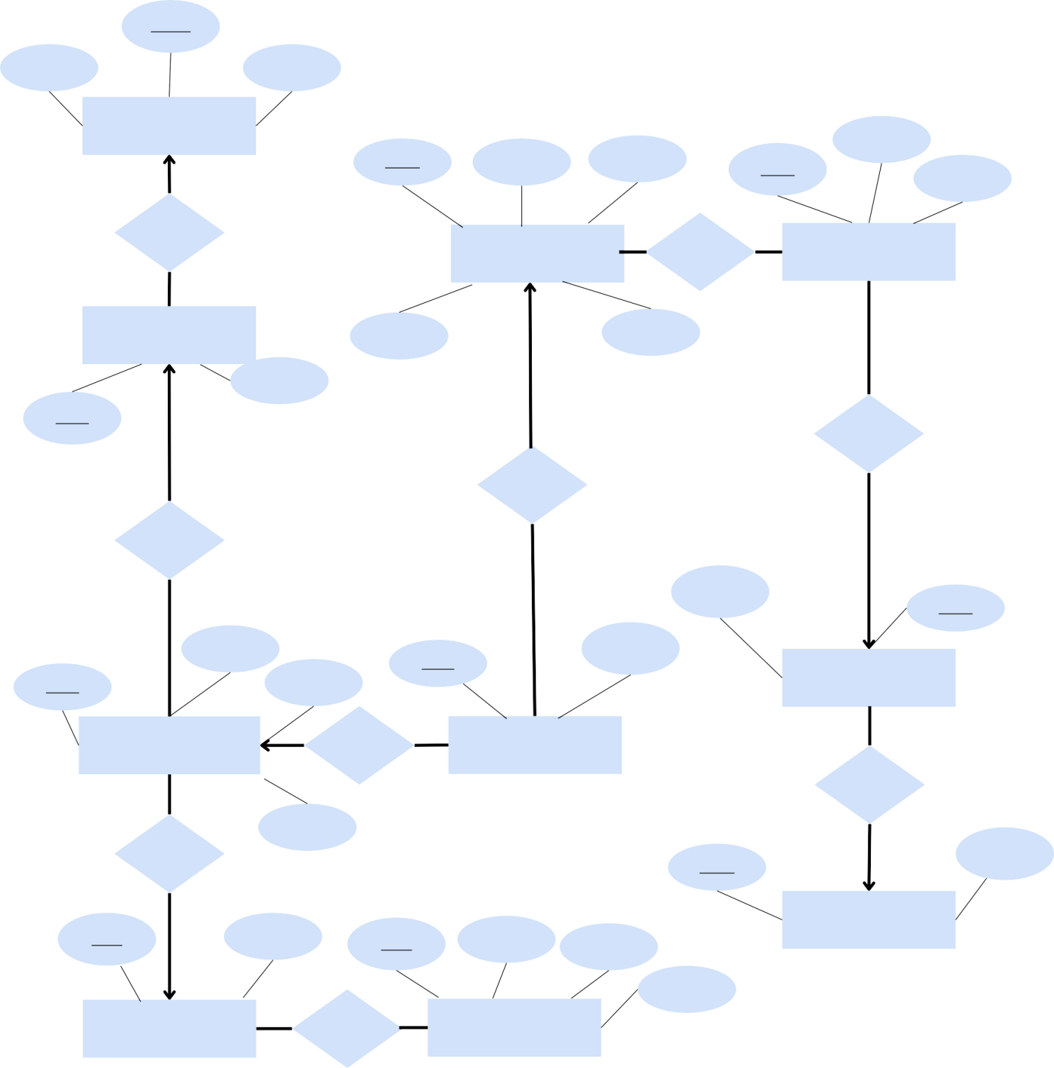ACT_ID

TYPE CAPACITY

**AIRCRAFT_TYPE**

PS_ID ADDRESS NAME

Cn_Id

Email

Mobile

Has

**PASSENGER** Has **Contact_Details**

**AIRCRAFT** Nationality AGE Mfg_DATE

AC_ID

Belongs to

Transacts

Has

State_name

ST_ID

Flight_Date

Ts_ID

Booking Date

FL_ID Departure **State**

**FLIGHT_SCHEDULE** On flight **Transaction**

in

Has

Arrival

CT_ID

Country_Na me

Af_Id Fare

Rt_Id Airport Destination

**Country**

Route code

**AirFare** on **Route**

# ER TO TABLE

1. Relation ‘Transacts’

Passenger:-ps_id, address, name,age, nationality Transaction:-ts_id, booking_date, ps_id(FK)

1. Relation ‘Belongs to’ State:-st_id, State_name

Contact_Details:-Cn_id, Email, Mobile, st_id(FK)

1. Relation ‘Has’

Passenger:-ps_id, address, name,age, nationality Contact_Details:-Cn_id, Email, Mobile

Has:-st_id, Cn_id;

1. Relation ‘in’

Country:-ct_id, Country_name State:-st_id,State_name, ct_id(FK)

1. Relation ‘on’ AirFare:-Af_id, Fare

Route:-Rt_id, Airport, Destination, Route_code On:-Af_id, Rt_id

1. Relation ‘Has’ AirFare:-Af_id, Fare

Flight_Schedule:-Fl_id, Flight_Date, Departure, Arrival, Af_id(FK)

1. Relation ‘Has’

Aircraft:-Ac_id, Mfg_date

Flight_Schedule:-Fl_id, Flight_Date, Departure, Arrival, Ac_id(FK)

1. Relation ‘Has’

Aircraft_Type:-Act_id, Type, Capacity Aircraft:-Ac_id, Mfg_date, Act_id(FK)

1. Relation ‘On flights’

Flight_Schedule:-Fl_id, Flight_Date, Departure, Arrival Transaction:-ts_id, booking_date, Fl_id(FK)

# NORMALIZATION

### Tables with functional dependencies

Country [BCNF] Primary Key: CUD

CtID ->CountryName

CREATE TABLE ‘Country’

{

‘CtID’ INT NOT NULL AUTO_INCREMENT,

‘Country_name’ varchar(32) NOT NULL,

};

State [BCNF]

Primary Key: StID

StID->StateName | Country

CREATE TABLE ‘State’

{

‘StID’ INT NOT NULL AUTO_INCREMENT UNIQUE,

‘StateName’ varchar(32) NOT NULL, ‘Country’INT NOT NULL, PRIMARY KEY (‘StID’),

FOREIGN KEY (‘Country’) REFERENCES ‘Country’ (‘CtID’)

};

Contact_Details [BCNF] Primary Key: CnID

CnID-> Email | Mobile | State

CREATE TABLE ‘Contact_Details’

{

‘CnID’ INT NOT NULL AUTO_INCREMENT,

‘Email’varchar(50) NOT NULL, ‘Mobile’varchar(16) NOT NULL, ‘State’ INT NOT NULL, PRIMARY KEY (‘CnID’),

FOREIGN KEY (‘State’) REFERENCES ‘State’ (‘StID’)

};

CREATE TABLE ‘Flight_Schedule’

{

‘FlID’ INT NOT NULL AUTO_INCREMENT,

‘FlightDate’ DATE NOT NULL, ‘Departure’ DATETIME NOT NULL, ‘Arrival’ DATETIME NOT NULL,

‘Aircraft’ INT NOT NULL, ‘NetFare’ INT NOT NULL, PRIMARY KEY (‘FlID’),

FOREIGN KEY (‘Aircraft’) REFERENCES ‘Aircraft’ (‘AcID’) FOREIGN KEY (‘Aircraft’) REFERENCES ‘Aircraft’ (‘AcID’)

};

AirFare [BCNF] Primary key: AfID

AfID -> Route | Fare

CREATE TABLE ‘Airfare’

{

‘AfID’ INT NOT NULL AUTO_INCREMENT, ‘Route’INT NOT NULL,

‘Fare’ INT NOT NULL, ‘NetFare’ INT NOT NULL, PRIMARY KEY (‘AfID’),

FOREIGN KEY (‘Route’) REFERENCES ‘Route’ (‘RtID’)

};

Route [BCNF]

Primary Key: RtID

RtID-> Airport | Destination | RouteCode

CREATE TABLE ‘Route’

{

‘RtID’ INT NOT NULL AUTO_INCREMENT,

‘Airport’varchar(32) NOT NULL, ‘Destination’varchar(32) NOT NULL,

‘RouteCode’varchar(16) NOT NULL UNIQUE, PRIMARY KEY (‘RtID’)

};

AirCraft [2NF]

Primary Key: AcID

AcID->Ac_Type | Capacity | Mfg_Date Ac_Type-> Capacity

AirCraft [BCNF] Primary Key: AcID

AcID->Ac_Type | Ac_Type | Mfg_Date

CREATE TABLE ‘AirCraft’

{

‘AcID’ INT NOT NULL AUTO_INCREMENT, ‘Air_Type’ INT NOT NULL,

‘Mfg_Date’DATE NOT NULL, PRIMARY KEY (‘AcID’)

FOREIGN KEY (‘Ac_Type’) REFERENCES ‘AirCraft_Type’ (‘AcID’)

};

AirCraft_Type [BCNF] (fron decomposition) Primary Key: ActID

ActID-> Type | Capacity

CREATE TABLE ‘AirCraft_Type’

{

‘ActID’ INT NOT NULL AUTO_INCREMENT,

‘Type’ varchar(32) NOT NULL, ‘Capacity’ INT NOT NULL, PRIMARY KEY (‘ActID’)

};

Passenger [BCNF] Primary Key: PsID

PsID-> Name | Address | Age | Nationality | Contacts

CREATE TABLE ‘Contact_Details’

{

‘PsID’ INT NOT NULL AUTO_INCREMENT,

‘Name’ varchar(32) NOT NULL, ‘Address’ varchar(64) NOT NULL,

‘Age’ INT NOT NULL,

‘Nationality’varchar(16) NOT NULL, ‘Contacts’ INT NOT NULL, PRIMARY KEY (‘PsID’),

FOREIGN KEY (‘Contacts’) REFERENCES ‘Contact_Detail’ (‘CnID’)

};

Transaction [BCNF] Primary Key: TsID

TsID->BookingDate | Passenger | Flight

CREATE TABLE ‘Transaction’

{

‘TsID’ INT NOT NULL AUTO_INCREMENT,

‘BookingDate’ DATETIME NOT NULL, ‘Passenger’ INT NOT NULL,

‘Flight’ INT NOT NULL, PRIMARY KEY (‘TsID’),

FOREIGN KEY (‘Passenger’) REFERENCES ‘Passenger’ (‘PsID’), FOREIGN KEY (‘Flight’) REFERENCES ‘Flight_Schedule’ (‘FlID’)

};

Flight_Schedule [2NF] Primary Key: FlID

FlID->FlightDate | Departure | Arrival | AirCraft | NetFare Departure->FlightDate

# SQL

### Creation of Tables:-

Table 1: Country

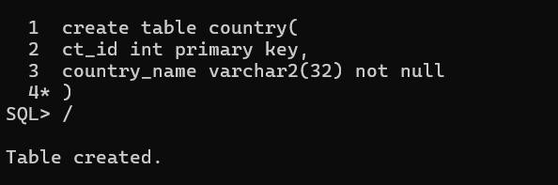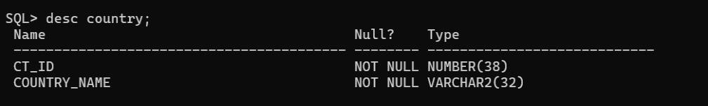

Table 2: State

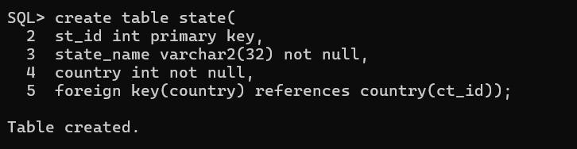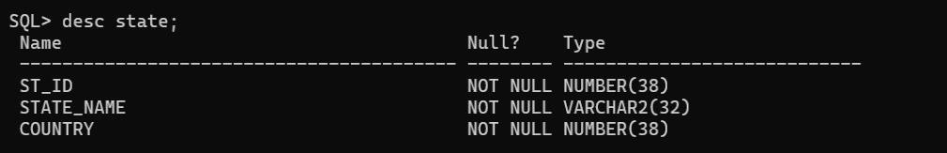

Table 3: Contact_Details

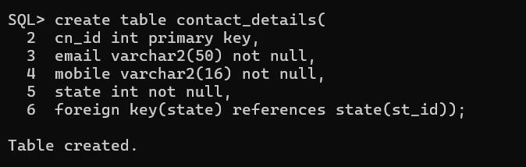

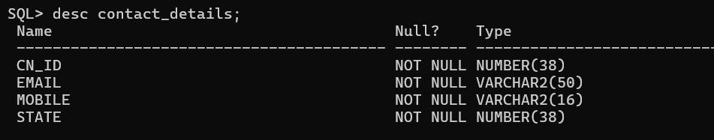

Table 4: Passenger

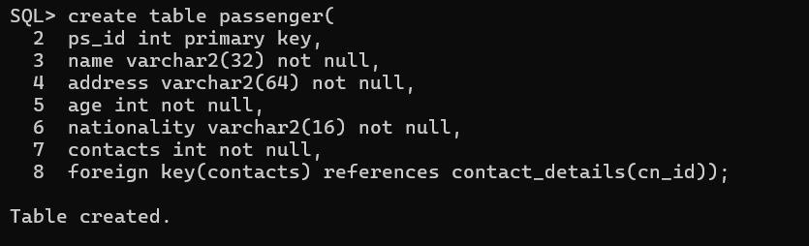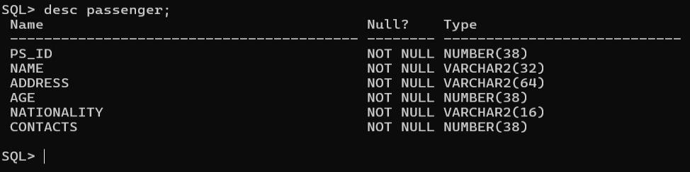

Table 5: Aircraft_Type

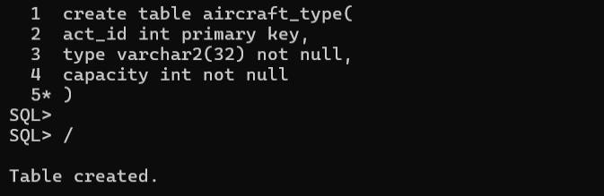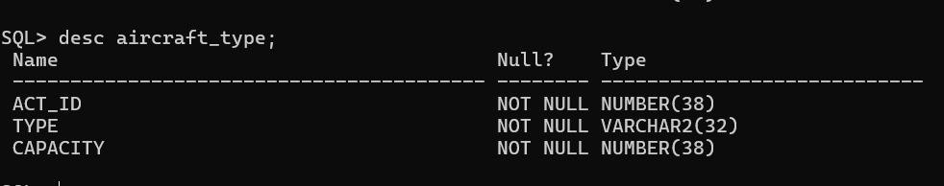

Table 6: Aircraft

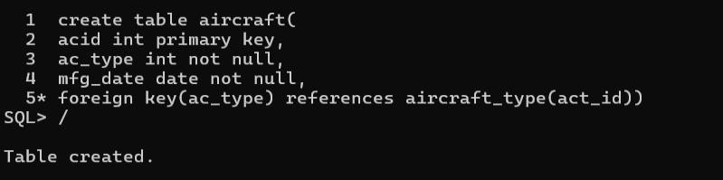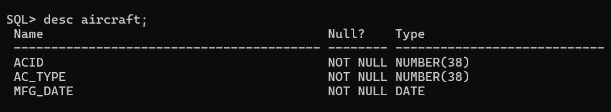

Table 7: Airfare

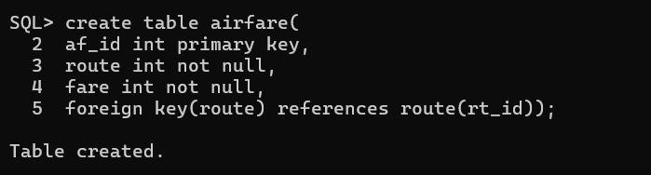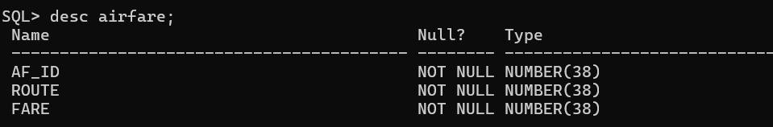

Table 8: Flight_Schedule

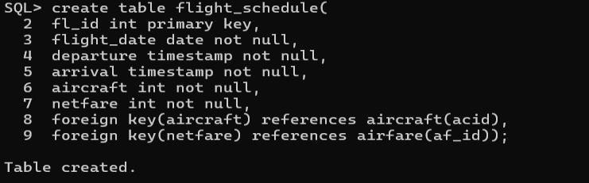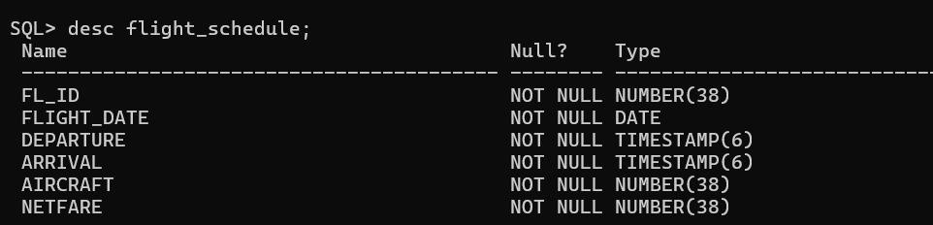

Table 9: Transaction

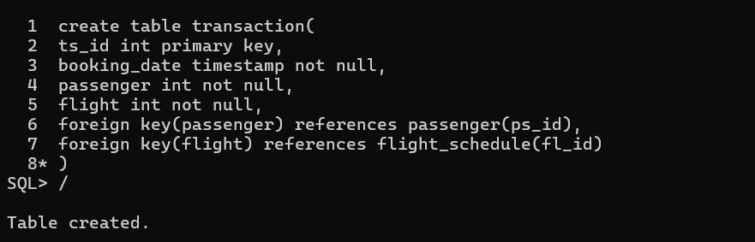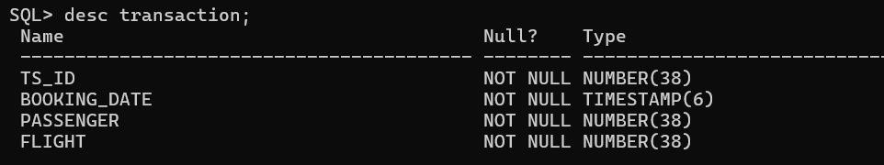

Table 10: Route

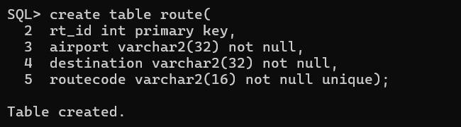

Inserting values into Tables:-

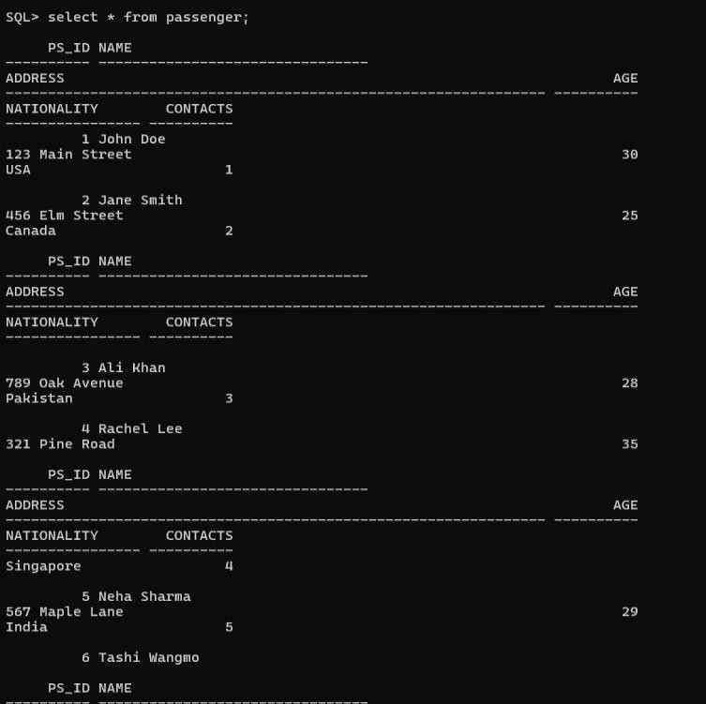

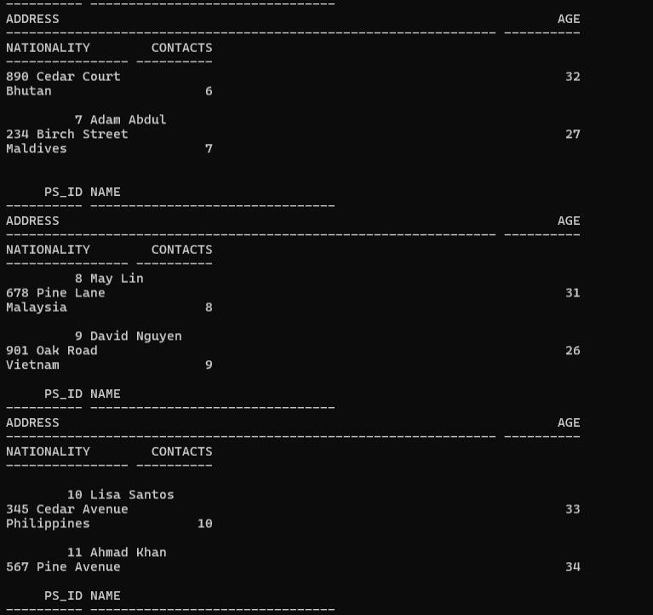

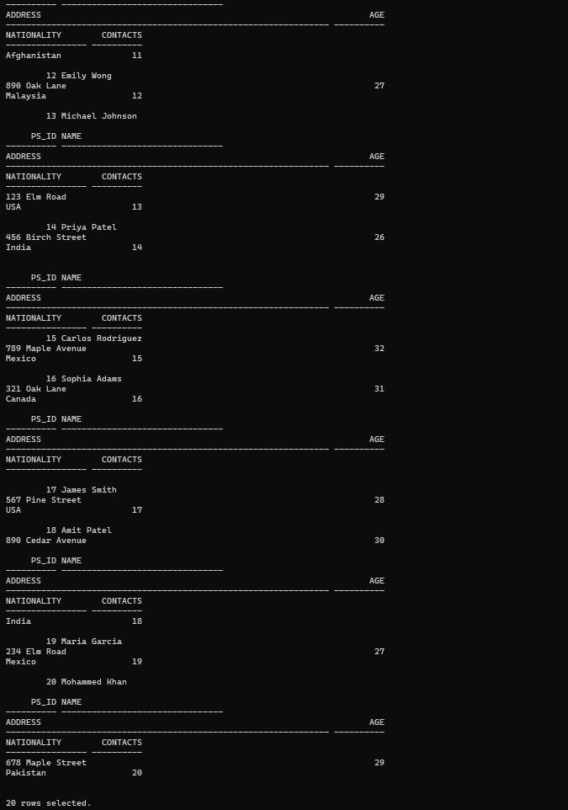

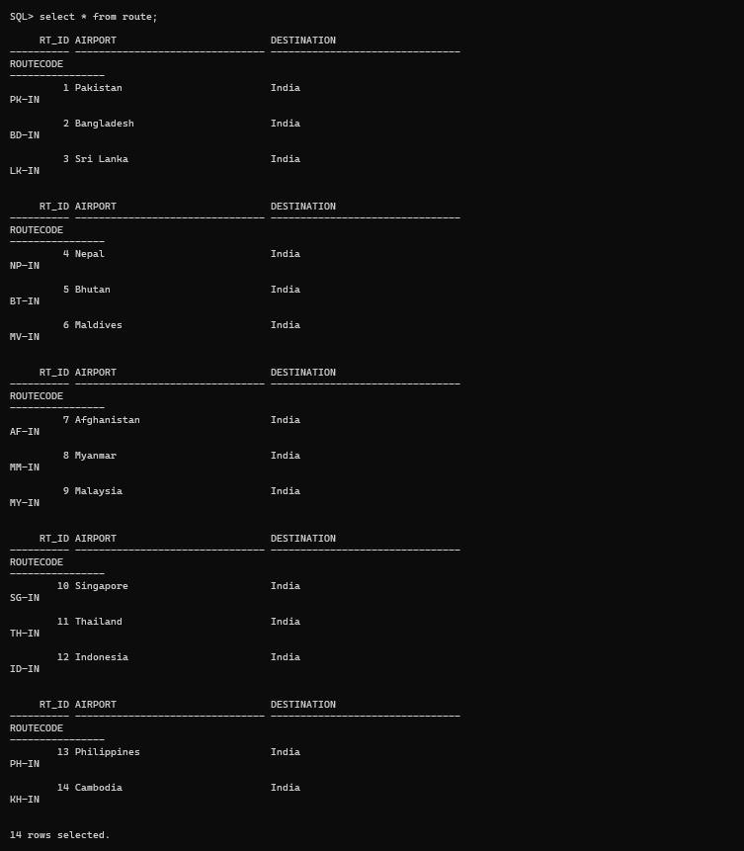

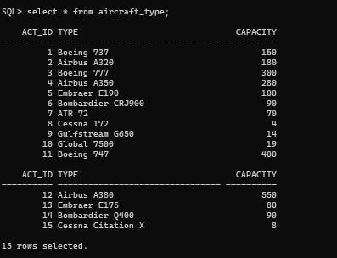

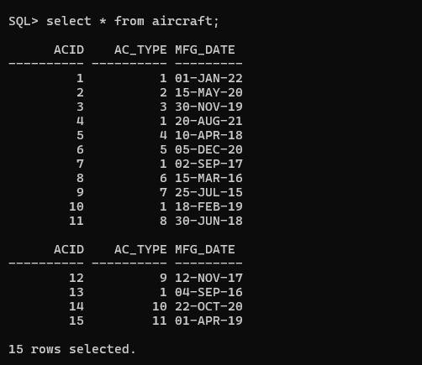

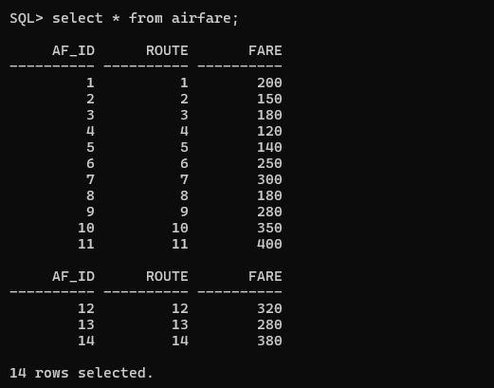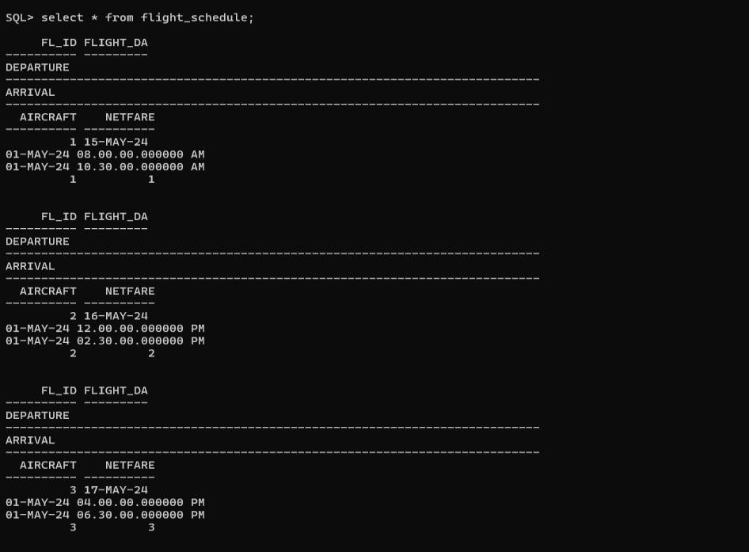

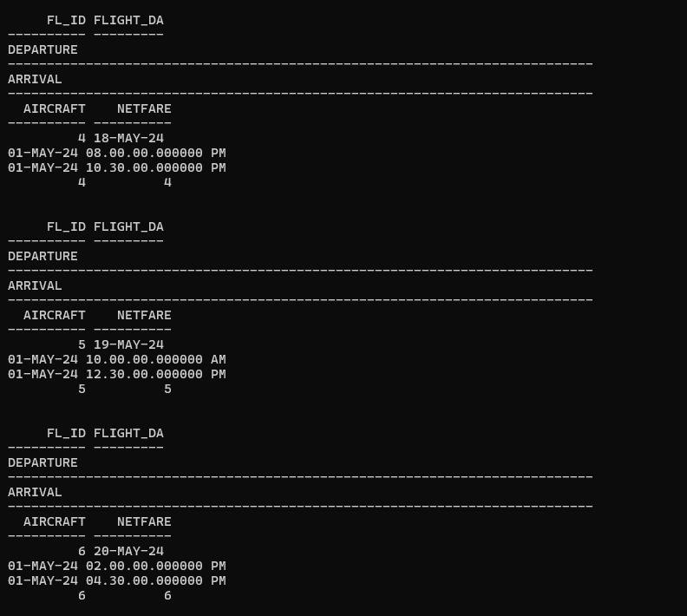

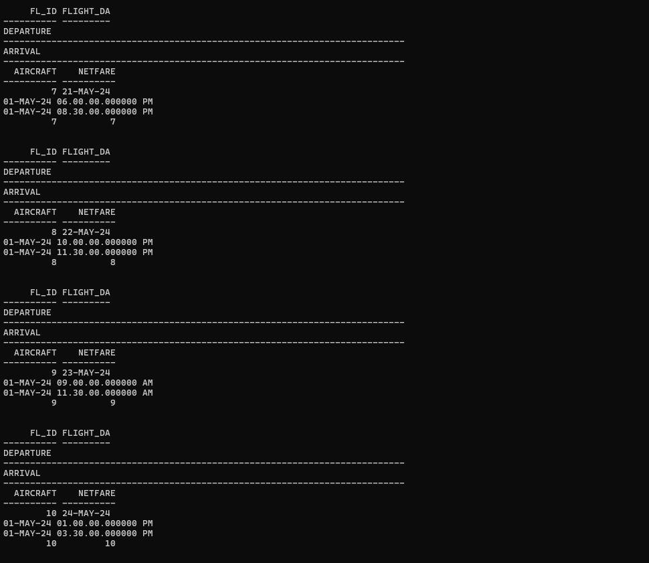

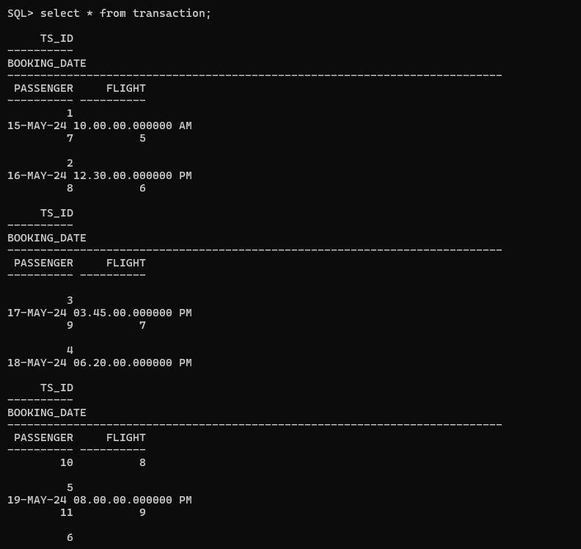

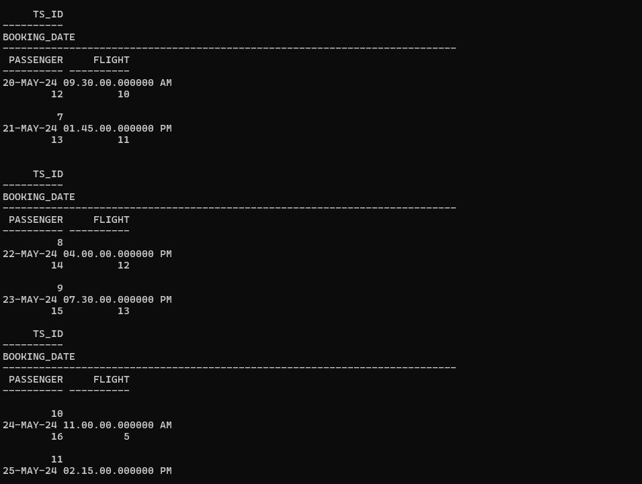



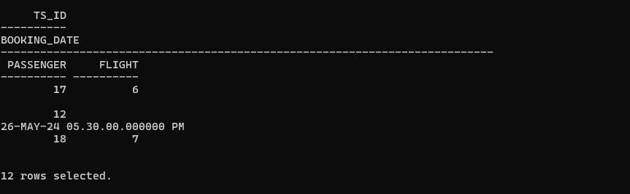

# PL/SQL

Which aircraft type has highest capacity? Using stored function in PL/SQL:

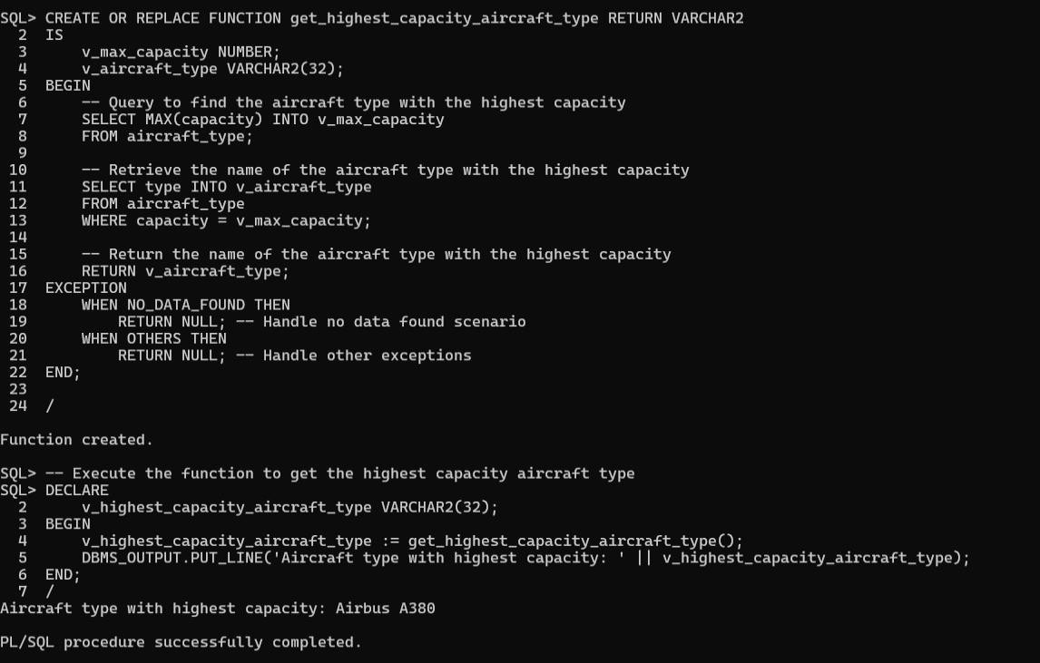

Total number of tickets booked from 15th May 2024 to 23rd May 2024:

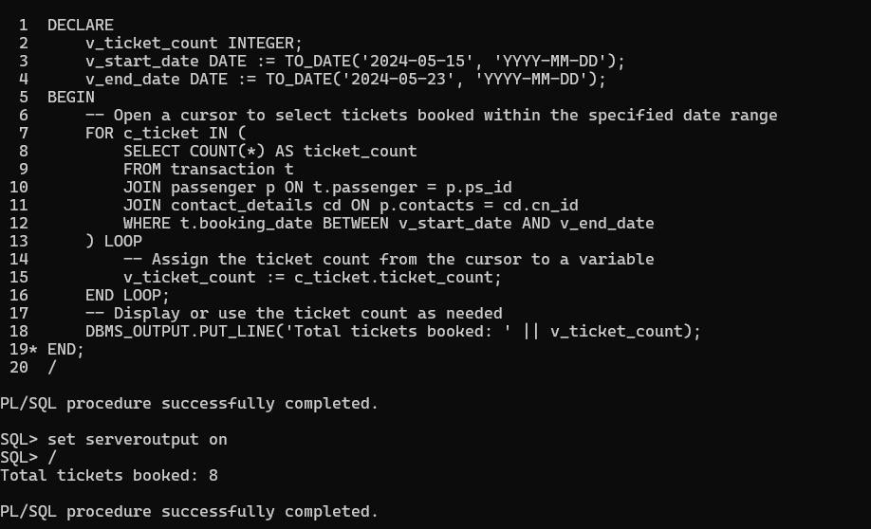

All flights reaching India 20th May to 25th May:

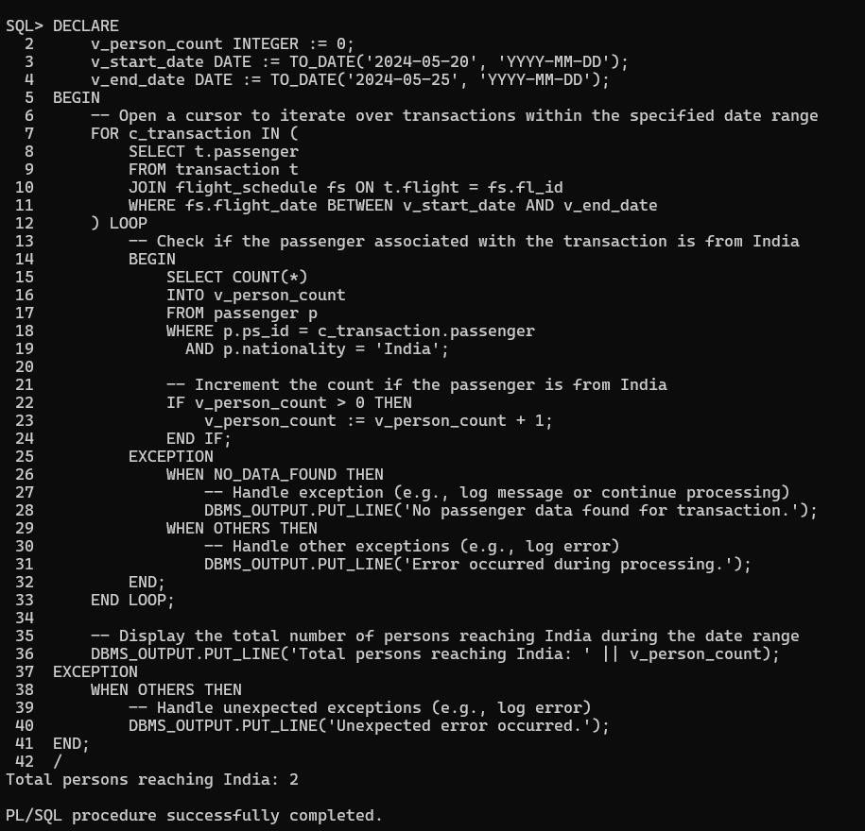

Printing all details of Flight No. 5:

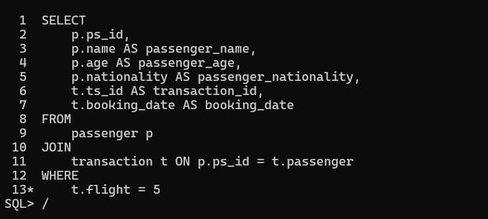

Passenger’s age above 30 years and travelling in Flight No. 5:

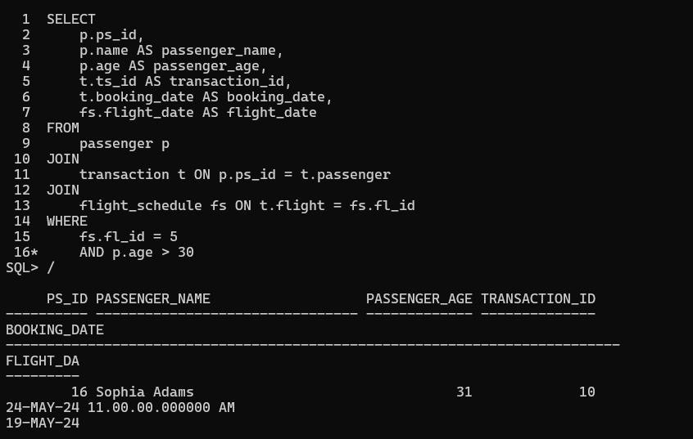

Printing all details of passenger with a ticket:

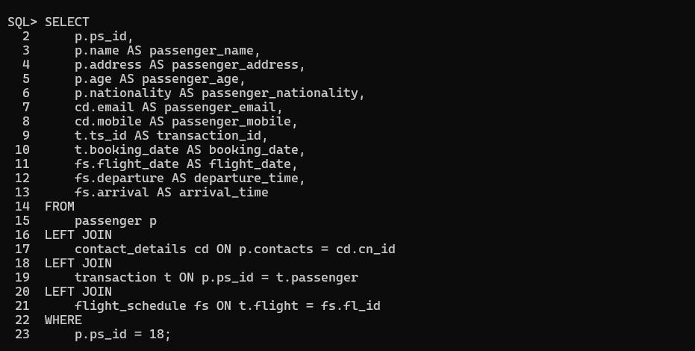



Summary of flight from Maldives to India:

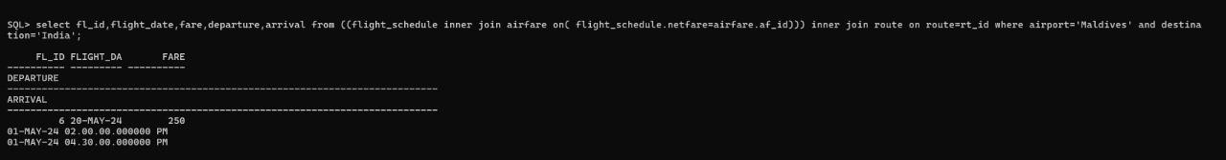

Maintenance of Aircrafts:

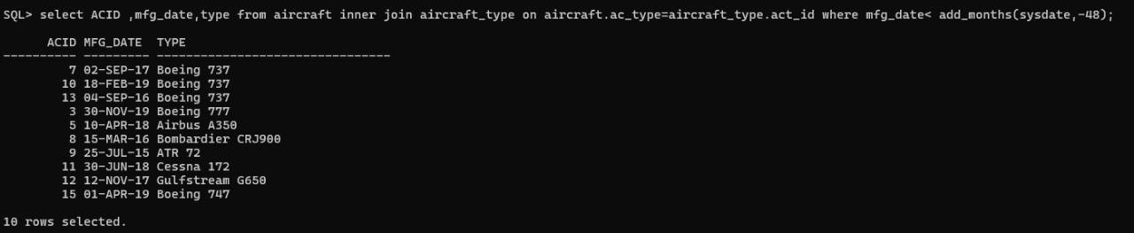

# CONCLUSION

The conclusion of the airline management system project represents a significant milestone in the journey towards modernizing and optimizing airline operations. Over the course of the project, a comprehensive system has been developed, encompassing a range of functionalities critical to the smooth functioning of an airline. These functionalities include reservation management, flight scheduling, ticketing, aircraft maintenance, and data management.

One of the primary achievements of the project is the enhanced efficiency achieved in flight planning and scheduling. By leveraging advanced algorithms and real-time data, the system can optimize routes, allocate resources effectively, and minimize delays, leading to improved on-time performance and operational reliability. This not only benefits the airline by reducing costs associated with disruptions but also enhances the overall travel experience for passengers.

Moreover, the implementation of streamlined booking processes has significantly improved the customer experience. With intuitive interfaces for reservation management and ticketing, passengers can easily book their flights, select seats, and complete payments hassle-free. This not only fosters customer satisfaction but also enhances the airline's reputation for providing convenient and reliable services.

Another critical aspect of the project's success is the optimization of resource allocation through effective maintenance management. By automating maintenance scheduling, tracking aircraft health data, and generating maintenance reports, the system ensures that aircraft remain in optimal condition, thereby minimizing downtime and maximizing operational efficiency. This proactive approach to maintenance not only enhances safety but also contributes to cost savings by reducing the need for unscheduled maintenance and repairs.

Looking ahead, the conclusion of the project marks the beginning of a new phase of ongoing monitoring, maintenance, and potential updates to the system. As the aviation industry continues to evolve, it will be essential to ensure that the system remains aligned with emerging trends, regulatory requirements, and customer expectations. By staying agile and adaptable, the airline management system will continue to play a vital role in optimizing airline operations and enhancing the overall travel experience for passengers in the years to come.

# REFERENCES

1. [https://www.youtube.com/@parteekbhatia](https://www.youtube.com/%40parteekbhatia)
2. Parteek Bhatia and Gurvinder Singh, Simplified Approach to DBMS.
3. Silverschatz A., Korth F. H. and Sudarshan S., Database System Concepts, Tata McGraw Hill (2010) 6th edition.

Signature of Faculty Member