
BRAINWARE UNIVERSITY
398, Ramkrishnapur Road, Barasat, North 24 Parganas, Kolkata – 700 125

PERSONALIZED LEARNING RECOMMENDATION SYSTEM

A PROJECT REPORT
Submitted by
Roll Number | Registration number | Student Code | Student Name
24103460064 | 24103002845 of 2024-2025 | BWU/BCA/24/066 | Swastika Barai

In partial fulfillment for the award of the degree of
BACHELOR OF COMPUTER APPLICATION
in
DEPARTMENT OF COMPUTATIONAL SCIENCES

BRAINWARE UNIVERSITY
398, Ramkrishnapur Road, Barasat, North 24 Parganas, Kolkata – 700 125

ACKNOWLEDGEMENT

I would like to express my heartfelt gratitude to the Management and Faculty of Brainware University for providing me with the opportunity, guidance and academic resources required to complete this project.
I extend my sincere thanks to my project supervisor, Dr. Rahul Kumar Ghosh, Assistant Professor, for his guidance, valuable suggestions and feedback throughout the development of this project. His encouragement helped me understand machine-learning concepts and apply them in a practical project.
I am also thankful to Dr. Jayanta Aich, Head of the Department of Computational Sciences, for providing a supportive academic environment and the necessary facilities. I express my appreciation to all faculty members for their knowledge and encouragement.
Finally, I thank my family and friends for their constant support and motivation.
SIGNATURE: ___________________________
Swastika Barai
(BWU/BCA/24/066)

ABSTRACT

The Personalized Learning Recommendation System is a Python-based machine-learning prototype designed to suggest a suitable learning-resource category based on a student's academic information and learning profile. It uses attributes such as previous score, quiz score, study hours, interest, learning style, completed topics, difficulty level and study consistency.
For development and demonstration, the system creates a synthetic dataset containing 500 student records. A recommendation label is assigned to each record using predefined conditions. The dataset is inspected for its shape, missing values and duplicate rows, and is saved as a CSV file. Exploratory Data Analysis is performed using Matplotlib to visualize previous-score distribution, study hours against quiz score, learning-style distribution and student-interest distribution.
The machine-learning workflow uses an 80:20 train-test split. Numeric features are passed through, while categorical features are transformed using OneHotEncoder within a Column Transformer. These steps are combined with a RandomForestClassifier in a Scikit-learn Pipeline. The model is evaluated using accuracy, a classification report and a confusion matrix. Feature importance is extracted from the trained Random Forest model.
The trained pipeline is saved using Joblib. The program accepts details for a new student and predicts a resource category, such as Beginner Tutorial, Python Practice, Data Visualization Practice, Web Development Project, Machine Learning Tutorial or SQL Practice.
The current project is an educational prototype based on synthetically generated data and rule-generated labels. Its evaluation results describe performance on this generated dataset and should not be treated as proof of performance on real student populations. Validation with real, anonymized student data is a future requirement.

INDEX

- ACKNOWLEDGEMENT
- ABSTRACT
- LIST OF FIGURES
- LIST OF TABLES

- INTRODUCTION
- LITERATURE SURVEY
- SYSTEM ANALYSIS AND DESIGN
- IMPLEMENTATION
- OUTPUT SCREENSHOTS
- SOURCE CODE
- TESTING AND DEBUGGING
- CONCLUSION AND FUTURE ENHANCEMENT
- REFERENCES

LIST OF FIGURES

- Figure 5.1: Previous Score Distribution
- Figure 5.2: Study Hours vs Quiz Score
- Figure 5.3: Student Learning Styles
- Figure 5.4: Student Interest Distribution
- Figure 5.5: Model Confusion Matrix
- Figure 5.6: Top 10 Important Features

LIST OF TABLES

- Table 3.1: Technologies Used
- Table 3.2: Dataset Attributes
- Table 7.1: Test Cases

INTRODUCTION

Students have different academic strengths, interests, learning preferences and study habits. A resource that is useful for one student may not be equally suitable for another. Choosing an appropriate topic, tutorial or practice activity can therefore be difficult when all students are offered the same general material.
The Personalized Learning Recommendation System explores the use of machine learning to support the selection of learning resources. It accepts information about a student's previous academic performance and learning profile, processes these details and predicts a suitable resource category.
The prototype is implemented in Python. Pandas and NumPy manage the dataset, Matplotlib creates visualizations, Scikit-learn performs preprocessing, training and evaluation, and Joblib saves the trained pipeline.

1.1 Aim and Objectives
Aim: To develop a simple machine-learning prototype that uses student academic and learning-profile information to predict a suitable learning-resource category.
- Generate a structured dataset containing student academic and learning-profile attributes.
- Inspect and clean the generated data by checking missing values and duplicate rows.
- Perform Exploratory Data Analysis using graphs.
- Prepare numeric and categorical input features for machine learning.
- Train a Random Forest classification model to predict a resource category.
- Evaluate the model using accuracy, a classification report and a confusion matrix.
- Analyse feature importance, save the trained model and predict for a new student.

1.2 Scope and Limitations
The project covers dataset generation, data inspection, visualisation, preprocessing, supervised classification, evaluation and prediction for a new student. It is not connected to a live Learning Management System or a real institutional student database.
- The dataset is synthetically generated and does not contain actual student records.
- Recommendation labels are assigned through predefined conditions before model training.
- The output is limited to resource categories defined in the program.
- The prototype uses command-line input rather than a web or mobile interface.
- Real-world usefulness must be assessed using real student data and feedback.

LITERATURE SURVEY

Personalized learning and educational data analysis focus on using information about learners to support teaching and learning decisions. Educational platforms commonly organise learning materials, quizzes, lessons and progress information. However, students may still need guidance when selecting what resource to use next.
Rule-based recommendation methods use predefined conditions to suggest content. For example, a system may recommend beginner material when a student's score is below a threshold, or suggest a topic based on the student's interest. Such methods are easy to understand, but their decisions are limited to the rules written by the developer.
Machine learning provides another approach. A classification model can learn associations between input features and known output categories from a training dataset. This project uses a Random Forest Classifier, an ensemble method that combines the predictions of multiple decision trees.
Data preprocessing is important when a dataset contains numeric and categorical information. One-hot encoding converts category values into numeric indicator features. ColumnTransformer applies different transformations to selected columns, while Pipeline combines preprocessing and model training into a single workflow.
This project applies these concepts as a prototype. Since its labels are generated from predefined rules and the dataset is synthetic, it is an implementation exercise rather than a validated educational recommendation service.

2.1 Existing and Proposed System
Existing systems may organise resources by subject, topic or course and require students to browse and choose materials themselves. Some simple systems use fixed rules or filters.
The proposed prototype generates a student-learning dataset, assigns resource labels using predefined conditions, trains a Random Forest classifier and predicts a resource category for new student details.

SYSTEM ANALYSIS AND DESIGN

3.1 System Analysis
System analysis identifies the need for a structured process that can use multiple student attributes to suggest a learning-resource category.
- Students may have to choose learning resources without personalised guidance.
- Generic materials may not match every student's current level or interest.
- Manual selection based on only one factor may ignore other learner attributes.
- Without analysis, it may be difficult to compare the influence of different input features.

3.2 System Modules
Module | Description
Dataset generation | Creates 500 synthetic student records with numeric and categorical attributes.
Label generation | The recommend_resource() function assigns a target resource category using conditions.
Data cleaning | Displays shape, missing-value count and duplicate count; removes duplicates and missing rows.
Exploratory Data Analysis | Creates graphs for score distribution, study hours vs quiz score, learning styles and interests.
Preprocessing | Passes numeric features through and applies OneHotEncoder to categorical features using ColumnTransformer.
Model training | Fits a RandomForestClassifier within a Scikit-learn Pipeline.
Evaluation | Calculates accuracy, classification report, confusion matrix and feature importance.
Prediction | Accepts new student details and predicts a resource category.
3.3 Technologies Used
Technology | Purpose
Python | Main programming language.
NumPy | Random number generation and numerical operations.
Pandas | Dataset creation, inspection, cleaning and CSV handling.
Matplotlib | Generation and saving of graphs.
Scikit-learn | Train-test split, encoding, pipeline, Random Forest and evaluation.
Joblib | Saving the trained machine-learning pipeline.
CSV | Storage for generated dataset and feature-importance output.
Visual Studio Code | Development environment.

3.4 Dataset Attributes
Attribute | Type | Description
previous_score | Numeric | Student's previous score.
quiz_score | Numeric | Student's quiz score.
study_hours | Numeric | Study hours per week.
interest | Categorical | Python, Data Science, Web Development, Machine Learning or Database.
learning_style | Categorical | Visual, Practical, Reading or Auditory.
completed_topics | Categorical | Basics, Intermediate or Advanced.
difficulty | Categorical | Beginner, Intermediate or Advanced.
study_consistency | Categorical | Regular or Irregular.

IMPLEMENTATION

4.1 Folder Creation
The program creates outputs and graphs folders using os.makedirs(..., exist_ok=True). The outputs folder stores data and model files, while graphs stores generated visualisations. The exist_ok option allows the program to run when these folders already exist.

4.2 Dataset Creation
NumPy's random seed is set to 42 so that generated values can be reproduced. The variable n is set to 500, and Pandas creates a DataFrame containing 500 synthetic student records. The dataset contains three numeric attributes—previous_score, quiz_score and study_hours—and five categorical attributes—interest, learning_style, completed_topics, difficulty and study_consistency.

4.3 Recommendation Label Generation
The function recommend_resource(row) assigns a recommended_resource label using conditional rules. A previous score below 40 results in Beginner Tutorial. Otherwise, the student's interest determines categories such as Python Practice, Data Visualization Practice, Web Development Project or Machine Learning Tutorial. Remaining cases receive SQL Practice.
The target labels are therefore generated by rules in the program. The Random Forest model is trained afterwards to learn the relationship between student attributes and these generated labels.

4.4 Data Cleaning
The program displays dataset shape, total missing-value count and duplicate-row count. It applies drop_duplicates() and dropna(), then saves the resulting dataset to outputs/student_learning_dataset.csv. Although a generated dataset may show zero missing values and duplicates, these checks demonstrate data-quality validation.

4.5 Exploratory Data Analysis
- Previous Score Distribution: histogram showing the distribution of generated previous scores.
- Study Hours vs Quiz Score: scatter plot showing generated study hours against quiz scores.
- Student Learning Styles: bar chart showing the count of records in each learning-style category.
- Student Interest Distribution: bar chart showing the count of records for each interest.

4.6 Preprocessing and Model Training
The target column recommended_resource is separated from the input features. Numeric and categorical columns are listed separately. ColumnTransformer passes numeric features through and applies OneHotEncoder(handle_unknown='ignore') to categorical features.
The data is divided using train_test_split with test_size=0.20, random_state=42 and stratify=y. A Pipeline combines the preprocessor withRandomForestClassifier(n_estimators=100, random_state=42). Calling model.fit(X_train, y_train) trains the pipeline.

4.7 Evaluation and Feature Importance
The trained pipeline predicts labels for X_test. Accuracy is calculated using accuracy_score and a classification report is printed. ConfusionMatrixDisplay creates the confusion-matrix graph. Feature names are obtained from the fitted preprocessor and feature_importances_ from the Random Forest classifier. The sorted feature-importance data is saved as outputs/feature_importance.csv and its top ten values are plotted.

4.8 Saving and Prediction
Joblib saves the complete trained pipeline to outputs/personalized_learning_model.pkl. The program then asks for a new student's previous score, quiz score, study hours, interest, learning style, completed topics, difficulty and study consistency. The values are placed

in a one-row DataFrame and passed to model.predict(). The predicted resource category is displayed.

OUTPUT SCREENSHOTS

The following figure sections are intended for the graph outputs shown in the submitted project presentation. The images below are extracted from the presentation where available; otherwise, the caption identifies the screenshot to insert from the final program run.
5.1 Previous Score Distribution
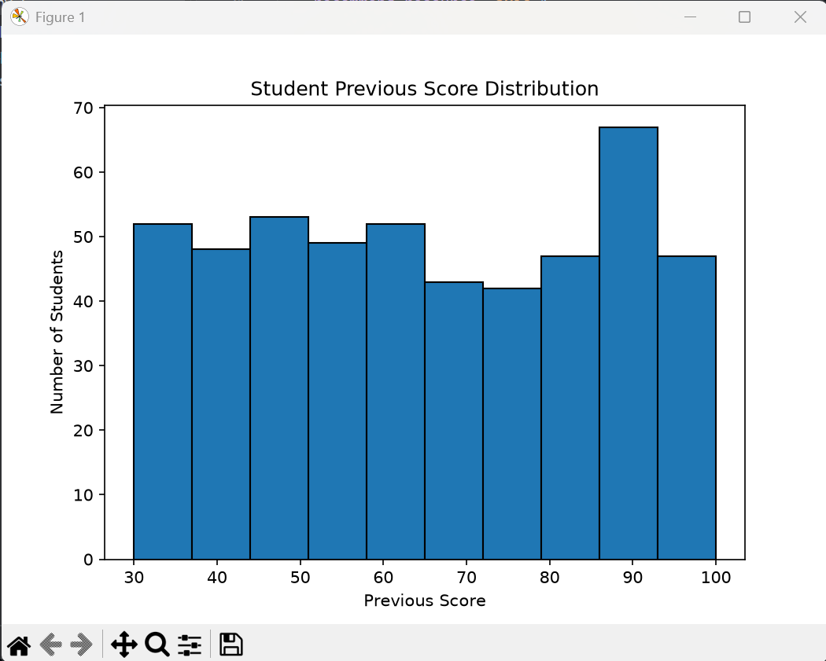
Figure 5.1: Previous Score Distribution
5.2 Study Hours vs Quiz Score
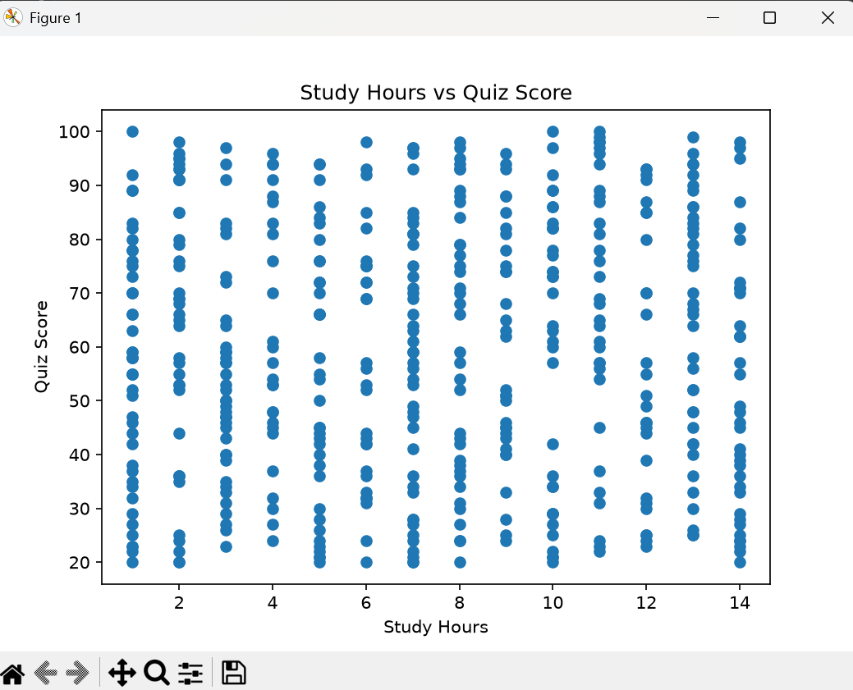
Figure 5.2: Study Hours vs Quiz Score

5.3 Student Learning Styles
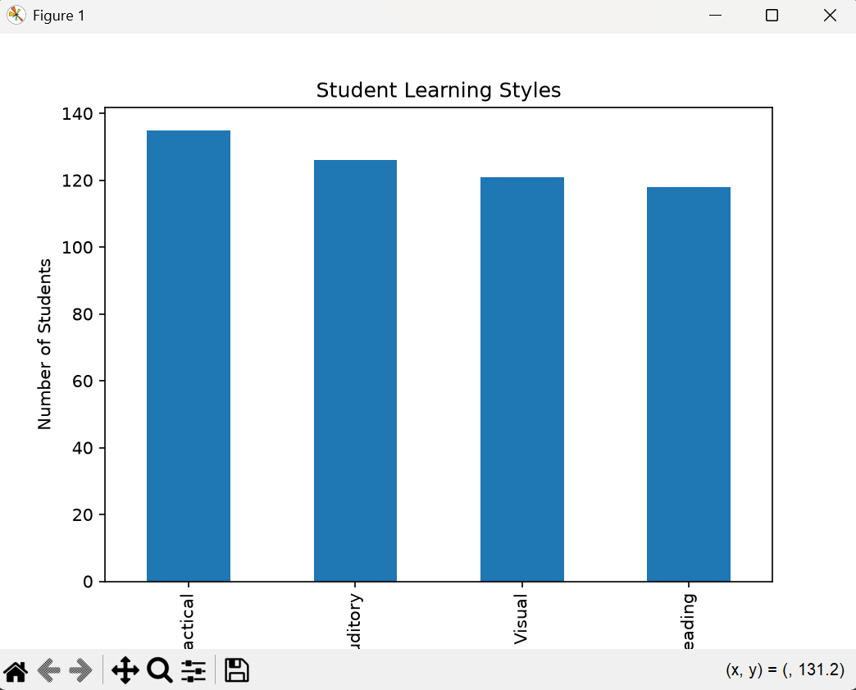
Figure 5.3: Student Learning Styles

5.4 Student Interest Distribution
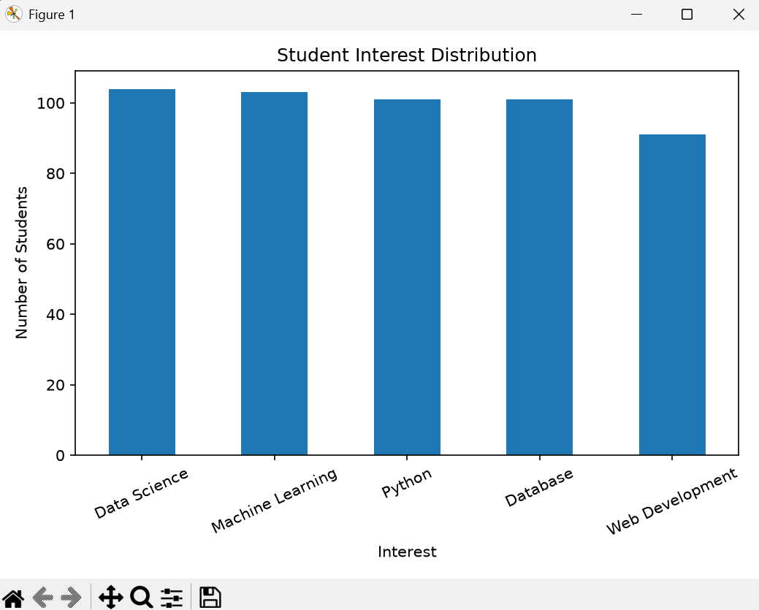
Figure 5.4: Student Interest Distribution

5.5 Model Confusion Matrix
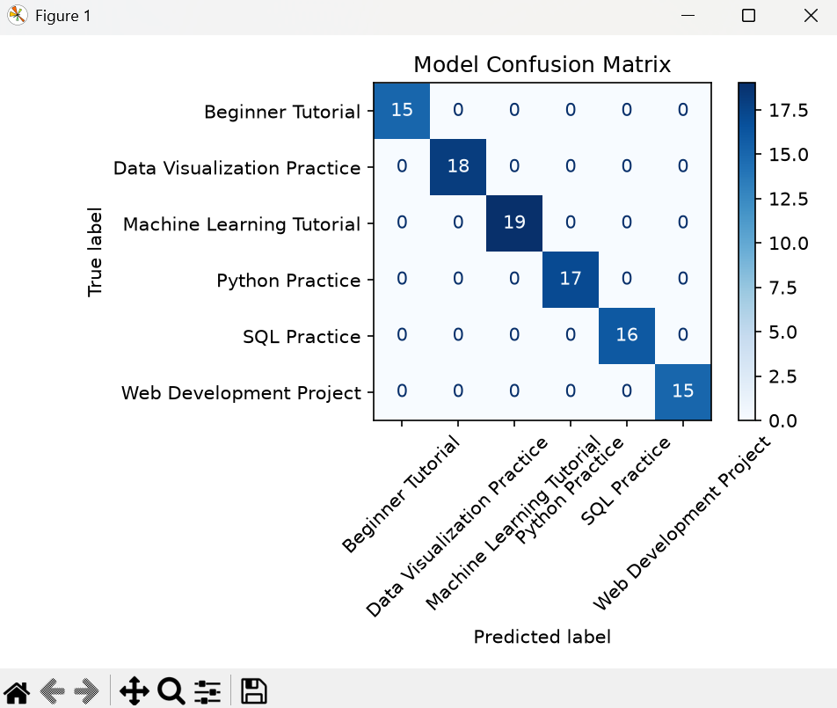
Figure 5.5: Model Confusion Matrix

5.6 Top 10 Important Features
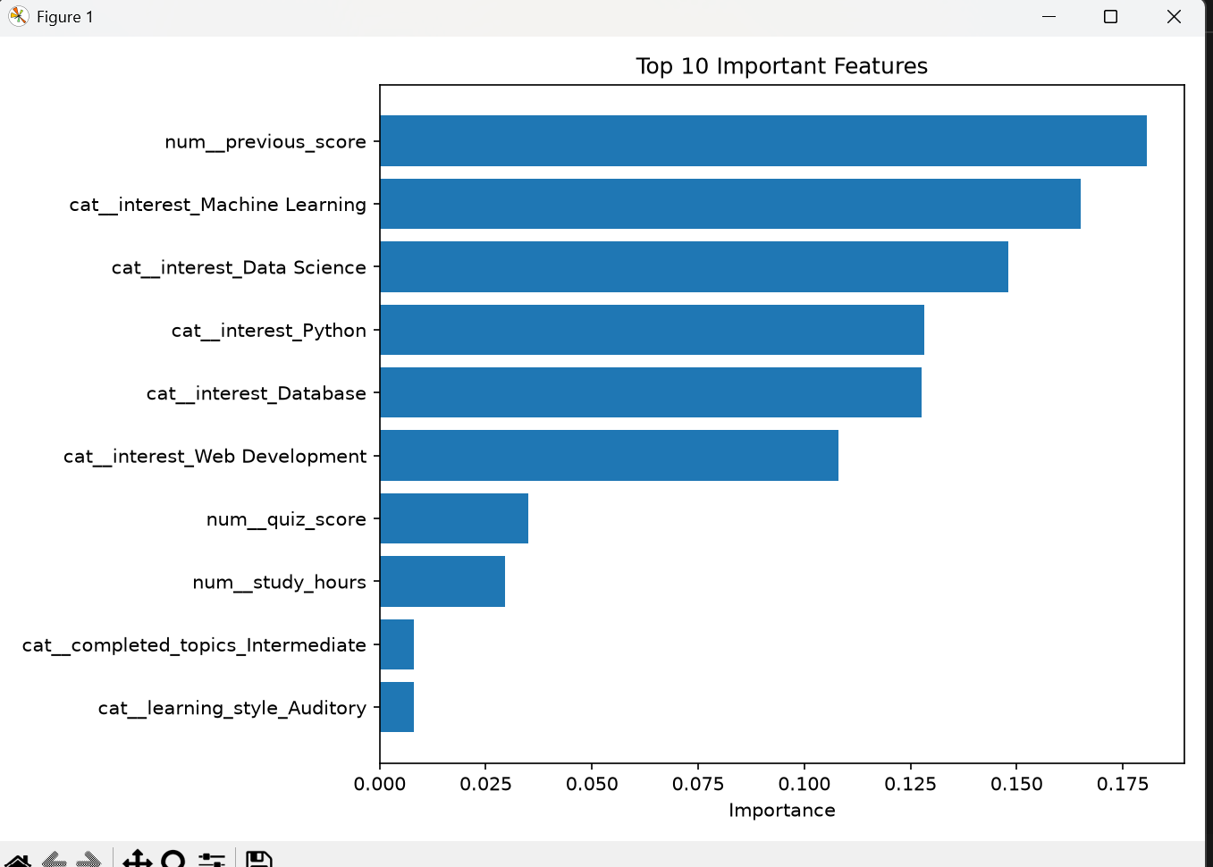
Figure 5.6: Top 10 Important Features

SOURCE CODE

The complete source program is submitted separately as personalized_learning(3).py. The following selected sections identify the main implementation components.
6.1 Recommendation Label Function
def recommend_resource(row):
if row["previous_score"] < 40:
return "Beginner Tutorial"
elif row["interest"] == "Python":
return "Python Practice"
elif row["interest"] == "Data Science":
return "Data Visualization Practice"
elif row["interest"] == "Web Development":
return "Web Development Project"
elif row["interest"] == "Machine Learning":
return "Machine Learning Tutorial"
else:
return "SQL Practice"

6.2 Preprocessing and Random Forest Pipeline
preprocessor = ColumnTransformer(
transformers=[
("num", "passthrough", numeric_features),
("cat", OneHotEncoder(handle_unknown="ignore"),
categorical_features)
]
)
model = Pipeline([
("preprocessor", preprocessor),
("classifier", RandomForestClassifier(
n_estimators=100, random_state=42

))
])

6.3 Training and Prediction
model.fit(X_train, y_train)
predictions = model.predict(X_test)
# New student details are collected into a DataFrame.
recommendation = model.predict(student)[0]
print("Recommended Resource:", recommendation)
Note: These are selected excerpts for explanation. The complete executable source code is provided separately.

TESTING AND DEBUGGING

Testing checks whether the project stages execute and produce the expected files and outputs. The final program includes dataset checks, model training, evaluation, graph generation, model saving and prediction for a new student.

7.1 Types of Testing
- Dataset validation: checks dimensions, missing-value count and duplicate-row count.
- Integration testing: checks that preprocessing, model training and prediction work together through the Pipeline.
- Model evaluation: checks predictions and evaluation outputs on the held-out test subset.
- Output testing: checks that graph, CSV and trained-model files are saved in the expected folders.
- Input testing: checks that the program accepts the requested student fields and returns a predicted category.
7.2 Test Cases
Test ID | Module | Expected result | Status / note
TC-01 | Dataset generation | 500 synthetic records are created. | Confirm by running final script.
TC-02 | Data quality checks | Shape, missing values and duplicate count are displayed. | Confirm by running final script.
TC-03 | CSV export | Dataset saved in outputs/student_learning_dataset.csv. | Check output folder.
TC-04 | EDA graphs | Four EDA graphs are saved and displayed. | Run final script.
TC-05 | Model training | Preprocessing pipeline and Random Forest are fitted. | Run final script.
TC-06 | Model evaluation | Accuracy, classification report and confusion matrix are produced. | Use metrics from same run.
TC-07 | Feature importance | CSV and feature-importance graph are generated. | Check output folder.
TC-08 | Model saving | Trained pipeline saved using Joblib. | Check output folder.
TC-09 | New student prediction | Program displays a recommended resource category. | Demonstrate with valid input.

Test statuses should be marked Pass only after each test is executed using the final source file. Accuracy and confusion-matrix values must come from the same execution.

CONCLUSION AND FUTURE ENHANCEMENT

8.1 Conclusion
The Personalized Learning Recommendation System demonstrates an introductory machine-learning workflow for predicting a learning-resource category from student academic and learning-profile information. It covers synthetic dataset generation, data-quality checks, exploratory visualisation, categorical preprocessing, Random Forest classification, model evaluation, feature-importance analysis and prediction for a new student.
The Scikit-learn Pipeline combines preprocessing and classification so that the same transformations are applied during training and prediction. Joblib saves the fitted pipeline for reuse. The project provides a practical demonstration of machine-learning concepts using Python libraries.
The system currently works with synthetic records and labels generated by predefined rules. Its results demonstrate how the model learns from this constructed dataset, but do not establish that recommendations will be accurate or useful for real students. Real-world validation and feedback are necessary before deployment.
8.2 Future Enhancements
- Collect a larger, anonymised dataset based on real student learning activity, with appropriate consent and privacy safeguards.
- Review and improve recommendation labels with educators and subject experts.
- Compare Random Forest with other classification algorithms and tune model parameters.
- Add validation for numeric ranges and categorical choices entered by users.
- Develop a user-friendly web or desktop interface instead of command-line input.
- Store student profiles and recommendation history in a suitable database.
- Connect the prototype with a Learning Management System where permitted.
- Use student feedback and learning outcomes to evaluate and improve recommendations.
- Recommend specific courses, videos, exercises and next topics rather than only broad resource categories.

9.REFERENCES

- Python Software Foundation. Python Documentation. https://docs.python.org/3/
- The pandas development team. pandas Documentation. https://pandas.pydata.org/docs/
- NumPy Developers. NumPy Documentation. https://numpy.org/doc/
- Matplotlib Development Team. Matplotlib Documentation. https://matplotlib.org/stable/
- Scikit-learn Developers. scikit-learn User Guide: model selection, preprocessing, ensemble methods and evaluation. https://scikit-learn.org/stable/user_guide.html
- Joblib Developers. Joblib Documentation. https://joblib.readthedocs.io/
- Brainware University. Class notes and study materials for Machine Learning, BCA57205.
- Project source code: personalized_learning(3).py.

