1.Photography Website-

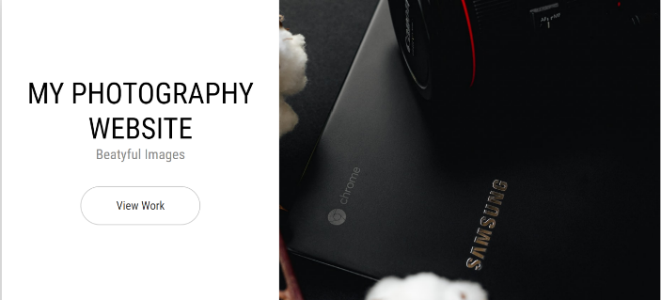

Source code link- <https://codepen.io/yan-evtimov/pen/VOayGG>

2.News Website-

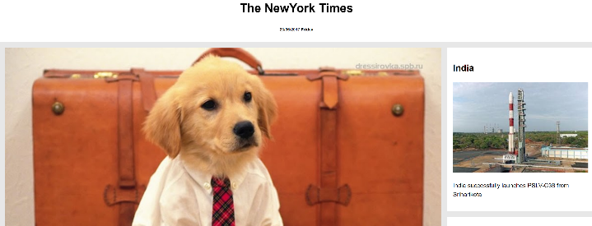

Source code link- <https://codepen.io/poojavpatel/pen/NaPPzQ>

3.User Profile Card-

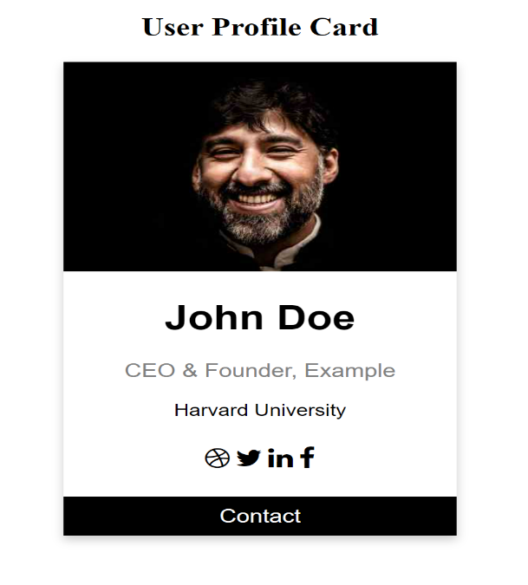

Source code link- <https://www.w3schools.com/howto/tryit.asp?filename=tryhow_css_profile_card>

4.Instagram Home Clone

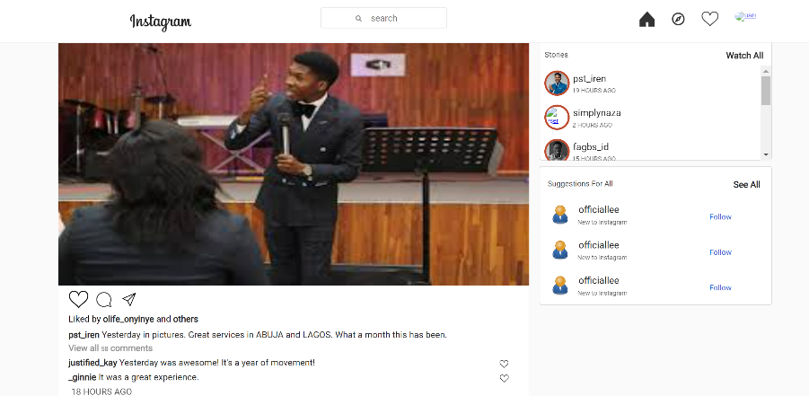

Source code link- <https://codepen.io/The-Accolade/pen/BaNGdMj>

5.Survey form –

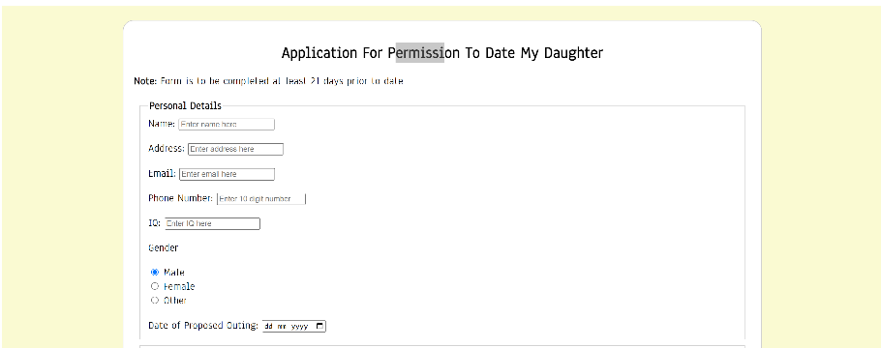

Source code link - <https://codepen.io/gregg50/pen/QWwOVKV>