**PIZZA SALES PROBLEM STATEMENT**

**KPI'S REQUIREMENT**

We need to analyze key indicators for our pizza sales data to gain insights into our business performance. Specifically, we want to calculate the following metrics:

**1. Total Revenue:** The sum of the total price of all pizza orders

**2. Average Order Value:** The average amount spent per order, calculated by dividing the total revenue by the total number of orders.

**3. Total Pizzas Sold:** The sum of the quantities of all pizzas sold.

**4. Total Orders:** The total number of orders placed.

**5. Average Pizzas Per Order:** The average number of pizzas sold per order, calculated by dividing the total number of pizzas sold by the total number of orders.

**CHARTS REQUIREMENT**

We would like to visualize various aspects of our pizza sales data to gain insights and understand key trends. We have identified the following requirements for creating charts:

**1.Daily Trend for Total Orders:**

Create a bar chart that displays the daily trend of total orders over a specific time period. This chart will help us identify any patterns or fluctuations in order volumes on a daily basis.

**2.Hourly Trend for Total Orders:**

Create a line chart that illustrates the hourly trend of total orders throughout the day. This chart will allow us to identify peak hours or periods of high order activity.

**3.Percentage of Sales by Pizza Category:**

Create a pie chart that shows the distribution of sales across different pizza categories. This chart will provide insights into the popularity of various pizza categories and their contribution to overall sales.

**4.Percentage of Sales by Pizza Size:**

Generate a pie chart that represents the percentage of sales attributed to different pizza sizes. This chart will help us understand customer preferences for pizza sizes and their impact on sales.

**5.Total Pizzas Sold by Pizza Category:**

Create a funnel chart that presents the total number of pizzas sold for each pizza category. This chart will allow us to compare the sales performance of different pizza categories.

**6.Top 5 Best Sellers by Total Pizzas Sold:**

Create a bar chart highlighting the top 5 best-selling pizzas based on the total number of pizzas sold. This chart will help us identify the most popular pizza options.

**7.Bottom 5 Worst Sellers by Total Pizzas Sold:**

Create a bar chart showcasing the bottom 5 worst-selling pizzas based on the total number of pizzas sold. This chart will enable us to identify underperforming or less popular pizza options.

**PIZZA SALES SQL QUERIES**

**KPI’s**

**1. Total Revenue:**

SELECT SUM(total_price) AS total_revenue

FROM [dbo].[pizza.sales];

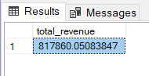

**2. Average Order Value**

SELECT SUM(total_price) / COUNT(DISTINCT order_id) AS average_order_value

FROM [dbo].[pizza.sales];

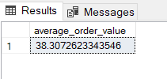

**3. Total Pizza Sold**

SELECT SUM(quantity) AS total_sales

FROM [dbo].[pizza.sales];

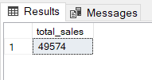

**4. Total Orders**

SELECT COUNT(DISTINCT order_id) AS total_orders

FROM [dbo].[pizza.sales];

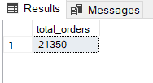

**5. Average Pizza per Orders**

SELECT CAST(CAST(SUM(quantity) AS DECIMAL(10,2)) /

CAST(COUNT(DISTINCT order_id) AS DECIMAL(10,2)) AS DECIMAL(10,2))

AS Avg_Pizzas_per_order

FROM [PizzaDB].[dbo].[pizza.sales];

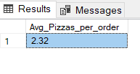

**CHARTS REQUIREMENT**

**A. Daily Trend for Total Orders**

SELECT DATENAME(DW, order_date) AS Order_day, COUNT(DISTINCT order_id) AS Total_orders

FROM [PizzaDB].[dbo].[pizza.sales]

GROUP BY DATENAME(DW, order_date);

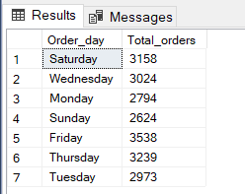

**B. Hourly Trend for Orders**

SELECT DATEPART(hour, order_time) as order_hours, count(DISTINCT order_id) as Total_orders

FROM [PizzaDB].[dbo].[pizza.sales]

GROUP BY DATEPART(hour, order_time)

ORDER BY DATEPART(hour, order_time);

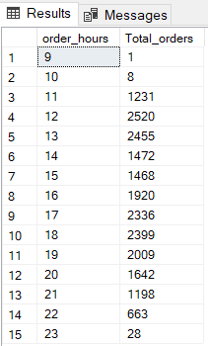

**C. % of Sales by Pizza Category**

SELECT pizza_category, sum(total_price) AS Total_sales, sum(total_price) * 100 / (SELECT sum(total_price) FROM [PizzaDB].[dbo].[pizza.sales] where MONTH(order_date) = 1) AS Per_Total_Sales

FROM [PizzaDB].[dbo].[pizza.sales]

WHERE MONTH(order_date) = 1

GROUP BY pizza_category;

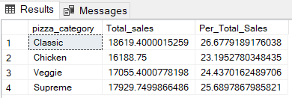

**D. % of Sales by Pizza Size**

SELECT pizza_size, ROUND(sum(total_price), 2) AS Total_sales, ROUND(sum(total_price) * 100 / (SELECT sum(total_price) FROM [PizzaDB].[dbo].[pizza.sales] WHERE DATEPART(quarter, order_date) = 1),2) AS Per_Total_Sales

FROM [PizzaDB].[dbo].[pizza.sales]

WHERE DATEPART(quarter, order_date) = 1

GROUP BY pizza_size

ORDER BY Per_Total_Sales DESC;

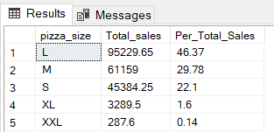

**E. Total Pizzas Sold by Pizza Category**

SELECT pizza_category, SUM(quantity) as total_sales

FROM [PizzaDB].[dbo].[pizza.sales]

GROUP BY pizza_category;

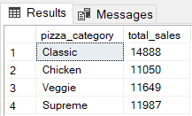

**F. Top 5 Best Sellers by Total Pizzas Sold**

SELECT TOP 5 pizza_name, sum(quantity) AS total_pizza_sold

FROM [PizzaDB].[dbo].[pizza.sales]

GROUP BY pizza_name

ORDER BY sum(quantity) DESC;

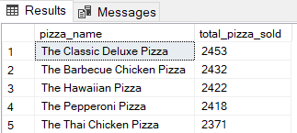

**G. Bottom 5 Best Sellers by Total Pizzas Sold**

SELECT TOP 5 pizza_name, sum(quantity) AS total_pizza_sold

FROM [PizzaDB].[dbo].[pizza.sales]

GROUP BY pizza_name

ORDER BY sum(quantity);

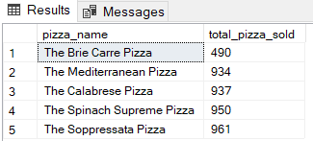

**PIVOT TABLES**

|  |  |
| --- | --- |
| Daily Trend For Total Orders | |
| **Row Labels** | **Sum of total_orders** |
| Sunday | 205 |
| Monday | 230 |
| Tuesday | 301 |
| Wednesday | 290 |
| Thursday | 179 |
| Friday | 215 |
| Saturday | 241 |
| **Grand Total** | **1661** |

|  |  |
| --- | --- |
| Hourly Trend For Total Orders | |
| **Row Labels** | **Sum of total_orders** |
| **10 AM** | **1** |
| **11 AM** | **105** |
| **12 PM** | **197** |
| **1 PM** | **190** |
| **2 PM** | **110** |
| **3 PM** | **108** |
| **4 PM** | **161** |
| **5 PM** | **194** |
| **6 PM** | **182** |
| **7 PM** | **147** |
| **8 PM** | **121** |
| **9 PM** | **105** |
| **10 PM** | **39** |
| **11 PM** | **1** |
| **Grand Total** | **1661** |

|  |  |
| --- | --- |
| % of sales by pizza category | |
| **Row Labels** | **Sum of total_price** |
| Chicken | 24.99% |
| Classic | 27.79% |
| Supreme | 23.83% |
| Veggie | 23.39% |
| **Grand Total** | **100.00%** |

|  |  |
| --- | --- |
| % of sales by pizza size | |
| **Row Labels** | **Sum of total_price** |
| Large | 46.55% |
| Medium | 29.54% |
| Regular | 22.32% |
| X-Large | 1.43% |
| XX-Large | 0.17% |
| **Grand Total** | **100.00%** |

|  |  |
| --- | --- |
| Total pizza sold by pizza category | |
| **Row Labels** | **Sum of quantity** |
| Classic | 1202 |
| Veggie | 911 |
| Chicken | 900 |
| Supreme | 877 |
| **Grand Total** | **3890** |

|  |  |
| --- | --- |
| Top 5 Best Sellers by Total pizza sold | |
| **Row Labels** | **Sum of quantity** |
| The Barbecue Chicken Pizza | 192 |
| The Hawaiian Pizza | 196 |
| The Pepperoni Pizza | 198 |
| The Thai Chicken Pizza | 203 |
| The Classic Deluxe Pizza | 209 |
| **Grand Total** | **998** |

|  |  |
| --- | --- |
| Bottom5 worst Sellers by Total pizza sold | |
| **Row Labels** | **Sum of quantity** |
| The Brie Carre Pizza | 49 |
| The Soppressata Pizza | 65 |
| The Calabrese Pizza | 66 |
| The Spinach Supreme Pizza | 71 |
| The Italian Vegetables Pizza | 72 |
| **Grand Total** | **323** |